Note for discussion with Member States' Competent Authorities for Biocidal Products
This document is drafted in the interest of consistency of the implementation of Regulation (EU) No 528/2012 and with the aim of finding an agreement between Member States' Competent Authorities for biocidal products on a harmonised approach. Please note, however, it does not represent the official position of the Commission and that Member States are not legally obliged to follow the approach set out in this document, since only the Court of Justice of the European Union can give authoritative interpretations on the contents of Union law.

Subject: Management of product authorisation for in situ cases

Background and purposes of the document
- Document "CA-March15-Doc.5.1-Final revised on 23 June 2015" provided for some basic principles regarding the regulatory approach for in situ generated actives substances. Later on, the BPC working groups provided detailed recommendations in order to approach the active substance (AS) approval stage.
- Following the approval of in situ generated ASs, applicants and competent authorities (CAs) will be confronted to product authorisation. Taking into account the wide range of biocidal products that would be subject to authorisation in the upcoming years, the possible complexity of the applications and its associated workload for both applicants and CAs, there is wide consensus on the need to find-out a pragmatic approach for product authorisation.
- From previous discussions since 2017 with stakeholders and CAs, it follows that such a pragmatic approach should be based on the following principles:
  - To cover the wide diversity of cases falling under the first or the second indent in the definition of a biocidal product pursuant to Article 3(1)(a) of the BPR. This includes addressing devices used as part of the in situ generation process. However, it has been made also clear that devices as such are not authorised as biocidal products under the BPR.
  - To optimise as much as possible the regulatory procedures and tools by applying, where relevant, the biocidal product family (BPF) concept. This could potentially lead to a reduction in the number of the required procedures compared to individual applications for authorisation. On the other hand, the identification of the maximum risks/minimum efficacy covering the proposed family in accordance with Article 19(6) of the BPR could be useful to address the assessment of several products within a given concentration range of the in situ generated AS.
  - To benefit as much as possible at the products authorisation stage from the work already done at the AS approval stage, while keeping some flexibility at the product authorisation stage in order to allow applicants to provide new relevant information on the relevant IGS generating the in situ AS,
  - To provide complementary guidance to support applicants in identifying the data necessary to support the risk/efficacy assessment compared to what is already available for the AS approval. In this respect, the specificities related to the use of technical standards, existing legislation or applicable regulatory guidance for precursors or devices, where relevant, should also be considered. It might be possible for the applicant to either demonstrate full compliance of the precursor/device to the agreed standard(s) or to demonstrate that the precursor/device meets relevant specifications identified in the AS approval (e.g. proof of technical equivalence between precursors).
  - To prevent as far as possible situations where some existing uses of in situ generated AS are not supported for product authorisation under the BPR (i.e. no submission of an application), which might affect business continuity and result in some unexpected side effects on society (e.g. supply of drinking water for human consumption).
- In order to address the above-mentioned principles, it is proposed to follow a step-wise-approach in which, following an agreement by the CA meeting on the regulatory aspects, ECHA will develop more detailed technical guidance addressing point 3(d) above.
- This note aims at addressing the regulatory aspects to be considered by prospective applicants and CAs in relation to the authorisation of biocidal products when ASs are generated in situ.
- This note includes in Annex VII the possibility of adding Q&A pairs about issues raised by CAs when dealing with this kind of applications and how the Coordination Group (either through e-consultation or at CG meetings) will have agreed to address them. The Q&A pairs will be endorsed by the CA meetings.

Understanding of terms
- The following definitions should apply throughout the text:
  - In situ generated active substance in this document means the AS generated in situ, as per the definitions in Articles 3(1)(c) of the BPR and 3(1) of REACH (i.e. including any impurity deriving from the in situ generation process used, such as reaction by-product, unreacted precursors – output = in situ generated active substance).
  - In situ biocidal products falling under the first indent of the definition of a biocidal product: any substance or mixture, in the form in which it is supplied to the user, consisting of, containing or generating one or more active substances, with the intention of destroying, deterring, rendering harmless, preventing the action of, or otherwise exerting a controlling effect on, any harmful organism by any means other than mere physical or mechanical action (emphasis added).
  - In situ biocidal products falling under the second indent of the definition of a biocidal product): any substance or mixture, generated from substances or mixtures which do not themselves fall under the first indent, to be used with the intention of destroying, deterring, rendering harmless, preventing the action of, or otherwise exerting a controlling effect on, any harmful organism by any means other than mere physical or mechanical action (emphasis added).
  - In situ generation means the reaction of one or more precursors to generate the AS at the place of use for direct application without isolation, purification, storage or transport.
  - In situ generation process means the whole process leading to the in situ generation, including those parameters that may affect the chemical reactions and impact the qualitative and quantitative composition of precursors (e.g. including impurities, etc…) and/or concentration of the in situ AS generated.
  - 'Device' designates the equipment or technology used in the in situ generation process. This device may enable the users to set the values of the parameters that may affect the chemical reactions and the composition of the AS generated in situ.
  - In situ generation system ('IGS') means a system generating an in situ AS that covers the combination of:
    - the precursor(s), which have to meet the conditions specified in the AS approval,
    - the relevant parameters affecting the generation process, including those to be applied in the relevant devices (if any) and,
    - the AS generated in situ which includes any impurities, such as reaction by-products and/or any unreacted precursors, (the so-called “output” of the IGS).
For the purpose of the authorisation of biocidal products for in situ generated ASs under either the first or the second indent (as defined above), the terms and conditions of the product authorisation and the SPC should specify all the relevant elements integrating the IGS that are involved in the generation of the in situ generated AS.

Proposed practical implementation
3.1 Case-types of in situ biocidal products
- When authorising in situ generated biocidal products, the following case-types could be considered (see Annex I):
  - In situ biocidal products falling under the first indent of the definition:
    - Case-type 1: the in situ biocidal products involve an IGS only based on the mixing of two or more precursors without using a device (e.g. active bromine generated from sodium bromide and sodium hypochlorite);
    - Case-type 2: the in situ biocidal products involve an IGS based on one or more precursors used in a device (e.g. active bromine generated from sodium bromide by electrolysis);
    - Case-type 3: the in situ biocidal products involve an IGS based on a coating that when exposed to ultraviolet light generates free radicals;
  - In situ biocidal products falling under the second indent of the definition:
    - Case-type 4: the in situ biocidal products involve an IGS generating an in situ AS from a precursor not placed on the market for biocidal purposes and using a device (e.g. “ozone” generated from ambient air by an ozone generator or “active chlorine” generated from salt "not supplied for biocidal purposes" by electrolysis through a device).
3.2 In situ biocidal products involving of one or more precursor, generating one or more in situ AS or belonging to one or more product-type(s) (PTs)
- In situ biocidal products may:
  - belong to one or more PTs,
  - involve of one or more precursors, in case of in situ biocidal products under the first indent,
  - generate one or more in situ AS, for example under case-type 2:
    - A device generates copper and silver ions from a single copper/silver electrode for PT5 applications. The electrode is placed on the market as a precursor for biocidal purposes and therefore will be authorised as a single biocidal product. By using this single electrode, two active substances are generated (copper ions and silver ions) in different concentrations depending on the settings of the device.
    - A device generates active chlorine and chlorine dioxide from sodium chloride for PT5 applications. Sodium chloride is placed on the market as a precursor for biocidal purposes and therefore will be authorised as a single biocidal product. By using this single precursor, an active substance is generated that contains as constituents active chlorine and chlorine dioxide. Different concentrations depending on the settings of the device may lead to different concentration of active substances generated in situ.
3.3 Applying for authorisation as a single biocidal product or as a BPF
- Document “CA-March15-Doc.5.1-Final revised on 23 June 2015” clarifies that:
  - Under the first indent of the definition of biocidal product under article 3 (1) (a), the precursor will be authorised as biocidal product
  - Under the second indent of the definition of biocidal product under article 3 (1) (b), the active substance generated in situ will be authorised as biocidal product.
- As for other biocidal products, an authorisation can be granted in the form of either a single biocidal product or a BPF. An application for authorisation of a BPF might cover different in situ biocidal products provided that the conditions in the definition for a BPF in Article 3(1)(s) BPR are met. In other words, the BPF may cover biocidal products involving the same in situ AS(s) within a given range of concentration for similar uses provided that similar levels of risk and efficacy are demonstrated.
- When considering whether an application for authorisation as a single biocidal product or as a BPF has to be submitted, the specificities of the different case-types identified under section 3.1 have to be considered:
- Case-type 1 with no device (see Annex III):
  - If the ratio when mixing the precursors is constant and a fixed concentration of the in situ AS is generated (e.g. X%, 2X%), then the authorisation could be granted as a single biocidal product (e.g. product a) with different in use concentrations (application rates to be indicated in section 4 of the SPC).
  - When the same set of precursors when mixed at different ratio compared to a) generates different fixed concentration of the in situ AS is generated (e.g. Y%), this would be a new product (e.g. product b). Products (a) and (b) could be combined in a BPF provided that the conditions in Article 3(1)(s) of the BPR are met.
  - If the ratio when the precursors is variable and a variable concentration range of the in situ AS (X-Y%) is generated, the authorisation should be granted as a BPF.
- Case-types 2 and 4 using a device that generates a fixed concentration of the in situ AS (see Annex IV):
  - Where the precursor is the biocidal product (case-type 2), the composition of the biocidal product is the same (e.g. 100% NaCl) irrespectively of any dilution made (i.e. application rate) that could lead to a different in use concentration (X%, Y% or Z%).
  - Where the in situ generated AS is the biocidal product (case-type 4), each concentration (X%, Y% or Z%) resulting from different dilutions of the precursor is an individual biocidal product. These individual products could be combined in a BPF provided that the conditions in Article 3(1)(s) of the BPR are met. For each family member, the final in use concentration could vary depending on the relevant application rate (e.g. dilution made) indicated in section 4 of the metaSPC.
- Case-types 2 and 4 using a device that generates a variable concentration of the in situ AS (see Annex V):
  - Where the precursor is the biocidal product (case-type 2), the composition of the biocidal product is the same (e.g. 100% NaCl) irrespectively of the dilution made with the precursor and the settings of the device that could lead to a range of in use concentration of the in situ AS (e.g. X-Y%, Q-R% or U-W%).
  - Where the in situ generated AS is the biocidal product (case-type 4), each active substance concentration range resulting from different dilutions of the precursor and the settings of the device (e.g. X-Y%, Q-R% or U-W%) should be authorised as a BPF provided that the conditions in Article 3(1)(s) of the BPR are met.
- Case-type 3 (coating generating free radicals):
  - Each coating (the biocidal product) will have its own concentration of the catalyst (e.g. TiO₂) and as such, it can be authorised as a single biocidal product with different in use concentrations (application rates to be indicated in section 4 of the SPC) of the free radicals.
  - Several individual products could be combined in a BPF provided that the conditions in Article 3(1)(s) of the BPR are met.
3.4 Data requirements and conditions for authorisation
- A product authorisation can only be granted if the conditions in Article 19 of the BPR are met. In order to allow the evaluating CA to reach such conclusion, the applicant needs to submit within the application the data referred to in Article 20 of the BPR.
- As indicated in paragraph 3(d), more specific technical guidance will be developed by ECHA at a later stage. However, the information contained in the application should cover all the elements that are relevant for the IGS involved in the generation of the in situ generated AS.
- On a more general note, at least the following elements should be taken into account for the purpose of product authorisation:
  - During the AS approval procedure, information on a "representative biocidal product" has to be submitted in order to consider whether the conditions in Article 19 of the BPR are met.
  - Document CA-March15-Doc.5.1-Final acknowledges that technical equivalence as defined in Article 54 of the BPR, would be technically difficult, if not impossible, to achieve for in situ AS. Nevertheless, it was agreed to establish specifications or to refer to existing standards, either for the in situ generated AS itself or its precursors or both at the time of the AS approval. It will then have to be ensured and demonstrated at the time of product authorisation that the precursors or the in situ generated AS(s) or both, as appropriate, meet the agreed reference specifications. This might in practice require the establishment of technical equivalence.
  - According to ECHA’s BPC WGs recommendations of 2017, for the approval of a given in situ generated AS, applicants have to provide information on the precursors used, the in situ generation process and the in situ generated AS. This includes, where relevant, how the parameters applied in the generation process affect the chemical reaction(s) or impact the composition and/or the concentration of the in situ AS generated.
  - Pursuant to Article 20(1)(a)(iii) of the BPR, the applicant for product authorisation may submit "a letter of access for the biocidal product satisfying the requirements set out in Annex II for each active substance in the biocidal product". Through that letter of access (LoA), the applicant for product authorisation will be given access to a significant amount of data that is relevant both for the precursors covered by the AS approval as well as for the in situ generation process.
- As a consequence, the additional data needed to address the requirements in Article 20(1)(a)(i) of the BPR (i.e. Annex III to the BPR) might be optimised depending on the information already provided at the AS approval stage. In particular, these additional data should address new elements, such as:
  - Environmental changes affecting the generation process or new specifications or standards of devices, use of which shall not impact on the specifications set for the precursor or the in situ AS at the AS approval stage. In the absence of internationally agreed standards for devices, the evaluating body may trigger during the evaluation phase an e-consultation through the relevant EU body (e.g. BPC WGs or CG) in order to check with the other CAs involved in the product authorisation procedure whether they would agree on the use of such standard(s).
  - Where relevant, analytical results demonstrating compliance with:
    - any standard established at the AS approval stage, or
    - the reference specifications established at the AS approval stage (i.e. proof of technical equivalence);
  - Intended uses that were not addressed at the AS approval stage.
  - Where relevant, data addressing the specific requirements for authorisation of a BPF (e.g. identification of the maximum risk and minimum efficacy; consideration about the similarity of uses, etc.).
3.5 Granting the authorisation, SPC and information to users
- Following the assessment of the application, evaluating bodies are responsible to conclude whether to grant the product authorisation. An intrinsic part of the authorisation is the Summary of the Product Characteristics (SPC), which shall stipulate the terms and conditions relating to the making available on the market and use of the biocidal product (family). The information in the SPC, together with the relevant requirements arising from the CLP Regulation, is the basis for the information to be put on the label of biocidal products.
- Taking into account the policy objective of providing end users with clear information enabling them to ensure a safe and efficacious use of IGSs (i.e. precursors, devices (if any) and the in situ generated AS), in addition to the standard information to be provided in any SPC, special emphasis could be made on the following elements for different sections of the SPC of authorised in situ biocidal products:
Section 1. Administrative information
- Authorisation holder: the approach agreed in document CA-March15-Doc.5.1-Final (revised on 23 June 2015) should apply; i.e. precursors suppliers/formulators, device manufacturers or end-users could become the authorisation holder (AH).
- Manufacturer(s) of the AS(s): this information would be irrelevant in all case-types (first or second indent), since the in situ generated AS is "manufactured" at the site of use.
- Manufacturer(s) of the biocidal product(s): this information would be irrelevant for those in situ biocidal products falling under case-type 4 (i.e. under second indent of the definition).
Section 2. Composition table
- It has to be noted that the composition presented in the SPC pursuant to Article 22(2)(e) of the BPR (i.e. AS(s) and non-active substances knowledge of which is essential for the proper use of the biocidal product) is not the full composition of the in situ biocidal product. For case-types 1, 2 and 3, the full composition only concerns the precursor(s) as they are placed on the market, while for case-type 4 it concerns the "output“ of the IGS (in situ generated AS, reaction by-products, unreacted precursor(s), etc…). The sum of the components included in the full composition is always 100%.
- However, irrespectively of the case-type, Article 22(2)(e) always require to indicate in the SPC (under section 2) the concentration of the in situ AS generated by the IGS and the concentration of SoCs, if any. In other words, the sum of the components included in section 2 of the SPC is not 100% (see Annex VI).
Section 3. Hazard and precautionary (H&P) statements
- For biocidal products falling under the first indent (case-types 1, 2 and 3), where the in situ AS has more severe H&P statements than the precursor(s) and these are relevant for the user of the in situ biocidal product, those H&P statements of the in situ AS should also be indicated in the SPC, .
- For case-type 4 products, the H&P statements of the precursor (e.g. table salt, sea water or ambient air) should not be indicated under section 3 of the SPC since the precursor is not placed on the market for biocidal purposes nor authorised as a biocidal product.
Section 4. Intended/authorised uses
- The information under this section is essential to provide users with clear information enabling them to ensure a safe and efficacious use of the IGS, as well as to specify which components of the IGS are covered by the product authorisation, namely:
  - The relevant specifications or standards of the precursors that may be used in the IGS in compliance with the relevant reference specifications or standards set during the AS approval process;
  - Information about the relevant parameters for the in situ generation process and where relevant, the relevant specifications or standards for the device(s) included in the product authorisation.
- Concerning how to refer to devices in the SPC, depending on the choice made by the applicant when submitting the application, it could be possible either to refer to:
  - Specific devices (i.e. with specific trademarks, under patent, etc…), or
  - Standards, existing (national) legislation or applicable regulatory guidance or specifications that might cover different devices. In this case, the information available in the product assessment report (PAR) should specify that the use of any device meeting the same specifications or being compliant with a given standard, existing (national) legislation or applicable regulatory guidance:
    - generates the in situ AS in accordance with any relevant specification set during the AS approval process,
    - ensures a safe and efficacious use of the whole IGS in accordance with the product authorisation.
- On request of enforcement authorities, AHs and users should be able to demonstrate that their precursors or devices are compliant to and used in compliance with the relevant product authorisation.
- Where a device is used in the in situ generation process, the device will have to be described in the field "Application method(s)" that is available in the tables describing the relevant uses in section 4 of the SPC. Such description should indicate the relevant specifications or standards of the device that will be covered by the product authorisation.
- It is proposed that under the section "instructions for use" of the SPC, the following information, where relevant, is included:
  - The reference specifications or reference to the relevant standards and corresponding standard (if applicable) of the precursors that could be used in the IGS,
  - A detailed description of the parameters that influence the “output” of the device (e.g. temperature, pH, etc.) and of any other relevant operating condition (e.g. water hardness or organic matter content) required for a proper functioning of the IGS involving the in the in situ biocidal product.
  - The relevant analytical (e.g. measurements), technical (e.g. alarm) or procedural (e.g. maintenance) instructions aiming at ensuring that the IGS involving the in situ biocidal products will be properly used and that the in situ AS concentration will remain within the limits of the authorisation. This information is also important for the user and enforcement authorities in order to enable them to verify that the output of the device complies with the authorisation.
3.6 Authorisation of in situ biocidal products in a BPF: specificities
- As mentioned above, the BPF concept could allow applicants to group under a BPF several in situ biocidal products that may be assessed and authorised together. Those products could be grouped provided that the conditions in the definition of a BPF in Article 3(1)(s) of the BPR are met. The general principles for the implementation of the BPF concept available in document CA-Nov14-Doc.5.8 – Final.rev3 would also apply to BPFs covering in situ biocidal products.
- The notification procedure described in Article 17(6) of the BPR shall apply to new in situ biocidal products within the authorised ranges of the BPF in the relevant meta-SPC to which the notified product will belong. This requires the knowledge of the exact composition of the notified product (not a range).
- In order to further benefit from the BPF concept, business operators could also cooperate through consortia in order to create an application covering a number of in situ biocidal products falling under the definition of a BPF (i.e. having similar uses, the same active substances, similar composition with specified variations and similar levels of risk an efficacy). Should a consortium become the AH of the BPF, the consortium will have the same responsibilities/duties than another AH. In accordance with Commission Implementing Regulation (EU) No 414/2013, participants within the consortium could also apply for a same biocidal product of one or more of the individual in situ biocidal products covered by the related reference BPF.
- In addition to the elements mentioned under section 3.3 concerning the SPC of single biocidal products, the following specificities of the SPC for a BPF of in situ biocidal products could be signalled:
- First level information: product family composition and formulation: The composition table should indicate the concentration range of the in situ AS that could be generated by the in situ biocidal products covered by the BPF.
- Second information level - metaSPC: The composition table should indicate the concentration range of the in situ generated AS that could be generated by the in situ biocidal products included in that metaSPC.
- Third information level: within each metaSPC, section 7 lists all biocidal products that are covered by that metaSPC, including the trade name(s), authorisation number and specific composition of each individual product in terms of concentration of the AS that is intended to be generated and non-active substances, knowledge of which is essential for proper use of the biocidal product.
- Therefore, applicants will have to decide at the time of submitting the application how many individual products will be explicitly identified in each metaSPC at the time of granting the first BPF authorisation (e.g. just some individual products falling within the authorised range and then to notify other products at a later stage under Article 17(6) of the BPR).
- It has to be noted that notifications under Article 17(6) of the BPR are only possible for the parameters already set in the BPF authorisation for a given metaSPC. Any change in those parameters has to be addressed through the submission of an application for a change.

3.5 In situ biocidal products already in use
- Some devices or IGSs involving in situ biocidal products have been bought, installed and used since many years in the EU, either by private companies or public authorities (e.g. industrial sites using an electrolysis system of seawater to disinfect their installations; cities using electrolysis system of salt supplied on the market to provide drinking water to people, etc...).
- It may happen that no other person than the user is interested to have a continued use of the IGS involved in the relevant in situ biocidal product(s). In any case, all in situ biocidal products will have to be authorised in accordance with the BPR at some point (i.e. once the in situ AS is approved for the relevant PTs), and only authorised in situ biocidal products and the involved IGSs will be allowed to be used.
- Each actor has to handle his own responsibility in order to ensure legal compliance: suppliers, end-users, the national authorities or any other third party willing to take that responsibility.
- If nobody upstream (e.g. suppliers of precursors or device manufacturers/suppliers) is interested to apply for authorisation, the end-user of the IGS will have either to handle the responsibility to apply and obtain an authorisation of the in situ biocidal products, or switch to an alternative method to control the target harmful organism(s) (i.e. use another authorised biocidal product, used a non-chemical alternative, etc.)
- The approach proposed in this note should also allow the relevant actors to organise themselves and anticipate the product authorisation stage, for instance by building up consortia to build up an application and ensure a continued use of the in situ biocidal products and the involved IGSs.
- In the meantime, Member States are invited to organise communication campaigns to raise awareness about the issue of potential "orphan" in situ biocidal products in order to avoid any possible side effects on their markets.

Action requested
- The Member States' Competent authorities are invited to discuss and agree the way forward outlined in the note.

Annex I
Case-types for in situ biocidal products

1. In situ products falling under the first indent of the definition:
Case-type 1: the in situ biocidal products involve an IGS based on the mixing of two or more precursors.

Case-type 2: the in situ biocidal products involve an IGS based on one or more precursors used in a device.

Case-type 3: the in situ biocidal products involve an IGS based on a coating that when exposed to ultraviolet light generates free radicals
2. In situ products falling under the second indent of the definition:
Case-type 4: the in situ biocidal products involve an IGS generating the in situ AS from precursors that are not placed on the market for biocidal purposes and using a device.
4
AS
AS
AS
In situ AS = BP
Annex II

Section 1. Particular case under case-type 1: one of the precursor is a chemical not supplied to the user with the intention to be used for biocidal purposes
- The definition of a biocidal product under the first indent of Article 3(1)(a) of the BPR refers to "any substance or mixture, in the form in which it is supplied to the user (emphasis added), consisting of, containing or generating one or more active substances, with the intention of… ".
- This could be the case of an in situ biocidal product involving an IGS with one specific "precursor A", and then another "precursor B", which might be widely available to users for non-biocidal purposes (the so-called “commodity chemicals”). The information in the application for product authorisation and the corresponding risk assessment should address the whole IGS (i.e. the use of precursors A and B to generate the in situ AS, in accordance with any specifications set during the AS approval). The product authorisation should also clearly specify how to use the IGS (e.g. how to mix-up both precursors, etc...). In this context, a question arose on whether:
  - Both precursors would have to be placed on the market by the AH as biocidal products (i.e. labelled in accordance with Article 69 of the BPR) and supplied always together to the end user, or
  - Both precursors would have to be placed on the market by the AH as biocidal products (i.e. labelled in accordance with Article 69 of the BPR), but they could be supplied separately to the end user, or
  - Only one precursor (e.g. A) would be placed on the market by the AH and supplied to the end user as a biocidal product. Users would then use precursor B not supplied for biocidal purposes provided that it meets the relevant requirements or standards defined during the AS approval process and/or product authorisation.
- Considering and provided that:
  - Precursor B would be a chemical that is not made available on the market with the intention to be used for biocidal purposes,
  - Precursor B will be properly described in the context of the AS approval process, including, where relevant, its relevant specifications (e.g. group of chemicals sharing common properties or precise identity, impurities, etc.) or the relevant standards to be met.
  - The use of precursor B will be properly addressed in the instructions for use established in the product authorisation (i.e. the SPC).
  - In case of some professional and industrial uses, a separate supply of precursor B might represent some relevant logistic, practical and economic advantages for end users,
  - In cases where a precursor has to be used in a device to generate the in situ AS, there is no obligation to supply the precursor together with such device,
- It is proposed that,
  - On case-by-case basis, and only for products intended for professional or industrial use, the product authorisation may establish that only precursor A is placed on the market as a biocidal product. However, the use of precursor B should be properly addressed in the instructions for use of the SPC including the requirements for the composition of precursor B.
  - Where the product authorisation establishes that both precursors are placed on the market as a biocidal product, they may be supplied separately to the user (e.g. where relevant, independent refills of both precursors) under the condition that both precursors have their own individual authorisation.
  - On case-by-case basis, particularly for small volume products to be used by the general public, the authorisation may explicitly require that both precursors are supplied together to the end user in order to ensure a correct use of the biocidal product.

Section 2. Particular case within case type 4: the precursor is a chemical not supplied to the user with the intention to be used for biocidal purposes
- The definition of a biocidal product under the second indent of Article 3(1)(a) of the BPR refers to "any substance or mixture, generated from substances or mixtures which do not themselves fall under the first indent … ".
- In this context, a question arose on whether:
  - the second indent of the definition only covers cases where the in situ AS is generated from a precursor that is not placed on the market at all (e.g. ambient air or sea water) or,
  - whether it could also cover the case of other precursors that are not supplied to the user with the intention to be used for biocidal purposes. For example, active chlorine generated from salt "not supplied for biocidal purposes" by electrolysis through a device to be installed in private swimming pools.
- Considering that:
  - The AS approval process properly described the precursor from which the AS is generated, including, where relevant, its relevant specifications (e.g. group of chemical sharing common properties or precise identity, impurities, etc.) or the relevant standards to be met,
  - When submitting the application for product authorisation, the applicant will have to submit data or a LoA satisfying the requirements set out in Annex II to the BPR for each AS in the biocidal product. Where a LoA is submitted, the applicant is contributing to compensate the effort made by the participant(s) in the review programme leading to the approval of the AS,
  - When assessing the application, the evaluating body will assess the whole IGS involved in the in situ biocidal product, including the reference specifications to be met by the relevant precursor. As a result, the use of that precursor with the device will be properly addressed in the instructions for use established in the product authorisation (i.e. the SPC),
  - The user has the obligation to use the whole IGS in accordance with the product authorisation (i.e. only using a precursor meeting the reference specifications prescribed therein),
It is proposed that under the second indent of the definition of a biocidal product, the product authorisation can also cover the use of precursors that are not supplied to the user with the intention to be used for biocidal purposes. For the example above, the manufacturer of the device could apply for product authorisation and users could also use a salt already supplied to the user e.g. for water softening provided that the chemical specifications established during approval of AS are met.
Annex III
This annex aims at illustrating whether an application for authorisation as a single biocidal product or as a BPF has to be submitted for case-type 1products where no device is involved in the IGS.

Annex IV
This annex aims at illustrating whether an application for authorisation as a single biocidal product or as a BPF has to be submitted for case-type 2 and 4 products where the device generates a fixed concentration of the in situ AS.
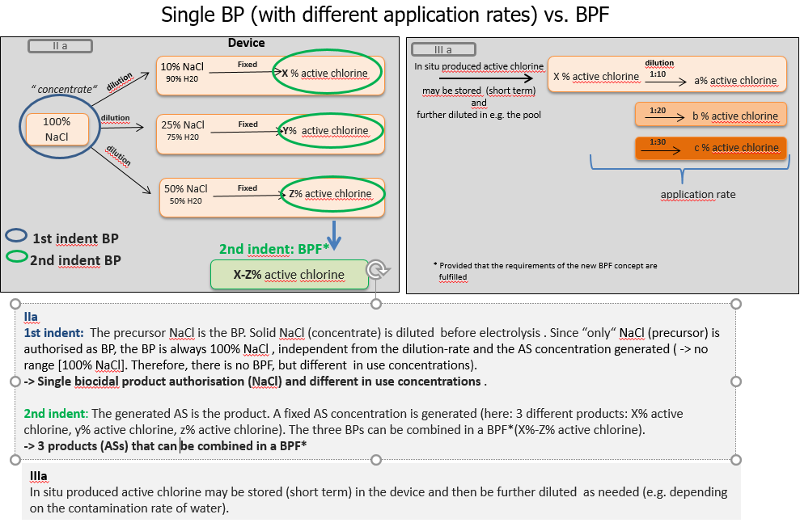

Annex V
This annex aims at illustrating whether an application for authorisation as a single biocidal product or as a BPF has to be submitted for case-type 2 and 4 products where the device generates a concentration range of the in situ AS.
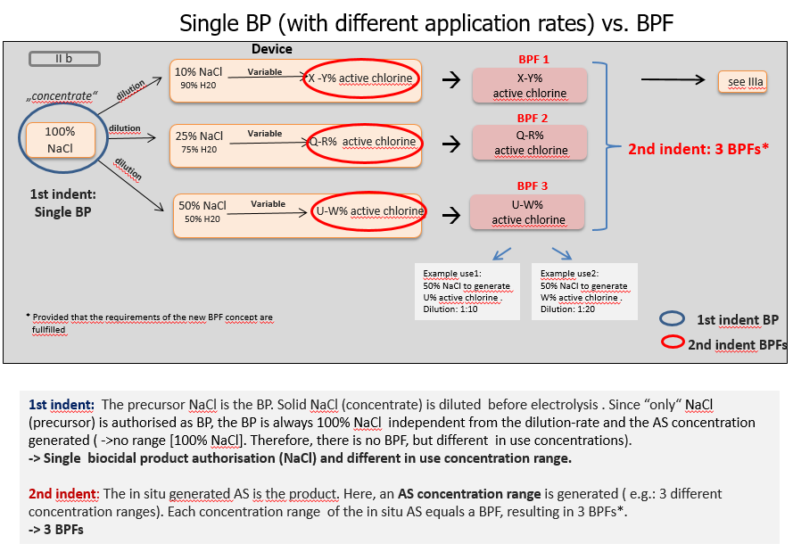

Annex VI

This annex aims at illustrating the distinction between the full composition of in situ biocidal products (left side) and the composition to be included in section 2 of the SPC in accordance with Article 22(2)(e) of the BPR for the different case-types.

Annex VII
Q&A pairs on the authorisation of in situ biocidal products

Available at https://circabc.europa.eu/w/browse/67bab047-23bc-4edb-a11f-819cb5a5f2da
Available at https://echa.europa.eu/documents/10162/13564/situ_as_precursors_wg_recommendation_+2017_en.pdf
The concept of “technical active substance” in the ECHA’s recommendation, when updated, will be aligned to this document (i.e. in line with the legal definition of “active substance” in the BPR and of a “substance” under REACH).
An 'in situ generation' situation is not applicable when the active substance generated is bottled prior to its placing on the market.
These case-types should not be considered as an exhaustive list.
See section II.1 in Annex II as a particular case of case-type 1.
See section II.2 in Annex II as a particular case of case-type 1.
The practical implementation of the BPF concept has been agreed in a dedicated Working Party of the Coordination Group. The conclusions of that working party will also be relevant for the BPFs covering in situ biocidal products
The user cannot modify the settings of the device and it generates a fixed concentration of the in situ generated AS.
In case of BPFs, each individual product needs to have its exact composition so that notifications under Article 17(6) of the BPR are possible.
The user can modify the settings of the device and it generates a variable concentration of the in situ generated AS. The possibility to modify those settings should be designed in a way that it cannot generate the in situ AS above the authorised concentration range.
The assessment of technical equivalence will require the submission of information about the quantitative composition of the precursors, the reaction mechanism and kinetics and the composition of the in situ generated active substance, since these three components are contributing to set the reference specifications.
Where a device is part of the IGS (case-types 2 and 4), this includes information about parameters and environmental changes affecting the output of the device
In case of biocidal products falling under the second indent of the definition of a biocidal product, the biocidal product is not placed on the market as such. Therefore, all the information requirements laid down in Article 69 of the BPR should be supplied to the end-users through other information materials (e.g. a leaflet accompanying a device used to generate the in situ AS).
The CG will consider whether the current SPC templates for both single biocidal products or BPFs would need any specific adaptation in order to address the specificities of in situ biocidal products. Should it be the case, further adaptations of the SPC editor could also be considered in future.
Where the authorisation is granted to in situ biocidal products involving IGSs placed in permanent infrastructures, the name and address of the relevant sites could be mentioned in the SPC.
Precautionary statements that are redundant with any risk mitigation measure (RMM) resulting from the risk assessment (e.g. wearing of personal protection equipment - PPE) should be left out of the SPC and of the label in accordance with paragraph 8 of document CA-May13-Doc.5.4. - Final.rev1, available at https://circabc.europa.eu/w/browse/e4e143d0-cae8-41cb-b4b6-c762e6f44622
Ideally, the SPC editor should allow in the future to clearly indicate the H&P statements for each precursor, and where relevant, for the in situ AS. Until it is further adapted, section 6 of the SPC (other information) could be used for that purpose if needed.
E.g. In the case of drinking water or pool water treatment, there are several national and sometimes European Regulations and standards in place
In those cases, the SPC will have not to refer to the factual device used in the tests included in the application.
Any on-site variation of these parameters that might result in a concentration of the in situ AS beyond the authorised concentration is not allowed.
Available at https://circabc.europa.eu/w/browse/c309ae58-bdd7-421d-a678-8d8ac361d4e0
See available guidance at https://echa.europa.eu/documents/10162/21742587/pg_consortia_en.pdf/4a3cc03c-0edc-45f6-9806-6ef3b8aa6e28
http://eur-lex.europa.eu/legal-content/EN/TXT/PDF/?uri=CELEX:02013R0414-20161101&from=EN
Otherwise, the user would not comply with the legal requirements in Article 17(5) of the BPR.
Otherwise, the supplier to the user would have the legal obligation to apply for product authorisation under the BPR. It has to be noted that the status of the supplier may change the moment he obtains the information from the user that he is, in fact, supplying the precursor for biocidal purposes. From that moment on, it cannot be claimed anymore that he is not supplying that chemical with the intention for biocidal use.
This might also include a conclusion on whether it can be regarded as a “simple” non-active substance that does not need a full analytical characterisation. Setting the specifications of precursor B at the AS approval stage will avoid further discussions at the product authorisation stage and reduce the amount of referrals related to disagreements concerning whether used precursor (e.g. acid) is acceptable.
The fact that the product authorisation refers to both precursors should not be understood by suppliers of precursor B as a "free pass" or exemption allowing them to supply it for biocidal purposes.
Even where precursor B has been supplied to the user as a chemical with no intention to be used for biocidal proposes, the use of precursor B in order to generate the in situ AS has to be compliant with the authorisation.
Where the precursor with no biocidal claim (e.g. salt) is presented/supplied to end users in a way that may suggest an intention to be used for biocidal purposes (e.g. in the "swimming pools" department of a supermarket), the enforcement authorities will have to judge whether the precursor itself should be authorised as a biocidal product.
I.e. the approval of active chlorine generated from sodium chloride by electrolysis.

