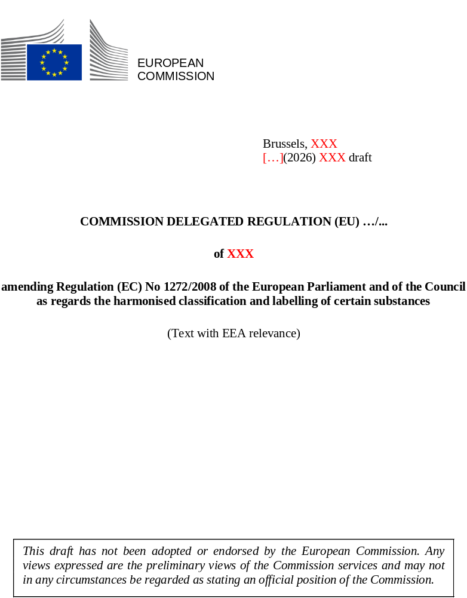

EXPLANATORY MEMORANDUM

1. CONTEXT OF THE DELEGATED ACT
Regulation (EC) No 1272/2008 on classification, labelling and packaging of substances and mixtures (‘the CLP Regulation’) aims to ensure a high level of protection of human health and the environment, while ensuring the free movement of substances, mixtures and articles within the single market. These objectives are achieved, in part, by the laying down of harmonised classification and labelling requirements in Annex VI of the CLP Regulation.
Article 37(7) point (b) of the CLP Regulation empowers the Commission to include in Table 3 of Part 3 of Annex VI substances identified as endocrine disruptors or as persistent, bioaccumulative and toxic (PBT) or very persistent and very bioaccumulative (vPvB) under Regulation (EC) No 1907/2006, Regulation (EC) No 1107/2009 or Regulation (EU) No 528/2012, based on the scientific assessments carried out under those legislative frameworks. This Article ensures that existing evaluations of hazardous properties are systematically reflected in the CLP framework, in line with the “one substance - one assessment” principle, and in order to avoid any duplication of work.
The resulting costs for stakeholders from inclusion of the above-mentioned substances in Table 3 of Part 3 of Annex VI to the CLP Regulation are expected to be limited, as those substances have already been scientifically assessed and identified as endocrine disruptors, PBT or vPvB under Regulation (EC) No 1907/2006, Regulation (EC) No 1107/2009 or Regulation (EU) No 528/2012. However, any additional potential costs linked to labelling are further mitigated by a transitional period of 18 months.

2. CONSULTATIONS PRIOR TO THE ADOPTION OF THE ACT
(To be completed after the public consultation)

3. LEGAL ELEMENTS OF THE DELEGATED ACT
The legal act amends Regulation (EC) No 1272/2008. The legal basis of this delegated act is Article 37(7) of Regulation (EC) No 1272/2008.

COMMISSION DELEGATED REGULATION (EU) …/...
of XXX
amending Regulation (EC) No 1272/2008 of the European Parliament and of the Council as regards the harmonised classification and labelling of certain substances
(Text with EEA relevance)
THE EUROPEAN COMMISSION,
Having regard to the Treaty on the Functioning of the European Union,
Having regard to Regulation (EC) No 1272/2008 of the European Parliament and of the Council of 16 December 2008 on classification, labelling and packaging of substances and mixtures, amending Regulation (EC) No 1907/2006, and in particular Article 37(7), point (b), thereof,
Whereas:
- The European Chemicals Agency (the Agency) has included certain substances in the candidate list referred to in Article 59(1) of Regulation (EC) No 1907/2006 of the European Parliament and of the Council as having endocrine disrupting properties for human health or the environment, or as persistent, bioaccumulative and toxic, or very persistent and very bioaccumulative, by adopting the following decisions:
- Decision of 28 October 2008 concerning bis(tributyltin) oxide [TBTO];
- Decision of 28 October 2008 concerning anthracene;
- Decision of 28 October 2008 concerning hexabromocyclododecane [HBCDD], including its main isomers α-hexabromocyclododecane [α-HBCDD], β-hexabromocyclododecane [β-HBCDD] and γ-hexabromocyclododecane [γ-HBCDD];
- Decision of 28 October 2008 concerning 5-tert-butyl-2,4,6-trinitro-m-xylene; musk xylene;
- Decision of 28 October 2008 concerning alkanes, C10-13, chloro (Short Chain Chlorinated Paraffins);
- Decision of 22 December 2009 concerning diisobutyl phthalate [DIBP];
- Decision of 22 December 2009 concerning pitch, coal tar, high-temp;
- Decision of 22 December 2009 concerning anthracene oil and anthracene oil fractions;
- Decision of 19 December 2011 concerning 4-(1,1,3,3-tetramethylbutyl)phenol; 4-tert-octylphenol;
- Decision of 18 December 2012 concerning bis(pentabromophenyl) ether; decabromodiphenyl ether [decaBDE];
- Decision of 18 December 2012 concerning 4-nonylphenol, branched and linear, ethoxylated, including its individual isomers and any combinations thereof;
- Decision of 18 December 2012 concerning 4-(1,1,3,3-tetramethylbutyl)phenol, ethoxylated;
- Decision of 18 December 2012 concerning tricosafluorododecanoic acid;
- Decision of 18 December 2012 concerning heptacosafluorotetradecanoic acid;
- Decision of 18 December 2012 concerning henicosafluoroundecanoic acid;
- Decision of 18 December 2012 concerning pentacosafluorotridecanoic acid;
- Decision of 18 December 2012 concerning 4-nonylphenol, branched and linear;
- Decision of 17 June 2013 concerning perfluorooctanoic acid [PFOA];
- Decision of 17 June 2013 concerning ammonium pentadecafluorooctanoate [APFO];
- Decision of 17 June 2013 concerning nonylphenol, branched and linear, ethoxylated;
- Decision of 12 December 2014 concerning 2-(2H-benzotriazol-2-yl)-4,6-di-tert-pentylphenol [UV-328];
- Decision of 12 December 2014 concerning 2-benzotriazol-2-yl-4,6-di-tert-butylphenol [UV-320];
- Decision of 12 December 2014 concerning bis(2-ethylhexyl) phthalate [DEHP];
- Decision of 12 June 2015 concerning 5-sec-butyl-2-(2,4-dimethylcyclohex-3-en-1-yl)-5-methyl-1,3-dioxane,5-sec-butyl-2-(4,6-dimethylcyclohex-3-en-1-yl)-5-methyl-1,3-dioxane and any of the individual isomers and/or combinations thereof;
- Decision of 15 December 2015 concerning 2,4-di-tert-butyl-6-(5-chlorobenzotriazol-2-yl)phenol [UV-327];
- Decision of 15 December 2015 concerning 2-(2H-benzotriazol-2-yl)-4-(tert-butyl)-6-(sec-butyl)phenol [UV-350];
- Decision of 15 December 2015 concerning perfluorononan-1-oic acid and its sodium and ammonium salts;
- Decision of 20 June 2016 concerning benzo[def]chrysene; benzo[a]pyrene;
- Decision of 4 January 2017 concerning p-(1,1-dimethylpropyl)phenol;
- Decision of 4 January 2017 concerning 4-heptylphenol, branched and linear, and any of the individual isomers and/or combinations thereof;
- Decision of 4 January 2017 concerning nonadecafluorodecanoic acid and its sodium and ammonium salts;
- Decision of 4 January 2017 concerning 4,4'-isopropylidenediphenol [bisphenol A];
- Decision of 6 July 2017 concerning perfluorohexane-1-sulphonic acid [PFHxS] and its salts;
- Decision of 6 July 2017 concerning dibutyl phthalate [DBP];
- Decision of 6 July 2017 concerning benzyl butyl phthalate [BBP];
- Decision of 3 January 2018 concerning reaction products of 1,3,4-thiadiazolidine-2,5-dithione, formaldehyde and 4-heptylphenol, branched and linear (RP-HP);
- Decision of 3 January 2018 concerning 1,6,7,8,9,14,15,16,17,17,18,18-dodecachloropentacyclo[12.2.1.1⁶,⁹.0²,¹³.0⁵,¹⁰]octadeca-7,15-diene, including its anti- and syn-isomers and any combinations thereof;
- Decision of 3 January 2018 concerning benz[a]anthracene;
- Decision of 3 January 2018 concerning chrysene;
- Decision of 20 June 2018 concerning dodecamethylcyclohexasiloxane [D6];
- Decision of 20 June 2018 concerning decamethylcyclopentasiloxane [D5];
- Decision of 20 June 2018 concerning benzo[ghi]perylene;
- Decision of 20 June 2018 concerning terphenyl, hydrogenated;
- Decision of 20 June 2018 concerning dicyclohexyl phthalate [DCHP];
- Decision of 20 June 2018 concerning octamethylcyclotetrasiloxane [D4];
- Decision of 19 December 2018 concerning phenanthrene;
- Decision of 19 December 2018 concerning pyrene;
- Decision of 19 December 2018 concerning fluoranthene;
- Decision of 19 December 2018 concerning 1,7,7-trimethyl-3-(phenylmethylene)bicyclo[2.2.1]heptan-2-one; 3-benzylidene camphor;
- Decision of 19 December 2018 concerning benzo[k]fluoranthene;
- Decision of 4 July 2019 concerning 4-tert-butylphenol;
- Decision of 4 July 2019 concerning tris(4-nonylphenyl, branched and linear) phosphite [TNPP].
- Decision of 18 June 2020 concerning butyl 4-hydroxybenzoate;
- Decision of 23 June 2021 concerning medium-chain chlorinated paraffins (MCCP);
- Decision of 23 June 2021 concerning 4,4'-(1-methylpropylidene)bisphenol [bisphenol B];
- Decision of 23 June 2021 concerning phenol, alkylation products (mainly in para position) with C12-rich branched alkyl chains from oligomerisation, covering any individual isomers and/ or combinations thereof (PDDP);
- Decision of 16 December 2021 concerning (±)-1,7,7-trimethyl-3-[(4- methylphenyl)methylene]bicyclo[2.2.1]heptan-2-one covering any of the individual isomers and/or combinations thereof (4-MBC);
- Decision of 16 December 2021 concerning S-(tricyclo[5.2.1.0²,⁶]deca-3-en-8(or 9)-yl) O-(isopropyl or isobutyl or 2-ethylhexyl) O-(isopropyl or isobutyl or 2-ethylhexyl) phosphorodithioate;
- Decision of 16 December 2022 concerning 1,1'-[ethane-1,2-diylbisoxy]bis[2,4,6-tribromobenzene];
- Decision of 16 December 2022 concerning isobutyl 4-hydroxybenzoate;
- Decision of 16 December 2022 concerning bis(2-ethylhexyl) tetrabromophthalate, and any of the individual isomers and/or combinations thereof;
- Decision of 16 December 2022 concerning perfluoroheptanoic acid and its salts;
- Decision of 16 December 2022 concerning reaction mass of 2,2,3,3,5,5,6,6-octafluoro-4-(1,1,1,2,3,3,3-heptafluoropropan-2-yl)morpholine and 2,2,3,3,5,5,6,6-octafluoro-4-(heptafluoropropyl)morpholine;
- Decision of 16 December 2022 concerning 4,4’-sulphonyldiphenol [bisphenol S];
- Decision of 24 May 2023 concerning bis(4-chlorophenyl) sulphone;
- Decision of 19 December 2023 concerning Oligomerisation and alkylation reaction products of 2-phenylpropene and phenol;
- Decision of 19 December 2023 concerning 2-(2H-benzotriazol-2-yl)-4-(1,1,3,3-tetramethylbutyl)phenol [UV-329];
- Decision of 19 December 2023 concerning bumetrizole; 2-tert-butyl-6-(5-chloro-2H-1,2,3-benzotriazol-2-yl)-4-methylphenol [UV-326];
- Decision of 19 December 2023 concerning 2,4,6-tri-tert-butylphenol;
- Decision of 10 October 2024 concerning triphenyl phosphate;
- Decision of 17 December 2024 concerning octamethyltrisiloxane;
- Decision of 17 December 2024 concerning O,O,O-triphenyl phosphorothioate;
- Decision of 17 December 2024 concerning perfluamine; 1,1,2,2,3,3,3-heptafluoro-N,N-bis(heptafluoropropyl)propan-1-amine;
- Decision of 17 December 2024 concerning reaction mass of triphenylthiophosphate and tertiary butylated phenyl derivatives;
- Decision of 13 June 2025 concerning decamethyltetrasiloxane [L4];
- Decision of 13 June 2025 concerning 1,1,1,3,5,5,5-heptamethyl-3-[(trimethylsilyl)oxy]trisiloxane [M3T];
- Decision of 8 October 2025 concerning 1,1'-(ethane-1,2-diyl)bis[pentabromobenzene] [DBDPE];
- The substances listed in the above-mentioned decisions of the Agency have been included in the candidate list referred to in Article 59(1) of Regulation (EC) No 1907/2006 before 11 June 2026 and a dossier as provided for in Annex XV to Regulation (EC) No 1907/2006 was under assessment by 11 June 2025.
- The Commission has adopted implementing regulations on the approval or renewal of approval of substances identified as having endocrine disrupting properties for human health or the environment, or as persistent, bioaccumulative and toxic, or very persistent, and very bioaccumulative, pursuant to Regulation (EC) No 1107/2009 of the European Parliament and of the Council , as follows:
- Commission Implementing Regulation (EU) 2018/1914 of 6 December 2018 concerning quinoxyfen (ISO);
- Commission Implementing Regulation (EU) 2020/1498 of 15 October 2020 concerning thiophanate-methyl;
- Commission Implementing Regulation (EU) 2020/2087 of 14 December 2020 concerning mancozeb (ISO);
- Commission Implementing Regulation (EU) 2023/2657 of 6 November 2023 concerning benthiavalicarb-isopropyl (ISO);
- Commission Implementing Regulation (EU) 2023/2456 of 7 November 2023 concerning clofentezine (ISO);
- Commission Implementing Regulation (EU) 2023/2513 of 16 November 2023 concerning triflusulfuron-methyl;
- Commission Implementing Regulation (EU) 2024/425 of 2 February 2024 concerning asulam-sodium;
- Commission Implementing Regulation (EU) 2024/1217 of 29 April 2024 concerning mepanipyrim (ISO);
- Commission Implementing Regulation (EU) 2024/1207 of 29 April 2024 concerning dimethomorph (ISO);
- Commission Implementing Regulation (EU) 2024/2806 of 31 October 2024 concerning metribuzin (ISO);
- Commission Implementing Regulation (EU) 2025/910 of 20 May 2025 concerning flufenacet (ISO).
- For the substances listed in the above-mentioned Commission Implementing Regulations a decision on the application for approval or renewal of the approval of these substances in accordance with the relevant provisions of Regulation (EC) No 1107/2009 was adopted by 11 June 2025.
- The Commission has adopted implementing regulations on the approval or renewal of approval of active substances identified as having endocrine disrupting properties for human health or the environment, or as persistent, bioaccumulative and toxic, or very persistent and very bioaccumulative, pursuant to Regulation (EU) No 528/2012 of the European Parliament and of the Council, as follows:
- Commission Implementing Regulation (EU) 2015/1982 of 4 November 2015 concerning hexaflumuron (ISO);
- Commission Implementing Regulation (EU) 2017/1381 of 25 July 2017 concerning brodifacoum (ISO);
- Commission Implementing Regulation (EU) 2017/1380 of 25 July 2017 concerning bromadiolone (ISO);
- Commission Implementing Regulation (EU) 2017/1379 of 25 July 2017 concerning difenacoum (ISO);
- Commission Implementing Regulation (EU) 2017/1382 of 25 July 2017 concerning difethialone (ISO);
- Commission Implementing Regulation (EU) 2017/1383 of 25 July 2017 concerning flocoumafen;
- Commission Implementing Regulation (EU) 2019/637 of 23 April 2019 concerning cholecalciferol (ISO);
- Commission Implementing Regulation (EU) 2022/1950 of 14 October 2022 concerning creosote;
- Commission Implementing Decision (EU) 2023/459 of 2 March 2023 concerning 2,2-dibromo-2-cyanoacetamide [DBNPA];
- Commission Implementing Decision (EU) 2023/1097 of 5 June 2023 concerning cyanamide;
- Commission Implementing Regulation (EU) 2023/2596 of 21 November 2023 concerning propiconazole (ISO).
- For the substances listed in the above-mentioned Commission Implementing Regulations a decision on the application for approval or renewal of the approval of those substances in accordance with the relevant provisions of Regulation (EU) No 528/2012 was adopted before 11 June 2025.
- In light of the above-mentioned decisions and implementing regulations, it is appropriate to insert new entries and modify existing ones in Part 3, Table 3, of Annex VI to Regulation (EC) No 1272/2008 in order to reflect the classification and labelling of the substances concerned as endocrine disruptors for human health or the environment or as persistent, bioaccumulative and toxic, or as very persistent and very bioaccumulative substances, on the basis of the assessments carried out under Regulation (EC) No 1907/2006, Regulation (EC) No 1107/2009 or Regulation (EU) No 528/2012.
- Regulation (EC) No 1272/2008 should therefore be amended accordingly.
- In order to allow a proportionate and practicable adaptation period for suppliers, the application of this Regulation should be deferred by a period of eighteen months. Suppliers should, however, have the possibility to apply the new or revised harmonised classifications, and to adapt the labelling and packaging accordingly, on a voluntary basis before the end of that period,
HAS ADOPTED THIS REGULATION:
Article 1
Annex VI to Regulation (EC) No 1272/2008 is amended as set out in the Annex to this Regulation.
Article 2
This Regulation shall enter into force on the twentieth day following that of its publication in the Official Journal of the European Union.
It shall apply from [first day of the month of entry into force plus 19 months]
However, suppliers may classify, label and package substances and mixtures in accordance with Regulation (EC) No 1272/2008 as amended by this Regulation from [date of entry into force].
This Regulation shall be binding in its entirety and directly applicable in all Member States.
Done at Brussels,
For the Commission
The President
Ursula VON DER LEYEN

OJ L 353, 31.12.2008, p. 1, ELI: http://data.europa.eu/eli/reg/2008/1272/oj.
Regulation (EC) No 1907/2006 of the European Parliament and of the Council of 18 December 2006 concerning the Registration, Evaluation, Authorisation and Restriction of Chemicals (REACH), establishing a European Chemicals Agency, amending Directive 1999/45/EC and repealing Council Regulation (EEC) No 793/93 and Commission Regulation (EC) No 1488/94 as well as Council Directive 76/769/EEC and Commission Directives 91/155/EEC, 93/67/EEC, 93/105/EC and 2000/21/EC (OJ L 396, 30.12.2006, p. 1, ELI: http://data.europa.eu/eli/reg/2006/1907/oj).
The decisions are accessible via the following website: Candidate List of substances of very high concern for Authorisation - ECHA
OJ L 311, 7.12.2018, p. 17, ELI: http://data.europa.eu/eli/reg_impl/2018/1914/oj
OJ L 342, 16.10.2020, p. 5, ELI: http://data.europa.eu/eli/reg_impl/2020/1498/oj.
OJ L 423, 15.12.2020, p. 50, ELI: http://data.europa.eu/eli/reg_impl/2020/2087/oj
OJ L, 2023/2657, 23.11.2023, ELI: http://data.europa.eu/eli/reg_impl/2023/2657/oj
OJ L, 2023/2456, 8.11.2023, ELI: http://data.europa.eu/eli/reg_impl/2023/2456/oj
OJ L, 2023/2513, 17.11.2023, ELI: http://data.europa.eu/eli/reg_impl/2023/2513/oj
OJ L, 2024/425, 5.2.2024, ELI: http://data.europa.eu/eli/reg_impl/2024/425/oj
OJ L, 2024/1217, 30.4.2024, ELI: http://data.europa.eu/eli/reg_impl/2024/1217/oj
OJ L, 2024/1207, 30.4.2024, ELI: http://data.europa.eu/eli/reg_impl/2024/1207/oj
OJ L, 2024/2806, 4.11.2024, ELI: http://data.europa.eu/eli/reg_impl/2024/2806/oj
OJ L, 2025/910, 21.5.2025, ELI: http://data.europa.eu/eli/reg_impl/2025/910/oj
Regulation (EU) No 528/2012 of the European Parliament and of the Council of 22 May 2012 concerning the making available on the market and use of biocidal products (OJ L 167, 27.6.2012, p. 1, ELI: http://data.europa.eu/eli/reg/2012/528/oj).
OJ L 289, 5.11.2015, p. 13, ELI: http://data.europa.eu/eli/reg_impl/2015/1982/oj
OJ L 194, 26.7.2017, p. 39, ELI: http://data.europa.eu/eli/reg_impl/2017/1381/oj
OJ L 194, 26.7.2017, p. 33, ELI: http://data.europa.eu/eli/reg_impl/2017/1380/oj
OJ L 194, 26.7.2017, p. 27, ELI: http://data.europa.eu/eli/reg_impl/2017/1379/oj
OJ L 194, 26.7.2017, p. 45, ELI: http://data.europa.eu/eli/reg_impl/2017/1382/oj
OJ L 194, 26.7.2017, p. 51, ELI: http://data.europa.eu/eli/reg_impl/2017/1383/oj
OJ L 109, 24.4.2019, p. 13, ELI: http://data.europa.eu/eli/reg_impl/2019/637/oj
OJ L 269, 17.10.2022, p. 1, ELI: http://data.europa.eu/eli/reg_impl/2022/1950/oj
OJ L 67, 3.3.2023, p. 54, ELI: http://data.europa.eu/eli/dec_impl/2023/459/oj
OJ L 146, 6.6.2023, p. 27, ELI: http://data.europa.eu/eli/dec_impl/2023/1097/oj)
OJ L, 2023/2596, 22.11.2023, ELI: http://data.europa.eu/eli/reg_impl/2023/2596/oj

