EUROPEAN COMMISSION
DIRECTORATE GENERAL
ECONOMIC AND FINANCIAL AFFAIRS
Growth, Competitiveness & Structural Reforms
Models and databases

Brussels,
FO

Adding Migration effects to potential output estimation explicitly – the example of Germany (2015-2020)

Update

-Note for the attention of the Output Gap Working Group -

(OGWG Meeting of 5 October 2016)

Adding migration effects to potential output estimation explicitly – the example of Germany
At the February 24th OGWG meeting of this year research has been presented on adding migration effects to potential output estimation explicitly in the case of Germany. It was requested by the German ministry to take migration into account in the next Autumn forecast. The current note presents the way forward, but for more background information we would like to refer back to the note of February.
In the February paper we have focused on how migration might affect three aspects of the PF:
1. adjustment of the labour force (participation and employment rates)
2. adjustment of trend unemployment rate
3. adjustment of labour productivity (and trend TFP)
The paper described how the NAWRU doesn't require any specific adjustment to deal with the migration stream. The Phillips curve which we use for identifying the NAWRU takes wage and productivity response to labour market shocks into account and should be able to accommodate different adjustment patterns in the labour market, such as the arrival of migrants.
In order to adjust trend TFP substantially more information on the migrants is needed (e.g. skill distribution) which is not readily available during a forecast round. Moreover the paper showed how the impact of changing the labour productivity turned out to be small. Therefore, it is suggested to also not explicitly adjust the TFP calculation.
Therefore we focus only on the first item, adjusting the participation rates.
1. Data description
The following additional information is needed:
- Migration projections (absolute numbers in population at working age) for 2015 and the medium term forecast
- A time path of migrant labour force participation rates (for cohort arriving in year t)
The total number for the labour force, population and actual participation rates are taken from the Spring 2016 forecast. The migration projections have been gathered by the German Desk at ECFIN. The data on migration participation and employment rates come from the German Council of Economic Experts (2015).
Out of the 1.092 million refugees that have arrived in 2015, 80% will seek asylum in DE. 74% of these asylum seekers are of working age. This leads to the first figures of 0.629 million 'migrants' in 2015. In 2016, another 1/18 of the asylum seekers of 2015 have become of working age and should be added to the group of migrants at working age. On top of this, new migrants arrive in 2016 of which again 80% will seek asylum and 74% of them will be of working age. Applying this method for all future years, we can calculate the number of migrants in DE for the total medium term horizon.
The participation rate of the migrants depends on the number of years they have already been in DE. The first year PART is equal to 40% and after 5 years the participation rate increases to 70%. Applying this to the number of migrants and the time when they arrived, leads to a participation rate which goes from 40% in 2015 to 62% in 2020 (see Figure 1). Given the information on participation rates and population at working age we are able to calculate the labour force (LF = POPW * PART).
Figure 1 Participation rate of refugees, by year of entry and average participation rates
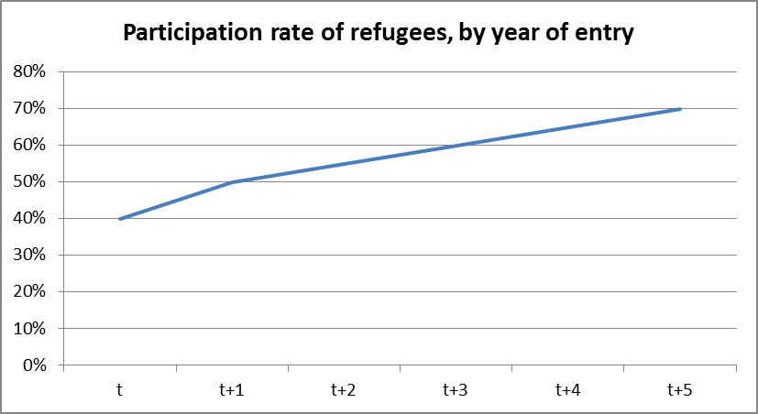 | 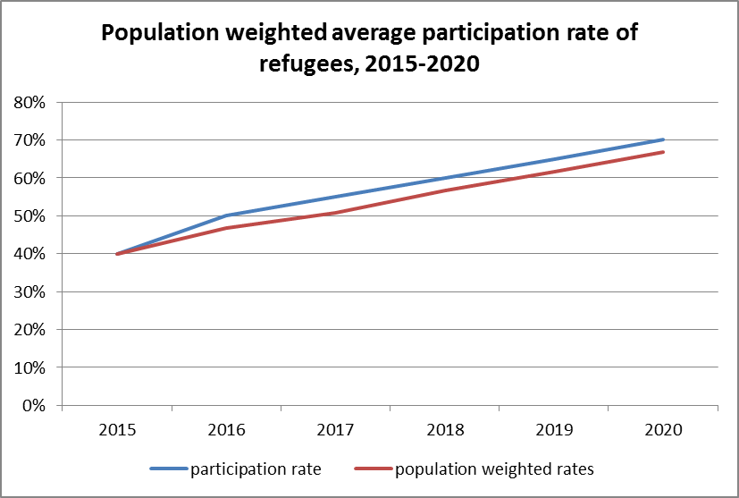

Information on unemployment rates of migrants is given in the study by the IAB as well as by the German Council. Each year that a migrant stays in DE, his or her employment rate increases (see Figure 2). Using this cohort approach we come to an overall unemployment rate of the migrants of 80% in 2015 and 32% in 2020. The employment rate can be calculated using the unemployment rate and the participation rate (ER = (1-UR)*PART). Employment can then be calculated using the labour force and the employment rate (L = LF * ER).
Figure 2 Employment rate for migrants over time, by type of entry, in % (source: IAB, 2015)
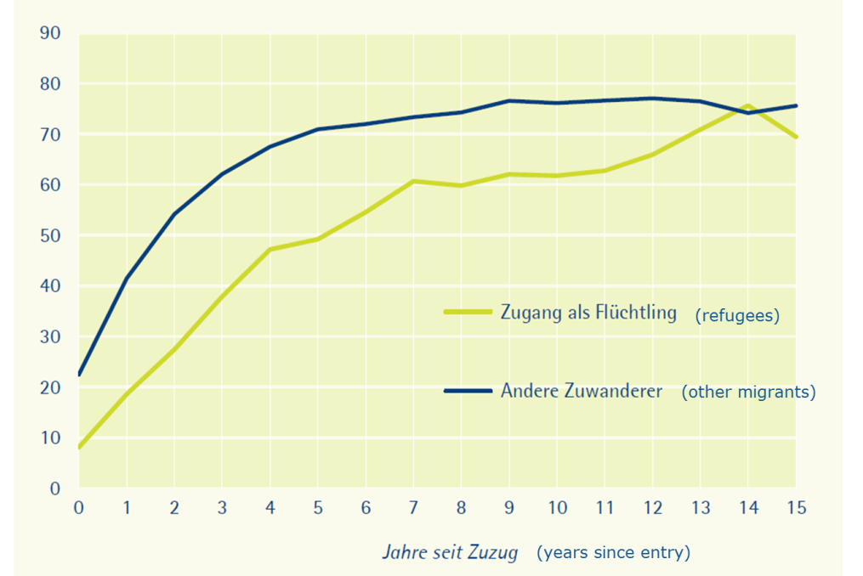
2. Method
We used explicitly available information which shows that the participation rate of migrants is substantially lower than the participation rate of the native-born population over an extended period of time, in particular a period extending the medium term. This implies that first, migration should not be seen as a purely cyclical phenomenon and second, it induces a discrete jump in the trend participation which is not properly reflected in the mechanical approach which is smoothing the aggregate participation rate. Here we propose a more refined approach which distinguishes explicitly between the participation rate of the native-born population (in working age) and the migrant population of working age. Therefore, instead of calculating a smooth trend over the total labour force (as done in the standard approach) we make use of the fact that the aggregate participation rate is a (population) weighted average of the participation rate of the native-born and migrant population. The adjusted approach makes use of the fact that for the native-born labour force a smooth trend can be assumed and therefore the HP filter can be applied to the native-born labour force, while for the migrant population, the estimates already refer to trend rates and therefore the migrant participation rate can be used unfiltered. Eq. (1) and (2) show the two alternative approaches for calculating trend participation
The mechanical participation trend $\left(LF{R\left(1\right)}^{T}\right)$ which was used in Spring 2016 is given by
$LF{R(1)}^{T}=HP(sh(popn)LFRn+sh\left(popm\right)LFRm)$ , sh(.): population shares (1)
While the adjusted participation trend $\left(LF{R\left(2\right)}^{T}\right)$is given by
$LF{R(2)}^{T}=sh(popn)HP(LFRn)+sh\left(popm\right)LFRm$ (2)
With this information we can split the labour force participation rate into native-born and migrant specific rates. This in turn allows us to calculate the trend rate for the native-born population and then form a weighted average trend using the population weights.
This procedure has the advantage that it avoids mechanical backward and forward smoothing effects when in fact there is a fairly discrete trend change in the year 2015.
Figure 3 Total and native-born (trend) participation rates – Spring 2016
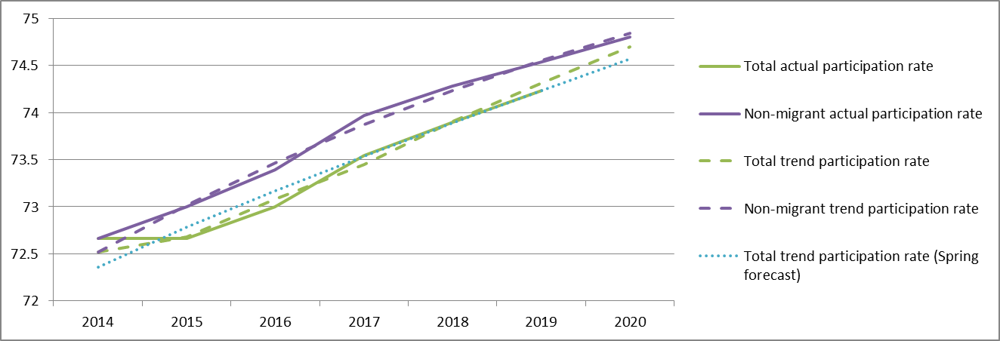
If we use the mechanical rule, as is the normal procedure, the fact that participation rate is declining leads to a backward revision of the trend participation rate (2014 and before). However, the adjusted trend participation rate avoids this problem while the difference between these two trends is extremely small (0.1-0.2).
Almost over the whole period (2015 – 2020), the trend increase is lower with the adjusted method. Only in the final two years, the adjusted method leads to a slightly larger trend participation rate. This is because the actual participation rate of the migrants, which is equal to their trend participation rate, increases over the years, coming closer to the non-migrant participation rates.

3. Impact on potential output and the output gap
Table 1 below shows the potential output calculations for the Spring 2016 adjusted for migration. Table 2 shows the difference between Spring 2016 adjusted for migration and unadjusted.
The trend participation rate changes, which leads to a lower contribution of labour to potential growth by -0.2 in 2015. In 2016 and 2017 the difference is smaller than -0.1 and therefore not reflected in Table 3. The changes in the labour component of potential output can also be seen in the general picture of potential output estimates. Especially in 2015 and 2016, potential output growth would deviate from the PF approach, by 0.1-0.2 percentage points (see Figure 5). In the medium term the impact becomes negligible (smaller than 0.1ppt). This reflects the fact that the standard approach and the adjusted approach mainly differ in the short run, because of the discrete adjustments made to the participation rate in 2015, while in the medium term both estimates converge.
As can also be seen from Table 3 the impact on the output gap estimate is very small. The output gap increases by about 0.1% over the short term forecast horizon, even though potential growth declines a bit more strongly. This is due to the fact that with the adjusted approach potential output prior to 2015 is estimated to be slightly higher compared to the standard approach.
Figure 4 Labour contribution to potential output, 2010-2020
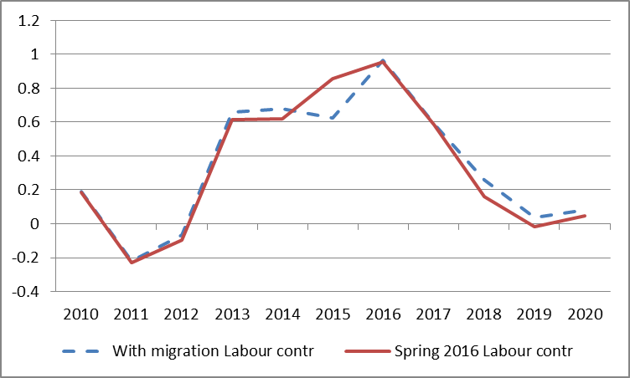
Figure 5 Potential growth estimates, 2010-2020
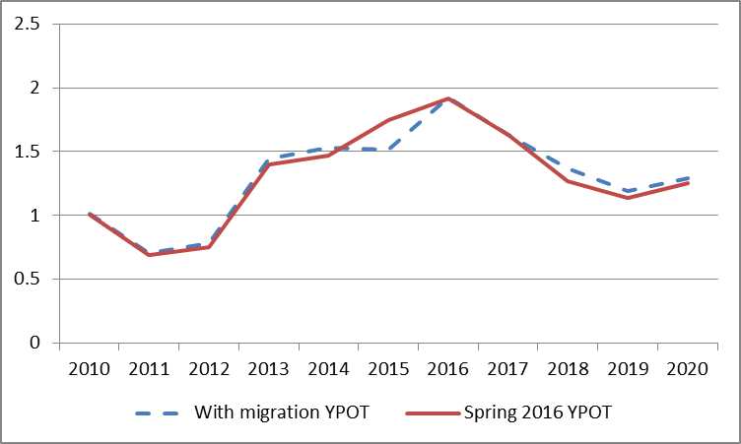

4. Conclusion
In the February paper it was concluded that "on the basis of the migration assumptions underlying the Commission's latest analyses, including the Winter 2015-2016 published forecasts, and bearing in mind the robustness of the potential output results to the alternative sets of assumptions which are currently available, an adjustment of the standard (mechanical) PF approach, with a more refined measurement of the migration shock, would not appear, at this stage at least, to be warranted". However, adjusting the trend participation rate as described above might lead to more sensible contribution of labour to potential output. Since we find that the absolute size of the potential growth rate bias, relative to a mechanical application of the method is still small and is rapidly declining to zero over the time horizon of the medium-term forecasts, choosing between the mechanical approach or the explicit approach might not have a big impact on the results.

Table 1 Spring 2016 estimates adjusted for migration

Table 2 Spring 2016 adjusted for migration – Spring 2016 (only absolute differences larger than 0.1 are shown)

References
Aiyar, S., Barkbu, B., Batini, N., Berger, H., Detragiache, E., Dizioli, A., Ebeke, C., Lin, H., Kaltani, L., Sosa, S., Spilimbergo, A. and Topalova, P. (2016) The Refugee Surge in Europe: Economic Challenges, IMF Staff Discussion Note, January 2016, SDN/16/02.
Batini, N. and Stepanyan, A. (2016) Austria Selected Issues, IMF Country Report No. 16/51, February 2016.
Beyer, R.C.M. (2016) The labor market performance of immigrants in Germany, IMF Working paper, January 2016.
European Commission (2015) European Economic Forecast – Autumn 2015, Institutional Paper 011, November 2015, Box I.1 – A first assessment of the macroeconomic impact of the refugee influx.
European Commission (2016) Mobility and migration in the EU: Opportunities and Challenges, Chapter II.2, Employment and Social Developments in Europe, DG for Employment, Social Affairs and Inclusion, Directorate A, 21/1/2016.
German Council of Economic Experts (2015) Annual Economic Report 2015/16, Chapter 1 – Economic Policy – Focus on Future Viability, Appendix, page 34.
Havik, K., McMorrow, K., Orlandi, F., Planas, C., Raciborski, R., Röger, W., Rossi, A., Thum-Thysen, A., Vandermeulen, V. (2014) The production function methodology for calculating potential growth rates and output gaps, European Economy, Economic Papers 535, November 2014.
IAB (2015) Flüchtlinge und andere Migranten am deutschen Arbeitsmarkt: Der Stand im September 2015, Aktuelle Berichte 14/2015.
NIER (2015) The Swedish Economy, Effects of the increase in refugees coming to Sweden, December 2015.
OECD (2015) How will the refugee surge affect the European economy?, Migration Policy Debates, OECD, n°8, November 2015.
Ott, E. (2013) The labour market integration of resettled refugees, Evaluation Report 2013/6, United Nations High Commissioner for Refugees Policy Development and Evaluation Services.
Roeger, W., Varga, J. and in ‘t Veld, J. (2008) Structural Reforms in the EU: A simulation-based analysis using the QUEST model with endogenous growth, European Economy — Economic Papers 351.
Statistisches Bundesamt (2013) Verdienste und Arbeitskosten, Fachserie 16, Verdienststrukturerhebung 2010 (Structure of Earnings Survey 2010).
VOWA, Fiskalrat Austria and ONB (2015) Economic impact of the current wave of refugees on Austria, FISK-info 12/2015.

The SVR participation rate (scenario 1) is constructed, based on the average speed in which a migrant cohort arriving in period t enters the labour force, i. e. in both cases there should be no cyclical component. In the QUEST data (scenario 2) we impose a gradual (trend) increase in the migrant participation rate.

