American mink in Denmark
The American mink (Neovison vison) industry is very important to the Danish economy as Denmark is the second largest producer of mink skins in the world and the largest exporter of raw skins. It thus has a central place in the Danish agricultural sector and adjacent sectors such as tanneries and auction houses.

Therefore, a listing of the American mink would imply large economic losses for the Danish economy due to the size of the Danish fur industry with regard to export, employment, value of production and value added. These losses must therefore not only be seen from a business economics perspective but also from a socioeconomic perspective.

The production of mink contributes with 2 per cent of Danish good exports and 7 per cent of the export of the Danish food cluster, the value of fur exports being 11 billion DKK in 2015 (1,470 billion Euros). The industry employs 4.300-6.700 people in Denmark and the gross value of the primary production of approximately 4 billion DKK (540 million Euros). The mink industry is operating on the world market and has managed to achieve consistent, high profits margins compared to other sectors in Denmark with almost 50 per cent of their revenue being value added by the sector.

The fur industry contributes to the Danish society through employment, tax revenue and by increasing economic activity and general consumption.

Primary production of mink pelts
There are 1.350 fulltime fur farms in Denmark and approximately 1.500 farms if small scale productions are included. Almost the entire Danish fur production is concentrated around mink since only a few farms are engaged in production of chinchilla fur and farming of foxes is banned in Denmark. The number of fulltime farms has been relatively steady since 2010. The majority of the farms are located in rural areas especially in the northern and central part of Jutland, while only a few farms are located at Zeeland, cf. table 1.

The mink industry is employing 4.300 persons full time within the primary production, i.e. at the farms. In addition to this, thousands are employed in related industries such as supplying sectors, tanneries, sales- and marketing as well as transportation and retail.

Between 2010 and 2015, the production has increased from 14 million pelts to almost 18 million. This increase in production implies that the average production per fulltime farm has increased from an average farm having 1.896 breeding bitches in 2010 to 2.355 in 2015. The Danish mink farmers therefore follow the same structural development as the other Danish agricultural sectors, towards larger farms.

According to the national projections, mink production is expected to increase from 3,2 million breeding bitches in 2015 towards 4,1 million in 2030 (Hansen, 2016a).

The mink is the third most important domestic animal in Denmark in terms of sales value. It represents approximately 16 per cent of the value of Danish animal production and 10 per cent of the total sales value of Danish agriculture.

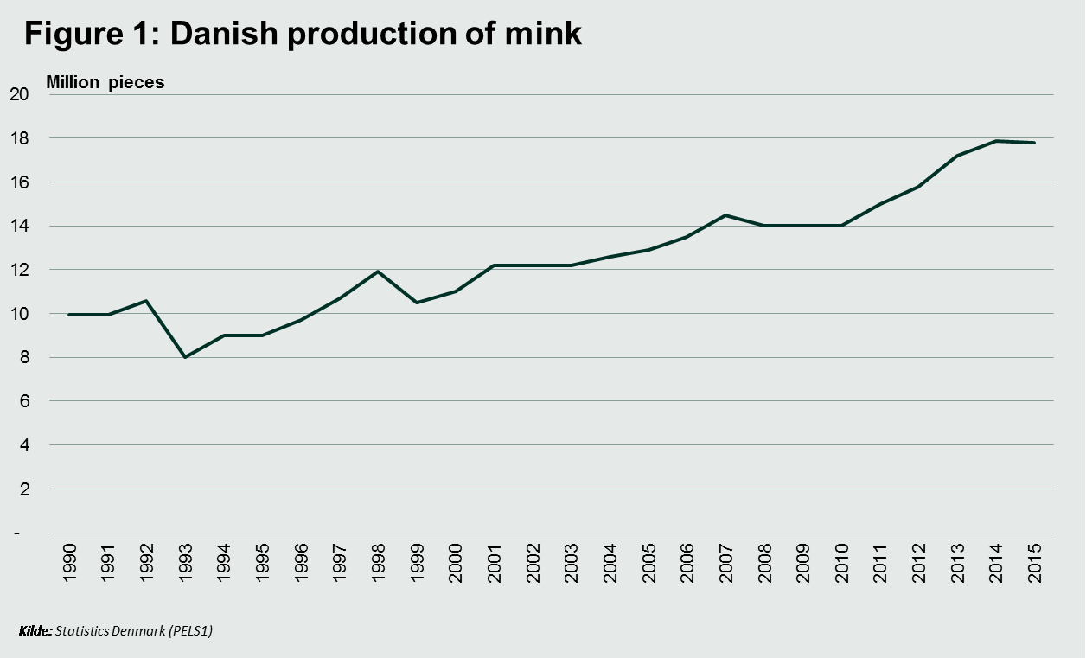

Danish mink production represents 21 per cent of the global production of mink. Despite the growing Danish production, this share has been decreasing primarily due to an increasing Chinese production. Since 2010 the Danish production has increased by 30 per cent while the Chinese production has doubled over the same period.

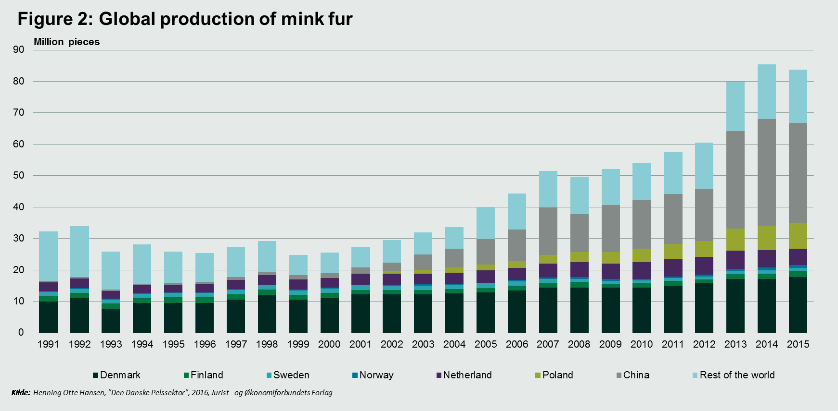

The value of the production has fluctuated significantly each year due to highly volatile prices on mink pelts. From 1990 to 2015 the total value of production has more than doubled in terms of current prices despite a large decrease since 2012 as a consequence of falling sale prices. In 2015 the production of the Danish fur farms had a value of 4 billion DKK (540 million Euros). This increase has primarily been driven by the larger quantity produced while prices have only risen modestly during the last 25 years.

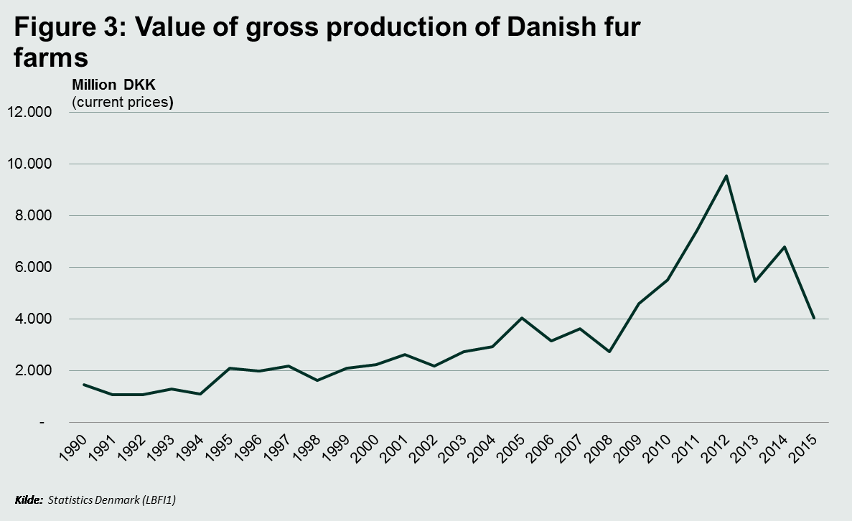

Although the value of production created by the mink farms gives an indication of the economic size one should keep in mind that it does not capture the value created by a given sector and hence how much value the sector adds to the society. Based on calculations, Hansen (2016b) estimates that the value added amounts to approximately half of the fur industry’s revenue, i.e. 50 per cent of the revenue is value added by the sector. Relative to other agricultural sectors, the fur production is thereby the sector with the highest value added as a percentage of the revenue of the sector. For example, agriculture in general adds approximately 25 per cent of its revenue, while the value added of livestock production is around 22 per cent.

Processing and distribution
The primary production of minks in Denmark has effects on employment in more sectors than the primary sector. For example tanneries and auction houses such as Kopenhagen Fur. Danish Agriculture and Food Council estimates that the Danish fur industry gave rise to approximately 6.700 Danish employments in 2010 including the primary production and the adjacent sectors such as tanneries, transportation, design, retail etc. The 6.700 persons do not include derived employment such as activities in the service sector related to the fur auctions in Copenhagen e.g. hotels, restaurants, and transportation and similar.

Besides Kopenhagen Fur, there are five other large auction houses worldwide; Helsinki, Toronto, Skt. Petersburg, Seattle and Ontario. As the largest auction house for fur, approximately 60 per cent of the global market according to Kopenhagen Fur, they have an important role to the Danish fur industry.
In 2014/15 Kopenhagen Fur had a turnover of 10,9 billion DKK (1.458 million Euro) and employed 447 persons.

Besides the auction houses, the supply sector, tanneries, tailories, designers and transportation sector is also benefitting from the breeding of minks in Denmark. There is no estimate for the how much of the economic value created within these sectors that can be attributed to the production of minks, besides the estimated 6.700 people employed in the industry.

Export and international markets
Unlike most other agricultural products, there are no interventions in the market for fur which makes it a volatile market, highly sensitive to changes in demand and supply. The market is affected by a high degree of specialization both with regard to participants and activities. For example, Denmark, the Netherland and China constituted 66 percent of the global production in 2015, cf. figure 2. With regard to the activities, the general impression is that countries such as Denmark are a net-exporter of raw pelts which are shipped to a country such as China for processing (Hansen 2016b). This geographical division of the value-chain can be compared to that of the textile industry, where breeding, design, marketing etc. are carried out in western economies and the processing of the skins are performed in Asia.

In 2015, Denmark’s export of mink fur and fur products amounted to 11 billion DKK (1,5 billion Euro), thereby constituting almost 2 per cent of the entire Danish export of goods. As a comparison, the value of exports of Danish fish and shellfish was almost 22 billion DKK (3 billion Euro), Danish furniture-export amounted to almost 15 billion DKK and Danish pharmaceutical companies exported for almost 86 billion DKK (11,5 billion Euro).

Of the 11 billion DKK, exports of raw mink skins was 10,7 billion DKK (1,4 billion Euro) in 2015. Denmark is the world largest exporter of raw mink and has around 28 per cent of the global market for raw mink, cf. table 3.

China is a particular important market for the Danish fur industry. In 2015 82 per cent of the Danish fur export went to China and Hong Kong while fur constituted 26 per cent of the entire Danish export to China and Hong Kong. As a comparison 20 per cent of the value of exports to Hong Kong and China was pharmaceutical products.

In general Danish producers can obtain prices above average at the international market, cf. figure 4, due to their good quality. Hansen (2016b) states that the Danish pelts on average sells for 15 to 25 per cent more. One cause to the better quality is the stricter animal welfare requirements in Denmark, which for example causes fewer bite-marks. Another cause of the high quality furs is long history of breeding and amelioration of the Danish breeding stock.

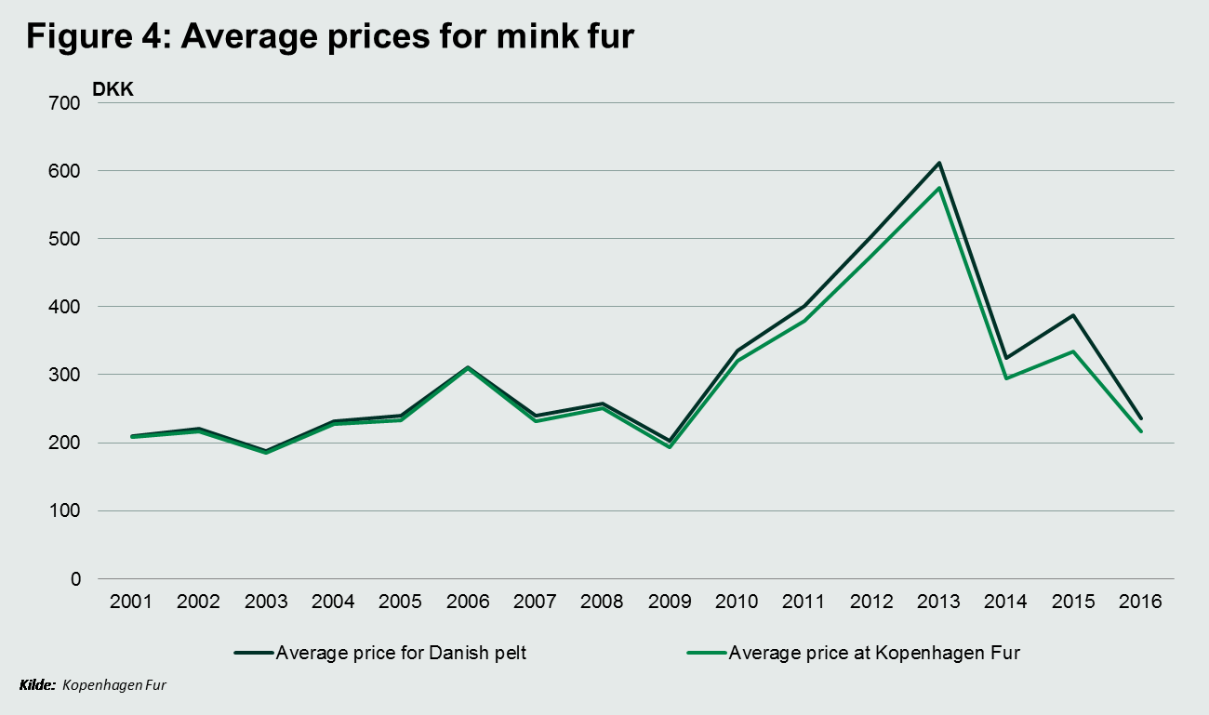

References
- Pälsfarmarens miljöhandbok, MTT – Forskningscentralen för jordbruk och levsmedelsekonomi, 2010
- Kopenhagen Fur, 2016
- Hansen, Henning Otte: ”Landbrugsfremskrivningen for mink”, 2016
- Hansen, Henning Otte, ”Den danske pelsektor”, 2016, Jurist og Økonomforbundets Forlag.

