 |  | EUROPEAN COMMISSION  EUROSTAT  Directorate E: Sectoral and regional statistics  Unit E.5: Energy
Luxembourg, 12 March 2024
Energy Statistics
Working Group
17-19 April 2024

Reporting of AC/DC capacities for solar PV
Doc. ESWG-2022-I-3

Document uploaded on CIRCABC on 13 March 2024: https://circabc.europa.eu

Executive Summary
The purpose of this document is to present some lessons learnt from the past reporting cycle and provide some methodological guidance to countries on how to report solar PV capacities in AC (alternating current) and in DC (direct current).
The Task Force on Methodology and Future reporting discussed the topic of AC and DC categories for solar PV capacities. This discussion followed concerns expressed by users about the increasing divergence between both ways of expressing solar PV capacity and a survey launched by the IEA among countries.
The Members of the Energy Statistics Working Group are invited to:
- Take note of lessons learnt from the past reporting cycle (the first cycle where countries were asked to report solar PV capacity split by AC and DC);
- Take note and apply in the future the methodological guidance presented in this document;
- Provide an opinion, feedback and/or any comment in the meeting and in writing to Fernando.Diaz-Alonso@ec.europa.eu by 17 May 2024.

Introduction
As indicated in the document presented to the Task Force on Methodology and future reporting in June 2023, as well as in the latest version of the reporting instructions for the annual questionnaire on renewables and wastes, a solar PV system works by capturing sunlight using photovoltaic cells and converting it into DC (direct current) electricity. The DC electricity is then usually converted into AC (alternating current) electricity using an inverter, as most electrical devices and systems use AC power. Therefore, there are differences between the solar PV capacity in DC and in AC. The former is the electrical capacity of the installed panel(s) that generate(s) electricity in DC. The latter is the electrical capacity of the AC side of the DC-AC conversion system, i.e. the maximum AC power the inverter(s) can provide.
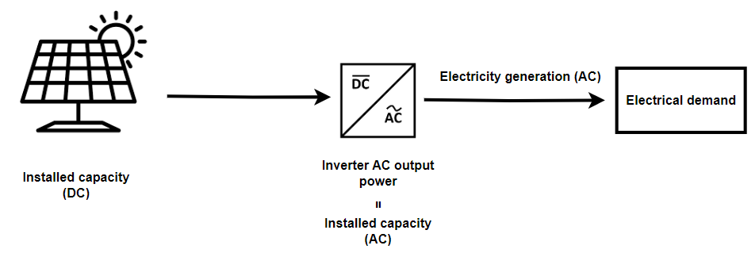
In the past, the DC capacity was similar to the AC. However, due to recent developments in the DC-AC conversion system sizing, these two values may now differ by 20-30%. During the solar system sizing phase, a possible design choice, for a given investment, is to install a DC capacity greater than the inverter AC output rating. The outcome of this approach is shown in the picture below, where the curves represent the AC output power in case AC and DC rating are similar (blue curve) and in case the DC power rating is significantly greater than the AC (green curve). In the latter case, some energy is lost because the inverter cannot work during the peak (“inverter clipping” area) but some energy is gained in the off-peak period because of the greater DC capacity installed.
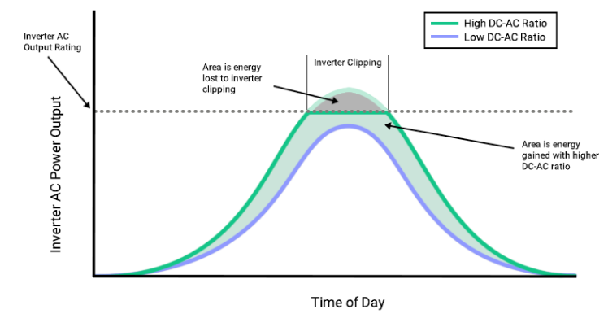

The IEA carried out a survey among reporting countries to determine how they were reporting their solar PV capacity (either based on DC or AC values). Results showed that there was not a clear majority of countries reporting in a consistent way one or the other variable. Some of them were reporting based on AC, some others on DC and some other were not sure.
Based on this outcome, the IEA and Eurostat discussed on the best way forward and both organisations agreed that it was necessary to have all countries reporting on the same basis.
Ideally, all countries should report based on both values (AC and DC), as this would help analysts to assess the functioning modalities and efficiency of the installations.
The Task Force agreed that, as a first step, countries should start reporting, at least in one of the two categories, but clearly identifying whether it was AC or DC values. At a later stage, countries should report based on both AC and DC values.

Lessons learnt from the 2022 annual data cycle
The table in Annex I shows how countries reported solar PV capacities in AC and DC during the 2022 annual data cycle. For clarity reasons, the subcategories rooftop and off-grid have been omitted from the table.
As observed in the table, most countries reported only in one of the categories, either AC or DC. Only few countries reported in both categories, with Italy and Ireland being the best-practice examples, as they reported real values in both categories. Two other countries (Greece and Norway) reported the same value in both categories. This option, although not as good as reporting real values in both categories, is preferred as a transitory solution to reporting in only one category.

We can then conclude that the preferred practice is the following, in decreasing order:
- Report real values in both AC and DC capacities (such as the best-practice cases of Ireland and Italy). This usually leads to slightly different AC and DC values, with AC being smaller than DC (refer to the methodological advice below for clarification).
- Report one real value, either AC or DC, and estimate the remaining one using the conversion factors given in the methodological advice below. If this does not seem suitable for your country, a back-up possibility is to make the missing category equal to the available one (such as Norway or Greece). This is acceptable during a transitory period (as the ratio between AC and DC is usually close to 1) to avoid leaving blank cells that could be interpreted as zeros by non-expert data users. In either of these cases, please note which value is real and which is estimated in the Remarks tab. This will aid data interpretation and validation and allow analysts to estimate the missing data, if necessary.
- Report only one category and leave the other as zero (rest of countries). This practice was accepted during the first reporting cycle, given the change in the reporting practice. However, this is discouraged for the future as it gives the impression to users that one of the two categories is a real zero.

When reporting in the 2023 annual data cycle, Eurostat and the IEA would appreciate if countries could revise data for 2022 (or earlier if data are available) providing both AC and DC values.

Some methodological advice for next cycle
Eurostat and the IEA recommend countries to investigate the AC and DC capacity figures with your data provider(s) and/or estimate an average DC/AC conversion ratio for each Solar PV category. In case this is not possible, we encourage you to report both DC or only AC capacity based on the kind of data at your disposal for each category and, if none, please estimate using the conversion factors below or, in case this is not suitable for your country, make one equal to the other during a transitory period.
As regards system size ratio (DC/AC), for residential rooftop systems it is 1 to 1, while for larger commercial and industrial installations it is around 1.0-1.1, and for utility-scale it is 1.2-1.3. However, in the latter case, sometimes it can go as high as 1.5. These usual ranges must be used carefully as they are installation-specific and influenced by country-specific policies and practices. It is always recommended to investigate these figures with your data providers.
Should the capacity of the inverter (AC capacity) exceed that of the solar panels (DC capacity), report the DC value as representative for both capacities. This is because the DC value indicates the maximum AC power the system can produce in these scenarios. Such cases are notably observed in smaller-scale systems.
In some (very limited) cases, such as in remote areas with limited access to the electrical grid, it may be more practical to use direct current without converting it to AC. This is known as a DC-only system. In these systems, the DC electricity generated by the photovoltaic cells is directly used to power DC devices. Since the amount of capacity of these systems is generally small, a DC-only category has not been deemed necessary. In this case, report only the DC capacity and specify in the remarks the amount of capacity of this kind. In addition, some large-scale PV plants, particularly those that are connected to the electrical grid, may use both DC and AC systems in different parts of the plant. For example, the photovoltaic cells may generate DC electricity, which is then converted to AC electricity for distribution on the grid, but some portions of the plant may use DC power directly. In this case, report the total electricity generated, DC and AC, under electricity generation and the AC and DC capacities as usual. Clarify the amount of DC-only component in the remarks sheet as for the previous case.
When it comes to electricity generation, report the electricity generation after the inverter. In case some installations have no conversion systems (such as those indicated above), i.e. electricity is used directly in DC (DC-only systems), e.g. small-scale off-grid systems, report the electricity generated in DC.

Next steps
Eurostat and the IEA will continue to monitor the quality of the solar PV capacities and encourage countries to provide more complete and more accurate data, both in AC and DC. During the next annual data cycle (for reference year 2023), more emphasis will be put during the validation to encourage countries to provide figures in both categories.

Annex I. Results on solar PV electrical capacities AC and DC reported by countries for 2022, MW
 | Solar photovoltaic (< 30 kW) |  | Solar photovoltaic (30 kW - 1000 kW) |  |  | Solar photovoltaic (1+ MW)
 | Electrical capacity - AC | Electrical capacity - DC |  | Electrical capacity - AC | Electrical capacity - DC | Electrical capacity - AC | Electrical capacity - DC
Belgium | 4,453.800 | 0.000 |  | 1,777.700 | 0.000 | 524.600 | 0.000
Bulgaria | 0.000 | 62.303 |  | 0.000 | 396.908 | 0.000 | 1,277.973
Czechia | 0.000 | 561.812 |  | 0.000 | 533.903 | 0.000 | 1,324.766
Denmark | 651.652 | 0.000 |  | 521.194 | 0.000 | 1,897.054 | 0.000
Germany | 0.000 | 23,773.000 |  | 0.000 | 25,409.000 | 0.000 | 18,295.000
Estonia | 102.000 | 0.000 |  | 411.000 | 0.000 | 7.000 | 0.000
Ireland | 95.189 | 118.986 |  | 44.629 | 55.786 | 48.048 | 69.542
Greece | 708.381 | 708.381 |  | 3,495.056 | 3,495.056 | 1,226.646 | 1,226.646
Spain | 2,662.330 | 0.000 |  | 3,943.711 | 0.000 | 16,705.220 | 0.000
France | 0.000 | 2,130.494 |  | 0.000 | 5,870.587 | 0.000 | 9,340.212
Croatia | 0.000 | 0.000 |  | 190.500 | 0.000 | 31.500 | 0.000
Italy | 6,397.314 | 6,571.589 |  | 12,989.507 | 13,134.253 | 5,168.427 | 5,358.076
Cyprus | 0.000 | 0.000 |  | 0.000 | 0.000 | 0.000 | 0.000
Latvia | 97.823 | 0.000 |  | 15.177 | 0.000 | 0.000 | 0.000
Lithuania | 0.000 | 488.000 |  | 0.000 | 73.000 | 0.000 | 11.000
Luxembourg | 113.919 | 0.000 |  | 158.754 | 0.000 | 43.961 | 0.000
Hungary | 1,265.000 | 0.000 |  | 1,768.000 | 0.000 | 1,202.000 | 0.000
Malta | 0.000 | 115.782 |  | 0.000 | 86.042 | 0.000 | 20.633
Netherlands | 0.000 | 8,957.964 |  | 0.000 | 5,173.501 | 0.000 | 5,468.343
Austria | 0.000 | 3,589.782 |  | 0.000 | 7.130 | 0.000 | 194.792
Poland | 0.000 | 9,042.725 |  | 0.000 | 2,427.385 | 0.000 | 700.282
Portugal | 381.176 | 0.000 |  | 763.759 | 0.000 | 1,501.322 | 0.000
Romania | 0.000 | 0.000 |  | 0.000 | 0.000 | 1,808.929 | 0.000
Slovenia | 357.665 | 0.000 |  | 262.779 | 0.000 | 5.720 | 0.000
Slovakia | 0.000 | 0.000 |  | 0.000 | 0.000 | 0.000 | 0.000
Finland | 0.000 | 444.000 |  | 0.000 | 215.000 | 0.000 | 5.000
Sweden | 1,640.000 | 0.000 |  | 628.000 | 0.000 | 120.000 | 0.000
Norway | 204.400 | 204.400 |  | 117.420 | 117.420 | 6.180 | 6.180
Montenegro | 2.870 | 0.000 |  | 0.000 | 0.000 | 0.000 | 0.000
Moldova | 15.300 | 0.000 |  | 48.200 | 0.000 | 0.000 | 0.000
North Macedonia | 0.000 | 0.000 |  | 0.000 | 0.000 | 0.000 | 0.000
Albania | 12.000 | 0.000 |  | 60.000 | 0.000 | 28.140 | 0.000
Serbia | 7.989 | 0.000 |  | 12.548 | 0.000 | 1.900 | 0.000
Türkiye | 0.000 | 0.000 |  | 5,480.941 | 0.000 | 3,944.499 | 0.000
Kosovo* | 0.000 | 0.000 |  | 5.031 | 0.000 | 9.000 | 0.000
Georgia | 0.000 | 0.000 |  | 0.000 | 0.000 | 0.000 | 0.000

