CA-May13-Doc.10.2

RISK MITIGATION MEASURES FOR ANTICOAGULANT RODENTICIDES

DRAFT INITIAL REPORT: state-of-the-art report on the use of anticoagulant rodenticides in the EU and beyond

Table of contents
Introduction 4
1. Objective 1-1-a: Research developments 4
Introduction 4
Alternative baits to anticoagulants 6
Alphachloralose 6
Powdered corn cob 6
Current and future developments of rodenticide active ingredients 7
Zinc phosphide 7
Bromethalin 7
Calciferol 7
Norbormide and alpha-chlorohydrin 8
Flupropadine 8
Sodium selenite-based products 8
Anticoagulant compound plus synergist 8
Methaemoglobin-inducing compounds 9
Various chemicals 9
New AVKs 9
2. Objective 1-1-b Resistance development and monitoring 10
The Norway rat 11
The Roof rat 14
The House mouse 14
Evidence for resistance in commensal rodents around the world 16
Denmark. 16
France 17
Belgium 18
USA + Canada 19
Germany 19
The Netherlands 21
UK 22
Resistance testing 25
Feeding test 25
BCR testing 25
VKOR Activity 26
Metabolism 26
Vkorc1 sequencing or genotyping 27
Resistance testing – summary 28
Monitoring systems for resistance 28
3. Objective 1-1-c: Alternatives to rodenticides 31
Mechanical alternatives 31
Traps and glue-traps 31
Ultrasonic rodent repellents 31
Electromagnetic devices 31
Vibration and Shock devices 32
Chemical repellents/ or attractants 32
Fertility control 32
New patterns of use for existing rodenticides 33
Anticoagulant resistance management 33
Rodent control practice 34
4. Objective 1-1-d: public/private monitoring systems of use 34
5. Objective 1-1-e: Monitoring non-target species incidents 35
Human poisoning cases 35
UK 36
Ireland 37
France 37
USA 37
Incidents with Wildlife and Domestic Animals 38
Primary toxicity in non-target species 38
Secondary poisoning 40
Monitoring systems for domestic and wildlife species 42
6. Objective 1-1-f: existing continuous professional development schemes for trained professional users 45
REFERENCES 46

Introduction
Control of rodent pests worldwide relies heavily on the use of rodenticides. In the 40s’, O'Connor, J. (1948) isolated and first suggested the use of dicoumarol (a naturally occurring substance responsible for the “sweet clover disease” in cattle) as a rodenticide. In the early 50s’, anticoagulant rodenticides (warfarin and later indanedione derivatives) replaced the acute poisons with great success. The delayed mode of action is the key for anticoagulant rodenticides’ success.
It is well known that Norway rats (Rattus norvegicus) are very suspicious to new, unfamiliar items in their environment (neophobia). Neophobia may extend to baits, bait boxes and traps when first introduced in the rat environment and may eat only a small, non-lethal dose of a new bait. If they survive, they learn to avoid the bait. This phenomenon is also known as food aversion (Lund, M. 1972). Some studies noted also food neophobia and food aversion in house mice populations (Humphries, R. E., Sibly, R. M., & Meehan, A. P. 2000), in contrast to other house mouse studies (Bonnefoy, X., Kampen, H., & Sweeney, K. 2008).
The delayed effect of anticoagulant rodenticides prevents rodents from associating the symptoms of toxicosis with the anticoagulant, which has caused it, and therefore, bait shyness is unknown. Anticoagulants act by interrupting the vitamin K cycle in the liver microsomes (MacNicoll, A. D. 1986), preventing the reduction of vitamin K epoxide to vitamin K by vitamin K epoxide reductase (VKOR). Vitamin K is an essential co-factor in the activation of several vitamin K-dependent coagulation factors through which it plays an important role in blood coagulation (Oldenburg, J. 2008). When anticoagulants bind with VKOR, intoxication with anticoagulants will lead to deficiency of vitamin K and coagulation factors, causing coagulation disorders such as spontaneous bleeding and eventually death (Thijssen, H. H. W. 1995). The action of the first generation anticoagulants is said to be cumulative, they must be taken repeatedly to have sufficiently prolonged effect cause death (Buckle, A. P. 1994). In the early 60s’, massive use of these first generation AVK was considered a great opportunity to reduce or even eradicate rat populations from many areas at that time, despite their behavioral traits. First-generation AVK include warfarin, coumafuryl, coumachlor, coumatetralyl, diphacinone, pindone and chlorophacinone (Bentley, E. W. 1972).
Unfortunately, a first detection of a resistant strain of rats was reported in Scotland in 1958, followed by similar reports in other areas in Europe: Wales, Denmark, the Netherlands, and Germany (Lund, M. 1972). At the same time, (Brooks, J. &. B. A. 1973) tested several strains of Norway rats from New York City and confirmed that warfarin resistance was also common among rat populations heavily treated with warfarin in the US. The World Health Organization (WHO) rapidly recognized this event and suggested some guidelines for the rapid detection of resistant rodent, based on feeding tests (Drummond, D. C. & Rennison, B. D. 1973). As a consequence and in order to overcome the resistance phenomenon, newer AVK were developed. These compounds are active after a single feeding, which makes them even more effective against neophobic rodents. They are usually more toxic and more persistent in animal tissues. These second-generation AVK include bromadiolone, difenacoum, brodifacoum and flocoumafen (Redfern, R. & Gill, J. E. 1980); (Petterino, C. &. P. B. 2001). The discovery of the second generation compounds (Hadler, M. R. & Shadbolt, R. S. 1975) redressed the balance for several years but, resistance to the first generation anticoagulants brought with it a measure of cross resistance to the second generation compounds and soon populations began to appear with reduced susceptibility to these more potent compounds (Greaves, J. H., Shepherd, D. S., & Gill, J. E. 1982). Presently, anticoagulant-resistant commensal rodents, such as Norway rats (Rattus norvegicus), house rats (Rattus rattus) and house mice (Mus musculus) occur in many countries throughout the world. A hierarchical resistance system was found with warfarin resistance at the base followed by coumatetralyl, cross-resistant to bromadiolone over difenacoum (Pelz, H. J., Hänisch, D., & Lauenstein, G. 1995) and up to brodifacoum at the top. However resistance to the modern anticoagulants like difenacoum or brodifacoum has never become as widespread as that to the first generation compounds (Buckle, A. P., Prescott, C., & Ward JR, J. P. 1994) up to now. The number of fitness trade-offs associated with rodenticide resistance in commensal rodents, such as an enhanced vitamin K requirement in some resistant strains (Jacob, J., Endepols, S., Pelz, H. J., Kampling, E., Cooper, T. G., Yeung, C. H. et al. 2011), might play a role.

Objective 1-1-a: Research developments

Introduction
Rodenticides are presently the mainstay of all practical rodent control programs in both urban and agricultural environments, and this situation will remain for the foreseeable future (Buckle, A. P. 1994). These lethal chemical agents are considered to fall into two categories: the acute, or fast-acting compounds, and the chronic rodenticides, exclusively anticoagulants, with a relatively slow mode of action. Reference has also been made to a third group of compounds, the subacute rodenticides, which falls between these two in terms of effect (Buckle, 1985).

Table 1: Toxicity (acute oral LD50 in mg/kg⁻¹) of some acute /subacute rodenticides and of some of the second-generation anticoagulants to warfarin-susceptible commensal rodents, from (Buckle, 1994).

Compound | Mus musculus | Rattus norvegicus | Rattus rattus
Acute/Subacute compound
Alphachloralose | 190-300 | 200-400
Bromethalin | 5.3-8.1 | 2.0-2.5 | 6.6
Calciferol | 23.7-42.5 | 43.6-56.0
Zinc phosphide | 32.3-53.3 | 27.0-40.5 | 21.0
Anticoagulant compound
Brodifacoum | 0.4 | 0.22-0.27 | 0.65-0.73
Bromadiolone | 1.75 | 1.1-1.8
Difenacoum | 0.8 | 1.8
Difethialone | 1.29 | 0.56
Flocoumafen | 0.79-2.4 | 0.25-0.56 | 1.0-1.8

Rodent pest control worldwide relies largely on the use of anti-vitamin K (AVK) anticoagulants. AVKs have considerably changed our practice and perspectives for rodent control. The delayed action of these compounds, with mortality occurring several days after bait consumption, makes them particularly effective against neophobic species such as the Norway rat (Rattus norvegicus). Anticoagulants act by interrupting the vitamin K cycle in the liver microsomes (MacNicoll, 1986), preventing the reduction of vitamin K epoxide to hydroquinone by vitamin K epoxide reductase (VKOR). When anticoagulants bind with VKOR, intoxication with anticoagulants will lead to deficiency of vitamin K and coagulation factors, causing coagulation disorders such as spontaneous bleeding and eventually death (Thijssen, 1995).
The intensive use of these compounds has been rapidly followed by the development of resistant strains in Norway rats, roof rats (Rattus rattus) and house mice (Mus domesticus). These resistant strains have developed specific genetic traits either via a modification of the VKOR enzyme involved in the catalytic cycle of vitamin K or via metabolic profile modification via induction and over expression of selected CYP450 isoforms (Berny, 2011). The most widely spread resistance mechanism appears to be related to VKOR alteration and specifically SNPs in vkorc1 gene (Pelz et al. 2005; Rost, 2009), see chapter 1.1.b.

In order to overcome resistance to first generation anticoagulants, second generation compounds can be successfully used. These compounds are more toxic and more persistent and, as a consequence, non-target poisoning is more common, especially secondary poisoning of predators and scavengers. This secondary poisoning issue has been raised to a new level by recent surveys showing that many different species (mammals and birds) contain detectable residues of AVKs in the liver, at low levels but still of concern (Albert et al. 2010, Christensen et al. 2012). There are also high levels in the pancreas, and lower levels in other tissues, but this is usually not monitored. There is a growing need for rodenticides that are effective in the field but less persistent than the second-generation anticoagulants, and less likely to be hazardous to non-target species (Eason, 2011).

The most prolific period of rodenticide development occurred between the 1940s and the 1980s. First generation anticoagulant rodenticides were developed in the 1940s, 50s and 60s, followed by calciferol, bromethalin and second generation anticoagulant rodenticides developed in the 1970’s and 80’s, partly to overcome resistance to the less potent anticoagulants (Buckle, 1994). During this period it was recognised that it was important to have more than one class of rodenticides, and this required alternatives to anticoagulants. The sustainable use of rodenticides is facilitated by the availability of active substances with different modes of action.

Rodenticide active substances being review under the Biocidal Product Directive (BPD) are of two types, those used in baits and those applied as fumigants. The specialised fumigant active substances are carbon dioxide and aluminium phosphide. Carbon dioxide is a low toxicity fumigant that is primarily used to terminate animals in specialised live capture traps. Aluminium phosphide is a high toxicity fumigant that has restricted use near farm buildings and housing. Gas generating compounds require specific safety measures and/or apparatus for effective and safe use as biocides or in plant protection. These safety measures are different in many respects to those applied to rodenticidal bait and are not further discussed here. Among the compounds used in baits, the majority are anticoagulant rodenticides. The review of the Product Type (PT) 14 active substances has resulted in the removal from the biocide market of three non-anticoagulant rodenticides that were previously used, zinc phosphide, calciferol and bromethalin. This has led to a significant increase in reliance upon the anticoagulant rodenticides. Four non-anticoagulant PT 14 active substances have either completed BPD active substance review or remain in review: The above mentioned two fumigants and two substances used in baits, alphachloralose and powdered corn cob (European Chemical Industry Council; http://www.cefic.org). Zinc phosphide has been used as a rodenticide since the early 20th century and is currently registered in the EU for field use in plant protection but is not being supported through the BPD.

Alternative baits to anticoagulants
The use of non-anticoagulant PT14 active substances is restricted to alphachloralose and powdered corn cob.

Alphachloralose
Alphachloralose is a narcotic with a rapid effect that is widely used against house mice, but not against Norway rats. It slows a number of essential metabolic processes, including brain activity, heart rate and respiration, inducing hypothermia and eventual death (Buckle, 1994). Symptoms of poisoning normally begin 5-20 minutes after consumption of bait, and may include loss of motor coordination and agitated wild or convulsive behaviour before prostration and torpor set in (Prescott and Johnson, in press). Despite the alarming appearance of the symptoms, alphachloralose is considered humane in view of its record as a human anaesthetic. The lethal effect is temperature dependent, and animals are likely to make a full recovery if they are kept warm. Alphachloralose is therefore more effective against small rodents (with a high surface area to volume ratio) that are housed in a cool environment (Buckle, 1994); so the warmth of a typical animal testing room may not be the best environment to assess efficacy of alphachloralose baits. Greaves (1968) reported laboratory tests showing apparently improved kill from bait feeding tests with encapsulated alphachloralose. Today alphachloralose baits use active capsulation technology, a process by which the active ingredient molecule is surrounded or coated with a continuous film of polymeric material. This ensures that an animal cannot taste or sense it, and will very quickly consume the bait. The use of baits containing this active substance provides good control of house mice in some circumstances (Buckle & Prescott, 2012).

Powdered corn cob
In comparison with other PT 14 active substances, powdered corn is relatively new to the market. The active substance is a natural product, formulated from comminuted plant material and sweet molasses, containing high fractions of α-cellulose. Powdered corn cob baits cause death to the rodent after 5-10 days by disrupting the digestive system, causing dehydration leading to reduced blood volume and blood pressure, tissue ischemia and circulatory shock. As the product is “non-toxic”, no residues are left in the environment and no unacceptable risks to human health and non-target animal exist. In a pesticide usage survey report by CSL (Dawson, 2004) powdered corn cob accounted for approximately 77% of the weight of rodenticide active substances used, reflecting its high rate of application per kg of bait compared to other rodenticides. This is due to the fact that the active ingredient is essentially the whole formulation, while most other rodenticides contain a very low concentration of active ingredient – typically 50mg/kg for second generation anticoagulants. Efficacy data concerning powdered corn cob are rare. Under the proposed conditions of use, the product has value to control rats and house mice indoors where food sources can be removed (website of Health Canada's Pest Management Regulatory Agency, under the authority of the Pest Control Products Act and Regulations). A study by Schmolz (2010) described the efficacy of baits containing cellulose or plaster. No-choice tests with house mice over a long period (14-21 days) with products containing cellulose were efficacious, but numerous incidents of cannibalism were observed and death through starvation seems likely. In choice-trials bait consumption was low and all mice survived. No efficacy was found in Norway rat trials. Plaster-based (CaSO₄·0.5H₂O) products, showed no efficacy against house mice and Norway rats.

Current and future developments of rodenticide active ingredients
It is important to retain and refine the use of rodent control tools for conservation, disease control and agricultural protection and to develop new alternatives to anticoagulants (Eason, 2011). Product innovation needs to be stimulated to encourage alternatives to the current suite of rodenticides, as a number of these are associated with secondary poisoning or bioaccumulation or they are viewed as inhumane (Mason et al. 2003). Ideally alternatives to existing anticoagulants would combine limited persistence, availability of an antidote, humaneness and high efficacy, however this is a significant challenge. Companies and research institutes are seeking to retrieve and retain older alternatives and develop novel rodenticides. Their three pronged approach is firstly to improve the performance of older non-anticoagulant rodenticides, secondly to optimize the performance of 1st generation anticoagulants/develop anticoagulants both active and not persistent and thirdly to identify new alternatives to anticoagulant (Eason, 2011).

The first approach might be to revive some of the better known non-anticoagulant compounds; such as the compounds listed below, which have been considered efficacious in a number of publications:

Zinc phosphide
Zinc phosphide was the most commonly used of the acute rodenticides. The mode of action is by the evolution of phosphine gas in the acid environment of the stomach, the gas entering the bloodstream and causing heart failure and damage to internal organs (Buckle, 1994). There is no specific antidote and the compound is toxic to other vertebrates. Little information is available on zinc phosphide from well-conducted trials, in either laboratory or the field. In the 1970s a few studies showed good control levels, even in Norway rats when pre-baiting was conducted (Hood, 1972; Rennison, 1976). A recently conducted study in New Zealand with an advanced formulation of microencapsulated zinc phosphide was 100% effective against caged rats (Eason, 2011).
Zinc phosphide is the only remaining plant protection rodenticide available for field use in the EU. It is generally regarded as effective for controlling small field rodents such as common voles (Microtus arvalis) but palatability is low and conditioned aversion occurs (Jacob et al., 2009).

Bromethalin
Bromethalin is formulated to serve as single-dose rodenticide that causes central nervous system depression and paralysis, leading to death in 2 to 4 days. Because it is slow-acting in comparison to zinc phosphide, bait shyness is not usually a problem, nor is pre-baiting necessary to get good control in most situations. Anorexia occurs after an effective dose has been consumed (Spaulding, S. R., vanLier, R. B. L., & Tarrant, M. E. 1985). No specific antidote is available but a symptomatic treatment has been described (Spaulding, S. R. 1987). Bromethalin was developed for use against warfarin resistant rodents and is confirmed to be effective against many rodent species, including those strains resistant to anticoagulants (Jackson et al. 1982).
In plant protection efficacy trials in alfalfa fields bromethalin baits were found to be more effective against common voles (Microtus arvalis) than zinc phosphide bait (Khalil et al., 2007). Bromethalin is not registered as rodenticide for plant protection or biocidal use in the EU.

Calciferol
There are two forms of calciferol that are used as rodenticides: ergocalciferol (Vitamin D2) and cholecalciferol (Vitamin D3). The calciferols are single-dose or multiple-dose rodenticides that promote intestinal absorption of calcium and reabsorption of bone minerals, leading to a hypercalcaemia, osteomalacia and metastatic calcification of the blood vessels (Meehan, 1984). These symptoms are the basis of the rodenticidal properties of calciferols, and the immediate cause of death in small animals is the calcification of the blood vessels around the heart. Time to death is 3 to 4 days after ingestion of a lethal dose. No specific antidote is available. Similar to bromethalin, a symptomatic treatment has been described (Morrow, 2001).

In laboratory studies calciferol was found to cause a stop feed effect in Norway rats, with female animals reducing food consumption by 80% and male animals halting food consumption completely within 24 hours; the calciferol also cause conditioned bait aversion or bait shyness in the rats (Prescott, 1992; Quy et al., 1995). Thus pre-baiting is important to obtain reasonable control in a field treatment (Quy et al., 1995). Calciferol baits do not pose a major risk to secondary non target (Eason et al. 2000), but caused a major problem with a primary non-target species, with numerous small passerines found dead or dying on the first day of treatment during a fully monitored field trial in the UK (Quy et al., 1995). It is believed that the birds had become accustomed to feeding inside the covered bait boxes during the pre-baiting phase of the treatment.

On a UK farm, a fully monitored field trial using ergocalciferol as the single active ingredient, treatment against an extensive Norway rat infestation achieved 69% control (Quy et al., 1995). A number of studies with cholecalciferol as the single active ingredient have also achieved good control of rodents (Eason, 2010).

A number of calciferol formulations also contain an anticoagulant active ingredient (typically warfarin or difenacoum). It is difficult to justify combining anticoagulant with calciferol, as the stop feed effect of calciferol would be expected to reduce the effectiveness of the anticoagulant, particularly for the first generation anticoagulants that require repeat consumption of active ingredient over a number of days.

Cholecalciferol has been recently (2013) submitted for evaluation as a rodenticide in the EU.

Norbormide and alpha-chlorohydrin
In the past two chemicals showed selective toxicity to rats, norbormide and alpha-chlorohydrin. Both chemicals affect the blood circulatory system. Further research into the reasons for their selectivity to Rattus spp., particularly Norway rats, could result in the eventual production of more selective rodenticides that are less harmful for non-target species. The low palatability of norbormide and other selective chemicals, and the bait shyness caused, may be overcome by improved bait micro-encapsulation techniques (Lazarus, A. B. 1989). The use of norbormide in rodent control has virtually ceased (Buckle, A. & Müller, F. 2003).

Flupropadine
Flupropandine was a promising subacute rodenticide extensively tested on UK farms for the control of house mice (Rowe, F. P., Bradfield, A., & Swinney, T. 1985) and warfarin-resistant Norway rats (Buckle, A. P. 1985). Difficulties were encountered in elucidating the mode of action and its development was halted (Buckle, A. P. 1994).

Sodium selenite-based products
According to the chemical classification, sodium selenite, as a sodium salt and as selenious acid, is one of the most common forms of free selenium in nature. Sodium selenite (Na₂SeO₃) was soon discovered to comprise rodenticidal properties. Their use in Serbia is restricted to biocidal applications in buildings according to (Vuksa et al., 2012). Selenium is environmentally safe and poses no threat of secondary poisoning. The rodenticide is based on selenium (0.1 % sodium selenite). As mode of action the interaction of inorganic selenium with endogenous –SH groups is mentioned (Vukša, 2007). In tests conducted in Serbia the new Se-based products achieved good efficacy against black rats and house mice in agricultural storage facilities; as well as cellulose products and cholecalciferol baits (Vukša, 2006). However, other studies demonstrated low efficacy or efficacy probably related to starvation of test animals in non-choice food trials with this type of alternative products, as sodium selenite, cellulose or plaster baits (Schmolz, 2010). Hence efficacy is questionable. Sodium selenite is not registered as a rodenticide in the EU.

Anticoagulant compound plus synergist
The second approach of companies and research institutes is to optimize the performance of 1st generation anticoagulants. One option is the combination of an anticoagulant compound and an enhancer, like calciferols (ergocalciferol, vitamin D2 or cholecalciferol, vitamin D3). In the past ergocalciferol had been successfully combined with warfarin or difenacoum. Baits with warfarin plus ergocalciferol had been extensively tested for rat and house mouse control and confirmed high efficacy (Rennison, 1974; Rowe et al., 1974). Cholecalciferol was added to first generation anticoagulants to overcome resistance in rats and house mice (Pospischil& Schnorbach, 1994). The synergistic effects are evident and such combination baits have been confirmed as having high potency in resistant rats (Eason, 2010).
Anticoagulant rodenticides have also been potentiated by an antibiotic, most commonly by sulfaquinoxaline. The aim of this association is that the antibiotic/bacteriostatic agent suppresses intestinal/gut symbiotic microflora that represents a source of vitamin K. Thus the symbiotic bacteria are killed or their metabolism is impaired and the production of vitamin K is reduced, an effect which logically contributes to the action of anticoagulants (Preusch, 1989). Antibiotic agents other than sulfaquinoxaline may also be used, for example co-trimoxazole, tetracycline, neomycin or metronidazole (Poche, 1999). Even three-component rodenticides, i.e. anticoagulant + antibiotic + vitamin D have been developed. Associations of a second-generation anticoagulant with an antibiotic and/or vitamin D are considered to be effective even against the most resistant strains of rodents, though some second generation anticoagulants are so toxic that no known resistant strain of rodents exists and even rodents resistant against any other derivatives are reliably exterminated by application of these most toxic anticoagulants (Merlet & Abribat, 2010).
These conceivable revivals and developments may provide partial solutions and help provide products that break the cycle of rodenticide resistance. However to produce completely new rodenticides a new level of innovation is needed.

Methaemoglobin-inducing compounds
The first of a new class of active ingredients is represented by Methaemoglobin-inducing compounds that are being evaluated for use as vertebrate pesticides for the control of feral pigs, stoats, ferrets, brushtail possums and feral cats (Eason, 2011) with the aim of improving the humaneness of pest control. They target red blood cells and induce the formation of MetHb, which reduces the capacity of blood to carry oxygen to tissues and causes depressed consciousness, respiratory depression and leads to death. Rodents have previously been demonstrated to have a high MetHb reductase activity after treatment with sodium nitrite (Stolk & Smith, 1966) or p-aminopropiophenone (PAPP) (Scawin, 1984). PAPP, a methaemoglobinaemia inducer, shows humaneness and low risk of bioaccumulation. It has an antidote and is partially selective for species like cats and stoats, but is not toxic to rodents like the Norway rat.
A research project has recently been started by colleagues in New-Zealand. Using PAPP as a lead compound, they have systematically designed novel derivates, completed synthesis of >50 different compounds and tested their potential to be a PAPP-like rodenticide. Newly synthesized analogues of PAPP have shown promise during in-vitro and in-vivo testing as being more toxic in rodents. To date they have identified one compound that comes close to meeting the performance criteria for a candidate rodenticide and further designs will be synthesized and tested to see if a more potent analogue can be developed for rodent control. They are part way through a program of research, development and registration activity and further in vitro and in-vivo testing is scheduled over a period of 3 years on novel candidates as well as field trials (Eason, 2010). In a recent study ,the animal welfare of rats poisoned with a lethal dose of a methaemoglobin-inducing compound (MetHb) has been assessed by Gibson (2011). The time to death from methaemoglobinaemia in rats is significantly shorter than that previously reported for anticoagulants (Littin, 2000), with no obvious signs of distress or pain. The events leading to death from methaemoglobinaemia are relatively more humane than those from anticoagulant intoxication, based on a reduced time to death, hypoxia-induced cerebral depression and absence of obvious signs of distress or pain.

Various chemicals
A Chinese patent suggests the use of a multiglycoside from Tripterygium wilfordii, known as a male fertility reducer and immune suppressor (WO 20070913121). Compounds from this plant have been suggested also as potential drugs for rheumatoid arthritis and as male contraceptives. Recent papers indicate that it has an effect on male rats and mice (Xiong et al., 2011). Questions remain with respect to potential endocrine effects in humans.
A British patent suggests the use of Yersinia murine toxin polypeptide from Yersinia pestis as a rodenticide. No other publication could be found to support the safe use of this toxin as a potent rodenticide. There is ample evidence that Yersinia pestis and this toxin especially can kill rodents, the safe use of a purifed (or genetically engineered) toxin has not been published yet. Some key questions would need to be addressed in order to use such a protein as a rodenticide: what is the level of safety for human professionally or accidentally exposed to such a compound? What are the environmental consequences of this compound? Is there a probability of rodents developing immune responses and tolerance?

New AVKs
Another valid approach for developing new rodenticides would be, based on enzymatic and ecotoxicology evaluation, to develop AVK compounds with a strong affinity for the enzyme and a short residence time, in order to avoid secondary poisoning, but no recent advances have been published, although a patent for new AVK has been issued in 2011 (Berny, 2011). A better knowledge of the structure of the mammalian vkorc1 enzyme could help to design new AVKs. Recent determination by Li et al. (2004) of a three-dimensional structure of a bacterial homolog of vkorc1 was an important step in this regard (Hodroge et. al., 2011). In January 2013, the Noeramus® project has been granted a 4.6 million euros financial support to develop and promote new strategies for integrated rodent population management (Souloy, 2013).

Objective 1-1-b Resistance development and monitoring

Evidence of resistance to AVK was clearly reported at the end of the 50s’ (Boyle, C. M. 1960) and observed in several European countries shortly thereafter as reported by (Lund, M. 1972). For years, the only evidence of resistance was based on feeding tests, as recommended by the World Health Organization (WHO) (Drummond, D. C. et al. 1973). Feeding tests performed with warfarin over 4 days are still considered a good indicator of phenotypic resistance and recommended by the WHO in order to evaluate the resistance of a given population in live-trapped animals (WHO 1982). Basically, rodents are fed a diet made of wheat+250 mg/kg warfarin for 4 days and mortality is evaluated until day 21. Phenotypic evaluation of resistance to AVK also relied on evaluation of coagulation (WHO 1982). The biochemical basis of resistance was eventually established in the 1990s’ when VKOR enzymatic activity could be assessed in liver microsomes (Misenheimer, T. M. & Suttie, J. W. 1990) established the enzymatic characteristics of a Chicago-resistant strain of rats, and showed that VKOR was inhibited by warfarin, but that this inhibition was partially reversible. Later, (Misenheimer, T. M., Lund, M., Miller Baker, A. E., & Suttie, J. W. 1994) showed that, in a Danish resistant strain of mice, VKOR enzymatic constants were altered, and also this enzyme was highly insensitive to in vitro inhibition by bromadiolone or warfarin.

It was rapidly established that resistance was an inheritable trait associated to a single autosomal gene Rw (Resistance to warfarin) located on chromosome 1 (Greaves, J. H. & Ayres, P. 1967). This gene was later found to be linked with the microsatellite D1Rat219 (Lasseur, R., Longin-Sauvageon, C., Videmann, B., Billeret, M., Berny, P., & Benoit, E. 2005). The first reports of resistance were mostly concerned with first generation AVK. It soon became obvious, however, that some strains of rats also developed resistance to the newer second generation AVK, such as difenacoum, bromadiolone or even brodifacoum. In the late 1980s Greaves, J. H. & Cullen-Ayres, P. B. (1988) suggested that a second recessive gene was modifying the Rw gene to confer difenacoum resistance in some individuals of the Hampshire warfarin-resistant strain. Greaves, J. H. et al. (1982) reported a field trial in a wild population showing evidence of difenacoum resistance in Southern UK. Although bromadiolone and brodifacoum had proven effective in laboratory tests, field trials were surprisingly disappointing with 51% lethality over 14 days and 83% after 35 days. As a consequence, in order to overcome this resistance, the authors suggested at that time to increase the rodenticide concentration in baits (up to 500 mg/kg bromadiolone), since they did not experience any loss of palatability in laboratory tests. Eventually, Greaves, J. H. (1994) defined resistance as a major lack of efficacy of AVK used correctly and under normal circumstances. This lack of efficacy is due to the presence of a strain of rodents less susceptible to AVK, and this reduced susceptibility is genetically transmitted.

In the house mouse, resistance was also rapidly described Wallace, M. E. & MacSwiney, F. J. (1976) and closely linked with the Frizzy (fr) gene on chromosome 7, in a linkage group similar to the one carrying Rw in the rat. Already in these early works on resistance, females appeared to be more resistant than males. The results also suggested that resistance was a dominant trait influenced by gender.

These historical data and early works on resistance suffered from one major problem: the genetic basis of resistance was not known and could not be further investigated. Some studies are also in favor of a metabolic resistance (i.e. increased degradation by cytochrom P450), especially in the roof rat or the house mouse (Sutcliffe, F. M. A. G. G. 1990), (Sugano, S. 2001). Very few data are available on this metabolic hypothesis in the Norway rat. Metabolic resistance will be discussed for each species. Recent advances in genetics in the Norway rat constituted a real breakthrough in 2004. Vitamin K reductase complex subunit 1 (VKORC1) was found to contribute to genetically determined variation in the activity of VKOR in Norway rats as well as in humans (Rost, S., Fregin, A., Ivaskevicius, V., Conzelmann, E., Hortnagel, K., Pelz, H. J. et al. 2004). The rodenticide resistance in rodent populations is associated with several single nucleotide polymorphisms in the VKORC1 gene in Norway rats or with one or multiple nucleotide polymorphisms in house mice (Pelz, H. J., Rost, S., Hunerberg, M., Fregin, A., Heiberg, A. C., Baert, K. et al. 2005). The effect of a lot of found amino acid exchanges for the resistance status is unknown, especially in house mice. Well known is that several of the nucleotide polymorphisms in the VKORC1 gene related to rodenticide resistance occur at codon position 139, such as Tyr139Cys or Tyr139Phe, but other variants in the gene like Leu128Gln can also be related to resistance (Pelz, H. J. et al. 2005). First studies showed that also other genes and physiological adaptations might affect the resistance status at least in Norway rats (Heiberg, A. C. 2009); (Markussen, M. D. K., Heiberg, A. C., Fredholm, M., & Kristensen, M. 2008) and house mice (Endepols, S., Klemann, N., Song, Y., & Kohn, M. H. 2012).
Reasons could be driven from research to humans. So far, in humans several variants in VKORC1 have been reported to influence warfarin sensitivity including four mutations that are linked to warfarin resistance (Rost, S. et al. 2004), 1173C in the intron 1 that is more common in high daily dose patients (D´Andrea, R. L. 2005) and a haplotype of 4 variants in the promoter, introns and 3'UTR that have been shown to correlate with maintenance dose (Rieder, M. J. 2005), although no variants have yet been shown to be directly causative. Recently, a variant of CYP4F2 has been shown to be associated with warfarin dose, although the specific role of CYP4F2 in warfarin Pharmacokinetics/Pharmacodynamics has yet to be determined (Caldwell, D. 2013). In humans, an increasing number of genetic variations affecting warfarin pharmacokinetics and/or pharmacodynamics have recently been reported to have major impact on dosage requirements, that is, polymorphisms in the VKORC1, CYP2C9, and CYP4F2 genes (Aithal.G.P. 1999), (Caldwell, D. 2013), (D´Andrea, R. L. 2005), (Rieder, M. J. 2005), (Wadelius, M. 2005) and (Wang, D. 2008).

In this chapter the biological basis of resistance will be reviewed for all three commensal rodent species.

The Norway rat

Although the biochemical tools to study VKOR have long been available, it was not until recently that biochemical investigation and biochemical characterization of VKOR activity was given full attention in rats. This approach has also been associated with recent genetic advances and the identification of the first gene involved in the synthesis of the VKOR enzyme (often presented as a complex, since many authors considered that VKOR activity was supported by several proteins) (Li et al., 2004, Rost et al., 2004).

This first gene (Vkorc1) is clearly located on the chromosome 1 of the rat, associated with the D1Rat219 microsatellite. Mutated forms are associated with severe changes in VKOR activity (Rost et al, 2004). The gene is rather small (1800 bp), with 3 exons and encodes a small trans-membrane protein (163 AA). This small protein (18kDa) has been computed and a suggested structure has been published (Tie et al, 2005) as depicted in Figure 1.
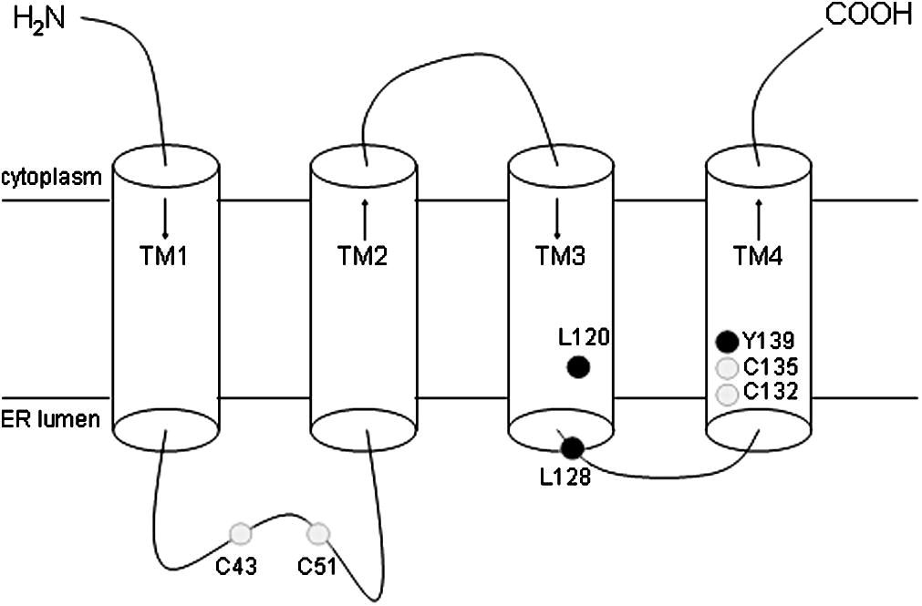
Figure 1: VKOR topology and localisation of the most common mutation sites (from Hodroge et al., 2011)

This protein has three trans-membrane domains. It is embedded in the endoplasmic reticulum. The catalytic center is considered to be the redox center C-X-X-C (C132 and C135), essential to the activity of the enzyme (Wajih et al., 2004). Back-crossing of resistant rats carrying the Y139F mutation into Sprague-Dawley susceptible rats over 7 generations was used to demonstrate the implication of this mutation in the phenotypic resistance observed via coagulation tests. Indeed, homozygous resistant rats (with less than 1.5% genetic material from the original resistant male, around the Vkorc1 gene) developed a phenotypic resistance similar to their wild counterparts. At the same time, it was demonstrated that Vkorc1 resistance is a co-dominant resistance, since heterozygous individuals are less intermediate between resistant and susceptible rodents (Grandemange et al., 2009).

In Europe, several strains of rats, known to be genetically resistant display some mutations at various loci, with some “hotspots”. For instance, Pelz et al (2005) analyzed resistant strains of rats from several countries in Europe and described several mutations associated with the phenotypic resistance, as well as the VKOR activity in recombinant cells transfected by VKORC1 as described in Table 1.

In their work, Pelz et al (2005) showed that recombinant cells including the Y139 mutations still displayed a high VKOR activity in the presence of warfarin, as compared with other mutations or the wild type. Investigation of the catalytic activity of the mutated enzyme was carried on by Lasseur et al. (2007) and showed that the mutated enzyme is very poorly susceptible to first generation AVK. In recombinant yeast cells, Hodroge et al (2011) investigated more thoroughly the consequences of the common mutations on the inhibitory constant (Ki) for several AVK (see Table 2).

Table 2: Inhibition constant (Ki, µM) for wild-type or mutated VKORC1 expressed in PIchia pastoris for various AVK rodenticides. rVKORC1 is the wild (susceptible) type (adapted from Hodroge et al., 2011)
Protein | Warfarin | Chlorophacinone | Bromadiolone | Difenacoum | Brodifacoum | Difethialone
rVKORC1 | 0.5±0,05 | 0,04±0,01 | 0,07±0,01 | 0,03±0,01 | 0,03±0,01 | 0,04±0,01
L120Q | >100 | 4,50±0,7 | 0,51±0,01 | 0,89±0,04 | 0,22±0,06 | 0,16±0,04
L128Q | 4,0±0,7 | 0,18±0,05 | 0,18±0,06 | 0,07±0,02 | 0,08±0,02 | 0,05±0,01
Y139C | >100 | 7,30±01±0,03,70 | 0,61±0,08 | 0,16±0,04 | 0,11±0,0,03 | 0,10±0,02
Y139F | >100 | 1,60±0,32 | 0,69±0,21 | 0,10±0,04 | 0,07±0,02 | 0,05±0,01
Y139S | >100 | 7,90±0,53 | 0,49±0,15 | 0,09±0,03 | 0,06±0,01 | 0,11±0,02

Apart from these studies, the actual impact of the various mutations (see Table 2bis for amino acid codes) detected has not been fully elucidated and our group is currently working on recombinant cell system dot express these mutants and evaluate the catalytic consequences of the various mutations identified so far, both on the basic activity level of Vkor, but also in response to AVK exposure, since this information can be of critical importance when deciding which rodenticide to use in the field.

Table 2bis: correspondence between mutation notations
Short code | 3-letter code
A26S | Ala26Ser
A48T | Ala48Thr
E155K | Glu155Lys
L120Q | Leu120Gln
L128Q | Leu128Gln
L128S | Leu128Ser
R12W | Arg12Trp
R61L | Arg61Leu
R33P | Arg33Pro
S103Y | Ser103Tyr
Y139C | Tyr139Cys
Y139F | Tyr139Phe
Y139S | Tyr139Ser

There is some evidence, at least in the Chicago-resistant strain, that some other proteins may play a role in the resistance phenomenon. Indeed, in this strain, Vkorc1 is not modified but a chaperone protein (calumenine) is over-expressed in resistant rats and not expressed in susceptible rats (Wajih et al., 2004). This pathway has not been described anywhere and, for instance, in the French strain carrying the Y139 mutation, calumenin is not overexpressed (Lasseur et al., 2005).

The metabolic hypothesis has been suggested for several years. Several isoforms of Cytochrom P450 (CYP450) are involved in the biotransformation of warfarin. Hydroxylation of warfarin by CYP450 is mainly due to CYP2C, CYP2B, CYP1A and CYP3A subfamilies. Several hydroxides are identified in the rat: 4’-, 6-, 7-, 8-, and 10-OH warfarin. These metabolites are more water soluble and may also undergo glucuronidation and urinary excretion (Ishizuka et al., 2006). Recently, Vein et al (2012) also showed that chlorophacinone was metabolized in at least 3 OH- derivatives and that resistant rats could carry more residues in the liver than susceptible rats, basically because of their prolonged survival time. There is however, to date, limited published evidence of any metabolic resistance in the Norway rat . Markussen et al. (2007) reported higher constitutive expression of various CYP isoforms in a resistant strain from Denmark. The over-expressed CYP were CYP2C13, CYP3A2. Upon bromadiolone exposure, several isoforms were induced: CYP1A2, CYP2C13, CYP2E1, CYP3A2 and CYP3A3. It is noteworthy that some of these isoforms are involved in the metabolism of warfarin. There is no evidence, however, that this overexpression or induction results in increased metabolism and reduced half-life of bromadiolone, which would be expected as a resistance phenomenon. Similarly, Heiberg (2009) confirmed the presence of phenotypic resistance to bromadiolone in wild rats from Denmark, without any mutation detected in the Vkorc1 gene.

One of the hypothesized consequences of Vkorc1 mutations is a potential vitamin K deficiency. Some work has been conducted on that matter and there is conflicting evidence on vitamin K requirements of resistant rats. For instance, Hermodson et al (1969), Greaves and Ayres (1973) clearly showed that the Welsh resistant strain was highly dependent on high daily vitamine K (about 13 times the standard requirements) in order to maintain normal coagulation. More recently Markussen et al. (2003) showed, on a Danish resistant strain, that the animals were moderately but significantly deprived of vitamin K and had higher daily requirements than susceptible individuals. Comparatively, based on enzymatic evaluation, the French resistant strain described by Lasseur et al., does not present any vitamin K deficiency (Km/Vm ratio constant) (Lasseur et al., 2005). This vitamin K deficiency could be a biological cost associated with resistance to AVK. In the Danish strain, Heiberg et al. (2006) showed that homozygous resistant rats had a lower reproductive success than expected and that heterozygous males or females had a better reproductive success. They suggested that the vitamin K deficiency may play a role in this phenomenon, especially in pregnant females, for which vitamine K is primarily directed to developing fetuses, thereby reducing their vitamin K status. Similarly, in Germany, Jacob et al (2012) demonstrated that resistance had a high biological cost in terms of Vitamin K requirement and reproduction. They showed that litter size and reproductive performance of resistant rats were reduced.

As a conclusion, Vkorc1 mutations appear to play a major role in the development of resistance in the Norway rat, with evidence from all over the world that these mutations are common and vary diverse in nature. A lot of work remains to be done in order to evaluate the individual consequences of each of these mutations on the catalytic properties of the enzyme, in order to adapt the AVK use to the resistance level observed in a given area, and some work is still needed to investigate the biological costs potentially associated with vkorc1 resistance. There is some evidence, at least in the Chicago-resistant strain, that some other proteins may play a role in the resistance phenomenon. Indeed, in this strain, Vkorc1 is not modified but a chaperone protein (calumenine) is over-expressed in resistant rats and not expressed in susceptible rats (Wajih, N. et al. 2004). However, it is noteworthy that this Chicago-resistant strain originally derived from a British resistant rat population known to carry VKORC1 mutations at codon position 139 (Pelz, H. J. et al. 2005), (Hermodson, M. A., Suttie, J. W., & Link, K. P. 1969). This pathway has not been described anywhere and, for instance, in the French strain carrying the Tyr139 mutation, calumenin is not overexpressed (Lasseur et al., 2005).

(Heiberg, A. C. 2009) confirmed the presence of phenotypic resistance to bromadiolone in wild rats from Denmark, without any mutation detected in the Vkorc1 gene. Pelz, H. J. et al. (2005) have also found a small proportion of rats appearing to be resistant when subjected to the BCR test but lacking the Tyr139Cys and any other VKORC1 mutations. The metabolic hypothesis has been suggested for several years. Several isoforms of Cytochrom P450 (CYP450) are involved in the biotransformation of warfarin. Hydroxylation of warfarin by CYP450 is mainly due to CYP2C, CYP2B, CYP1A and CYP3A subfamilies. Several hydroxides are identified in the rat: 4’-, 6-, 7-, 8-, and 10-OH warfarin. These metabolites are more water soluble and may also undergo glucuronidation and urinary excretion (Ishizuka, M., Okajima, F., Tanikawa, T., Min, H., Tanaka, K. D., Sakamoto, K. Q. et al. 2007). Recently, (Berny, P., Vein, J., & Vey, D. 2012;Vein, J., Vey, D., Fourel, I., & Berny, P. 2013) also showed that chlorophacinone was metabolized in at least 3 OH- derivatives and that resistant rats could carry more residues in the liver than susceptible rats, basically because of their prolonged survival time. There is however, to date, limited published evidence of any metabolic resistance in the Norway rat. (Markussen, M. D. K., Heiberg, A. C., Alsbo, C., Nielsen, P. S., Kauppinen, S., & Kristensen, M. 2007) reported higher constitutive expression of various CYP isoforms in a resistant strain from Denmark. The over-expressed CYP were CYP2C13, CYP3A2. Upon bromadiolone exposure, several isoforms were induced: CYP1A2, CYP2C13, CYP2E1, CYP3A2 and CYP3A3. It is noteworthy that some of these isoforms are involved in the metabolism of warfarin. There is no evidence, however, that this over-expression or induction results in increased metabolism and reduced half-life of bromadiolone, which would be expected as a resistance phenomenon.

One of the hypothesized consequences of Vkorc1 mutations is a potential vitamin K deficiency. Some work has been conducted on that matter and there is conflicting evidence on vitamin K requirements of resistant rats. For instance, (Hermodson, M. A. et al. 1969) and (Greaves, J. H. & Ayres, P. 1973) clearly showed that the Welsh resistant strain was highly dependent on high daily vitamine K (about 13 times the standard requirements) in order to maintain normal coagulation. More recently (Markussen, M. D. K., Heiberg, A. C., Nielsen, R., & Leirs, H. 2003) showed, on a Danish resistant strain, that the animals were moderately but significantly deprived of vitamin K and had higher daily requirements than susceptible individuals. Comparatively, based on enzymatic evaluation, the French resistant strain described by Lasseur et al., does not present any vitamin K deficiency (Km/Vm ratio constant) (Lasseur et al., 2005). This vitamin K deficiency could be a biological cost associated with resistance to AVK. In the Danish strain, (Heiberg, A. C., Leirs, H., & Siegismund, H. R. 2006) showed that homozygous resistant rats had a lower reproductive success than expected and that heterozygous males or females had a better reproductive success. They suggested that the vitamin K deficiency may play a role in this phenomenon, especially in pregnant females, for which vitamin K is primarily directed to developing fetuses, thereby reducing their vitamin K status. Similarly, in Germany, Jacob et al. (2012) demonstrated that resistance had a high biological cost in terms of Vitamin K requirement and reproduction. They showed that litter size and reproductive performance of resistant rats were reduced.

As a conclusion, Vkorc1 mutations appear to play a major role in the development of resistance in the Norway rat, with evidence from all over the world that these mutations are common and vary diverse in nature. A lot of work remains to be done in order to evaluate the individual consequences of each of these mutations on the catalytic properties of the enzyme, in order to adapt the AVK use to the resistance level observed in a given area, and some work is still needed to investigate the biological costs potentially associated with vkorc1 resistance.

The Roof rat

Comparatively few information is available for the roof rat. There is only limited evidence of Vkorc1-dependent resistance, but the gene has been sequenced and is highly conserved (Ishizuka et al., 2006). Species-specific microsatellites have also been identified to help determine Vkorc1 sequence and potentially identify SNPs’ in the gene sequence (Diaz et al., 2010). In this study, none of the roof rat tested had any mutation known to confer resistance. Tanaka et al (2012) published the first evidence of a SNP in Vkorc1 gene in the roof rat associated with dramatic changes in the catalytic activity of the enzyme in resistant rats, with almost no basic activity of the enzyme in the mutated rats (R33P). Unfortunately, they did not determine Ki and AVK resistance in their study.

Sugano et al (2001) described a resistant strain in Tokyo with evidence of metabolic resistance. In a wild resistant Rattus rattus population in Tokyo, Ishizuka et al. (2006) failed to detect any mutation in Vkorc1. The authors investigated the potential involvement of CYP isoforms in the metabolism of warfarin. Based on a one-month feeding trial, they selected surviving rodents as resistant. A first evidence of metabolic differences was detected with higher plasma concentrations of warfarin in susceptible rats vs resistant rats. The CYP profile exhibited an increased expression of CYP3A subfamily, known to be involved in the metabolism of warfarin, and especially in the production of 10-OH warfarin, which was clearly more produced in resistant rats (Ishizuka et al., 2006). These hydroxylated metabolites are known to be less or even not active on the coagulation process, thereby confirming the lack of susceptibility of rodents. Ishizuka et al. (2007) also demonstrated that NADPH cytochrome c reductase activity (dependent on NADPH cytochrome P450 reductase) was markedly higher in resistant rats, with increased general metabolic activity in all degradation pathways of warfarin in resistant animals. As a confirmation, use of a P450 inhibitor (SKF-525A) resulted in a higher mortality rate in animals exposed to warfarin. These results tend to show that CYP-dependent metabolism of warfarin is a resistance pathway for the roof rat (Ishizuka et al., 2008). Unfortunately, there is no other evidence or work related to resistance in the roof rat and it is difficult to compare the resistance level achieved with metabolic resistance as compared with genetic resistance conferred by vkorc1 mutations. Obviously, much still needs to be done on the roof rat, one of the most abundant rat species around the world.

The House mouse

Few studies have considered the house mouse and its resistance status towards AVK. Indeed, at least from a European perspective, there are still other rodenticides marketed to control mice populations, as for instance alpha-chloralose. Nevertheless, resistance has been rapidly identified in mice after AVKs were introduced on the market in the 50s’. For instance, Redfern and Gill (1980) described warfarin resistance in mice from the UK and the effective use of bromadiolone to overcome this resistance and Lund (1984) also reported resistance in mice. A recent investigation in farm mice in Argentina concluded, however, that resistance was present in South America as well as in other areas of the world (Guidobono et al., 2009). Countries reporting house mouse resistant to AVKs are listed in Table 1. In their recent survey, Pelz et al. (2012) showed that Vkorc1 mutations were highly prevalent in the 30 sites tested in Germany and Switzerland.

Despite the limited number of studies available, the results show that the two major resistance pathways exist in the house mouse. Indeed, genetic alterations of vkorc1 have been described and altered VKOR activity or lack of susceptibility to AVKs has been reported (Lasseur et al, 2006) together with a mutation in vkorc1 (W59G). Rost et al. (2009) also described and identified several strains of resistant mice with mutated vkorc1 (R12W, R58G, R61L for instance) and these amino acid substitutions resulted in reduced VKOR activity (33, 39 and 49% respectively). They also reported a R58G with no evidence of VKOR activity modification and the more common Y139C mutation, known to confer resistance in rats, in mice from Germany and the Azores. At the same time, Endepols et al (2012) investigated some sites with field evidence of warfarin and/or difenacoum resistance and could not relate this phenotypic resistance to a mutation in the Vkorc1 gene. An interesting genetic investigation (Song et al, 2011) in mice population of Europe suggest that Vkor resistance is genetically present in the Algerian mouse and was introduced by hybridization in the house mouse. Anticoagulant resistance in most house mouse would then be the result of an introduction of this gene, which appears extremely frequent in Spain spreading north and eastward. There is no evidence of any introduction of mutations in the house mouse in Eastern Europe.

In the paper by Lasseur et al. (2006) the catalytic properties of VKOR in the house mouse have been investigated and the results are quite surprising (Figure 2). These data complete the first work by Misenheimer et al. (1993), who only described reduced Km and Vm in resistant Danish mice.
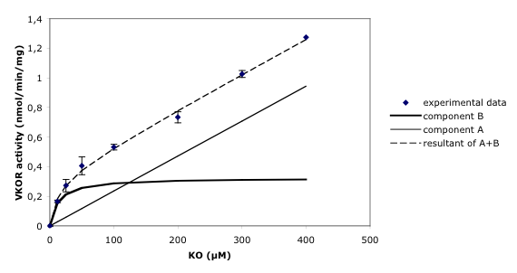
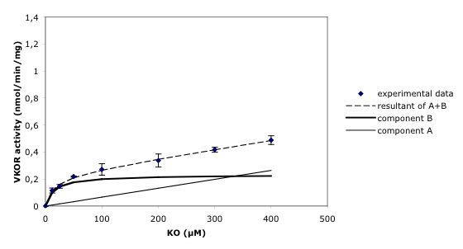
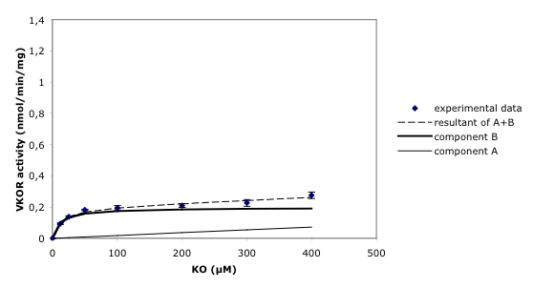
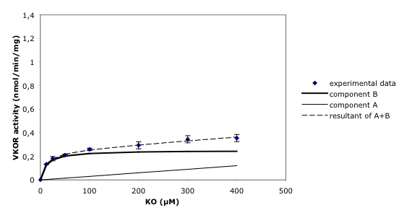

Figure 2: VKOR activity in the susceptible (left) and resistant (right) mouse without (upper) or with (lower) 1 µM warfarin (adapted from Lasseur et al., 2006)

The interpretation of the enzyme activity could only be possible with a bi-component model in which component A is highly active in the susceptible mouse and highly susceptible to AVK, while the resistant mouse seems to lack this susceptible component A. This complex model advocates for more biochemical studies of the VKOR complex in the House mouse.
Investigation of the metabolic pathways of AVKs also showed evidence of increased metabolic degradation of AVKs. Indeed, Sutclife et al. (1990) treated mice with various P450 inducers and showed that the metabolic profile for Warfarin 4’-, 6-, 7-, and 8-OH metabolites were different between susceptible and resistant strains. Based on this very different metabolic profile and CYP induction pattern, they concluded that CYP450 was highly involved in the resistance of the house mouse to AVKs. The metabolic resistance has not been fully evaluated though, and is only reported for warfarin metabolism. There is still much work to be done in order to evaluate the potential for CYP450 to metabolize other AVKs especially second- generation products such as bromadiolone or difenacoum for instance.

Evidence for resistance in commensal rodents around the world
After the first report of warfarin resistance in Scotland, several papers were published identifying other resistant Norway rat populations, mostly in the United Kingdom, in Denmark (Lund, 1972) and in the United States (Brooks and Bowerman, 1973). There is published evidence of resistance to AVK in rodents from all continents but Africa. Most studies and reports are available from western-European countries in the three commensal rodent species. Very limited information is available, however from Eastern or Suddern EU countries and we failed to identify published reports or paper indicating that resistance had been identified in at least one rodent species. It should be stated also, that very few research teams work on rodenticide resistance: in Belgium, France, Germany, The Netherlands and in the United Kingdom. This lack of research effort is a major limitation to both the understanding of resistance mechanisms and the investigation of its reality and consequences in the field.
Pelz et al. (2005) published a survey of countries reporting resistance in commensal rodents (2005). The major findings are described in Table 3 below for the three major commensal rodent species.
Table 3: Warfarin resistance in the Norway rat (Rattus norvegicus), the roof rat (Rattus rattus) and the house mouse (Mus musculus) around the world (completed from Pelz et al., 2005) (* Rattus tanezumi, **Rattus flavipectus, *** Rattus losea)
Country | Rattus norvegicus | Rattus rattus | Mus musculus | Reference
Belgium | + | ? | + | Lund 1984; Baert, 2003, Baert et al., 2012
Denmark | + | + | + | Myllymaki, 1995, Lodal, 2001, Heiberg 200
Finland | ? | ? | + | Myllymaki, 1995
France | + | + | + | Myllymaki, 1995, Pelz et al., 2005, Lasseur et al., 2005, Grandemange et al., 2010
Germany | + | + | + | Myllymaki, 1995, Pelz, 2001, Pelz et al., 2005
Italy | + | ? | ? | Alessandroni et al., 1980
Sweden | ? | ? | + | Lund, 1984
Switzerland | ? | ? | + | Muhr, 1981
United Kingdom  Netherlands  Hungary | +  +  + | + | +  + | Myllymaki, 1995, Kerins et al., 2001  (van der Lee, T. A. J. 2011), (Ophof, A. J. & Langeveld, D. W. 1969)  (Rost.S. 2009)
Argentina | ? | ? | + | Guidobono et al., 2009
Canada | + | ? | + | Siddiqi and Blaine, 1982
USA | + | + | + | Jackson and Ashton, 1981
Australia | ? | + | ? | Saunders, 1978
New-Zealand | + | ? | + | De Jonge, 1994
Japan | ? | + | ? | Naganuma et al, 1981
Korea | + | ? | ? | Rost et al., 2009
Indonesia  China | *  +  **  *** | ? | ? | (Andru, J. 2013)  (Huang, B. H., Feng, Z. Y., Yue, L. F., Yao, D. D., Gao, Z. X., Wang, D. W. et al. 2011), (Liang, L. 2005), (Wang, H. S., Feng, Z. Y., Yao, D. D., Sui, J. J., Zhong, W. Q., Li, M. et al. 2008)

Denmark.
The research team in Denmark is no longer supported, but there is a long history of resistance monitoring in this country, with a very high prevalence of resistance in Norway rats in most areas (Lodal, J. 2001) (see figure 3). During a five-year test program, rats from 117 municipalities were tested, 500-1000 individuals annually. The highest level of resistance was difenacoum for 15, bromadiolone for 25 and coumatetralyl for 17 municipalities. (Pelz, H. J. et al. 2005) tested 43 resistant wild rats from Jütland, Zealand, Fünen and Bornholm and found the mutation Tyr139Cys. Incidence of resistance in sewer systems was monitored on the basis of the Blood Clotting Response test (Gill, J. E., Kerins, G. M., Langton, S. D., & MacNicoll, A. D. 1994). The very small number of resistant sewer rats (11 resistant out of 207 trapped rats in six sewer locations) showed no resistance-related changes in the VKORC1 gene (Heiberg, A. C. 2009).
House mice (Mus musculus domesticus) resistance in Denmark and in south of Sweden was detected for the anticoagulant compounds warfarin and bromadiolone (Lund, M. 1984) , (Misenheimer, T. M. et al. 1994). Denmark is one of very few countries with described occurrence of brodifacoum resistant house mice (Myllymäki, A. 1995), (Rowe, F. P., Swinney, T., & Plant, C. 1978).

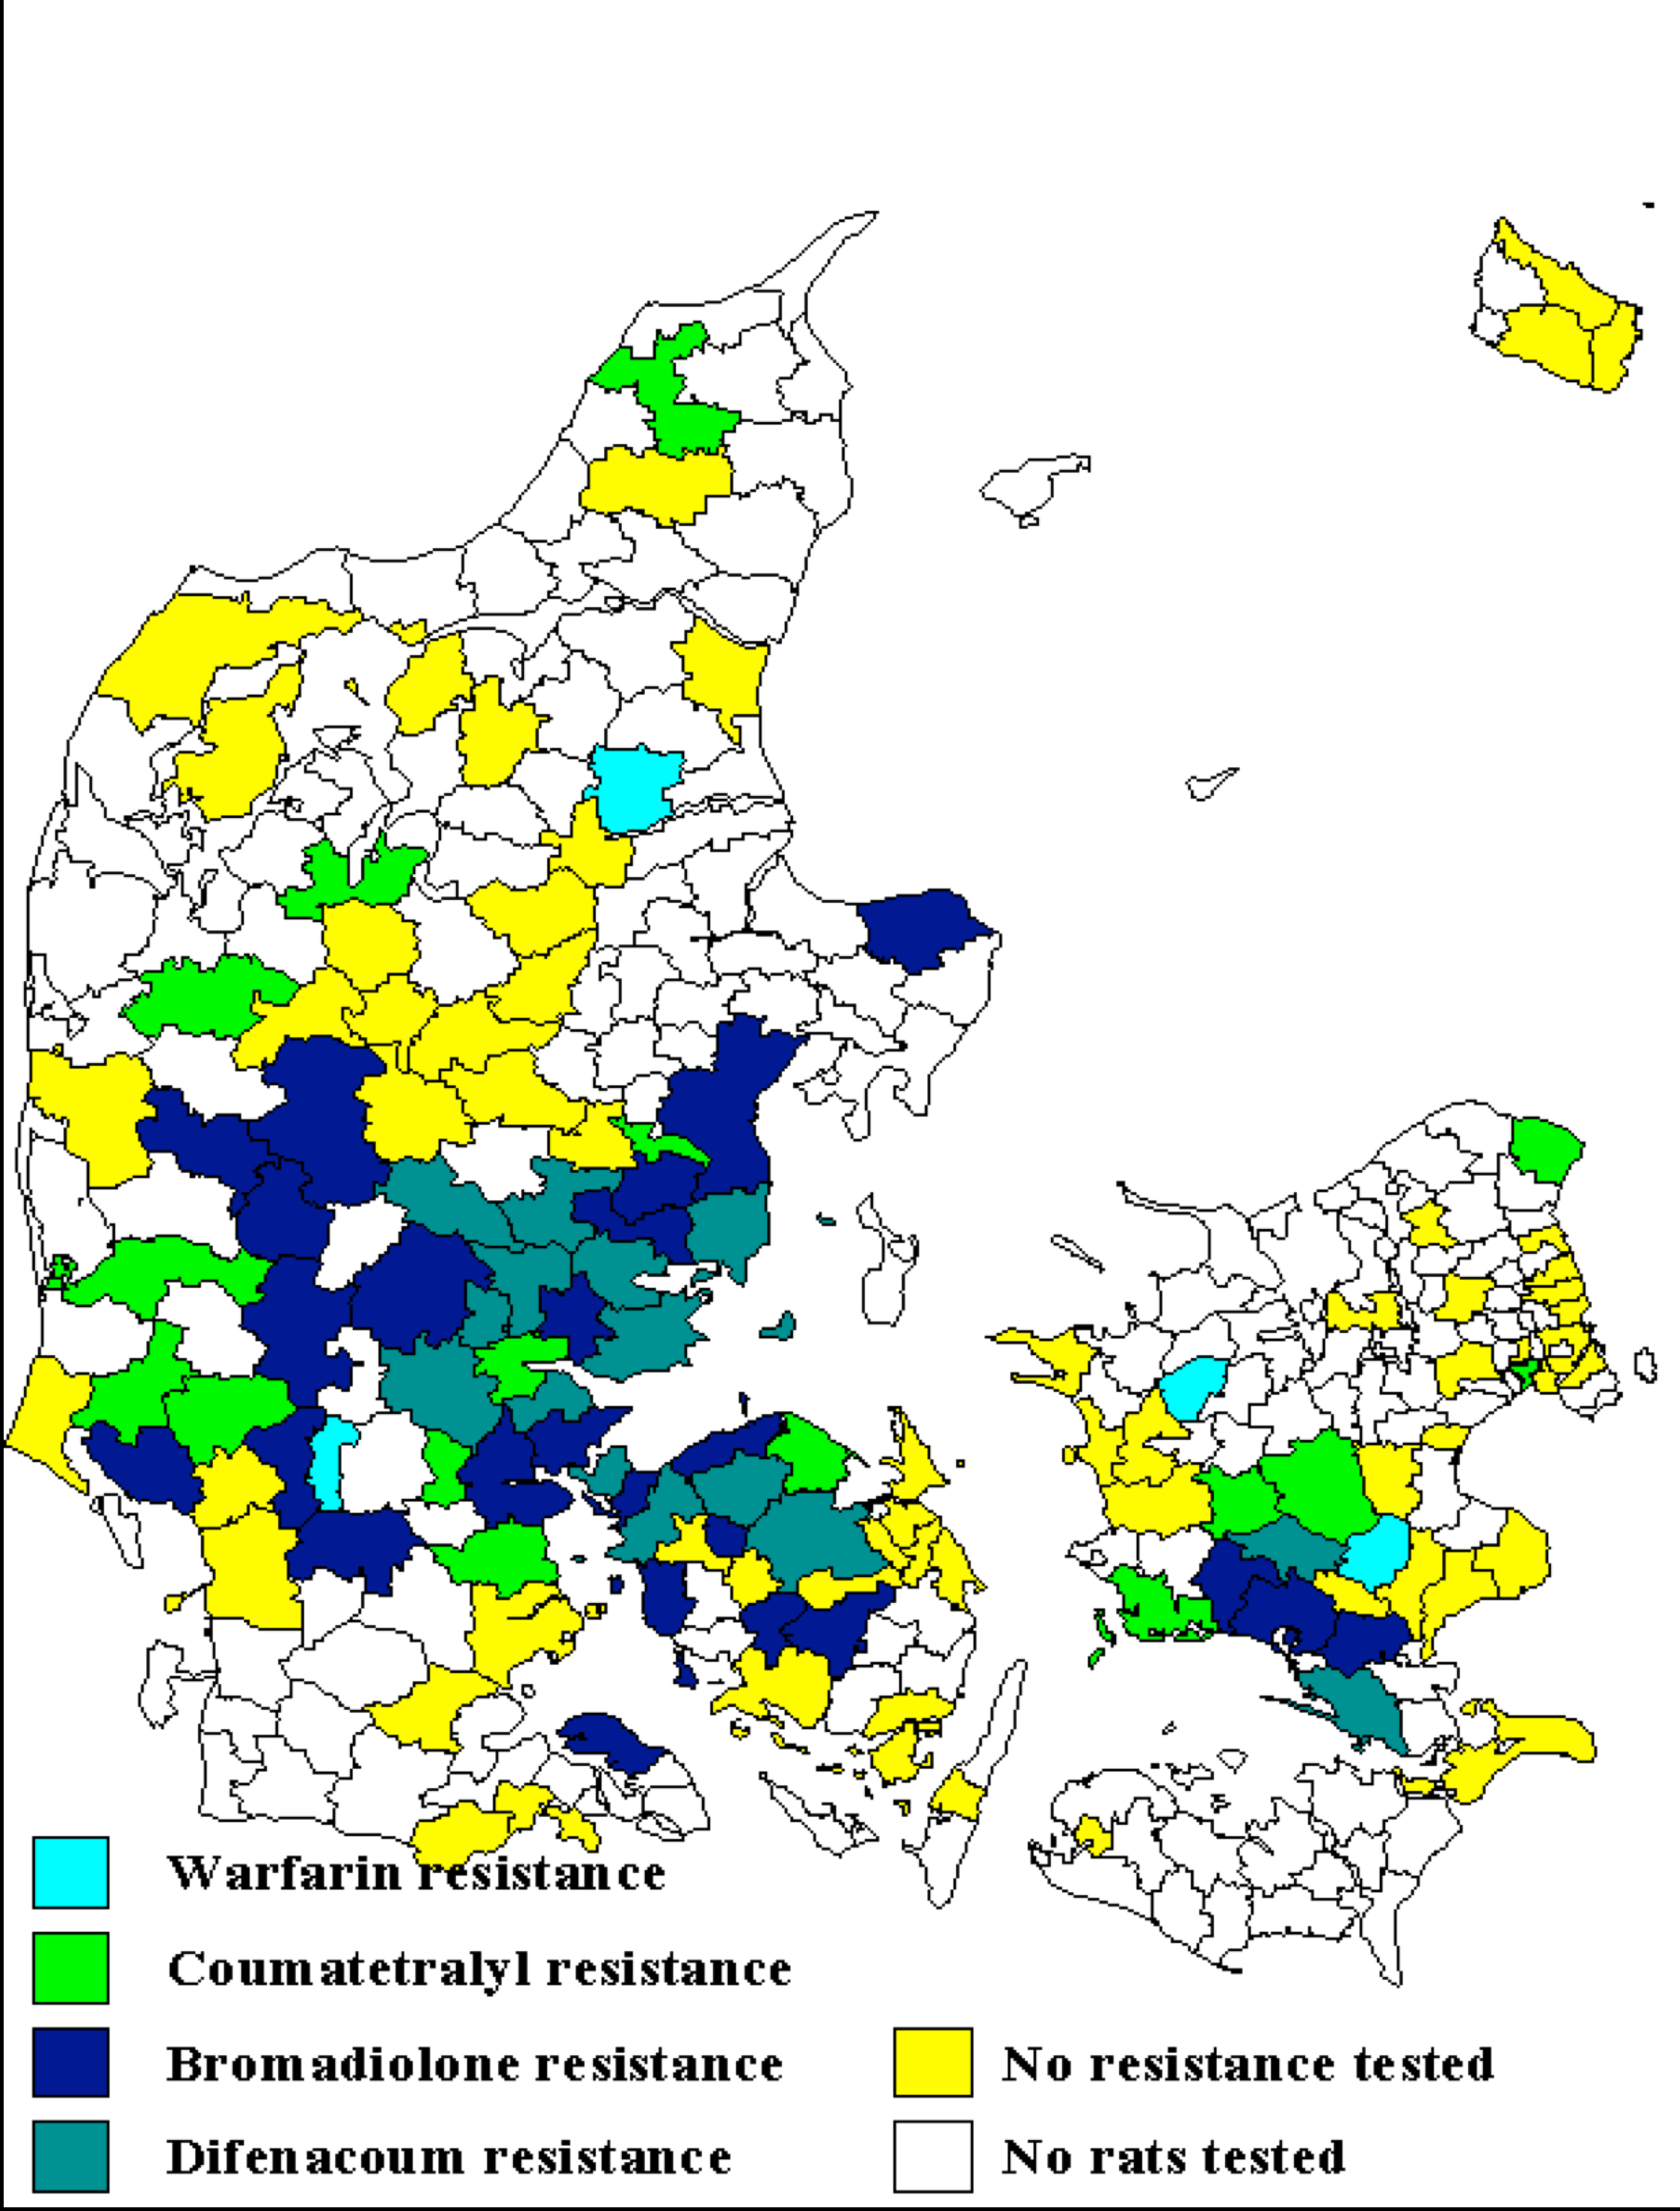

Figure 3: AVK resistance in Norway rats trapped in Denmark (Lodal, 2001)

France
Grandemange et al. (2010) conducted a nation-wide survey in France and analyzed almost 300 different rats obtained from urban and rural areas (see Figure 4). They identified 100 rats with at least one SNP on the VKORC1 gene conferring resistance (37%) in rats from 92 different locations across the country (see chapter 2 below). Undergoing research projects in France around the city of Lyon identified 70 to 100% resistant rats in two distinct rural communities in the western part of the city (Berny et al, in prep).
The main mutation found to date is the Tyr139Phe mutation. In 41 sites out of 92, at least one rat carrying this mutation was found (28% of the whole sample) (Grandemange, A., Lasseur, R., Longin-Sauvageon, C., Benoit, E., & Berny, P. 2010). The Tyr139Phe confers resistance to the first generation anticoagulants (Grandemange, A. 2009). Some mutations known to be associated with AVK were found, as Tyr139Cys or Leu120Gln. Some further mutations suspected to be associated with resistance were also detected, but no information is available about the phenotypic expression of these new mutations. For instance, haplotypes C and D, non-encoding ones, were found, but it is known that an intronic mutation is highly related to the promoter of the gene and is associated with AVK resistance (Yuan, H.-Y. 2005).

In house mice genetic alterations of VKORC1 have been described and altered VKOR activity or lack of susceptibility to AVKs has been reported together with a mutation in VKORC1 (Trp59Gly), (Lasseur, R. 2006). For details see also chapter 2.

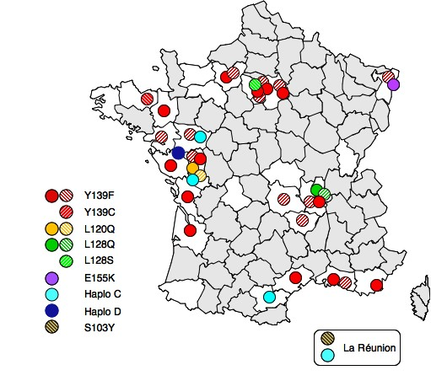

Figure 4: Sampling area and mutations detected in Norway rats caught in France (full circle: presence of homozygous individuals, dashed circles: only heterozygous individuals) (adapted from Grandemange et al. 2010)

Belgium
Recently, (Baert, K., Stuyck, J., Breyne, P., Maes, D., & Casaer, J. 2012) published an extensive survey on 691 rats trapped in various parts of Belgium. Resistance was monitored on the basis of the Blood Clotting Response test (Prescott, C. V., Buckle, A. P., Hussain, I., & Endepols, S. 2007) , an in vivo evaluation of resistance. Overall, resistance was identified in 17% of the animals caught. The distribution of resistant population was not even and some areas had significantly higher proportions of warfarin or bromadiolone resistant populations like Flanders (see Figure 5). In 2005 (Pelz, H. J. et al. 2005) found in 14 resistant tested rats from Flanders the Tyr139Phe mutation. Later (Baert, K. et al. 2012) showed that anticoagulant resistance in Belgium was related to two different mutations in VKORC1, namely Tyr139Phe and Leu120Gln.
Warfarin resistance in house mice in Belgium was mentioned by (Lund, M. 1984).
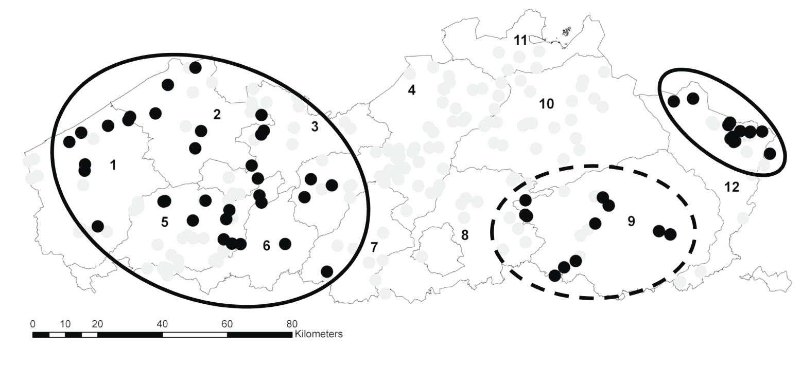
Figure 5: Three different areas with resistance in Belgium. Full line: bromadiolone resistance ; broken line : warfarin resistance. Grey dots represent sampling locations with only susceptible rats

USA + Canada
In the US, a nation-wide survey was conducted in the late 70s’ and identified at least 45 of 98 sites with some level of resistance in Norway rats, mainly in urban centers (See figure 6). The authors suggested, at the time, that resistance was associated with the repeated use of warfarin, mostly in urban centers.
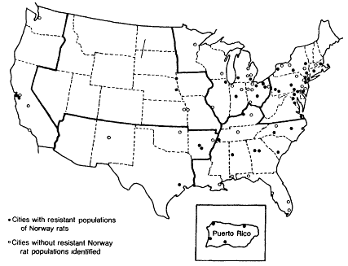
Figure 6: Rat strains resistant to warfarin identified in the US (from Jackson and Ashton, 1986)
A similar level of about 50% resistance was detected in house mice at the time, with localized “hot spots, like in North Carolina. In Toronto, Canada, house mice have shown increased tolerance to brodifacoum (Siddiqi, Z. & Blaine, W. D. 1982). It is considered by the United States Environmental Protection Agency that the use of first generation AVK in the 60s’ and 70s’ resulted in the selection of resistant commensal rodent species, but that the availability of other rodenticide (different from AVKs) should help overcome this resistance issue (Bradbury, 2008).

Germany
In Germany resistance to anticolagulants has been found in all commensal rodent species (Rattus norvegicus, Rattus rattus, Mus domesticus). Among these species, resistance to the brown rats has been thouroughly investigated. Resistance monitoring in Germany is intensively ongoing by JKI and Lower Saxony State Office for Consumer Protection and Food Safety (LAVES). The findings of anticoagulant resistance in Norway rats and House mice are presented on the website of JKI (www.jki.bund.de/stand-rodentizidresistenz.html) and shown in Figure 8a. Samples of > 2600 Norway rats and >250 house mice were investigated until now by sequencing and PCR-tests.

Five mutations in VKORC1 (Ala26Thr, Ser79Phe, Ser56Pro, Tyr139Phe, Tyr139Cys) in Norway rats were found up to now (Esther et al. 2013 in press). Resistance effects are known for Tyr139Cys and Tyr139Phe. In contrast to Tyr139Phe, found on one place 2010, Tyr139Cys seem to be wide distributed on NW-Germany (Pelz, H. J. 2007); (Runge, M., von Keyserlingk, M., Braune, S., Becker, D., Plenge-B+Ânig, A., Freise, J. F. et al. 2013). Within the NW-Germany, the frequency of the resistance gene Tyr139Cys varied considerably between < 20% and > 80% within short distances between infested sites, e.g. less than one kilometer (Klemann, N., Esther, A., & Endepols, S. 2011). The Norway rat resistant strain Tyr139Cys in VKOR, is basically resistant to warfarin. The majority of rats are also resistant to coumatetralyl and bromadiolone, which was determined in BCR-tests conducted according to (Prescott, C. V. et al. 2007) and confirmed under practical control conditions in field trials (Endepols, S. et al. 2012). Even no acceptable control level of resistant Norway rat infestations was achieved using difenacoum (Buckle, A., Endepols, S., Klemann, N., & Jacob, J. 2013). Brodifacoum has been found to be fully effective against Tyr139Cys infestations in Germany (Buckle, A. P., Klemann, N., & Prescott, C. V. 2012). Comprehensive standard BCR-tests (Prescott, C. V. et al. 2007) are conducted by Esther et al. at the moment supported by RRAC.

Recently, (Pelz, H. J., Rost, S., Müller, E., Esther, A., Ulrich, R., & Müller, C. R. 2012) published a first survey on resistant house mice in Germany (Figure 7b). This study investigated 30 different sampling sites. Only one sampling site showed only wild-type mice (no mutation). In all other instances, the frequency of resistance (mutations on Vkorc1) was beween 7 and 95% of the individuals tested. This result shows that AVK resistance in mice may be more important than in Norway rats in face of more than 16 variants and combinations of variants in VKORC1 found in Germany (Rost.S. 2009). The effect of the most amino acid substitutions on control success is unknown. We could not find any other published survey on the extent of resistance in mice but, as will be described in the corresponding chapter, the biological basis for resistance in mice is not as clear as in the Norway rat. However, the occurrence of the three most common Vkorc1 variants, which are known to be linked to anticoagulant resistance, in house mouse populations was confirmed nationwide in Germany: Arg12Trp/Ala26Ser/ Ala48Thr/Arg61Leu, Leu128Ser and Tyr139Cys (Rost.S. 2009).
Switzerland and Azores.- The occurrence of the three most common Vkorc1 variants, which are known to be linked to anticoagulant resistance, in house mouse populations was confirmed nationwide in the Switzerland: Arg12Trp/Ala26Ser/ Ala48Thr/Arg61Leu, Leu128Ser and Tyr139Cys (Figure 8, (Pelz, H. J. et al. 2012). The same study includes also 34 samples from the Azores, which revealed the variants Leu128Ser and Tyr139Cys.
Figure 7a: Norway rats since 1999 with the genotype  Tyr139Cys | 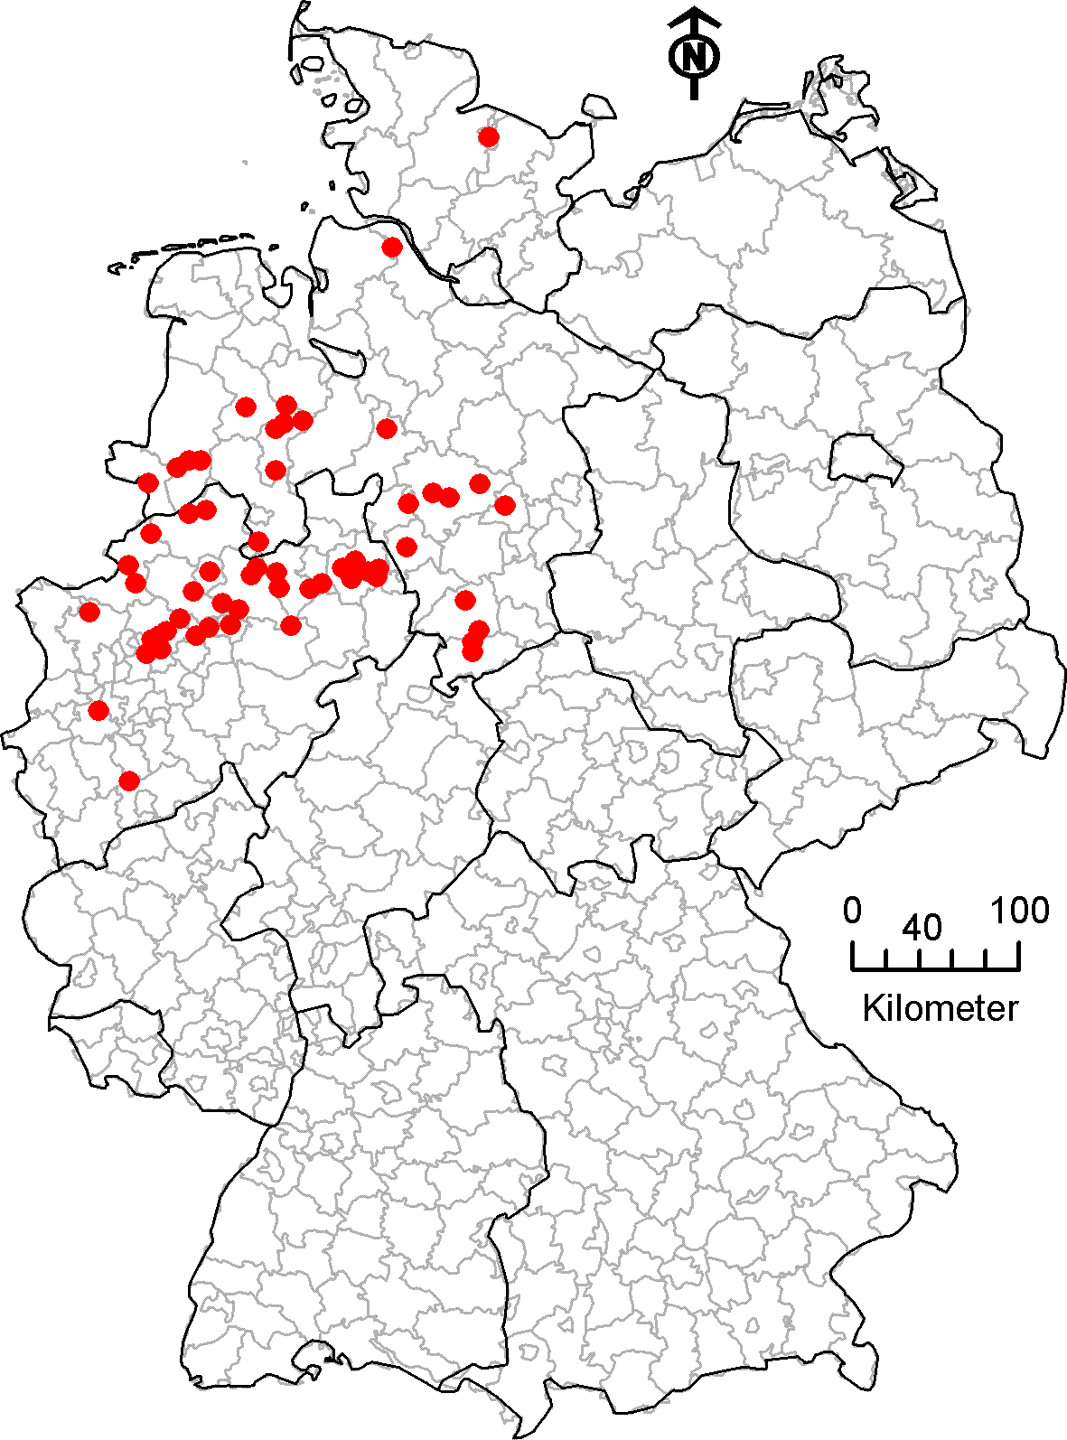
Figure 7b: House mice with at least one of the following genotypes:  Arg12Trp/Ala26Ser/ Ala48Thr/Arg61Leu,  Leu128Ser  Tyr139Cys. | 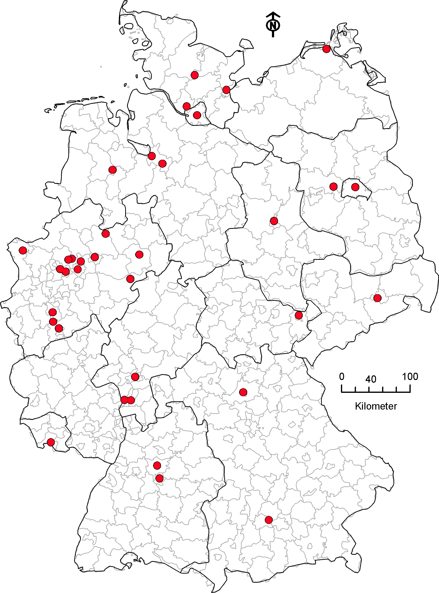
Figure 7: Findings of anticoagulant resistance in Norway rats (Figure 8a) and House mice (Figure 8b), April 2013 (www.jki.bund.de/stand-rodentizidresistenz.html).

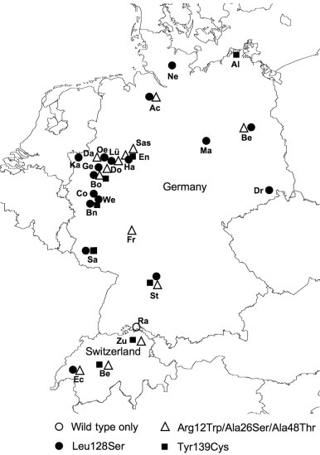
Figure 8: Occurrence of the three most common VKORC1 sequence variants in house mice in Germany and Switzerland, samples collected between 2004-2009, (Pelz, H. J. et al. 2012).

The Netherlands
In the Netherlands Norway rat resistance monitoring was conducted in a nation-wide survey on the basis of sampling faeces. The project is still running, but the actual raw data are shown on the website of Wageningen UR Livestock Research (http://www.bruinerat.nl/resultaten.html). In a pre-study, developing the genetic tests, with a low sample size (van der Lee, T. A. J. 2011) two genotypes known to be linked to resistance, Tyr139Cys and Tyr139Phe, have been found (Table 6). The actual resistance distribution, which is presented on their website, showed that the resistance incidence is highest in the south-east part of the country (Figure 9). Detailed data including distribution of genotypes will be published soon (Meerburg, pers. com).
House mouse anticoagulant resistance was confirmed in the Netherlands. In the late 1960s house mouse resistance to warfarin was described by (Ophof, A. J. et al. 1969).
Table 5: Overview of detected genotypes in a pre-test, Van der Lee, 2011.
Genotype | TAQMan | Number of sample | Percentage
Tyr139Tyr | FAM/NED | 27 | 44
Tyr139Tyr | FAM | 10 | 16
Tyr139Cys | NED/FAM | 14 | 23
Cys139Cys | NED | 8 | 13
Phe139Cys | NED/VIC | 1 | 2
Tyr139Phe | FAM/VIC | 1 | 2
Total |  | 61 | 100
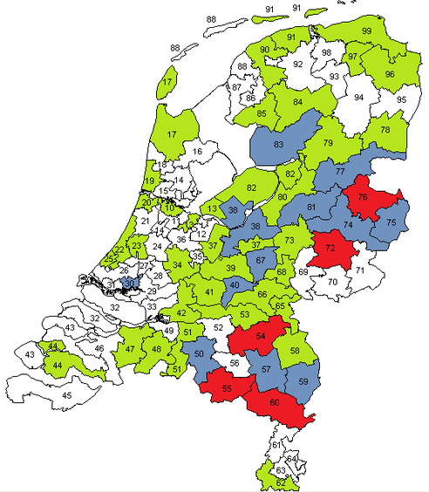

Figure 9: Sampling area and mutations detected in Norway rats in the Netherlands (green: no resistance, blue: both resistant and susceptible rats, red: only resistant rats were found), March 2013, see also the website: http://www.bruinerat.nl/resultaten.html

UK
In the UK a total of nine different anticoagulant resistance mutations are found among Norway rats. In no other country worldwide are present so many different forms of Norway rat resistance. Among these nine SNPs’, five are known to confer on rats that carry them a significant degree of resistance to anticoagulant rodenticides. These mutations are: Leu128Gln (L128Q, as shown in figure 8), Tyr139Ser (Y139S), Leu120Gln (L120Q), Tyr139Cys (Y139C) and Tyr139Phe (Y139F) (Buckle, A. 2013). In table 6 the different anticoagulant compounds and their effectiveness against the genotypes found in rats are shown. A map summarizing all DNA sequencing results submitted to RRAG is given in Figure 10.

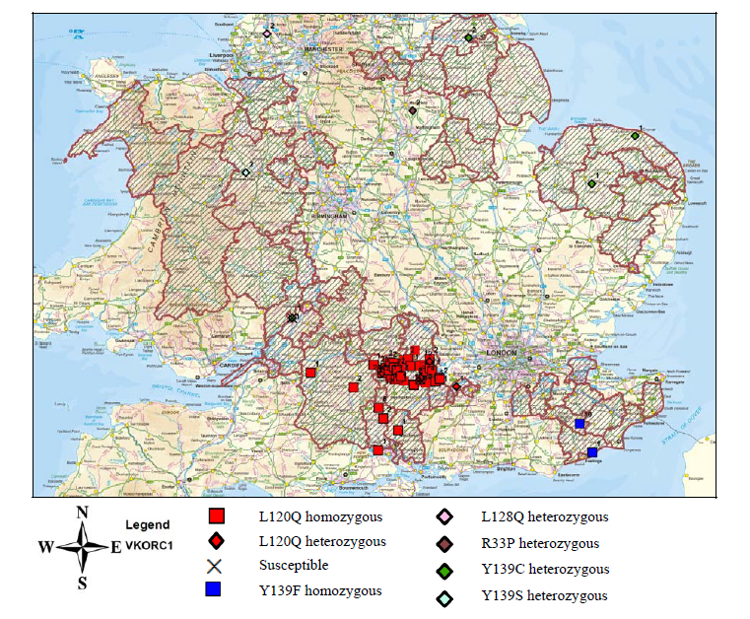

Figure 10: Combined results of DNA genotyping of tissue samples from Norway rats from various sources
in the UK (from RRAG).

Table 4: The different anticoagulant active substances and their effectiveness against the resistance mutations found in rats in the UK. A cross means that the active substance should not be used against that strain and a tick means that it may be used with a reasonable expectation of a successful outcome. Some treatments may be effective using bromadiolone and/or difenacoum against resistant rats carrying the Gloucestershire, Hampshire and Kent genes, although complete eradication may not be achieved. http://www.bpca.org.uk/assets/RRAG_Resistance_Guideline.pdf
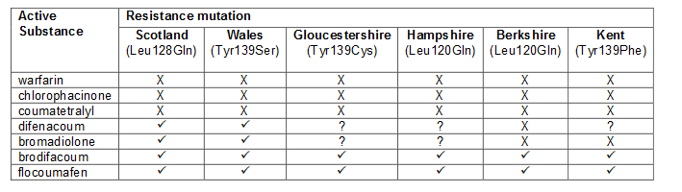
Two genetic mutations known to be linked to anticoagulant resistance have been found in house mice up to now. The first mutation is the one occurring in the Cambridge Cream resistance strain. These ‘Cambridge Cream’ mice were held in the laboratory and much subsequent assessment of the activity of anticoagulants against resistant house mice relied on tests on the progeny from this original breeding stock. The genotype is now known as the Leu128Ser mutation. In the 1990s, a population of resistant mice was discovered in the Reading area and studies were conducted on them, which resulted in the development of a pure laboratory strain of resistant house mice. The mutation later found in this strain was Tyr139Cys.

European Union summary.- A summary of the actual occurrence of detected genotypes in Norway rats in some countries of the European Union is shown in table 5. Only genotypes that are known to impact practical rat control are shown, adapted (Buckle, A. 2013), March 2013.
Table 5: Occurrence of detected genotypes known to be associated with resistance in Norway rats in some countries of the EU.
Country | Genotype in VKORC1
Denmark | Tyr139Cys
Germany | Tyr139Cys ; (Tyr139Phe)
Belgium | Leu120Gln ; Tyr139Phe
France | Tyr139Cys ; Tyr139Phe ; Leu120Gln ; Leu128Gln
UK | Tyr139Cys ; Tyr139Phe ; Tyr139Ser ; Leu120Gln ; Leu128Gln
Netherlands | Tyr139Cys; Tyr139Phe
Hungary | Tyr139Cys
Rodent research studies from many countries confirmed resistance against a lot of anticoagulant compounds. The following table 6 gives an overview picture of the anticoagulant compounds affected by resistance in Europe, as revealed by the questionnaire dispatched by EPPO to its member countries in 1992, and amended by actual research studies. Resistance tests on roof rats have mostly been intermitted, as this species is seldom a major pest in countries that reported research results in the above-mentioned EPPO-study. Interesting resistance in Rattus rattus to bromadiolone and difenacoum was reported from France (Desidiri, D. 1978) (Lund, M. 1984) be the only country where anticoagulant other than warfarin have been tested (Myllymäki, A. 1995).
Table 6: Summary of distribution of resistance to anticoagulant compounds against the three commensal rodent pests in Europe, as revealed by the questionnaire dispatched by EPPO to its member countries in 1992, Adapted (Myllymäki, A. 1995), March 2013.
Country | Rattus norvegicus | Rattus rattus | Mus domesticus
Denmark | Warfarin, Coumatetralyl, Bromadiolone, Difenacoum, | Warfarin | Warfarin, Bromadiolone, Brodifacoum
Finland | ? | ? | Warfarin, Coumatetralyl, Bromadiolone
France | Warfarin, Coumatetralyl, Bromadiolone, Difenacoum | Warfarin, Bromadiolone, Difenacoum | Warfarin, Bromadiolone
Germany | Warfarin, Coumatetralyl, Bromadiolone, Difenacoum | Warfarin | Warfarin, Difenacoum
UK | Warfarin, Coumatetralyl, Bromadiolone, Difenacoum, (Brodifacoum) | Warfarin | Warfarin, Coumatetralyl, Bromdiolone, (Brodifacoum)
Belgium | Warfarin, Bromadiolone | ? | Warfarin
Netherlands | Warfarin, Coumatetralyl, Bromadiolone, Difenacoum | ? | Warfarin
Italy | Warfarin | ? | ?
Besides the three commensal rodent species, Norway rat, black rat and house mouse, some recent studies revealed anticoagulant resistance in other rodent species. Recently, warfarin resistance has also been reported in the Lesser Rice-field rat (Rattus losea) (Wang, H. S. et al. 2008). (Andru, J. 2013) also published evidence of coumatetralyl resistance in Rattus tanezumi in Indonesia, in oil palm plantations regularly treated with this first generation AVK. In China warfarin resistance was found in Rattus norvegicus (Liang, L. 2005), Rattus losea (Wang, H. S. et al. 2008) and in Rattus flavipectus which possessed the VKORC1 mutation Tyr139Cys (Huang, B. H. et al. 2011). (Vein, J., Grandemange, A., Cosson, J. F., Benoit, E., & Berny, P. J. 2011) have recently published some enzymatic evidence of resistance to warfarin in water voles (Arvicola terrestris) trapped in French areas where bromadiolone is repeatedly used to control vole populations. This resistance does not appear to be linked to a modification of the vkorc1 gene but rather to alterations of the VKOR enzyme function as could be determined by promoter alteration for instance.

Resistance testing

Testing for resistance existence may be considered in order to adapt the AVK applied. As of today, there are few standardized techniques: in vivo assays (feeding test, Blood Clotting Resistance test) and in vitro assays (VKOR activity, CYP450 metabolism and vkorc1 testing) (Grandemange et al., 2010), depending on the nature of resistance suspected. The in vivo assays give phenotypic evidence of resistance with a good indication of practical resistance. The in vitro assays are mostly developed for Vkorc1 mutations so far and not routine for metabolic resistance.

Feeding test

This strategy has been the first developed by the WHO (Drummond and Rennison, 1973). After several revisions, it has been established in its present form in 1982 (WHO, 1982), with various doses of the AVK to test. It is basically a no-choice feeding test over 6 days with a 50 ppm warfarin, bromadiolone or difenacoum bait for instance. Rodents surviving the 5-day test period (+14 days observation) are classified as resistant to the AVK tested. This test needs to be conducted on a sufficient number of animals in order to be significant. It also involves intense trapping and maintaining rat colonies in order to evaluate the resistance status. Some authors consider that this test has several limitations, especially with regards to local variations in the resistance of the strain, which would need adaptation of the exposure period to cover a wider range of susceptibility. Unfortunately, this approach, which provides a good estimate of the field resistance level, requires a large number of animals and is ethically critical (Gill and McNicoll, 1991).

BCR testing

The Blood Clotting Response test (BCR) was first developed by the EPPO (European Plant Protection Organization) (Martin, A. D., Steed, L. C., Redfern, R., Gill, J. E., & Huson, L. W. 1979).

The approach is to determine the rat capacity to use the vitamin K epoxide substrate (1 mg/kg) as a vitamin K source in the presence of an AVK such as warfarin (5 mg/kg). Determination of the clotting response (Prothrombin time) 24hours later is a good indicator of the resistance status. A revised version of this test only relies on the administration of a low dose (1 mg/kg) warfarin, with no vitamine K epoxyde and investigation of the clotting capacity 24hours later. The recent developments of this approach are based on the works by (Gill, J. E., Kerins, G. M., Langton, S. D., & MacNicoll, A. D. 1993) and Prescott and Buckle (2000), who tested several protocols with various AVKs. These works led to the production of a technical Monograph by the Rodenticide Resistance Action Committee (http://www.rrac.info/) in 2003. The idea is to administer normalized and increasing doses of AVK to rodents (as multiples of a known effective dose 50 for which 50% of the animals treated will have an International Normalized Ratio (INR) >5, in which the INR is a standardized ratio for the measurement of the prothrombin time). Table 7 below gives a list of ED50s of various AVKs in the Norway rat and the House mouse for resistance investigation.

Table 7: ED50’s of various AVKs in susceptible strains of Norway rat (Rattus norvegicus) and House Mouse (Mus musculus) (adapted from RRAC, 2003).
Species / strain | AVK | Gender | ED50 (mg/kg)
R. norvegicus (CD) | Warfarin | M | 1.51
 |  | F | 2.13
 | Diphacinone | M | 0.86
 |  | F | 1.12
 | Chlorophacinone | M | 0.54
 |  | F | 0.67
 | Coumatétralyl | M | 0.36
 |  | F | 0.44
 | Bromadiolone | M | 0.47
 |  | F | 0.61
 | Difenacoum | M | 0.65
 |  | F | 0.79
 | Difethialone | M | 0.43
 |  | F | 0.49
 | Flocoumafen | M | 0.29
 |  | F | 0.34
 | Brodifacoum | M | 0.22
 |  | F | 0.23
M. musculus (CD-1) | Bromadiolone | M | 1.96
 |  | F | 1.68
 | Difenacoum | M | 0.85
 |  | F | 0.56
 | Difethialone | M | 0.83
 |  | F | 0.83
 | Flocoumafen | M | 0.51
 |  | F | 0.44
 | Brodifacoum | M | 0.39
 |  | F | 0.35

This approach gives phenotypic results and a good idea of the general resistance status of a given strain, both in terms of molecules and level of resistance (a “resistance factor” can be computed for each AVK tested and is a reliable estimate of the potential field efficacy of an AVK as confirmed in studies (Buckle, A., Endepols, S., Klemann, N., & Jacob, J. 2013); (Endepols, S., Klemann, N., Jacob, J., & Buckle, A. P. 2012). Its limitations are still similar to the feeding test, i.e. manipulation of live-trapped animals, sanitary and ethical problems with the manipulation of wild mammals. It is still commonly used nowadays.

VKOR Activity

Numerous studies have reported the determination of kinetic constants and/or enzyme activity for VKOR in susceptible and resistant Norway rats. Several protocols may be used (Lasseur et al., 2005 ; Lasseur et al., 2007) on liver microsomes or any other enzyme system (recombinant cells for instance as in Rost et al., 2009). This assay can be conducted on a limited number of animals and does not require extensive rodent trapping. Also, animals do not need to be maintained in laboratory facilities. This approach provides a very good estimate of the enzyme activity and the resistance status of a population. It is also rapid and cost-effective, and all AVKs can be tested in a very short time period (Lasseur et al., 2006). This determination requires analytical material (HPLC or LC-MS) for routine determination. Only a few strains will not respond to this assay: metabolic resistance will not be detected, for instance.

Metabolism

Although CYP metabolism of warfarin has been described in the Norway rat (Ishizuka et al., 2006), in the roof rat (Sugano et al., 2001; Ishizuka et al., 2006) and in the House Mouse (Sutclife, 1990), it is not a standard tool for the monitoring of resistance so far. More work needs to be done to determine the CYP450 isoforms involved, as well as the AVK concerned, in order to develop this approach as a routine monitoring tool for metabolic resistance in rodent species. Undoubtedly, this resistance pathway needs to be more deeply investigated at that point. Nevertheless, it is an in vitro approach, like the VKOR activity assay, and requires microsoms and analytical devices to look at warfarin metabolites produced. Preliminary work conducted in our lab indicates that each AVK is metabolized by a different CYP450 isoform (Lattard V, personal communication).

Vkorc1 sequencing or genotyping

This last in vitro approach has been suggested in our work (Grandemange et al., 2010). Basically, sequencing of Vkorc1 only requires a piece of animal tissue (tail, ear, fur may be used) and does not necessitate live-trapping of rodents. In the Norway rat, considering the major importance of the SNPs’ identified so far, sequencing of Vkorc1 appears as one of the most interesting and cost effective tools to date. As compared with other resistance detection assays, it can be applied rapidly on large scale samples, even across a country (Grandemange et al., 2010). Coupled with VKOR activity measurement in recombinant cells, it can also provide a good indication of the resistance level conveyed by a given mutation. The following primers have been used in the rat: rat VKORC1 exon 1 (VKORC1 GenBank accession no. NM-203 335) are exon1-forward 5′ -GTGGCGGGTTCTTCCCTC-3′ ), and exon1-reverse primer (5′-GACTCCAAAATCATCTGGCAACC-3′ ).

In very specific situations, especially when only one mutation is expected or known to occur, this approach may be simplified even further with the use of qPCR and specific primers. In this case, the different genotypes (homozygous, heterozygous, resistant and susceptible) are tested and their characteristic cycle threshold values (∆Ct, i.e. the difference between the matched and the mismatched primer extension for homozygous rats and the absence of such a difference in Ct values for heterozygous animals) gives significantly different results (see figure 11).

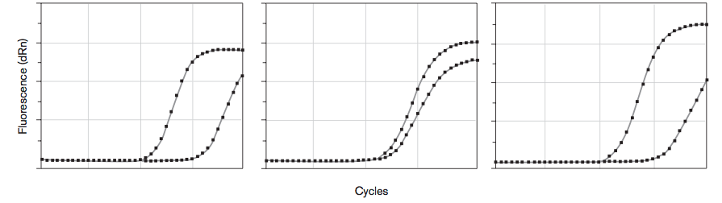

Figure 11: fluorescence and qPCR determination of the genotype of Norway rats (for the Y139F mutation). The first graph represents the SYBER green fluorescence curves for a SD/SD animal, with a cycle threshold (DCt) of – 9.28 cycles, the second graph represents the SYBER green fluorescence curves for a SD/Y139F animal, with a DCt of 0.91 cycles and the third graph represents the SYBER green fluorescence curves for a Y139F/Y139F animal, with a DCt of 9.83 cycles. dRn, baseline corrected normalized fluorescence (adapted from Grandemange et al., 2009)

This last approach is the most cost-effective one when the resistance status of a population is known. It is used extensively in our group to investigate wild populations of rats, since the Y139F mutation is the major (sometime only) SNP detected so far in our study sites. Nevertheless, a similar approach can be conducted with specific primers for each SNP and the results combined. Only very small pieces of tissue are required and we have evidence that this technique could be applied to fecal samples, which are extremely common and easy to collect when rat populations are installed.

Molecular tools are widely available and private or public labs may be able to operate those systems. It is important, however, to understand that identifying a mutation is only part of the test: the mutation needs to be characterized in the given species to be considered as responsible for resistance or not.

Resistance testing – summary
Table 8 summarizes the test methods available to determine the resistance status and/or level of a given rat strain.
Table 8: summary of the methods available to determine the resistance status of a rodent.
 | Norway rat | Roof rat | House mouse
Feeding test | OK  - standardized,  - good estimate of practical resistance  - Needs live animal  - 21 days | OK  - standardized,  - good estimate of practical resistance  - Needs live animal  - 21 days | OK  - standardized,  - good estimate of practical resistance  - Needs live animal  - 21 days
BCR test | OK  - standardized,  - good estimate of practical resistance  - Needs live animal  - <48h | ? Unpublished | OK  - standardized,  - good estimate of practical resistance  - Needs live animal  - <48h
Vkor activity | OK  - in vitro  - test for all AVK  - limited number of animals  - rapid  - not for metabolic resistance | OK  - in vitro  - test for all AVK  - limited number of animals  - rapid  - not for metabolic resistance | OK  - in vitro  - test for all AVK  - limited number of animals  - rapid  - not for metabolic resistance
Vkorc1 genotyping | OK  - well adapted  - routine  - needs information on mutation/activity | ?  - limited evidence  - routine  - needs more information in this species | OK  - limited evidence  - routine  - needs more information in this species
Metabolic resistance | Suspected  - not routine  - different for each AVK | Described  - not routine  - different for each AVK | Described  - not routine  - different for each AVK

Monitoring systems for resistance
Apparent increase in geographical areas where anticoagulant resistance is found in EU Member States, and increased severity of resistance at resistance foci, is of the highest concern and a significant threat to sustainable use of rodenticides. This is particularly the case because of our virtual complete reliance on anticoagulant active substances for rodent control in the EU, due to the limitations of alternatives. Therefore, anticoagulant resistance management is an essential part of sustainable use. Several guidelines are available which set out resistance management strategies, aimed both at preventing the development of resistance and the removal of resistant infestations once they are established (Rodenticide Resistance Action Committee 2003) (Buckle, A. 2013;Buckle, A., Charlton, A., Meyer, A., & Prescott, C. V. 2010) and ECPR-R (in press).

Two guiding principles emerge. The first is the requirement to monitor rodent infestations for resistance. The development of novel DNA sequencing techniques for resistance monitoring is a major breakthrough in this endeavour. The second is that use of anticoagulant active substances that are resisted by rodent infestations should cease at resistance foci and effective alternatives should be used. The reasons for this are that continued use exacerbates the severity of resistance and promotes its spread. The use of resisted anticoagulants is also ineffective and therefore presents unnecessary risk to the environment. The development of comprehensive resistance monitoring programs in Member States where resistance occurs, the dissemination of information on the physiological nature and distribution of resistance and the adoption of robust resistance management strategies are essential to sustainable use of anticoagulants in the EU.

Very limited information about resistance monitoring systems is available. We could not find an existing sustainable resistance monitoring program in the EU. Research projects to elucidate distribution of resistance have been conducted in Belgium, Denmark, France, Germany, the Netherlands and UK (see chapter 4). Below are developed two examples of nation-wide strategies towards monitoring of AVK-resistance in commensal rodents (in Germany and in the UK).

In Germany first steps of a sustainable monitoring system have been initialized. Since 2001 at the JKI more than 2000 tissue samples from Norway rats and 250 house mice have been sequenced and analyzed for the amino acid exchange Tyr139Cys on VKORC1. Samples also from locations with anticoagulant control problems, were taken by JKI, research partners (e.g. RRAC) or pest control operators. In addition, in Hamburg 121 samples have been checked since 2007 (Institute of Hygiene and Environment, Hamburg), and in Lower Saxony more than 600 samples have been analyzed for Tyr139Cys by the Lower Saxony State Office for Consumer Protection and Food Safety since 2008. A cumulative distribution of resistance of Norway rats and house mice is shown on the website of the Expert Committee on Pesticide Resistance - Working Group Rodenticides, ECPR - R (www.jki.bund.de/ stand-rodentizidresistenz.html) and in further publications (Esther et al., in press). ECPR-R in Germany published plans on their website for creating an “ideal” monitoring system. Detailed recommendations for the ongoing and improvement of the existing monitoring program are compiled and a conceivable map for developing a resistance raster including the sequencing results is shown (Figure 12).

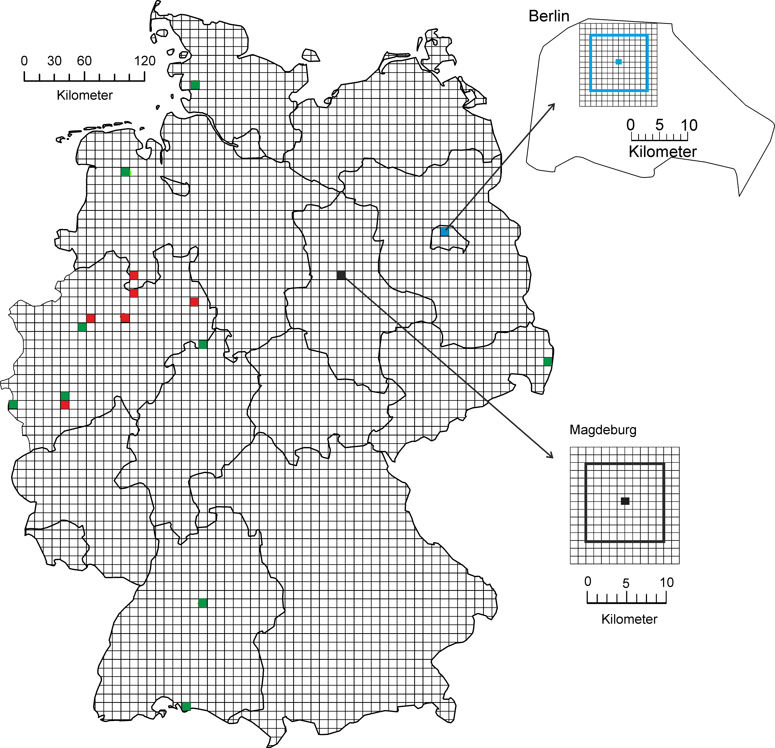

Figure 12: Suggested map for analyzing the local distribution of VKORC1 sequencing results of Norway rats (green: no amino acid exchange, red: Tyr139Cys, black: Ser79Phe, blue: Ala26Thr). Presentation based on a cluster of 10 km x 10 km (1km x 1km for locations with detected amino acid exchange), from ECPR-R.
Historically, resistance monitoring in the UK was actively carried out by the Ministry of Agriculture Fisheries and Food (MAFF), which was responsible for the development of many of the early resistance testing methodologies. The MAFF Pest Infestation Control Laboratories, which subsequently became the Central Science Laboratory (CSL) and then the Food and Environment Research Agency (FERA), actively conducted research in this area, but in recent years, UK government funding has been drastically reduced. Thus resistance monitoring is no longer routinely conducted by Government Agencies, and the breeding colonies of resistant Norway rats strains originally set up by Government laboratories, are no longer maintained. In April 2013, the FERA Wildlife Program of work will transfer into the Animal Health and Veterinary Laboratory Agency (another Agency of DEFRA). The impact of this relocation on future research on resistance is unknown.
In 2009 a consortium of Industry funders, headed by Killgerm Group Limited, entered into an agreement with the Universities of Huddersfield and Reading, to conduct molecular sequencing of the VKORC1 resistant gene of Norway rats sampled from six areas of the UK; with the University of Reading responsible for samples originating from Central Southern England, South East England and East Anglia, and the University of Huddersfield responsible for samples originating from ‘Wales and West Midlands’, ‘Yorkshire and Nottinghamshire’ and ‘Gloucester and Avon’. The collection and delivery of samples to both Universities was the responsibility of the consortium, and has been problematic.
This project is on-going, and the University of Reading has circulated preliminary results to the consortium of funders, and has presented the data on the website of the Rodenticide Resistance Action Group (RRAG). To date, no results from the University of Huddersfield have been made available to the consortium. Nine mutations of the VKORC1 gene have been identified in UK Norway rats, three of which have the potential to cause a practical impact on field control using the second generation anticoagulants, bromadiolone and difenacoum^{1,2}.
In addition to the above, a number of ad-hoc resistance monitoring surveys have been conducted by the University of Reading in central southern England.
With House mice, resistance to the first generation anticoagulants is known to be widespread³, and in one location near Reading (in Berkshire), practical resistance to bromadiolone has been established⁴. To date two mutations of the VKORC1 gene have been identified in animals originally trapped from the Cambridge area and the Reading area, and the UK Rodenticide Resistance Action Group is now planning a survey of House mouse resistance across the UK, along similar lines to that of the Norway rat survey.
In Ireland, no monitoring of resistance in Norway rats or House mice has been conducted. However, discussions are on-going about establishing a monitoring system for Norway rat resistance, with samples shipped to the University of Reading for analysis.
A major advantage of the new molecular resistance testing methodology is that it does not involve laboratory tests on live animals. However, the test itself provides little information about the potential impact of the different VKORC1 mutations on field control. Early studies of Norway rat resistance in the United Kingdom have investigated the impact on field efficacy at a number of resistance foci, and more recently it has been possible to link these resistance foci with mutations of the VKORC1 resistance gene⁵. Further work on the potential impact of the VKORC1 mutations on field efficacy is being conducted using the new resistance testing methodology that is based on the blood clotting response⁶ work conducted at the University of Reading using this new methodology, has established Norway rat susceptibility baselines for warfarin, diphacinone, chlorophacinone and coumatetralyl, and Norway rat and House mouse susceptibility baselines for bromadiolone, difenacoum, difethialone, flocoumafen and brodifacoum⁶, and work is on-going, partly funded by the University of Reading and partly funded by Industry, through the Rodenticide Resistance Action Committee of CropLife International, to generate resistance baselines for established resistant strains of Norway rat and House mice that are each homozygous for one of the VKORC1 mutations. Comparison of resistance baselines with the susceptibility baselines will provide a resistance ratio that can be used to assess the likely impact of each VKORC1 mutation on field control. Similar studies are on-going at other European laboratories using established resistant strains of Norway rat that are each homozygous for other VKORC1 mutations.

Our virtual complete reliance on the use of anticoagulants for the chemical control of rodents in the EU, calls for improved schemes for resistance management. Although this may well involve the use of alternatives to anticoagulant rodenticides, it is extremely important to obtain a clear understanding of the geographical distribution of all the resistance mutations in rats and mice identified to date, and to ensure that only fully effective anticoagulants are used against them.
Identifying Vkorc1 mutations by genotyping and relating these mutations to phenotypic effects (either via in vitro or in vivo evaluation) appears as the most cost-effective and promising approach for general resistance monitoring strategies.

Objective 1-1-c: Alternatives to rodenticides

Today it is assumed that alternatives to rodenticides cannot work as stand-alone control method, but suitable methods might be integrated into rodent control management.

Mechanical alternatives

Traps and glue-traps
From the old killing-trap to the newest electronic traps with integrated GPS monitoring and email alert, trapping is a control strategy that has to be considered under all circumstances. Among its advantages are: easiness of use, limited cost (except for recent electronic traps), re-usable device, no environmental impact. Some disadvantages include limited efficacy, need for prolonged use, constant monitoring and activation of traps, removal/destruction of dead rats. Despite all possible limitations, traps are still widely used across the world.

Ultrasonic rodent repellents
A wide variety of electronic rodent repellent devices have been researched, developed, and marketed over the past 30 years.
A vast array of devices that operate above the human-hearing frequency range have been manufactured and marketed as electronic pest control "tools" that can prevent rodent invasions, repel rodents in existing infestations, or enhance conventional rodent control methods (e. g. baiting and trapping) by influencing rodent movements to improve efficacy in an "integrated" approach. Almost all applications recommended for ultrasonic rodent control devices are in structures (e.g., homes, businesses, warehouses).
Most devices generate ultrasonic output in the 70-140 dB range of intensity as measured 30.5 cm from the transducer. Putative mechanisms of action for ultrasonic rodent repellency with commercially manufactured devices have included pain, interference with communication, disorientation, or fear-inducing danger signals. Ultrasonic devices capable of producing pain (i.e., > 140 dB), would (1) exceed the OSHA Standards for 8-hr workplace exposures in humans, (2) probably lead to deafness in short order in the rodent target species, (3) produce objections related to animal welfare and humaneness, and (4) be effective only over very limited areas due to the rapid decrement in intensity of ultrasound as the distance from the source is increased (Schumake, S. A. 1995).
Controlled efficacy test protocols have indicated only marginal repellency effects (i.e., 30-50% reduction in movement activity), and rapid habituation (i.e., no significant repellency effects beyond 3 to 7 days of exposure). None of these devices seems to have a satisfactory effect on the target animals even when used under optimal conditions (Lodal, 1993), (Iglisch & Ising, 1985). This conclusion holds for both preventive and corrective applications, and for those applications that include combining ultrasonic rodent repellent devices with baits, traps, or glue boards (Schumake, 1984).
No rodent control ultrasonic devices have been developed that are capable of delivering "supernormal" stimuli that could exceed natural repellency generated by co-specifics or predators (Bomford & O´Brien, 1990). Research and development of ultrasonic and other electronic rodent pest control devices are generally considered low priority endeavors. A more productive research approach could involve an assessment of natural rodent alarm or distress calls as repellent stimuli (Menke et al., 2012). The capabilities of digitally recorded or synthesized critical frequencies have continued to improve at a rapid pace within industry. It is also possible that ultrasonic stimuli could be used in combination with other sensory modalities (e.g. alarm pheromones, predator odors) to enhance repellency in terms of potency and duration. With the recent increased interest in and emphasis on repellency in general in the field of animal damage control (Jacob, 2013), such questions involving cross-modal repellents could have increased priority in future rodent control research (Schumake, 1995).

Electromagnetic devices
These units for controlling pest species including rodents were offered for sale during the 1970's. Devices were advertized as capable of generating their own magnetic fields or distorting the earth's magnetic fields in such a manner that animal pest species (but not "beneficial species") stopped eating, drinking, and reproducing. Laboratory efficacy tests on the control of Norway rats and field efficacy tests indicated definitively that such devices have no effect on feeding, drinking, mating, or infestation patterns (Schumake 1995). Fitzwater (1978) found little scientific support for their use in pest control.

Vibration and Shock devices
Other electrically operated devices that have been marketed for rodent control include vibration devices designed to frighten pests from buildings or agricultural crops. Efficacy for such devices has yet to be demonstrated for any application (Schumake, 1995). Recent attempts to use vibration to scare away water voles have yielded equivocal results (Menke et al., 2008). Electrical barriers and electrical shocking devices have been used in attempts to control rodent problems where baiting and trapping have failed. Electric barriers may be feasible in some circumstances, though as with all methods they must be compared with the efficacy, cost-effectiveness and acceptability of alternatives (Buckle, 1994).

Chemical repellents/ or attractants
There is no effective chemical repellent available that is not also toxic (Meehan, 1984). An important requirement of a repellent is that it should repel by olfaction rather than taste, or else damage to a commodity or structure will occur during tasting (Buckle, 1994). The idea of using distasteful or foul-smelling materials to prevent losses from animal is not new and probably goes back to antiquity (Welch, 1967). However, increased importance has been placed on this method of "control", and research has been stepped up in recent years, in an effort to develop more effective and useful materials to reduce losses by commensal rodents that damage food packages, textiles, and other materials of economic importance. House mice and rats find some chemical tastes and odors distasteful, but chemical repellents usually are not a practical method of controlling rodent damage (West & Messmer, 1998). As with most repellents, house mice and rats may become accustomed quickly to the chemical and gnaw on objects even though the repellent. Substances such as moth balls (naphthalene) or household ammonia, in sufficient concentration, may have at least temporary effects in keeping house mice out of certain enclosed areas.
Some extractions of plant material have repellent properties, possibly due to plant secondary compounds that have evolved to minimize damage by herbivores. Recent research demonstrated efficacy of several substances in repelling field rodents (Fischer et al. 2013a+b).
One idea of research biologist is to detect a pheromone or other chemical that communicate a response other than a simple distaste (Buckle, 1994). Pheromones have been reported to play an important part in social interactions in small rodents. Some of the chemical messengers involved may have a potential use in control of rodent pests, both as repellent or attractant (Christiansen, 1975). The use of chemical signals in communication offers at least two major advantages: the "message" can linger on long after the "sender" has left the stage, and communication works as well in total darkness as in broad daylight. In rodents, pheromones can be divided into two groups: (1) signal pheromones or releasers, i.e. substances that trigger immediate behavioral responses, and (2) primers, i.e. substances that produce effects that become manifest only after some time has passed, by working through some neuro-endocrine pathway. A couple of releasers (signal) pheromones seem to be of more immediate interest to pest control. Those are the sex attractants, and the aggression eliciting pheromones (Christiansen, 1975). The sex pheromone, which is found in female rodent urine or vaginal discharge could be an important substance for attracting males to traps or to stations with toxic bait or chemosterilants. An attempt to evaluate this potential possibility has been made by (Field, 1971), who reported increased acceptability of chemosterilant bait by rats on treatment with estrus urine. However, more research is needed to quantify the attractant capacity of these pheromones, and to isolate and identify the chemical components that are responsible for this presumed attraction. The males generally are more active than females in searching mates. Nevertheless, a male produced odor attracting females could be very useful in rodent control. The preputial glands in house mice produce a factor that is strongly attractive to sexually experienced females, and a similar attraction may exist in rats. The role of the preputial gland in rodent communication should be an object of intensive study by rodent pest control researchers, because of the possible potentials in manipulation of rodent populations (Christiansen, 1975). A rodent pheromone (sexual attractant) has been suggested in a recent patent (WO2013003946), based on extracts of lactating females in baits.

Fertility control
Reducing a pest’s birth rate would decrease the “standing crop” population of pests over time (Buckle, 1994; Sinclair, 1989). There are various possibilities for reducing the birth rate of the pest such as removal of nesting opportunities, disrupting of reproductive behavior, reproductive inhibitors and biological sterilants (Buckle, 1994).
Fertility control could provide another potential tool for vertebrate pest management (Hinds, 2011; Jacob et al. 2007; Jacob et al. 2008). A lot of conceivable control methods by influencing the reproduction status are possible. Smith & Greaves (1986) suggest that male chemosterilants could have an important role to play in the management of anticoagulant resistance by sterilizing resistant survivors of anticoagulant treatments, and Marsh & Howard (1970) discuss the use of chemosterilants in integrated programmes alongside conventional rodenticides. Reproductive management is an approach that has potential, but remains to be proven as an effective means of control comparable with chemical rodenticides. For the management of commensal rodent problems, the time for fertility control to be effective may be too long compared to the almost immediate result achieved by the use of rodenticides.
A study is currently undergoing in the US, in order to demonstrate the efficacy of ContraPest®, a chemosterilant rat bait containing 4-vinylcyclohexene diepoxide (VCD). This substance has been recognized as a chemical inducer of menopause in animals (Hoyer et al., 2001). VCD needs to be administered on a prolonged basis to mimic follicular atresia and induce oocyst depletion. After 15 days of daily dosing, healthy follicles are reduced by 50% in female rats (Hoyer et al., 2001 ; Van Kampen et al., 2011). ContraPest® is a registered bait currently being tested in a large-scale field trial in the urban area of New York city (www.senestech.com/)
However, fertility control may be an appropriate approach to limit the peak population during field rodent eruptions sufficiently to minimize crop damage; a view supported by modeling (Davis et al., 2003), enclosure studies (Chambers et al., 1999; Jacob et al., 2004) and in the field (Liu et al., 2012).
The advantages of bait-based fertility control products include large scale applicability and prevention of pain and suffering of in target and non-target species compared to the application of rodenticides.

New patterns of use for existing rodenticides
As a result of these limitations, and because no novel rodenticide is close to marketing, the vast majority of rodent control operations in the EU are conducted using AVKs, and will be so for the foreseeable future. Rodenticide management strategies have to be developed or redesigned. Requirements and recommendations for control methods and use of AVKs should be reconsidered to optimize their efficacy.
Promising approaches for re-organization of rodenticide management strategies are a substantial resistance management and an optimized rodent control practice.

Anticoagulant resistance management
The apparent increase in geographical areas where anticoagulant resistance is found, and increased severity of resistance at resistance foci, is of the highest concern and a significant threat to the sustainable use of rodenticides. Our virtual complete reliance on the use of anticoagulants for the chemical control of rodents, calls for improved schemes for resistance management. Therefore, anticoagulant resistance management is an essential part of sustainable use. Several guidelines (from RRAG, RRAC, ECPR-R) are available which set out resistance management strategies, aimed both at preventing the development of resistance and the removal of resistant infestations once they are established. Two guiding principles emerge. The first is the requirement to monitor rodent infestations for resistance (see also section 1.1.b). The second is that use of anticoagulant active substances that are resisted by rodent infestations should cease at resistance foci and effective alternatives should be used. The reasons for this are that continued use exacerbates the severity of resistance and promotes its spread. The use of resisted anticoagulants is also ineffective and therefore presents unnecessary risk to the environment. The development of comprehensive resistance monitoring programs where resistance occurs, the dissemination of information on the physiological nature and distribution of resistance and the adoption of robust resistance management strategies are essential for the sustainable use of anticoagulants in the EU.

One area that merits further investigation is the potential effect of the additive menadione (vitamin K₃) to farm animal feeds across Europe. An important pleiotropic cost of resistance is an increased dietary requirement of Vitamin K, with certain homozygous resistant animals reported to have vitamin K requirements 20 times as great as that of susceptible animals (Greaves and Culen-Ayres, 1988). In normal circumstances in the absence of an anticoagulant treatment, such animals would be at a disadvantage compared to susceptible and, to a lesser extent, heterozygous animals. There would be strong selection against homozygous animals and weaker selection against heterozygous animals. Indeed, Smith and Greaves (1987) suggested that resistance might largely disappear from Norway populations in the absence of anticoagulant treatment. However, the widespread inclusion of vitamin K₃ in animal feeds will have the effect of completely removing this pleiotropic cost.

Vitamin K₃ is a common additive to the diets of farm animals, and is therefore available to wild rodent populations in the farm environment. Reasons for the inclusion of vitamin K₃ in animal feeds are equivocal. It is believed that poultry, such as broiler chickens and turkeys, are more likely to develop signs of vitamin K deficiency than other species of animals and it is thought that this can be attributed to their short digestive tract and the fast rate of food passage. However, ruminant animals such as cattle and sheep do not appear to need a dietary source of vitamin K due to the microbial synthesis of this vitamin that occurs in rumen, and the vitamin K requirements of other farm herbivores may be met from sources present in plants and from microbial synthesis in the lower gut (Pillai et al., 2008).

With the possible exception of poultry, the removal of vitamin K₃ from farm animal feeds could put resistant rodent populations at a significant disadvantage in the field situation, and would thus be a useful resistance management strategy.

Rodent control practice
Rat control should be conducted keeping in mind that chemical control cannot be the only alternative. As stated by various international organisms (WHO, EBPF…), rodent infestations can only occur of they are encouraged. Food, water and shelter are necessary requirements for rats and mice. Therefore, denied access to these resources should be the first objective of effective rodent control. Integrated Pest Management in rodent pest management considers that rodent-proofing of buildings should is of major importance. Specific guidelines exist for this purpose. Small infestations may be controlled with non-chemical alternatives such as traps, glue-boards for mice, carefully placed in order to avoid non-target trapping f small mammals for instance. The WHO recommends the use of rodenticide in a broader strategy including building-repair, monitoring of high-risk areas etc, and it should really be considered as a community problem (Bonnefoy et al. 2008).

Rat control is often performed irregularly and with poor preparation and documentation, especially on small- and medium-sized farms. Underestimating the extent of an infestation is considered the most common reason for the failure of control operations (Meyer, 1994). The goal is to establish an effective rodent-control program that is easy to conduct. A previous study investigated whether the allocation of rodenticide baiting-points to specific structural elements as opposed to only assigning the baiting-points to places where there were obvious signs of rat activity, would result in complete rat eradication (Endepols et al., 2003). The study was conducted on 25 farms in Germany’s Muensterland, an area with a high density of pig farming and a long history of unsatisfactory approaches to rat control on many farms. It was found that the strict allocation of bait to specific structural habitat elements on farms guarantees a high degree of control success. As a result of this study, a rodent control program was established that is easy to conduct, effective, and easy to be monitored. The control scheme employed is an effective alternative to current rat control advice, which recommends carefully determining infestation, searching for signs of rat activity in order to give an indication of where to place the bait (Kaukeinen, 1994). This new approach was incorporated into the self-explanatory computer programme BayTool®, which is available on the internet (www.baytool.info).

Objective 1-1-d: public/private monitoring systems of use
We questioned public/private professionals in order to investigate this question. Private companies monitor their production and could provide reliable estimates of production/use of AVK. It should be noted, however, that these figures are usually considered highly confidential by these companies and will not be communicated easily.
In some countries, it is mandatory to provide this information (amount of product sold) to the regulatory authority. We could obtain, for instance, this figures (see Table 9) for France over the last few years (SIMMBAD database):
Table 9: amount of selected AVK produced in France from 2010 to 2012.
 | 2010( KG) | 2011( KG) | 2012( KG)
chlorophacinone | 238459 | 246364 | 168523
bromadiolone | 1616608 | 1698083 | 1876613
difénacoum | 843301 | 929279 | 524831
brodifacoum | 598023 | 1079124 | 736288
diféthialone | 1156466 | 800955 | 396884
flocoumafène | 0 | 0 | 0
These figure should be take with caution, since they include all products sold, i.e. a same product may be sold from a chemical company to a manufacturing company and further sold to a retailer, therefore they overestimate the total amount of product actually used. They only give an estimate of the total amount of AVK used, since most products have a shelf life of 2 years. Last, they only provide information on the amount of commercial product sold, not on the active ingredients.
We are still investigating existing monitoring systems of use at that stage. Definite data will be included in the final report.

Objective 1-1-e: Monitoring non-target species incidents

Human poisoning cases
It is not the object of this review paper to discuss in depth the toxicological aspects of anticoagulant rodenticides in human beings. Only reference to accidental exposure will be given.
A comparison between human and animal exposure recently demonstrated that AVK exposure was rare and usually involved young children. Most cases resulted in no harmful exposure and resulted in very moderate (if any) clinical signs. Intentional exposure (suicidal attempts for instance), although uncommon, resulted in more severe cases (Berny et al., 2010).
In the EU, MSs have established poison control centers and hotlines available to the general public, medical doctors, emergency units etc. These units serve either on a regional or national basis, depending on the country. Most countries have at least one poison control center or toxicology unit.
Below are several examples of Poison Information Centers in the UK, Ireland or France. An updated list of active poison control centers around the world can be found on the WHO web site (http://www.who.int/gho/phe/chemical_safety/poisons_centres/en/index.html)
Table 10 presents a list of poison control centers in
Table 10: Poison control centers in Europe (adapted from the World Health Organization, 2012) (in blue : Non-EU countries)
Country | Name of poison centre | Hours of operation | Available to the public
Austria | Vergiftungsinformationszentrale (Poisons Information Centre) | 24hrs | Yes
Azerbaijan | Poison Information Unit | 24hrs | Yes
Belarus | The Belarus Republican Poison Centre, | 24hrs | Yes
Belgium | Centre Antipoisons-Antigifcentrum | 24hrs | Yes
Bulgaria | National Toxicological Information Centre at National Clinical Toxicology Centre | 24hrs | No
Croatia | Poison Control Centre Zagreb | 24hrs | Yes
Czech Republic | Toxicological Information Centre | 24hrs | Yes
Denmark | Poison Information Center | 24hrs | Yes
Estonia | Estonian Poison Information Centre |  | Yes
Finland | Finnish Poison Information Centre | 24hrs | Yes
France | Centre Antipoison et de Toxicovigilance de Angers | 24hrs | Yes
France | Centre Antipoison (Bordeaux) | 24hrs | Yes
France | Centre Antipoison de Lille | 24hrs | Yes
France | Centre Antipoison de Lyon | 24hrs | Yes
France | Centre Antipoison de Marseille | 24hrs | Yes
France | Centre Antipoison et de Toxicovigilance de Nancy | 24hrs | Yes
France | Centre antipoison et de toxicovigilance de Paris | 24hrs | Yes
France | Centre Antipoison et de Toxicovigilance de Rennes | 24hrs | Yes
France | Centre Antipoison et de Toxicovigilance de Strasbourg | 24hrs | Yes
France | Centre Antipoison et de Toxicovigilance de Toulouse | 24hrs | Yes
Georgia | Disaster Medicine Center | 9.00-23.30 daily | Yes
Germany | Clinical Toxicology and Berlin Poison Information Centre | 24hrs | Yes
Germany | Poison Center Bonn | 24hrs | Yes
Germany | Poisons Information Centre Erfurt | 24hrs | Yes
Germany | Poisons Information Centre (Vergiftungs-Informations-Zentrale) | 24hrs | Yes
Germany | GIZ-Nord Poisons Centre | 24hrs | Yes
Germany | Informations und Behandlungszentrum für Vergiftungen | 24hrs | Yes
Germany | Giftinformationszentrum Mainz | 24hrs | Yes
Germany | Giftnotruf München | 24hrs | Yes
Germany | Giftinformationszentrale Nürnberg | 24hrs | Yes
Greece | Poisons Information Centre | 24hrs | Yes
Hungary | Health Toxicological Information Service | 24hrs | Yes
Iceland | Iceland Poison Information Centre | 24hrs | Yes
Ireland | Poisons Information Centre of Ireland | 24hrs | Yes
Israel | Israel Poison Information Center | 24hrs | Yes
Italy | Bergamo Poison Control Center | 24hrs | Yes
Italy | Centro Antiveleni di Firenze | 24hrs | Yes
Italy | Centro Antiveleni
Italy | Centro Antiveleni Genoa | 24hrs | Yes
Italy | Poison Control Centre Milano | 24hrs | Yes
Italy | Service Antiveleni | 08:00-20:00 | Yes
Italy | Poison Control Centre and National Toxicology Information Centre | 24hrs | Yes
Italy | Poison Centre - Catholic University School of Medicine | 24hrs | Yes
Italy | Centro Antiveleni Rome | 24hrs | Yes
Italy | Centro Antiveleni Turin | 24hrs | Yes
Kazakhstan | Republican Toxicology Centre | 24hrs | Yes
Lithuania | Lithuania Poisons Control and Information Bureau | 24hrs | Yes
Norway | Department for Poisons Information | 24hrs | Yes
Poland | Pomerania Center of Toxicology | 24hrs | Yes
Poland | Ośrodek Informacji Toksykologicznej | 24hrs | Yes
Poland | National Poisons Information Centre | 24hrs | Yes
Poland | Regional Poison Control Centre | 24hrs | Yes
Poland | Warsaw Poison Information and Control Centre | 24hrs | Yes
Poland | Lower Silesian Poisons and Toxicilogical Information Centre | 24hrs | Yes
Portugal | CIAV - Centro de Informações Antivenenos | 24hrs | Yes
Romania | TOXAPEL - Paediatric Poison Centre | 24hrs | Yes
Russian Federation | Sverdlovsk Regional Centre of Acute Poisonings | 24hrs | Yes
Russian Federation | Research and Applied Toxicology Center of Federal Medico-Biological Agency | 24hrs | Yes
Russian Federation | Saint-Petersburg Center of Treatment of Poisonings | 24hrs | No
Serbia | National Poison Control Centre | 24hrs | Yes
Slovakia | National Toxicological Information Center | 24hrs | Yes
Slovenia | Poison Control Centre Ljubljana | 24hrs | No
Spain | Instituto Nacional de Toxicologia | 24hrs | Yes
Sweden | Giftinformationscentralen (Swedish Poisons Information Centre) | 24hrs | Yes
Switzerland | Swiss Toxicological Information Centre | 24hrs | Yes
The Former Yugoslav Republic of Macedonia | National Control and Information Center for Poisonings | 24hrs | Yes
The Netherlands | National Poisons Information Centre, The Netherlands | 24hrs | No
Turkey | Toxicology Department and Poisons Centre | 24hrs | Yes
United Kingdom | Regional Medicines and Poisons Information Centre NI | 24hrs | Yes
United Kingdom | National Poisons Information Service (Birmingham Unit) | 24hrs | No
United Kingdom | National Poisons Information Service Edinburgh | 24hrs | No
United Kingdom | National Poisons Information Service (Newcastle Unit) | 24hrs | No
United Kingdom | National Poisons Information Service (Cardiff) | 24hrs | No

UK
The National Poisons Information Service (NPIS) is the UK Department of Health’s approved, and Health Protection Agency (HPA) commissioned, national service that provides expert advice on all aspects of acute and chronic poisoning. The service comprises four individual Units, based in Birmingham, Cardiff, Edinburgh and Newcastle. Each Unit is staffed by Consultant Clinical Toxicologists and Specialists in Poison Information, who work together to provide a national service, that has been established for almost 50 years.

The role of the NPIS is to provide best practice for the management of cases of poisoning in NHS facilities. It is the service to which frontline NHS staff turn for advice on the diagnosis, treatment and care of patients who have been - or may have been - poisoned, either by accident or intentionally. NPIS provides essential support for NHS healthcare professionals, assisting them in ensuring optimal care for patients in cases of serious poisoning, and, where toxicity is low, offering advice to minimize unnecessary hospital attendances and admissions. NPIS is funded mainly through ‘Government Grant in Aid’ from the UK Health Departments, some contract income and some research income.

Ireland
National Poisons Information Centre (http://www.beaumont.ie/index.jsp?p=105&n=241)

The main function of the National Poisons Information Centre (NPIC) is to provide information to doctors and healthcare professionals to assist them in the management of acute poisoning. Poisons may include pharmaceuticals, agrochemicals, household products, industrial chemicals and plants. The Centre is also the contracting body for TOXBASE, an on-line clinical toxicology database used by hospital emergency departments and intensive care units, liaising with the database administrators to ensure that relevant Irish products are listed on TOXBASE.

France
In France, a common system has been set up for the 10 poison control centers, which are operating on a regional basis. They are staffed with trained MDs and pharmacists. They operate on a 24 hours a day basis, year round. These units are publically funded and provide clinical data for the Institut National de Veille Sanitaire (INVS), in charge of all toxicovigilance issues. Each call is entered in a national database for further recall, case-evaluation and statistical analysis.

USA
In the US, the American Association of Poison Control Centers (AAPCC) includes most poison control centers of the country. Objectives and function of poison control centers are very similar to those seen in Europe. It is important to point out the yearly publication of annual reports giving very precise data about poisoning incident cases in the US (all these can be obtained freely from the Clinical Toxicology journal). Figure 13 presents published data on AVK poisoning incidents reported to the AAPCC. Annual reports and data can be obtained from the website (http://www.aapcc.org) and are published in Clinical Toxicology (http://informahealthcare.com/ctx ) .

Figure 13: number of reported second generation AVK poisoning incidents in humans by the AAPCC from 1994 to 2012 (top) and proportion of second generation products among all poisoning cases (in cases per thousand).

In Figure 13 the number of suspected poisoning cases with second generation AVK over the last few years is depicted. In 2008, the USEPA restricted drastically the use and availability of these compounds to the general public (amateur use). As can be seen from the data, the decrease in the total number of cases started before this regulatory change and the trend has not been drastically modified by this reduction in commercial availability.

The US AAPCC has already published recommendations with respect to anticoagulant exposure and generally considers that these incidents are generally benigne (Caravatti et al., 2007) and do not require follow-up or hospitalization. Similar conclusions were obtained from a French study (Berny et al., 2010).

Incidents with Wildlife and Domestic Animals

When we consider the AVK family, one striking characteristic is that development has always led, so far, to newer, more potent and more persistent compounds, which is by no means acceptable for ecological reasons (Lasseur et al., 2006). AVKs are quite unique because they have a common mode of action and, as a consequence, all AVKs share the clinical features of poisoning with severe bleeding and coagulopathy (Kolf-Clauw et al, 1995). The only differences of interest are the toxic doses and potential for secondary poisoning.

Primary toxicity in non-target species

Primary poisoning is the result of direct exposure to the toxic bait. Several reviews are available on that topic. Petterino and Paolo (2001) published a paper providing many toxic doses in domestic or laboratory animal species. Watt et al. (2005) also provided a general toxicology paper on human toxicity of AVKs. Recently, we published a survey of AVK poisoning in human beings, domestic and wild animals based on poison control center data (Berny et al., 2010). Human exposure is fairly limited, thanks to the use of bittering agents and the vast majority of AVK exposure in humans result in no clinical signs. Only suicidal attempts may result in severe poisoning cases, but, generally speaking, AVK exposure in humans does not result in prolonged surveillance of patients (Caravatti et al., 2007) The high frequency of rodenticide primary poisoning in companion animals is fairly widespread across Europe and the US (Roben et al., 1998, Guitart et al., 2010a, Guitart et al., 2010b). Most cases involve dogs, although cats may sometimes be affected as well (Kohn et al., 2003). A summary of the major toxicity data is provided in Table 11 below.

Table 11: Toxicity data (acute oral LD50s in mg/kg/day) for AVKs in animals (adapted from Petterino and Paolo, 2001, Toxnet® : values in bold+italics and USEPA : values in blue)
AVK | Rat | Mouse | G. pig | Rabbit | Dog | Cat | Quail | Chicken | Cattle
Warfarin | 186 (1-5d) | 374 | - | - | 3 (5d) | 3 (5d) | >2150° | - | 200 (5d)
Coumatetralyl | 16.5 (0.3-5d) | - | >250 | >500 | - | 50 | 2000 | - | -
Bromadiolone | 1.12 | 1.75 | - | 1.0 | 8.1 | >25 | 1600 | - | -
Difenacoum | 1.8 | 0.8 | 50 | 2.0 | >50 | 100 | - | >50 | 100**
Flocoumafen | 0.25 | 0.8 | >50* | 0.2 | 0.075-0.25 | >10 | >300 | >100
Brodifacoum | 0.27 | 0.4 | 2.8 | 0.3 | 0.25-1 | 25 | - | 4.5 | >3**
Difethialone | 0.56 | 1.29 | - | - | 4 | 16 | - | - | -
Diphacinone | 2.3 | 340 | - | 35 | 3-7.5 | 14.7 | >400° | - | -
Chlorophacinone | 6.26 | 1.06 | - | 50 | 50-100 | - | 258° | - | -

*hamster, **goat and sheep, °Northern Bobwhite quail

The values reported show the wide variability of toxicity for each AVK across species. Nevertheless, some surprising results need to be considered. For instance, chlorophacinone appears to be moderately toxic. Indeed, the lowest reported LD50 In the dog is 50 mg/kg. Considering the amount available in most baits in the EU (50 to 75 mg/kg bait), a 10-kg dog would need to eat 6.6 kg bait to reach this LD50. Even considering 1/10th of this dose still potentially lethal, the same dog would still need to eat about 700g bait to be poisoned. Clinical data reported in our survey are quite opposite to that, since chlorophacinone is one of the most commonly involved AVK in companion animal poisoning (Berny et al., 2010). It is our hypothesis that AVK toxicity may be more pronounced in real case situations, mainly because animals are more active and may suffer from hemorrhages more rapidly than laboratory animals, confined and quiet. A second possibility can be deduced from Table 5. Warfarin and coumatetralyl, for instance, have very low LD50s’ when administered over several days, as compared with acute oral LD50s’. This is probably due to the accumulation of AVKs in the liver. None of the other AVK has been specifically tested to validate this hypothesis but we suggest that repeated exposure (even 2 or 3 times) could significantly reduce the toxic dose necessary to poison a dog and certainly be more consistent with the results of the survey.

Among domestic species, herbivores appear to be absent. A survey at the Animal Poison Control Center (Lyon, France) confirmed that cattle, sheep and goat are rarely affected by AVK poisoning, as compared with other species (Berny et al, 2005). These cases, however, usually involve several animals (mean = 6 for cattle, 33 for sheep/goat) and raise questions regarding residues of AVK in milk, for which there is no published data. Affected animals develop hemorrhagic disorders (digestive and respiratory mostly). Pre-ruminant animals are usually considered to be more susceptible and, indeed, they are usually more affected (Berny et al., 2005) and sometimes also more exposed (Del Braselton et al., 1992, Del Piero and Poppenga, 2003). Some cases of AVK poisoning are reported in horses (Guitart et al, 2010a), although rarely. Lethal cases are also described with hemorrhages in horses. This seems to occur only with potent, second generation AVKs such as Brodifacoum (Ayala et al., 2007): a pony ingested ca 2 kg of a commercial bait, reaching almost 0.8 mg/kg, which is a lethal dose for many species as can be seen in Table 11.

Questions may also be raised with respect to wildlife. Direct poisoning may occur when baits are applied to extensive areas. This is frequently observed in rodent eradication campaigns, for instance, when aerial application or wide application of AVKs is considered. Thorsen et al. (2000) have evaluated the consequences of brodifacoum application in the Seychelles archipelago and discuss the cost/benefit ratio. In a more generalized view, Howald et al. (2007) reviewed the invasive rodent eradication campaigns in islands and showed that the use of tampered bait stations could successfully reduce primary non-target poisoning. Many species can be affected, depending on the bait nature. One can cite hares, rabbits (Erickson and Urban, 2002), roe deers, wild boars (Berny et al., 2005). In wildlife, however, primary poisoning is not a major issue and more concern is raised by secondary poisoning.

Secondary poisoning

Secondary poisoning is quite unique to AVKs and can be defined as clinical poisoning occurring in predators and scavengers feeding on contaminated preys, as a result of prolonged half-life of most AVKs in biological fluids and tissues (see Table 12). . Fairly soon after AVKs started to be used, secondary poisoning was considered as a potential adverse effect of these compounds. Cases of warfarin secondary poisoning have been reported by Bentley (1972) in dogs fed poisoned Coypu. At that time, the author concluded that warfarin should not be used to control coypu invasive populations in Florida for this reason. It was not until second-generation AVKs were marketed that secondary poisoning was given full attention. Evidence was published by Gray et al. (1994a) that some of the most recent AVKs (namely: brodifacoum, difenacoum, flocoumafen) were experimentally responsible for secondary poisoning in Barn owls (Tyto alba). This first trial, however, only showed that owls fed contaminated mice over 15 days would accumulate AVK residues in the liver, considered as the primary target organ for accumulation. This information was used in surveys that started soon afterwards to be published. For instance, evidence of secondary poisoning was confirmed in red foxes (Vulpes vulpes) and buzzards (Buteo buteo) (Berny et al., 1997), but also in non-target native species in New-Zealand (Eason et al., 2002). Liver samples were used as an indicator of AVK exposure in animals found dead. AVKs are very specific in that their clinical and pathological features are fairly similar across species and animals always die of hemorrhages. Gross necropsy is usually indicative of AVK poisoning with evidence of massive hemorrhages and lack of coagulation (Berny et al., 2007). There is evidence that vitamin K may play a role in bone metabolism and humans exposed to prolonged AVK therapy may experience increased frequency of bone fractures and osteoporosis. In wildlife species exposed to AVKs, there is, as of to day, no evidence that this is the case, but only one study has been dealing with this issue so far (Knopper et al., 2007). In the UK, small mustelids also were detected with secondary AVK poisoning (Shore et al., 1999). These first reports clearly confirmed the high susceptibility of canids and birds of prey to AVK rodenticides. In some instances, critically endangered sand protected species may be concerned and unexpected death from AVK exposure may be dramatic, such as shown for the Red kite (Milvus milvus) (Berny and Gaillet, 2008). Some unusual species such as the European Otter (Lutra lutra) and the European mink (Mustela vison) have also been found to be exposed to AVKs (Fournier-Chambrillon et al., 2004), with reference to the use of AVK against coypu in wetlands in France.

Table 12: half-lives of selected AVKs in plasma (h) and liver (days) of various species.
AVK | Rat-blood | Dog-blood | Sheep-blood | Rabbit-blood | Rat-liver | Dog-liver | Sheep-liver | Rabbit-liver
Warfarin | 0.7-1.2  14.9°° |  | 9.5 | 0.2 | 66.8°° | - | - | -
Coumatetralyl | 0.5°° | - | - | - | 15.8°° | - | - | -
Bromadiolone | 1-2.4  33.3°° | 12.7-72.2† | 49.5 | - | 170-318  28.1°° | - | 256* | -
Difenacoum | 20.4°° | - | - | - | 61.8°° | - | - | -
Flocoumafen | 26.6°° | - | - | - | 93.8°° | - | - | -
Brodifacoum | 6.5  91.7°° | 0.9-4.7 | - | 2.5 | 128-350  307°° | - | >128* | -
Difethialone | 2.3  38.9°° | 2.2-3.2 | - | - | 74-126  28.5°° | - | - | -
Diphacinone |  | - | - | - | - | - | >90*° | -
Chlorophacinone | 0.4  11.7°° | - | 30.1 | - | 35.4°° | - | - | -

*estimated liver retention in days, ° cattle, °°mouse, in days, †in the red fox

from Erickson and Urban, 2002, Robben et al., 1998, Berny et al., 2006, Vandenbroucke et al., 2008a, Sage et al, 2010

More generalized surveys have also been conducted on animals found dead and submitted to a diagnostic laboratory. Several publications and countries now report a high prevalence of AVK exposure (i.e. detection of AVK, with or without evidence of poisoning). This is the case in birds of prey from New York (Stone et al., 2003), who showed that 49% of the 265 animals analyzed contained detectable residues of AVKs in the liver. Similarly, in a survey conducted on 58 birds received dead at a rehabilitation center in France (Lambert et al., 2007), 73% of the animals contained detectable residues. In Great Britain, a survey on Tawny owls (Walker et al., 2008) also indicated a high prevalence of AVK exposure (>20%), very stable over time. In Canada, there is also evidence that owl species are highly exposed to AVK rodenticides (Albert et al., 2010). More recently, even insectivores such as the Hedgehog have been shown to accumulate AVK to significant extent (Dowding et al., 2010). Probably the most severe contamination appears to be in Californian Mountain Lions (Puma concolor) and bobcats (Lynx rufus), since almost 90% of them have been found with residues (Riley et al., 2007). The authors even consider the interaction of AVK exposure with the development of other diseases such as a parasitic infestation with notoedric mange in this case. With respect to clinical signs of poisoning, hemorrhages are described in many papers. It is known however, that Vitamin K and AVK may interfere with other vitamin K-dependent proteins, including osteocalcin for instance. Knopper et al (2007) investigated the association between AVK liver residues and bone alterations (bone breaking strength, bone length, width and density) but failed to demonstrate any relationship.

Despite some discrepancies, probably due to different analytical techniques and sampling times, the general trend points out the prolonged liver retention of second generation AVKs.

These data clearly confirm that secondary poisoning with AVKs is not a theoretical problem. In a review paper on island preservation and rodent eradication, Howald et al. (2007) confirmed that secondary poisoning occured regularly after aerial or general bait application, but they also show that, generally speaking, the local population recovers shortly after bait removal. As a general overview, Table 13 describes the proportion of animals detected with AVK residues in various European countries, based on published data (Christensen et al, 2012, Dowding et al., 2010, Langford et al, 2013, Sanchez-barbudo et al, 2012 and unpublished data (France). These results clearly point out the high frequency of detection of residues of AVKs despite limited outdoor use in the UK and restricted used in France. All recent papers published in Europe indicate that there is an increase both in the number of products available and in the prevalence of AVK residues in wildlife (predators and scavengers). For instance, Langford et al (2013) recently demonstrated that there is a large proportion of birds of prey sampled in Norway with detectable residues of second-generation AVKs bromadiolone, brodifacoum, flocoumafen), reflecting a recent increase in the number of products available.

These studies clearly point out the presence of residues in numerous species in the wild, but it is impossible to determine, at that stage based on published work or our on experience and on-going experiments, the actual impact of biocidal or plant protection products (i.e. pesticides). More work would be needed on this topic.

Studies on secondary poisoning have been possible because of the rapid evolution of analytical techniques. Today, many LC-MS-MS techniques are available to detect minute amounts of AVKs in various biological samples such as the liver, plasma or fecal samples (Jin et al., 2008, Vandenbroucke et al., 2008b, Fourel et al., 2010 ; Sage et al., 2010, Vudathala et al., 2010). We have even shown that non-invasive monitoring, as already suggested by Gray et al (1994) on pellets of birds of prey could easily use fecal samples of foxes for instance: it is possible to confirm exposure even one month after the last ingestion of a contaminated prey (Sage et al., 2010). Using this approach could certainly improve our knowledge of AVK exposure in non-target predators and be used as monitoring tools for wide-scale surveys. This would certainly be of help, in order to monitor potential exposure, since there is evidence that AVK application could still improve to reduce unnecessary exposure of non-target species (Tosh et al., 2011). Another gap to be filled is the relationship between liver concentrations of AVKs and the potential toxic outcome. Thomas et al (2011) recently developed a statistical investigation on cases collected in birds of prey, in order to determine a probabilistic toxic liver concentration. Although there is general agreement that a 0.1-0.2 µg/g concentration is usually associated with hemorrhagic disorders (based on the work by Newton et al., 1998 in Barn owls), this level of concern needs to be refined for different species and exposure scenarios. The USEPA suggested a level of concern of 0.7 µg/g, which is considered to high (Thomas et al., 2011). Overall, this study provided estimated levels of concern for 5%, 10%, 15% or 20% of the animals (5 species of birds of prey). For instance, the Great Horned Owl appears to be more susceptible than other species, with a level of concern for 5% of the birds as low as 0.02 µg/g. A survey conducted on plasma concentrations of AVKs in dogs poisoned with anticoagulants did not show any association between the plasma concentration and the severity or outcome of the poisoning incident (Waddell et al. 2013).

One question of concern is the long-term impact of a bottleneck in the diversity of the population afterwards. Instead of facing such an adverse effect in non-target species, some authors consider alternatives to the use of AVKs (Donlan et al., 2003) in various instances and control of rodent species.

Table 13: Proportion of animals with detectable residues in Europe (Denmark DK, France F, Norway NO, Spain ESP, United Kingdom UK (in%)*

Species | Country | N | COUT | CHLO | BRD | BRO | DFN | FLO
Hedgehog (Erinaceus europaeus) | UK | 120 | - | - | 3,3 | 10,8 | 13,3 | 0
Polecat (Mustela putorius) | UK | 100 | - | - | 3,0 | 12,0 | 22,0 | 0
Stoat  (Mustela erminea) | UK | 40 | 15,0 | - | 2,5 | 6,7 | - | -
Weasel (Mustela nivalis) | UK | 10 | 30,0 | - | - | 10,0 | - | -
Red fox (Vulpes vulpes) | UK | 92 | 7,6 | - | 5,4 | 26,1 | 16,3 | -
Ref Fox | F | 62 | 0 | 4,8 | 0 | 12,9 | 1,6 | 0
Barn owl (Tyto alba) | UK | 717 | - | - | 3,9 | 11,0 | 16,7 | 1,1
Buzzard (Buteo buteo) | UK | 40 | - | - | 2,5 | 5 | 32,5 | 2,5
Buzzard | F | 98 | 0 | 5,1 | 0 | 14,2 | 0 | 0
Buzzard | ESP | 15 | - | 6,7 | 0 | 26,6 | - | -
Eurasian griffon (Gyps fulvus) | ESP | 23 | - | 4,3 | 0 | 4,3 | 4,3 | 0
Golden eagle (Aquila chrysaetos) | NO | 16 | - | - | 37,5 | 43,8 | 0 | 12,5
Red kite (Milvus milvus) | UK | 20 | - | - | - | 1,2 | - | 0
Red kite | F | 62 | 0 | 4,8 | 0 | 38,7 | 0 | 0
Red kite | ESP | 8 | - | 0 | 25,0 | 50,0 | 12,5 | 0

Cout=coumatetraly, Chlo = chlorophacinone, Brd = Brodifacoum, Bro = Bromadiolone, Dfn = Difenacoum, Flo = Flocoumafen

* completed from Berny et al 2008, Dowding et al., 2010, Sanchez-Barbudo et al, 2012, Langford et al, 2013)

Monitoring systems for domestic and wildlife species
In domestic and wild species, the situation may differ markedly from one country to another. Several surveys have been conducted, attempting to identify institutions dedicated to the monitoring of domestic or wildlife incidents involving AVK (Berny, 2007, De Snoo, 1999). In contrast with human incidents, there is no standardized approach to dealing with animal poisoning cases. Below are described some monitoring systems in different EU MSs’, in order to provide a general idea of what is being done and how animal poisoning cases are handled in the EU.
Table 14 gives an overview of existing monitoring systems and institutions dedicated to domestic and/or wildlife species poisoning incidents which could be identified (i.e. these institutes may provide long-term monitoring data for AVK poisoning) in Europe
Table 14: European countries with suitable monitoring systems for domestic and wildlife species poisoning investigation
Country | Reporting for domestic species | Reporting for Wildlife
Austria | ? | Yes
Belgium | ? | Yes
Denmark | ? | Yes
Finland | ? | Yes
France | Yes | Yes
Germany | - | Yes
Greece | ? | Yes
Italy | Yes | Yes
The Netherlands | ? | Yes
Norway | ? | Yes
Spain | Yes | Yes
Sweden | ? | Yes
Switzerland |  | Yes
UK | Yes | Yes

In other EU countries, poisoning cases are handled via general veterinary of wildlife activities, but no specific unit for poisoning could be identified at that stage.
In the UK, the Wildlife Incident Investigation Scheme (WIIS) was set up to investigate deaths of wildlife, including beneficial insects, pets and some livestock, where there is evidence to suggest that pesticide poisoning may be involved. Where poisoning is suspected, a combination of field work, veterinary examination and chemical analysis is used to try to determine the underlying cause of death.
The Scheme is financed by the UK Government Health and Safety Executive; and operated in Britain, through the Animal Health and Veterinary Laboratory Agency (an Agency of DEFRA); in Scotland, through the Scottish Agricultural Science Agency; in Wales, through the Welsh Assembly Government; and in Northern Ireland, through the Department of Agriculture and Rural Development.
The Scheme provides a unique means of post-registration surveillance of pesticide use, and provides means of verification and improvement of the risk assessments used in the registration of compounds. It may also be used to enforce legislation on the use of pesticides.
The results are available on-line from their dedicated web site and are updated on a quarterly basis. Their most recent spread-sheet details incidence that occurred from January to September 2012; when there were a total of 81 separate incidents involving anticoagulant rodenticides, with 49 incidents involving raptors and owls, 4 incidents involving other bird species, 17 incidents involving wild mammals, 5 incidents involving dogs, 1 incident involving a cat, and 8 incidents involving just the bait.
[http://www.pesticides.gov.uk/guidance/industries/pesticides/topics/reducing-environmental-impact/wildlife]
The Predatory Bird Monitoring Scheme (PBMS) is operated by the Centre for Ecology and Hydrology. Its main function is to quantify exposure of pesticides and pollutants in predatory birds throughout Britain. The scheme started in the mid 1960’s and was instrumental in proving that organochlorine pesticides (like DDT) caused mass declines in predatory bird species. Their work contributed to the scientific evidence that led to the bans on the agricultural use of these insecticides in Britain and elsewhere.
Results of the PBMS are regularly presented in a series of Predatory Bird Monitoring Scheme (PBMS) reports that are freely available on-line (at http://pbms.ceh.ac.uk/), and show widespread exposure of a diverse range of predators in Britain to second generation anticoagulant rodenticides. The latest Report, entitled “Anticoagulant rodenticides in predatory birds 2011”, which was published in 2013⁷,summarises PBMS monitoring for anticoagulant rodenticides in barn owls (Tyto alba), kestrel (Falco tinnuculus) and red kites (Milvus milvus) that were found dead in 2011.
In The Republic of Ireland there are no schemes in operation that are equivalent to the UK WIIS, investigating deaths of wildlife, pets and livestock, where there is evidence to suggest that pesticide poisoning could be involved. However, ad hoc monitoring of the distribution of SGAR residues in barn owls and red kites has been conducted recently by, respectively BirdWatch Ireland and The Golden Eagle Trust. Both species are extensively contaminated with SGARs in Ireland and deaths of recently-released red kites have been recorded. A consequence of this has been the requirement placed on industry by the Pesticides Registration and Control Division (Department of Agriculture, Fisheries and Food) to initiate a Campaign for Responsible Use of Rodenticides (CRRU), like the one that has been running in the UK since 2006.
The Centre for Ecology and Hydrology is collaborating with BirdWatch Ireland in a preliminary investigation to quantify exposure of pesticides and pollutants in predatory birds in Southern Ireland (along similar lines to the UK PBMS). Results are being prepared for publication, and further funding is now required to establish an on-going scheme comparable with the UK PBMS.
In France, two approaches exist with respect to animal poisoning surveillance.
- Animal poison control centers are in function in Lyon and Nantes. Trained veterinarians and students offer 24--hour per day service to veterinarians as well as the general public. These structures are quite similar to human poison control centers and collect data, which can be used in retrospective surveys of animal poisoning cases. Evidence of AVK poisoning cases in domestic animals has been published for companion animals (Berny et al, 2010) as well as food-producing animals (Berny et al., 2006). These poison control centers are supported by donations from veterinarians and the general public, but also with the production of reports for stakeholders.
- The national Game and hunting office (ONCFS) coordinates a monitoring network for the surveillance of wildlife mortality events. This network (SAGIR) has a very general objective and is not specifically dedicated to poisoning incidents, although it started as a “survey of pesticide incidents” (Lamarque et al., 1999???, Decors et al, in press). This network is based on the voluntary submission of animals found dead to the network for diagnostic investigation by hunters. As such, it has major drawbacks and biases (mainly due to the financial contribution of hunters) and cannot provide a population-based investigation of poisoning incidents but rather an indication of the nature and extent of poisoning issues. There is ample evidence from this network that AVK (mostly bromadiolone used against water voles) is responsible for several outbreaks of AVK poisoning, following major population outbreaks. The network identified, for instance, AVK poisoning as a repeated problem in Red kites in France (Berny and Gaillet, 2008). The network can be contacted (http://www.oncfs.gouv.fr/Reseau-SAGIR-ru105) for direct inquiry. The results are available online for the general surveillance, but also for toxicological investigations in wildlife (http://www2.vetagro-sup.fr/ens/toxico/faune.html) specifically.
In the US, there is one private animal poison control center (National Animal Poison Control Center available online at http://www.aspca.org/pet-care/poison-control/) and the National Pesticide Information Center (http://npic.orst.edu) for domestic species. Wildlife incidents can be reported to the Pesticide site, but also to one of the Wildlife Centers. Compared with the European situation, the US approach is well structured and organized at the federal or state level. Analytical confirmation of exposure can be obtained from any of the state veterinary laboratories, the state Environmental Protection Agency.

Structures have been contacted and available data will be included in the final report. For all available information, declaration is always voluntary and should only be considered as an indicator of problems encountered with Biocidal products, and not representative of the population effects. Nevertheless, long-term analysis of poisoning data can definitely provide valuable information with respect to the consequences of modification of regulatory status of a given compound. Figure 14 gives an overview of chlorophacinone poisoning cases in animals in France from 1995 to 2010 and clearly shows some interesting trends with respect to official uses. 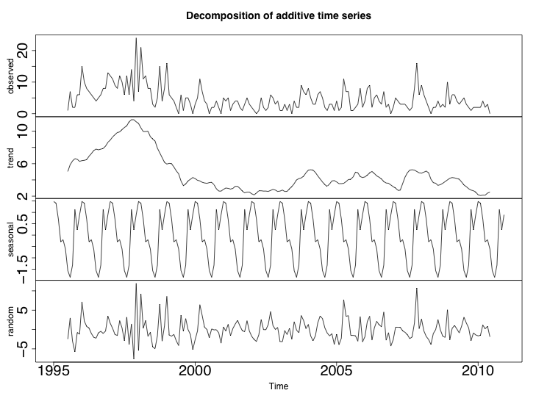
Figure 14: decomposition of additive time-series for chlorophacinone confirmed poisoning cases in animals in France (data : Vetagro sup Lyon). Trend: annual trend, seasonal: seasonal variation, random: individual, unaccounted for effect

In 1998, the use of liquid concentrated formulations was restricted to professional users for this compound. Later on (2004), the liquid formulation was only delivered to bait-producing companies. The annual trend clearly shows that the restriction applied in 1998 is associated with a decrease in the total number of cases received at the Toxicology unit of Vetagro Sup.

Objective 1-1-f: existing continuous professional development schemes for trained professional users
Among the key questions, the clear definition of a trained professional appears to be a major issue in the world of rodent control. Indeed, there is no specific EU requirement for people or companies undertaking rodent control. Some countries have national regulations (such as France, Germany, Malta, Spain). In France, for instance, Certiphyto is a specific professional certificate for pesticide applicators, but it is also used as a surrogate for biocidal products and is based on the NFU43500 guideline.
There is currently no legal requirement for those undertaking pest control related to public health to be qualified or to be registered in the UK. The Act under which the pesticides are regulated is the Food and Environment Protection Act 1985 and the subsequent Regulations covering the pesticides are the Control of Pesticides Regulations 1986. The Health and Safety at Work Act 1974, and the Control of Substances Hazardous to Health Regulations 2002 also have bearings on the operations on those undertaking pest control. However, all of this legislation is in the process of replacement as the result of implementation in the UK of the terms of the European Union’s Biocidal Products Regulation (the BPR, Regulation (EU) 528/2012). Whilst there are no requirements for users of public health pesticides to be qualified or indeed registered is any way, there are pest control qualifications that are recognized in the industry and frequently required by customers. The details of these qualifications are available from the BPCA and the RSPH. A training course for wildlife is also established. This training course and associated accreditation scheme has been established by the Campaign for Responsible Rodenticide Use (CRRU) for professional pest control technicians and other competent users of rodenticides. This accreditation is intended to indicate to customers for rodent pest control services that those who hold the accreditation will work to the highest standards in order to achieve effective pest control with minimum adverse effects on wildlife and the wider environment.
In Spain, a specific training session has been developed on internet, with e-learning tools. A royal decree of 2010 has enforced the need for professional training for PCOs’ (N&PI, 2011, HS: 21-23)
The European association CEPA (Confederation of European Pest Management Associations) started a project on the development and application of a European norm for rodenticide application. This project has been approved by the European Standard Institute (CEN), under the number CEN/TC404. Among the objectives, a European norm should provide a sound basis for the recognition of a “trained-professional” since it will describe requirements, recommendations and basic competences necessary for appropriate rodent control application. Formal training sessions will be included and certificates issued to both trainee and companies (www.cepa-europe.org ) . Such a norm is highly desirable in order to implement appropriate chemical control strategies against rodents in the EU today, especially with respect to both resistance management strategies and non-target incidents.
The recommendations have not been issued yet and this part of the project will be followed-up in the next coming months.

REFERENCES

Aithal.G.P, Day, C. P. Kesteven P. J. L. and Daly AkK1999. Association of polymorphisms in the cytochrome P450 CYP2C9 with warfarin dose requirement and risk of bleeding complications. The Lancet 353.
Albert, C. A., Wilson, L. K., Mineau, P., Trudeau, S., & Elliott, J. E. 2010. Anticoagulant rodenticides in three owl species from Western Canada, 1988-2003. Archives of Environmental Contamination and Toxicology, 58(2): 451-459.
Alessandroni, P., Marchini, S., Bernardo, A., Terranova, F., Turillazi, P. (1980). Valutazione della presenza di ratti resistenti al warfarin nella cita di reggio Calabria. Ann. 1st Super Sanita, 16: 271-286.
Andru, J. Coumatetralyl resistance of Rattus tanezumi infesting oil palm plantations in Indonesia. 22[2]. 2013. Ecotoxicology.
Ayala, I., Rodríguez, M., Martos, N., & Zilberschtein, J. (2007). Fatal brodifacoum poisoning in a pony. The Canadian Veterinary Journal . 48 : 627-629
Baert, K. (2003). Bestrijding van de Bruine rat. Resistentie tegen anticoagulantia bij de Bruine rat. In: IBW (ed.). Jaarrapport-Onderzoeksgroep Rattenbestijding. AMINAL afdeling Water, IBW, Geraardsbergen, 18-23
Baert, K., Stuyck, J., Breyne, P., Maes, D., & Casaer, J. 2012. Distribution of anticoagulant resistance in the brown rat in Belgium. Belgian Journal of Zoology, 142(1): 39-48.
Bentley, E. W. 1972. A review of anticoagulant rodenticides in current use. Wld.Org.Mond.Sant, 47: 275-280.
Berny, P., Buronfosse, T., Buronfosse, F., & Lamarque, F. (1997). Field evidence of secondary poisoning of foxes (Vulpes vulpes) and buzzards (Buteo buteo) by bromadiolone : a 4-year survey. Chemosphere 35 (8) : 1817-1829
Berny, P, Alves, L., Simon V., & Rossi, S. (2005) Intoxication des ruminants par les raticides anti-coagulants: quelle réalité? Revue de médecine vétérinaire 156, (8-9): 449-454.
Berny, P, Alves de Oliveira L., Videmann, B., & Rossi S. (2006) Assessment of ruminal degradation, oral bioavailability, and toxic effects of anticoagulant rodenticides in sheep. American Journal of Veterinary Research 67 (2) : 363-371
Berny, P. (2007). Pesticides and the intoxication of wild animals. Journal of Veterinary Pharmacology and Therapeutics. 30 : 93-100
Berny, P., & Gaillet, J.-R. (2008). Acute poisoning of Red Kites (Milvus milvus) in France: Data from the SAGIR network. Journal Of Wildlife Diseases , 44 (2), 417-426.
Berny, P., Velardo, J., Pulce, C., D’Amico, A., Kammerer, M., & Lasseur, M (2010) Prevalence of anticoagulant rodenticide poisonings in humans and animals in France and substances involved. Clinical Toxicology, 48 : 935-941

Berny, P. Challenges of anticoagulant rodenticides: resistance and ecotoxicology. 2011. pp.441-468 In: Stoytcheva, M. (ed.) Pesticides in the modern world - pests control and pesticides exposure and toxicity assessment. inTech, 614 pages
Berny, P., Vein, J., & Vey, D. 2012. Bioaccumulation of chlorophacinone in strains of rats resistant to anticoagulants. Pest Management Science, DOI: 10.1002/ps.3367.
Bomford, M. and O´Brien, P. H. 1990. Sonic deterrents in animal damage control: a review ofdevice tests and effectiveness. Wildlife Society Bulletin 18.4: 411-422
Bonnefoy, X., Kampen, H., & Sweeney, K. 2008. Public health significance of urban pests. WHO, Copenhagen, 1-569.
Boyer, P., Devine, P., Hu, X., Thompson, K., Sipes, L. 2001. Ovarian toxicity of 4-Vinylcyclohexene diepoxide : a mechanistic model. Toxicologic Pathology 29 : 91-99
Boyle, C. M. 1960. Case of apparent resistance of Rattus norvegicus Berkenhout to anticoagulant poisons. Nature, 188: 517.
Braselton, W., Regg, D., & Poppenga, R. (1992). Confirmation of indanedione rodenticide toxicoses by mass spectrometry/mass spectrometry. J. vet. Diagn. Invest. , 4, 441-446.
Brooks, J. & Bowerman A. Anticoagulant resistance in wild Norway rats in New York. 71[2], 217-222. 1973. The Journal of hygiene.
Buckle, A. P. 1985. Field trials of a new sub-acute rodenticide flupropadine, against wild norway rats (Rattus norvegicus). Journal of Hygiene, 95: 505-512.
Buckle, A. 2013. Anticoagulant resistance in the United Kingdom and a new guideline for the management of resistant infestations of Norway rats (Rattus norvegicus Berk.). Pest Management Science, 69(3): 334-341.
Buckle, A., Charlton, A., Meyer, A., and Prescott, C. V. Anticoagulant resistance in the Norway rat and Guidelines for the management of resistant rat infestations in the UK. 2010.
Buckle, A., Endepols, S., Klemann, N., & Jacob, J. 2013. Resistance testing and the effectiveness of difenacoum against Norway rats (Rattus norvegicus) in a tyrosine139cysteine focus of anticoagulant resistance, Westphalia, Germany. Pest Management Science, 69(2): 233-239.
Buckle, A., Endepols, S., Klemann, N., & Jacob, J. 2013. Resistance testing and the effectiveness of difenacoum against Norway rats (Rattus norvegicus) in a tyrosine139cysteine focus of anticoagulant resistance, Westphalia, Germany. Pest Manag.Sci., 69(2): 233-239.
Buckle, A. P. 1994. Rodent pests and their control. CAB International, 1EP-405.
Buckle, A. P., Klemann, N., & Prescott, C. V. 2012. Brodifacoum is effective against Norway rats (Rattus norvegicus) in a tyrosine139cysteine focus of anticoagulant resistance in Westphalia, Germany. Pest Management Science, 68(12): 1579-1585.
Buckle, A. and Müller, F. Rodenticides. 2003. Encyclopedia of Agrochemicals.
Buckle, A. P., Prescott, C., and Ward JR, J. P. Resistance to the first and second generation anticoagulant rodenticides - a new perspective. 1994. Proceedings of the 16th vertebrate pest conference.
Buckle, A. and Prescott, C. The Current Status of Anticoagulant Resistance in Rats and Mice in the UK. 2012. Report from the Rodenticide Resistance Action Group of the United Kingdom.
Caldwell, D. CYP4F-2 genetic variant alters required warfarin dose. Awad, T. and Johnson. J. A. 111[8]. 2013. Blood.
Caravatti, E.M., Erdman, A.R., Scharman, E.J., Woolf, A.D., Chyka, P.A., Cobaugh, D.J., Wax, P.M., Manoguerra, AS., Christianson, G., Nelson, L.S., Olson, K.R., Booze, L.L., Troutman, W.G. (2007) Long-acting anticoagulant rodenticide poisoning: an evidence-based consensus guideline for out-of-hospital management. Clin Toxicol 42: 1-22
Chambers, L. K., Singleton, G. R., & Hinds, L. A. 1999. Fertility control of wild mouse populations: the effects of hormonal competence and an imposed level of sterility. Wildlife Research, 26(5): 579-591.
Christensen, T. K., Lassen, P., & Elmeros, M. 2012. High exposure rates of anticoagulant rodenticides in predatory bird species in intensively managed landscapes in Denmark. Archives of Environmental Contamination and Toxicology, 63(3): 437-444.
Christiansen, E. 1975. Pheromones in small rodents - occurence and supposed usefulness in biological control. Ecological Bulletins, 19: 221-227.
Cornwell, P. B. Studies on microencapsulation of rodenticides. 1970. Proceedings of the 4th Vertebrate Pest Conference. Paper 18.
Davis, S. A., Pech, R. P., & Singleton, G. R. 2003. Simulation of fertility control in an eruptive house mouse (Mus domesticus) population in southeastern Australia. In G. R. Singleton, L. A. Hinds, C. J. Krebs, & D. M. Spratt (Eds.), Rats, Mice and People: Rodent Biology and Management: 320-324. ACIAR, Canberra.
Dawson, A. Rodenticide usage by local authorities in Great Britain : 2001. Garthwaite, D. 2004. Pesticide usage survey report (Great Britain. Dept. for Environment, Food & Rural Affairs), 185., London : Dept. for Environment Food and Rural Affairs, 2004.
De Jonge, J. (1994). Resistentieproblemen bij de bestrijding van knaagdieren in Nederland. Dierplagen en Milieu 42: 99-101
Del Piero, F., & Poppenga, R. (2006). Chlorophacinone exposure causing an epizootic of acute fatal hemorrhage in lambs. Journal of Veterinary Diagnostic Investigation 18 : 483-485
Desidiri, D. Supplementary report on the study of resistance to coumafene in Rattus rattus observed at Marseilles. Aldighieri R, Le Louet M Tardieu A. 71[3]. 1978. Bull Soc Pathol Exot Filiales.
Diaz, J. and Song, Y. Moore A. Borchert J. & Kohn M. Analysis of vkorc1polymorphisms in Norway rats using the roof rat as outgroup. 11. 2010. BMC genetics.
Donlan, C., Howald, G., Tershy, B., & Croll, D. (2003). Evaluating alternative rodenticides for island conservation: roof rat eradication from the San Jorge Islands, Mexico Biological Conservation 114 : 29-34
Dowding, C., Shore, R., Worgan, A., Baker, P., & Harris, S. (2010). Accumulation of anticoagulant rodenticides in a non-target insectivore, the European hedgehog (Erinaceus europaeus). Environmental pollution (Barking, Essex : 1987) , 158 (1), 161-6.
Drummond, D. C. & Rennison, B. D. 1973. The detection of rodent resistance to anticoagulants. Bulletin of the World Health Organization, 48: 239-242.
D´Andrea, R. L. A polymorphism in the VKORC1 gene is associated with an interindividual variability in the dose-anticoagulant effect of warfarin. D'Ambrosio.R.L., Di Perna P. 105[2]. 2005. Blood.
Eason, C. T., Henderson, R., Hix, S., MacMorran, D., Miller, A., Ross, J., Ogilvie, S. 2010. Alternatives to brodifacoum for possum and rodent control - how and why? New Zealand Journal of Zoology 37: 175-183.
Eason, C. T., Baigent, D., Wilson, L., Hix, S., MacMorran, D., Ross, J., Miller, A., and Ogilvie, S., 2010. Toxicity of cholecalciferol to rats in a multi-species bait. New Zealand Journal of Ecology 34(2): 233.
Eason, C. T., Henderson, R., Murphy, E., Shapiro, L., MacMorran, D., Blackie, H., Brimble, M., Conole, D., Rennison, D., Gibson, T. J. Gregory, N.G. 2011. Retrieving and retaining older and advancing novel rodenticides-as alternatives to anticoagulants. Julius-Kühn-Archiv 432: 19.
Eason, C. T., Murphy, E.C., Wright, G. R. & SPURR, E.B. (2002). Assessment of risks of brodifacoum to non-target birds and mammals in New- Zealand. Ecotoxicology 11: 35–48
Eason, C. T., Wickstrom, M., Henderson, R., Milne, L., & Arthur, D. 2000. Non-target and secondary poisoning risks associated with cholecalciferol. 53rd Conference Proceedings of The New Zealand Plant Protection Society Incorporated, 299-304.
Endepols, S., Klemann, N., Pelz, H. J., & Ziebell, K. L. 2003. A scheme for the placement of rodenticide baits for rat eradication on confinement livestock farms. Preventive Veterinary Medicine, 58(3-4): 115-123.
Endepols, S., Klemann, N., Jacob, J., & Buckle, A. P. 2012. Resistance tests and field trials with bromadiolone for the control of Norway rats (Rattus norvegicus) on farms in Westphalia, Germany. Pest.Manag.Sci., 68(3): 348-354.
Endepols, S., Klemann, N., Song, Y., & Kohn, M. H. 2012. Vkorc1 variation in house mice during warfarin and difenacoum field trials. Pest Management Science, 69: 409-413.
Erickson, W., & Urban, D. (2002). Comparative Rodenticide Risk Assessment pp1-202. United States Environmental Protection Agency, Washington DC
Fasco, M., Principe, L. (1982). R- and S-Warfarin inhibition of vitamin K and vitamin K 2,3-epoxide reductase activities in the rat. J. biol. Chem. 257, (9): 4894-4901
Field, R. J. The use of sexual attractant pheromones to increase the acceptability of the male chemosteri1 ant 3-Chloro-l,2 Propanediol by wild Norway rats (Rattus norvegicus). 1971. Thesis, Michigan State University.
Fischer, D., Imholt, C., Pelz, H. J., Wink, M., Prokop, A., & Jacob, J. 2013a. The repelling effect of plant secondary metabolites on water voles, Arvicola amphibius. Pest Management Science, 69(3): 437-443.
Fischer, D., Imholt, C., Prokop, A., & Jacob, J. 2013b. Efficacy of methyl nonyl ketone as an in-soil repellent for common voles (Microtus arvalis). Pest Management Science, 69(3): 431-436.
Fitzwater, W. D. Electromagnetic repellers—fact or fiction? 1978. Proceedings of the 8th Vertebrate Pest Conference, paper 17.
Fourel, I., Hugnet, C., Goy-Thollot, I., & Berny, P. (2010). Validation of a new liquid chromatography- tandem mass spectrometry ion-trap technique for the simultaneous determination of thirteen anticoagulant rodenticides, drugs, or natural products. Journal of Analytical Toxicology , 34 (2), 95-102.
Fournier-Chambrillon, C., Berny, P., Coiffier, O., Barbedienne, P., Dassé, B., Delas, G., Galineau, H., Mazet, A., Pouzenc, P., Rosoux, R., & Fournier, P. (2004). Evidence of secondary poisoning of free-ranging riparian mustelids by anticoagulant rodenticides in France: implications for conservation of European mink (Mustela lutreola). Journal of Wildlife Diseases , 40 (4), 688-695.
Gibson, T. J., Gregory, N. G., Quy, R. J. ,Eason, C.T. 2011. Welfare assessment of fatal methaemoglobinaemia in adult rats (Rattus norvegicus). Julius-Kühn-Archiv 432: 148.
Gill, J. E., Kerins, G. M., Langton, S. D., & MacNicoll, A. D. 1993. The development of a blood clotting response test for discriminating between difenacoum-resistant and susceptible Norway rats (Rattus norvegicus Berk.). Comp.Biochem.Physiol., 104C(1): 29-36.
Gill, J. E., Kerins, G. M., Langton, S. D., & MacNicoll, A. D. 1994. Blood-clotting response test for bromadiolone resistance in Norway rats. Journal of Wildlife Management, 58(3): 454-461.
Gill, J., MacNicoll, A. (1991). Determination of the susceptibility of wild populations of Norway rat (Rattus norvegicus) to the anticoagulant rodenticide brodifacoum. Z. Fuer Angewandte Zool. 78: 101-117.
Grandemange, A. Consequences of the Y139F Vkorc1 mutation on resistance to AVKs: in-vivo investigation in a 7th generation of congenic Y139F strain of rats. Kohn, M. H. and Lasseur, R. Longin-Sauvageon C. Berny P. & Benoit E. 19 (10). 2009. Pharmacogenetics and Genomics.
Grandemange, A., Lasseur, R., Longin-Sauvageon, C., Benoit, E., & Berny, P. 2010. Distribution of VKORC1 single nucleotide polymorphism in wild Rattus norvegicus in France. Pest Management Science, 66(3): 270-276.
Gray, A., Eadsforth, C., Dutton, A., & Vaughan, J. (1994). The toxicity of three second-generation rodenticides to barn owls. Pesticide Science , 42 (3).
Greaves, J. H. 1994. Resistance to anticoagulant rodenticides. In A. P. Buckle & R. H. Smith (Eds.), Rodent pests and their control: 197-217. Wallingford, UK: CAB International.
Greaves, J. H. & Ayres, P. 1967. Heritable resistance to warfarin in rats. Nature, 215: 877-878.
Greaves, J. H. & Ayres, P. 1973. Warfarin resistance and vitamin k requirement in the rat. Laboratory Animals, 7: 141-148.
Greaves, J. H. & Cullen-Ayres, P. B. 1988. Genetics of difenacoum resistance in the rat. In J. W. Suttie (Ed.), Current Advances in Vitamin K Research: 389-397. New York.
Greaves, J. H., Shepherd, D. S., & Gill, J. E. 1982. An investigation of difenacoum resistance in Norway rat populations in Hampshire. Annales of Applied Biology, 100: 581-587.
Greaves, J. H., Rowe, F. P., REDFERN R., & Ayres P. 1968. Microencapsulation of rodenticides. Nature 219 (5152): 402-403 .
Guidobono, J. León V. Gómez Villafañe I. & Busch M. Bromadiolone susceptibility in wild and laboratory Mus musculusL.(house mice) in Buenos Aires, Argentina. 162-167. 2010. Pest Management Science.
Guitart, R., Croubels, S., Caloni, F., Sachana, M., Davanzo, F., Vandenbroucke, V., &Berny, P (2010a). Animal poisoning in Europe. Part 1: Farm livestock and poultry. The Veterinary Journal , 183, (3) : 249-254
Guitart, R., Sachana, M., Caloni, F., Croubels, S., Vandenbroucke, V., & Berny, P. (2010b). Animal poisoning in Europe. Part 3: Wildlife. Veterinary journa , 183 (3) : 260-265.
Hadler, M. R. & Shadbolt, R. S. 1975. Novel 4-hydroxycoumarin anticoagulants active against resistant rats. Nature, 253: 275-277.
Heiberg, A. C. 2009. Anticoagulant resistance: a relevant issue in sewer rat (Rattus norvegicus) control? Pest Management Science, 65(4): 444-449.
Heiberg, A. C., Leirs, H., & Siegismund, H. R. 2006. Reproductive success of bromadiolone-resistant rats in absence of anticoagulant pressure. Pest Management Science, 62: 862-871.
Hermodson, M. A., Suttie, J. W., & Link, K. P. 1969. Warfarin metabolism and vitamin k requirement in the warfarin-resistant rat. American Journal of Physiology, 217(5): 1316-1319.
Hinds, L. (2011): Fertility control for invasive pest mammals –are we making progress? 432. Julius Kühn Archiv 432: 15.
Hodroge, A., Longin-Sauvageon, C., Fourel, I., Benoit, E., & Lattard, V. 2011. Biochemical characterization of spontaneous mutants of rat VKORC1 involved in the resistance to antivitamin K anticoagulants. Archiv of Biochemistry and Biophysics, 515(1-2): 14-20.
Hood, G. A. 1972. Zinc phosphide - a new look at an old rodenticide for field rodents. Proceedings of the 5th Vertebrate Pest Conference, Fresno, California, 85-92.
Howald, G., Donlan, C., Galván, J., Russell, J., Parkes, J., Samaniego, A., Wang, Y., Veitch, D., Genovesi, P., Pascal, M., Sanuders, A., Tershy, B. (2007). Invasive rodent eradication on islands. Conservation Biology , 21 (5), 1258-68
Huang, B. H., Feng, Z. Y., Yue, L. F., Yao, D. D., Gao, Z. X., Wang, D. W., & Liu, X. H. 2011. Warfarin resistance test and polymorphism screening in the VKORC1 gene in Rattus flavipectus. Journal of Pest Science, 84(1): 87-92.
Humphries, R. E., Sibly, R. M., & Meehan, A. P. 2000. Cereal aversion in behaviourally resistant house mice in Birmingham, UK. Elsevier, 66: 323-333.
Iglisch, I. & Ising, H. 1985. Was leisten Ultraschallgeräte? Der Praktische Schädlingsbekämpfer, 37(5): 106-115.
Ishizuka, M., Okajima, F., Tanikawa, T., Min, H., Tanaka, K. D., Sakamoto, K. Q., & Fujita, S. 2007. Elevated warfarin metabolism in warfarin-resistant roof rats (Rattus rattus) in Tokyo. Drug Metabolism and Disposition, 35(1): 62-66.
Ishizuka, M., Tanikawa, T., Tanaka, K. D., Heewon, M., Okajima, F., Sakamoto, K. Q., & Fujita, S. 2008. Pesticide resistance in wild mammals - mechanisms of anticoagulant resistance in wild rodents. Journal of Toxicological Sciences, 33(3): 283-291.
Jacob, J. 2013. Vertebrate pest management: science and application. Pest Management Science, 69(3): 321-322.
Jacob, J., Budde, M., & Leukers, A. 2009. Efficacy and attractiveness of zinc phosphide bait in common voles (Microtus arvalis). Pest Management Science, 66: 132-136.
Jacob, J., Endepols, S., Pelz, H. J., Kampling, E., Cooper, T. G., Yeung, C. H., & Schlatt, S. 2011. Vitamin k requirement and reproduction in bromadiolone resistant Norway rats. UNPUBLISHED.
Jacob, J., Herawati, N. A., Davis, S. A., & Singleton, G. R. 2004. The impact of sterilised females on enclosed populations of ricefield rats. Journal of Wildlife Management, 68(4): 1130-1137.
Jacob, J., Singleton, G. R., & Hinds, L. A. 2007. Simulation of fertility control of pest rodents in enclosure and field populations. 6th Fertility Control for Wildlife Conference, 2-5 September 2007, York, UK(51).
Jacob, J., Singleton, G. R., & Hinds, L. A. 2008. Fertility control of rodent pests. Wildlife Research, 35: 487-493.
Kaukeinen, D. 1994. Rodent control in practice: housekeepers, pest control operators and municipal authorities. In A. P. Buckle & R. H. Smith (Eds.), Rodent pests and their control: 249-271. Wallingford, UK: CAB International.
Jackson, W., Ashton, A. (1986). Case histories of anticoagulant resistance. In: Committee on strategies for the management of pesticide resistant pest populations, National Research Council (eds). Pesticide resistance: strategies and tactics for management, National Academy Press, Washington pp: 335-369
Jin, M., Chen, X., Ye, M., & Zhu, Y. (2008). Analysis of indandione anticoagulant rodenticides in animal liver by eluent generator reagent free ion chromatography coupled with electrospray mass spectrometry. Journal of Chromatography A , 1213 (1), 77-82.
Khalil, A., Naseri, M., and Morovati, M. Efficacy of the Rodenticide Bromethalin in the Control of Microtus arvalis and Nesokia indica in Alfalfa Fields. 31, 261-264. 2007. Turkish Journal of Zoology.
Klemann, N., Esther, A., & Endepols, S. 2011. Characteristics of the local distribution of the Y139C resistance gene in Norway rats ( Rattus norvegicus) in a focus of resistance in Westphalia, Germany. Julius-Kuhn-Archiv,(432): 73-74.
Knopper, L., Mineau, P., Walker, L., & Shore, R. (2007). Bone Density and Breaking Strength in UK Raptors Exposed to Second Generation Anticoagulant Rodenticides Bulletin of Environmental Contamination and Toxicology 78 : 249-251
Kohn, B., Weingart, C., & Giger, U. (2003). Haemorrhage in seven cats with suspected anticoagulant rodenticide intoxication. Journal of Feline Medicine and Surgery 5 : 295-304
Kolf-Clauw, M., Alvarez, E., Maytray, O. (1995). Anticoagulants rodenticides: étiologie, diagnostic et traitement des intoxications. Rec. Méd. vét. 171, 2/3: 127-134
Lambert, O., Pouliquen, H., Larhantec, M., Thorin, C., & L’Hostis, M. (2007). Exposure of raptors and waterbirds to Anticoagulant Rodenticides (Difenacoum, Bromadiolone, Coumatetralyl, Coumafen, Brodifacoum): epidemiological survey in Loire Atlantique (France) Bulletin of Environmental Contamination and Toxicology 79 : 91-94
Langford, K., Reid, M., Thomas K. 2013 The occurrence of second generation anticoagulant rodenticdes in non-target raptor species in Norway. Science of the total environment 450-451: 205-208-
Lasseur, R. Heterogeneity of the coumarin anticoagulant targeted vitamin K epoxide reduction . Grandemange, A. Longin-Sauvageon C. Berny P. & Benoît E. 20[5]. 2006. Biochem. Mol . Toxicol.
Lasseur, R., Grandemange, A., Longin-Sauvageon, C., Berny, P., & Benoit, E. 2007. Comparison of the inhibition effect of different anticoagulants on vitamin K epoxide reductase activity from warfarin-susceptible and resistant rat. Pesticide Biochemistry and Physiology, 88(2): 203-208.
Lasseur, R., Longin-Sauvageon, C., Videmann, B., Billeret, M., Berny, P., & Benoit, E. 2005. Warfarin resistance in a French strain of rats Journal of Biochemical and Molecular Toxicology, 19(6): 379-385.
Lazarus, A. B. Progress in rodent control and strategies for the future. 1989. Mammals as pests.
Leung, L., & Clark, N. (2005). Bait avoidance and habitat use by the roof rat, Rattus rattus, in a piggery. International Biodeterioration & Biodegradation 55 : 77-84
Li, T., Chang, C. Y., Jin, D. Y., Lin, P. J., Khvorova, A., & Stafford, D. W. 2004. Identification of the gene for vitamin K epoxide reductase. Nature, 427(6974): 541-544.
Liang, L. The resistance in rattus flavipectus and R. norvegicus to Anticoagulant Rodenticide in Zhanjiang Proper. 16. 2005. Chin J Biol Control.
Littin, K. E., O'Connor, C.E., Eason, C.T. 2000 Comparative effects of brodifacoum on rats and possums. New Zealand Plant Protection, 310-315 .
Liu, M., Qu, J. P., Yang, M., Wang, Z. L., Wang, Y. L., Zhang, Y. M., & Zhang, Z. B. 2012. Effects of quinestrol and levonorgestrel on populations of plateau pikas, Ochotona curzoniae, in the Qinghai-Tibetan Plateau. Pest Management Science, 68(4): 592-601.
Lodal, J. 1993. Ultrasound device against house mouse. Danish Pest Infestation Laboratory Annual Report, 57
Lodal, J. (2001). Distribution and levels of anticoagulant resistance in rat (Rattus norvegicus) in Denmark. In: Peltz, H.J., Cowan, D., Feare, C. (eds). Advances in Vertebrate Pest Management II, Finlander Verlag, Fürth, Germany, 139-148
Lund, M. Rodent resistance to the anticoagulant rodenticides, with particular reference to Denmark. 47[5], 611-8. 1972. Bulletin of the World Health Organization.
Lund, M. Resistance to the second-generation anticoagulant rodenticides. Clark, D. O., Marsh, R. E., and Beadle, D. E. 11th Vertebrate Pest Conference, University of California, Davis , 89-94. 1984.
MacNicoll, A. D. 1986. Resistance to 4-hydroxycoumarin anticoagulants in rodents. In Committee on Strategies for the Management of Pesticide Resistant Pest Populations (Ed.), Pesticide resistance: Strategies and tactics for management: 87-99. Washington, D.C.: National Academy Press.
Markussen, M. D. K., Heiberg, A. C., Alsbo, C., Nielsen, P. S., Kauppinen, S., & Kristensen, M. 2007. Involvement of hepatic xenobiotic related genes in bromadiolone resistance in wild Norway rats, Rattus norvegicus (Berk.). Pesticide Biochemistry and Physiology, 88: 284-295.
Markussen, M. D. K., Heiberg, A. C., Fredholm, M., & Kristensen, M. 2008. Identification of cytochrome P450 differentiated expression related to developmental stages in bromadiolone resistance in rats (Rattus norvegicus). Pesticide Biochemistry and Physiology, 91(3): 147-152.
Markussen, M. D. K., Heiberg, A. C., Nielsen, R., & Leirs, H. 2003. Vitamin K requirement in Danish anticoagulant-resistant Norway rats (Rattus norvegicus). Pest Management Science, 59(8): 913-920.
Marsh, R. E. and Howard, W. E. 1970. Chemosterilants as an approach to rodent control. 1970. Davis, University of California. 55-63.
Martin, A. D., Steed, L. C., Redfern, R., Gill, J. E., & Huson, L. W. 1979. Warfarin-resistance genotype determination in the Norway rat, Rattus norvegicus. Laboratory Animals, 13: 209-214.
Mason, G. & Littin, K. E. 2003. The humaneness of rodent pest control. Animal Welfare, 12(1): 1-37.
Meehan, A. P. 1984. Rats and mice. Their biology and control. Rentokil Ltd.East Grinstead, England, 1-383.
Menke, T., Jacob, J., and Prokop, A. 2012. Vorstellung eines akustischen Gerätes zur Vertreibung von Schermäusen (Arvicola terrestris). Deutsche Pflanzenschutztagung, 10-14 September 2012, Braunschweig, Germany, 428.
Menke, T., Prokop, A., Pelz HJ, (2008) Verwendung von Bodenvibrationen und arteigenen Ruflauten zur Vergrämung der Schermaus, Arvicola terrestris. Mitteilungen aus dem Julius Kühn-Institut 417:221.
Merlet, S. and Abribat, B. 2010. Non-aqueous agricultural compositions. European Patent application - Bulletin 52.2010.
Meyer, A. N. 1994. Rodent control in practice: food stores. In A. P. Buckle & R. H. Smith (Eds.), Rodent pests and their control: 273-290. Wallingford, UK: CAB International.
Misenheimer, T. M., Lund, M., Miller Baker, A. E., & Suttie, J. W. 1994. Biochemical basis of warfarin and bromadiolone resistance in the house mouse, Mus musculus domesticus. Biochemical Pharmacology, 47(4): 673-678.
Misenheimer, T. M. & Suttie, J. W. 1990. Warfarin resistance in a Chicago strain of rats. Biochemical Pharmacology, 40(9): 2079-2084.
Morrow, C. 2001 Cholecalciferol poisoning. Veterinary medicine 96(12): 905-911.
Muhr, A. (1981). Zur problematik der Hausmausbekämpfung, resistenzprobleme und Möglichkeiten ihrer Uberwindung. In: Iglisch, I. (ed.). Aktuelle Probleme der Bekämpfung und Abwehr von Ratten und Hausmäusen, Pentagon Publishing GmbH, Frankfurt, 93-109
Myllymäki, A. 1995. Anticoagulant resistance in Europe: Appraisal of the data from the 1992 EPPO Questionnaire. Pesticide Science, 43 : 69-72.
Naganuma, K., Fukita, A., Taniguchi, N., Takada, S. (1981). Warfarin susceptibility in the roof rat, Rattus rattus, in some locations of Tokyo. Jap. J. sanit. Zool. 32: 243-245
O'Connor, J. The use of blood anticoagulants for rodent control. 1, 334-336. 1948. Research.
Oldenburg, J. The vitamin K cycle. 78. 2008. Vitamins & Hormons.
Ophof, A. J. & Langeveld, D. W. 1969. Warfarin-resistance in the Netherlands. SchrReihe Ver.Wass.-Boden-Lufthyg.Berlin-Dahlem, 32: 39-47.
Pelz, H.J. (2001). Extensive distribution and high frequency of resistance to anticoagulants rodenticides in rat populations from north-western Germany. In: Pelz, H.J., Cowan, D., Feare, C. (eds). Advances in Vertebrate Pest Management volume II, Finlander Verlag, Fürth, Germany, 161-170
Pelz, H. J. 2007. Spread of resistance to anticoagulant rodenticides in Germany. International Journal of Pest Management, 53(4): 299-302.
Pelz, H. J., Hänisch, D., & Lauenstein, G. 1995. Resistance to anticoagulant rodenticides in Germany and future strategies to control Rattus norvegicus. Pesticide Science, 43: 61-67.
Pelz, H. J., Rost, S., Hunerberg, M., Fregin, A., Heiberg, A. C., Baert, K., MacNicoll, A. D., Prescott, C. V., Walker, A. S., Oldenburg, J., & Muller, C. R. 2005. The genetic basis of resistance to anticoagulants in rodents. Genetics, 170(4): 1839-1847.
Pelz, H. J., Rost, S., Müller, E., Esther, A., Ulrich, R., & Müller, C. R. 2012. Distribution and frequency of VKORC1 sequence variants conferring resistance to anticoagulants in Mus musculus. Pest Management Science, 68(2): 254-259.
Petterino, C. & Paolo B. Toxicology of Various Anticoagulant Rodenticides in Animals. 2001. 43: 353-360 Veterinary and Human Toxicology.
Poche, R. M. Enhancing the toxicity of warfarin in rodents. 1999. United State Patent.
Pospischil, R. and Schnorbach, H. J. 1994. Racumin Plus, a new promising rodenticide against rats and mice. Proceedings of the 16th Vertebrate Pest Conference, paper 48.
Prescott, C. 1992. Calciferol and bait shyness in the laboratory rat. Proceedings 15th Vertebrate Pest Conference, paper 64.
Prescott, C., & Buckle, A. (2000). Blood-clotting response tests for resistance to diphacinone and chlorophacinone in the Norway Rat (Rattus norvegicus, Berk) Crop Protection 19 : 291-296
Prescott, C. V., Buckle, A. P., Hussain, I., & Endepols, S. 2007. A standardised BCR resistance test for all anticoagulant rodenticides. International Journal of Pest Management, 53(4): 265-272.
Preusch, P. C., Hazelett, S.E., Lemasters, K.K. 1989. Sulfaquinoxaline inhibition of vitamin K epoxide and quinone reductase. Arch. Biochem. Biophys. 269(1); 19-24.
Quy, R., Cowan, D., Prescott, C., Gill, J., Kerins, G., Dunsford, G., Jones, A., MacNicoll, A. (1995). Control of a population of Norway rats resistant to anticoagulant rodenticides. Pest. Sci. 45: 247-256.
Redfern, R. & Gill, J. E. 1980. Laboratory evaluation of bromadiolone as a rodenticide for use against warfarin-resistant and non-resistant rats and mice. Journal of Hygiene, 84(2): 263-268.
Rennison, B. D. 1974. Field trials of calciferol against warfarin resistant infestations of the norway rat (Rattus norwegicus berk.). Journal of Hygiene, 73: 361-367.
Rennison, B. D. 1976. A comparative field trial, conducted without pre-baiting, of the rodenticide zinc phosohide, thallium sulphate and gophacide against Rattus norvegicus. Journal of Hygiene 66:147-158.
Rieder, M. J. Effect of VKORC1 haplotypes on transcriptional regulation and warfarin dose. Reiner, A. P. Gage B. F. 352[22]. 2005. The New England Journal of Medicine.
Robben, J., Kuijpers, E., & Mout, H. (1998). Plasma superwarfarin levels and vitamin K1 treatment in dogs with anticoagulant rodenticide poisoning Vet Quarterly 20 : 24-27
Rodenticide Resistance Action Committee. Anticoagulant resistance management strategy forpest management professionals, central and local governmentand other competent users of rodenticides. 2003. Technical Monograph, CropLife International.
Rost, S. 2004. Mutations in VKORC1 cause warfarin resistance and multiple coagulation factor deficiency type 2. Nature, 427: 537-541.
Rost, S., Fregin, A., Ivaskevicius, V., Conzelmann, E., Hortnagel, K., Pelz, H. J., Lappegard, K., Seifried, E., Scharrer, I., Tuddenham, E. G. D., Muller, C. R., Strom, T. M., & Oldenburg, J. 2004. Mutations in VKORC1 cause warfarin resistance and multiple coagulation factor deficiency type 2. Nature, 427(6974): 537-541.
Rost.S. Pelz, H.-J. Menzel S. MacNicoll A. León V. Song K. J. Jäkel T. Oldenburg J. Müller, C. 2009. Novel mutations in the VKORC1 gene of wild rats and mice – a response to 50 years of selection pressure by warfarin? BMC Genetics 2009 10:4.
Rowe, F. P., Bradfield, A., & Swinney, T. 1985. Pen and field trials of flupropadine against the house mouse (Mus musculus l.). Journal of Hygiene, 95: 513-518.
Rowe, F. P., Swinney, T., & Plant, C. 1978. Field trials of brodifacoum (WBA 8119) against the house mouse (Mus musculus L.). Journal of Hygiene, 81: 197-201.
Runge, M., von Keyserlingk, M., Braune, S., Becker, D., Plenge-B+Ânig, A., Freise, J. F., Pelz, H. J., & Esther, A. 2013. Distribution of rodenticide resistance and zoonotic pathogens in Norway rats in Lower Saxony and Hamburg, Germany. Pest Management Science, 69(3): 403-408.
Sage, M., Fourel, I., Cœurdassier, M., Barrat, J., Berny, P., & Giraudoux, P. (2010). Determination of bromadiolone residues in fox faeces by LC/ESI-MS in relationship with toxicological data and clinical signs after repeated exposure. Environmental Research 110 (7) : 664-674
Sanchez-Barbudo, I., Camarero, P., Mateo, R. 2012. Primary and secondary poisoning by anticoagulant rodenticides of non-target. Science of the total Environment
Saunders, G. (1978). Resistance to warfarin in the roof rat in Sydney. New South Wales Search, 9: 39-40
Scawin, J.W., Swanston, D.W., Marrs, T.C. 1984. The acute oral and intravenous toxicity of p-aminopropiophenone. Toxicology Letters 32(3): 163-169.
Schmolz, E. 2010. Efficacy of anticoagulant-free alternative bait products against house mice (Mus musculus) and brown rats (Rattus norvegicus). Integrative Zoology 5: 44-52.
Schumake, S. A. 1984. Efficacy test protocols for evaluation of ultrasonic rodent repellent devices. In Lavoie, G. K. and Crane, K. 1984: Proceedings of the Eleventh Vertebrate Pest Conference, paper 37.
Schumake, S. A. 1995. Electronic rodent repellent devices: a review of efficacy test protocols and regulatory actions. National Wildlife Research Center Repellents Conference, Paper 34.
Shore, R., Birks, J., & Freestone, P. (1999). Exposure of non-target vertebrates to second-generation rodenticides in Britain, with particular reference to the polecat Mustela putorius. New Zealand Journal of Ecology 23 (2) : 199-206
Siddiqi, Z. and Blaine, W. D. Anticoagulant resistance in house mice in Toronto, Canad. 32. 1982. Environ. Health Rev. 26: 49-51
Sinclair, A. R. E. 1989. Population regulation in animals. Ecological concepts: 197-241. Oxford, UK: Blackwell Scientific Publications
Smith, R. H. and Greaves, J. H., Donahaye, E., and Navarro, S. 2002. Resistance to anticoagulant rodenticides: the problem and its management. Proceedings of the 4Th International Working Conference on Stored-Products Protection, Tel Aviv. Israel, 302-315.
Song, Y. Endepols S. Klemann N. Richter D. Matuschka F. R. Shih C. H. Nachman M. W. Kohn M. H. Adaptive introgressive hybridization with the Algerian mouse (Mus spretus) promoted the evolution of anticoagulant rodenticide resistance in European house mice (M. musculus domesticus). 2011.
Souloy, B. 2013. Neormaus ou le vent de l’innovation. Nutrition & parasites information 79 : 28-32
Spaulding, S.R. 1987. Bromethalin - an alternative to anticoagulants. British Crop Protection Council Monograph37, 137-147.
Spaulding, S.R., vanLier, R.B. L., & Tarrant, M.E. 1985. Tocicitiy and efficacy of bromethalin. Acta Zoologica Fennica, 173: 171-172.
Stolk, J. M. and Smith, R. P. 1966. Species differences in methemoglobin reductase activity. Biochemical Pharmacology 15(3): 343-351.
Stone, W., Okoniewski, J., & Stedelin, J. (2003). Anticoagulant rodenticides and raptors: Recent findings from New York, 1998-2001. Bulletin of Environmental Contamination and Toxicology 70 : 34-40
Sugano, S. Kobayashi, T. Tanikawa T. Kawakami Y. Kojima H. Nakamura K. Uchida A. Morishima N. Tamai Y. 2001. Suppression of CYP3A2 mRNA expression in the warfarin-resistant roof rat, Rattus rattus : possible involvement of cytochrome P450 in the warfarin resistance mechanism. Xenobiotica. 31, 399-407.
Sutcliffe, F. MacNicoll A. Gibson G. 1990. Hepatic microsomal warfarin metabolism in warfarin-resistant and susceptible mouse strains: influence of pretreatment with cytochrome P-450 inducers. Chem. biol. Interact. 75: 171-184.
Tanaka, K. D., Kawai, Y. K., Ikenaka, Y., Harunari, T., Tanikawa, T., Ando, S., Min, H. W., Okajima, F., Fujita, S., & Ishizuka, M. 2012. The genetic mechanisms of warfarin resistance in Rattus rattus found in the wild in Japan. Pesticide Biochemistry and Physiology, 103(2): 144-151.
Thijssen, H. H. W. 1995. Warfarin-Based Rodenticides - Mode of Action and Mechanism of Resistance. Pesticide Science, 43(1): 73-78.
Thorsen, M., Shorten, R., Lucking, R., & Lucking, V. (2000, Jan 1). Norway rats (Rattus norvegicus) on Frégate Island, Seychelles: the invasion; subsequent eradication attempts and implications for the Island’s fauna Biological Conservation 96 : 133-138
Tie, J. K., Nicchitta, C., von Heijne, G., & Stafford, D. W. 2005. Membrane topology mapping of vitamin K epoxide reductase by in vitro translation/cotranslocation. Journal of Biological Chemistry, 280(16): 16410-16416.
Tosh, D., Shore, R., Jess, S., Withers, A., Bearhop, S., Montgomery, W., et al. (2011, Jan 25). User behaviour, best practice and the risks of non-target exposure associated with anticoagulant rodenticide use. Journal of Environmental Management , 92 (6) : 1503-1508
Vandenbroucke, V., Bousquet-Melou, A., De Backer, P., & Croubels, S. (2008). Pharmacokinetics of eight anticoagulant rodenticides in mice after single oral administration. Journal of Veterinary Pharmacology and Therapeutics , 31 (5), 437-445.
Vandenbroucke, V., Desmet, N., Debacker, P., & Croubels, S. (2008). Multi-residue analysis of eight anticoagulant rodenticides in animal plasma and liver using liquid chromatography combined with heated electrospray ionization tandem mass spectrometry. Journal of Chromatography B , 869 (1-2), 101-110.
Van der Lee, T. A. J. Ontwikkeling en toepassing van een snelle diagnostische test voor resistentie van de bruine rat tegen rodenticiden. van Hoof, Brouwer Meerburg. 510. 2011. Rapport, Livestock Research Wageningen UR.
Van Kampen, T., Milner, T., Waters, E. 2011. Accelerated ovarian failure : a novel, chemically induced animal model of menopause. Brain Research 1379 : 176-187
Vein, J., Grandemange, A., Cosson, J. F., Benoit, E., & Berny, P. J. 2011. Are water vole resistant to anticoagulant rodenticides following field treatments? Ecotoxicology, 20(6): 1432-1441.
Vein, J., Vey, D., Fourel, I., & Berny, P. 2013. Bioaccumulation of chlorophacinone in strains of rats resistant to anticoagulants. Pest Manag.Sci, 69(3): 397-402.
Vudathala, D., Cummings, M., & Murphy, L. (2010). Analysis of multiple anticoagulant rodenticides in animal blood and liver tissue using principles of QuEChERS method. Journal of analytical toxicology , 34 (5), 273-9.
Vukša, M., Draganic, M., Dedovic, S., Jokic, G. 2006. Laboratory effects and efficacy of a Se-based rodenticide in controlling rodents in storage facilities. 9th International Working Conference on Stored Product Protection, 920-925.
Vukša, M., Jokic, G., Dedovic, S. 2007. IPM strategy for rodent control in storage facilities. Biotechnology in Animal Husbandry 23: 375-382.
Vuksa, M., Jokic, G., Dedovic, S., Vuksa, P., & Stojnic, B. 2012. The justification for application and development trends of non-conventional rodenticides in protection of alfalfa from rodents. Biotechnology in Animal Husbandry, 28(4): 659-673.
Waddell, L., Poppenga, R., Drobatz, K. 2013. Anticoagulant rodenticide screening in dogs: 123 cases (1996-2003). Journal of the American veterinary Medical Association. 242 (4): 516-521
Wadelius, M. Common VKORC1 and GGCX polymorphisms associated with warfarin dose. Chen, L. Y. Downes K. 5[4]. 2005. Pharmacogenomics Journal.
Wajih, N., Sane, D. C., Hutson, S. M., & Wallin, R. 2004. The inhibitory effect of calumenin on the vitamin K-dependent gamma-carboxylation system - Characterization of the system in normal and warfarin-resistant rats. Journal of Biological Chemistry, 279(24): 25276-25283.
Wallace, M. E. & MacSwiney, F. J. 1976. A major gene controlling warfarin-resistance in the house mouse. Journal of Hygiene, 76: 173-181.
Walker, L., Turk, A., Long, S., Wienburg, C., Best, J., & Shore, R. (2008). Second generation anticoagulant rodenticides in tawny owls (Strix aluco) from Great Britain. Science of the Total Environment , 392 (1), 93-98
Wang, D. Regulatory polymorphism in vitamin K epoxide reductase complex subunit 1 ( VKORC1) affects gene expression and warfarin dose requirement. Momary, K. M. Cavallari L. H. Johnson J. A. and Sadée W. 2008. Blood.
Wang, H. S., Feng, Z. Y., Yao, D. D., Sui, J. J., Zhong, W. Q., Li, M., & Dai, J. Y. 2008. Warfarin resistance in Rattus losea in Guangdong Province, China. Pesticide Biochemistry and Physiology, 91(2): 90-95.
Watt, B., Proudfoot, A., Bradberry, S., & Vale, J. (2005). Anticoagulant rodenticides. Toxicological reviews , 24 (4): 259-269.
Welch, J. F. 1967. Review of animal repellents. Proceedings of the 3rd Vertebrate Pest Conference, paper 9.
West, B.C. and Messmer, T.A. 1998. Commensal rodents. Archived USU Extension
Publications, paper 996.
Whisson, D., & Salmon, T. (2002). Effect of the timing of applications and amount of 0.01% diphacinone consumed on mortality of California ground squirrels (Spermophilus beecheyi) Crop Protection 21 : 885-889
WHO 1982. Instructions for determining the susceptibility of resistance of rodents to anticoagulant rodenticides. World Health Organization Vector Biol. Control. Ser. 8: 843-849.
Yuan, H.-Y. A novel functional VKORC1 promoter polymorphism is associated with inter-individual and inter-ethnic differences in warfarin sensitivity. Jin-Jer Chen , M. T. Michael Lee Ju-Chieh Wung Ying-Fu Chen Min-Ji Charng Ming-Jen Lu Chi-Ren Hung Chun-Yu Wei Chien-Hsiun Chen Jer-Yuarn Wu andYuan-Tsong Chen. 14[13]. 2005. Human Molecular Genetic.

