EUROPEAN AND MEDITERRANEAN PLANT PROTECTION ORGANIZATION
ORGANISATION EUROPEENNE ET MEDITERRANEENNE
POUR LA PROTECTION DES PLANTES

09-15076
WPPR point 8.3

Report of a Pest Risk Analysis

This summary presents the main features of a pest risk analysis which has been conducted on the pest, according to EPPO Decision support scheme for quarantine pests.

Pest: | Heracleum persicum Fischer
PRA area: | EPPO region
Assessor: | EPPO Panel on Invasive Alien Species
Date: | 2009-04
STAGE 1: INITIATION

Reason for doing PRA: | Heracleum persicum is considered invasive in Scandinavia and represents a threat to other EPPO countries.  A PRA exists for H. sosnowskyi which is very similar to H. persicum. The PRA on H. sosnowskyi will therefore be used since it is valid and similar on many aspects.
Taxonomic position of pest: | Kingdom: Plantae  Class: Magnoliopsida (Dicotyledons)  Family: Apiaceae
STAGE 2: PEST RISK ASSESSMENT

Probability of introduction
Entry

Geographical distribution: | EPPO region: Denmark, Norway, Finland, Sweden.  Asia (native): Turkey, Iran, Iraq (in mountainous areas)  Note: Possible occurrence in Hungary and in the UK
Major host plants or habitats: | Coastal habitats (beaches), grasslands, meadows, pasturelands, edges of forests (e.g. Betula spp.), wetlands, riverbanks/canal sides, rail/roadsides, and urban areas.  According to the CORINE Land Cover nomenclature, the suitable habitats are (see map in Appendix 1):  - Coastal wetlands  - Pastures  - Banks of continental water, Riverbanks / canalsides (dry river beds)  - Road and rail networks and associated land  - Other artificial surfaces (wastelands).
Which pathway(s) is the pest likely to be introduced on: | - Soil/growing medium (with organic matters) as a commodity. Not only seeds, but also vegetative parts of the plants which may start new individual may be spread with soil, providing the perennial tap root is divided into smaller parts.  - Involuntary entry with soil as a contaminant on used machinery  - Involuntary entry with soil as a contaminant on used vehicles  - Involuntary entry with soil as a contaminant on footwear
Establishment

Plants or habitats at risk in the PRA area: | Coastal habitats (beaches), grasslands, meadows, pasturelands, edges of forests (e.g. Betula spp.), wetlands, riverbanks/canal sides, rail/roadsides, and urban areas.
Climatic similarity of present distribution with PRA area (or parts thereof):  Similar  Medium uncertainty | H. persicum is native from mountainous areas of Turkey, Iran and Iraq, and naturalized in Scandinavia.  The species therefore seems able to adapt to different climatic conditions. There is no additional information on its environmental requirements.
Aspects of the pest's biology that would favour establishment: | The plant has a growth and development similar to H. mantegazzianum. Pollination by insects is common, but even self-pollination occurs. The species is spread by seeds and does not reproduce actively vegetatively. Because the side umbels of the plant are often poorly developed and do not always produce ripe fruits, H. persicum’s potential for seed production is thought to be inferior to H. mantegazzianum and H. sosnowskyi.  But H. persicum is polycarpic and blooms several times, while H. sosnowskyi and H. mantegazzianum are monocarpic, making H. persicum’s reproductive strategy more competitive. It means that the leaves of H. persicum wilt in the autumn, but the plant overwinters with buds below the soil surface. Nutrients are stored in the plant’s root system and the size and development of the root system determine the time for flowering.  The plant needs one or more years to build up a nutrient reserve in its root system to be able to bloom.  The plant does not reproduce actively vegetatively but since the plant has a perennial root (Often & Graff 1994) digging or dividing it may result in new plant establishment from buds on lower stem and root parts. These root parts are only spread by human assistance e.g. by transport of soil.  Seeds are dispersed locally near the mother plants and over long distances by watercourses. Additionally, the presence of H. persicum on unpopulated islands indicates that it may be spread with sea water (Alm 1988; Alm & Jensen 1993).
Characteristics (other than climatic) of the PRA area that would favour establishment: | There are no data on abiotic requirements of the species, but the species is native from mountainous area of Irak and Turkey. In Scandinavia, it established in diverse habitats including beaches. The abiotic factors of the PRA area are therefore considered to be similar from the ones of the current area of distribution of the species.  In managed habitats such as pastures and road sides, usual measure is cutting. This existing measure is usually insufficient since there is rapid re-growth from below ground, and it may encourgae the flowering of the plant (Holm, 2005).
Which part of the PRA area is the endangered area: | Coastal habitats (beaches), Grasslands, meadows, pasturelands, edges of forests (e.g. Betula spp.), wetlands, riverbanks/canal sides, rail/roadsides, and urban areas.  Comparing Oslo (Norway) and Erzurum (2400 m above sea level in Turkey) with the world with the software CLIMEX, it appears that central Europe and Scandinavia are the areas the most at risk.  Countries with similar climates are: Austria, Belarus, Belgium, Czech Republic, Denmark, Estonia, Finland, France (North-East), Germany, Hungary, Latvia, Lithuania, Norway, Poland, Romania, Russia, United Kingdom (South-East), Slovakia, Sweden, Switzerland, Ukraine (see Appendix 2).
POTENTIAL ECONOMIC CONSEQUENCES
How much economic impact does the pest have in its present distribution:  Moderate to major  Medium uncertainty | There are no records of direct impact on crops.  Control costs are not reported.  Social impacts  As H. mantegazzianum and H. sosnowskyi, H. persicum contains photosensitizing furanocoumarins. In contact with the human skin and in combination with ultraviolet radiation, a phytotoxic reaction can occur 15 minutes after contact, with a sensitivity peak between 30 min and 2 hours causing burnings of the skin.  After about 24 hours, flushing or reddening of the skin (erythema) and excessive accumulation of fluid in the skin (edema) appear, followed by an inflammatory reaction after three days. Approximately one week later a hyper-pigmentation (usually darkening the skin) occurs which can last for months. The affected skin may remain sensitive to ultraviolet for years.  In addition, several furanocoumarins have been reported to cause cancer (carcinogenic) and to cause malformation in the growing embryo (teratogenic) (Nielsen et al., 2005).  Nevertheless, such impacts are reported for H. mantegazzinum and H. sosnowskyi, but data are missing for H. persicum.  Moreover, dense infestations can seriously interfere with access to amenity areas, riverbanks, etc., and along roadsides, large stands can reduce visibility and result in road safety hazards.
Describe damage to potential hosts in PRA area:  Minor  Medium uncertainty | Environmental impact  Heracleum spp. can create stands that may range in extent from square metres to hectares; small patches, linear stands or fringes can be found. The density of populations may also vary: in large stands, it ranges from sparse growth (1-3 adult individuals/10 m²) to almost entire ground cover (more than 20 adult individuals/10 m²) (Nielsen et al., 2005).  Along riverbanks, it can almost totally replace the natural vegetation and threaten biodiversity, including fauna associated with (native) plants, building a ‘giant hogweed landscape’ (Nielsen et al., 2005). Nevertheless, these impacts are nuanced in Thiele and Otte (2007), stating loss of plant species diversity in habitats invaded by H. mantegazzianum in Germany is a general symptom of successional changes rather than a particular effect of invasive species.  Since H. persicum colonizes natural habitats such as beaches, it is expected that its impact might be higher than H. mantegazzianum.  In Norway, H. persicum has similar impacts as H. mantegazzianum, but in locally infested areas in Northern Norway, H. persicum is more present than H. mantegazzianum (Jan Netland, pers comm., 2008).
How much economic impact would the pest have in the PRA area:  Low to moderate  Medium uncertainty | If introduced into suitable temperate areas, the species could form dense stands and have photosensitizing effects on people. Nevertheless, The plant has been massively planted in Scandinavia, but not in other countries.
CONCLUSIONS OF PEST RISK ASSESSMENT
Summarize the major factors that influence the acceptability of the risk from this pest:
Estimate the probability of entry:  Moderate  Medium uncertainty | - Soil/growing medium (with organic matters) as a commodity: unlikely to moderately likely in EU countries, very unlikely in non EU EPPO countries.  - Involuntary entry with soil as a contaminant on used machinery: unlikely to moderately likely  The probability of H. sosnowskyi to be on tires of used machinery is quite high, but the movement of such machinery is considered to be restricted to local areas, or neighbouring countries.  - Involuntary entry with soil as a contaminant on used vehicles: unlikely to moderatly likely. The probability of the seed of H. sosnowskyi to be a contaminant of vehicles is lower than its probability to be associated to machinery, but the movement of vehicles is more frequent and widespread than the movement of machinery.  - Involuntary entry with soil as a contaminant on footwear: moderately likely.  - Voluntary entry for agricultural (used as a fodder, melferifous plant) or ornamental purposes: unlikely. The species is not used anymore.
Estimate the probability of establishment:  Moderate  Medium uncertainty | H. persicum is already established in some countries of the EPPO region. The species would enter a new country mainly as a seed, and it has a short longevity and needs cold temperatures for 2 months at least.
Estimate the potential economic impact:  Moderate  Medium uncertainty | The most important impact are on:  - Erosion of river banks  - Impact on biodiversity through competition with other species  - Human health,
Degree of uncertainty  High | When performing the PRA the following uncertainties have been identified:  - The difficulty in differentiating the Heracleum species adds uncertainty in the PRA and interpretation of the literature.  - Longevity of seeds  - Vegetative reproduction  - Soil pathway: volumes, frequency, uses  - Climatic prediction for the species and ability to establish in the Mediterranean area  - Ease of management and eradication  - Impact on environment  - Records on photosentizing impact on people
OVERALL CONCLUSIONS | The species represents a threat to biodiversity and human health. Voluntary introduction is unlikely, and the most likely entry pathways identified are not regulated (in the European Union). National management measures could be efficient measures as well.

Stage 3: PEST RISK MANAGEMENT

IDENTIFICATION OF THE PATHWAYS
Pathways studied in the pest risk management | - Soil/growing medium (with organic matters) as a commodity  - Involuntary entry with soil as a contaminant on used machinery  - Involuntary entry with soil as a contaminant on used vehicles  - Involuntary entry with soil as a contaminant on footwear
Other pathways identified but not studied | - H. persicum has been voluntary introduced in Scandinavia as an ornamental plant. According to the PPP index (See website), the species is not traded anymore. The plant has been massively planted in Scandinavia, but not in other countries.  - While H. sosnowskyi has been voluntary introduced as a fodder crop or as a meliferous plant, it is not the case for H. persicum, this pathway is therefore not considered.  - Australian people on internet report that the species is traded as a spice by Persian grocers (The Garden Web Website), and wish to cultivate the plant themselves. This could possibly happen as well in Europe, but this remains very anecdotic and is not considered further.

IDENTIFICation of POSSIBLE measures

Possible measures for pathways | Soil/growing medium (with organic matters) as a commodity (for entry in the EU)
Measures related to consignments: | /
Measures related to the crop or to places of production: | Pest-free place of production  Pest-free area
Other possible measures | Internal surveillance and/or eradication campaign (See EPPO PM9 on Heracleum spp.)

Possible measures for pathways | Involuntary entry with soil as a contaminant on used machinery
Measures related to consignments: | Cleaning of machinery
Measures related to the crop or to places of production: | /
Other possible measures | Internal surveillance and/or eradication campaign (See EPPO PM9 on Heracleum spp.)

Possible measures for pathways | Involuntary entry with soil as a contaminant on used vehicles
Measures related to consignments: | /
Measures related to the crop or to places of production: | /
Other possible measures | Internal surveillance and/or eradication campaign (See EPPO PM9 on Heracleum spp.)

Possible measures for pathways | Involuntary entry with soil as a contaminant on footwear
Measures related to consignments: | /
Measures related to the crop or to places of production: | /
Other possible measures | Publicity to enhance public awareness on pest risks  Internal surveillance and/or eradication campaign (See EPPO PM9 on Heracleum spp.)

EVALUATION OF THE MEASURES IDENTIFIED IN RELATION TO THE RISKS PRESENTED BY THE PATHWAYS

Degree of uncertainty | Low

CONCLUSION:
Recommendation for possible measures (type presentation):
Soil/growing medium (with organic matters) as a commodity (for entry in the EU) | PC  Or  Pest free areas (see ISPM no. 4)  Or  Pest free production places  A lower level of protection can be achieved with:  Internal surveillance and/or eradication campaign (See EPPO PM9 on Heracleum spp.)

Involuntary entry with soil as a contaminant on used machinery | Cleaning of machinery  A lower level of protection can be achieved with:  Internal surveillance and/or eradication campaign (See EPPO PM9 on Heracleum spp.)

Involuntary entry with soil as a contaminant on used vehicles | Internal surveillance and/or eradication campaign (See EPPO PM9 on Heracleum spp.)

Involuntary entry with soil as a contaminant on footwear | Publicity to enhance public awareness on pest risks  Internal surveillance and/or eradication campaign (See EPPO PM9 on Heracleum spp.)

References

Alm T (1988) Floaraen i Tromsø by. Floristisk sluttrapport prosjektet Planteliv i Tromsø. Polarflokken 12(1), 1-156

Alm T & Jensen C (1993) Tromsøpalmen (Hercleum lacinatum auct. Scand.) noen kommentarer till artens innkomst og ekoansjon i Nord-Norge. Blyttia 51, 61-69.

Garden Web Website: http://www.au.gardenweb.com/forums/load/ozherb/msg0819435625323.html

Holm B (2005) Biology, distribution and control of invasive Heracleum species. Master thesis in Estonian Agricultural University.

Nielsen C, Ravn HP, Nentwig W & Wade M (eds.) (2005) The Giant Hogweed Best Practice Manual. Guidelines for the management and control of an invasive weed in Europe. - Forest and Landscape Denmark, Hoersholm, 44 pp.
http://www.giant-alien.dk/pdf/Giant_alien_uk.pdf

Often A & Graff G (1994) Caracteristics separating Heracleum mantegazzianum and H. lacinatum (Tromsøpalme). Blyttia nr. 1994 pp 129-133.

PPP Index
http://www.ppp-index.de/ Last accessed on 2008-06-12.

Thiele J & Otte A (2007) Impact of Heracleum mantegazzianum on invaded vegetation and human activities. In Pyšek P, Cock MJW, Nentwig W, Ravn HP (eds) (2007) Ecology and management of Giant Hogweed (Heracleum mantegazzianum). CAB International. P. 144-156

Appendix 1

CORINE land cover classification

Map available at: http://dataservice.eea.eu.int/download.asp?id=5859&type=gif.

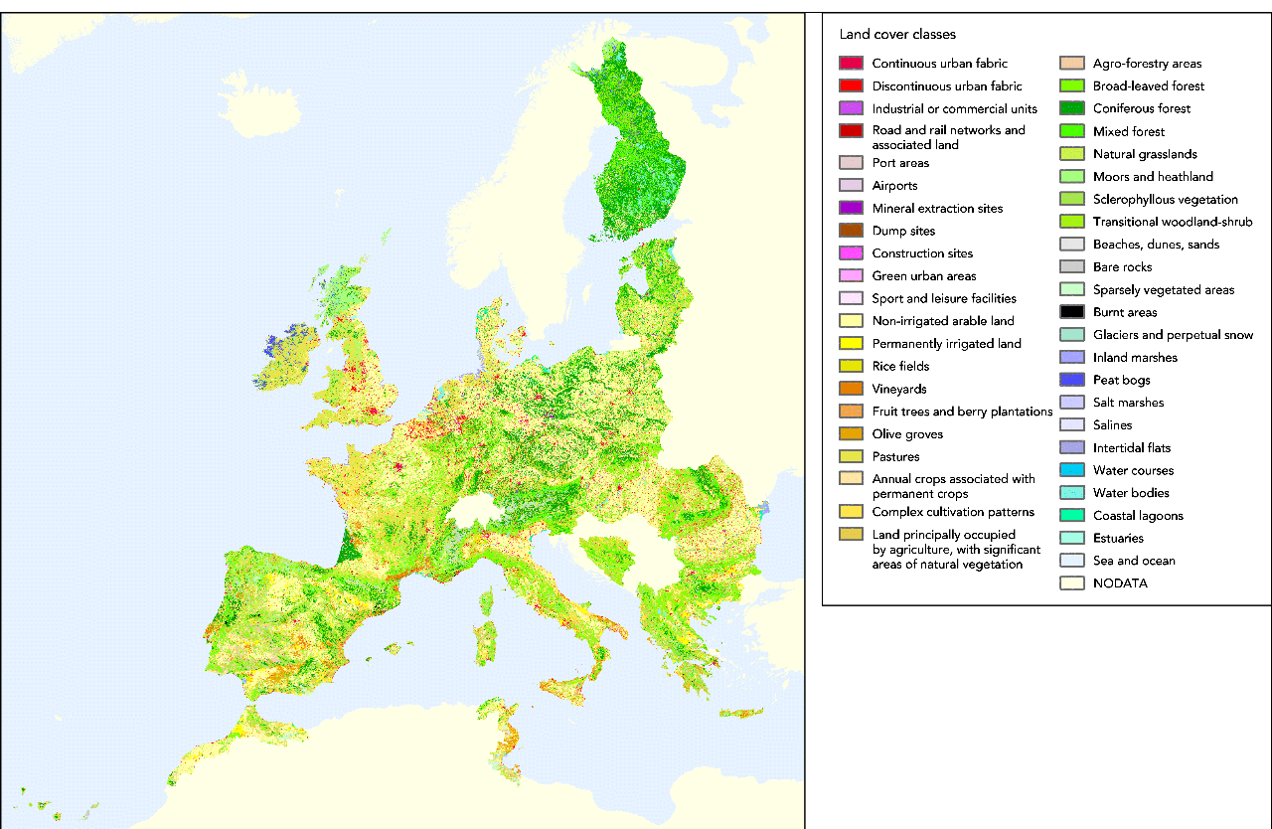
Appendix 2

Climatic prediction for Heracleum sosnowskyi

The CLIMEX model is a computer programme aiming at predicting the potential geographical distribution of an organism considering its climatic requirements. It is based on the hypothesis that climate is an essential factor for the establishment of a species in a country.

For Heracleum sosnowskyi, a match climate has been performed.

- Geographical distribution of the species

H. sosnowskyi is native from the mountainous areas: Caucasus, Transcaucasia, and North-East Turkey (Jahodová et al., 2007) but is invasive in Baltic countries having a different climate, where it has been introduced as a fodder crop.
It is associated with areas with warm to hot wet summers and cool winters. It is not favoured by dry conditions. The new shoots of H. sosnowskyi are rather cold resistant and can survive –4 to –7°C. It is found that starting from the second year, they can survive up to–25°C, and under a snow cover, even down to -45°C (Oboļeviča 2001). Seeds germinate in early spring (but not during summer) and require a period of cold stratification for breaking dormancy (less than 2 month). This makes the plant adapted to temperate climates, and probably unadapted to Mediterranean climates.
The distribution of the species is:
EPPO region: Armenia (native), Azerbaidzhan, Russia (Karachay-Cherkessia, Kabardino-Balkaria, North Ossetia, Ingushetia, Chechnya, Dagestan and possibly Black Sea coast), Belarus, Estonia, Germany, Hungary, Latvia, Lithuania, Poland, Russia (Central and Northern), Ukraine (introduced).

- Match climates

Comparing Riga and Vladikavkav with the world with the software CLIMEX, it appears that central Europe and Scandinavia are the areas the most at risk.
Countries with similar climates are: Austria, Belarus, Belgium, Czech Republic, Denmark, Estonia, Finland, France (North-East), Germany, Hungary, Latvia, Lithuania, Norway, Poland, Romania, Russia, United Kingdom (South-East), Slovakia, Sweden, Switzerland, Ukraine.

Comparing Riga (Latvia) with Europe, with an Ecoclimatic index of 0.7:
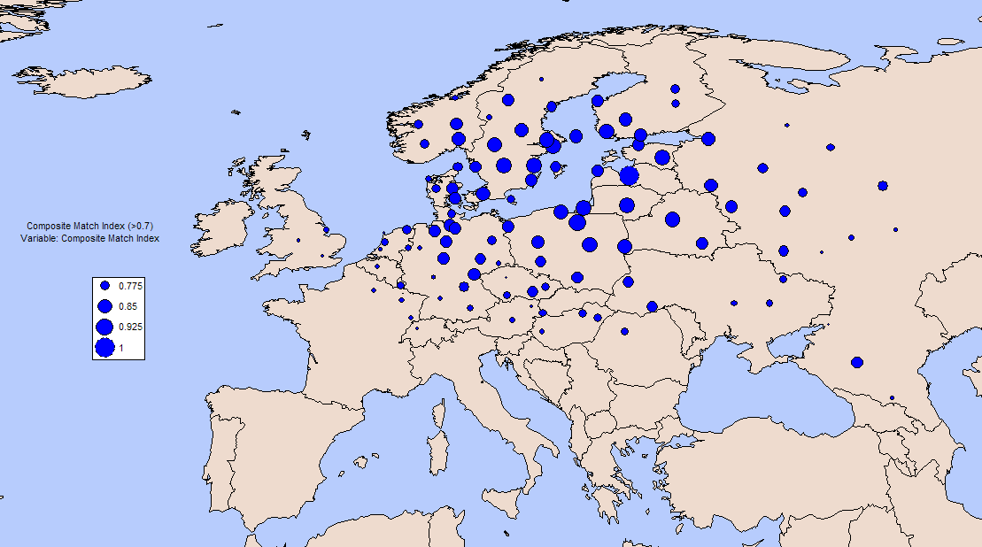
Areas where the species is present do not appear on this match climate map (e.g. Armenia)

Countries with similar climates are: Austria, Belarus, Belgium, Czech Republic, Denmark, Estonia, Finland, France (North-East), Germany, Hungary, Latvia, Lithuania, Norway, Poland, Romania, Russia, United Kingdom (South-East), Slovakia, Sweden, Switzerland, Ukraine.

Comparing Vladikavkav North Ossetia with Europe, with an Ecoclimatic index of 0.7:
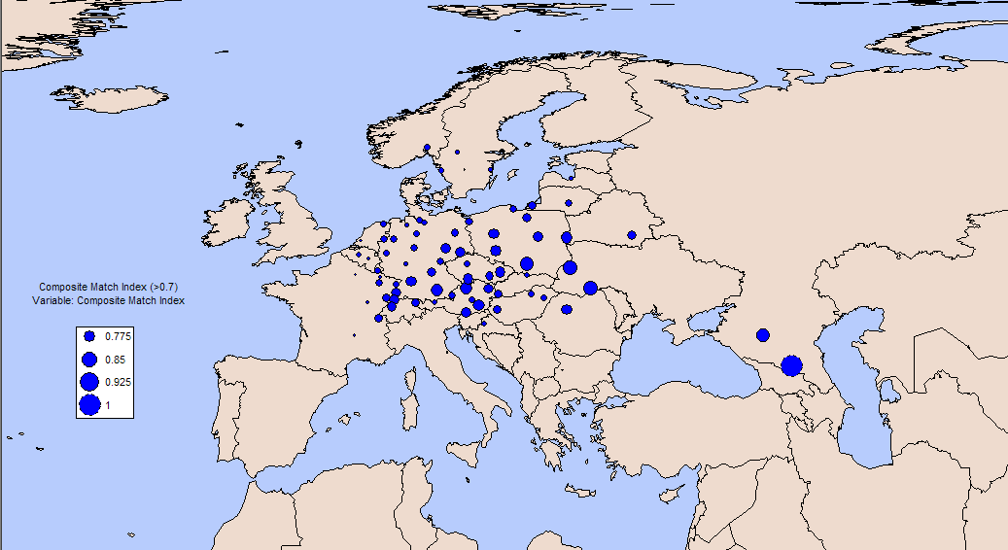
Countries having a similar climate with Vadikakav are almost the same as the ones having a similar climate with Riga.
Countries like Armenia, Azerbaijan may not appear as the plant is present in these areas in mountainous areas, while there are only a few climatic stations for these areas in CLIMEX which may not capture these climatic conditions.

