DIME/ITDG Plenary 24 February 2015/06/EN

Directors of Methodology group
IT DIRECTORS Group
Joint Meeting

24 February 2015

Item 6 of the agenda

Standardisation

- Input sought from the DIME/ITDG Steering Group
The DIME/ITDG is invited:
- To give a positive opinion on the proposals of the Task Force on Standardisation; this includes the proposed process of standardisation and the governance at the strategic level;
- to relieve the Task Force of its duties.

- Background
The Sponsorship on Standardisation presented its recommendations to the September 2013 ESSC (http://www.cros-portal.eu/content/sponsorship-standardisation). The ESSC concluded as follows:
1. The ESSC welcomed the work done by the Sponsorship on Standardisation; it approved the recommendations and asked the Directors’ Group on Methodology (DIME) to develop a roadmap for the next steps specified in the individual recommendations.
2. The Directors’ Group on Methodology (DIME) shall coordinate the standardisation activities in the ESS assisted by a Steering Group.
3. The Sponsorship on Standardisation shall be relieved from its duties.
The follow-up of these conclusions were discussed in the Joint DIME-ITDG Steering Group in December 2013. The Steering Group decided to appoint a Task Force to prepare the task for the March 2014 Joint plenary DIME-ITDG meeting. The Task Force on Standardisation consisted of Hungary, France, the Netherlands, Spain and Eurostat. The Task Force worked on three areas: the roadmap, the mandate of the steering group and options for dealing with more operational tasks (especially offering guidance).
The DIME-ITDG meeting of March 2014 discussed the proposals of the Task Force and concluded that further development and justification were needed, especially for the proposed governance.
After the 2014 DIME/ITDG meeting countries were asked to indicate their interest for joining the Task Force. On top of the existing members of the task force, the UK and Italy showed interest. The DIME/ITDG approved the mandate of the Task Force in a written consultation.
Directions and approach of the Task Force were discussed in the DIME-ITDG Steering Group of 8 December 2014. The Steering Group largely supported the directions, mainly based on the further specification of the process of standardisation in the ESSnet on Standardisation.
- Summary of findings
Improvement of the efficiency and robustness of statistical processes through systematic collaboration within the ESS requires agreed standards (The ESS Vision 2020). Standards support the sharing of knowledge, experiences and methodologies and as a consequence the sharing of tools, data, services and resources. The implementation of standard methods and tools also improves the comparability of statistical outputs.
With the adoption of the recommendations of the Sponsorship on Standardisation in September 2013 it was also decided to adopt the ISO definition of standard with an interpretation to the ESS context: A standard is a document, established by consensus and approved by a recognized body, that provides for common and repeated use, rules, guidelines or characteristics for activities or their results, aimed at the achievement of the optimum degree of order in a given context. At the same time the ESSC was recognised as the single authority to set ESS standards. Consensus is a crucial element in the definition. Acceptance by consensus ensures that all views are heard and the resulting standard is generally agreed. Consensus does not imply unanimity.

The scope is standardisation in the ESS; this does not imply that potential standards developed outside the ESS should be ignored. Reuse of already developed standards should be the primary intuition. The most obvious types of standards are methods and tools, but other types of standards might also be useful, e.g. glossaries, templates. Important is the element in the definition of a standard that it is for common and repeated use; there should be long and broad interest.

The development, adoption and implementation of standards require several steps as summarised in the figure below (taken from the paper on the further development of the process of standardisation by the ESSnet on Standardisation, see annex). Each step has its own actors and tools. The process is driven by the domain experts; they have to clarify the need, to develop the standard and to implement the standard in the end. The process also needs strategic directions for instance on what new standards need to be developed, what standards are mature enough for adoption and how to guarantee the coherence of standards. The process also involves several operational tasks. This concerns the support of the process on the basis of templates and guidance and dissemination. An important operational task is the maintenance of the catalogue of standards. Such a catalogue is essential to ensure smooth communication in the system and to make process components interoperable (The ESS Vision 2020).
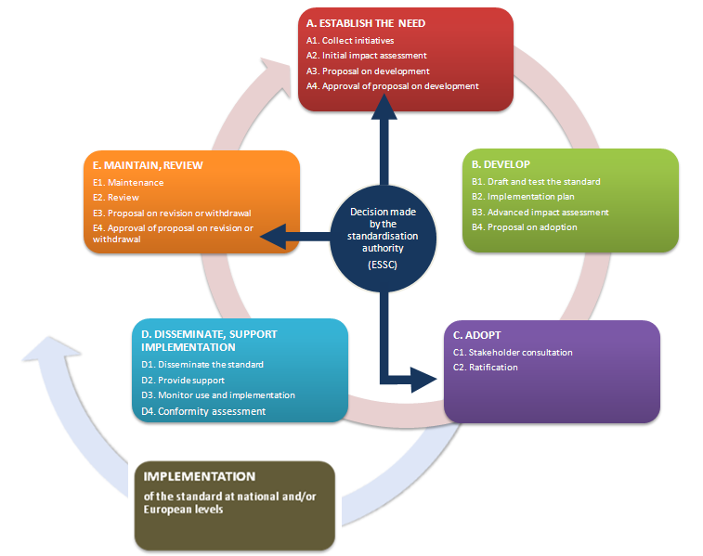
Figure: Steps of the standardisation process
It is not always necessary to go through all steps; this is for instance the case with potential standards already developed inside or outside the ESS.
The Task Force proposes to allocate the strategic coordination of standardisation activities to the DIME. The task force supports the idea presented in agenda item 2 of the joint meeting on the governance structure to have a dedicated expert group (EG) reporting directly to the DIME (Expert groups have a permanent nature and, in principle, not a full Member States compositon). This approach makes sense especially in the first years, as guidelines and templates have to be approved and the alignment with the implementation of the Vision 2020 has to be assured. It will require more frequent exchange and the use of other internal communication mechanisms than traditional meetings. As an alternative solution the DIME/ITDG steering group will have to deal with these tasks, which will change their usual way of working significantly. Important tasks of strategic governance are:
- Coordinating the portfolio of standardisation activities; this will also require an evaluation what path is appropriate: regulation, standardisation or just a normative document without any formal adoption
- Approving the guidance documents and templates; overviewing operational tasks on standardisation
- Giving an opinion on potential standards to be sent for adoption to the ESSC (from a standardisation perspective)
- Aligning with the implementation of the Vision 2020
- Contributing to the communication on standards and the process of standardisation
In line with the advice from the DIME/ITDG steering group, the Task Force proposes to set up a Centre of Excellence on Standardisation to deal with the operational tasks related to the standardisation process. In the short run the current ESSnet on Standardisation could fulfil this role. The main operational tasks are:
- Develop guidance on all phases of the process of standardisation (guidance documents, templates, glossaries etc.)
- Offer guidance to proposers, developers and implementers of standards;
- Review proposed standards prior to their submission to the DIME;
- Maintain the catalogue of standards;
- Prepare an annual activity report for the DIME; prepare special reports on request of the DIME or on own initiative;
- Disseminate and actively promote the implementation of standards.
The information about the resources required for the Centre of Excellence is only indicative. It is partly based on experiences with the ESSnet on Standardisation with similar tasks. It will probably require about 3 FTE per year in the first years, and somewhat less in the following years. Please note that the Centre of Excellence is an investment in the quality of the standardisation process, and especially in the crucial element of consensus and transparency.
These proposals are in line with the strategic directions given by the DIME/ITDG in March 2014, stressing that preferably no new bodies or governance structures should be created. The proposals are also in line with the process of standardisation as further developed by the ESSnet on Standardisation (see annex). This process is currently tested on the basis of ongoing standardisation activities in the ESS. A first report on the test results will be given in the meeting. This testing will not only clarify whether the proposed process is feasible and where clarifications are needed, it will also indicate whether the process is a heavy burden to proposers, developers or implementers of standards.
Lack of standardisation will lead to inefficiency, to reduced comparability of statistics and to under development of common tools and shared services. A too formalistic implementation of standardisation can, on the other hand, create unnecessary costs of bureaucratic overhead and will result in aversion. Anyway, standardisation should support the flexibility of the European Statistical System, and should not block progress.
- Next steps
The following steps are identified:

- Opinion of the DIME/ITDG on the standardisation process, the governance and the way to deal with the operational tasks: February 2015
- Decision of the ESSC on the standardisation process, on the DIME to be responsible for the coordination of standardisation activities and on the way to organise the operational tasks: May 2015
- Priority of the Centre of Excellence on Standardisation on operational catalogue of standards and overview of on-going standardisation activities
- After a positive decision of the ESSC, the DIME/ITDG Steering Group June 2015 proposes governance in the DIME environment

Annexes
1 ESSnet on Standardisation-Process of standardisation
2 Roadmap
3 Mandate of the Expert Group on standardisation

