EUROPEAN AND MEDITERRANEAN PLANT PROTECTION ORGANIZATION
ORGANISATION EUROPEENNE ET MEDITERRANEENNE POUR LA PROTECTION DES PLANTES

18-23440 (17-20705)
Pest Risk Analysis for Prosopis juliflora
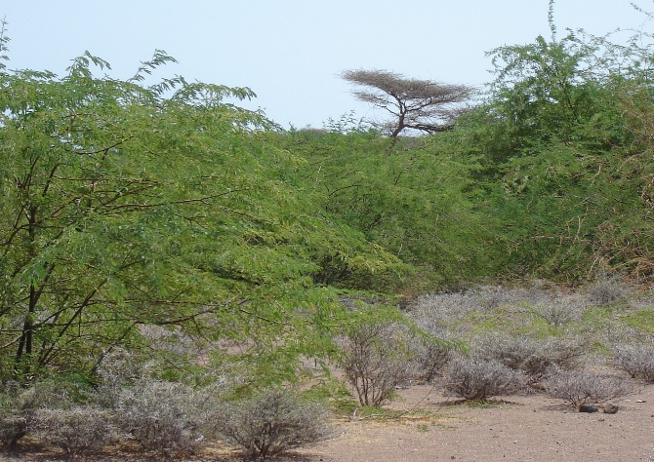

2018, EPPO
21 Boulevard Richard Lenoir
75011 Paris
www.eppo.int hq@eppo.int

This pest risk analysis scheme has been specifically amended from the EPPO Decision-Support Scheme for an Express Pest Risk Analysis document PM 5/5(1) to incorporate the minimum requirements for risk assessment when considering invasive alien plant species under the EU Regulation 1143/2014. Amendments and use are specific to the LIFE Project (LIFE15 PRE FR 001) ‘Mitigating the threat of invasive alien plants to the EU through pest risk analysis to support the Regulation 1143/2014’.
Cite this document as:
EPPO (2018) Pest risk analysis for Prosopis juliflora. EPPO, Paris.
Available at:

Photo: P. juliflora invading native Acacia tortillis dominated savanna scrub, Djibouti. Nick Pasiecznik

EUROPEAN AND MEDITERRANEAN PLANT PROTECTION ORGANIZATION

Pest risk analysis for Prosopis juliflora

This PRA follows EPPO Standard PM5/5 Decision support scheme for an Express Pest Risk Analysis

Composition of the Expert Working Group

Chapman Daniel (Dr) | Centre for Ecology and Hydrology Bush Estate, Penicuik, Edinburgh , UK, dcha@ceh.ac.uk
LE ROUX Jaco (Mr) | Department of Botany and Zoology, Stellenbosh University, Private Bag X1, 7602 Matieland, South Africa  - jleroux@sun.ac.za
LINNAMäGI Merike (Ms) | Ministry of Environment, Nature Conservation Department, Narva mnt 7a - 329, 15712 Tallinn, Estonia  - merike.linnamagi@envir.ee
PASIECZNIK Nick (Mr) | Agroforestry Enterprises, 16 Place Docteurs C et C Merieux, 69007 Lyon, France  - npasiecznik@wanadoo.fr
PESCOTT Oliver (Mr) | Centre for Ecology and Hydrology Wallingford, Benson Lane, Crowmarsh Gifford, OX10 8BB Wallingford, Oxfordshire, United Kingdom  - olipes@nerc.ac.uk
SINGH Inderjit (Mr.) | Department of Environmental Studies,University of Delhi, Department of Environmental Studies, University of Delhi, 110007 Delhi, India  - inderjitdu@gmail.com
STARFINGER Uwe (Mr) | Julius Kühn Institut (JKI), Federal Research Centre for Cultivated Plants, Institute for National and International Plant Health, Messeweg 11/12, 38104 Braunschweig, Germany  - uwe.starfinger@julius-kuehn.de
VICENTE Joana (Ms) | CIBIO/InBIO - Universidade do Porto, CIBIO - Centro de Investigação em Biodiversidade e Recursos Genéticos, Universidade do Porto Campus Agrário de Vairão, Rua Padre Armando Quintas, nº 7, 4485-661 Vairão  Portugal, 4485-661 Vairão, Portugal  - jsvicente@fc.up.pt
TANNER Rob (Mr) | OEPP/EPPO, 21 boulevard Richard Lenoir, 75011 Paris, France  - rt@eppo.int

The pest risk analysis for Prosopis juliflora has been performed under the LIFE funded project:

LIFE15 PRE FR 001

Mitigating the threat of invasive alien plants to the EU through pest risk analysis to support the Regulation 1143/2014

In partnership with

EUROPEAN AND MEDITERRANEAN PLANT PROTECTION ORGANIZATION

And

NERC CENTRE FOR ECOLOGY AND HYDROLOGY

Review Process

- This PRA on Prosopis juliflora was first drafted by Nick Pasiecznik

- The PRA was evaluated under an Expert Working Group (EWG) at the EPPO headquarters between 2017-05-15/19

- Following the finalisation of the document by the expert working group the PRA was peer reviewed by the following:

- The EPPO Panel on Invasive Alien Plants (2017)
(2) The EPPO PRA Core members (2017)

Contents

Summary 6

Stage 1: Initiation 12
Stage 2: Pest Risk Assessment 13
- Taxonomy 13
- Pest overview 15
- Is the pest a vector? 19
- Is a vector needed for pest entry or spread? 19
- Regulatory status of the pest 19
- Distribution 20
- Habitats and their distribution in the PRA area 24
- Pathways for entry 26
- Likelihood of establishment in the natural environment (PRA area) 28
- Likelihood of establishment in the managed environment (PRA area) 29
- Spread in the PRA area 29
- Impact in the current area of distribution 30
12.01. Impact on biodiversity and ecosystem patterns 30
12.02. Impact on ecosystem services 31
12.03. Socio-economic impact 32
- Potential impact in the PRA area 34
- Identification of the endangered area 35
- Climate change 36
- Overall assessment of risk 38

Stage 3: Pest risk management 40
- Phytosanitary measures 40
17.01Management measures for eradication, containment and control 41
- Uncertainty 45
- Remarks 46
20. References 47

Appendices
Appendix 1 Projection of climate suitability for Prosopis juliflora 55
Appendix 2 EU Biogeographical regions 68
Appendix 3 Supplementary information 69
Appendix 4 Images of Prosopis juliflora 73
Appendix 5 Distribution maps of Prosopis juliflora 85

Summary of the Express Pest Risk Analysis for Prosopis juliflora

PRA area: https://www.eppo.int/ABOUT_EPPO/images/clickable_map.htm

Describe the endangered area:
Based on the current environmental conditions, species distribution modeling identified suitable areas for establishment of P. juliflora in the Mediterranean and Macaronesian biogeographical region. Largely frost-free coastal and low-lying inland areas are suitable, including parts of Cyprus, Greece (and the islands), Italy (including Sardinia and Sicily), Malta, Portugal (including Madeira and the Azores), Spain (including Gran Canaria (Canary Islands)) and the wider EPPO region - Turkey, North African countries (Algeria, Morocco and Tunisia), and Israel, the West Bank and Jordan (see appendix 1 and 2).

Arid or semi-arid habitats in the endangered area are those at risk. The main limiting factor restricting suitability appears to be low winter temperatures.
Main conclusions
The results of the PRA show that Prosopis juliflora poses a moderate risk to the endangered area. The EWG consider this the case as, notwithstanding the high score for impact, indisputable in the current area and considered high for the PRA area, the risk of introduction and the potential area for establishment are both perceived as low, leading the EWG to propose an overall phytosanitary risk score of moderate.

Entry and establishment
In the EPPO region, P. juliflora is recorded as established in Israel, the West bank and Jordan, and two trees planted in Spain in 1988 still survive. In addition, the species is naturalised in a small area in Gran Canaria (Canary Islands). The likelihood of P. juliflora entering the EPPO region is low with a moderate uncertainty. The species is traded from outside the region.

Potential impacts in the PRA area
To-date there have been no studies on the impact of Prosopis juliflora in the EPPO region. Dufour-Dror and Shmida (2017) suggests that the establishment of Prosopis species along streams with a permanent water flow in the Dead Sea Valley will impact on biodiversity, displacing native plant species like Acacia raddiana, Salvadora persica or Moringa peregrina and goes on to suggest that the potential impacts in Jordan will be greater than Israel.

In addition to impacts on biodiversity, impacts on ecosystem services will potentially be similar to those impacts seen in the current area of distribution, with the exception, potentially, of significant impacts on communities and local livelihoods. The potential establishment of Prosopis species along protected stream systems around the Dead Sea may have significant impacts on water flow and availability (Dufour-Dror and Shmida, 2017).
What is clear is that the impacts will be restricted to a small area of the EPPO region where the species can establish (the endangered area, see above). In the absence of specific data on impacts in the PRA area the rating of magnitude of impacts remains high for impacts on biodiversity, ecosystem services and socio-economic impacts, however, uncertainty is raised to high for all categories, as it is not clear if these impacts will be realised throughout areas of potential establishment in the PRA area (EWG opinion). However, the text within this section does not relate equally to EU Member States and non-EU Member States in the EPPO region (see section 13.04). In the EU, in frost-free coastal and low-lying inland areas of Cyprus, Greece, Italy, Malta, Portugal, Spain impacts on biodiversity and impacts on ecosystem services could be similar to those impacts seen in the current area of distribution and the isolated areas of establishment in the EPPO region, with the exception, potentially, of significant impacts on communities and local livelihoods (EWG opinion). However, for this to be realised extensive populations of the species would need to occur and this would be more uncertain of occurring compared to areas in Israel and Jordan. In addition, even though the species has been sold as an ornamental species and as a forestry species globally, this is unlikely to be a significant pathway into the EU in future. Therefore, for EU Member States detailed in the endangered area (as above) a moderate rating has been given for impacts on biodiversity, ecosystem services and socio-economic impacts with a high uncertainty.

Climate change
By the 2070s, under climate change scenario RCP8.5, the suitability region in Europe is predicted to increase somewhat, but still be restricted to the same regions. The Biogeographical Regions most suitable for P. juliflora establishment are predicted to be Macaronesia and the Mediterranean, with both projected to become more suitable under the climate change scenario evaluated. Ranges may increase in countries where it already predicted to be suitable (Cyprus, Greece, Italy, Malta, Portugal, Spain and Turkey, North Africa (Algeria, Morocco and Tunisia), and Israel, the West Bank and Jordan), with the addition of Albania and Croatia.

Phytosanitary measures

The results of this PRA show that Prosopis juliflora poses a moderate risk to the endangered area (Mediterranean and Macaronesian Biogeographical region) with a moderate uncertainty.

The major pathway(s) being considered:

(1) Plants for planting

Given the significant impact of the species in other parts of the world and the identified risk to the PRA area, the EWG recommends the following measures for the endangered area:

International measures:

For the pathway plant for planting:
- Prohibition of import into and movement within countries in the endangered area, of plants labeled or otherwise identified as Prosopis juliflora,
- Recommend that Prosopis juliflora is banned from sale within the endangered area,
- Prosopis juliflora should be recommended as a quarantine pest within the endangered area.

National measures
- Prosopis juliflora should be monitored and eradicated, contained or controlled where it occurs in the endangered area. In addition, public awareness campaigns to prevent spread from existing populations or from botanic gardens in countries at high risk are necessary. If these measures are not implemented by all countries, they will not be effective since the species could spread from one country to another. National measures should be combined with international measures, and international coordination of management of the species between countries is recommended.
- The EWG recommends the prohibition of selling and movement of the plant. These measures, in combination with management plans for early warning; obligation to report findings, eradication and containment plans, and public awareness campaigns should be implemented.

Containment and control of the species in the PRA area
- Eradication measures should be promoted where feasible with a planned strategy to include surveillance, containment, treatment and follow-up measures to assess the success of such actions. As highlighted by EPPO (2012), regional cooperation is essential to promote phytosanitary measures and information exchange in identification and management methods. Eradication may only be feasible in the initial stages of infestation, and this should be a priority. The EWG considers that this is possible at the current level of occurrence the species has in the EPPO region.
- General considerations should be taken into account for all potential pathways, where, as detailed in EPPO (2014), these measures should involve awareness raising, monitoring, containment and eradication measures. NPPOs should facilitate collaboration with all sectors to enable early identification including education measures to promote citizen science and linking with universities, land managers and government departments.

Import for plant trade
- Prohibition of the import, selling, planting, and movement of seed in the endangered area.

Unintended release into the environment
- The species should be placed on NPPO’s alert lists and a ban from sale would be recommended in countries most prone to invasion. Export of the plant should be prohibited within the EPPO region. Management measures would be recommended to include an integrated management plan to control existing populations including manual and mechanical techniques, targeted herbicides and proven biological control techniques. Monitoring and surveillance including early detection for countries most prone to risk. NPPOs should report any finding in the whole EPPO region in particular the Mediterranean area.

Intentional release into the environment
- Prohibition on planting the species or allowing the plant to grow in the wild.

Natural spread (method of spread within the EPPO region):
- Increase surveillance in areas where there is a high risk the species may invade. NPPO’s should provide land managers and stakeholders with identification guides and facilitate regional cooperation, including information on site specific studies of the plant, control techniques and management.

See Standard PM3/67 ‘Guidelines for the management of invasive alien plants or potentially invasive alien plants which are intended for import or have been intentionally imported’ (EPPO, 2006).
Phytosanitary risk for the endangered area (current/future climate)*  * Where the EWG consider scores will be different between EU and non-EU countries in the EPPO region an additional score is detailed.  Pathway for entry:  Plants for planting (horticulture): Low/Low  Plants for planting (forestry) Low/Low  Likelihood of establishment in natural areas (EPPO region): Moderate/High  Likelihood of establishment in managed areas (EPPO region):  Moderate/High  Likelihood of establishment in natural areas (EU MS):  Moderate/High  Likelihood of establishment in managed areas (EU MS):  Moderate/High  Spread (EPPO region): High/High  Spread (EU Member States) Moderate/Moderate  Impacts (current area of distribution)  Biodiversity and environment: High/High  Ecosystem services: High/High  Socio-economic: High/High  Impacts (EPPO region)  Biodiversity and environment: High/High  Ecosystem services: High/High  Socio-economic: High/High  Impacts (EU Member States)  Biodiversity and environment: Moderate/High  Ecosystem services: Moderate/High  Socio-economic: Moderate/High  For EU Member States, the overall phytosanitary risk remains as moderate. | High | ☐ | Moderate | X | Low | ☐
Level of uncertainty of assessment  (current/future climate)*  * Where the EWG consider scores will be different between EU and non-EU countries in the EPPO region an additional score is detailed.  Pathway for entry  Plants for planting: Moderate/Moderate  Plants for planting (forestry) Moderate/Moderate  Likelihood of establishment in natural areas (EPPO region): Low/High  Likelihood of establishment in managed areas (EPPO region): Low/High  Likelihood of establishment in natural areas (EU Member States): High/High  Likelihood of establishment in managed areas (EU Member States): High/High  Spread (EPPO region): Moderate/Moderate  Spread (EU Member States) High/High  Impacts (current area of distribution)  Biodiversity and environment: Low: Low  Ecosystem services: Low: Low  Socio-economic: Low: Low  Impacts (EPPO region)  Biodiversity and environment: High/High  Ecosystem services: High/High  Socio-economic: High/High  Impacts (EU Member States)  Biodiversity and environment: High/High  Ecosystem services: High/High  Socio-economic: High/High  For EU Member States, the overall uncertainty increases from moderate to high. | High | ☐ | Moderate | X | Low | ☐
Other recommendations:

- This PRA was conducted specifically for Prosopis juliflora as the species was identified through horizon scanning studies. However, as highlighted during the work of the EWG and noted in the text, several other Prosopis species are also a potential threat to the EU and the EPPO region. These are P. chilensis and P. velutina that have both been observed fruiting and the latter naturally reseeding in Almeria, south-eastern Spain (first report, Pasiecznik and Penalvo Lopes, 2016), P. velutina naturalising in Morocco (first report, Sukhorukov et al., 2017), and the closely related P. glandulosa. And noting these first reports, a detailed review may reveal further recent reports of naturalisations of these species in the EPPO region.
- All these three species are also recorded as having very similar ecological and socio-economic impacts compared to P. juliflora, and the latter two are reported as highly invasive in Australia, South Africa and the USA. But being more frost tolerant than P. juliflora, they are also considered to pose an even greater threat to the PRA area. It was not possible to expand the PRA to cover these additional species in the current project, but it recommended that these be considered for future PRAs.

- Noting the taxonomic difficulties in distinguishing P. juliflora from all the other above mentioned species, the EWG recommend careful identification of any Prosopis taxa entering the region. This is currently constrained by the lack of confirmed reference material and supporting systematic treatment of all introduced taxa. Further morphological and genetic analysis is recommended.

Express Pest Risk Analysis:
…………..

Prosopis juliflora

Prepared by:

Nick Pasiecznik
Agroforestry Enterprises, 16 Place Docteurs C et C Mérieux, 69007 Lyon
France
npasiecznik@wanadoo.fr, Tel: 0033782626917/0033980979476

Date: 9 April 2017 (first draft, v1)

Stage 1. Initiation

Reason for performing the PRA:

Prosopis juliflora currently has a very limited naturalised distribution in the EPPO region. It is currently reported as naturalised in low lying areas in Israel, the West Bank and Jordan(Dufour-Dror and Shmida, 2017), although records of P. juliflora outside of the Jordan valley are considered by the Expert Working Group (EWG) to be possible mis-identifications. P. juliflora was first confirmed as present in Jordan by Harris et al. (2003). P. juliflora is also confirmed as present (two planted trees only) in Almeria, south-eastern Spain (Pasiecznik and Peñalvo López, 2016) and the species is reported as naturalised in a very limited area in Gran Canaria (Canary Islands) (Verloove, 2013, 2017). In 2016, the species was prioritized (along with 36 additional species from the EPPO List of Invasive Alien Plants and a recent horizon scanning study) for PRA within the LIFE funded project “Mitigating the threat of invasive alien plants to the EU through pest risk analysis to support the Regulation 1143/2014’ (see www.iap-risk.eu). P. juliflora was one of 16 species identified as having a high priority for PRA. The species is certainly one of the most invasive woody weeds in the world’s tropical drylands, and the genus as a whole was included in the widely cited ‘100 of the World’s Worst Invasive Alien Species’. For example, of all the introductions of Prosopis species globally, reviewed by Shackleton et al., (2014), 79% led to naturalisation of which 38 % have become invasive.

PRA area: EPPO region (https://www.eppo.int/ABOUT_EPPO/images/clickable_map.htm)

Stage 2. Pest risk assessment

1. Taxonomy:

Prosopis juliflora (Sw.) DC. (Spermatophyta, Dicotyledonae, Fabales, Fabaceae/Leguminosae, subfam. Mimosoideae).

EPPO Code: PRCJU

Synonyms: Acacia cumanensis Willd., Acacia juliflora (Sw.) Willd., Acacia salinarum (Vahl) DC., Algarobia juliflora (Sw.) Heynh., Algarobia juliflora (Sw.) Benth., Desmanthus salinarum (Vahl) Steud., Mimosa juliflora Sw., Mimosa piliflora Sw., Mimosa salinarum Vahl, Neltuma bakeri Britton & Rose, Neltuma juliflora (Sw.) Raf., Neltuma occidenatlis Britton & Rose, Neltuma pallescens Britton & Rose, Prosopis bracteolata DC., Prosopis cumanensis (Willd.) Kunth, Prosopis domingensis DC., Prosopis dulcis var. domingensis (DC.) Benth., Prosopis juliflora var. juliflora, Prosopis vidaliana Fern.-Vill.

Common name: English: mesquite (see Appendix 3 for additional common names)

Plant type: Evergreen, broadleaved, perennial, seed propagated, woody shrub or tree

Related species in the EPPO region:

The distantly related P. farcta, a low shrub/sub-shrub noted as a weed of rangelands and orchards, is the only Prosopis species native to parts of the EPPO region. EPPO member countries where Burkart (1976) and USDA-ARS (2017) records P. farcta as native include those in the southern and eastern Mediterranean (Algeria, Tunisia, Cyprus, Israel, Jordan, Turkey), the Caucasus (Georgia, Azerbaijan, southern Russia) and Central Asia (Kazakhstan, Uzbekistan). Of ‘potential EPPO member countries’, it is recorded as present in Egypt, Iran, Lebanon, Tajikistan, Turkmenistan (USDA-ARS, 2017). P. cineraria and P. koelziana are also native to Iran (Shackleton et al., 2014).

Individuals of P. chilensis, P. glandulosa and P. velutina along with P. juliflora were planted out in trials in Almeria, Spain in 1988-89, and of particular concern, both P. chilensis and P. velutina have been observed to be fruiting. Concern was raised about the invasive potential of the latter two prosopis species and were recommended for eradication (Pasiecznik and Peñalvo López, 2016).

Both P. juliflora and P. glandulosa are available acording to the PPP-Index which lists plant species available for sale in Europe.

Taxonomic confusion

The taxonomical confusion surrounding species of Prosopis Section Algarobia must be highlighted at the outset, and that some databases (incorrectly) group all Prosopis species together or repeat taxonomical errors of the past.

The general common name is mesquite or simply prosopis, but note, that as a common group name, species of Prosopis are hereby referred to in normal script (not italics) and all in lower case, as are acacia, eucalyptus, leucaena, etc. Also, as a common name, mesquite is also used for other species of Section Algarobia such as P. glandulosa (Lowe et al., 2000), and occasionally for others outside of this Section, either with or without a specific epithet (e.g. P. glandulosa should be honey mesquite, P. velutina, velvet mesquite, etc.).

The following information on taxonomy and nomenclature is adapted from the P. juliflora datasheet in the Invasive Species Compendium (CABI, 2017), including a recent review submitted (February 2017, unpublished), the most up-to-date review of the taxonomy of species.

Prosopis juliflora (Sw.) DC. has had an array of synonymy since its first description in 1788. Originally known as Mimosa juliflora Sw., it became both Algarobia juliflora (Sw.) Benth. ex Heynh. and Neltuma juliflora (Sw.) Raf. during the last two centuries before both genera were incorporated into the single, overarching genus Prosopis. Bentham (1875) noted P. limensis (syn. P. pallida) from Peru as the only Prosopis species of section Algarobia he was aware of that was not sympatric with others in the section. This may assume that he was either unaware of P. juliflora and hybrids in Ecuador and northern Peru, or that he treated them all as the same species, distinct from the P. juliflora of Central America, Colombia and the Caribbean.

P. juliflora was used by Pasiecznik et al. (2001) in its original, restricted and certainly biological sense, re-established by Burkart (1940) and accepted by Benson (1941) and Johnston (1962). The all-embracing, collective P. juliflora concept of Bentham (1875) was maintained by others and, although currently rejected by most taxonomists and researchers, it is still used occasionally to this day. Much confusion occurs when referring to old literature, because the binomial P. juliflora was used to describe species now generally accepted as separate taxa.

The following three varieties were accepted by Burkart (1976) and without any information to the contrary, also by Pasiecznik et al. (2001): Prosopis juliflora (Sw.) DC. var. juliflora, Prosopis juliflora (Sw.) DC. var. inermis (H.B.K.) Burkart and Prosopis juliflora (Sw.) DC. var. horrida (Kunth) Burkart. However, even then, the taxonomy was still uncertain, with Burkart noting that the two varieties var. inermis and var. horrida, differed from var. juliflora principally in the relative presence/absence of armature, will no other striking morphological basis for the separation. However, particularly at the range limits in Mexico and Peru/Ecuador, further revision is expected.

The ‘P. pallida – P. juliflora complex’ was proposed by Pasiecznik et al. (2001) as a means to overcome the observed ambiguities and lack of agreement on how to taxonomically deal with tropical American prosopis, and discusses previous proposals and revisions in detail. This followed the treatment by Johnston (1962), who divided P. juliflora into two races, the Central American, and Colombian-Caribbean race, mainly on the basis of leaflet length, and noted the similarities and the differences between these two and the truly South American P. limensis (syn. P. pallida).

However, since then, it has been unequivocally shown that the two are distinct taxa, morphologically and genetically (e.g. Harris et al., 2003; Landeras et al., 2006; Catalano et al., 2008; Trenchard et al., 2008; Palacios et al. 2012; Sherry et al., 2012). Comparing native range material with that from introduced populations, however, highlighted a number of serious misidentifications, notable being that the ‘common’ prosopis in the north east of Brazil, Cape Verde and parts of Senegal is in fact P. pallida, and not P. juliflora as it has always been referred to (Harris et al., 2003). P. pallida has also been positively identified in southern Mauritania (Pasiecznik et al., 2006) and Djibouti (Pasiecznik et al., 2013), from naturalized populations. However, scientific publications from Brazil and Cape Verde, for example, still tend to incorrectly refer to P. julilfora as the dominant species there (e.g. Fonseca et al., 2016; Tavares and Barros, 2016).

2. Pest overview

Life cycle

P. juliflora usually begins to flower and fruit after 2-3 years, but this is highly dependent upon site conditions, as trees as young as 12 months old have been observed to flower in the Sahel, and trees 15 years old or more on poor exposed sites have never been seen to flower (Pasiecznik et al., 2001). Almost continuous year-round flowering of P. juliflora is seen in India (Goel and Behl, 1995) and Haiti (Timyan, 1996) but there is always a period of maximum fruit production. In parts of India, one or two fruiting periods occur, depending on site and the 'form' of P. juliflora present (Luna, 1996). With continuous flowering, periods of major fruit production may correspond to periods of increased pollinator activity and not necessarily to genetic controls, particularly with introduced material.

Prosopis species are generally assumed to be self-incompatible (Solbrig and Cantino, 1975; Simpson, 1977), although some limited self-compatibility (4%) has been observed in P. juliflora following bagging and hand pollination (Sareen and Yadav, 1987). Insects are the main pollinators known for the species, in particular bee species (Hymenoptera) (Pasiecznik et al., 2001. Anther glands in P. juliflora release a protein-carbohydrate exudate and the flower is pollinated while the insect eats the gland (Chaudhry and Vijayaraghavan, 1992). Anther glands also exude a sticky substance to attach the pollen to the body of the insect, to protect the anthers and ovaries, and may also exude an odorous chemical attractant.

P. juliflora seeds possess an inherently high level of dormancy, and the hard seed coats must be broken or weakened to allow water absorption and for germination to occur. Though seed coats soften over time and older seed that is still viable tends to germinate without pre-treatment (Pasiecznik and Felker, 1992). Seeds in entire pods or endocarp shells exhibit decreased germination, thought to be due to impeded water uptake by the seeds, although an allelopathic chemical extract from pod pericarps decreased germination in P. juliflora (Warrag, 1994). The passage of seed through the digestive tracts of different animal species has varying effects on germination, through the removal of the mesocarp or endocarp, or other mechanical or chemical factors. P. juliflora seeds showed no decrease in final germination with up to 30% added sea water, although the rate of germination was retarded (Khan et al., 1987). Increasing alkalinity markedly decreased the final germination and germination rate of P. juliflora seed above pH 9.0 (Srinivasu and Toky, 1996). The optimum temperature for germination of P. juliflora seeds is 30-35°C, with germination decreasing rapidly at temperatures below 20°C or above 40°C (Pasiecznik et al., 2001). The optimum sowing depth for seed is 10 mm for P. juliflora with germination falling markedly when sown below 20-30 mm deep (Mutha and Burman, 1998).

All Prosopis species are able to survive in areas with exceptionally low annual rainfall or very lengthy dry periods but only if the roots are able to tap ground water or another permanent water source within the first few years. Being adapted to arid and semi-arid climates, P. juliflora generally germinates and establishes during the brief rainy season and seedlings must be sufficiently well established to survive the first dry season. The existence of two root systems, a deep tap root to reach ground water and a mat of surface lateral roots to make use of infrequent rainfall events, puts Prosopis species firmly in the category of phreatophytes, but they show a variety of mesophytic and xerophytic characteristics depending on water availability. The need for rain or high water tables is reduced in coastal areas, where sufficient atmospheric moisture exists with persistent trade winds or seasonal fog.

Each pod can produce up to 25 seeds, commonly up to 16 seeds (Pasiecznik et al., 2001). Each tree can produce 300-420 kg of pods per year (Pasiecznik et al., 2001), with an estimate of 2000 seeds per kilo of pods (Pasiecznik et al., 2012). Felker (1979) and Harding (1988) estimate that each tree can produce between 630,000 and 980,000 seeds per year. In the native range, the seed bank of prosopis spp. is long lived and can persist for at least 15 years (Pasiecznik and Felker, 1992). Estimates from South Africa detail the seed bank can contain as many as 2500 seeds per m² (Zachariades et al., 2011).

Environmental requirements

P. juliflora thrives in a wide range of rainfall zones, from 100 mm mean annual rainfall or less in dry coastal zones to 1500 mm at higher altitudes, and the ability to tolerate very low annual rainfall is well known. Mean annual air temperature in the shade where P. juliflora is found is generally above 20°C, with optimum temperatures for growth in the range 20-30°C. There appears to be no natural upper limit to temperature, with introduced P. juliflora known to tolerate day-time shade temperatures of over 50°C (Pasiecznik et al., 2001).

A major limitation to the distribution of P. juliflora is mean minimum temperature and the frequency and duration of frosts. Light frosts cause dieback of the branches, harder frosts may cause complete stem mortality, and more severe or longer-lasting frosts can cause complete death of the plant (Felker et al., 1982). Frost damage is more severe on seedlings and younger trees of P. juliflora and on trees in inter-dunal or other low lying areas (Muthana, 1974). Hyde et al. (1990) found that P. juliflora seedlings were killed by a -2°C frost in Spain, whereas P. juliflora was noted to suffer frost damage but survive when temperatures fell below 0°C in India (Muthana, 1974). There is also considerable variation in frost tolerance exhibited by different provenances of the same species, and this would be expected also in land races of P. juliflora.

P. juliflora has a broad ecological amplitude, and is adapted to a very wide range of soils and habitat types from sand dunes and coastal flats to cracking clays. It is often found in areas where water, soil fertility and salt are the principal agents limiting plant growth, and it is able to survive and even thrive on some of the poorest land unsuitable for any other plant species. P. juliflora has a deep tap root, and can become dominant in dry, or seasonally dry, watercourses or depressions, around wells or water points, and commonly, along canalsides, irrigation ditches and around lakes and other water bodies. It is also salt tolerant, so can also be found on beaches growing right up to the shoreline, as well as salt flats and coastal areas where the water table is saline, and is even seen growing a few metres from mangroves in Sri Lanka (Pasiecznik and Weerawardane, 2011). However, whereas it will survive periods of flooding, it tends to suffer dieback or plant mortality when areas are waterlogged for extended periods of time.

Habitats

In the native and introduced ranges, P. juliflora is found in a number of different habitats including: wasteland, forest, managed and natural grassland, coastal areas (including coastal dunes), wetlands, abandoned field and urban areas (for example roadside). In particular, in the introduced range, P. juliflora invades rangeland, where it can form impenetrable thickets over hundreds or thousands of hectares, and encroaches upon agricultural and abandoned land and can quickly invade uncultivated fields.

Detection and identification

See Appendix 4 for relevant images of the species through its native and introduced range.

The following description is taken from Burkart (1976) as the over-arching species morphology including all varieties from all parts of the world. Although some material that Burkart (1976) identified as P. juliflora is now likely to be P. pallida (Harris et al., 2003), this description is still accepted in the absence of a new acknowledged taxonomy.

P. juliflora is a tree 3-12 m tall, sometimes shrubby with spreading branches; wood hard; branches cylindrical, green, more or less round- or flat-topped, somewhat spiny with persistent, green (sometimes glaucous or greyish, not reddish) foliage, glabrous or somewhat pubescent or ciliate on the leaflets; spines axillary, uninodal, divergent, paired, or solitary and paired on the same branches, sometimes absent, not on all branchlets, measuring 0.5-5.0 cm long, being largest on strong, basal shoots. Leaves bipinnate, glabrous or pubescent, 1-3 pairs of pinnae, rarely 4 pairs; petiole plus rachis (when present) 0.5-7.5 cm long; pinnae 3-11 cm long; leaflets 6 to 29, generally 11 to 15 pairs per pinna, elliptic-oblong, glabrous or ciliate, rarely pubescent, approximate on the rachis or distant a little more than their own width, herbaceous to submembranous (not sub-coriaceous as in more xerophilous species and therefore often corrugated or curved when dried), emarginated or obtuse, pinnate-reticulately curved; leaflets 6-23 mm long x 1.6-5.5 mm wide. Racemes cylindric, 7-15 cm long, rachis puberulent; florets as usual, greenish-white, turning light yellow. Legume straight with incurved apex, sometimes falcate, straw-yellow to brown, compressed, linear with parallel margins, stalked and acuminate, 8-29 cm long x 9-17 mm broad x 4-8 mm thick; stipe to 2 cm; endocarp segments up to 25, rectangular to subquadrate, mostly broader than long; seeds oval, brown, transverse.
Prosopis species, however, exhibit high levels of variability in morphological characters in its native range. The reproductive self-incompatibility and obligate outcrossing observed tends to lead to large phenological variation, being a combination of both clinal (continuous) variation in response to broad climatic factors and ecotypic (discontinuous) variation in response to disjunct environmental factors. Differences in continuous climatic clines such as temperature, rainfall and day length, and discrete differences in site such as soil type, salinity or depth combine to create a variety of phenological responses.

Identifying Tropical Prosopis Species: A field guide (Pasiecznik et al., 2004) provides the easiest to use means of separating the eight most common prosopis species from field observations and measurements of morphological characteristics. It includes a description of the most common misidentifications, and a simple key to separate P. juliflora and P. pallida using leaf/leaflet size and number. The fact that P. juliflora is confirmed as the only tetraploid species in the Genus means that flow cytometry can be used as a tool from separating this species from others (Trenchard et al., 2008).

PRAs

Several PRAs have been undertaken on prosopis species, with those for P. juliflora, but also P. glandulosa, and ‘P. spp.’, listed below. It is worth noting that many of the characteristics of P. glandulosa are similar to those for P. juliflora, thus these PRAs could be considered/taken into account. Furthermore, one PRA also exists for Spain, thus making it relevant for this analysis.

P. juliflora
- Australian/New Zealand Weed Risk Assessment adapted for Hawai‘i (2005), - High risk, Score 19. www.hear.org/pier/wra/pacific/prosopis_juliflora_htmlwra.htm.

P. glandulosa
- Spain –Score 22 and 32, ranking 6th and 4th in a list of 80 potential invasive plants, assessed by WRA and WG-WRA, respectively (Andreu and Vilà, 2010).
- Hawaii/Pacific - High risk, Score 19 (www.hear.org/pier/wra/pacific/Prosopis%20glandulosa.pdf)

P. spp.
- Australia - Reject, Score 20 (www.hear.org/pier/wra/australia/prosp-wra.htm)

In addition, a detailed datasheet can be found in CABI’s Invasive Species Compendium.

Socio-economic benefits

P. juliflora is a very valuable multi-purpose tree, but much more so where introduced than where native. Principal uses are wood for fuel, posts, poles and sawn timber, and pods for fodder and human food sources (Pasiecznik et al., 2001). There are numerous other tree products including wood as a biofuel for electricity generation, honey from the flowers, medicines from various plant parts, exudate gums, fibres, tannins, leaf compost, and chemical extracts from the wood or pods. It has also been widely planted for soil conservation, in hedgerows, and as an urban and general amenity tree, and continues to be planted as such in some countries (e.g. Chad, Mauritania, Niger, India, Iran, Pakistan). For a comprehensive review of the uses of P. juliflora, refer to Pasiecznik et al. (2001).

As with many other invasive species, it is mostly developing countries that realise the economic benefits for the species (Shackleton et al., 2014). For examples in Kenya, trade in prosopis goods and services was worth US$2,122 per household per year in some villages in 2002, and ten years was estimated to exceed US $ 1.5 million in four selected areas (Choge et al., 2012).

Within the EPPO region including EU Member States, there are no known socio-economic benefits reported.

3. Is the pest a vector? | Yes | ☐ | No | X

P. juliflora is a known host for various nematodes (e.g. Meloidogyne spp.) and other pests (Pasiecznik et al., 2001), but as it is not transported internationally as a pot plant, the risk of it acting as a vector is very limited.

4. Is a vector needed for pest entry or spread? | Yes | ☐ | No | X

5. Regulatory status of the pest

Australia
Prosopis spp. (as a genus) is listed as one of the 30 Weeds of National Significance (www.environment.gov.au/cgi-bin/biodiversity/invasive/weeds/weeddetails.pl?taxon_id=68407), and includes P. juliflora as one of four naturalized species (the others being P. glandulosa, P. pallida and P. velutina, and hybrids).

South Africa
P. juliflora is not listed as invasive. Under the country’s National Environmental Management and Biodiversity Act, P. glandulosa and P. velutina, and their hybrids are listed as Category 1b (may not be owned, imported or grown) in Eastern Cape, Free State, North-West and Western Cape, and Category 3 (may hold but cannot propagate or sell) in Northern Cape (www.environment.co.za/weeds-invaders-alien-vegetation/alien-invasive-plants-list-for-south-africa.html#notice1)

USA
P. juliflora is not included in the USDA Federal noxious weed list (last updated 21 March 2017, (www.aphis.usda.gov/plant_health/plant_pest_info/weeds/downloads/weedlist.pdf), although 20 of the 44 Prosopis species recognized by Burkart (1976) are listed, 16 as A1 weeds and 4 as A2 weeds. The reasons for not being included is unclear, however, but may be due, perhaps, the mistaken view that P. juliflora is native to the USA, following Bentham’s classification. Other native species (P. glandulosa and P. velutina) are not listed.

However, one US state, Hawaii, does include P. juliflora on its list of noxious weeds (see, Division of Plant Industry. List of plant species designated as noxious weeds (20 October 2003). Hawaii Department of Agriculture, Hawaii. (in https://plants.usda.gov/java/reference?symbol=PRJU3)). Many other states contain the same species as listed in the federal USDA, with some variation, e.g. the California State-listed noxious weeds (https://plants.usda.gov/java/noxious?rptType=State&statefips=06) includes P. velutina as the preferred name for P. articulata (whereas Burkart (1976) considered them as separate species and not synonyms). The whole Genus is listed as a noxious weed in the State of Florida (https://plants.usda.gov/java/noxious).

6. Distribution (see also appendix 3, supplementary information, notes on distribution)

Continent | Distribution | Provide comments on the pest status in the different countries where it occurs | Reference
Africa | Chad, Djibouti, Egypt, Eritrea, Ethiopia, Kenya, Mauritania, Mozambique, Namibia, Niger, Nigeria, Réunion, Senegal, Somalia, South Africa, Sudan, Tanzania, Uganda  Algeria, Botswana, Burkina Faso, Cape Verde, Gambia, Ghana, Guinea-Bissau, Liberia, Libya, Madagascar, Mali, Mauritius, Morocco, Zanzibar, Tunisia, Zimbabwe | Introduced, Invasive  Introduced | Burkart, 1976; Pasiecznik et al., 2001; CABI, 2017;
America | - North America - Mexico  - Central America - Guatemala, Honduras, El Salvador, Nicaragua, Costa Rica, Panama  - Caribbean* - Antigua and Barbuda, Aruba, British Virgin Islands, Cuba, *Curacao, *Dominican Republic, Cuba, Haiti, Montserrat, Puerto Rico, Trinidad and Tobago, United States Virgin Islands  - South America - Colombia, Venezuela  - North America - Hawaii  - South America - Brazil | Native  (*Possibly naturalized in pre-history)  Introduced and invasive | Burkart, 1976; Pasiecznik et al., 2001; CABI, 2017
Asia | India, Iran, Iraq, Israel, Jordan, Kuwait, Myanmar, Oman, Pakistan, Saudi Arabia, Sri Lanka, United Arab Emirates, West Bank, Yemen  Bahrain, Bangladesh, Brunei Darussalam, Cambodia, China (Guangdong, Hainan), Indonesia, Nepal, Philippines, Qatar, Taiwan, Thailand, Vietnam | Introduced, invasive  Introduced | Burkart, 1976; Pasiecznik et al., 2001; CABI, 2017
Oceania | Australia (Queensland, Western Australia), French Polynesia  Australia (NSW), Papua New Guinea | Introduced, Invasive  Introduced | Burkart, 1976; Pasiecznik et al., 2001; CABI, 2017
Europe | Spain  Gran Canaria (Canary Islands, Spain) | Spain, mainland: Introduced (Planted  two trees only)  Spain, Gran Canaria: at least locally naturalized | Pasiecznik and Penalvo-Lopez, 2016; Verloove, 2017

History of introduction and spread

Introduction
Almost no records exist of early introductions of P. juliflora within its natural range but it may be assumed that there were introductions of varieties with sweeter pods made by early man during his journeys across the Americas, or inadvertently by the domesticated animals which may have followed. Routes of man-induced introductions during pre-history may include the Pacific coast of Central American and the Caribbean. P. juliflora is often quoted as being native to the Caribbean where it is often found in coastal areas, but several authors have suggested that it was introduced (Little and Wadsworth, 1964; Burkart, 1976) possibly with the arrival of the first human settlers from Venezuela (ca 0-1000 AD) (Timyan, 1996). It is possible that trade between the Caribbean and Brazil may have led to the introduction of P. juliflora to the dry coastal areas of Ceará and Rio Grande do Norte in northeast Brazil from Venezuela or the Caribbean (Pasiecznik et al., 2001) where it was definitely recorded in 1879 (Burkart, 1976) and still exists. However, later introductions of P. pallida into Brazil from Peru beginning in the 1940s appear to be the source of the now dominant species and especially in interior regions.

Pacific islands
Pacific islands have naturalized populations of both P. juliflora and P. pallida recorded for Hawaii and the Marquesa islands (Burkart, 1976) and it might be assumed that they were introduced from Pacific coastal areas of Peru and Central America where they are native (Pasiecznik et al., 2001). The first introduction into Hawaii is thought to have been in 1828 (Perry, 1998) or 1838 (Esbenshade, 1980), probably being P. pallida, and it is from here that introductions to other Pacific islands such as the Marquesas were probably made. The distinction between P. pallida and P. juliflora is apparently clear in Hawaii but much less so elsewhere in the Pacific, Brazil, Cape Verde and coastal West Africa.

Australia
Prosopis was introduced into Australia around 1900 though no exact records of the first introductions exist. Major planting and possibly further introductions were made in the 1920s and 1930s (Csurhes, 1996). Later introductions may have come from the Americas, e.g. Mexico (Panetta and Carstairs, 1989) or possibly from India or South Africa where Prosopis species had already become naturalized. No information on the dates and sources of seed introduced to South-East Asia can be located, but it is assumed that seed was introduced from the Americas via Australia and the Pacific, although they may also have been introduced from the Indian sub-continent.

Asia
There appear to be several competing histories as to the introduction of P. juliflora into the Indian sub-continent, with no doubt that it first occurred in the 1800s. Reddy (1978) gives the most compelling account of the request for Prosopis seed made by Lt. Col. RH Bedome, Conservator of Forests of Northern Circle (Madras) to the Secretary of the Revenue Department of Madras in 1876:

"The Prosopis dulcis, the Prosopis pubescens and P. glandulosa - are stated to grow best on dry arid soil. They yield hard and valuable timber and also an abundance of sweet succulent pods which are used for cattle feeding and also ground into meal. It is very desirable to introduce these trees into the fuel plantations in our dry districts; and I have the honour to suggest that the British Consuls at Galveston and San Francisco should be applied to for the seed. The Prosopis juliflora is a species growing in Jamaica which I should be very glad to get seed of".

This letter was sent to the Secretary of State and seeds arrived and were sown that same year and outplanted in 1878 (Reddy, 1978). Mohan (1884) refers to 'cashaw', the common name for P. juliflora used only in Jamaica, and suggests that this may have been the origin of this introduction of Prosopis to India. Raizada and Chatterji (1954) state that the first introductions were of Mexican origin in 1877, with two further supplies of seed received through Kew Gardens, UK, and the India Office in 1878. Whichever account is preferred, P. juliflora was certainly widespread throughout present-day India, Pakistan and Sri Lanka by 1900.

P. juliflora was introduced into the Middle East in the 1950s, although there is one very large P. juliflora tree in Bahrain that is said to be 500 years old (Ahmad et al., 1996). Although not possibly so old, it may show that there was some limited introduction of Prosopis by merchant and colonial traders long before the trees were intentionally introduced for other perceived benefits. However, the source of most of the invasions of P. juliflora in tropical (Sahelian and eastern) Africa and the Arabian Peninsula is very likely to have come from material planted by or sourced from FAO via their DANIDA-managed seedbank in the 1970s, 1980 and 1990s (some of it also being incorrectly labelled as P. chilensis), or planted by NGOs, some of whom sourced seed from commercial suppliers such as Setropa. The escape of P. juliflora from trial plots was first noted in the late 1990s (Choge et al., 2012).

Africa
Early introductions of Prosopis into Africa are poorly documented, but appear to have begun in 1822 in Rcihard Toll, in the north of modern-day Senegal at the mouth of the river Senegal This introduction was identified as P. juliflora but looks very likely to have been P. pallida (Harris et al., 2003). P. juliflora had been introduced from Senegal to Mauritania before 1960 (Diagne, 1992) but had certainly been introduced elsewhere in the Sahel before this. It appears that P. juliflora was already present in Egypt by the early 1900s, and was introduced into Sudan by RE Massey from the Egyptian Department of Agriculture at Giza and from South Africa both in 1917 (Broun and Massey, 1929; in El Fadl, 1997). The exact origins of P. juliflora species and their subsequent introductions in East Africa remain unknown, but they were possibly introduced in the 1930s (Choge et al., 2012) by livestock from Sudan or southern Africa, or by traders from India or southern Africa, and it was also planted along the new railroad from Mombasa to Nairobi and beyond. For details of its recent spread in Kenya and areas at risk of invasion, see Maundu et al. (2009). Probably the source of much of the Prosopis to arrive in South Africa was the introduction of 23 seed lots from the USA/Hawaii and Mexico from 1897 to 1916. Although they were all called P. juliflora, they almost certainly contained P. velutina and all varieties of P. glandulosa, and it is unsure whether there is any naturalize P. juliflora in South Africa today.

EPPO region
Prosopis juliflora currently has a very limited naturalised distribution in the EPPO region. It is currently reported as naturalized only in low lying areas in Israel, the West Bank and Jordan(Dufour-Dror and Shmida, 2017), although records of P. juliflora outside of the Jordan valley are considered by the Expert Working Group (EWG) to be possible mis-identifications. P. juliflora was first confirmed as present in Jordan by Harris et al. (2003). P. juliflora is also confirmed as present (two planted trees only) in Almeria, south-eastern Spain (Pasiecznik and Peñalvo López, 2016) and the species is reported as naturalised in a very limited area in Gran Canaria (Canary Islands) Verloove, 2013, 2017). Here the species has been known since 2011 as an escape from cultivation in the drier, southernmost parts of Gran Canaria. In 2015 it was recorded in several additional localities, all in barrancos. In one of these, in the estuary of barranco del Polvo in Arinaga, it is present in relative abundance and in various stages of development, in a natural coastal vegetation. At least in this locality it can be considered naturalized.

7. Habitats and where they occur in the PRA area

At present, P. juliflora is only present in arid, semi-arid regions of the Jordan Valley (Dufour-Dror and Shmida, 2017). Throughout its introduced range, P. juliflora has a broad ecological amplitude, and is adapted to a very wide range of soils and habitat types from sand dunes to cracking clays. It is generally found in areas where water and soil fertility are the principal agents limiting plant growth, and is able to survive, and even thrive, on some of the poorest land, unsuitable for any other tree species. P. juliflora dominates in dry, or seasonally dry, watercourses or depressions, and is often found in coastal flats and dunes. Importantly, however, it is frost sensitive, thus in areas at its temperature limits, it will tend to inhabit more protected sites.

The table below, however, contains only those habitat types from EUNIS where P. juliflora is known to occur (e.g. Pasiecznik et al., 2001), outside of the PRA area but has the potential of invading within. Other habitat types are not included, as they do not occur (or are very rare) in the EU/EPPO region. These are, notably, warm and hot deserts, savannah, and xerophytic woodlands (‘scrub’ and shrublands).

Habitat (main) | EUNIS habitat types | Status of habitat (e.g. threatened or protected) | Is the pest present in the habitat in the PRA area | Comments (e.g. major/minor habitats in the PRA area) | Reference
Coastal habitats | B1: Coastal dunes and sandy shores (Partly threatened) | European Red List: B1.4b, B1.6c, B1.3b, B1.6b  Annex 1. H. Directive: 2130, 2210, 2220, 2230, 2240, | No | Major | Janssen et al., (2016)
Grasslands | E1: Dry grasslands,  E6: Inland salt steppes,  E7: Sparsely wooded grasslands | European Red List:  Annex 1. H, Directive: E1.3 6220 | No | Major | Janssen et al., (2016)
Habitat complexes | X02: Saline coastal lagoons  X18: Wooded steppe  X35: Inland sand dunes | X13, X14, X15 | No | Major | Janssen et al., (2016)
Heathland Scrub and Tundra | F5 (Maquis, arborescent matorral and thermo-Mediterranean brushes), F6 (Garrigue), F7 (Spiny Mediterranean heaths), F8 (Thermo-Atlantic xerophytic scrub) | European Red List: F8.1  F8.2 | No | Major | Janssen et al., (2016)
Arable land | I1. Arable land and market gardens | European Red List: I1.3 | No | Major | Janssen et al., (2016)
Desert | Not listed in EUNIS | Not present in Europe | Yes | Moderate | (Dufour-Dror and Shmida, 2017).

8. Pathways for entry

Possible pathway | Pathway: Plants for planting (horticulture)  (CBD terminology: Escape from confinement – horticulture)
Short description explaining why it is considered as a pathway | P. juliflora seeds are widely available via numerous online global mail order suppliers. For example www.sunshine-seeds.de; http://www.treeseedsindia.com/prosopis-juliflora.htm and Amazon.com.  P. juliflora is available from 4 suppliers according to the PPP-Index which lists plant species available for sale in Europe.
Is the pathway prohibited in the PRA area? | Neither the pathway or the species are prohibited into the PRA area.
Has the pest already been intercepted on the pathway? | P. juliflora is the commodity
What is the most likely stage associated with the pathway? | Seeds are the most likely stage associated with the pathway
What are the important factors for association with the pathway? | Seed are widely available by mail order and the species is available from suppliers in the USA, India and other international suppliers.
Is the pest likely to survive transport and storage along this pathway? | Yes seeds can survive for in their pods under sub-optimal conditions for at least 15 years (Pasiecznik and Felker, 1992).
Can the pest transfer from this pathway to a suitable habitat? | Yes, but seeds are unlikely to germinate under natural conditions in most EPPO countries (in particular EU Member States)
Will the volume of movement along the pathway support entry? | The species is already present in the EPPO region and there are a lot of suppliers that will send the seeds of the species to the PRA area.
Will the frequency of movement along the pathway support entry? | It is unlikely that the frequency of movement along this pathway will support entry but this statement is highly uncertain as there are no figures on the volume of movement.
Rating of the likelihood of entry | Low X Moderate ☐ High ☐
Rating of uncertainty | Low ☐ Moderate X High ☐

As the species is imported as a commodity, all European biogeographical regions will have the same likelihood of entry and uncertainty scores.

Possible pathway | Pathway: Plants for planting (forestry)  (CBD terminology: Escape from confinement – forestry)
Short description explaining why it is considered as a pathway | P. juliflora seeds are widely available via numerous online global mail order suppliers. For example www.sunshine-seeds.de; http://www.treeseedsindia.com/prosopis-juliflora.htm and Amazon.com.  The two reported introductions into Europe (Pasiecznik and Penalvo-Lopez, 2016; Dufour-Dror and Shmida, 2017), as with most global introductions, have been as seed for reforestation (Pasiecznik et al., 2001). However, this is highly unlikely to happen now.
Is the pathway prohibited in the PRA area? | Neither the pathway or the species are prohibited into the PRA area.
Has the pest already been intercepted on the pathway? | P. juliflora is the commodity
What is the most likely stage associated with the pathway? | Seeds are the most likely stage associated with the pathway
What are the important factors for association with the pathway? | Intentional introduction for reforestation. Seed are widely available by mail order and the species is available from suppliers in the USA, India and other international suppliers.
Is the pest likely to survive transport and storage along this pathway? | Yes seeds can survive for in their pods under sub-optimal conditions for at least 15 years (Pasiecznik and Felker, 1992).
Can the pest transfer from this pathway to a suitable habitat? | Yes, but seeds are unlikely to germinate and grow in most EU countries.
Will the volume of movement along the pathway support entry? | The species is already present in the EPPO region and there are a lot of suppliers that will send the seeds of the species to the PRA area.
Will the frequency of movement along the pathway support entry? | It is unlikely that the frequency of movement along this pathway will support entry but this statement is highly uncertain as there are no figures on the volume of movement.
Rating of the likelihood of entry | Low X Moderate ☐ High ☐
Rating of uncertainty | Low ☐ Moderate X High ☐

As the species is imported as a commodity, all European biogeographical regions will have the same likelihood of entry and uncertainty scores.

Do other pathways need to be considered? NO
if no | Go to 9

9. Likelihood of establishment in the natural environment in the PRA area

As a species that is predominantly of frost-free tropical areas, there are only limited areas within the PRA area of the EPPO region that may be considered suitable. And as was seen in Almeria, south-eastern Spain in an area where frosts are mild and seldom, no seedlings were recorded under or near the only two P. juliflora trees that had survived in a sheltered terrace site in Almeria, Spain, 25 years after planting (Pasiecznik and Penalvo-Lopez, 2016). However, the species is reported as naturalised in a very limited area in Gran Canaria (Canary Islands – Macaronesian biogeographical region) (Verloove, 2013, 2017). In the Jordan valley (Israel, West Bank and Jordan) where there is no recorded frost, P. julflora is known to naturalize, including “in wadi beds on limestone outcrops as well as in depressions within the loess hilly areas” in Israel, and in canyons of southern Jordan and has formed a savanna like stand in wadis and flood plains (Dufour-Dror and Shmida, 2017). However, records from the Negev Desert require confirmation (EWG opinion).

Most of the environmental requirements for P. juliflora are unconducive with that of the EPPO region, in particular EU Member States. P. juliflora thrives in a wide range of rainfall zones, from 100 mm mean annual rainfall or less in dry coastal zones to 1500 mm at higher altitudes, and the ability to tolerate very low annual rainfall is well known. Mean annual air temperature in the shade where P. juliflora is found is generally above 20°C, with optimum temperatures for growth in the range 20-30°C. There appears to be no natural upper limit to temperature, with introduced P. juliflora known to tolerate day-time shade temperatures of over 50°C (Pasiecznik et al., 2001).

A major limitation to the distribution of P. juliflora is mean minimum temperature and the frequency and duration of frosts. Light frosts cause dieback of the branches, harder frosts may cause complete stem mortality, and more severe or longer-lasting frosts can cause complete death of the plant (Felker et al., 1982). Frost damage is more severe on seedlings and younger trees of P. juliflora and on trees in inter-dunal or other low lying areas (Muthana, 1974). Hyde et al. (1990) found that P. juliflora seedlings were killed by a -2°C frost in Spain, whereas P. juliflora was noted to suffer frost damage but survive when temperatures fell below 0°C in India (Muthana, 1974). There is also considerable variation in frost tolerance exhibited by different provenances of the same species, and this would be expected also in land races of P. juliflora.

P. juliflora has a broad ecological amplitude, and is adapted to a very wide range of soils and habitat types from sand dunes and coastal flats to cracking clays. It is often found in areas where water, soil fertility and salt are the principal agents limiting plant growth, and it is able to survive and even thrive on some of the poorest land unsuitable for any other plant species. P. juliflora can become dominant in dry, or seasonally dry, watercourses or depressions, around wells or water points, and commonly, along canalsides, irrigation ditches and around lakes and other water bodies. It is also salt tolerant, so can also be found on beaches growing right up to the shoreline, as well as salt flats and coastal areas where the water table is saline, and is even seen growing a few metres from mangroves in Sri Lanka (Pasiecznik and Weerawardane, 2011). However, whereas it will survive periods of flooding, it tends to suffer dieback or plant mortality when areas are waterlogged for extended periods of time.

A score of moderate has been given as the species is known to have established in the natural environment in a limited area of the EPPO region (Jordan Valley). However, the bio-climatic conditions of the Jordan Valley are not representative of most areas of the EPPO region. A moderate score is further supported by the modelling output, where limited areas have been identified for establishment, include areas in the Mediterranean and Macaronesian biogeographical region. Largely frost-free coastal and low-lying inland areas are suitable, including parts of Cyprus, Greece (and the islands), Italy (including Sardinia and Sicily), Malta, Portugal (including Madeira and the Azores), Spain (including Gran Canaria (Canary Islands)) and Turkey, North African countries (Algeria, Morocco and Tunisia), and Israel, the West Bank and Jordan (see appendix 1 and 2). The EWG consider the moderate rating will apply to both EU and non-EU countries within the EPPO region but uncertainty will raise to high for EU countries.

Rating of the likelihood of establishment in the natural environment | Low | Moderate X | High ☐
Rating of uncertainty | Low X | Moderate ☐ | High ☐

10. Likelihood of establishment in managed environment in the PRA area

Prosopis juliflora has been planted along roadsides in Jordan since the 1980s and the first observed naturalisation of the species in this region were close to roadsides (Dufour-Dror and Shmida, 2017). Since the 1960s in Israel, it was planted in arid and semi-arid regions by the Forestry Department, where it has since naturalised. In Jordan and Israel, it has also established in irrigated agricultural fields (Dufour-Dror and Shmida, 2017). In Gran Canaria, P. juliflora is planted as an ornamental tree at the interchange of motorway GC 1 near Bahía Feliz. Young, self-sown plants were seen on several occasions in 2011 and 2012 in the vicinity of these plantations (Verloove, 2013).

A score of moderate has been given as the species is known to have established in these areas in a limited part of the EPPO region (Jordan Valley). However, the conditions of the Jordan Valley are not representative of most areas of the EPPO region. The EWG consider the moderate rating will apply to both EU and non-EU countries within the EPPO region but uncertainty will raise to high for EU countries.

Rating of the likelihood of establishment in the managed environment | Low ☐ | Moderate X | High ☐
Rating of uncertainty | Low X | Moderate | High ☐

11. Spread in the PRA area

Natural spread

The only mode of spread is by seed. There is the possible of spread of seeds from established, fruiting trees, either down dry valleys (wadis, barrancos...) after rains, or along coastlines (Pasiecznik et al., 2001). Pods float, and seeds can survive if pods spend extended periods in seawater (Pasiecznik et al., 2001). More likely, however, would be spread via animals, as the sweet and nutritious pods are highly sought after by wild mammals (Pasiecznik et al., 2001). This is the main cause of rapid expansion of prosopis as an invasive species elsewhere in the world, and may be the main reason for spread in the Jordan valley.
Each pod can produce up to 25 seeds, but commonly 6 – 12 seeds are produced (Pasiecznik et al., 2001). Each tree can produce 300-420 kg of pods per year (Pasiecznik et al., 2001), with an estimate of 2000 seeds per kilo of pods (Pasiecznik et al.,2012). Felker (1979) and Harding (1988) estimate that each tree can produce between 630 000 and 980 000 seeds per year. As an indication of spread, in India, spread have been recorded using satellite imagery from 378 to 684km ² (an increase of 81 %) from 1980-1990 in Banni grassland and expanding at a rate of about 25km² per year (Pasha et al., 2014).

Spread via livestock is likely with seeds passing through the digestive tract having enhanced germination (Pasiecznik et al., 2001).

Human assisted spread

Human assisted spread has been the main reason for the spread of P. juliflora around the world over the past 200 years, as a fuel and fodder species able to tolerate the most arid sites and the poorest soils, where little else will grow. There have been two main periods of introduction. The first was by Europeans to their colonies in the late 1800s and early 1900s, and the second was by aid agencies as part of tree planting programmes in the 1980s and early 1990s. Seed stock is available from online supplier and may be spread throughout the EPPO region along this route, e.g. from www.sunshine-seeds.de and www.treeseedsindia.com/prosopis-juliflora.htm and via large online suppliers such as Amazon.com.

A high rating for spread is given for P. juliflora in the EPPO region with moderate uncertainty. However, the EWG consider the rating will decrease for EU Member States to a moderate rating with a high uncertainty.

Rating of the magnitude of spread in the PRA area (EPPO region) | Low ☐ | Moderate ☐ | High X
Rating of uncertainty | Low ☐ | Moderate X | High ☐

12. Impact in the current area of distribution

12.01 Impacts on biodiversity

P. juliflora is a very aggressive invader with the potential to outcompete and replace native vegetation. P. juliflora has been noted as invasive in protected areas in South Asia, notably grasslands in Gujarat and native xerophytic woodlands in Rajasthan (Kaur et al., 2012), as well as a national park in Sri Lanka (Pasiecznik and Weerwadane, 2012). Even amongst the protected and undisturbed sites, dominance of late successional species, e.g., Acacia senegal, Maytenus emarginata, Ziziphus nummularia and Acacia nilotica, was less at sites with Prosopis juliflora than at sites without it (Kumar and Mathur 2014). Density of Commiphora wightii, an endangered species, decreased with increasing density of P. juliflora. Invasion of P. juliflora has thus demonstrable adverse impacts on plant communities in arid grazing lands (Kumar and Mathur, 2014).

Some plant species are suppressed when P. juliflora forms dense stands and Maundu et al. (2009) showed plant biodiversity was reduced in P. juliflora thickets in Kenya compared with areas outside. In India and Hawaii, USA, where P. juliflora is an aggressive invader, canopy effects were consistently and strongly negative on species richness (Kaur et al., 2012). In the United Arab Emirates, Malva parviflora, attained 600 individuals under compared to 4,289 individuals/100 m2 outside canopies (El-Keblawy and Al-Rawai, 2007).

Observations on the overall effects of the species on mammal species’ populations and diversity should take into account the negative effect of P. juliflora on native forage plants. However, the presence of P. juliflora as a readily available source of fuel has drastically reduced the previous over-exploitation and illegal cutting in protected reserves, and as such, whereas biodiversity may be reduced in invaded areas, neighbouring natural forests may be ‘saved’, and thus the net effects should be assessed on the landscape level, noting clearly marked local variations in environmental effects (Pasiecznik et al., 2001).

Rating of magnitude of impact on biodiversity in the current area of distribution | Low ☐ | Moderate ☐ | High X
Rating of uncertainty | Low X | Moderate ☐ | High ☐

12.02. Impact on ecosystem services

Prosopis species have large impacts upon water resources, nutrient cycling, successional process, and soil conservation (Shackleton et al., 2014). Negative effects of Prosopis invasions also include complete loss of native pasture and rangelands, transforming natural grasslands into thorn woodland (i.e. encroachment). Prosopis rapidly form dense thorny thickets that reduce biodiversity and can also block irrigation channels, obstruct roads, and block smaller trails completely affecting access to pasture, croplands, water sources and fishing areas (Weber, 2003). Loss of grass cover under canopies may also promote soil erosion.

Prosopis species are amongst a range of invasive woody plants being eradicated in South Africa under the Work for Water programme, due to their noted effect in exploiting soil water and lowering water tables (Zachariades et al., 2011), where stands of Prosopis species were estimated to be using water equivalent to four times mean annual rainfall. Prosopis are known to possess very deep roots which will use subterranean water when no surface water is available. However, there is some debate as to the extent of effects of Prosopis on water tables. In India, Cape Verde and elsewhere in the Sahel, Prosopis species have been blamed by large-scale farmers for the lowering of water tables, while some researchers suggest that this is due to the increase in the number of boreholes and the amounts of water being extracted for irrigation by these very same farmers (Pasiecznik 1998).

Invasion of P. juliflora was also blamed to limit transhumance, occupying settlement areas and affecting multipurpose trees/bushes and grass availability. All these effects put pressure on livestock assets, with livestock ill health reported in Kenya (Choge et al., 2002, Mwangi and Swallow, 2005) and Brazil (Tabosa et al., 2006).
Specific examples of negative impacts of P. juliflora on ecosystem services are highlighted in the table below.

Ecosystem service | Does the pest impact on this Ecosystem service? | Short description of impact | Reference
Provisioning | Yes | - P. juliflora invades pasture land reducing yields.  - P. juliflora utilises significant amounts of water which have a negative impact on the local resource.  - P. juliflora can negatively impact on livestock health. Consuming pods have been reported to result in facial contortions, impacted rumen and constipation among livestock. These ill effects may sometimes result in death.  - Conflicts over resources due to limiting resources as an effect of invasion. | Pasiecznik et al. (2001), Kaur et al., 2012; Weber 2003.Kaur et al., 2014, Shackleton et al., 2014
Regulating | Yes | P. juliflora decreases the flow of water in natural habitats in Ethiopia and South Africa.  P. juliflora has large impacts upon nutrient cycling, successional process, and soil conservation. | Ayanu et al., 2014; Ntshidi et al., 2015;  Zachariades et al., 2011; Pasiecznik et al. (2001)
Cultural | Yes | P. juliflora invades communities and impacts on local livelihoods | Mwangi and Swallow, 2005.

Rating of magnitude of impact on ecosystem services in the current area of distribution | Low ☐ | Moderate ☐ | High X
Rating of uncertainty | Low X | Moderate ☐ | High ☐

12.03. Socio-economic impact
The principal cause for concern arises from the strong and often profuse thorns of P. juliflora, which are able to pierce tyres and all but the toughest of shoes or hooves. The scratches are said in some parts to cause infection by themselves and even lead to amputations (e.g. Choge et al., 2002), though there is no actual poison in the P. juliflora thorns. On the contrary, many plant extracts are used in local medicines as fungicides and bactericides, and a poultice of damp leaves is recommended by some to cure infections.

In the USA, Mexico, Saudi Arabia, Kuwait, United Arab Emirates, India and South Africa the pollen has been identified as a major allergen (e.g. Killian and McMichael, 2004), and Dhyani et al. (2008) described P. juliflora as an ‘important source of respiratory allergens in tropical countries’. Killian and McMichael (2004) identified at least 13 human allergens in the pollen. P. juliflora has a close allergenic relationship with Ailanthus excelsa, Cassia siamea and Salvadora persica and the lima bean Phaseolus lunatus (Dhyani et al., 2008). As it is a major cause of allergenic disease and has close allergenic relationships with other species, further planting of P. juliflora in urban areas is not recommended.

Weedy invasions can become an obstruction on roads or even block smaller trails completely. An additional and unusual negative social affect was noted by Choge et al. (2002) in 12% of respondents in Kenya, who identified P. juliflora stands as a 'refuge for thieves', notably livestock poachers and rustlers. However, an increasing issue regarding social impacts is where invasions are particularly dense, the availability of traditional grass fodder is reduced, and some pastoralists have chosen to move to other areas. This has been the case in part of Gujarat, India, especially the Rann of Katchh. In Baringo, Kenya, demands to be relocated have been made by some local people, using invasion of P. juliflora as a reason.

Controlling P. juliflora is labour intensive and costly. In South Africa, clearing dense populations of Prosopis spp was estimated to cost US$534 per ha (Zacharaides et al., 2011). In Kenya, costs for clearing P. juliflora were estimated to be US$2, 270 per hectare (Maundu et al. 2009). In Western Australia, almost 120,000 ha are infested with Prosopis species (Dodd and Martin 1986), with most infestations occuring on pastoral land in the Pilbara and Kimberley regions. The infestation at Mardie station is believed to be a hybrid species, possibly P. pallida x P. glandulosa x P. laevigata and the cost of aerially spraying has been estimated at US$1-1.5 million (Csurhes et al., 1996). In 2005, the Kassala state government in Sudan made contracts with private companies to eradicate P. juliflora from 6,300 hectares in the Gash area. The cost of mechanical clearing was 350 Sudanese pounds (US$50) per feddan (0.42 hectare), compared to the cost for manual removal which was 150 Sudanese pounds (US$21) per feddan (Kool et al. 2014).

Notwithstanding the high cost, control may be economically feasible. Wakie et al. (2015) found that conversion to irrigated cotton is economically profitable, with Net Present Value (NPV) of US$5234 per hectare over 10 years and at an interest rate of 10% per year. Conversion greatly reduces the spread of Prosopis species on farmlands. Managing infested lands for charcoal production with a four-year harvest cycle is profitable, with an NPV of US$805 hectare. However, the production process needs vigilant regulation to protect native plants from exploitation and caution should be taken to prevent charcoal production sites from becoming potential seed sources.

Control methods

The species can be controlled using mechanical and chemical methods (see section 3. Risk management).

Rating of magnitude of socio-economic impact in the current area of distribution | Low ☐ | Moderate ☐ | High X
Rating of uncertainty | Low X | Moderate ☐ | High ☐

13. Potential impact in the PRA area

To-date there have been no studies on the impact of Prosopis juliflora in the limited areas where it is present in the EPPO region. Dufour-Dror and Shmida (2017) suggests that the establishment of Prosopis species along streams with a permanent water flow in the Dead Sea Valley will impact on biodiversity, displacing native plant species like Acacia raddiana, Salvadora persica or Moringa peregrina and goes on to suggest that the potential impacts in Jordan will be greater than Israel.

In addition to impacts on biodiversity, impacts on ecosystem services will potentially be similar to those impacts seen in the current area of distribution, with the exception, potentially, of significant impacts on communities and local livelihoods. The potential establishment of Prosopis species along protected stream systems around the Dead Sea may have significant impacts on water flow and of course water availability (Dufour-Dror and Shmida, 2017).

What is clear is that the impacts will be restricted to a small area of the EPPO region where the species can establish (the endangered area, see section 14).

In the absence of specific data on impacts in the PRA area the rating of magnitude of impacts remains high for impacts on biodiversity, ecosystem services and socio-economic impacts, however, uncertainty is raised to high for all categories, as it is not clear if these impacts will be realised throughout areas of potential establishment in the PRA area (EWG opinion).

To date there are no impacts recorded on Red List species or species listed in the Birds and Habitats Directives.

The text within this section does not relate equally to EU Member States and non-EU Member States in the EPPO region (see section 13.04).

Will impacts be largely the same as in the current area of distribution? Yes (In part)

13.01. Potential impacts on biodiversity in the PRA area (EPPO region)

Rating of magnitude of impact on biodiversity in the area of potential establishment (EPPO region) | Low ☐ | Moderate ☐ | High X
Rating of uncertainty | Low ☐ | Moderate ☐ | High X

13.02. Potential impact on ecosystem services in the PRA area

Rating of magnitude of impact on ecosystem services in the area of potential establishment (EPPO region) | Low ☐ | Moderate ☐ | High X
Rating of uncertainty | Low ☐ | Moderate ☐ | High X

13.03 Potential socio-economic impact in the PRA area

Rating of magnitude of socio-economic impact in the area of potential establishment (EPPO region) | Low ☐ | Moderate ☐ | High X
Rating of uncertainty | Low ☐ | Moderate ☐ | High X

13.04 Potential impacts in the EU

In frost-free coastal and low-lying inland areas of Cyprus, Greece, Italy, Malta, Portugal, Spain impacts on biodiversity, impacts on ecosystem services could be similar to those impacts seen in the current area of distribution and the isolated areas of establishment in the EPPO region, with the exception, potentially, of significant impacts on communities and local livelihoods (EWG opinion). However, for this to be realised extensive populations of the species would need to occur and this would be more uncertainty of occurring compared to areas in Israel and Jordan. In addition, even though the species has been sold as an ornamental species and as a forestry species globally, this is unlikely to be a significant pathway into the EU in future.

Therefore, based on this information new ratings have been given for impacts in the EU.

Rating of magnitude of impact on biodiversity in EU Member States | Low | Moderate X | High
Rating of uncertainty | Low ☐ | Moderate ☐ | High X

Rating of magnitude of impact on ecosystem services in EU Member States | Low | Moderate X | High
Rating of uncertainty | Low ☐ | Moderate ☐ | High X

Rating of magnitude of socio-economic impact in EU Member States | Low | Moderate X | High
Rating of uncertainty | Low ☐ | Moderate ☐ | High X

14. Identification of the endangered area

Based on the current environmental conditions, species distribution modeling identified suitable areas for establishment of P. juliflora in the Mediterranean and Macaronesian biogeographical region. Largely frost-free coastal and low-lying inland areas are suitable, including parts of Cyprus, Greece (and the islands), Italy (including Sardinia and Sicily), Malta, Portugal (including Madeira and the Azores), Spain (Canary Islands) and Turkey, North African countries (Algeria, Morocco and Tunisia), and Israel, the West Bank and Jordan (see appendix 1 and 2).

Habitats at risk in the endangered area are arid or semi-arid regions. The main limiting factor preventing further predicted suitability appears to be low winter temperatures.

15. Climate change

15.01. Define which climate projection you are using from 2050 to 2100*

Climate projection RCP.8.5 2070

15.02. Which component of climate change do you think is the most relevant for this organism?

Temperature (yes) Precipitation (yes) C0₂ levels (minor)
Sea level rise (no) Salinity (yes) Nitrogen deposition (minor)
Acidification (no) Land use change (yes) Other (please specify)

The identified ‘components’ are relevant for establishment and spread of P. juliflora, but all may be minor. The key factor limiting spread in the EPPO region is considered to be the severity and frequency of frosts. Certain changes would favour Prosopis species, including mean annual temperatures increase, rainfall decrease and salinity increase. However, if frosts are still likely to occur, or increase in severity and frequency, then this will more than counter any positive effects.

15.03. Consider the influence of projected climate change scenarios on the pest.

Are the pathways likely to change due to climate change? (If yes, provide a new rating for likelihood and uncertainty) | Reference
No, introduction into the EPPO region via plants for planting (horticulture and forestry) is unlikely to change as a result of climate change. As shown in Appendix 1, the areas suitable for the species will increase but not sustainably, and thus the demand for the species in horticulture is unlikely to increase.  The overall rating for introduction pathways will not change. | EWG opinion
Is the likelihood of establishment likely to change due to climate change? (If yes, provide a new rating for likelihood and uncertainty) | Reference
By 2070s, under IPPC 5 climate projections for RCP8.5, the suitability region in Europe is predicted to increase somewhat, but still be restricted to the same regions (Figure 7, Appendix 1). The Biogeographical Regions most suitable for P. juliflora establishment are predicted to be Macaronesia and the Mediterranean, with both projected to become more suitable under the climate change scenario evaluated (Figure 8).  The establishment of Prosopis juliflora as an ecological process is likely to be higher in both managed and natural environments.  The overall rating for establishment will increase to high with a high uncertainty. | Species distribution modelling (Appendix 1) and EWG opinion
Is the magnitude of spread likely to change due to climate change? (If yes, provide a new rating for the magnitude of spread and uncertainty) | Reference
The risk of spread may potentially increase as a result of climate change due to extreme weather events such as flooding.  The overall ratings for spread will not change. | EWG opinion
Will impacts in the PRA area change due to climate change? (If yes, provide a new rating of magnitude of impact and uncertainty for biodiversity, ecosystem services and socio-economic impacts separately) | Reference
Warmer temperatures may increase the predicted impacts and also impacts may affect a larger area. However, the current score impacts on biodiversity, ecosystem services and socio-economic in the PRA area, along with high uncertainty will remain the same for the future 2070 projection.  The overall rating and uncertainty for impacts will not change as the current scores are high. | Species distribution modelling and EWG opinion

16. Overall assessment of risk

The results of the PRA show that Prosopis juliflora poses a moderate risk to the PRA area. The EWG consider this the case as, notwithstanding the high score for impact, indisputable in the current area and considered high for the endangered area, the risk of introduction and the potential area for establishment are both perceived as low, leading the EWG to propose an overall phytosanitary risk score of moderate.

Pathways for entry:

Plants for planting (Horticulture)
Rating of the likelihood of entry for the pathway, plants for planting | Low X | Moderate | High
Rating of uncertainty | Low | Moderate X | High

Plants for planting (Forestry)

Rating of the likelihood of entry for the pathway, plants for planting | Low X | Moderate | High
Rating of uncertainty | Low | Moderate X | High

Rating of the likelihood of establishment in the natural environment in the PRA area
Rating of the likelihood of establishment in the natural environment | Low | Moderate X | High
Rating of uncertainty | Low X | Moderate | High

Rating of the likelihood of establishment in the managed environment in the PRA area
Rating of the likelihood of establishment in the natural environment | Low | Moderate X | High
Rating of uncertainty | Low X | Moderate | High

Magnitude of spread
Rating of the magnitude of spread | Low | Moderate | High X
Rating of uncertainty | Low | Moderate X | High

Impacts within the EPPO region:

Impact on biodiversity
Rating of the magnitude of impact in the current area of distribution (Biodiversity) | Low ☐ | Moderate | High X
Rating of uncertainty | Low ☐ | Moderate ☐ | High X

Negative impact the pest may have on categories of ecosystem services
Rating of the magnitude of impact in the current area of distribution (ecosystem services) | Low | Moderate | High X
Rating of uncertainty | Low ☐ | Moderate ☐ | High X

Socio-economic impact of the species
Rating of the magnitude of impact in the current area of distribution (ecosystem services) | Low | Moderate | High X
Rating of uncertainty | Low ☐ | Moderate | High X

Impacts within EU Member States:

Impact on biodiversity
Rating of the magnitude of impact in the current area of distribution (Biodiversity) | Low ☐ | Moderate X | High
Rating of uncertainty | Low ☐ | Moderate ☐ | High X

Negative impact the pest may have on categories of ecosystem services
Rating of the magnitude of impact in the current area of distribution (ecosystem services) | Low | Moderate X | High
Rating of uncertainty | Low ☐ | Moderate ☐ | High X

Socio-economic impact of the species
Rating of the magnitude of impact in the current area of distribution (ecosystem services) | Low | Moderate X | High
Rating of uncertainty | Low ☐ | Moderate | High X

Stage 3. Pest risk management

17. Phytosanitary measures

The results of this PRA show that Prosopis juliflora poses a moderate risk to the endangered area (Mediterranean and Macaronesian biogeographical region) with a moderate uncertainty.

The major pathway(s) being considered:

(1) Plants for planting

Given the significant impact of the species in other parts of the world and the identified risk to the PRA area, the EWG recommends the following measures for the endangered area:

International measures:

For the pathway plant for planting:

- Prohibition of import into and movement within countries in the endangered area, of plants labeled or otherwise identified as Prosopis juliflora,

- Recommend that Prosopis juliflora is banned from sale within the endangered area,

- Prosopis juliflora should be recommended as a quarantine pest within the endangered area.

National measures
Prosopis juliflora should be monitored and eradicated, contained or controlled where it occurs in the endangered area. In addition, public awareness campaigns to prevent spread from existing populations or from botanic gardens in countries at high risk are necessary. If these measures are not implemented by all countries, they will not be effective since the species could spread from one country to another. National measures should be combined with international measures, and international coordination of management of the species between countries is recommended.

The EWG recommends the prohibition of selling and movement of the plant. These measures, in combination with management plans for early warning; obligation to report findings, eradication and containment plans, and public awareness campaigns should be implemented.

Containment and control of the species in the PRA area
Eradication measures should be promoted where feasible with a planned strategy to include surveillance, containment, treatment and follow-up measures to assess the success of such actions. As highlighted by EPPO (2012), regional cooperation is essential to promote phytosanitary measures and information exchange in identification and management methods. Eradication may only be feasible in the initial stages of infestation, and this should be a priority. The EWG considers that this is possible at the current level of occurrence the species has in the EPPO region.

General considerations should be taken into account for all potential pathways, where, as detailed in EPPO (2014), these measures should involve awareness raising, monitoring, containment and eradication measures. NPPOs should facilitate collaboration with all sectors to enable early identification including education measures to promote citizen science and linking with universities, land managers and government departments.

Import for plant trade
Prohibition of the import, selling, planting, and movement of seed in the endangered area.

Unintended release into the environment
The species should be placed on NPPO’s alert lists and a ban from sale would be recommended in countries most prone to invasion. Export of the plant should be prohibited within the EPPO region. Management measures would be recommended to include an integrated management plan to control existing populations including manual and mechanical techniques, targeted herbicides and proven biological control techniques. Monitoring and surveillance including early detection for countries most prone to risk. NPPOs should report any finding in the whole EPPO region in particular the Mediterranean area.

Intentional release into the environment
Prohibition on planting the species or allowing the plant to grow in the wild.

Natural spread (method of spread within the EPPO region):
Increase surveillance in areas where there is a high risk the species may invade. NPPO’s should provide land managers and stakeholders with identification guides and facilitate regional cooperation, including information on site specific studies of the plant, control techniques and management.

See Standard PM3/67 ‘Guidelines for the management of invasive alien plants or potentially invasive alien plants which are intended for import or have been intentionally imported’ (EPPO, 2006).

17.02 Management measures for eradication, containment and control

Control methods

The following is adapted from Pasiecznik et al. (2001) and CABI (2017), including those used on closely related Prosopis species as it is considered that control methods suitable for one species could be successfully applied to others. However, methods of eradication attempted for over half a century in the Americas have proved very expensive and largely unsuccessful in the long term. Total tree kill may be possible with some treatments, but adequate techniques for preventing the re-introduction of seeds and re-establishment of trees have yet to be developed, and it is considered that eradication over large areas is not possible using these techniques and, at best, only some form of control is feasible.

Cultural control

Hand clearance is the first method used to deal with Prosopis as a weed. Work teams are sent into invaded stands to fell trees and uproot stumps. Although effective, the operation is labour-intensive and hand clearing remains practical only for small land holdings or where labour is relatively cheap. Hand clearing can also be used in conjunction with mechanical or chemical methods, such as chemical stump treatment. In Pakistan, hand grubbing was cheaper than chemical stump treatment (Khan, 1961). Grubbing is more cost effective in lighter infestations.

Fire, probably one of the original management tools used in American grasslands, has undergone limited assessment for controlling Prosopis. Young seedlings are fire-sensitive but older trees become increasingly protected by thick bark as they mature and will resprout rapidly after fire. However, fire could be used successfully as a management tool for preventing re-establishment of young Prosopis seedlings while also improving forage production. Fire has been used in Australia in conjunction with other methods in the development of integrated eradication programmes. For example, spraying with herbicides produces dead wood that will ignite and support a sustained fire with more likelihood of killing the remaining trees.

Studies on succession suggest the possibility of 'ecological control', by leaving succession to take its natural course. The invasion of Prosopis species into rangeland has been observed and studied for over a century in the USA (e.g. Archer, 1995) and for long periods in South America (e.g. D'Antoni and Solbrig, 1977) and India (e.g. Chinnimani, 1998). Long-term ecological observations and the use of models have indicated that dense thickets associated with the problems of invasion are only a temporary stage in the process of succession. The initial stages of invasion involve the introduction of small numbers of Prosopis trees, which eventually produce seed and act as centres of dissemination (Archer, 1995). Prosopis stand density increases if land-use systems allow the establishment of seedlings, leading to the formation of dense thickets where conditions allow. But Chinnimani (1998) showed that Prosopis density eventually declines as other species become established and, if left to take a natural course, a new vegetation complex will occur with Prosopis as only a minor component. Felker et al. (1990) also observed that self-thinning occurred in stands of P. glandulosa over time. The dense thickets identified as weedy invasions in many countries may only be indicative of the stage of invasion and, if left alone, ecological control may reduce Prosopis numbers.

Than (2011) reported that P. juliflora appeared to struggle to compete with the climber Combretum roxburghii [C. album] and the shrub Azima sarmentosa.

Mechanical control

Mechanical site clearance involves tractor operations developed for removing trees, in which the roots are severed below ground level to ensure the tree is killed. These operations include root ploughing and chaining, which are often the most effective mechanical means, using a mouldboard plough pulled behind a Caterpillar tractor or a heavy chain pulled between two machines. For root ploughing, large trees must first be felled by hand, but this treatment has been used to remove stumps up to 50 cm in diameter without difficulty and has a treatment life of 20 years or more (Jacoby and Ansley, 1991). Other advantages are that only a single pass is required, and whole site cultivation is effected leading to improved soil water conservation, and there is a chance to reseed with improved forage species. However, this method is one of the most expensive control treatments and is recommended only on deep soils that have a high potential for subsequent increased forage production (Jacoby and Ansley, 1991).

The soil should be neither too wet nor too dry for effective root ploughing. Chaining involves pulling a heavy chain between two slow-moving Caterpillar tractors, with the effect of pulling over larger trees and uprooting them. A second pass in the opposite direction ensures that roots on all sides are severed to ease tree removal (Jacoby and Ansley, 1991). Soil moisture is again important, with soil that is dry on the surface and moist below giving the optimal conditions. If the soil is too dry, the stem breaks leading to coppicing, if too wet, the soil and understorey are damaged (Jacoby and Ansley, 1991). Smaller, unbroken trees have to be removed by other means. Although expensive, this treatment is effective where there are many mature trees. It is most widely used following herbicide application to remove dead standing trees. Clearance with a biomass harvester produces wood chips that can be sold for energy production offsetting the operational costs (e.g. Felker et al., 1999).

Biological control

Prosopis species continue to spread widely in parts of their native ranges where many insect species including bruchids, twig girdlers, psyllids and other injurious pests are common components of the ecology. These regularly attack Prosopis but the trees have adapted to infestation by these pests and are still able to become invasive weeds over large tracts of land. But, several biological control programmes using species of seed-feeding bruchid beetles have been developed and implemented. The advantage with bruchids is their observed host specificity, with many species found to feed only on Prosopis, and some only on a single species. Other insect species known to have a deleterious effect on native and exotic Prosopis in the Americas, mainly twig girdlers and psyllids, have also been suggested as possible biological control agents. The twig girdler Oncideres limpida attacks P. pallida in Brazil (Lima, 1994), whereas Oncideres rhodostricta is seen as a serious pest of P. glandulosa in the USA (Polk and Ueckert, 1973). Psyllids are known to severely affect the growth of Prosopis (Hodkinson, 1991) and have been suggested for use in controlling invasions.

Most work on biological control of Prosopis to date has been carried out in South Africa, where several programmes are underway. The seed-feeding insects Mimosetes protractus and Neltumius arizonensis were introduced to eastern South Africa in conjunction with the bruchid beetles Algarobius prosopis and A. bottimeri for the control of invasive Prosopis species. N. arizonensis and A. prosopis were successful in establishing themselves in large numbers and having a significant effect on Prosopis spp., whereas the other species were only found in low numbers (Hoffmann et al., 1993). Maximum damage to seed occurred where grazing was controlled, as the multiplication and progress is hampered by livestock devouring pods before the insects destroy them.

The same two bruchid species were also introduced to Ascension Island in an attempt to control P. juliflora which is present on 80% of the island, often in dense thickets. Two other species, one a psyllid and the other a mirid, were identified as attacking P. juliflora on Ascension Island and were thought to have been introduced accidentally from the Caribbean. The mirid Rhinocloa sp. causes widespread damage and is thought to lead to substantial mortality of trees (Fowler, 1998). In Australia, Prosopis infestations are at a relatively early stage and extreme care is being employed in the selection of suitable biological control agents, following the long history of problems caused there by plant and animal introductions. Insect species continue to be tested for their efficacy and host specificity as possible biological control agents of Prosopis species in Australia (e.g. van Klinken, 1999; van Klinken et al., 2009). Besides the two Algarobius species, the sap-sucking psyllid Prosopidosylla flava and the leaf-tying moth, Evippe sp. have both been found to provide some control in Australia.

Where identified as an invasive species in dry zone in northern Myanmar (e.g. Aung and Koike, 2015), there has been at least an initial focus on biological control agents for this forest invasive species (Than, 2011), with investigation for biological control agents conducted in Pyawbwe in January 2010. Damage was detected in the form of yellowing foliage and damage from pathogens around cuts during fuelwood harvesting, identified as Fusarium sp., Tubercularia sp. and Nectria sp., and small-scale trials have been initiated to examine the potential for these fungal pathogens to aid in biological control of P. juliflora.

Chemical control

Note: This section lists chemicals (PPP) that have been cited for use against the species. This does not mean the chemicals are available or legal to use and countries should check to ensure chemicals are licensed for use in their country.

Chemical treatments involve the use of herbicides to kill trees, with the most effective being stem or aerial applications of systemic herbicides. Effectiveness is dependent upon chemical uptake, which in Prosopis is limited by the thick bark, woody stems and small leaves with a protective waxy outer layer. The formulation and application of chemicals for trees of mixed ages and sizes within a stand is difficult. Many herbicides and herbicide mixtures have been tested, mostly on P. glandulosa.). Although 2,4-D provided excellent suppression of top growth, few trees were actually killed and such chemical treatments had to be applied periodically to ensure that forage yields were maintained. Infested sites often needed spraying every 5-7 years. The most effective chemical for high tree kill in the USA is clopyralid, but dicamba, picloram and triclopyr have also been successfully used, either alone or in combination (Jacoby and Ansley, 1991). In India, ammonium sulfamate was successful in killing P. juliflora trees and as a stump treatment (Panchal and Shetty, 1977). The potential environmental damage from the widespread use of herbicides must also be taken into consideration.

As there are very limited occurrences of P. juliflora in the EPPO region (and the EU) in the natural environment, implementation costs for Member States would be relatively low. The cost of inaction could significantly increase potential costs in the future as any management programme would have to take place on a larger scale and this would reduce the cost-effectiveness of any measures.

18. Uncertainty

Noting the taxonomic difficulties in distinguishing P. juliflora from all the other above mentioned species, the EWG recommend careful identification of any prosopis taxa entering the region. This is currently constrained by the lack of confirmed reference material and supporting systematic treatment of all introduced taxa. Further morphological and genetic analysis is recommended.

Uncertainty also relates to the modelling:

There was considerable uncertainty as to the status of the P. juliflora distribution records obtained from global databases. We used expert opinion to filter out records that were potentially unreliable, but it is possible that some true P. juliflora were lost. The potential effect of this could be to underestimate the range of conditions under which the species could establish.
To remove spatial recording biases, the selection of the background sample was weighted by the density of Tracheophyte records on the Global Biodiversity Information Facility (GBIF). While this is preferable to not accounting for recording bias at all, a number of factors mean this may not be the perfect null model for species occurrence:
- The GBIF API query used to did not appear to give completely accurate results. For example, in a small number of cases, GBIF indicated no Tracheophyte records in grid cells in which it also yielded records of the focal species.
- We located additional data sources to GBIF, which may have been from regions without GBIF records.
Other variables potentially affecting the distribution of the species, such as soil nutrients, were not included in the model.
Model outputs were classified as suitable or unsuitable using a threshold of 0.5, effectively a ‘prevalence threshold’ given the prevalence weighting of model-fitting. There is disagreement about the best way to select suitability thresholds so we evaluated the threshold selected by the commonly-used ‘minROCdist’ method. This would have selected a threshold of 0.48, slightly increasing the region predicted to be suitable.
The climate change scenario used is the most extreme of the four RCPs. However, it is also the most consistent with recent emissions trends and could be seen as worst case scenario for informing risk assessment.

The naturalised reports in Gran Canaria (Canary Islands) were identified following the completion of the PRA and hence the modelling of the species and although the EWG does not consider this will change the output of the modelling it is noted here.

19. Remarks

This PRA was conducted specifically for Prosopis juliflora as the species was identified through horizon scanning studies. However, as highlighted during the work of the EWG and noted in the text, several other Prosopis species are also a potential threat to the EU and the EPPO region. These are P. chilensis and P. velutina that have both been observed fruiting and the latter naturally reseeding in Almeria, south-eastern Spain (first report, Pasiecznik and Penalvo Lopes, 2016), and the closely related P. glandulosa. All these three species are also recorded as having very similar ecological and socio-economic impacts compared to P. juliflora, and the latter two are reported as highly invasive in Australia, South Africa and the USA. But being more frost tolerant than P. juliflora, they are also considered to pose an even greater threat to the PRA area. It was not possible to expand the PRA to cover these additional species in the current project, but it recommended that these be considered for future PRAs.

Noting the taxonomic difficulties in distinguishing P. juliflora from all the other above mentioned species, the EWG recommend careful identification of any prosopis taxa entering the region. This is currently constrained by the lack of confirmed reference material and supporting systematic treatment of all introduced taxa. Further morphological and genetic analysis is recommended.

20. REFERENCES

Ahmad R, Ismail s, Khan D, 1996. Use of Prosopis in Arab/Gulf states, including possible cultivation with saline water in deserts. In: Felker P, Moss J, eds. Prosopis: Semiarid Fuelwood and Forage Tree; Building Consensus for the Disenfranchised. Kingsville, Texas, USA: Center for Semi-Arid Resources, 1.41-1.52.

Andreu J, Vilà M, 2010. Risk analysis of potential invasive plants in Spain. Journal for Nature Conservation, 18(1):34–44.

Archer S, 1995. Tree-grass dynamics in a Prosopis-thornscrub savanna parkland -reconstructing the past and predicting the future. Ecoscience, 2:83-99.

Aung T, Koike F, 2015. Identification of invasion status using a habitat invasibility assessment model: The case of Prosopis species in the dry zone of Myanmar. Journal of Arid Environments, 120:87–94.

Ayanu J, Jentsch A, Müller-Mahn D, Rettberg S, Romankiewicz C, Koellner T, 2015. Ecosystem engineer unleashed: Prosopis juliflora threatening ecosystem services? Regional Environmental Change, 15(1):155–167.

Burkart A, 1976. A monograph of the genus Prosopis (Leguminosae, subfam. Mimosoideae). (Part 1 and 2) Catalogue of the recognized species of Prosopis. Journal of the Arnold Arboretum, 57:217-246, 450-525.

Benson L, 1941. The mesquites and screwbeans of the United States. American Journal of Botany, 28:748-754.

Bentham G, 1875. Revision of the suborder Mimoseae. The Transactions of the Linnean Society of London, 30:335-664.

CABI, 2017. Prosopis juliflora. In: Invasive Species Compendium. CABI, Wallingford, UK.

Catalano SA, Vilardi JC, Tosto D, and Saidman BO. 2008. Molecular phtlogeny and diversification history of Prosopis (Fabaceae: Misosoideae). Biol. J. of the Linnean Society, 93:621-640.

Chaudhry B, Vijayaraghavan MR, 1992. Structure and function of the anther gland in Prosopis juliflora (leguminosae, mimosoideae) - a histochemical analysis. Phyton-Annales Rei Botanicae, 32:1-7.

Chinnimani S, 1998. Ecology of succession of Prosopis juliflora in the ravines of India. In: Tewari JC, Pasiecznik NM, Harsh LN, Harris PJC, eds. Prosopis Species in the Arid and Semi-Arid Zones of India. Coventry, UK: Prosopis Society of India and the Henry Doubleday Research Association, 21-22.

Choge SK, Ngujiri FD, Kuria MN, Busaka EA, Muthondeki JK. 2002. The status and impact of Prosopis spp. in Kenya. KEFRI, Nairobi, Kenya.

Choge S, Clement N, Gitonga M, Okuye J, 2012. Status report on commercialization of prosopis tree resources in Kenya. Technical report for KEFRI/KFS Technical Forest Management and Research Liaison Committee. KEFRI, Nairobi, Kenya.

Csurhes SM, 1996. Pest Status Review Series - Land Protection Branch: Mesquite (Prosopis spp.) in Queensland. Queensland, Australia: Department of Natural Resources.

D'Antoni HL, Solbrig OT, 1977. Algarrobos in South American cultures: past and present. In: Simpson BB, ed. Mesquite: Its Biology in Two Desert Ecosystems. Stroudsburg, Pennsylvania, USA: Dowden, Hutchinson and Ross, 189-200.

Dhyani A, Singh BP, Arora N, Jain VK, Sridhara S, 2008. A clinically relevant major cross-reactive allergen from mesquite tree pollen. European Journal of Clinical Investigation, 38(10):774-781.

Diagne O, 1992. Current developments on Prosopis species in Senegal including work on nitrogen fixation. Dutton RW, ed. Prosopis Species: Aspects of their Value, Research and Development. University of Durham, UK: CORD, 47-60.

Dufour-Dror JM, Shmida A, 2017. Invasion of alien Prosopis species in Israel, the West Bank and western Jordan: characteristics, distribution and control perspectives. BioInvasions Records, 6(1):1–7.

El Fadl MA, 1997. Management of Prosopis juliflora for use in agroforestry systems in the Sudan. Tropical Forestry Reports 16. Helsinki, Finland: University of Helsinki.

El-Keblawy A, Al-Rawai A, 2007. Impacts of the invasive exotic Prosopis juliflora (Sw.) D.C. on the native flora and soils of the UAE. Plant Ecology, 190(1):23-35.

Esbenshade HW, 1980. Kiawe: a tree crop in Hawaii. International Tree Crops Journal, 1:125-130.

Fônseca NC, Albuquerque AS, Leite MJ de H, Lira CS de, 2016. Similarity floristic and biological colonization of Prosopis juliflora [(Sw) DC] along the Paraíba river. Nativa: Pesquisas Agrárias e Ambientais, 4(6):392-397.

Felker, P., 1979. Mesquite an all purpose leguminous arid land tree. In: Ritchie GA (ed.), New Agricultural Crops. American Association Advance. Sci. Publ., Bowder, USA, 38:89-125.

Felker P, Meyer JM, Gronski SJ, 1990. Application of self-thinning in mesquite (Prosopis glandulosa var glandulosa) to range management and lumber production. Forest Ecology and Management, 31:225-232.

Felker P, Clark PR, Nash P, Osborn JF, Cannell GH, 1982. Screening Prosopis (mesquite) for cold tolerance. Forest Science, 28:556-562.

Felker P, McLauchlan RA, Conkey A, Brown S, 1999. Case study: development of a swath harvester for small diameter (<10 cm) woody vegetation. Biomass and Bioenergy, 17:1-17.

Fowler SV, 1998. Report on the invasion, impact and control of 'Mexican thorn', Prosopis juliflora, on Ascension Island. Ascot, UK: CABI Bioscience.

Goel VL, Behl HM, 1996. Phenological traits of some woody species grown on stress soil. Journal of the Indian Botanical Society, 75:11-16.

Habit MA, Saavedra JC, eds., 1990. The Current State of Knowledge on Prosopis juliflora. II International Conference on Prosopis, Recife, Brazil, 25-29 August, 1986. Rome, Italy: FAO.

Harding GB, 1991. Sheep can reduce seed recruitment of invasive Prosopis species. Applied Plant Science, 5(1):25-27.

Harris PJC, Pasiecznik NM, Smith SJ, Billington J, Ramírez L, 2003. Differentiation of Prosopis juliflora (Sw.) DC. and P. pallida (H. & B. ex. Willd.) H.B.K. using foliar characters and ploidy. Forest Ecology and Management, 180:153-164.

Hodkinson ID, 1991. New World legume-feeding psyllids of the genus Aphalaroida Crawford (Insecta: Homoptera: Psylloidea). Journal of Natural History, 25(5):1281-1296.

Hoffmann JH, Impson FAC, Moran VC, 1993. Competitive interactions between two bruchid species (Algarobius spp.) introduced into South Africa for biological control of mesquite weeds (Prosopis spp.). Biological Control, 3(3):215-220.

Hyde EA, Pasiecznik N, Harris PJC, 1990. Evaluation of multi-purpose trees in southern Spain. Nitrogen Fixing Tree Research Reports, 8:73-74.

Jacoby P, Ansley RJ, 1991. Mesquite: classification, distribution, ecology and control. In: James LF, Evans JO, Ralphs MH, Child RD, eds. Noxious Range Weeds. Boulder, Colorado, USA: Westview Press.

Jannsen JAM, et al., 2016. European Red List of habitats. Part 2. Terrestrial and freshwater habitats. European Union, Brussels, Belgium. 38pp.

Johnston MC, 1962. The North American Mesquites, Prosopis Sect. Algarobia (Leguminosae). Brittonia, 14:72-90.

Kaur R, Gonzáles WL, Llambi LD, Soriano PJ, Callaway RM, Rout ME, Gallaher TJ, Inderjit, 2012.

Community impacts of Prosopis juliflora invasion: biogeographic and congeneric comparisons. PLoS ONE, 7(9):e44966.

Khan AA, 1961. Efficacy of "Fernoxone" to prevent resprouting of cut-back mesquite. Pakistan Journal of Forestry, 11:375-377.

Khan D, Ahmad R, Ismail S, 1987. Germination, growth and ion regulation in Prosopis juliflora (Swartz) DC under saline conditions. Pakistan Journal of Botany, 19:131-138.

Killian S, McMichael J, 2004. The human allergens of mesquite (Prosopis juliflora). Clinical and Molecular Allergy, 2(8).

Kool M, van Steenbergen F, Haile AM, Mohamed YA, Nzumira H, 2014. Controlling and/or using Prosopis juliflora in spate irrigation systems. Practical Note 25. Spate Irrigation Network.

Kumar S, Mathur M, 2014. Impact of invasion by Prosopis juliflora on plant communities in arid grazing lands. Tropical Ecology, 55(1):33-46.

Landeras G, Alfonso M, Pasiecznik NM, Harris PJC, Ramírez L, 2006. Identification of Prosopis juliflora (Sw.) DC. and P. pallida (H. & B. ex. Willd.) H.B.K. using molecular markers. Biodiversity and Conservation, 15:1829-1844.

Lima PCF, 1994. Comportamento silvicultural de especies de Prosopis, em Petrolina-PE, Regi¦o Semi-Arida Brasileira. PhD Thesis. Curitiba, Brazil: Universidade Federal do Parana.

Little EL, Wadsworth FH, 1964. Common trees of Puerto Rico and the Virgin Islands. US Department of Agriculture, Agricultural Handbook 249.

Lowe S, Browne M, Boudjelas S, De Poorter M, 2000. 100 of the World’s Worst Invasive Alien Species A selection from the Global Invasive Species Database. Invasive Species Specialist Group (ISSG), trheWorld Conservation Union (IUCN), Gland, Switzerland. 12pp.

Luna RK, 1996. Prosopis juliflora (Swartz) DC. In: Plantation Trees. Delhi, India: International Book Distributors.

Maundu P, Kibet S, Morimoto Y, Imbumi M, Adekar R, 2009. Impact of Prosopis juliflora on Kenya's semi-arid and arid ecosystems and local livelihoods. Biodiversity, 10(2-3):33.

Mohan NP, 1940. The Mesquite. Punjab Forestry Record (Silva Publ.) 9.

Mutha N, Burman U, 1998. Effect of seed weight and sowing depth on germination and seedling quality of Prosopis juliflora. In: Tewari JC, Pasiecznik NM, Harsh LN, Harris PJC, eds. Prosopis Species in the Arid and Semi-Arid Zones of India. Coventry, UK: Prosopis Society of India and the Henry Doubleday Research Association, 43-45.

Muthana KD, 1974. A note on frost susceptibility in arid zone trees. Annals of Arid Zone13:370-373.

Mwangi E, Swallow B, 2005. Invasion of Prosopis juliflora and local livelihoods: Case study from the Lake Baringo area of Kenya. Nairobi, Kenya: World Agroforestry Centre, 68 pp.

Ntshidi Z, Dzikiti S, Mazvimavi D, Bugan RDH, Le Maitre DC, Gush MB, Jovanovic NZ, 2015. Comparative use of groundwater by invasive alien Prosopis spp and co-occurring indigenous v. karroo in a semi-arid catchment. In: 14th Biennial Ground Water Division Conference and Exhibition, 21-23 September 2015, Muldersdrift, South Africa, p1-10.

Palacios RA, 2006. Mezquites Mexicanos: biodiversidad y distribución geográfica. Bol. Sociedad Argentina Botanica, 41(1-2):91-121.

Palacios RA, Burghardt AD, Frías-Hernández JT, Olalde-Portugal V, Grados N, Alban L, Martínez Vega O de la, 2012. Comparative study (AFLP and morphology) of three species of Prosopis of the section Algarobia: P. juliflora, P. pallida, and P. limensis. Evidence for resolution of the "P. pallida-P. juliflora complex". Plant Systematics and Evolution, 298:165-171.

Panchal YC, Shetty P, 1977. Chemical control of Prosopis juliflora (Sw) DC. Program and Abstracts of Papers, Weed Science Conference and Workshop in India, No. 153.

Panetta FD, Carstairs SA, 1989. Isozymic discrimination of tropical Australian populations of mesquite (Prosopis spp.): implications for biological control. Weed Research, UK, 29(3):157-165

Pasha SV, Satish KV, Reddy CS, Rao PVVP, Jha CS, 2014. Satellite image based quantification of invasion and patch dynamics of mesquite (Prosopis juliflora) in Great Rann of Kachchh, Kachchh biosphere reserve, Gujarat, India. Journal of Earth System Science, 123(7):1481-1490.

Pasiecznik NM, 1998. Prosopis and provenance research in Cape Verde. In: Tewari JC, Pasiecznik NM, Harsh LN, Harris PJC (eds). Prosopis Species in the Arid and Semi-Arid Zones of India, pp73-76. Proceedings of a Conference, 21-23 November 1993. CAZRI, Jodhpur, India. The Prosopis Society of India and the Henry Doubleday Research Association, Coventry, UK.

Pasiecznik N, Choge S, Fre Z, Tsegay B, Parra F, 2015. The Great Green Forest is here and expanding all on its own: A call for action. International Conference on Resilience, Research and Innovation, Djibouti, 26-28 October 2015.

Pasiecznik NM, 2013. Preliminary survey of prosopis invasions in Djibouti. TCP/DJI/3303(A). Report of a mission, 21 April – 13 May 2013. FAO, Djibouti. 16pp.

Pasiecznik NM, Choge SK, Trenchard EJ, Harris PJC. 2012. Improving food security in famine-prone areas using invasive and underutilised prosopis trees. Food Chain 2(2): 197-206.

Pasiecznik NM, Felker P, Harris PJC, Harsh LN, Cruz G, Tewari JC, Cadoret K, Maldonado LJ, 2001. The Prosopis juliflora - Prosopis pallida Complex: A Monograph. HDRA, Coventry, UK. 162pp.

Pasiecznik NM, Harris PJC, Smith SJ, 2004. Identifying Tropical Prosopis Species: A Field Guide. HDRA, Coventry, UK. 30pp.

Pasiecznik NM, Ould Mohamed Ali A, Nourissier-Mountou S, Danthu P, Murch J, McHugh MJ, Harris PJC, 2006. Discovery of a life history shift: precocious flowering in an introduced population of Prosopis. Biological Invasions, 8:1681-1687.

Pasiecznik NM, Weerawardane NDR, 2011. Invasion of the exotic tree species Prosopis juliflora Sw. (DC) in Puttalam District – its spread, new records, and the need for action. Sri Lankan Forester, 32/33: 43-50.

Pasiecznik NM, Peñalvo López E, 2016. 25 year results of a dryland tree trial, and an invasive risk assessment of introduced species [Resultados tras 25 años de un ensayo de reforestación de zonas semiáridas, y el riesgo de introducción de especies exóticas]. Zonas Áridas, 16(1): 52-71.

Perry G, 1998. Prosopis. Flora of Australia, 12:7-13.

Polk KL, Ueckert DN, 1973. Biology and ecology of a mesquite twig girdler, Oncideres rhodosticta, in West Texas. Annals of the Entomological Society of America, 66(2):411-417.

Raizada MB, Chatterji RN, 1954. A diagnostic key to the various forms of introduced mesquite (Prosopis juliflora DC). Indian Forester, 80:675-680.

Reddy CVK, 1978. Prosopis juliflora, the precocious child of the plant world. Indian Forester, 104:14-18.

Sareen TS, Yadav SK, 1987. Self-incompatibility in Prosopis juliflora DC (Leguminosae). Incompatibility Newsletter, 19:66-68.

Shackleton RT, Le Maitre DC, Pasiecznik NM, Richardson DM, 2014. Prosopis: A global assessment of the biogeography, benefits, impacts and management of one of the world’s worst woody invasive plant taxa. AoB PLANTS. doi: 10.1093/aobpla/plu027

Sherry M, Smith S, Patel A, Harris P, Hand P, Trenchard L, Henderson J, 2011. RAPD and microsatellite transferability studies in selected species of Prosopis (section Algarobia) with emphasis on Prosopis juliflora and P. pallida. Journal of Genetics, 90:251-264.

Simpson BB, ed., 1977. Mesquite, its Biology in Two Desert Shrub Ecosystems. Stroudsberg, Pennsylvania, USA: Dowden, Hutchinson & Ross.

Sinha AK, Shirke PA, Pathre U, Sane PV, 1997. Sucrose-phosphate synthase in tree species: light/dark regulation involves a component of protein turnover in Prosopis juliflora (SW DC). Biochemistry and Molecular Biology International, 43:421-431.

Solbrig O, Cantino P, 1975. Reproductive adaptations in Prosopis (Leguminosae-Mimosoideae). Journal of the Arnold Arboretum, 56(2):185-210.

Srinivasu V, Toky O, 1996. Effect of alkalinities on seed germination and seedling growth of important arid trees. Indian Journal of Forestry, 19:227-233.

Sukhorukov AP, Verloove F, Ángeles Alonso M, Belyaeva IV, Chapanoe C, Crespo MB, El Aouni MH, El Moknif R, Maroyi A, Shekede MD, Vicente A, Dreyer A, Kushunina M, 2017. Chorological and taxonomic notes on African plants, 2. Botany Letters, http://dx.doi.org/10.1080/23818107.2017.1311281

Tabosa IM, Riet-Correa F, Barros SS, Summers BA, Simões SV, Medeiros RM, Nobre VM, 2006. Neurohistologic and ultrastructural lesions in cattle experimentally intoxicated with the plant Prosopis juliflora. Vetenary Pathology, 43(5):695-701.

Tavares J de P, Barros D, 2016. Reforestation as a strategy in the restoration of shallow soils and recharge of groundwater in Cabo Verde. Nature and Faune, 30(2):56-61.

Than WW, 2011. An initial focus on biological control agents for the forest invasive species Prosopis juliflora in the dry zone of Myanmar. In: XIII International Symposium on Biological Control of Weeds, Session 4, Target and Agent Selection. p178.

Timyan J, 1996. Bwa yo: important trees of Haiti. Bwa yo: important trees of Haiti., 418 pp.

The Plant List, 2017. The Plant List Version 1. UK: Royal Botanic Gardens, Kew and Missouri Botanical Gardens. http://www.theplantlist.org/

Trenchard EJ, Harris PJC, Smith SJ, Pasiecznik NM, 2008. A review of ploidy in the genus Prosopis (Leguminosae). Biological Journal of the Linnean Society, 156:425-438.

USDA-ARS, 2017. Germplasm Resources Information Network (GRIN). Online Database. National Germplasm Resources Laboratory, Beltsville, USA.

Van Klinken RD, 1999. Developmental host-specificity of Mozena obtusa (Heteroptera: Coreidae), a potential biocontrol agent for Prosopis species (mesquite) in Australia. Biological Control, 16(3):283-290.

Van Klinken RD, Hoffmann JH, Zimmermann HG, Roberts AP, 2009. Prosopis spp. (Leguminosae). In: Biological Control of Tropical Weeds Using Arthropods [ed. by Muniappan, R, Reddy GVP, Raman A.] Cambridge, UK, 353-377.

Verloove F, 2013. New xenophytes from Gran Canaria (Canary Islands, Spain), with emphasis on naturalized and (potentially) invasive species. Collectanea Botanica, 32:59–82

Verloove F, 2017. New xenophytes from the Canary Islands (Gran Canaria and Tenerife; Spain). Acta Bot. Croat. 76 (2), 120–131

Wakie TT, Hoag D, Evangelista PH, Luizza M, Laituri M, 2016. Is control through utilization a cost effective Prosopis juliflora management strategy? Journal of Environmental Management, 168:74-86.

Warrag MOA, 1994. Autotoxicity of mesquite (Prosopis juliflora) pericarps on seed germination and seedling growth. Journal of Arid Environments, 27:79-84.

Weber E, 2003. Invasive plant species of the world: a reference guide to environmental weeds. CABI Publishing, Wallingford, UK. 548pp.

Zachariades C, Hoffmann JC, Roberts AP, 2011. Biological control of mesquite (Prosopis species) (Fabaceae) in South Africa. African Entomology, 19:402-415.

Appendix 1: Projection of climatic suitability for Prosopis juliflora establishment

Aim
To project the suitability for potential establishment of Prosopis juliflora in the EPPO region, under current and predicted future climatic conditions.

Data for modelling
Climate data were taken from ‘Bioclim’ variables contained within the WorldClim database (Hijmans et al., 2005) originally at 5 arcminute resolution (0.083 x 0.083 degrees of longitude/latitude) and aggregated to a 0.25 x 0.25 degree grid for use in the model. Based on the biology of the focal species, the following climate variables were used in the modelling:
- Mean minimum temperature of the coldest month (Bio6 °C) reflecting exposure to frost. Reports suggests that P. juliflora is highly sensitive to frost and restricted to largely frost-free areas (CABI, 2015). This is likely to be a key limit on its invasive distribution.
- Mean temperature of the warmest quarter (Bio10 °C) reflecting the growing season thermal regime. Low temperatures are likely to limit P. juliflora’s invasive distribution in Europe through effects on seed germination (Pasiecznik, 2001) and growth, which are both optimal between 20 and 30 °C (CABI, 2015).
- Climatic moisture index (CMI, ratio of mean annual precipitation, Bio12, to potential evapotranspiration) reflecting drought regimes. P. juliflora can occupy a range of rainfall regimes but is principally a species of arid environments so may be restricted from extremely wet environments (CABI, 2015). For calculation of CMI, monthly potential evapotranspirations were estimated from the WorldClim monthly temperature data and solar radiation using the simple method of Zomer et al. (2008) which is based on the Hargreaves evapotranspiration equation (Hargreaves, 1994).
- Precipitation of the driest quarter (Bio17 mm, ln+1 transformed) based on P. juliflora’s preference for arid climates (CABI, 2015).
To estimate the effect of climate change on the potential distribution, equivalent modelled future climate conditions for the 2070s under the Representative Concentration Pathway (RCP) 8.5 were also obtained. This assumes an increase in atmospheric CO₂ concentrations to approximately 850 ppm by the 2070s. Climate models suggest this would result in an increase in global mean temperatures of 3.7 °C by the end of the 21st century. The above variables were obtained as averages of outputs of eight Global Climate Models (BCC-CSM1-1, CCSM4, GISS-E2-R, HadGEM2-AO, IPSL-CM5A-LR, MIROC-ESM, MRI-CGCM3, NorESM1-M), downscaled and calibrated against the WorldClim baseline (see http://www.worldclim.org/cmip5_5m). RCP8.5 is the most extreme of the RCP scenarios, and may therefore represent the worst case scenario for reasonably anticipated climate change.
We also included a habitat variable:
- Percentage tree cover (ln+1 transformed) as P. juliflora does not generally occur in dense forest habitats (CABI, 2015). Tree cover was estimated from the MODIS Vegetation Continuous Fields product, distributed by the Global Land Cover Facility (DiMiceli et al., 2011).
Species occurrence data were obtained from the Global Biodiversity Information Facility (GBIF), USGS Biodiversity Information Serving Our Nation (BISON), Integrated Digitized Biocollections (iDigBio), iNaturalist, literature sources (Van Klinken & Campbell, 2001) and members of the Expert Working Group conducting its Pest Risk Analysis. We scrutinised occurrence records from regions where the species is not known to be well established and removed any that appeared to be dubious or planted specimens (e.g. plantations, botanic gardens) or where the georeferencing was too imprecise (e.g. records referenced to a country or island centroid) or outside of the coverage of the predictor layers (e.g. small island or coastal occurrences). In the opinion of the Expert Working Group, apparent P. juliflora records held in these global databases are actually other Prosopis species or hybrid swarms . Therefore, we filtered out records from regions where this was likely to be the case (Figure 1). The remaining records were gridded at a 0.25 x 0.25 degree resolution for modelling (Figure 1). There were 221 grid cells with established occurrence records available for the modelling (Figure 1)
Figure 1. Occurrence records obtained for Prosopis juliflora. Points show the records used in the modelling and those considered unreliable and therefore not used in the modelling.
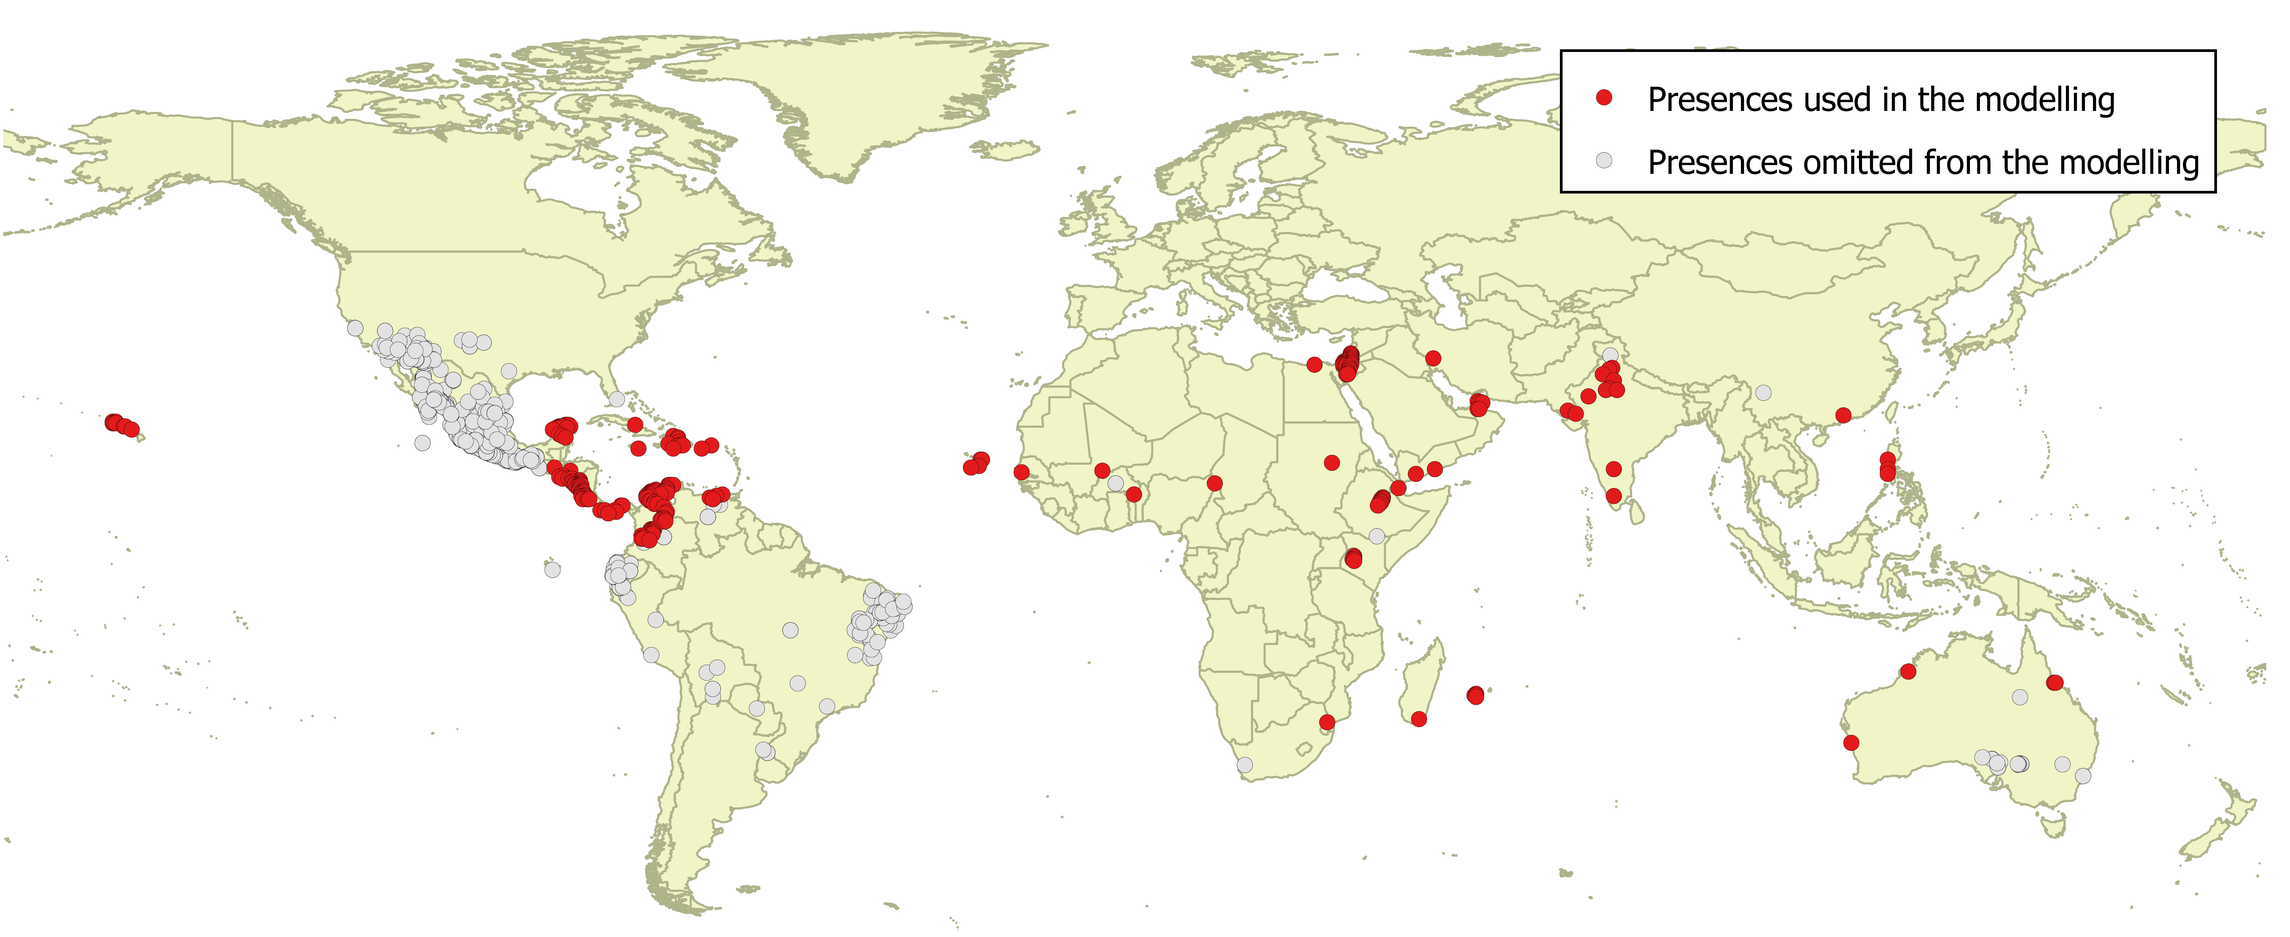

Species distribution model
A presence-background (presence-only) ensemble modelling strategy was employed using the BIOMOD2 R package v3.3-7 (Thuiller et al., 2014, Thuiller et al., 2009). These models contrast the environment at the species’ occurrence locations against a random sample of the global background environmental conditions (often termed ‘pseudo-absences’) in order to characterise and project suitability for occurrence. This approach has been developed for distributions that are in equilibrium with the environment. Because invasive species’ distributions are not at equilibrium and subject to dispersal constraints at a global scale, we took care to minimise the inclusion of locations suitable for the species but where it has not been able to disperse to. Therefore the background sampling region included:
- The area accessible by native P. juliflora populations, in which the species is likely to have had sufficient time to disperse to all locations. For the model we assumed the native range to be a 300 km buffer around the minimum convex polygon bounding all occurrences from Central America (including the Carribbean islands, Colombia and Venezuela); AND
- A relatively small 30 km buffer around all non-native occurrences, encompassing regions likely to have had high propagule pressure for introduction by humans and/or dispersal of the species; AND
- Regions where we have an a priori expectation of high unsuitability for the species (see Figure 2). Absence from these regions is considered to be irrespective of dispersal constraints. The following rules were applied to define the region expected to be highly unsuitable for P. juliflora at the spatial scale of the model:
  - Mean minimum temperature of the coldest month (Bio6) < 5 °C (CABI, 2015). P. juliflora is highly insensitive to frosts and the coldest occurrence has Bio6 = 5.0 °C suggesting this is its minimum tolerance.
  - Mean temperature of the warmest quarter (Bio10) < 14 °C. We assumed areas colder than this would be unable to support growth and reproduction of the species, since the coldest occurrence had Bio10 = 14.1 °C.
  - Climatic moisture index (CMI) > 1.5. Although it tolerates a range of precipitation regimes, P. juliflora is adapted to arid environments (CABI, 2015), so we assumed that regions where precipitation is more than 1.5 times potential evapotranspiration would be too wet. In fact six occurrences (2.7%) were at wetter CMI values, but these were outliers from the main distribution.
  - Precipitation of the driest quarter (Bio17) > 275 mm, also reflecting a preference for arid environments with prolonged dry periods. Four outlying occurrences (1.8%) had higher Bio17 than this.
  - Tree cover > 50%, since P. juliflora is mostly found in open habitats. Four outlying occurrences (1.8%) were in more tree-covered grid cells than this.
In total, 11 occurrence grid cells (5%) were in regions classified as highly unsuitable for the species.
Within this sampling region there will be substantial spatial biases in recording effort, which may interfere with the characterisation of habitat suitability. Specifically, areas with a large amount of recording effort will appear more suitable than those without much recording, regardless of the underlying suitability for occurrence. Therefore, a measure of vascular plant recording effort was made by querying the Global Biodiversity Information Facility application programming interface (API) for the number of phylum Tracheophyta records in each 0.25 x 0.25 degree grid cell. The sampling of background grid cells was then weighted in proportion to the Tracheophyte recording density. Assuming Tracheophyte recording density is proportional to recording effort for the focal species, this is an appropriate null model for the species’ occurrence.
To sample as much of the background environment as possible, without overloading the models with too many pseudo-absences, ten background samples of 10,000 randomly chosen grid cells were obtained (Figure 2).

Figure 2. Randomly selected background grid cells used in the modelling of Prosopis juliflora, mapped as red points. Points are sampled from the native range, a small buffer around non-native occurrences and from areas expected to be highly unsuitable for the species (grey background region), and weighted by a proxy for plant recording effort.
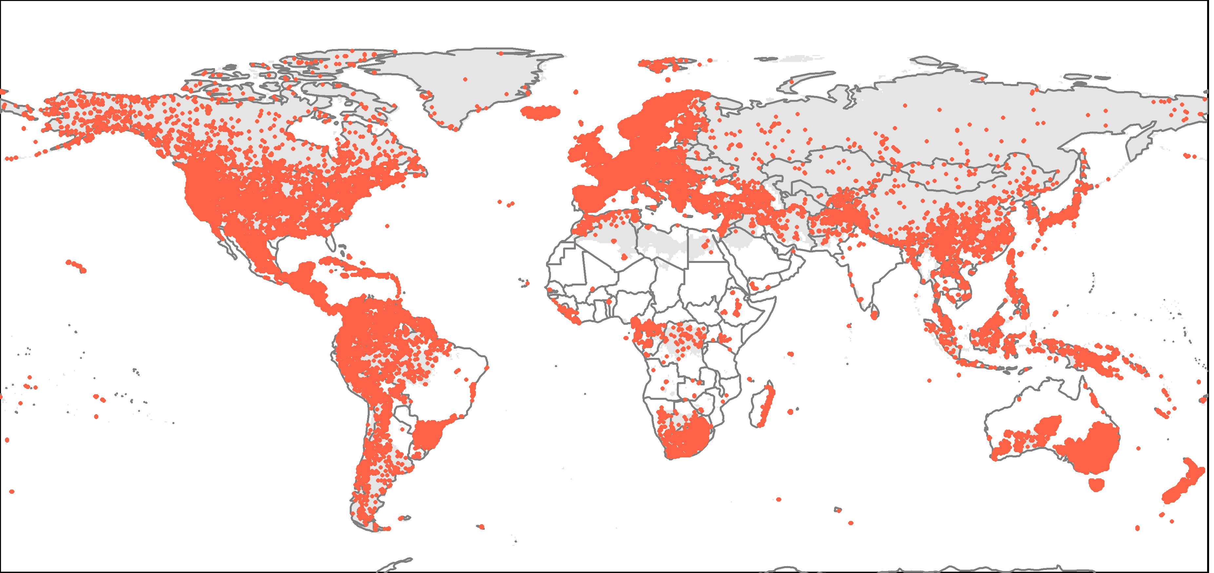

Each dataset (i.e. combination of the presences and the individual background samples) was randomly split into 80% for model training and 20% for model evaluation. With each training dataset, ten statistical algorithms were fitted with the default BIOMOD2 settings and rescaled using logistic regression, except where specified below:
- Generalised linear model (GLM)
- Generalised boosting model (GBM)
- Generalised additive model (GAM) with a maximum of four degrees of freedom per smoothing spline.
- Classification tree algorithm (CTA)
- Artificial neural network (ANN)
- Flexible discriminant analysis (FDA)
- Multivariate adaptive regression splines (MARS)
- Random forest (RF)
- MaxEnt
- Maximum entropy multinomial logistic regression (MEMLR)
Since the background sample was much larger than the number of occurrences, prevalence fitting weights were applied to give equal overall importance to the occurrences and the background. Normalised variable importance was assessed and variable response functions were produced using BIOMOD2’s default procedure. Model predictive performance was assessed by calculating the Area Under the Receiver-Operator Curve (AUC) for model predictions on the evaluation data, that were reserved from model fitting. AUC can be interpreted as the probability that a randomly selected presence has a higher model-predicted suitability than a randomly selected absence.
An ensemble model was created by first rejecting poorly performing algorithms with relatively extreme low AUC values and then averaging the predictions of the remaining algorithms, weighted by their AUC. To identify poorly performing algorithms, AUC values were converted into modified z-scores based on their difference to the median and the median absolute deviation across all algorithms (Iglewicz & Hoaglin, 1993). Algorithms with z < -2 were rejected. In this way, ensemble projections were made for each dataset and then averaged to give an overall suitability.

Results
The ensemble model suggested that suitability for P. juliflora was most strongly determined by the minimum temperature of the coldest month but with substantial effects of the other variables included in the model (Table 1). From Figure 3, the ensemble model estimated suitable conditions for occurrence (>50% suitability) with:
- Minimum temperature of the coldest month > 6.7 °C
- Low climatic moisture index
- Low tree cover
- Low precipitation of the driest quarter
- High mean temperature of the warmest quarter
These estimates are conditional on the other predictors being at their median value in the data used in model fitting.
There was substantial variation among modelling algorithms in the partial response plots (Figure 3). In part this will reflect their different treatment of interactions among variables. Since partial plots are made with other variables held at their median, there may be values of a particular variable at which this does not provide a realistic combination of variables to predict from. It also demonstrates the value of an ensemble modelling approach in averaging out the uncertainty between algorithms.
Global projection of the model in current climatic conditions indicates that the native and known invaded records generally fell within regions predicted to have high suitability (Figure 4). Interestingly, several regions with unreliable records of P. juliflora (see Figure 1) were also modelled as potentially suitable, including the coasts of Mexico and Ecuador, and northeast Brazil. Elsewhere, large areas of Africa, the Middle East, India, southeast Asia and western Australia were projected as being potentially climatically suitable for P. juliflora invasion (Figure 4).
The projection of suitability in Europe and the Mediterranean region suggests that P. juliflora may be capable of establishing around parts of the coastline of the Mediterranean, especially in North Africa and the Middle East, but also in Greece, Cyprus, Italy (Sicily) and Spain (Figure 6). South Portugal and Macaronesia may also have potential for P. juliflora to establish (Figure 6). The main limiting factor preventing further predicted suitability appeared to be low winter temperatures.
By the 2070s, under climate change scenario RCP8.5, the suitability region in Europe is predicted to increase somewhat, but still be restricted to the same regions (Figure 7). The Biogeographical Regions (Bundesamt fur Naturschutz (BfN), 2003) most suitable for P. juliflora establishment are predicted to be Macaronesia and the Mediterranean, with the latter projected to become more suitable under the climate change scenario we evaluated (Figure 8).

Table 1. Summary of the cross-validation predictive performance (AUC) and variable importances of the fitted model algorithms and the ensemble (AUC-weighted average of the best performing algorithms). Results are the average from models fitted to five different background samples of the data.
Algorithm | Predictive AUC | Used in the ensemble | Variable importance
 |  |  | Minimum temperature of coldest month | Mean temperature of warmest quarter | Precipitation of the driest quarter | Climatic moisture index | Tree cover
MARS | 0.9850 | yes | 67% | 3% | 4% | 12% | 13%
GAM | 0.9846 | yes | 63% | 8% | 4% | 13% | 13%
GLM | 0.9831 | yes | 59% | 13% | 5% | 12% | 11%
GBM | 0.9831 | yes | 60% | 4% | 7% | 12% | 17%
ANN | 0.9829 | yes | 49% | 10% | 11% | 16% | 15%
RF | 0.9756 | yes | 52% | 6% | 8% | 22% | 11%
FDA | 0.9754 | yes | 59% | 14% | 20% | 3% | 4%
Maxent | 0.9714 | yes | 64% | 4% | 4% | 18% | 10%
MEMLR | 0.9660 | yes | 57% | 4% | 7% | 27% | 4%
CTA | 0.9606 | no | 57% | 2% | 9% | 16% | 16%
Ensemble | 0.9860 | no | 59% | 7% | 8% | 15% | 11%

Figure 3. Partial response plots from the fitted models, ordered from most to least important. Thin coloured lines show responses from the algorithms in the ensemble, while the thick black line is their ensemble. In each plot, other model variables are held at their median value in the training data. Some of the divergence among algorithms is because of their different treatment of interactions among variables.
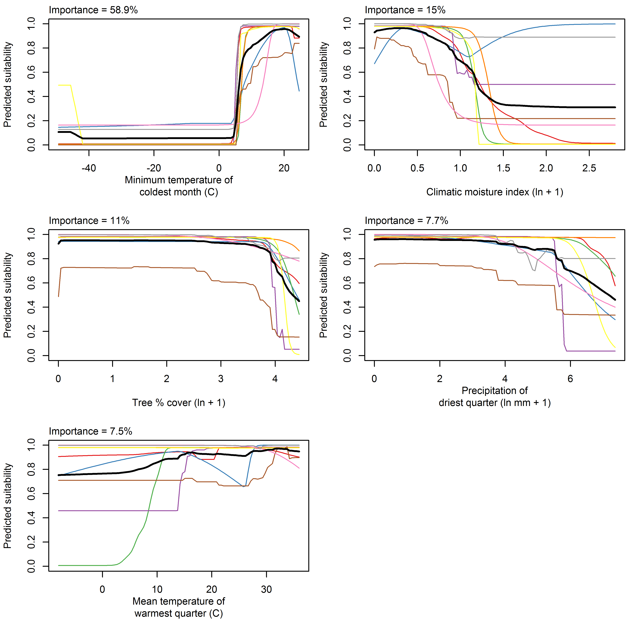

Figure 4. Projected global suitability for Prosopis juliflora establishment in the current climate. For visualisation, the projection has been aggregated to a 0.5 x 0.5 degree resolution, by taking the maximum suitability of constituent higher resolution grid cells. Values > 0.5 may be suitable for the species. The white areas have climatic conditions outside the range of the training data so were excluded from the projection.
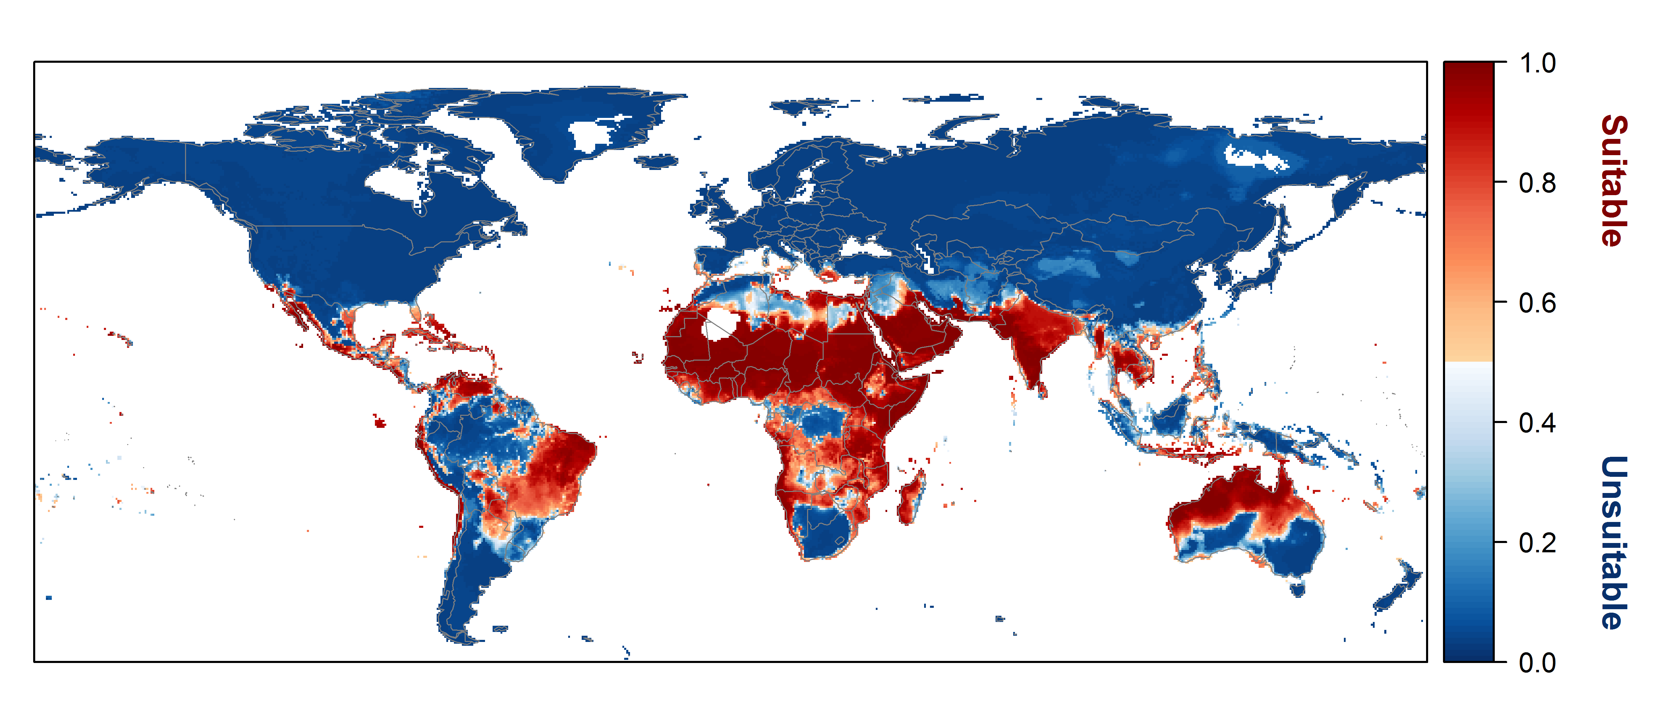

Figure 5. Projected current suitability for Prosopis juliflora establishment in Europe and the Mediterranean region. The white areas have climatic conditions outside the range of the training data so were excluded from the projection.
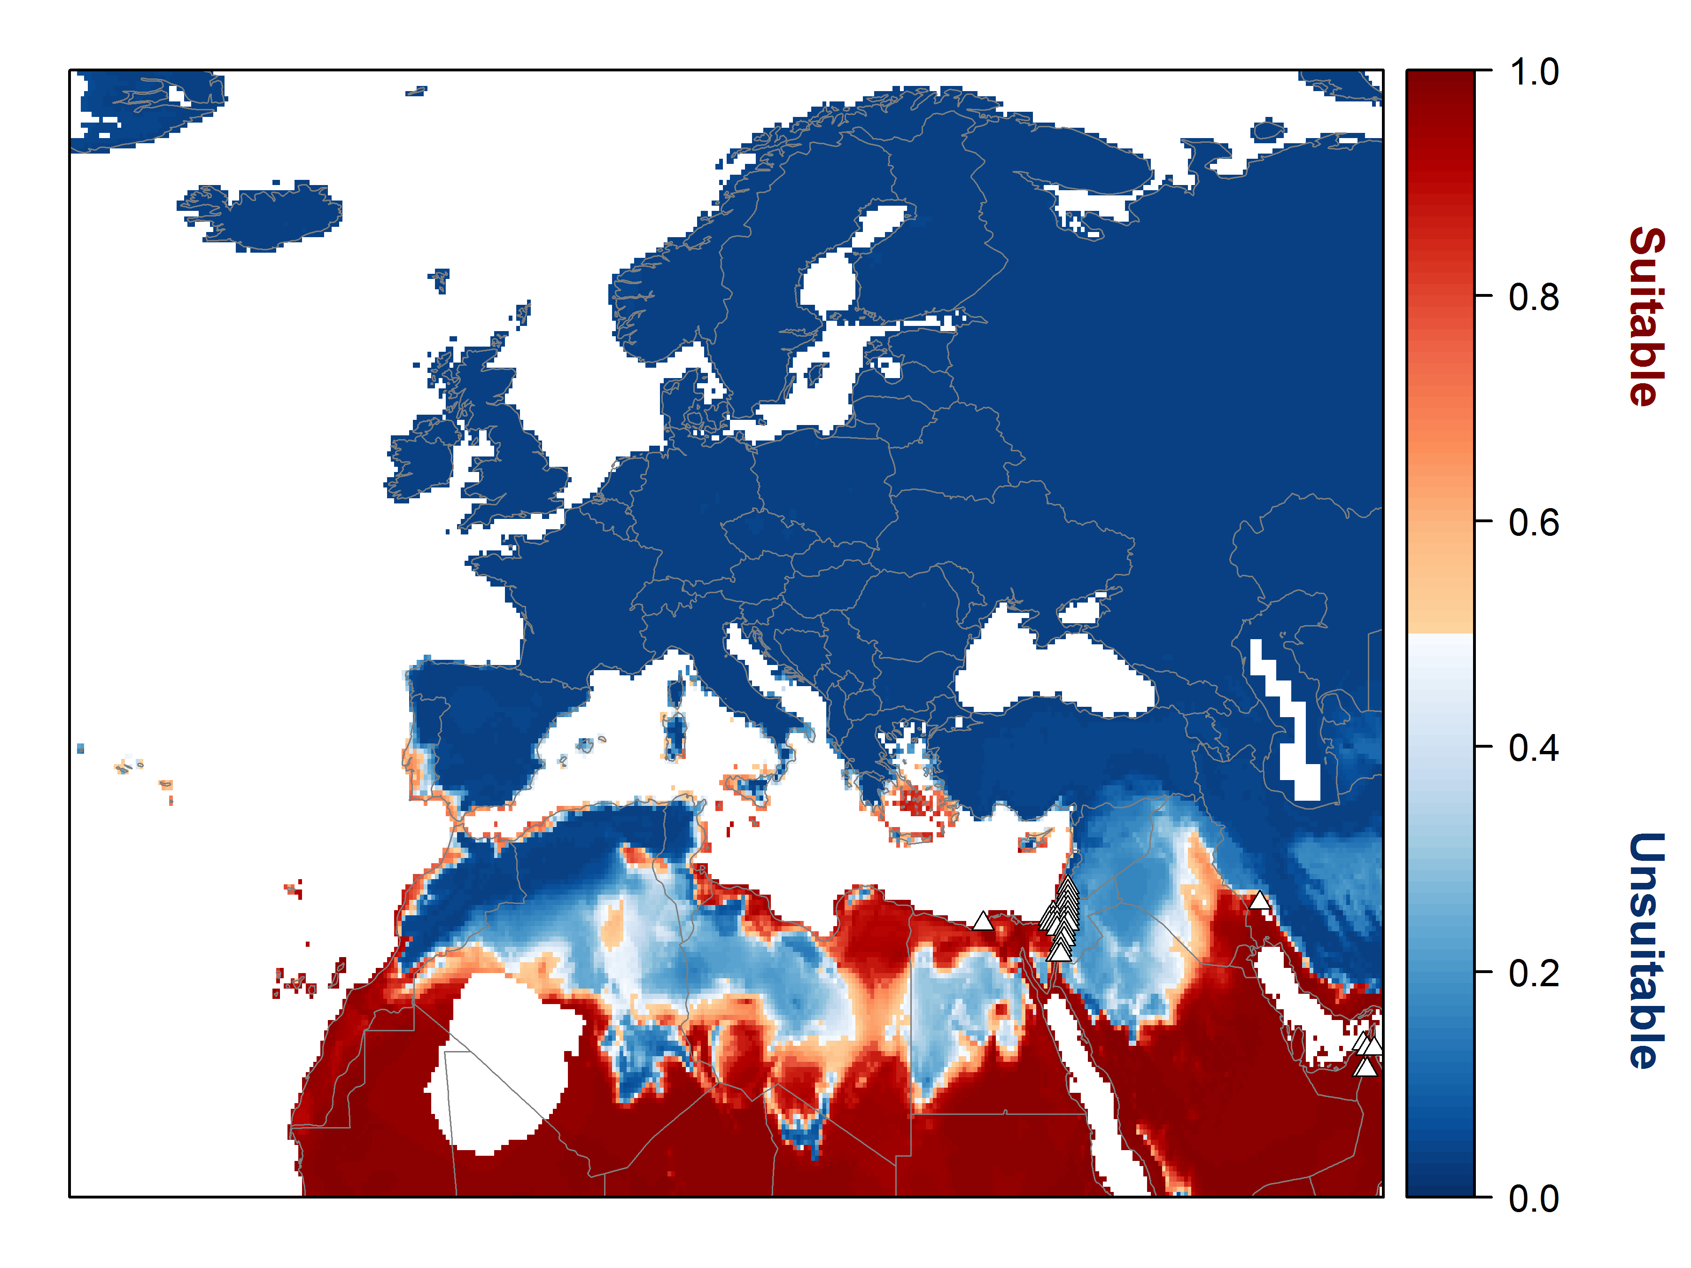

Figure 6. Projected suitability for Prosopis juliflora establishment in Europe and the Mediterranean region in the 2070s under climate change scenario RCP8.5, equivalent to Figure 5.
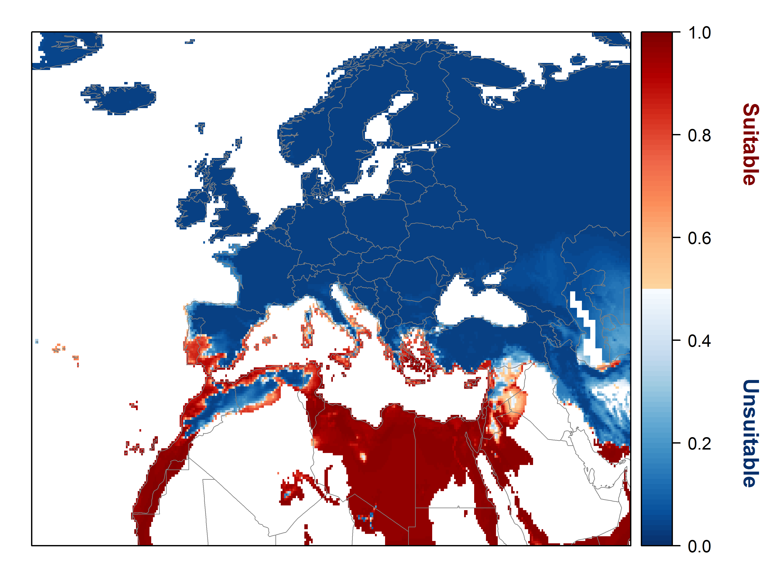

Figure 8. Variation in projected suitability among Biogeographical regions of Europe (Bundesamt fur Naturschutz (BfN), 2003). The bar plots show the proportion of grid cells in each region classified as suitable in the current climate and projected climate for the 2070s under emissions scenario RCP8.5. The coverage of each region is shown in the map below.
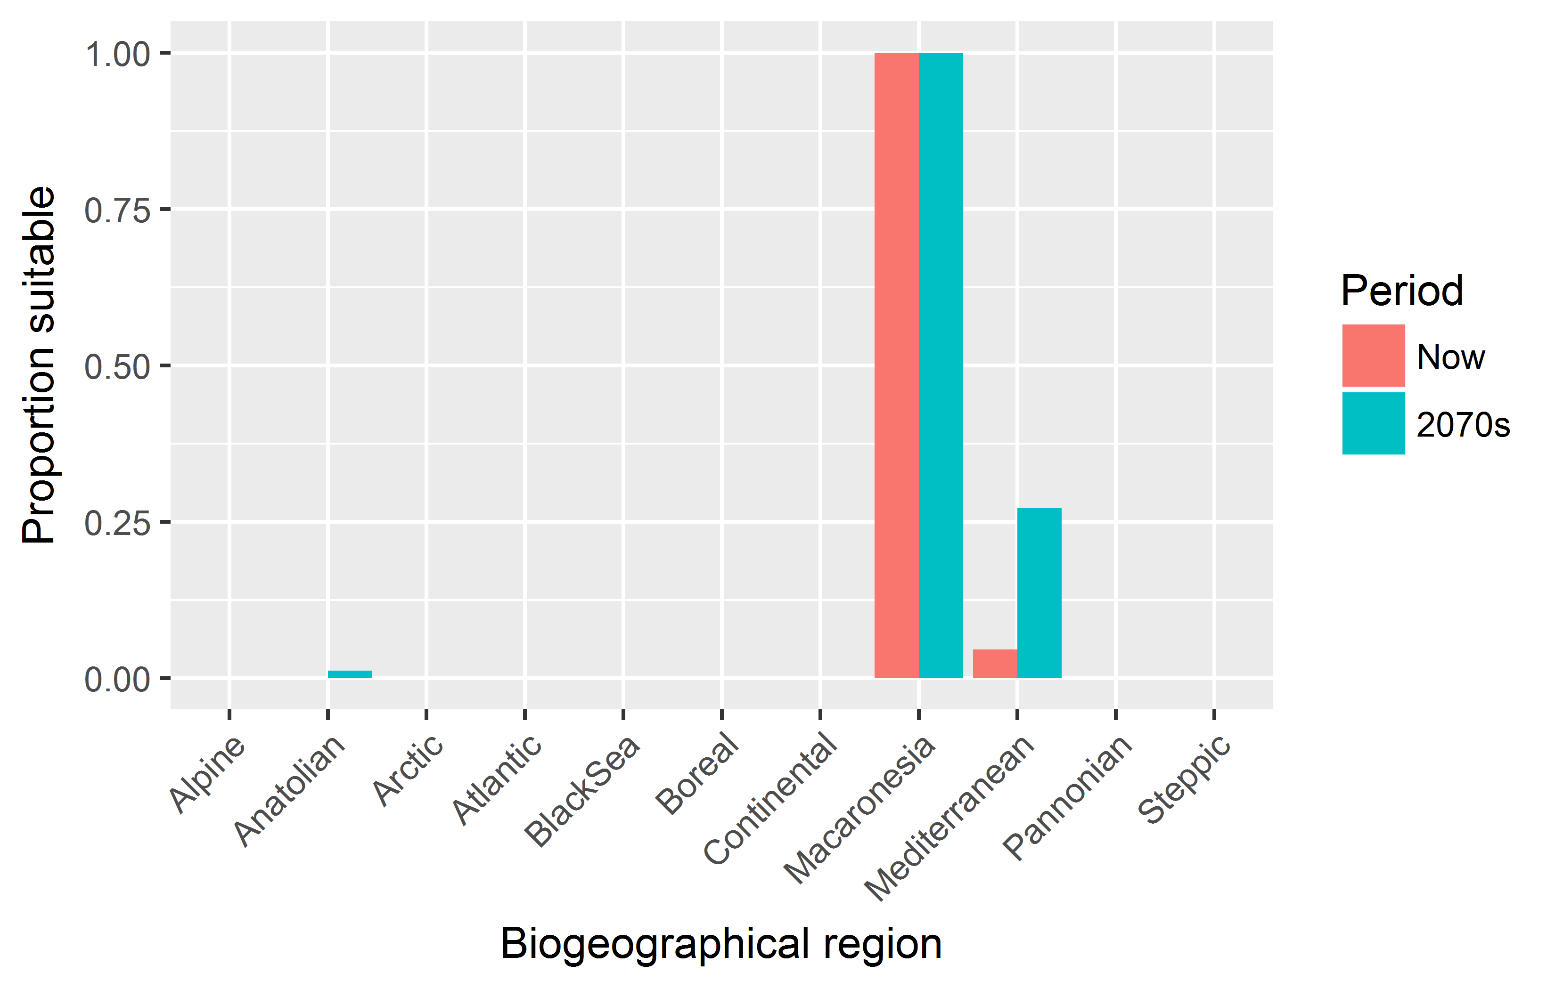

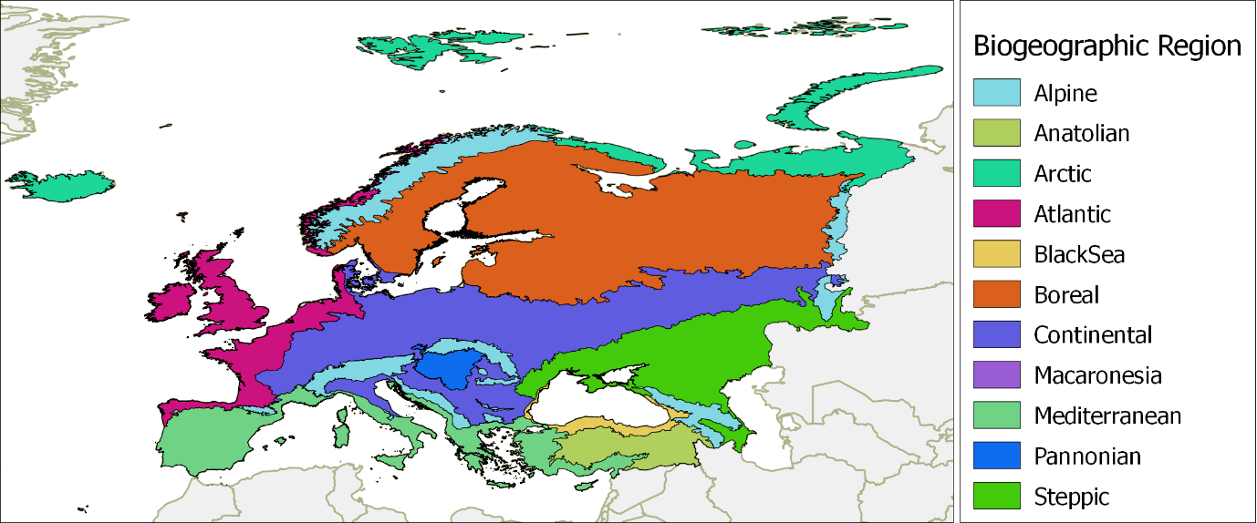

Caveats to the modelling
There was considerable uncertainty as to the status of the P. juliflora distribution records obtained from global databases. We used expert opinion to filter out records that were potentially unreliable, but it is possible that some true P. juliflora were lost. The potential effect of this could be to underestimate the range of conditions under which the species could establish.
To remove spatial recording biases, the selection of the background sample was weighted by the density of Tracheophyte records on the Global Biodiversity Information Facility (GBIF). While this is preferable to not accounting for recording bias at all, a number of factors mean this may not be the perfect null model for species occurrence:
- The GBIF API query used to did not appear to give completely accurate results. For example, in a small number of cases, GBIF indicated no Tracheophyte records in grid cells in which it also yielded records of the focal species.
- We located additional data sources to GBIF, which may have been from regions without GBIF records.
Other variables potentially affecting the distribution of the species, such as soil nutrients, were not included in the model.
Model outputs were classified as suitable or unsuitable using a threshold of 0.5, effectively a ‘prevalence threshold’ given the prevalence weighting of model-fitting. There is disagreement about the best way to select suitability thresholds so we evaluated the threshold selected by the commonly-used ‘minROCdist’ method. This would have selected a threshold of 0.48, slightly increasing the region predicted to be suitable.
The climate change scenario used is the most extreme of the four RCPs. However, it is also the most consistent with recent emissions trends and could be seen as worst case scenario for informing risk assessment.

References
R. J. Hijmans, S. E. Cameron, J. L. Parra, P. G. Jones & A. Jarvis (2005) Very high resolution interpolated climate surfaces for global land areas. International Journal of Climatology 25, 1965-1978.
CABI (2015) Prosopis juliflora (mesquite). In Invasive Species Compendium, Wallingford, UK.
N. Pasiecznik (2001) Prosopis-management by exploitation, not eradication, required to control weedy invasions.
R. J. Zomer, A. Trabucco, D. A. Bossio & L. V. Verchot (2008) Climate change mitigation: A spatial analysis of global land suitability for clean development mechanism afforestation and reforestation. Agriculture, Ecosystems & Environment 126, 67-80.
G. H. Hargreaves (1994) Defining and Using Reference Evapotranspiration. Journal of Irrigation and Drainage Engineering 120.
C. DiMiceli, M. Carroll, R. Sohlberg, C. Huang, M. Hansen & J. Townshend (2011) Annual global automated MODIS vegetation continuous fields (MOD44B) at 250 m spatial resolution for data years beginning day 65, 2000–2010, collection 5 percent tree cover. University of Maryland, College Park, MD, USA.
R. Van Klinken & S. Campbell (2001) The biology of Australian weeds. 37. Prosopis L. species. Plant Protection Quarterly 16, 2-20.
W. Thuiller, D. Georges & R. Engler (2014) biomod2: Ensemble platform for species distribution modeling. R package version 3.3-7 Available at: https://cran.r-project.org/web/packages/biomod2/index.html.
W. Thuiller, B. Lafourcade, R. Engler & M. B. Araújo (2009) BIOMOD–a platform for ensemble forecasting of species distributions. Ecography 32, 369-373.
B. Iglewicz & D. C. Hoaglin (1993) How to detect and handle outliers. Asq Press.
Bundesamt fur Naturschutz (BfN) (2003) Map of natural vegetation of Europe. Web site: http://www.bfn.de/. National data included.

Appendix 2 Biogeographical regions

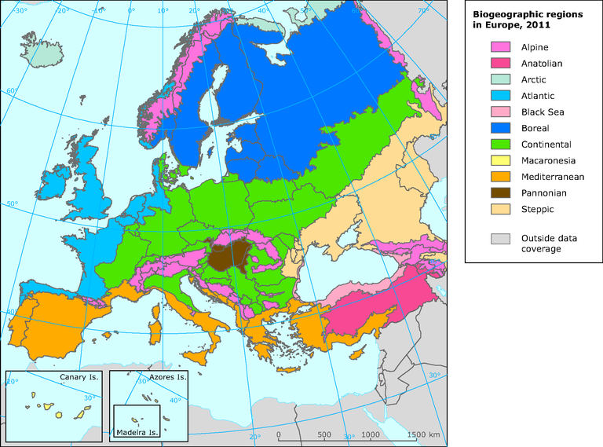

Appendix 3 Supplementary information

Additional common names:
Brazil: algarobeira; algarobia; algarobo; algaroba; Cape Verde: espinheiro; spinho; Colombia: algarrobo; algarrobo forragero; anchipia guaiva; aroma; cují; cují negro; cují yaque; manca-caballo; trupi; trupillo; Costa Rica: arómo; Cuba: algarrobo del Brasil; algarrobo exótico; cambrón; chachaca; guatapaná; pluma de oro; Curaçao: cojí wawalú; cuida; indjoe; indju; kuigi; qui; wawahi; Djibouti: Dat caxa; garan-wa; Dominican Republic: bayahon; bayahonda; bayahonda blanca; bayahonde; bohahunda; cambrón; mezquite; vallahonda; Ecuador: algarrobo; El Salvador: carbon; Germany: Mesquitbaum; Mesquitebaum; Guatemala: campeche; nacascol; nacasol; palo de Campeche; Haiti: baron; bayahonde; bayahonde française; bayarone; bayawon; bayawonn; bayawonn française; bayohon; chambron; guatapaná; Hawaii: algaroba; kiawe; mesquite; Honduras: algarrobo; espino real; espino ruco; India: angrezi bavaliya; belari jali; ganda babul; ganda-babool; gando baval; vilayati babool; vilayati babul; vilayati khejra; vilayati kikar; karuvelam; Iraq: shouk shami; Jamaica: cashaw; cashew; Kenya: eterai; mathenge; prosopis; Mali: gaudi maaka; Marquesas: carobier; Mexico: algarroba; catzimec; chachaca; mareño; mesquite; Middle East: ghaf; Nicaragua: acacia de Catarina; aquijote negro; espino negro; Niger: mugun kawa; shejain kawa; Pakistan: vilayati babul; vilayati jand; vilayati kikar; Panama: aromo; manca-caballo; Peru: algarrobo; huarango; Philippines: aroma; Puerto Rico: algarroba; Algarroba del Hawaii; algarrobo americano; aroma; aroma americana; bayahonde; cambrón; mesquite; Senegal: dakkar toubab; Somalia: garan-wa; lebi; Sudan: mesquite; Trinidad and Tobago: mesquit-tree; Venezuela: caóbano gateado; cuji; cují amarillo; cuji negro; cují yague; cují yaque; cujicarora; maíz criollo; yaque; yaque blanco; yaque negro

Notes on distribution:
This following text section has been added, based on discussions between members of the EWG and has formed the basis of the occurrence data used for the model calibration. Data are supported by collections of leaf and plant material that were later analyzed, results being reported in Harris et al. (2003), Pasiecznik et al. (2004), Landeras et al. (2006), Pasiecznik et al. (2006), Trenchard et al. (2008), Sherry et al. (2011). See appendix 4 for the distribution of the species.
P. juliflora is considered the only prosopis species present or naturalized or by far the most dominant, in the following ‘P. juliflora only’ list of countries. In these, records for presence of a naturalized specimen of prosopis is considered very likely to be P. juliflora (sensu lato). The second list (‘P. juliflora + other species’) includes other countries where P. julilfora is only one of several naturalized (or native) species, and the situation for each is summarized individually.

Note: This list refers to taxonomic confusion between P. juliflora and of any other Prosopis species of section Algarobia that includes all of the most commonly introduced species, e.g. P. alba, P. chilensis, P. glandulosa, P. juliflora, P. pallida, P. velutina, etc.). It does not include the few ‘Old World natives’, notably P. africana in Africa and P. cineraria and P. farcta in Asia, that are not a taxonomic issue, nor have never been, as these species are very distinct in terms of morphology (and uses), etc. (see Pasiecznik et al. (2004).
And as a rule of a ‘rule of thumb’ from observations in Africa and Asia, it is considered that where Acacia tortillis is native, P. juliflora can survive, and as such, is a good indicator species (Personal communication; N. Pasiecznik, 2017).
P. juliflora only
Americas
Caribbean islands (all) + Atlantic islands (Ascension, St Helena)
Colombia
- with the exception of, perhaps, the very south, near the Ecuador border where the range limits with P. pallida are not clearly defined, but may be considered as discrete.
Venezuela

Africa
Sahelian Africa and the Horn
- Mali, Burkina Faso, Niger, Chad (except around Lake Chad where P. chilensis has been positively identified from scans of leaf sample received, but the frequency and other information is unknown), Sudan (South Sudan likely), Ethiopia, Somalia (including Somaliland and Puntland) (Personal communication, N. Pasiecznik, 2017).
East Africa
- Kenya, and considered very likely in Tanzania and Uganda; and likely in Angola, northern Botswana, Zambia and Zimbabwe (though samples not seen).
Southern Africa
- Mozambique, Madagascar (highly likely)

Asia
Middle East
- Arabian Peninsula countries (all)
- Iran (south coast)
South Asia
- India, Pakistan, Sri Lanka, and whereas plantations of other prosopis species were made and a few scientific trials have been widely published, none are known to have become naturalized (Personal communication, N. Pasiecznik, 2017).
South East Asia
- Myanmar (in the norther, recently identified invasions).
- Philippines (identified as of the Central American race)

Europe
The naturalised reports in Gran Canaria were identified following the completion of the PRA and hence the modelling of the species and although the EWG does not consider this will change the output of the modelling it is noted here.

P. juliflora + other species
Americas
Brazil
- The dominant species in the north east and especially inland areas is certainly P. pallida, and not P. julilfora as is widely used in the literature even today. However, there are records for P. juliflora from coastal areas, and it is likely that it has also naturalized especially in norther coastal areas, adding to the difficulty in resolving the confusion.
Mexico
- The confusion as to the northern native range limit of P. juliflora remains unconfirmed, but it appears likely that the latest detailed analysis (Palacios, 2006) may be correct, and that this lies south of the Guatemala-Mexico border, and all Pacific coastal and inland populations north of this were of other species. However, his work did identify a small population of P. juliflora in coastal Yucatan and which is probable, related to the Caribbean population.
Central America (mainland)
- P. juliflora is certainly the dominant species in Pacific coastal areas, extending up valleys and can be found also on some dry plateau sometime far inland (e.g. in Honduras). It must be noted, however, that away from the coast, there are at least five other native Prosopis species recorded, and although they are rarely confused, confirmation by the untrained eye is not guaranteed.
South America (south of Colombia and Venezuela)
- Palacios et al. (2012) finally accepted that Burkart (1976) was wrong - and de facto, that Johnston (1962) was right), in that there is no P. juliflora in Peru or Ecuador. Thus, all other records for P. juliflora presence the neighbouring countries of Bolivia and Chile must also now be considered as incorrect.

Africa
North Africa
The Mediterranean coast
- The taxonomy of any prosopis material in this region is questioned, including the whole of Tunisia. Many species were planted in early trails, and many have been recorded as ‘present’ in papers such as those in the FAO State of Knowledge (Habit and Saavedra, 1990), etc. More information is needed.
Egypt
- P. juliflora is certainly the common invasive species in the Halaib triangle (south east corner), and is likely elsewhere along the southern border with Sudan, and the Red Sea coast.
Morocco
- It is highly likely that P. julilfora may be presence in Western Sahara, especially in coastal areas.
Algeria and Libya, south of the Tropic of Cancer
- It is possible but not certain that P. juliflora is present in these areas.
Sahelian Africa and the Horn
Cape Verde
- The dominant species is certainly P. pallida, and not P. juliflora as is widely used in the literature even today. However, the only records for P. juliflora (and other species) are from research trials with no naturalization has observed up to 1995, but sterile triploids and it is likely that it is also naturalized especially in coastal areas, adding to the difficulty in resolving the confusion.
Senegal
- The name P. juliflora has and still referred to as the common species. However, earlier work confirmed that P. pallida was the dominant species along the coast (see, e.g Harris et al., 2003, Landeras et al., 2006), and was noted also as the main species in central Senegal as far as Kaffrine, though it is likely that P. juliflora is also present in other areas (Personal communication, N. Pasiecznik, 2017).
Mauritania
- P. juliflora is likely to be the dominant species, widely planted by FAO and other development organizations around Nouakchott and in other parts of the country, but P. pallida was also positively identified as naturalized around Aleg and may be more common in the south and coastal areas (Pasiecznik et al., 2006).
Djibouti
- A nationwide survey (Pasiecznik, 2013) found P. juliflora the dominant species, making up >95%, with P. pallida naturalized in only two areas (Djibouti Ville and Ali Sabieh).
Southern Africa
South Africa (and central and southern Namibia and Botswana).
- The common species are P. glandulosa and P. velutina and hybrids, though as P. juliflora has been identified from around Maputo, Mozambique (pers comm, Pasiecznik) and has been tentatively identified from herbarium samples in Zimbabwe, it is highly likely that it occurs in Limpopo, eastern Mpumalanga, and north coastal Kwazulu Natal.

Asia
Near East
Israel, the West Bank and Jordan
- P. juliflora is present in the Jordon Valley (Dufour-Dror and Shmida, 2017). But occurrence data in Israel, the West Bank and Jordan is questioned by the EWG.
South East Asia
- Records for many Asian countries especially those in the east and south east, are often old and with no further details (e.g. Burkart 1976), though many have been repeated in later publications (e.g. Pasiecznik et al. 2001, Shackleton et al. 2014). As such, specimens may only be ‘odd’ trees and the taxonomy used cannot be verified in any case.

Oceania
Australia
- P. juliflora is consider as the least frequent of the four identified invasive species. In southern areas, P. glandulosa, P. velutina and hybrids dominate. In northern WA, NT and Qld, P. pallida is the dominant invasive, with P. juliflora noted in parts of WA and Qld, though records from NSW may well be mis-identifications.
Hawaii
- Both species are present, it seems, though P. pallida appears to be dominant.
Galapagos
- P. juliflora has been positively identified, but noting the revised classification of Palacios et al. (2012) and the proximity to coastal Peruvian populations, this must be revisited.
Other Pacific Islands
- Both species are apparently present, it seems, though P. pallida appears to be dominant.

Appendix 4. Relevant illustrative pictures (for information)

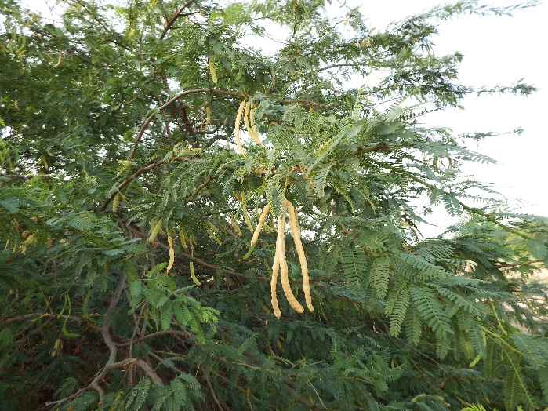

P. juliflora leaves and pods, Somaliland.
Nick Pasiecznik

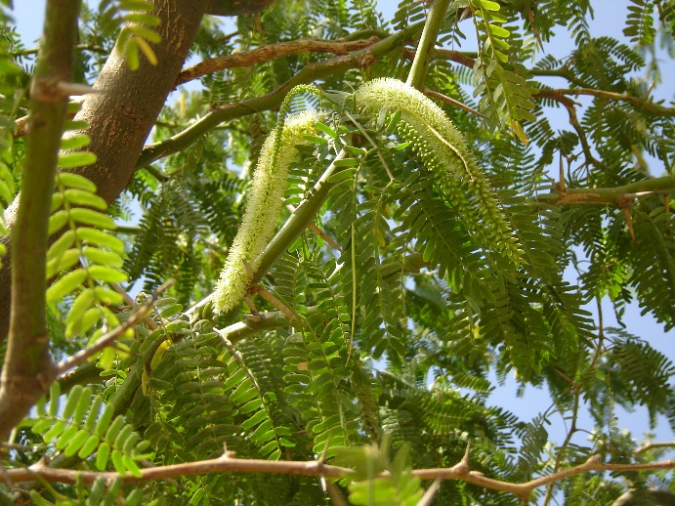

P. juliflora flowers and leaves, Djibouti.
Nick Pasiecznik

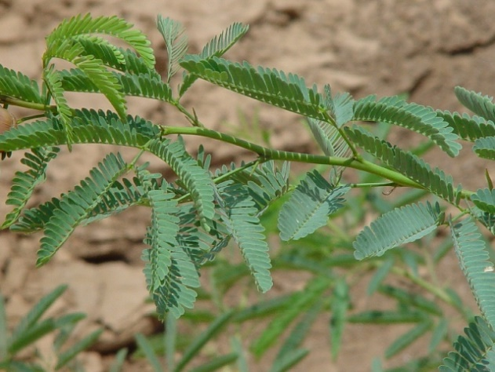

Typical P. juliflora leaves and thorns on an emerging shoot.
Nick Pasiecznik

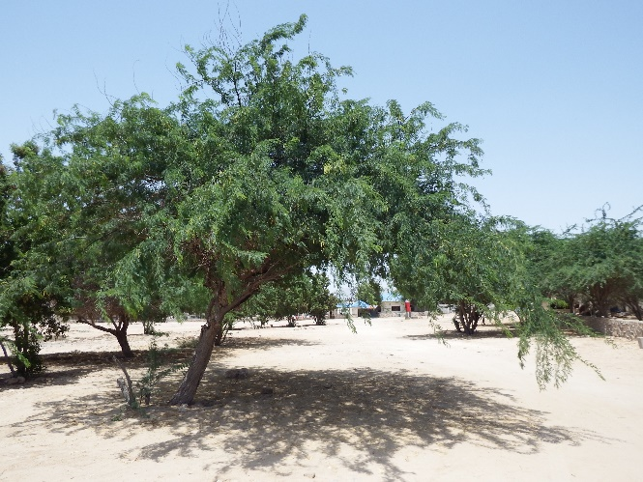

P. juliflora ‘tree’. Around a hotel compound it may have also been ‘pruned’ Nick pasiecznik

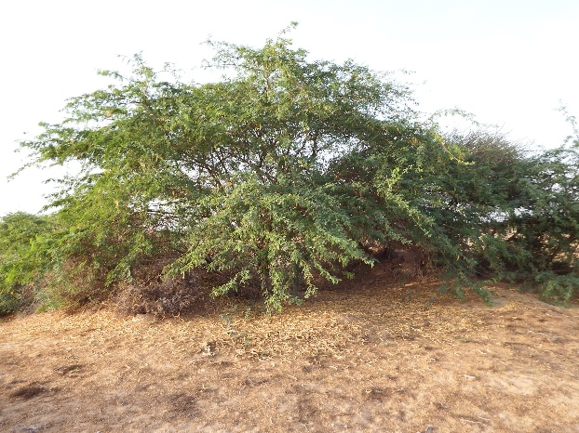

Typical P. juliflora multi-stemmed form. Note also the masses of pods below and around.
Nick Pasiecznik

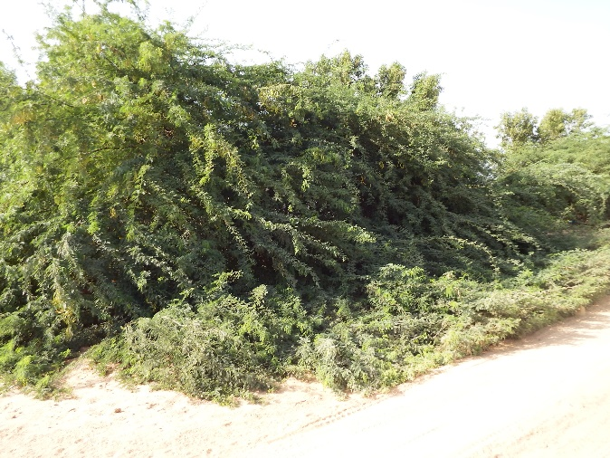

Some P. juliflora shows a much more prostrate form with some branches growing along the ground. Nick Pasiecznik

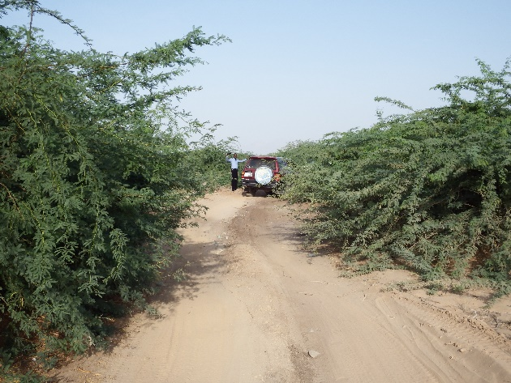

P. juliflora invasion between to block a dirt road, Berbera, Somaliland.
Nick Pasiecznik

P. juliflora invading native Acacia tortillis dominated savanna scrub, Djibouti.
Nick Pasiecznik

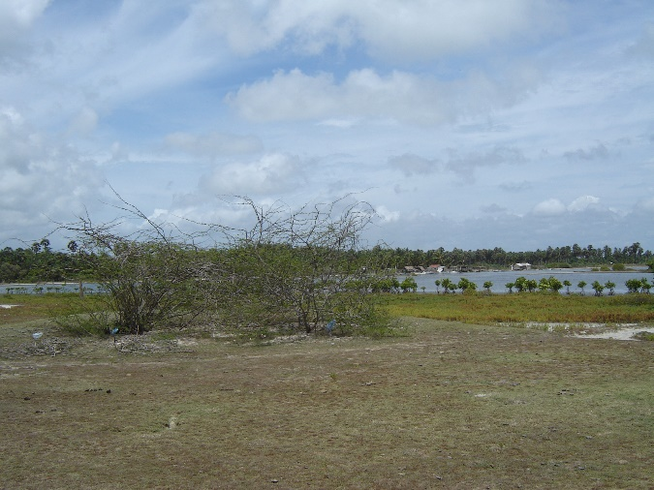

The start of P. juliflora invasion in coastal Sri Lanka, within metres of the shore and mangroves at Puttalam lagoon.
Nick Pasiecznik

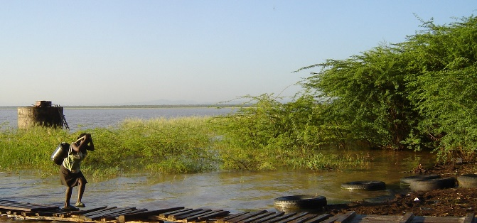

P. julifora invading Lake Baringo shoreline, Kenya, Rains have raised the water level, and waterlogged plants will eventually die, but subrmerged thorned branches are a bane to local people as they tear fishing nets
Nick Pasiecznik

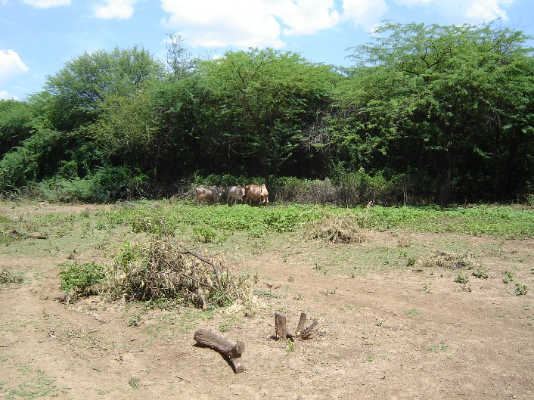

P. julifora invasion, Baringo, Kenya, with cleared land in the foreground.
Nick Pasiecznik

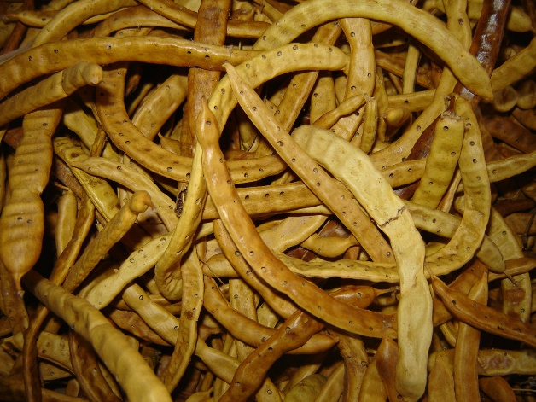

P. juliflora pods attacked by bruchid beetles in Djibouti, assumed to have been introduced accidently from Yemen where they are considered accidentally released by FAO. However, even high levels of infection are not reducing spread, thus showing ineffectualness of bruchids as biocontrol agents.
Nick Pasiecznik

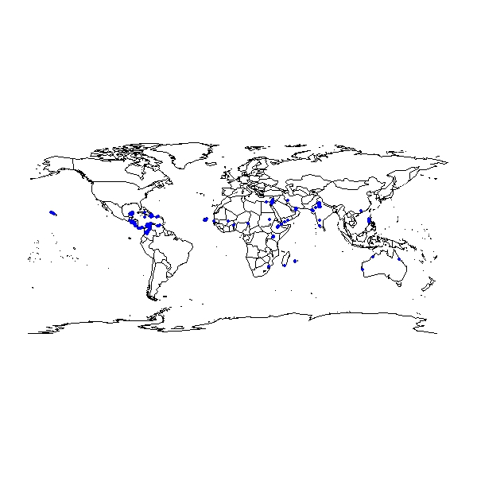
Appendix 5 Distribution maps

Distribution of P. juliflora in central and South America.

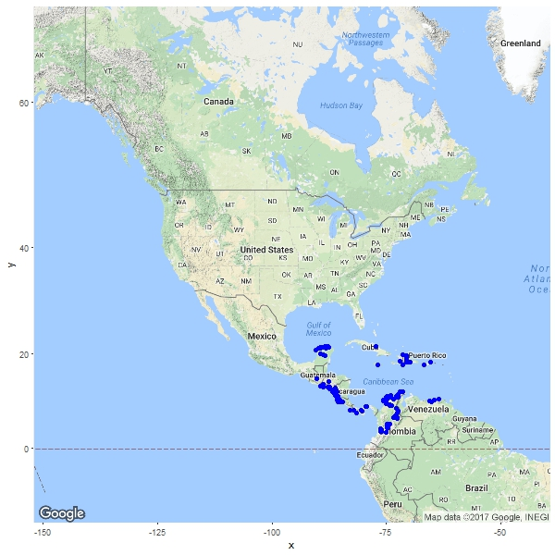

Distribution of P. juliflora in Africa and Asia.

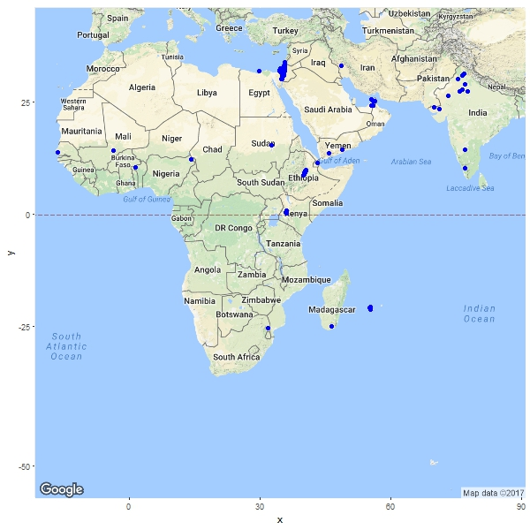

Distribution of P. juliflora in Hawaii

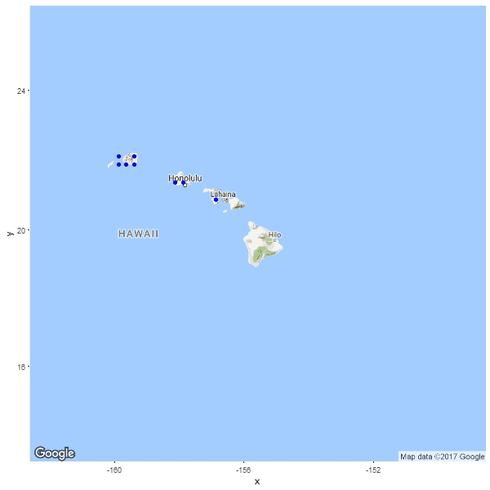

Distribution of P. juliflora in Australia

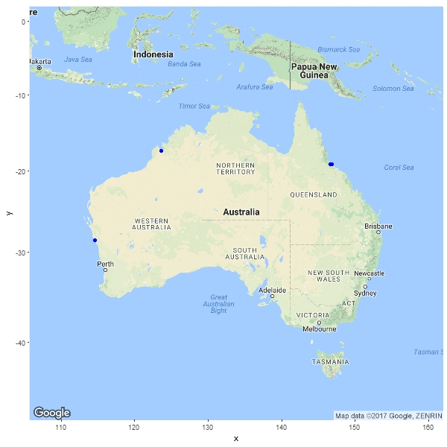

The summary should be elaborated once the analysis is completed
http://ec.europa.eu/environment/nature/invasivealien/docs/Prioritising%20prevention%20efforts%20through%20horizon%20scanning.pdf
Note that these maps may contain records, e.g. herbarium records, that were not considered during the climate modelling stage

