EU Fuel Quality Monitoring - 2010 Summary Report
[

Final Report to the European Commission – DG Climate Action

Ref: DG ENV. 070307/572479/SER/C2

Restricted Commercial
ED56267
Draft V7
Date: 24/07/12

Title | EU Fuel Quality Monitoring Summary Report 2010

Customer | European Commission – DG Climate Action

Customer reference | DG ENV. 070307/572479/SER/C2/SER/C2

Confidentiality, copyright and reproduction | This report is the Copyright of the European Commission and has been prepared by AEA Technology plc. under contract DG ENV. 070307/572479/SER/C2 dated 15/10/2011. The contents of this report may not be reproduced, in whole or in part, nor passed to any organisation or person without the specific prior written permission of the European Commission. AEA Technology plc. accepts no liability whatsoever to any third party for any loss or damage arising from any interpretation or use of the information contained in this report, or reliance on any views expressed therein, other than the liability that is agreed in the said contract

AEA reference | ED56267

Contact details AEA
Gemini Building
Fermi Avenue
Harwell International Business Centre
Didcot
OX11 0QR
United Kingdom
t: +44 (0)870 190 6723
e: Fiona.twisse@aeat.co.uk

AEA is a business name of AEA Technology plc.
AEA is certificated to ISO9001 and ISO14001

Authors | Fiona Twisse, Paul Scott

Approved By | Nikolas Hill

Signed | 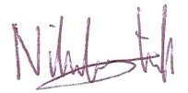

Date | 25th June 2012

Executive Summary
Introduction
This report produced for DG Climate Action represents a consolidation of the tenth year of Member States’ submissions under Directive 98/70/EC, summarising the quality of petrol and diesel in the Community for the year 2010 and reporting on the lifecycle GHG emissions from supplied transport fuels. Specifications for petrol and diesel sold in the European Community are included in the Directive. Three sets of fuel specifications are included, the first entered into force on 1 January 2000 and the second entered into force on 1 January 2005. A third specification for automotive road fuels came into force on 1 January 2009 and limits the sulphur content of all automotive road fuels in the EU to 10 ppm. Additional requirements were defined in the European Standard for fuel quality monitoring systems, EN 14274:2003, required from 2004 under Directive 2003/17/EC. Member States were required under the Directive to report for the first time by 30 June 2002 for the preceding calendar year (i.e. 2001).
The Directive also stipulates that Member States are required to report summaries of the quality of fuels sold in their territories. The original reporting format for this was laid out in Commission Decision 2002/159/EC of 18 February 2002. The requirements of the Directive have changed with the introduction of new fuel specifications and reporting requirements. It is therefore anticipated that a new Commission Decision on the common reporting format for Fuel Quality Monitoring report will be released in line with these changes – although nothing had been released prior to finalisation of this Summary report. All Member States receive an annually updated reporting template in order to ensure inclusion of all pertinent details to enable European wide analysis and comparison of Fuel Quality Monitoring results. This template follows the reporting requirements outlined in Commission Decision 2002/159/EC and is annually reviewed and agreed by the Commission. The 2010 reporting template has been included as an appendix (Reporting Template (2010)).
In 2010, all Member States have complied with the new fuel specifications that states that all automotive road fuels available on the market from 1st January 2009 comply contain less than 10ppm sulphur content. Some Member States have already begun to report fuels with added ethanol from Biofuels (France) and this will be a mandatory reporting requirement from all Member States from 1st January 2011 under Directive amendment 2009/30/EC.
Four Member States (Poland, Germany, the Netherlands and Spain) submitted reports in old reporting templates – or in National formats. In addition, of the 27 annual FQMS reports, 17 were received in time for the reporting deadline of the 30th June, 8 were received less than one month late – during July with two reports received 3 months late (Germany) and 4 months late (the Netherlands). Figure 1-1 presents reporting submissions (of reports received in the correct template) compared to the deadline from 2001. Although it is difficult to identify an overall trend, the majority of submissions have been received either on time or within one month of the reporting deadline. Late submissions can be due to delays in internal approvals within Member State departments but can also be due to submitting the report through incorrect channels.
Figure 1-1: Temporal trends in the punctuality of report submissions
No. of reports received
 | Year
 |  | By deadline |  | 1-2 months late
 |  | 3-4 months late |  | More than 4 months late
 | * Excludes France in 2003 - 2005, as no submissions were provided. Excludes Luxembourg in 2007 to 2009 and Malta in 2006 and 2009 as no reports were provided.
Fuel sales in the EU in 2010 were heavily weighted toward diesel with 246,841 million litres of diesel fuel sales compared to 121,231 million litres of combined petrol grade fuel sales. Of the petrol fuel grades, very small amounts of RON 91 were still available on the market with sales of only 1,617 million litres. RON 98 and RON 95=<RON<98 fuel sales totalled 6,409 and 32,897 million litres respectively whilst RON 95 represented the majority of petrol fuel sales with 80,307 million litres.
Figure 1-2: EU fuel sales by fuel type
Petrol  Diesel | 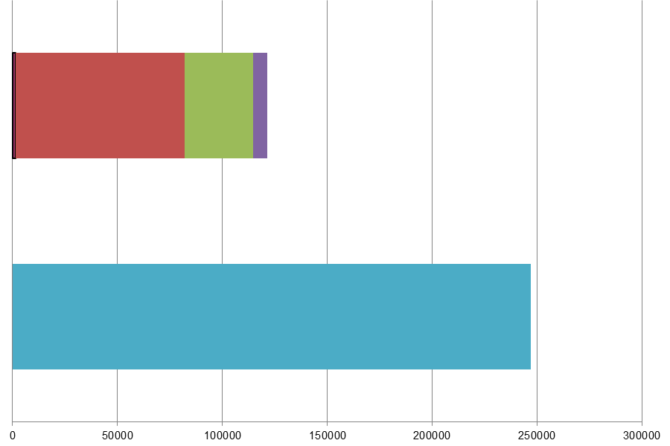
 | Million Litres
 |  |  | RON=91 |  |  | RON = 95 |  |  | RON 95=<RON<98 |  |  | RON 98 |  |  | Diesel
The overall EU-wide fuel sales in 2010 (see Figure 1-3) remained similar to sales in 2009 – with a marginal increase in diesel fuel sales and a decrease in petrol fuel sales resulting in a total increase of 229 million litres automotive road fuels.
Figure 1-3: Temporal trends in EU fuel sales
Year |  | 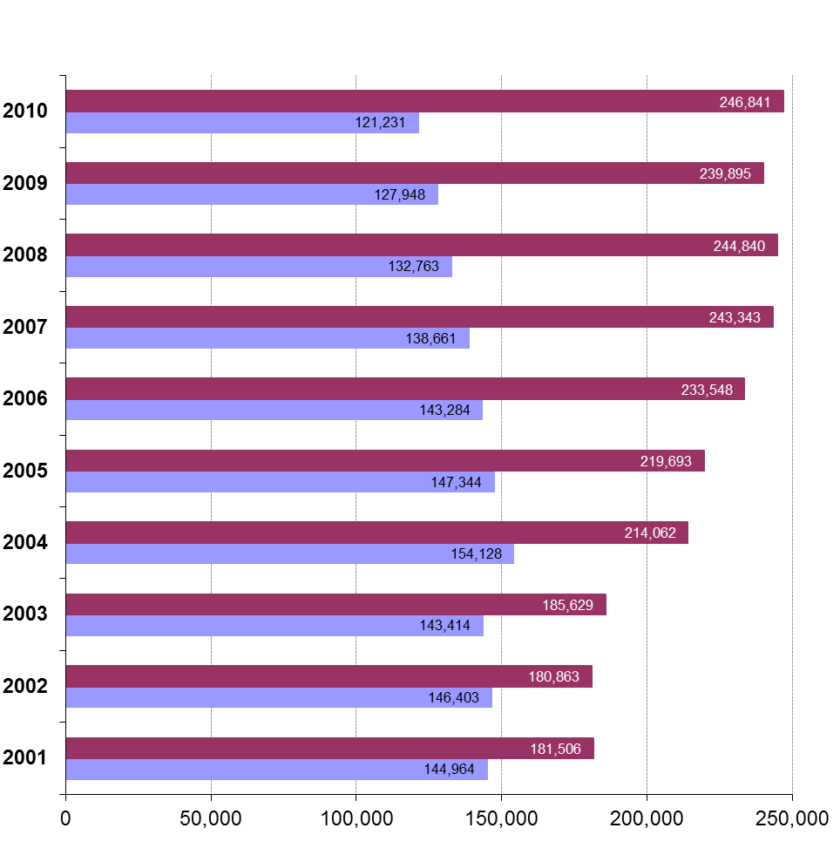
 | Million Litres
 |  |  |  |  | Diesel |  |  |  |  |  | Petrol
* Excludes France in 2003 - 2005, as no submissions were provided. Excludes Luxembourg in 2007 to 2009 and Malta in 2006 and 2009 as no reports were provided.
Individual member state reports in 2010 demonstrated increased compliance with the minimum sampling requirements outlined in EN 14274, however national models still, in some cases fall short of equivalence with EN 14274 standards. Figure 1-4 shows the total samples taken in the EU temporally from 2001 – 2010.
Figure 1-4: Temporal trends in sample quantities
Samples taken | 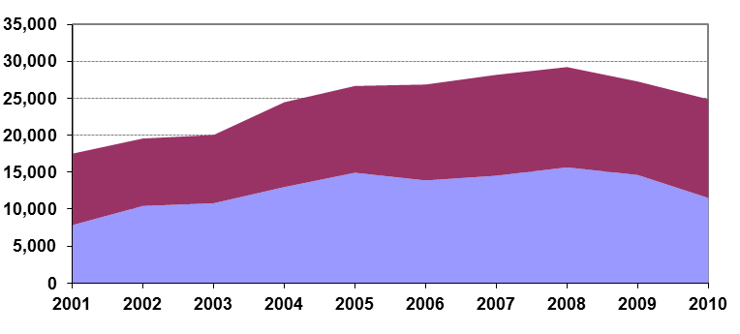
 | Year
 |  | Diesel |  | Petrol
* Excludes France in 2003 - 2005, as no submissions were provided. Excludes Luxembourg in 2007 to 2009 and Malta in 2006 and 2009 as no reports were provided.
Non-compliance of individual sample tests with petrol fuel standard EN 228 have increased slightly in 2010 compared to 2009 – with non-compliances for diesel against EN 590 have decreasing slightly in 2010. Exceedences have been assessed against the volume of fuel sold compared to the number of samples taken and reported by the Member State to give volume weighted exceedences in Figure 1-5. This shows an increase in 2010 compared to previous years and the continuation of a somewhat disturbing upward trend since 2003.
Figure 1-5: Temporal trends in total limit value non-compliances for petrol and diesel fuels
Non-compliance as a % weighted by fuel sales volume
 | Year
 |  | Diesel |  | Petrol
* Excludes France in 2003 - 2005, as no submissions were provided. Excludes Luxembourg in 2007 to 2009 and Malta in 2006 and 2009 as no reports were provided.

Key areas for improvement
- A significant number of Fuel Quality Monitoring reports were received after the deadline of 30th June 2010. This could be improved and Member States should submit reports to the Commission according to instructions given in the Commission Decision 2002/159/EC of 18 February 2002 and submit an electronic copy of the report to ENV-Report-98-70@ec.europa.eu along with a hard copy submitted formally to the Secretary General.
- Some Member States are unable to confirm sales figures at the time of submitting the original report and request updates to their report after the submission deadline date. These requests are honoured wherever possible; however Member States should endeavour to submit their complete and accurate reports by the 30th June.
- Reporting templates have been developed and disseminated to all in order to enable accurate, consistent, replicable and comparable reporting. Member States are encouraged to provide their annual FQM report in the template provided to assist with the timely analysis and reporting of EU-wide results. The report template is also updated annually to reflect changes as new requirements superseded those outlined originally in Directive 98/70/EC. It is anticipated that a new Commission Decision will update the Common reporting format for Fuel Quality Monitoring reports, shortly.
- As in previous years, some Member States basic numerical data appears to be inconsistent when scrutinised for the analysis. Most inconsistencies are minor – for example contradictory sample numbers when comparing those in reporting sheets with those cited in the sales reporting table. These errors are not insurmountable but delay reporting and, in some cases, the correct number of samples has been impossible to determine, resulting in some anomalous figures.
- Member States can be clearer about the transition periods during which time the winter/ summer fuel grades are replaced with the corresponding grades for the opposite season. If the Member States are reporting samples found to be out of specification that were taken during the transition period – this should be made clear.
- Monitoring and consistency with EN 14274 standards;
  - Some Member States have consistently selected a statistical model from those outlined in EN 14274 or a National model that may not be the best suited to their fuel sales, supply and distribution conditions.
  - Some Member States still report samples taken from terminals and refineries in place of those at service stations. Any sampling from terminals/ refineries should be taken and reported in addition to those at service stations to allow presentation of fuel quality at the point of use and highlight any issues or contamination in the supply chain. Latvia, the UK and Sweden have not provided details of sample locations – making it impossible to determine equivalence or compliance with EN 14274. Additionally, Greece, Malta, Ireland, Italy and Luxembourg have all sampled insufficient quantities at service stations while Lithuania has sampled only diesel insufficiently at service stations. This list includes Member States who have sampled according to a National system as National systems should demonstrate equivalence with minimum requirements of the EN 14274 statistical models and the samples quantities at service stations do not appear to do so.
  - Required sample quantities are defined in EN 14274 according to the market share of the fuel type. Any fuels with a market share within the national territory of 10% and above should be sampled a minimum of 50, 100 or 200 times in both summer and winter periods according to the size of the territory and the FQMS model (or National equivalent) used. Some Member States still sample in insufficient quantities.
  - Fuels with a market share of less than 10% can be sampled in lower quantities as per EN 14274 section 5.4.2 – however sample quantities should also be carried out in each period (summer and winter).
  - Member States have the option of using a nationally defined monitoring system in place of those outlined in EN 14274. However, Member States are not using notes sections provided in the reporting template to give details about the model used and equivalence with EN 14274 statistical models A, B and C. Member States should provide an explanation of the National monitoring system and the rationale for using this system to demonstrate equivalence with models described in EN14274.
  - In some instances, Member States have reported all 18 petrol and 5 diesel parameters, but have omitted results for some parameters from the report because the samples results are >1. Part of the report analysis is to assess reports for completeness – it is essential, therefore that as much supporting information is provided as possible, to ensure no incorrect conclusions are drawn from the reports.

Table of Contents
1 Introduction 1
1.1 Report Structure 2
1.2 Context 3
2 Member State Summaries: Reporting Format and Requirements 10
2.1 Fuel Availability 13
2.2 Fuel Quality Monitoring 15
2.3 Greenhouse gas emissions 19
2.4 Temporal trends 19
2.5 Statistical Analysis 19
2.6 Member State Summaries 20
3 EU Summary 21
3.1 Fuel Availability 2010 21
3.2 Fuel Quality Monitoring 2010 26
3.3 Temporal Trends 37
4 Statistical Analysis 42
4.1 Introduction to the Analysis Process 42
4.2 Key parameters – EU results 45
5 Austria 52
5.1 Fuel Availability 2010 52
5.2 Fuel Quality Monitoring 2010 53
5.3 Temporal Trends 55
5.4 Statistical Analysis 55
5.5 Key Areas for Improvement 59
6 Belgium 60
6.1 Fuel Availability 2010 60
6.2 Fuel Quality Monitoring 2010 62
6.3 Temporal Trends 64
6.4 Statistical Analysis 64
6.5 Key Areas for Improvement 67
7 Bulgaria 69
7.1 Fuel Availability 2010 69
7.2 Fuel Quality Monitoring 2010 71
7.3 Temporal Trends 74
7.4 Statistical Analysis 74
7.5 Key Areas for Improvement 76
8 Cyprus 78
8.1 Fuel Availability 2010 78
8.2 Fuel Quality Monitoring 2010 80
8.3 Temporal Trends 82
8.4 Statistical Analysis 82
8.5 Key Areas for Improvement 85
9 Czech Republic 87
9.1 Fuel Availability 2010 87
9.2 Fuel Quality Monitoring 2010 88
9.3 Temporal Trends 91
9.4 Statistical Analysis 91
9.5 Key Areas for Improvement 94
10 Denmark 96
10.1 Fuel Availability 2010 96
10.2 Fuel Quality Monitoring 2010 98
10.3 Temporal Trends 99
10.4 Statistical Analysis 100
10.5 Key Areas for Improvement 103
11 Estonia 105
11.1 Fuel Availability 2010 105
11.2 Fuel Quality Monitoring 2010 106
11.3 Temporal Trends 108
11.4 Statistical Analysis 109
11.5 Key Areas for Improvement 112
12 Finland 113
12.1 Fuel Availability 2010 113
12.2 Fuel Quality Monitoring 2010 114
12.3 Temporal Trends 116
12.4 Statistical Analysis 116
12.5 Key Areas for Improvement 120
13 France 121
13.1 Fuel Availability 2010 121
13.2 Fuel Quality Monitoring 2010 122
13.3 Temporal Trends 125
13.4 Statistical Analysis 125
13.5 Key Areas for Improvement 129
14 Germany 130
14.1 Fuel Availability 2010 130
14.2 Fuel Quality Monitoring 2010 132
14.3 Temporal Trends 134
14.4 Statistical Analysis 134
14.5 Key Areas for Improvement 135
15 Greece 136
15.1 Fuel Availability 2010 136
15.2 Fuel Quality Monitoring 2010 138
15.3 Temporal Trends 139
15.4 Statistical Analysis 139
15.5 Key Areas for Improvement 142
16 Hungary 144
16.1 Fuel Availability 2010 144
16.2 Fuel Quality Monitoring 2010 145
16.3 Temporal Trends 146
16.4 Statistical Analysis 147
16.5 Key Areas for Improvement 150
17 Ireland 151
17.1 Fuel Availability 2010 151
17.2 Fuel Quality Monitoring 2010 152
17.3 Temporal Trends 154
17.4 Statistical Analysis 155
17.5 Key Areas for Improvement 158
18 Italy 159
18.1 Fuel Availability 2010 159
18.2 Fuel Quality Monitoring 2010 160
18.3 Temporal Trends 162
18.4 Statistical Analysis 163
18.5 Key Areas for Improvement 166
19 Latvia 167
19.1 Fuel Availability 2010 167
19.2 Fuel Quality Monitoring 2010 168
19.3 Temporal Trends 169
19.4 Statistical Analysis 170
19.5 Key Areas for Improvement 173
20 Lithuania 174
20.1 Fuel Availability 2010 174
20.2 Fuel Quality Monitoring 2010 176
20.3 Temporal Trends 176
20.4 Statistical Analysis 177
20.5 Key Areas for Improvement 180
21 Luxembourg 182
21.1 Fuel Availability 2010 182
21.2 Fuel Quality Monitoring 2010 184
21.3 Temporal Trends 185
21.4 Statistical Analysis 185
21.5 Key Areas for Improvement 188
22 Malta 190
22.1 Fuel Availability 2010 190
22.2 Fuel Quality Monitoring 2010 191
22.3 Temporal Trends 193
22.4 Statistical Analysis 193
22.5 Key Areas for Improvement 197
23 Netherlands 199
23.1 Fuel Availability 2010 199
23.2 Fuel Quality Monitoring 2010 201
23.3 Temporal Trends 202
23.4 Statistical Analysis 203
23.5 Key Areas for Improvement 203
24 Poland 205
24.1 Fuel Availability 2010 205
24.2 Fuel Quality Monitoring 2010 207
24.3 Temporal Trends 208
24.4 Statistical Analysis 209
24.5 Key Areas for Improvement 209
25 Portugal 211
25.1 Fuel Availability 2010 211
25.2 Fuel Quality Monitoring 2010 212
25.3 Temporal Trends 215
25.4 Statistical Analysis 215
25.5 Key Areas for Improvement 219
26 Romania 220
26.1 Fuel Availability 2010 220
26.2 Fuel Quality Monitoring 2010 221
26.3 Temporal Trends 224
26.4 Statistical Analysis 224
26.5 Key Areas for Improvement 225
27 Slovakia 227
27.1 Fuel Availability 2010 227
27.2 Fuel Quality Monitoring 2010 228
27.3 Temporal Trends 229
27.4 Statistical Analysis 230
27.5 Key Areas for Improvement 233
28 Slovenia 235
28.1 Fuel Availability 2010 235
28.2 Fuel Quality Monitoring 2010 237
28.3 Temporal Trends 238
28.4 Statistical Analysis 238
28.5 Key Areas for Improvement 238
29 Spain 240
29.1 Fuel Availability 2010 240
29.2 Fuel Quality Monitoring 2010 242
29.3 Temporal Trends 243
29.4 Statistical Analysis 244
29.5 Key Areas for Improvement 245
30 Sweden 246
30.1 Fuel Availability 2010 246
30.2 Fuel Quality Monitoring 2010 247
30.3 Temporal Trends 248
30.4 Statistical Analysis 249
30.5 Key Areas for Improvement 250
31 UK 251
31.1 Fuel Availability 2010 251
31.2 Fuel Quality Monitoring 2010 253
31.3 Temporal Trends 254
31.4 Statistical Analysis 254
31.5 Key Areas for Improvement 257
32 Discussion and Conclusion 259
32.1 Discussion 259
32.2 Conclusions and Recommendations 260
33 Glossary 261
33.1 Member State Abbreviations 263
34 Appendices 264
34.1 Details on Limit Values, Test Methods and Tolerance Limits 265
34.2 Reporting Template (2010) 266

Introduction
Key Messages
This report summarises the quality of petrol and diesel in the Community for the year 2010.
Concerns over air quality and climate change have grown significantly in the past decade. Transport is a significant contributor to emissions of greenhouse gases and other pollutants that are harmful to human health. The European Union has introduced specifications on fuel quality in order to reduce these emissions.
This report provides an EU-wide Summary of an analysis of the quality of automotive road fuels available in the community during 2010. In addition to the EU-wide analysis, Member State reports are summarised in individual chapters. This report is accompanied by an online database, to be made publicly available by the Commission that provides Member State data in its raw form.
This section outlines the key amendments to the Directives and implications for FQM reporting. The specifications and reporting formats have evolved since the first Directive entered into force in 1998. The most recent amendments entered into force in 2009 are discussed in detail at the end of this chapter
Directive 98/70/EC, introduced specifications on the quality of petrol and diesel available within the European Community. The specifications for petrol and diesel sold in the European Community are included in the Directive for each parameter to be reported. Three sets of fuel specifications are included in the Directive; the first entered into force on 1 January 2000, the second entered into force on 1 January 2004 and both were superseded by specifications outlined in Directive 2009/30/EC which came into force on 1st January 2010 (which amended and widened the scope of Member States FQM reporting obligations as well as updating fuel specifications). The Directives have also effected a reduction in the sulphur content of automotive road fuels with the maximum sulphur content limit of 10ppm coming into force on the 1st January 2009.
The Directive also stipulates that Member States must report on the quality of fuels sold in their territories. The original reporting format for this was laid out in Commission Decision 2002/159/EC of 18 February 2002. Additional requirements were defined in the European Standard for fuel quality monitoring systems, EN 14274:2003, required from 2004 under Directive 2003/17/EC.
Directive 2009/30/EC of 23 April 2009 has introduced a number of new requirements to fuel quality monitoring reporting, summarised briefly as follows:
- Article 7a – with effect from 1 January 2011, Member States are required to collect lifecycle GHG emissions characteristics for fuels within their national territories from suppliers with further obligations to reduce GHG emissions according to a predetermined timeline.
- Introduction of a new grade of petrol with up to 10% ethanol by volume.
- Provisions for a derogation whereby petrol fuels with added ethanol may be subject to higher summer vapour pressure limits, where the increase in vapour pressure corresponds with the additional ethanol content and the ethanol added is a biofuel.
- Article 8a - Metallic Additives (MMT) to be limited to 6 mg Manganese per litre from 1 January 2011 (with a subsequent reduction in 2014) and the presence of MMT in fuels shall be labelled clearly at the point of sale.
- Revisions to the definition of ‘Severe’ or ‘Arctic’ conditions based on temperatures being below the EU average.
- A requirement for Member States to ensure that suppliers market petrol with a maximum oxygen content of 2.7 % and a maximum ethanol content of 5 % until 2013.
Member States are required, under the Directive, to report on fuel quality monitoring findings of the previous calendar year by 30 June. The first year of reporting was 2002. The 10 new Member States joining the EU in 2004 submitted their first reports in 2005 for the period between May and December 2004. Bulgaria and Romania joined the EU in 2007, and both countries voluntarily submitted reports for 2006. A summary of all the submissions received for the years 2001 to 2009 have been presented in previous reports.
The FQM reporting template was originally developed in line with Commission Decision 2002/159/EC and is updated on an annual basis to reflect changing requirements and to encourage accurate and complete reporting from Member States. The Member States submitted reports for 2010 with varying degrees of completeness and accuracy. Of particular note, Sweden has sampled only at terminals and as the same diesel grade is available in Sweden in both summer and winter, only provides a full year report. However The Swedish samples have only been taken from terminals in June and December – with no temporal spread to the sampling and no sampling at the end of the supply chain. Sweden has also neglected to provide the Standard Deviation for samples (as required by the Directive) and does not provide additional statistical information requested by the Commission for 2010 reporting. Some Member States still do not sample and test according to test methods outlined in the Directive – for example Sweden still reports cetane index rather than cetane number and Ireland has stated that the reproducibility of some of the test methods used mean that the sample results cannot be fully relied upon.
The majority of Member States have submitted complete reports that contain all information requested for 2010 by the Commission. However, some have not provided additional statistical detail about sample results requested for 2010; where the 25% of sample values and 75% of fuel sample values occur. This information has been requested in order to enable more complete statistical analysis of the sample results and EU-wide comparison of fuel quality between Member States. Countries who have not provided this additional level of detail are Sweden, Slovenia, Romania, Spain, The Netherlands, Poland and Germany.

Report Structure
The original FQM reporting template was developed in 2004, agreed with the European Commission and validated at expert meetings with stakeholders. The stakeholders included Member State and EU candidate country representatives, the auto industry and the oil industry. The reporting format for 2010 can be found in the appendix in section 34.2.
Section 1 | This introductory section outlines the background and context of the Fuel Quality EU Summary report.
Section 2 | Outlines the format for the summary chapter on each EU Member State, along with an explanation of the fuel quality monitoring and reporting requirements assessed in each part of the chapter.
Sections 3 & 4 | Provides an overall EU summary, discussion of the 2010 reporting and conclusions/recommendations for future reporting.
Section 6 - 31 | Provides a more detailed summary of the information reported by individual EU Member States. This includes information on:  - Fuel availability;  - Summary descriptions of the monitoring systems in place;  - Compliance with sampling, reporting requirements and with Directive 98/70/EC limits;  - Temporal trends;  - Sales of fuels per Member State;  - Statistical Analysis
Section 32 | Discussion and Conclusion
Section 33 | Appendices which provide further detail on the specifications used for the analysis, the 2010 reporting format and the reports as received from Poland, Germany and the Netherlands.

Context
Concerns over air quality and climate change have grown significantly in the past decade. Reduction of fuel consumption and associated greenhouse gas and other emissions has therefore become a higher priority for governments, the public, vehicle manufacturers and the fuel industry alike. Transport is a significant contributor to carbon dioxide (CO₂), as well as other emissions, and demand is increasing. The extent of the recent growth in transport emissions is reinforced by Figure 1-1, which presents a sectoral split of trends in CO₂ emissions from 1990 - 2007. Whilst the CO₂ emissions from other sectors have levelled out or have begun to decrease, transport’s CO₂ emissions have risen steadily since 1990.
By far the largest single portion of transport emissions derives from passenger cars, which account for around half of the total transport CO₂ emissions in the European Union. Fuel quality has strong links to both CO₂ and air quality related emissions; the following sections briefly outline the main policy drivers relating to fuel consumption, CO₂ emissions, air quality and their influence on fuel quality legislation.
Figure 1-1: Carbon dioxide emissions by sector EU-27 (indexed)
Notes:
- The figures include international bunker fuels (where relevant), but exclude land use, land use change and forestry.
- The figures for transport include bunker fuels (international traffic departing from the EU), pipeline activities and ground activities in airports and ports
- “Other” emissions include solvent use, fugitive emissions, waste and agriculture.

Fuel Consumption and Carbon Dioxide Emissions
The Community’s strategy to reduce CO₂ emissions from passenger cars and improve fuel economy is aimed at delivering an average CO₂ emission value for new passenger cars. The automobile industry has also committed itself through voluntary agreements to improving the fuel economy of vehicles. Additionally on 7 February 2007, the Commission adopted Communication (COM (2007) 19) outlining a comprehensive new strategy to reduce CO₂ emissions from new cars and vans sold in the European Union. Furthermore, on 17 December 2008, the European Commission adopted a new schedule (Regulation (EC) No 443/2009) to phase in emission standards. The Commission has also introduced compulsory requirements aimed at the gradual decarbonisation of road fuels, through the amendment of the fuel quality directive under Directive 2009/30/EC (discussed later in Section 1.2.4).
The automobile industry attached a great importance to the availability of low sulphur (<50 ppm) and sulphur-free (<10 ppm) fuel to meet both the mandatory emission limits for nitrogen oxides (and diesel particulates) and the targets for reduced CO₂ emissions. Sulphur free fuels enable the use of improved catalytic technology and reduce particle emissions. Under the Directive 2009/30/EC, Member States have been required to implement mandatory full conversion to sulphur free fuels from 1 January 2009 onwards. This represents the second year of reporting since mandatory conversion.
In previous years, this report placed significant emphasis on the sulphur content of fuel grades. These sections have now been reduced as all fuel grades are now ‘sulphur free’ fuels (<10ppm sulphur content). Individual incidences where sample results indicate that the sulphur content exceeds Directive specifications will be highlighted within Member State report sections compliance tables and also within the EU Summary.

Life Cycle Greenhouse Gas Emissions
Transport fuel makes a significant contribution to overall Community greenhouse gas (GHG) emissions. One of the key changes in reporting requirements resulting from Directive 2009/30/EC is Article 7a on life cycle greenhouse gas (GHG) reporting. This article states that Member States must designate the supplier(s) responsible for monitoring and reporting life cycle GHG emissions per unit of energy from fuel and energy supplied. From 1 January 2011 onwards, the suppliers are required to report annually:
- Total volume of each type of fuel or energy supplied, indicating where purchased and its origin;
- Life cycle GHG emissions per unit of energy.
The aim of Article 7a is to ensure that a fuel supplier makes choices to achieve a reduction in aggregate GHG intensity for the fuel supplied to road transport and additionally to non-road mobile machinery (NRMM), inland waterways and rail networks. Directive 2009/30/EC also introduces a 10 ppm sulphur limit on NRMM fuels effective from 2011. Suppliers should, by 31 December 2020, reduce life cycle GHG emissions by up to 10% per unit of energy compared to 2010 levels. At least 6% of this target is expected to be achieved via the increased use of biofuels, the increased use of alternative fuels, and/or reductions in flaring and venting emissions and fuel production and refining facilities (i.e. reduction in lifecycle emissions of conventional fossil petrol and diesel fuels). Subject to review, a further 2% reduction should be obtained through the use of environmentally friendly carbon capture storage technologies and electric vehicles. An additional further 2% reduction should be obtained through the purchase of credits under the Clean Development Mechanism of the Kyoto Protocol.
Annex D of Directive 2009/28/EC sets out a list of typical and default life cycle GHG emissions for a number of biofuel and bioliquid production pathways. The default values will be used unless the producer can demonstrate their emissions are lower than those that were assumed in the calculation of the default values. Annex C of the Directive sets out the methodology for calculating the life cycle GHG emissions from the production of biofuels. The biofuels used for compliance with the 6% reduction in life cycle GHG emissions should be sustainable and are required to fulfil sustainability criteria. These sustainability criteria are set out in Directive 2009/28/EC. The life cycle GHG emissions of fossil fuels that should be used are the latest available actual average GHG emissions from fossil fuels, however if no such data is available then 83.8 gCO₂eq/MJ should be used as found in Annex C.

Air Quality
In September 2005, the European Commission adopted a Thematic Strategy on Air Pollution, which defined the ambition level for further improvements in some key environmental problem areas related to air pollution in the European Community up to the year 2020. One of the key measures of the Thematic Strategy was a proposal for a new directive on air quality, bringing together a number of separate instruments into a single legal act, as well as introducing new limit values and exposure related objectives for PM_{2.5}. This new Directive was adopted on 21 May 2008. Member States have two years from the date of adoption to transpose the Directive; until then the existing legislation generally applies, with some provisions of the new Directive to be implemented sooner.
Releases of carbon monoxide (CO), hydrocarbons (HC), nitrogen oxides (NO_{x}) and particulate matter (PM) from vehicles are covered under the vehicle emission standards (so-called Euro standards). These are all measured separately for petrol and diesel cars as well as light and heavy goods vehicle classes, and contain maximum permitted emissions over a standard drive cycle. There are currently five stages for cars and Light Commercial Vehicles (LCVs) – conventionally labelled with Arabic numerals - that have progressively tighter emissions limits. Euro 4 has been in force for new types of vehicles since 1 January 2005 and since 1 January 2006 for all new vehicles. A further two new standards, Euro 5 and Euro 6, were introduced in Regulation No 715/2007, June 2007. Euro 5 has been in force since 1 September 2009 and sets tighter emission limits of particles and NO_{x} for new cars and vans sold in the EU, for example an 80% reduction in PM emissions and a 20% reduction in NO_{x} emissions from diesel cars compared with Euro 4 limits. Euro 6, which will enter into force on 1 September 2014, sets significantly lower limits for NO_{x} emissions from diesel cars (68% lower than the current Euro 4 limits).
The emission classes for Heavy Duty Vehicles (HDVs) are also conventionally labelled with Roman numerals. Euro IV entered into force on 9 November 2006 for new types of vehicles, while Euro V entered into force on 1 October 2008 and set a 43% reduction in the NO_{x} emission limit compared with Euro IV. In December 2007 the European Commission released a proposal for a further, Euro VI stage which would apply from 1 April 2013 for new vehicle types and 1 October 2014 for all new registrations. Under Euro VI, the emission limits for HDVs would be further reduced by 80% for NO_{x} and 68% for PM versus Euro V.
The stakeholder consultations for the Euro V and VI emission limits have shown that the only parameter of importance is the availability of sulphur-free fuels, which has since been implemented.

Fuel Quality
There are currently six key documents that set requirements for the quality of fuel sold in the EU and the monitoring and reporting of fuel quality. These are as follows;
- Directive 98/70/EC;
- Commission Decision 2002/159/EC;
- European Standard EN 14274:2003;
- Directive 2003/17/EC;
- Commission Recommendation 2005/27/EC;
- Directive 2009/30/EC
The parameters covered in the fuel quality standards outlined in Directive 98/70/EC fall loosely into two categories. The first include physical properties, such as octane number (RON and MON) for petrol; Cetane number and density for diesel. These need to be within certain limits in order for internal combustion engines to function efficiently, and have an impact on emissions of both air quality pollutants and CO₂. The second category includes fuel content that may be more directly linked to harmful emissions, such as hydrocarbons, sulphur and lead content. The standards are listed within Commission Decision 2002/159/EC.
A general ban on the marketing of leaded petrol was agreed by EU institutions from 2000. Sulphur is of particular interest as its presence in fuels can harm the effectiveness of several existing and emerging automotive technologies such as three-way catalytic converters, oxidation catalysts, NO_{x} adsorber catalysts (NACs) and particulate traps. The mandatory limit for sulphur in 2005 was set at 50 ppm for petrol and diesel. Some EU states already provided fuel in previous years at <50 ppm ahead of this mandatory requirement. Debate as to whether the 2005 limit should be reduced further prompted the EC to launch a consultation with stakeholders in 2000. The decision to amend Directive 98/70/EC resulted in a requirement for sulphur-free fuel (<10 ppm sulphur) to be made available “on an appropriately balanced geographical basis” from January 2005 (with annual reporting in availability). Full mandatory conversion to sulphur-free petrol was to be implemented and achieved before 2009. The Commission has not found any grounds to propose prolonging that date. These requirements are implemented under the amending Directive 2003/17/EC.
The European Commission has conducted a review of the fuel quality Directive (98/70/EC). The publicly available information on the review is published at https://circabc.europa.eu/faces/jsp/extension/wai/navigation/container.jsp. Following this review, the Commission made a proposal in early 2007 to modify certain aspects of the Directive, which was subsequently adopted as Directive 2009/30. This is discussed in more detail later in this section.

Reporting on Fuel Quality from 2005
Amendments to Directive 98/70/EC made in 2003 (Directive 2003/17/EC) required Member States to develop Fuel Quality Monitoring Systems (FQMS) in accordance with European Standard EN 14274:2003 and to implement these monitoring systems by 1 January 2004. A summary of monitoring and reporting requirements under the standard follows:
- Specification of information requirements in order to set up the FQMS, including regional level data (number of refuelling stations, sales, population and number of vehicles);
- The system is to be run twice a year, for the summer and the winter periods (as summer and winter fuels have different specifications);
- Specification of the minimum number of sample sites of fuel grades required (in order to make the FQMS as robust and representative as possible), depending on the statistical model being used (chosen depending on the size of the country and how it is split into regions);
- Specification of a list of all retail (public vehicle) and commercial (private fleet) fuel dispensing sites is required (by region) and that sampling should take place across randomly selected samples of these;
- Specification of the minimum number of samples/sites for fuel grades with less than 10% of sales.
Directive 2003/17/EC required that Member States report on the geographical availability of sulphur free fuels during the phase-in period before all fuels had to become sulphur-free, but neither the Directive nor EN 14274 defined what the appropriate geographical availability should be or how to measure this. These issues were addressed in Commission Recommendation 2005/27/EC, which contains guidance on what constitutes appropriate geographical availability and suggests a range of methods (options) by which Member States can calculate and report on geographical availability. However, the recommendations were not mandatory and many Member States did not supply this level of detail in their reports during the phase in period for sulphur-free fuels.
The progressive adoption of EN 14274 by Member States is leading to greater consistency in the data available for assessment of the various fuel quality parameters and Member States have been making efforts to improve their understanding of reporting requirements for the purposes of this summary report. However, there is an option in Directive 2003/17/EC, in which: “the use of an alternative fuel quality monitoring system may be permitted provided that such a system ensures results of equivalent confidence”. This means that some Member States use alternative systems, i.e. national systems, thus reducing both the ease of direct comparisons between different Member States and the guarantee of availability of certain data.

Reporting on Fuel Quality from 2009
EU Directive 98/70/EC as amended specifies mandatory quality requirements for all petrol, diesel and gas oil for use in non-road mobile machinery (NRMM) sold in the EU. The specified quality requirements are designed to deliver air quality benefits directly (e.g. by limiting lead and benzene content of petrol) or indirectly (e.g. by limiting sulphur content to enable efficient and durable operation of catalytic after treatment systems) and to standardise key operability parameters (e.g. octane rating of petrol and cetane number of diesel) to support a common market for vehicles.
The Commission’s amendments to the original Directive (Directive 98/70/EC) delete a number of now obsolete requirements and Member States are required to bring laws, regulations and the administrative provisions necessary to comply with amendments to the Directive into force no later than 31 December 2010. In addition the amendments make a number of changes to requirements, summarised briefly as follows:
- Introduction of a requirement for fuel suppliers to report on the lifecycle greenhouse gas emissions of their fuels.
- Revision to the definition of 'Arctic or severe' conditions based on winter temperatures being below the EU average.
- Amendment to the maximum distillation point of diesel fuels and gas oils for Member States with severe weather conditions.
- Introduction of a new grade of petrol with up to 10% ethanol by volume (an increase in the current limit of 5%).
- A requirement to update EN 590:2004 diesel fuel standards to enable placing diesel fuel with a higher bioethanol content on the market than provided for in the standard.
- Creates provision for derogation (subject to Commission assessment), whereby petrol fuels with added ethanol may be allowed a higher summer vapour pressure where the increase in vapour pressure corresponds with the additional ethanol content and ethanol added is a biofuel.
- Member States are required to ensure that suppliers market petrol with a maximum oxygen content of 2.7 % and a maximum ethanol content of 5 % until 2013. They may require the placing on the market of such petrol for a longer period if Member States consider it necessary. They shall also ensure the provision of appropriate information to consumers concerning the biofuel content of petrol and, in particular, on the appropriate use of different blends of petrol.
- The Commission has been tasked with developing a test methodology for approving metallic additives for use in fuels.
- Additionally, the presence of methylcyclopentadienyl manganese tricarbonyl (MMT) in fuel shall be limited to 6mg of manganese per litre from 1 January 2011; the limit will be reduced to 2mg of manganese per litre from 1 January 2014.

Member State Summaries: Reporting Format and Requirements
Key Messages
The Reporting Template has been provided to help Member States to comply with Fuel Quality Directive requirements. Use of the template is recommended to ensure that the reported information is complete, thus reducing the need for further clarification to be sought.
This section provides an outline of the presentation and format of Member State Fuel Quality Monitoring summary sections.
Information in the Member State summary sections has been provided by Member States either as part of their Fuel Quality Monitoring report for 2010, or following a request for clarification - where necessary.
The EU Fuel Quality Monitoring Submissions Reporting Template (Appendix 34.2) was designed based on the reporting requirements of the Directives and was updated most recently for 2010 reporting. The template has been provided to help Member States ensure that the information they report is complete, thus reducing the need for further clarification to be sought.
The Reporting Template is divided into mandatory reporting requirements under the Directives (including EN 14274 requirements) and optional reporting fields as per the Commission Decisions. Examples of these supplementary fields include test methods used for each parameter, which is important information to determine compliance with limit values, and the number of samples non-compliant with the limits and their values, which give an indication of the scale of the issue. Completion of these parts of the template reduces the need to seek clarifications or additional information from Member States. Provision has been made in the specifically designed reporting template to gather supplementary information in order to assist in the evaluation of the accuracy, reliability and compliance of Member States Fuel Quality Monitoring Systems.
The information reported by individual Member States, as part of their annual submission of national fuel quality data, includes:
- Sales quantities of different fuel grades;
- Summary descriptions of the monitoring systems in place;
- Compliance with sampling and reporting requirements and with Directive 98/70/EC limit values in the analysis of samples.
- Life cycle greenhouse gas emissions
Box 1 summarises the requirements of the six key documents relating to fuel quality monitoring and reporting in the EU.
Box 1: Key documents and requirements relating to fuel quality
Directive 98/70/EC
relating to the quality of petrol and diesel fuels and amending Council Directive 93/12/EEC
Specifies for the parent fuel grades, RON>91 petrol, RON>95 petrol and diesel:
- Limit values (and tolerance limits according to EN ISO 4259:1995) for each fuel parameter. The limit values are either a minimum (e.g. RON) or maximum (e.g. vapour pressure, DVPE).
- Test methods for monitoring the above.
Two sets of fuel specifications are included in the Directive, the first entered into force on 1 January 2000 and the second entered into force on 1 January 2005 (as amended by Directive 2003/17/EC). The Directive also stipulates that Member States are required to report summaries of the quality of fuels sold in their territories.
Commission Decision 2002/159/EC
on the common format for the submission of summaries of national fuel quality data
- Provides a common report template covering all parameters in Directive 98/70/EC.
- Reports to be submitted in both paper and electronic formats.
- Reports to be submitted by 30 June each year, data for the preceding calendar year.
European Standard EN14274:2003
Automotive fuels – Assessment of petrol and diesel quality – Fuel quality monitoring system (FQMS)
- Each Member State must establish a Fuel Quality Monitoring System (FQMS), taking into account factors such as the number of refineries supplying the market, the number of fuel grades available and the sales volumes of different types of fuel.
- Builds on and expands the reporting format specified in Commission Decision 2002/159/EC.
- Summary of sampling requirements:
Sampling parameter | Requirement
By whom | Sampling by appointed organisations; analysis by accredited laboratories
Where | Refuelling stations
When | Separate summer and winter sampling and reporting periods
Number of sites | Minimum numbers for each of the summer and winter periods, according to statistical Model A, B or C or a national system.
Sample selection | Randomly in each region, to fulfil the minimum number of sample sites.
Methods | Specified in Directive 98/70/EC or EN228:2008 (petrol) and EN590:2009 (diesel) and EN 14275:2003.

European Standard EN14275:2003
Automotive fuels - Assessment of petrol and diesel fuel quality - Sampling from retail site pumps and commercial site fuel dispensers
- Determines sampling methodology and analysis and testing of samples for petrol and diesel automotive fuels at retail site pumps and commercial fuel dispensers.
Directive 2003/17/EC
amending Directive 98/70/EC relating to the quality of petrol and diesel fuels
- In each Member State from 1 January 2005, sulphur-free (<10ppm) fuels were required to be made available “on an appropriately balanced geographical basis”. From 1 January 2009 this limit was reduced to 10ppm for both petrol and diesel fuels.
- Requires Member States to annually report on the availability of sulphur-free fuels.
Commission Recommendation 2005/27/EC
Guidance on what constitutes availability of fuels “on an appropriately balanced geographical basis”. Excepting special cases where there is very high availability or a single terminal/island market, Member States may choose to calculate availability by:
- Option A, proportion of refuelling stations with sulphur-free grade available by region;
- Option B, average distance between refuelling stations with sulphur-free grade available;
- Option C, availability of sulphur-free fuels at large refuelling stations;
- Option D, availability of sulphur-free fuels at highway/motorway refuelling stations; or
- Their own alternative means.
Directive 2009/30/EC
amending Directive 98/70/EC relating to the quality of petrol and diesel fuels
Key amendments brought into force by this Directive include;
- Article 7a - GHG Reporting whereby Member States are required to collect lifecycle GHG emissions characteristics for fuels within their national territories from suppliers with further obligations to reduce GHG emissions according to a predetermined timeline.
- Introduction of a new grade of petrol with up to 10% ethanol by volume.
- Provisions for a derogation whereby petrol fuels with added ethanol may be subject to higher summer vapour pressure limits where the increase in vapour pressure corresponds with the additional ethanol content and ethanol added is a biofuel.
- Article 8a - Metallic Additives (MMT) to be limited to 6 mg Manganese per litre from 1st January 2011 (with a subsequent reduction in 2014) and the presence of MMT in fuels shall be labelled clearly at the point of sale.
- Revisions to the definition of ‘Severe’ or ‘Arctic’ conditions based on temperatures being below the EU average
- A requirement for Member States to ensure that suppliers market petrol with a maximum oxygen content of 2.7 % and a maximum ethanol content of 5 % until 2013

The following sections outline the reporting structure used to summarise Member State reports.

Fuel Availability
For each Member State a table is presented listing the fuels that were reported to be available nationally, where full sales data were provided and the category under which sample analysis results were reported.
Sales in the EU of fuels containing more than 50ppm sulphur content were no longer permitted from 1 January 2005 and sales of fuels containing more than 10ppm sulphur content were no longer permitted from 1 January 2009. Therefore fuels under categories 1, 2, 4, 5, 7, 8, 10, 11 (petrol) and 13, 14 (diesel) are no longer available and have been removed from the reporting template.
Table 2-1: Basic European fuel grade categories
Basic fuel grades | Fuel ID
Regular unleaded petrol (minimum RON = 91 & < 10 ppm sulphur) | 3
Unleaded petrol (minimum RON = 95 & < 10 ppm sulphur) | 6
Unleaded petrol (minimum 95 =< RON < 98 & < 10 ppm sulphur) | 9
Unleaded petrol (minimum RON = 98 & < 10 ppm sulphur) | 12
Diesel fuel (< 10 ppm sulphur) | 15

Sales, sampling and reporting

Sales
This section shows the proportion of each of the fuel grade categories sold in the Member State. The charts are useful for comparing the degree to which different fuel grades have permeated the market in each Member State, as there is much variability across the EU.
There are three distinct levels of fuel grade categorisation, each a subset of the former level, under which Member States have previously reported sales quantities (or sample analyses). These levels are as follows:
- Parent fuel grades – defined according to Directive 98/70/EC (i.e. minimum RON 91 unleaded or minimum RON 95 unleaded petrol);
- National fuel grades – defined at a national level with additional requirements to the Directive parent grades, for example minimum RON 98 unleaded petrol, or sulphur-free fuels;
- Marketed fuel grades – fuels may be marketed and sold by fuel suppliers as distinct grades with additional specifications beyond Directive and national requirements, e.g. higher RON levels or sulphur-free fuel grades.
In previous years, the Sulphur Content of fuel grades also represented a distinct categorisation, however this category is no longer applicable as all fuel grades are now ‘sulphur free’ fuels (containing less than 10ppm sulphur content).

Sampling and reporting
For each Member State a summary of reported sampling is provided, along with an assessment of compliance with the various elements of Directive 98/70/EC and EN14274.
Directive 98/70/EC specifies the parameters that are to be monitored for petrol and diesel fuels (18 and 5 parameters respectively). Member States are required under the Directive to use a monitoring system based on European Standard EN 14274, unless given dispensation by the European Commission to use their own national system where it is of equivalent statistical confidence. Where a National system has been utilised, information should be provided to demonstrate equivalence with EN 14274.
EN 14274 specifies separate reporting for summer and winter periods, and sets minimum sampling numbers for each fuel (dependant on the statistical model used and sales proportion). The standard specifies a minimum number of samples to be taken per fuel grade (in each of the winter and summer periods), see Table 2-2. This is to ensure a high level of statistical confidence (95%) that the results are representative of all the fuel sold in the territory.
Table 2-2: Fuel dispensing site sampling requirements for different Fuel Quality Monitoring Systems
Model | Samples per grade and per winter and summer period*
Model | Small Country | Large Country
EN 14274 Statistical Model A | 50 | 100
EN 14274 Statistical Model B | 100 | 200
EN 14274 Statistical Model C | 50 | -
National System | - | -
* Annual sampling requirements are therefore double the table values per grade.
Any terminal and/ or refinery sampling should be carried out in addition to the minimum number of samples specified above.
The countries defined as “large” are France, Germany, Italy, Spain, Poland and the UK according to the definition contained in the European Standard EN 14274 (greater than 15 million tonnes automotive fuel sales per year). Individual Member States sections compare the FQM implemented by each Member State against the requirements outlined in Table 1.2 (above).
The standard also specifies that individual samples are to be taken at separate refuelling stations. In Member States where sampling also takes place at other points of the distribution chain, the number/proportion of samples taken at refuelling stations needs to be reported and samples taken from other points in the distribution chain should be taken in addition to those from refuelling stations.
Definitions of the three statistical models from the standard are presented in Box 2, with the corresponding total sampling requirements previously identified in Table 2-2. In the macro region model (A), regions are defined with similar fuel sales and number of supply sources. For very small countries, such as Luxembourg, Malta and Cyprus, where there is basically only supply from one source, it does not make sense to divide the country into separate regions; therefore Model C may be applied. Other Member States, such as Ireland have also previously chosen to use Model C and in these cases a clear rationale for its use should be demonstrated on the basis of both number of fuel sources/supply points and size/possibility of division of the territory into regions. Similarly, Member States choosing to use own national systems should provide information on the fuel supply situation in their country and the statistical confidence of their system in order to demonstrate compliance with the Directive.

Box 2: Models for the FQMS defined in EN 14274:2003
Model A – Macro regions
In this model, the regions within the country are grouped (preserving some geographical identity) into macro regions so that they have similar total sales volumes relative to each other and also about the same number of different supply sources. This approach is recommended for countries as it is designed to capture fuel variation efficiently and hence requires a smaller number of samples. If geographical, and destructive or other circumstances do not allow fulfilment of the requirements for the design of this preferred model, Model B shall be considered the next best model.
Model B – Non-macro region
If the construction of macro regions (based on fuel supply patterns) is not possible within the country, then the country shall be divided into regions using only geographic and administrative criteria. To ensure that fuel variability is reliably captured, a large number of samples per grade are required: 100 for small-size countries and 200 for large-size countries.
Model C – Non-region model
If the country is small-sized and when it can be demonstrated that a division into macro regions or non-macro regions is not possible, having considered the procedures and provisions given in this European standard, then the country shall be considered as one region for sampling purposes.

Fuel Quality Monitoring

Description of system
This section outlines a summary of the key information components of the Member States individual Fuel Quality Monitoring System (FQMS), under the following headings:
Responsible organisation(s) | The organisation responsible for monitoring and reporting on fuel quality in the Member State, but not necessarily the actual sampling organisation which is often carried out by fuel companies or the organisation responsible for collation of fuel sales data.
Fuel Quality Monitoring System (FQMS) | EN 14274 statistical models A, B or C, or a national system.
Country Size | Classified as: Large (greater than 15 million tonnes automotive fuel dispensed per year), or Small.
Summer Period | 1 May to 30 September (normal), or 1 June to 31 August (for Member States experiencing arctic or severe weather conditions). Different grades are available in the summer and winter periods. As far as reporting is concerned, the summer period is mainly relevant to vapour pressure limit values, however separate reporting tables on analyses for summer and winter periods are specified in EN 14274.
Location(s) of sampling | At refuelling stations (as required by EN 14274), and in addition, refineries or terminals/depots
Time/frequency of sampling | EN 14274 requires that sampling is undertaken in both the winter and summer periods
Specification of test methods | As per Directive 98/70/EC (as amended) tests should be carried out using methods specified in EN 590 (diesel) and EN 228 (petrol).
Collection of sales data | Details of who collates sales data; by the responsible organisation, from fuel companies or other sources.
Other details | This could include (for example) the number of refineries and distribution of fuel in the country, progress on implementation of EN 14274 or even full details and rationale for the use of a national system, plus any other details the Member State regards as pertinent to reporting.

Compliance with fuel quality limit values
This section provides details for each grade of fuel sold in the Member State on any non-compliance with the limit values specified in Directive 98/70/EC, and associated tolerance limits for the test methods. Where information has been provided by the Member States, it gives an indication of the number of non-compliances, their magnitude and statistical significance.
Directive 98/70/EC sets test methods, limit values and tolerance limits for a total of 18 parameters for petrol and 5 for diesel. The permitted test methods are those specified in Directive 98/70/EC or EN 228:2000 for petrol and EN 590:2000 for diesel, or later versions.
Each test method has a tolerance limit, based on the reproducibility of the method. The tolerance limit is the value that gives 95% statistical confidence of being equal to the limit value.
For each parameter Member States are required to report the minimum, maximum, mean and standard deviation of values, as per the reporting template. In addition from 2009, Member States were asked to provide the median for each parameter in order to aid statistical analysis. From 2010, Member States have been asked for two additional pieces of information to aid statistical analysis of EU-wide fuel quality; the first and last quartile of results (e.g. the results that represent 25% from minimum and 75% from minimum of all sample results). The Directive (and European Standard) does not require Member States to report the test method used for each parameter, although this information is required to confirm whether samples have exceeded limits where there is more than one possible method. Additional information is usually sought from Member States in order to determine compliance with the tolerance limits in these cases, because the test reproducibility (determining the tolerance limit) varies according to each specific analysis. Fields are provided in the Excel reporting template to allow Member States to provide this information with their submission.
This situation has been improved upon for the petrol and diesel distillation limit values in Directive 98/70/EC, for which the European Committee for Standardization (CEN) derived fixed precision statements (reproducibility) based on an extensive analysis of large sets of distillation data of petrol and diesel from national monitoring schemes. As recommended by CEN, these fixed precision statements were incorporated into the Excel reporting template and are now used to determine compliance where the reproducibility of a specific test is unavailable.
To facilitate improved compliance with fuel quality standards, Directive 2003/17/EC states “Member States shall determine the penalties applicable to breaches of the national provisions adopted pursuant to this Directive. The penalties determined must be effective, proportionate and dissuasive.” The Excel reporting template provides fields for Member States to describe punitive action taken against companies supplying non-compliant fuel.
In evaluating different Member State submissions there are clear variations in trends that emerge. Sample analysis results for different parameters show different trends with regards to levels of compliance with limit values and the range distribution of sample analysis results in relation to the mean and Directive limit values. In some cases the mean of sample values can appear very close to the Directive limit values even without any reported exceedence of these limits by any of the samples. As part of the assessment of the compliance in relation to these analyses it is therefore useful to understand the reasons behind these differences.
Discussion with members of CEN Technical Committee 19, which deals with fuel quality issues, has helped provide valuable insight in this area. A summary of the parameters covered by the Directive and the likely proximity of the market quality to the limit values is presented in Box 3. Essentially there are at least three types of sample analysis distributions associated the different fuel quality parameters:
- Distributions for properties of relevant "economic" value, e.g. Research Octane Number (RON) for petrol and Cetane Number (CN) for diesel. In this case most results are just above the limit value (95 for RON and 51 for CN) and the distribution of sample analysis results is quite asymmetrical.
- Distributions for properties that are quite easily fulfilled, e.g. percentage of petrol evaporated at 100°C. In this case the distribution of sample values is more normal (closer to a more typical symmetrical ‘bell shaped’ distribution).
- Distributions for properties with tighter limits to be adopted in the near future (e.g. moving from <50ppm to <10ppm sulphur). In this case distributions are again not very normal as the decrease of sulphur content follows strategies that can be different from company to company and from region to region (and from country to country).
There is therefore no typical distribution curve associated with each test method (and these distributions can also change over time). A variety of functions might be generated to describe the distribution, based on the summary data supplied by each Member State, but these would not provide much insight unless one understands what is really motivating the particular refiner to meet the specification. The fuels supplied to many Member States are sourced from quite a wide variety of different companies (and different refineries from the same company). Therefore individual Member State submissions on analysis of sampling carried out across the fuel network will most likely contain a mix of fuels produced by different refineries with varying (and unknown) strategies. This means that the actual distribution curves of sample analysis would vary depending on the combination of these different fuels.
As a result there does not appear to be a suitable way available to statistically verify Member State submission analysis results with a level of demonstrable confidence with the available information currently provided. This would only be possible with the full sample analysis dataset, which would require a very significant additional reporting burden on Member States as well as a considerable increase in submission evaluation effort. There does not appear to be evidence to suggest this level of additional effort would provide significant benefits to the fuel quality monitoring process to warrant consideration.

Box 3: Key fuel parameters as regulated by the FQD
The following provides a brief overview (provided by CEN) of the parameters covered by the Fuel Quality Directive and the likely proximity of the market quality to the maximum or minimum limit value specifications:
Petrol
- Research Octane Number (RON): It is usual for a refinery to be tight to specification on either RON or MON - it is unusual to be tight to both specs.
- Motor Octane Number (MON): This is usually the most limiting specification for European refineries.
- Vapour Pressure for the Summer Period: It is always difficult to meet this specification, whilst maintaining octane and not exceeding the maximum aromatics specification. Refineries try to maximise butane into the blend as it provides high octane but also has a high vapour pressure. The problem is made worse when ethanol is blended to the petrol due to its azeotropic effect causing a rapid increase in vapour pressure. It is therefore expected to see all countries tight to this specification.
- Distillation: This is generally not tight to specification, but may change in the future with the blending of ethanol, which causes a shift in the distillation curve.
- Hydrocarbon Analysis: Generally refineries will be tight to the maximum aromatics and benzene specifications. Some refineries will be tight to the maximum olefin specification but this is more unusual.
- Oxygenates: Due to the biofuels obligations in Europe there will be a move to be tight to the maximum ethanol, ETBE and oxygen specifications in future years.
- Sulphur Content: There are strong economic and supply reliability reasons for refiners to blend tight to the sulphur specifications. The industry tends to run tight to spec to maximise the hydrotreating catalyst lifetime and the energy consumption at the refinery. Thus for a 10ppm max sulphur specification blending is usually targeted around 8ppm max to account for downstream contamination issues in the distribution system where product can interface with 1000ppm gas oil and kerosene. Because of the uncertainty in testing this means that the real blend target can be as low as 6ppm. This is reaching the limit of the desulphurising capacity of the refinery and rapidly increasing energy consumption and reducing the catalyst life. The 10ppm sulphur specification is lower than may be required for many vehicle aftertreatment systems. In the USA legislation has settled on a maximum of 30ppm for petrol and 15ppm for diesel. Therefore, from an environmental perspective running tight to the maximum sulphur specification for sulphur-free fuels should not be construed as an indication of non-compliances.
Diesel
- Cetane number: There are strong economic drivers to upgrade lower quality high acid crude oils particularly as North Sea crude runs out. These lower quality crudes yield low cetane diesel that is brought up to specification by the use of cetane improver (2 ethyl hexyl nitrate). The cetane improver content is optimised such that cetane will be tight to specification at many refineries.
- Density: At the 845 kg/m³ limit for this parameter it is unlikely that many refineries will be consistently tight to this specification unless they have medium/high pressure hydrofining. However, the blending of FAME (density approx. 890 kg/m³) is likely to result in density being tighter to the maximum specification in the future as increasing amounts of biofuels will need to be blended with conventional fuels to achieve European biofuel targets.
- Distillation 95% recovered: This can be limiting but not all refineries are tight to this specification.
- Polycyclic aromatic hydrocarbons: The highest European levels are around 8 - 8.5%, which is now tight to the maximum specification of 8%.
- Sulphur content: As for petrol there are strong economic and supply reliability reasons for refiners to blend tight to the sulphur specifications.
- FAME content: A maximum of 7% FAME content is permissible as regulated by Annex II of Directive 2009/30/EC; however there is also provision in Article 4.1 for Member States to market diesel fuel with FAME content greater than 7%. This has caused concerns amongst vehicle manufacturers as to the quality control of European fuels with regard to FAME.

Greenhouse gas emissions
From 2011, the amendments in Article 7a of Directive 2009/30/EC introduce a requirement for fuel suppliers to report on the lifecycle greenhouse gas emissions of their fuels and reduce these by up to 10% by 31 December 2020 compared with the fuel baseline standard. This GHG emission reduction is to be achieved through the use of biofuels and alternative fuels with reduced GHG intensity on a well to wheel basis. As a result, the extraction, refining and processing of fuels is also taken into consideration with the aim of encouraging greater movements towards reduced GHG intensity fuel supplies. Directive 2009/30/EC incorporates greater reporting obligations – and these obligations are scheduled to come into force with the 2011 Fuel Quality Monitoring report submissions.

Temporal trends
Temporal trends are depicted in the individual Member State chapters in the form of either stacked area or line charts. This will include temporal trends of:
- Sales of fuels per Member State since reporting began
In future years, with the submission of GHG Reporting, the EU Summary report will begin to build a picture of the EU wide trends over time of GHG intensity.

Statistical Analysis
In addition to the assessment of Member States compliance with fuel quality limit values, each Member State report chapter features a section that outlines fuel quality performance within the national territory. Additional analysis and interpretation is made of the following parameters for petrol and diesel:
Petrol:
  - RON (Research Octane Number)
  - MON (Motor Octane Number)
  - Vapour Pressure, DVPE which shows limit values for Member States with a low ambient temperature (Arctic) and those who do not have a derogation from the Commission (Normal)
Diesel:
  - Density at 15 ºC
  - Distillation -- 95-%-Point
Member States have been asked for the additional information to carry out more detailed assessment on these parameters from 2010.

Member State Summaries
A summary has been prepared for each Member State listing the key areas for further improvement. The recommendations cover areas such as non-compliance or uncertainty about compliance, EN14274 sampling requirements, reporting issues and fuel availability. Recommendations are also presented for the current reporting year – and the previous 3 years. Given that the reporting is carried out per calendar year, data collection for the next reporting period will already be well underway by the time the EU Summary report provides key recommendations. Featuring the key recommendations for the past 3 years gives the opportunity to demonstrate that issues identified in earlier years are being addressed by the Member State. Examples of the types of recommendations include:
Key Areas for Improvement (example comments)
 | Monitoring | Reporting
2010 | - MS is only carrying out sampling at refineries and depots. Samples should be taken from refuelling stations to comply with the Directive. | No comment
2009 | - MS is only carrying out sampling at refineries and depots. Samples should be taken from refuelling stations to comply with the Directive.  - MS has not provided an explanation for utilising a National FQMS in place of the European Standard or its statistical equivalence to the standard. | - MS is reporting using an old reporting format, which results in missing information.
2008 | - MS is not taking sufficient samples to comply with Statistical Model.  - MS is only carrying out sampling at refineries and depots. Samples should be taken from refuelling stations to comply with the Directive.  - MS is sampling at refuelling stations, terminals and refineries, however it is not clear what proportion has been taken from refuelling stations, therefore it is difficult to determine compliance according to sample numbers.  - MS has not provided an explanation for utilising a National FQMS in place of the European Standard or its statistical equivalence to the standard. | - MS is reporting using an old reporting format, which results in missing information (required by Directive amends after the Commission Decision on a common reporting format).  - MS was X months late in submitting its report.  - MS reported a significant number of non-compliances with limit values  - MS is not/only partially compliant with reporting requirements, for example:  - The MS did not sample/report all of the required reporting parameters (18 for petrol, 5 for diesel)

EU Summary
Key Messages
Key Messages
- Member States continue to utilise diverse monitoring systems; 3 have opted to use EN 14274 statistical model A (Finland, Greece and Italy), 3 have used EN 14274 statistical model B (Bulgaria, France and Romania) and 10 have opted for EN 14274 statistical model C. 7 Member States have used a National monitoring system.
- Fuel sales in the EU in 2010 were heavily weighted toward diesel with over 155,000 million litres of diesel fuel sales compared to less than 76,000 million litres of combined petrol grade fuel sales.
- The only exceptions to this balance of fuel sales were Greece and Cyprus who both reported higher petrol fuel sales than diesel (with petrol fuel type weighted towards RON 95 grade petrol).
- France, the UK and Italy (respectively) had the highest volume of fuel sales in 2010 with 21.9%, 19.6% and 18.1% of the share of EU fuel sales.
- Countries classified as ‘Large’ under the EN 14274 definition of fuel sales (whereby more than 15 million tons of automotive road fuel is dispensed per annum) in 2010 are; France, Italy, Germany, Poland, Spain and the UK.
- Cyprus, Estonia, Latvia and Malta all reported 1 million tonnes or less of automotive road fuel sales.
- Swedish diesel sales figures include NRMM as the diesel grades for both automotive road fuels and off-road fuels meet the same standards.
- Fuel sales were the least in Cyprus, Estonia, Latvia, Lithuania, Malta, Slovakia and Slovenia who represent less than 1% of total EU fuel sales.
- The level of detail from Member States is improving – which is in turn leading to greater comparison of data.
- The increased level of detail within Member State reports can be seen within temporal trends as non-compliance appears to increase over time. How much this is due to more accurate reporting – or sampling at higher quantities is difficult to determine.
- Sampling patterns will also be affected by increases/ reductions to the number of fuel grades available on the EU market.
- The average sulphur content EU-wide in 2010 for fuels remained below the limit of 10ppm mandated from 1st January 2009 with average sulphur content of 5.8 ppm (Petrol) and 6.5 ppm (diesel)
- In general, of the 11,415 samples tested for petrol in 2010, 3.6% were found to be non-compliant. Of the 13,345 samples tested for the 5 mandatory parameters for diesel in 2010, 1.6% of all samples were out of specification with Directive limits

Fuel Availability 2010

Sales
As can be seen in Figure 3-1 and Table 3-1, very small amounts of RON 91 were still available on the market in 2010 with sales of only 1,617 million litres. RON 98 and RON 95=<RON<98 fuel sales totalled 6,409 and 32,897 million litres respectively whilst RON 95 represented the majority (66%) of petrol fuel sales with 80,307 million litres. Temporal trends in fuel sales and the adoption rates of the differing fuel types have been discussed separately in Section 3.3 of the summary report.
Figure 3-1: EU Fuel Sales volumes by fuel type
Petrol

Diesel

 | Million Litres
 |  |  | RON=91 |  |  | RON = 95 |  |  | RON 95=<RON<98 |  |  | RON 98 |  |  | Diesel

Table 3-1: 2010 EU Summary by fuel type
Fuel Grade | Million Litres | EU market share
Unleaded min. RON=91 | 1,617 | 1%
Unleaded min. RON=95 | 80,307 | 66%
Unleaded 95≤RON<98 | 32,897 | 27%
Unleaded RON≥98 | 6,409 | 5%
Total Petrol | 117,651 | 100.0%
Diesel (<10 ppm S) | 246,841 | 100.0%
Total Diesel | 246,841 | 100.0%
Table 3-2 gives fuel sales for each Member State according to fuel type in 2010.
Table 3-2: 2010 EU27 Fuel Sales by type
Fuel Type | Petrol Sales  (million litres) |  |  |  |  | Diesel Sales  (million litres)
Member State | min. RON=91 | min. RON=95 | 95≤ RON <98 | RON ≥98 | Total Petrol | Total Diesel
Austria | 150 | - | 2,251 | 64 | 2,465 | 7,437
Belgium | - | 1,251 | - | 363 | 1,614 | 7,733
Bulgaria | - | 847 | - | - | 847 | 2,168
Cyprus | - | 479 | - | 47 | 526 | 428
Czech Rep. | 5 |  | 2,459 | 49 | 2,513 | 4,637
Denmark | 517 | 1,570 | - | 3 | 2,090 | 3,101
Estonia | - | - | 338 | 33 | 371 | 572
Finland | - | 2,075 | 162 | - | 2,237 | 2,790
France | - | 8,677 | - | 2,202 | 10,879 | 39,749
Germany | 943 | - | 24,901 | 740 | 26,584 | 38,356
Greece | - | 4,634 | 220 | 153 | 5,007 | 2,977
Hungary | - | 1,743 | - | 47 | 1,790 | 3,274
Ireland | - | 1,974 | - | - | 1,974 | 2,672
Italy | - | 11,678 | - | - | 11,678 | 30,238
Latvia | - | - | 347 | 29 | 376 | 801
Lithuania | - | 385 | - | 9 | 394 | 1,190
Luxembourg | 1 | 373 | - | 92 | 466 | 1,894
Malta | - | - | 91 | 10 | 101 | 120
Netherlands | - | 5,496 | - | 75 | 5,571 | 7,634
Poland | - | 5,138 | - | 513 | 5,651 | 13,896
Portugal | - | - | 1,703 | 187 | 1,890 | 5,898
Romania | - | - | 1,274 | 793 | 2,067 | 4,997
Slovakia | - | 781 | - | 19 | 800 | 1,281
Slovenia | - | - | 660 | 79 | 739 | 1,419
Spain | - | 6,908 | - | 766 | 7,674 | 31,540
Sweden | - | 4,394 | - | 138 | 4,532 | 5,164
UK | - | 19,444 | 953 | - | 20,397 | 24,876
Figure 3-2 shows the proportion of fuel sales per Member State by fuel type (segregated by fuel type; petrol and diesel). Some general trends within the community can be noted;
- Diesel dominates the market in all but two of the Member States (Greege and Cyprus).
- Belgium demonstrates the heaviest dependence on diesel which dominates fuel sales having 82.7% share of the market – the highest proportion of all the Member States.
- The greatest volume of fuel sales in 2010 took place in Germany, with 17.81% total EU fuel sales and a petrol/ diesel share of 22,6% of petrol fuel sales and 15,53% of total diesel fuel sales. The next biggest market was the France with a 13.9% share of EU petrol and diesel fuel sales of 9.24% and 16.1% respectively while UK fuel sales totalled 12.42% of all fuel sales with a breakdown of 17.33% (petrol) and 10.1% (diesel) of the EU market share.
Figure 3-2: National fuel sales by fuel type across the EU (million litres)
Member State* | 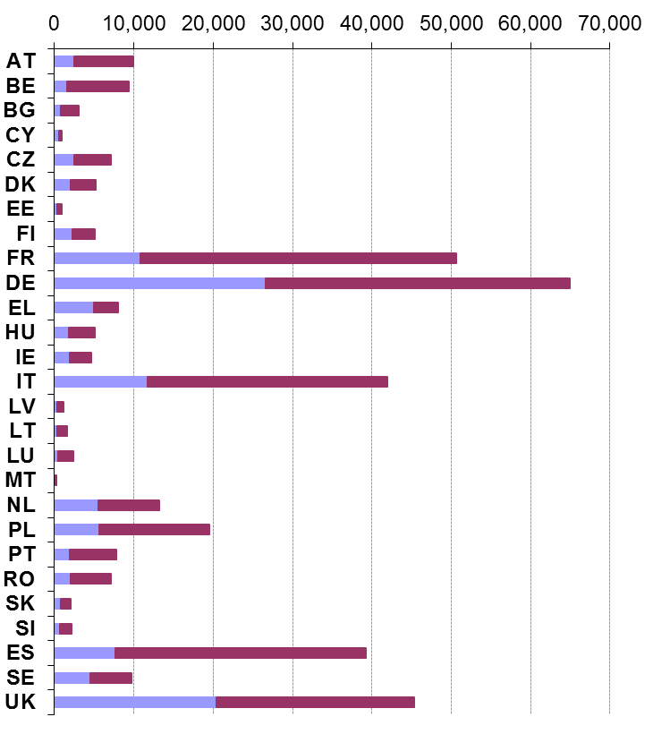
 | Fuel Sales (million litres)
 |  |  |  | Petrol |  | Diesel
*Please see Glossary in Section 33.1 for country abbreviations

Figure 3-3 provides details of the number of fuel grades available within Member States territories. In 2010, with the reduction in permissible maximum sulphur content there have been fewer fuel grades– however, in future years with the introduction of fuels with variable ethanol content from biodiesel.

Figure 3-3: Number of Fuel Grades per Member State
Member State* | 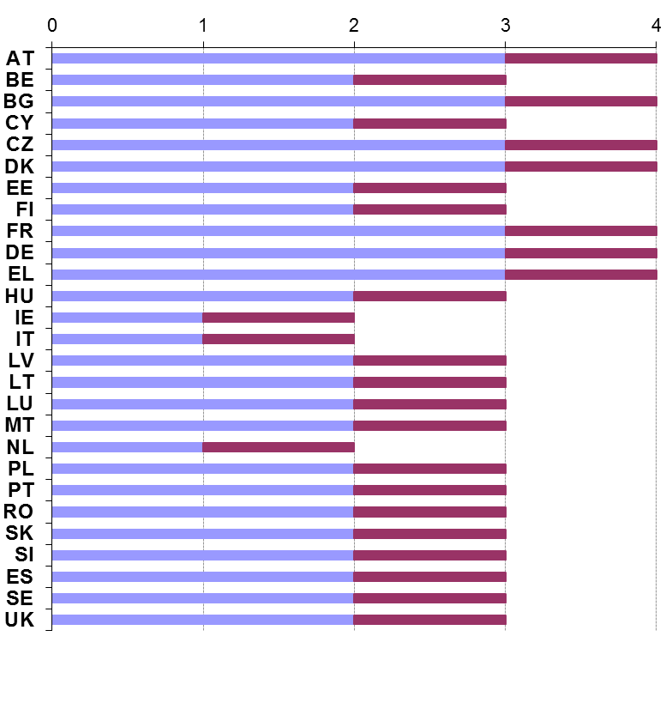
 | Fuel Grades
 |  |  |  | Petrol |  | Diesel
*Please see Glossary in Section 33.1 for country abbreviations

Fuel Quality Monitoring 2010

Description of systems
A number of different approaches have been used to implement Fuel Quality Monitoring Systems (FQMS) across the EU, although consistency between Member States has improved slightly year on year. Approaches range from those based on European Standard EN 14274 with sampling at a range of fuel retail stations through to national systems
Alternative monitoring systems may be permitted by the Directive, provided such systems ensure the results are of an equivalent confidence, although the criteria for assessing this are not specified. It is therefore not clear whether the existing systems not based on EN 14274 meet this criterion. In 2010, the majority of Member States have provided additional information about their selection of monitoring system (if using a statistical model from EN 14274) or have provided information about the selection of a National monitoring system.
Of the 27 Member State Fuel Quality Monitoring Systems used in 2010;
- 4 have opted to use EN 14274 statistical model A (Finland, Greece, The Netherlands and Italy)
- 4 have used EN 14274 statistical model B (Bulgaria, France, Poland and Romania)
- 10 have opted for EN 14274 statistical model C, and;
- 9 have used a National monitoring system (see Table 3-3)
Model A is the monitoring approach generally recommended in EN 14274 as it groups territories into macro regions with similar sales volumes and fuel supply sources. This approach requires fewer samples as it’s designed to account for geographical and supply variability within the country. Model B similarly divides the National territory into regions, however this is when there is no way to make divisions using sales or supply patterns and so existing administrative boundaries may be used to collect monitoring information. Model C should only be considered where the Nation State is very small and it can effectively be demonstrated that the country cannot be divided into separate sales/supply regions – and does not have distinct administrative or governing regions. As demonstrated in Table 3-3, most Member States have opted to use statistical model C when there may be a very good case for them to use model B or even A.
With regards to regional information on sampling, provision has been made within the reporting templates for Member States to provide a regional breakdown of fuel sales and sampling. This is required for countries using models A, B or an equivalent National model that has determined regional divisions. Of the Member States who have utilised Models A or B, Bulgaria has provided only partial data and Greece have not provided regional sampling and sales data. Both The Netherlands and Poland have not provided statistical data to support the EU wide analysis. Of the Member States using a National system, none have provided a regional breakdown of sales or sampling – the UK, Spain and Germany, all classified as large countries (with automotive road fuel sales of over 15 million tons) could have provided such a breakdown to justify the design and selection of the National system that has been used.

Sampling and reporting
There are detailed requirements in EN 14274 on the number and location of samples to be taken and reported in Member States fuel quality reports. EN 14274 lists a number of useful factors to take into account when assessing the sampling regime; such as the number of refineries supplying the market, the number of fuel grades available and the number of different imported fuel grades and sources. The standard specifies minimum number of samples per fuel grade (in each of the winter and summer periods), as discussed in the introductory section. In previous years, there was some uncertainty from Member States about the sampling requirements – however sample quantities and the division of reporting between summer and winter periods have improved in recent years.
Table 3-3 provides a breakdown of individual Member States sampling and reporting in 2010. The total minimum samples required is calculated where the Member State has used a statistical model as outlined in EN 14274 given that the minimum sample requirement is known for each model (A, B and C). The table also provides a breakdown of the total sample numbers taken and the sampling carried out at service stations. Not all Member States provided this breakdown in 2010 (Sweden, the UK, Spain, Germany and Latvia) so it has not been possible to determine compliance with sample quantities in these instances. The European Standard EN 14274 specifies that the minimum sampling requirement should be taken from fuel dispensing sites – which are defined as a “site, retail or commercial where fuel is dispensed into road vehicles for propulsion.” Therefore any sampling taken at distribution terminals or refineries should be taken in addition to those from service stations in order to meet minimum sampling requirements.
Where Member States have reported using a National system – an assessment has been made of the equivalent minimum sample requirements on the basis of the size of the country, and other details provided. Where the location of samples is known – it is possible to determine whether sample quantities demonstrate compliance with EN 14274. Belgium have reported as a small country (less than 15 million tonnes of fuel sales) and has not reported results broken down by sub-regions. Therefore the minimum number of samples – to ensure the Belgium monitoring system sample quantities are equivalent to the specifications outlined in EN 14274 – will be a minimum of 100 samples per fuel grade in each summer and winter period. Reporting two separate petrol fuel grades in 2010 – and one diesel fuel grade, Belgium has also taken all samples from service stations – with 2,133 petrol fuel samples and 4,985 diesel fuel samples taken, Belgium clearly demonstrates compliance with the minimum number of samples required to achieve equivalence to EN 14274 requirements.
Denmark have also reported 2010 fuel quality monitoring using a National Model and with fuel sales of less than 15 million tonnes and no sub-regional breakdown of reporting, is also required to take 100 samples per fuel grade per period. In contrast to Belgium, Denmark has reported a fuel type (petrol RON 98) that represents a market share of national fuel sales of less than 10%. Subsequently, to meet equivalence with EN 14274 minimum sampling requirements, fewer samples are required. Using the calculation methodology laid out in EN 14274, at least 2 samples are required for petrol RON 98 to meet equivalence with the international standard – and this has been achieved. However, Denmark have reported only 40 petrol samples in total – against an equivalence requirement of 200 – and only 22 diesel samples. Therefore the Danish FQMS is not compliant with the Directive as the national monitoring system does not demonstrate equivalence with EN 14274.
As a small country, Malta has also reported a small number of fuel samples using a national monitoring system. With two petrol fuel grades – one of which represents less than 10% of the market share of petrol in 2010, and one diesel fuel grade – and no sub-regions, Malta would be expected to report a minimum of 209 petrol samples and 200 diesel samples in total. In 2010, Malta sampled and reported only 39 petrol samples in total – and only 30 diesel samples.
Portugal has also reported using a National monitoring system as a small country. Similar to Belgium, Denmark and Malta, Portugal have not reported sub-regional and the Portuguese monitoring system should also demonstrate sample number equivalence by 100 samples per fuel grade per period. This gives a total of 209 Petrol samples and 200 diesel samples. Portugal have reported 200 petrol samples and 100 diesel samples from service stations and so complies with equivalent standards in EN 14274. In addition, Portugal have sampled both petrol and diesel fuels at a refinery location – however these samples are in addition to the minimum requirement.
Germany, Spain, Sweden and the UK have also reported using a National monitoring system. However, these Member States have not provided information about the location of fuel sampling. Where Member States have not provided a breakdown of sampling location, it is not possible to fully assess sampling compliance as all samples may have been taken from terminals/ refineries – which would mean that samples are totally non-compliant with the Directive – or that all samples have been taken from service\stations which may indicate compliance (depending on the number of samples taken compared to the minimum number required). All of these Member States have therefore been assessed to be non-compliant with the Directive as they have not provided sufficient information to demonstrate equivalence with the European Standard. Table 3-3 details the minimum sample number required to be taken from Service stations for these Member States to have demonstrated compliance with the Directive.
There is also some uncertainly regarding the sample quantities required from fuels with a market share of less than 10%. European Standard EN 14274 suggests that this should be determined by dividing the proportion of market share of the fuel with a share of less than 10% by the share of the parent fuel grade and then multiplying it by the number of samples required for the parent fuel grade. In most cases sample quantities taken by the Member State for fuels with a share of less than 10% exceed the minimum requirement.
Table 3-3: Summary of Member State sampling and reporting in relation to the requirements of Directive 98/70/EC and of European Standard EN 14274
MS |  | FQMS Model (1) | Size (2) | Separate S&W? (3) | Samples per grade per period (4) | Total samples required (5) |  | Samples Taken (6) |  | Samples Taken at Service Stations (7) |  | Sampling Compliance (8)
 |  |  |  |  |  | Pet. | Dsl. | Pet. | Dsl. | Pet. | Dsl. | Pet. | Dsl.
Austria | AT | C | S |  | 50 | 102 | 100 | 203 | 100 | 203 | 100
Belgium | BE | N | S |  | 100 | 400 | 200 | 2133 | 4985 | 2133 | 4958
Bulgaria | BG | B | S |  | 100 | 200 | 200 | 427 | 468 | 418 | 456
Cyprus | CY | C | S |  | 50 | 100 | 100 | 293 | 167 | 149 | 167
Czech Republic | CZ | C | S |  | 50 | 101 | 100 | 747 | 877 | 747 | 877
Denmark | DK | N | S |  | 50 | 201 | 100 | 42 | 22 | 42 | 22 | × | ×
Estonia | EE | C | S |  | 50 | 103 | 100 | 350 | 200 | 350 | 200
Finland | FI | A | S |  | 50 | 103 | 100 | 185 | 162 | 140 | 117
France | FR | B | L |  | 200 | 416 | 400 | 827 | 395 | 827 | 395 |  | ×
Germany | DE | N | L |  | 200 | 405 | 400 | 417 | 305 | - | - | × | ×
Greece | EL | A | S |  | 50 | 105 | 100 | 250 | 120 | 29 | 17 | × | ×
Hungary | HU | C | S |  | 50 | 101 | 100 | 120 | 120 | 120 | 120
Ireland | IE | C | S |  | 50 | 100 | 100 | 144 | 126 | 92 | 92 | × | ×
Italy | IT | A | L |  | 100 | 200 | 200 | 200 | 200 | 100 | 100 | × | ×
Latvia | LV | N | S |  | 100 | 400 | 200 | 438 | 674 | - | - | × | ×
Lithuania | LT | C | S |  | 50 | 101 | 100 | 101 | 100 | 97 | 95 | × | ×
Luxembourg | LU | C | S |  | 50 | 104 | 100 | 47 | 75 | 43 | 71 | × | ×
Malta | MT | N | S |  | 100 | 209 | 200 | 49 | 43 | 39 | 30 | × | ×
Netherlands | NL | A | S |  | 50 | 100 | 100 | 100 | 100 | 100 | 100
Poland | PL | B | L |  | 200 | 408 | 400 | 291 | 229 | 291 | 229 | × | ×
Portugal | PT | N | S |  | 100 | 209 | 200 | 236 | 118 | 200 | 100
Romania | RO | B | S |  | 100 | 400 | 200 | 360 | 210 | 360 | 210 | ×
Slovakia | SK | C | S |  | 50 | 101 | 100 | 168 | 137 | 168 | 137
Slovenia | SI | C | S |  | 50 | 103 | 100 | 149 | 181 | 145 | 115
Spain | ES | N | L |  | 200 | 409 | 400 | 520 | 264 | - | - | × | ×
Sweden | SE | N | S |  | 100 | 203 | 200 | 553 | 620 | - | - | × | ×
UK | UK | N | L |  | 200 | 404 | 400 | 2195 | 2428 | - | - | × | ×

# | Column | Explanatory notes
(1) | FQMS Model | N = National Fuel Quality Monitoring System (FQMS)  A = EN 14274 Statistical Model A  B = EN 14274 Statistical Model B  C = EN 14274 Statistical Model C
(2) | Size – Country size | S = Small (total automotive road fuel sales < 15 million tonnes pa)  L = Large (total automotive road fuel sales > 15 million tonnes pa)
(3) | Separate S & W? | Separate summer & winter reporting indicates full year sample results reporting only.
(4) | Samples per grade per period | EN 14274: There are reduced sampling requirements for grades comprising of less than 10% total sales
(5) | Total samples required | Calculation of the EN 14274 minimum sample total required according to FQM model and country size. The minimum sample requirement is to be taken from the ‘point of use’ at fuel dispensing sites.  Where a national model has been used, an assessment of the equivalent number of samples required has been made on the basis of country size (based on fuel sales) and other details about the fuel quality monitoring model used (e.g. reporting by regional breakdown).
(6) | Samples Taken | The total number of samples taken per fuel type at all locations (service stations, terminals and refineries).
(7) | Samples taken at Service Stations | The total number of samples taken at service stations; fuel dispensing sites (public and commercial). Where it is not possible to determine compliance because the information has not been provided by the Member State, this has been denoted by a dash ‘-‘and this is the case for Sweden, the UK, Spain, Germany and Latvia.
(8) | Sampling Compliance | indicates compliance with EN 14274 Sampling Number requirement and × indicates non-compliance.  Where Member States have not provided a breakdown of sampling location, it is not possible to assess sampling compliance.
 | Pet. | Petrol
 | Dsl | Diesel

Figure 3-4: 2010 Sampling rate across the EU (average number of samples per fuel grade)
Member State* | 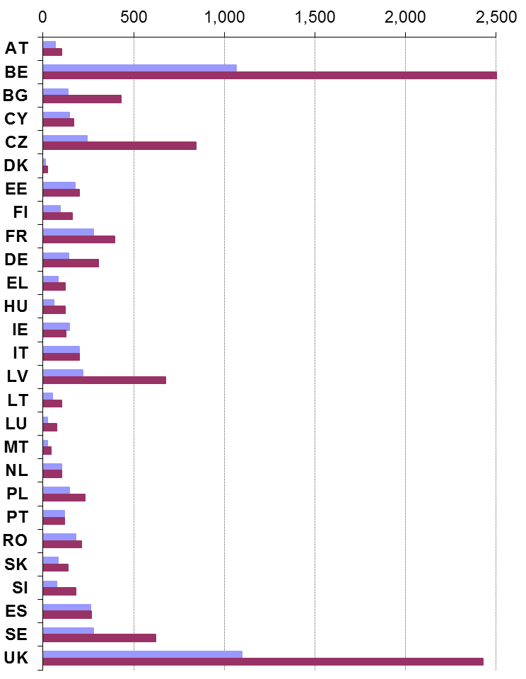
 | No. of samples by fuel grade
 |  |  |  | Petrol |  | Diesel
*Belgian diesel sampling = 4985
*UK diesel sampling = 2428
*Sampling taken from all locations (includes terminal/ refinery sampling)
*Please see Glossary in Section 33.1 for country abbreviations

Figure 3-5: No. of fuel samples per thousand litres
Member State* | 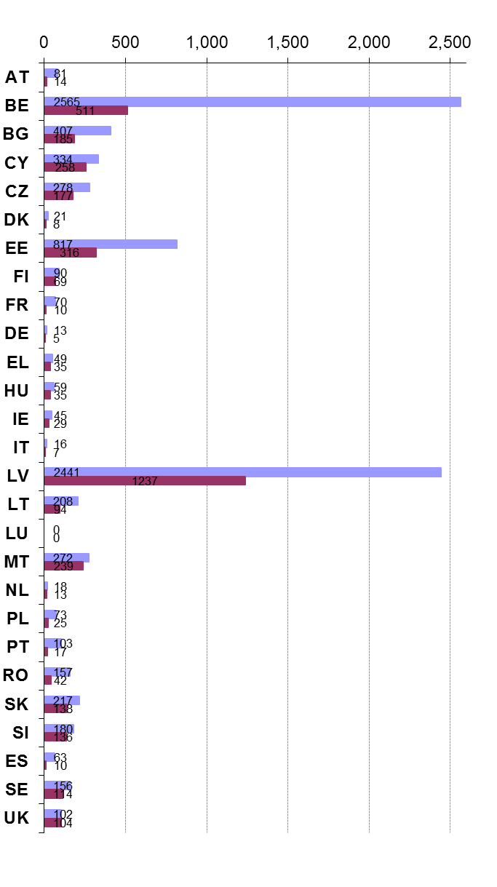
 | No. of samples by fuel grade
 |  |  |  | Petrol |  | Diesel
*Sampling taken from all locations (includes terminal/ refinery sampling)
*Please see Glossary in Section 33.1 for country abbreviations

Compliance with 98/70/EC Limit Values

Petrol reporting
In 2010, most Member States provided full information about petrol sample compliance. In order to determine compliance, it is necessary to know which test method has been used to test for some parameters (because reproducibility and tolerance levels differ according to test method). Provision has been made for Member States to give this information within the reporting template – although this is not a mandatory part of the reporting it is vital to determine compliance levels. The symbol ‘>’also indicates where details about the number of non-compliant samples have not been provided by Member States and so the figure presented is a minimum with the actual value potentially larger. This is when Member States have not confirmed exactly how many samples were found to be out of specification with tolerance limits – yet have reported a minimum or maximum sample value that exceed tolerance limits.
The parameters found to be out of specification most frequently within the Community in 2010 were;
- Summer Vapour Pressure was exceeded 215imes in 2010 – however it is becoming apparent that many exceedences are the result of transitional periods; when suppliers swap the summer specification fuel for winter specification fuels and vice versa.
- RON/ MON samples found to be out of specification in 2010 totalled 59samples within the Community.
- The Sulphur content maximum of 10ppm was exceeded by a total of 34 samples, with the highest sample value of 45.9 mg/kg (Portugal). However the average sulphur content for all Member States remains below the mandatory limit of 10ppm at 5.8 ppm.
The Netherlands has not provided full details of samples found to be out of compliance with tolerance limits – and Germany was unable to provide the details of some non-compliance for Normal petrol (RON 91). Presentation of the temporal trends in compliance with limit values can be found in Section 3.3.3.

Diesel reporting
In 2010, only two Member State did not provide details of sample/s found to be out of specification for diesel (Latvia and the Netherlands – where at least one fuel sample tested in each Member State exceeded tolerance limits). As with petrol reporting, details of temporal trends in parameter compliance can be found in Section 3.3.3.
Of the 5 parameters required to be tested for diesel in 2010, parameters found to be out of specification were;
- In spite of the average EU sulphur content remaining below the mandatory 10ppm limit – at 6.5 ppm,- there were 169 samples found to be non-compliant with extreme values of:
  - a maximum value of 500 mg/kg in Bulgaria (who fined the supplier as a result of the non-compliant fuel sample)
  - One or more samples in Poland were found to be out of compliant – with a maximum sulphur content value of 455 mg/kg. In Poland, where fuel was found to have extremely high sulphur content, it was withdrawn from the market. Polish authorities also notified the Office of Fiscal Control and Customs Board and the Regional Inspectorate of Environment Protection of the non-compliant fuel.
  - 294 mg/kg in Romania (no details of action taken has been provided) and;
  - 94.2 mg/kg in Cyprus - where contamination at the service station was found to be as a result of mixing automotive diesel with heating diesel. Penal prosecution was instigated against the petrol station.
- A total of 38 samples exceeded distillation limits in 2010.
- In total, 4 samples tested for cetane number were found to be out of specification.

Overall Summary
Table 3-4 summarises the compliance of Member States with Directive 98/70/EC for the year 2010 reporting in terms of the results of the analysis of samples against Tolerance Limits and the reporting format and content. Amendments to Directive 98/70/EC (Directive 2003/17/EC) included the insertion of a paragraph stating “Member States shall determine the penalties applicable to breaches of the national provisions adopted pursuant to this Directive. The penalties determined must be effective, proportionate and dissuasive.” Some Member States have provided an explanation of the remedial actions and penalties imposed by national authorities where samples are found to be out of specification. These and other notes pertinent to the Member States monitoring systems have been highlighted in and also given in more detail in the individual Member State chapters of this report.
In general, of the 11,415 samples tested for petrol in 2010, 411 were found to be out of specification with tolerance limits for one or more parameter – which represents a non-compliance rate of 3.6%. Of the 13,345 samples tested for the 5 mandatory parameters for diesel in 2010, 219 were found to be non-compliant with specified limits – representing 1.6% of all samples reported.
The proportion of samples found to be out of specification is reliant on the number of samples taken – which should be dependant (within each Member State) on the fuel sales volume, and supply sources. However, with Member States using National systems that may not demonstrate equivalence with Statistical models A, B or C and using statistical models that may not be the most suitable, it is necessary to also consider non-compliances within the Community weighted by volume and by sample numbers. Figure 3-6 gives the rate of non-compliances weighted according to sales volume and sample numbers and shows an upward trend to 2010. A full discussion of temporal trends in compliance is provided in Section 3.3.3.
Figure 3-6: Temporal trends in total limit value non-compliances for petrol and diesel fuels
Non-compliance as a % weighted by fuel sales volume
 | Year
 |  | Diesel |  | Petrol
* Excludes France in 2003 - 2005, as no submissions were provided. Excludes Luxembourg in 2007 to 2009 and Malta in 2006 and 2009 as no reports were provided.
Table 3-4: Summary of Member State compliance with 98/70/EC for 2010 reporting.
 | MS |  | Non-compliance with limit values  non-compliant samples (NC) / total samples |  |  |  |  |  |  | Incomplete reporting  parameters not measured (NM) / total |  |  |  |  |  | Late report
 |  |  | (1) |  |  |  |  |  |  | (2) |  |  |  |  |  | (3)
 |  |  | Petrol |  |  | Diesel |  |  |  | Petrol |  |  | Diesel
 |  |  | NC | Total |  | NC |  |  | Total | NM |  | Total | NM |  | Total | (months)
 | AT |  | 6 | 203 |  | 3 |  |  | 100 | 0 |  | 18 | 0 |  | 5 | <1
 | BE |  | 103 | 2133 |  | 79 |  |  | 4985 | 0 |  | 18 | 0 |  | 5 | On time
 | BG |  | 39 | 427 |  | 56 |  |  | 468 | 3 |  | 18 | 0 |  | 5 | On time
 | CY |  | 41 | 293 |  | 1 |  |  | 167 | 0 |  | 18 | 0 |  | 5 | <1
 | CZ |  | >61 | 747 |  | 29 |  |  | 877 | 0 |  | 18 | 0 |  | 5 | On time
 | DK |  | 0 | 42 |  | 0 |  |  | 22 | 0 |  | 18 | 0 |  | 5 | On time
 | EE |  | 17 | 350 |  | 3 |  |  | 200 | 0 |  | 18 | 0 |  | 5 | On time
 | FI |  | 0 | 185 |  | 1 |  |  | 162 | 0 |  | 18 | 0 |  | 5 | On time
 | FR |  | 56 | 827 |  | 10 |  |  | 395 | 0 |  | 18 | 1 |  | 5 | On time
 | DE |  | >7 | 417 |  | 1 |  |  | 305 | 0 |  | 18 | 0 |  | 5 | <4
 | EL |  | 0 | 250 |  | 0 |  |  | 120 | 0 |  | 18 | 0 |  | 5 | <1
 | HU |  | 0 | 120 |  | 0 |  |  | 120 | 0 |  | 18 | 0 |  | 5 | On time
 | IE |  | 15 | 144 |  | 1 |  |  | 126 | 0 |  | 18 | 0 |  | 5 | On time
 | IT |  | 2 | 200 |  | 0 |  |  | 200 | 1 |  | 18 | 0 |  | 5 | <1
 | LV |  | 0 | 438 |  | 0 |  |  | 674 | 0 |  | 18 | 0 |  | 5 | On time
 | LT |  | 0 | 101 |  | >1 |  |  | 100 | 0 |  | 18 | 0 |  | 5 | On time
 | LU |  | 7 | 47 |  | 0 |  |  | 75 | 1 |  | 18 | 0 |  | 5 | <1
 | MT |  | 2 | 49 |  | 3 |  |  | 43 | 0 |  | 18 | 0 |  | 5 | On time
 | NL |  | >2 | 100 |  | >1 |  |  | 100 | 0 |  | 18 | 0 |  | 5 | <5
 | PL |  | 15 | 291 |  | 3 |  |  | 229 | 0 |  | 18 | 0 |  | 5 | On time
 | PT |  | 29 | 236 |  | 8 |  |  | 118 | 0 |  | 18 | 0 |  | 5 | <1
 | RO |  | >5 | 360 |  | 11 |  |  | 210 | 0 |  | 18 | 0 |  | 5 | <1
 | SK |  | 0 | 168 |  | 7 |  |  | 137 | 0 |  | 18 | 0 |  | 5 | On time
 | SI |  | 0 | 149 |  | 0 |  |  | 181 | 0 |  | 18 | 0 |  | 5 | On time
 | ES |  | 6 | 520 |  | 0 |  |  | 264 | 0 |  | 18 | 0 |  | 5 | <2
 | SE |  | 0 | 553 |  | 0 |  |  | 620 | 6 |  | 18 | 0 |  | 5 | On time
 | UK |  | 5 | 2195 |  | 0 |  |  | 2428 | 2 |  | 18 | 0 |  | 5 | On time
 | No. Countries |  |  |  | 14 |  | 14 |  |  |  | 5 |  |  | 1 |  | 23
 | *NS = no submission
# |  | Column |  |  |  |  |  | Explanatory notes
(1) |  | Non-compliance with limit values  (95% confidence limits) |  |  |  |  |  | It is not possible to confirm whether limit values have been respected in all samples, where reporting data is incomplete. Where it has not been possible to establish from submissions the number of samples exceeding the limit value a ‘>’ symbol indicates that the number of samples exceeding limits is a minimum and might be greater.
(2) |  | Incomplete reporting |  |  |  |  |  | Some parameters may be sampled in smaller quantities, however all parameters should be sampled to accurately assess fuel quality. Member States should make it clear when sample results have been obtained and provide sample results.
(3) |  | Late report |  |  |  |  |  | Directive 98/70/EC states that Member States should submit monitoring reports by no later than 30 June each year

Temporal Trends

Temporal Trends in Sampling and Reporting
The following figures provide a summary of the temporal trends in sampling and reporting in the European Union. The interpretation of temporal trends, EU-wide is heavily reliant on consistent reporting by Member States on an annual basis.
The majority of reports in 2010 were received by the 30th June deadline, however there are still reports arriving late (see Figure 3-7).
Figure 3-7: Temporal trends in the punctuality of report submissions
No. of reports received
 | Year
 |  | By deadline |  | 1-2 months late
 |  | 3-4 months late |  | More than 4 months late
*Excludes France in 2003 - 2005, as no submissions were provided. Excludes Luxembourg in 2007 to 2009 and Malta in 2006 and 2009 as no reports were provided.
Figure 3-8 gives the format of the reports received from Member States in 2010. EN 14274 specifies that Member States should submit their report by the reporting deadline of 30th June annually. The submission process is to email a copy of the report to ENV-Report-98-70@ec.europa.eu and also to send a hard copy of the report to the Secretary General.
Whilst some Member States have submitted their reports in a non-specified manner (via fax, or using the European Environment Agency database), the majority have subsequently submitted reports electronically – or in the correct manner. Some reports were also initially submitted using outdated or inconsistent reporting formats. However, most have, on request copied their reporting into the template provided by the Commission for 2010.
Reporting consistency and accuracy is greatly enhanced by using a consistent format for reporting. In addition, the timely and accurate analysis of EU-wide and combined data is assisted with reporting in a consistent format. This enables feedback to the Community about fuel quality for the previous calendar year to be provided as soon as possible.
Figure 3-8: Temporal trends in the format of Member State submissions
No. of reports received
 | Year
 |  | template |  | Electronic copy
 |  | Paper copy only
*Excludes France in 2003 - 2005, as no submissions were provided. *Excludes Luxembourg in 2007 to 2009 and Malta in 2006 and 2009 as no reports were provided.
Figure 3-9 exhibits a dip in sampling quantities in 2010. Absolute sample quantity figures are 11,415 samples tested and reported for petrol and 13,345 samples tested and reported for diesel. This weighting corresponds to the higher sales volume of diesel within the Community. In addition, with fewer fuel grades available on the market in 2009 and 2010 (4 petrol fuel grades and only 1 diesel fuel grade) – a decline in sample numbers is to be expected in 2009 and 2010. Future trends in sampling quantities will depend on availability of fuels with added ethanol content as the new specifications of Directive 2009/30/EC begin to have an impact on sample requirements and increase the number of fuel grades available within parent fuel specifications.
Figure 3-9: Temporal trends in the total number of petrol and diesel samples taken
Samples taken | 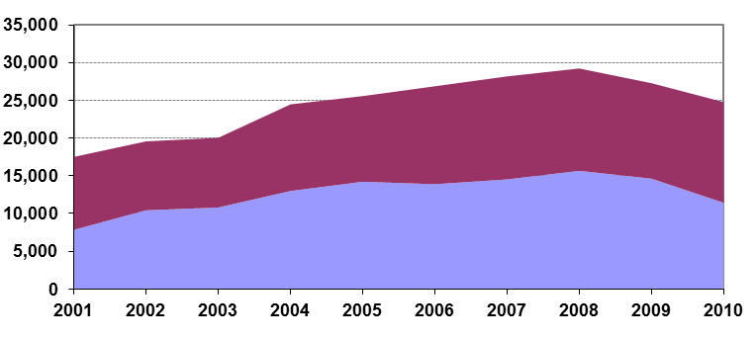
 | Year
 |  | Diesel |  | Petrol
* Excludes France in 2003 - 2005, as no submissions were provided. Excludes Luxembourg in 2007 to 2009 and Malta in 2006 and 2009 as no reports were provided.

Fuel Sales and Sulphur Content
Figure 3-10 gives the temporal trend in fuel sales from 2001 to 2010. Some reports have been missing from the data over the years which generates slight inconsistencies year on year.
Of the 27 Member state reports represented in Figure 3-10, 14 have seen an overall increase in fuel sales in 2010 compared to 2009 while fuel sales in 13 Member States have decreased compared to the previous year. This is in contrast to fuel sales in 2009, when only 5 Member States experienced a growth in fuel sales (out of 27) while the remaining 22 reported a decrease in overall fuel sales on the preceding year. As a result, fuel sales in the EU have increased by 0.1% between 2009 and 2010 (having declined by 2.6% in 2009 compared to the previous year).
Figure 3-10: Temporal trends in EU27 Sales of petrol and diesel (million litres)
Samples taken | 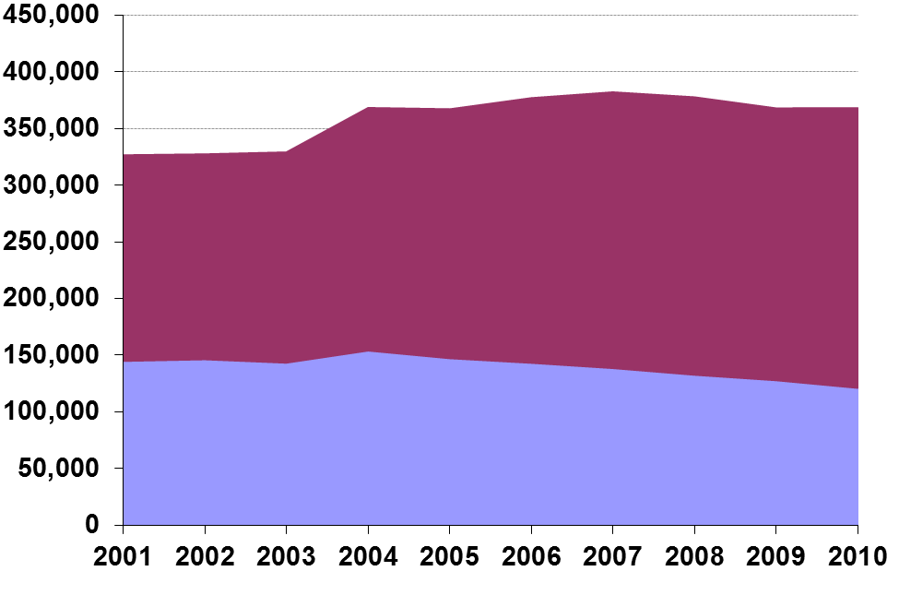
 | Year
 |  | Diesel |  | Petrol
* Excludes France in 2003 - 2005, as no submissions were provided. Excludes Luxembourg in 2007 to 2009 and Malta in 2006 and 2009 as no reports were provided.

Compliance with Limit Values
The following charts show the trends in the numbers of limit value non-compliances for petrol and diesel fuels in the European Union. Figure 3-11 gives the temporal trend in limit value non-compliance between 2001 and 2010. Figure 3-12 and Figure 3-13 provide a breakdown by key parameters of the temporal trends in non-compliant samples for petrol and diesel. The figures show an increase in non-compliances between 2003 and 2010; and this may be the result of a number of different factors;
- New Member States joining the Community in 2004 and 2006 bringing additional sampling (and therefore a proportion of non-compliant samples).
- An increase in samples taken over the years as the number of fuel grades available expanded.
- Increased sampling as Member States became more accustomed to sampling requirements – understanding that minimum sample numbers presented in EN 14274 are to be taken per summer and winter period.
- Greater accuracy of reporting non-compliant samples. Historically, Member States have reported the maximum/ minimum values of all samples – however this does not describe how many samples were found to be out of specification. Updates to the design of the reporting template and requests for clarification from Member States has greatly enhanced the detail given within Member State reports with regard to compliance reporting.
- ‘Bedding’ in of new fuel specifications – as Sulphur content limits steadily decreased, using old fuel reserves that met with the previous year’s specifications may have contributed the number of non-compliant samples.
- Member States are increasingly providing detail about the test methods used to determine fuel quality. As this level of detail increases, the accuracy of summary reporting also improves.
Figure 3-11: EU27 % temporal trend total limit value non-compliances for petrol and diesel fuels
Non-compliance as a % weighted by fuel sales volume
 | Year
 |  | Diesel |  | Petrol
* Excludes France in 2003 - 2005, as no submissions were provided. Excludes Luxembourg in 2007 to 2009 and Malta in 2006 and 2009 as no reports were provided.
Figure 3-12: EU27 temporal trends in numbers of samples exceeding limit values for specific petrol parameters
No. of samples exceeding limit values | 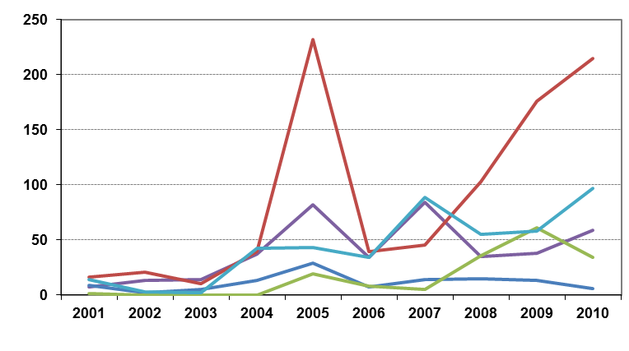
 | Year
 |  | Summer Vapour Pressure |  | RON/ MON
 |  | Other |  | Distillation Limits
 |  |  |  | Sulphur
* Excludes France in 2003 - 2005, as no submissions were provided. Excludes Luxembourg in 2007 to 2009 and Malta in 2006 and 2009 as no reports were provided.
Figure 3-13: EU27 temporal trends in numbers of samples exceeding limit values for specific diesel parameters
No. of samples exceeding limit values | 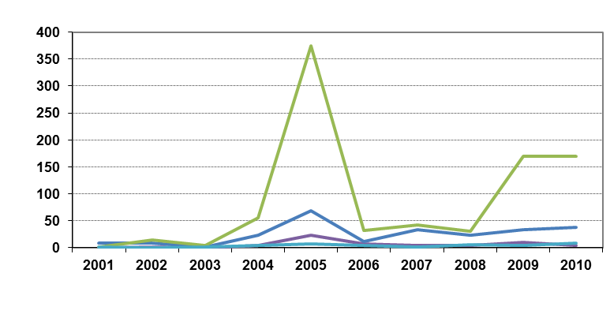
 | Year
 |  | Sulphur |  | Cetane number
 |  | Other |  | Distillation Limits
* Excludes France in 2003 - 2005, as no submissions were provided. Excludes Luxembourg in 2007 to 2009 and Malta in 2006 and 2009 as no reports were provided.

Statistical Analysis
Key Messages
The majority of Member States have provided additional detail within their 2010 report to enable further statistical analysis of parameter results. Member states who did not provide additional information are Germany (late report), The Netherlands (late report), Poland (reported in a word document), Spain, Romania and Sweden.
Petrol
- Parameter reporting shows that test results for RON and MON are relatively tight to fuel quality specification, with the majority of results above the specified minimum for the parameter (RON; 91 for RON 91 fuels or 95 for fuels with the higher specification and MON; 81 and 85 respectively); with very few outliers. Discussions with members of CEN Technical Committee indicate that this is to be anticipated – given the ‘economic’ value of the properties.
- Petrol vapour pressure shows a greater range in reported test results; with more Member States exceeding maximum specified limits (60 kPa and 70 kPa for countries with derogation for low ambient summer temperatures). In addition, the skew of results from samples tested within the Member States shows greater variation.
Diesel
- Density at 15ºC demonstrates variation in results – with very few samples exceeding or approaching the maximum limiting values for the parameter (845 kg/m³). Only Portugal reports outliers that exceed the limiting value while the majority of Member States report results comfortably within the range of 830 – 840 845 kg/m³.
- Distillation results for diesel show results where the majority of samples are tight to the specified limit (maximum 360 ºC) but most Member States also demonstrate significant outliers demonstrated by a long ‘tail’ on charted results.

Introduction to the Analysis Process
In evaluating different Member State submissions there are clear variations in trends that emerge. Sample analysis results for different parameters show different trends with regards to levels of compliance with limit values and the range distribution of sample analysis results in relation to the mean and Directive limit values. In some cases the mean of sample values can appear very close to the Directive limit values even without any reported exceedences of these limits by any of the samples. As part of the assessment of the compliance in relation to these analyses it is therefore useful to understand the reasons behind these differences.
In previous years, there was no suitable method to statistically verify Member State submission analysis results with a level of demonstrable confidence with the available information currently provided. Therefore, for the first time in 2010, individually selected parameters have been subject to a higher level of analysis with the aim of determining trends and statistical anomalies within the EU-wide sample data. With this aim, Member States were asked to provide two additional pieces of information within their 2010 FQM reports; the lower 25% data range and the upper 25% data range (e.g. the results placed at 25% and 75% within the total results for that parameter). The majority of Member States were able to provide this information and individual summaries have been provided in Member State chapters. Sweden, Slovenia and Romania did not provide sufficient additional information for the analysis – in addition where very low quantities (>5 samples) have been taken, results have been omitted from the overall calculations. The purpose of this section is to present the data across the EU to help identify possible trends or anomalies in fuel quality within the community.
The following charts are known as box-plots and they display the distribution of fuel characteristics by illustrating the:
- Sample minimum (already required by the Directive)
- Lower 25% range (requested from 2010 onwards)
- Middle 50% range (otherwise known as the mean - already required by the Directive)
- Median (requested from 2009 onwards)
- Upper 25% range (requested from 2010 onwards)
- Maximum (already required by the Directive)
Figure 4-1 illustrates how the box plot is constructed from a histogram (above the box plot) as a guide. This allows a comparison of one Member State fuel sample distribution with another which could aid in the spotting reporting irregularities. Figure 4-1 provides an illustration of a skewed distribution. This means that there are more samples on one side of the range than the other (to the right). This will mean that one of 25% values (‘tails’ in the box plot) will be longer than the other, and that the median value will not be centred in the middle 50% box. Box plots will help to determine how wide the sample values range – or how close they are to fuel specifications set by the Directive across the Community.
Figure 4-1: Explanation of Box Plot
Minimum
Maximum

Lower 25%
Median

Upper 25%

Middle 50%

No. of samples

Fuel parameter value
This statistical analysis, for 2010 has been presented for some key parameters for petrol and diesel fuels. The selected parameters may change in future years with the introduction of new, key parameters and may also change to more closely monitor trends as fuel specifications change over time. The following parameters have been presented in this section, and within Member State reports;
Petrol:
- Research Octane Number
- Motor Octane Number
- Summer Vapour Pressure
Diesel:
- Density at 15ºC
- Distillation – 95% v/v recovered
Sample results for these parameters have been depicted using box plots based on the reported sample minimum, lower quartile (Q1), median (Q2), upper quartile (Q3), and the maximum sample value.
Sample results have been presented in the following figures with limit values for the parameter (maximum or minimum) to demonstrate the skew of sample results. Limit value does not depict compliance or non-compliance as the Tolerance Limits - which do determine whether sample results can be considered to be compliant or non-compliant - are dependent on the test methods used – and the reproducibility of those test methods. The level of detail provided by Member States is not yet consistently sufficient to assess parameters against test methods used. However, limit values represent the maximum and minimum limits as determined by Directive specifications.
If less than 5 samples were tested and reported by the Member State, results have been removed from the following charts to avoid inaccuracies (a minimum of 5 datasets are required). In addition, where data appeared to be inaccurate, the data has been removed to avoid anomalous skew in the data (e.g. where reported results do not conform to maximum/ minimum parameter results provided in sampling analysis). More detail on Member State specific results and the anomalies observed have been provided within individual Member State chapters.

Key parameters – EU results

Petrol

Research Octane Number (RON) Analysis
Figure 4-2: Box plot of RON samples per Member State
Limit Values | Min RON 98  Min RON 95  Min RON 91
Member State | 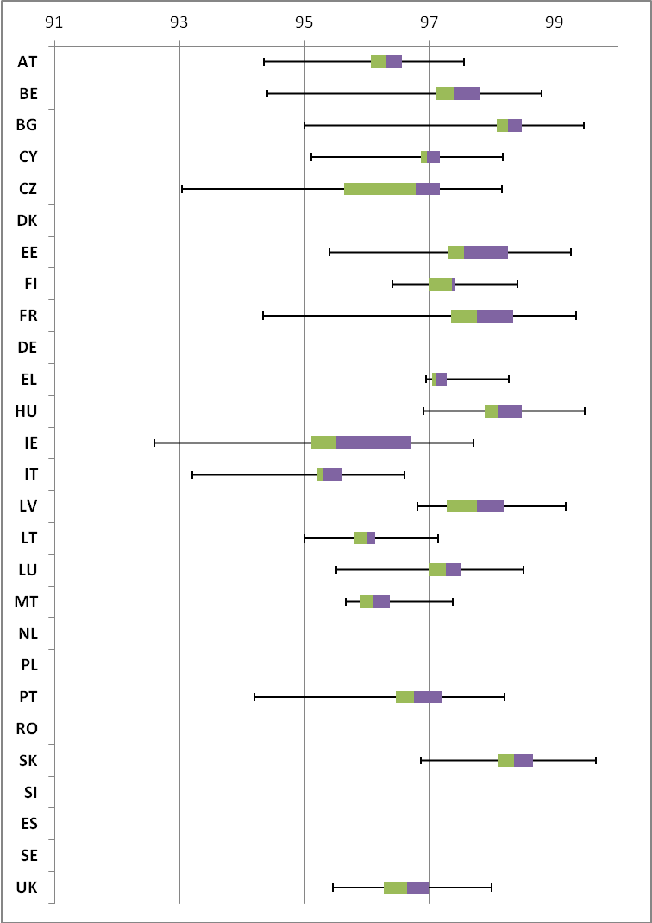
 | Research Octane Number
*Results from >5 samples have been removed and anomalous datasets have been removed.
*Please see Glossary in Section 33.1 for country abbreviations

Sample results for Research Octane Number in 2010 have been presented in Figure 4-2 and show that fuels in the Community (according to the data provided by Member States) were tight to specifications for RON. The majority of fuel sold in the EU is RON 95 (66%) and so you would expect to see the majority of sample results to be above the minimum limit value of 95. RON 91 fuels (with a minimum limit value of 91) were available in Austria, the Czech Republic, Denmark and Luxembourg and you would therefore expect to see a proportion of samples between 91 and 95. Denmark has not sampled RON 91 in sufficient quantities for the purposes of the box chart (only 3 samples of RON have been tested and reported). Where the Box Plot tail exceeds the minimum of 95 for Member States where no RON 91 fuel sales are reported, this indicates that non-compliant samples have been found in 2010. Further details of individual member States sample results have been provided in the following Member State chapters.

Petrol - Motor Octane Number (MON) Analysis
Figure 4-3: Box plot of MON samples per Member State
Min 81 for RON 91 fuel only
Limit Values | Min 85
Member State | 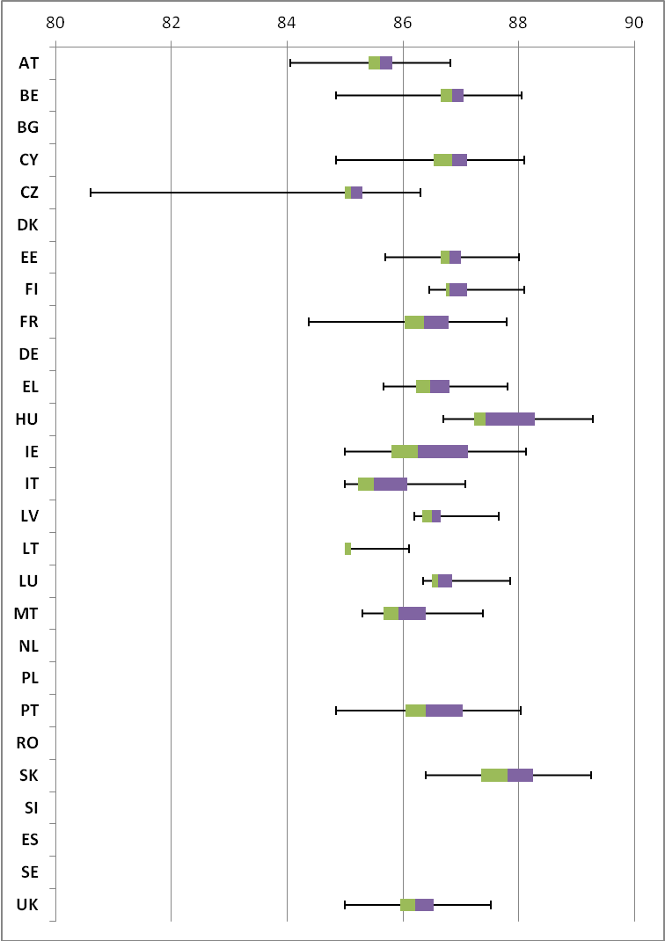
 | Research Octane Number
*Results from >5 samples have been removed and anomalous datasets have been removed.
*Please see Glossary in Section 33.1 for country abbreviations

Figure 4-3 demonstrates the MON results for petrol in 2010. As with RON, the parameter is relatively tight to specification with few outliers. Results extending as far as MON 81 can be expected in Austria, the Czech Republic, Denmark and Luxembourg where lower specification RON 91 fuels are available on the market – however Belgium, Cyprus, the Czech Republic, France Ireland, Italy, Lithuania and Portugal have also reported sample results for MON that fall below the specified minimum limit of 85 for higher grade fuels. On the whole, the majority of sample results show a very tight banding of around 85 to 87 MON, while even outliers largely fall within the specified limits for the parameter.

Petrol - Vapour Pressure (VP) Analysis
Figure 4-4: Box plot of Vapour Pressure samples across Member States
Max 70 kPa
‘Arctic’ only
Max 60 kPa
‘Normal’
Limit Values
Member State | 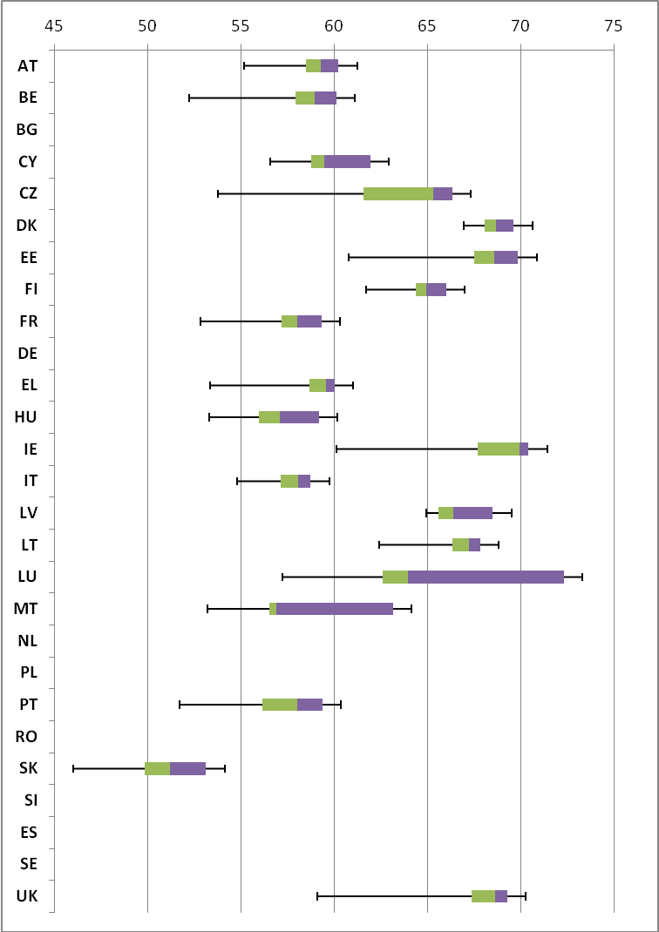
 | Vapour Pressure - summer only (kPa)
*Results from >5 samples have been removed and anomalous datasets have been removed.
*Member States represented in the data above with a derogation to report according to ‘Arctic’ conditions with a corresponding summer vapour pressure maximum limit of 70kPa are Denmark, Estonia, Finland, Ireland, Latvia, Sweden and the UK.
*The maximum vapour pressure limit in Lithuania is 70kPa – however the state remains classed as ‘normal’.
*Please see Glossary in Section 33.1 for country abbreviations

The Summer Vapour Pressure results in 2010 demonstrate more separation in fuel quality between the Member States in Figure 4-4. Vapour pressure for the summer period is monitored closely and fuel specifications are subject to different limits in the winter period. Only the summer vapour pressure results are requested from Member States, however some also provide winter results. Wherever possible, winter results have been excluded from the chart. In addition, there is a transitional period, during this time, twice a year the summer and winter fuels are swapped in supply outlets.
There is a lack of consistency between Member States with regard to this transition period – with some Member States excluding results from samples taken during the transitional period and others reporting all summer, winter and transition period results. Therefore, until there is greater consistency, the results above may not provide an accurate comparison and might portray poorer quality fuels than neighbouring States when it might not be the case.
In general, however the summer vapour pressure results for 2010 are more widely dispersed, with only Slovakia and Italy reporting all fuel sample results to be below the ‘Normal’ maximum limit of 60 kPa. Denmark, Estonia, Ireland, Luxembourg and the UK all reported results out of specification with the maximum limit value of 70kPa – Luxembourg demonstrated the heaviest weighting beyond the limit value however does not have the ‘Arctic’ derogation in place.

Diesel

Density at 15°C Analysis
Figure 4-5: Box plot of Density samples across Member States
Limit Value | Max 845 kg/m³
Member State | 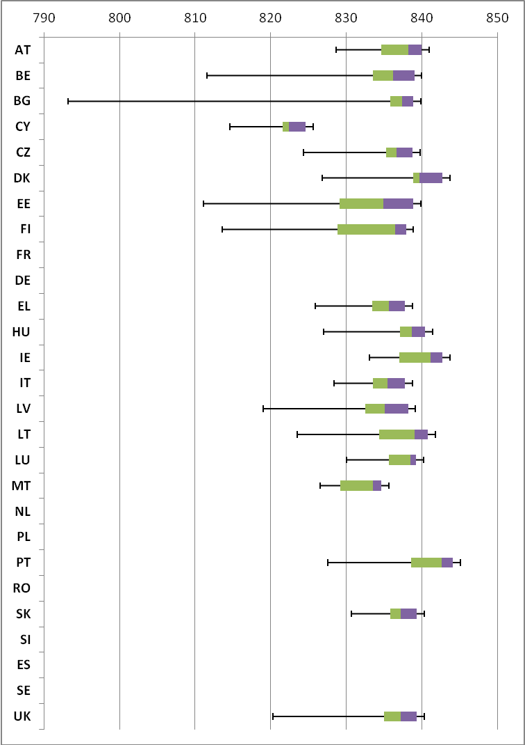
 | Density at 15°C (kg/m³)
*Results from >5 samples have been removed and anomalous datasets have been removed.
*Please see Glossary in Section 33.1 for country abbreviations

No Member State can be seen to have exceeded the maximum limit value for Density and the majority of Member States results show a comfortable margin between maximum limits for the parameter, and the Limit Value. In spite of this, the majority results are skewed towards the maximum value, rather than the minimum value (as can be observed by the boxed areas remaining tight to the maximum value). This could suggest that the minimum values reported are outliers.

Diesel - Distillation – 95% Point Analysis
Figure 4-6: Box plot of Distillation samples across Member States
Limit Value | Max 360 ºC
Member State | 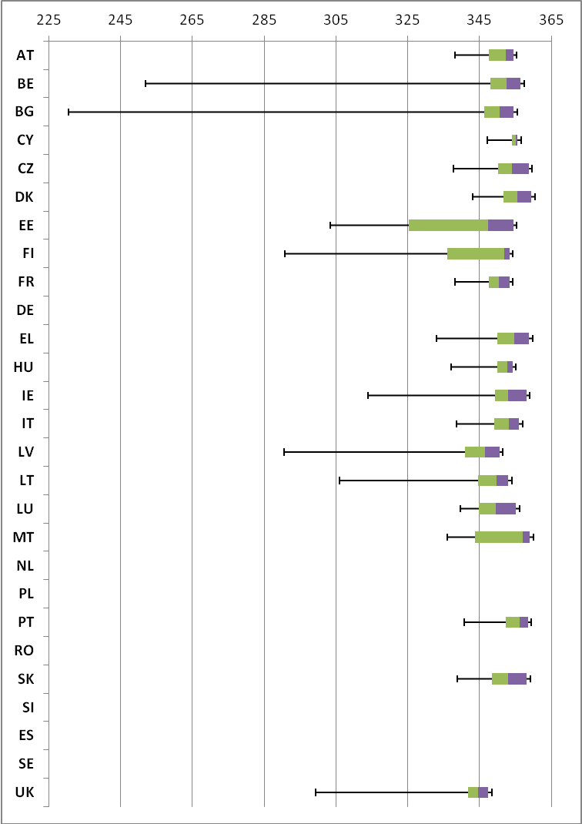
 | Distillation – 95 % Point (°C)
*Results from >5 samples have been removed and anomalous datasets have been removed.
*Please see Glossary in Section 33.1 for country abbreviations

Similar to the results for Density at 15 ºC, Community wide results for Distillation results are skewed towards the maximum value. This could suggest that the minimum values reported are outliers. Member States have reported results that are comfortably within the limit value for diesel; however a much wider range than the results discussed previously.

Austria

Fuel Availability 2010
The following table lists the fuels that were reported to be available nationally in 2010.
Table 5-1: National fuel grade
Fuel grade | National fuel grade
RON 91 < 10 ppm Sulphur | Normal
RON 95=<RON<98 < 10 ppm Sulphur | Super
RON 98 < 10 ppm Sulphur | Super Plus
Diesel < 10 ppm Sulphur | Diesel

Sales, sampling and reporting
During 2010 fuel sales in Austria were dominated by diesel fuel sales. Almost 7,500 million litres of diesel was sold in comparison to less than 2,500 million litres of petrol fuel sales (all petrol grades combined). Petrol fuel sales were mainly comprised of fuel grade RON 95=<RON<98.
Figure 5-1: Fuel Sales proportions by fuel type
Petrol  Diesel | 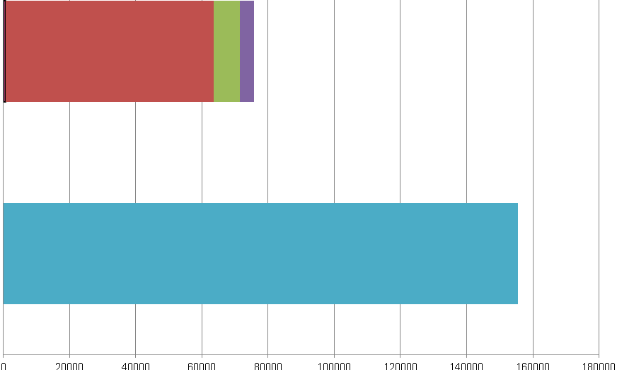
 | Million Litres
 |  |  | RON=91 |  |  | RON = 95 |  |  | RON 95=<RON<98 |  |  | RON 98 |  |  | Diesel

Table 5-2: Fuel sales and sampling
Fuel type (Parent Grade) | Sales | Sales, | Samples ⁽¹⁾ |  |  | Separate | Param’s measured ⁽⁴⁾ | Add. Notes
Fuel type (Parent Grade) | (Million litres) | % total of fuel type | S | W | TR ⁽²⁾ | S/W⁽³⁾ | Param’s measured ⁽⁴⁾ | Add. Notes
Unleaded min. RON=91 | 150 | 6.1% | 50 | 50 | 7 | Yes | All of 18
Unleaded 95=<RON<98 | 2,251 | 91.3% | 50 | 50 | 100 | Yes | All of 18
Unleaded RON>=98 | 64 | 2.6% | 3 | 0 | 3 | Yes | All of 18
Total Petrol | 2,465 | 100% | 103 | 100 | 110 | Yes
Diesel (<10 ppm S) | 7,437 | 100% | 50 | 50 | 100 | Yes | All of 5
Total Diesel | 7,437 | 100% | 50 | 50 | 100 | Yes
(1) | Samples |  |  |  | The actual number of samples taken by the Member State in the summer (s) and winter (w) periods
(2) | TR |  |  |  | Total requirement according to EN 14274. Dash (-) denotes National system has been used.
(3) | Separate S & W? |  |  |  | Yes indicates separate summer and winter reporting, and No indicates full year sample results reporting only.
(4) | Parameters measured |  |  |  | Currently 18 petrol parameters should be tested and reported by the Member States and 5 diesel parameters.

Petrol Samples
- Austria have complied with or exceeded minimum sampling requirements for all petrol fuel grades.

Diesel Samples
- Diesel fuel samples tested in 2010 complied with the total minimum requirement.

Fuel Quality Monitoring 2010

Description of System
Responsible organisation(s) | Umweltbundesamt GmbH Wien
Fuel Quality Monitoring System (FQMS) | EN 14274 Statistical model C
Country Size | Small
Summer Period | Normal
Location(s) of sampling | Service stations
Time/frequency of sampling | Samples for petrol fuel grades RON 95 and RON 95 ≤ RON <98 have been taken in 6 months throughout 2010 – dispersed across summer and winter periods. Fuel Grade RON 98 has been sampled in July to September, but represents less than 1% market share of fuels.
Specification of test methods | Austria has sampled and reported using EN 228 and EN 590 test methods.
Collection of sales data | Sales data for 2010 has been provided by the Federal Ministry of Economy, Family and Youth.
Other details
The fuel grade "Normal" is specified to have a minimum RON of 91, but in fact average figures range about more than 96 RON and there is just one sample below 95 (including tolerance level).

Compliance with Fuel Quality Limit Values
Table 5-3: Petrol Fuel Grades
Normal Petrol (RON 91)- Details of samples that exceed tolerance limits:
Parameter | Limit Value | Tolerance Limit* (TL) | Max/Min value of samples tested | No samples outside TL | % samples outside TL
Summer vapour pressure, kPa | 60 | 61.8 | 69 | 6 | 12%
Member State notes
12% samples outside tolerance limits refer only to the proportion of samples taken during the summer period.

Table 5-4: Diesel Fuel Grades
Diesel - Details of samples that exceed tolerance limits:
Parameter | Limit Value | Tolerance Limit* (TL) | Max/Min value of samples tested | No samples outside TL | % samples outside TL
Distillation – 95-%-Point, ºC | 360 | 365.9 | 376 | 1 | 1%
Sulphur content, mg/kg | 10 | 11.3 | 24.3 | 2 | 2%
Member State notes

Temporal Trends
Figure 5-2 shows the trend in total fuel sales since 2001. Diesel sales in Austria have increased by 4% compared to 2009 sales figures – representing an increase in 37% since 2001. Petrol fuel sales have reduced by 1% in the period between 2009 and 2010 with an overall reduction of 11% in the period 2001-2010.
Figure 5-2: Temporal trends in national sales of petrol and diesel (million litres)
Sales (million litres)

 |  |  |  |  | Petrol |  | Diesel

Statistical Analysis
The following charts in this section are known as box-plots and they display the distribution of fuel characteristics per Member State by illustrating the:
- Sample minimum
- Lower 25% range
- Middle 50% range
- Median
- Upper 25% range
- Maximum
For a full explanation of the information presented in a Box Plot diagram, please see Appendix 1.

Petrol Analysis
Fuel sampling in Austria in 2010 recorded relatively few test results out of specification with limits. The analysis charts for petrol (Figure 5-3) and diesel (Figure 5-4) detail the distribution of sample results for the 5 selected parameters;
Petrol:
- Research Octane Number
- Motor Octane Number
- Summer Vapour Pressure
Diesel:
- Density at 15ºC
- Distillation – 95% v/v recovered
Sample results for these parameters have been depicted using box plots based on the reported sample minimum, lower quartile (Q1), median (Q2), upper quartile (Q3), and the maximum sample value.
Sample results in 2010 have been presented in the following figures with limit values for the parameter (maximum or minimum) to demonstrate the skew of sample results. RON and MON sample results show that the fuels available in Austria have reasonably small variation in Octane levels for the majority of samples – with one or two outliers. Summer Vapour pressure results shows that the samples were found to be tighter to the specifications of the Fuel Quality Directive, with some samples exceeding limit values and the majority of samples skewed closer to the limit.
Diesel sample results for Density show a slightly wider variation in density, exhibited by the widely spread coloured bands at the 25 and 75 quartile – in comparison to the tight bands shown in the petrol analysis box plots.
Figure 5-3: petrol analysis
 | Research Octane Number
RON | 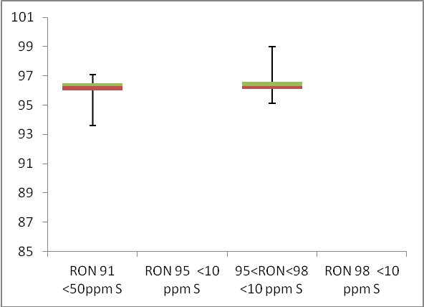  Min 95  Min 91
 | Motor Octane Number
MON | Min 81  Min 85
 | Summer Vapour Pressure (DVPE)
kPa | Max 60

Diesel Analysis
Figure 5-4: Diesel analysis
 | Density at 15ºC
Kg/m³ | 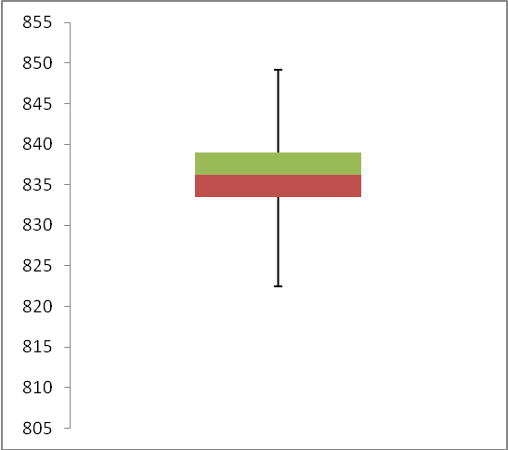  Max 845

 | Distillation – 95% v/v recovered
(⁰C) | 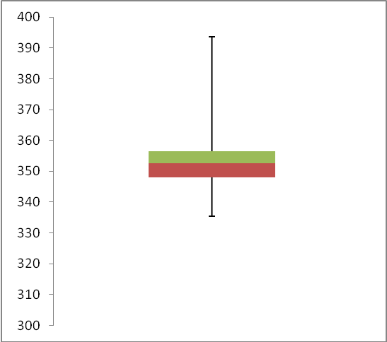  Max 360

Key Areas for Improvement
The following table summarises the main areas in which improvements could be made to the monitoring system, reporting or compliance with Directive limit values. The table includes key recommendations from the previous year to give an assessment of what action has been taken by the Member State to address any issues that may have been highlighted.
Key Areas for Improvement (3 years)
 | Monitoring | Reporting
2010 | - Uses Model C but Model A may be appropriate due to the country’s size | - The 2010 report was submitted days after the Member State reporting deadline
2009 | - Uses Model C but Model A may be appropriate due to the country’s size | - Report was submitted shortly after the deadline
2008 | - Some low sulphur petrol  - Insufficient labelling of sulphur-free  - Uses Model C but A may be more appropriate | - Sales reported separately by sulphur grade but not sampling results  - Insufficient diesel sampling as low-sulphur and sulphur-free should have been sampled separately

Belgium

Fuel Availability 2010
The following table lists the fuels that were reported to be available nationally in 2010.
Table 6-1: National fuel grade
Fuel grade | National fuel grade
RON 95 < 10 ppm Sulphur | Eurosuper- 95RON
RON 98 < 10 ppm Sulphur | Super+ 98RON
Diesel < 10 ppm Sulphur | Diesel 10S

Sales, sampling and reporting
Fuel sales in 2010 in Belgium show that diesel continue to dominate the automotive fuel sales market with more than 7.7 million tonnes of diesel sales compared to more than 1.6 million tonnes of petrol sales (all petrol grades combined). Petrol sales were dominated by petrol fuel grade RON 95 at more than 1.2 million tonnes.
Figure 6-1: Fuel Sales proportions by fuel type
Petrol

Diesel

 | Million Litres
 |  |  | RON=91 |  |  | RON = 95 |  |  | RON 95=<RON<98 |  |  | RON 98 |  |  | Diesel
Table 6-2: Fuel sales and sampling
Fuel type (Parent Grade) | Sales | Sales, | Samples ⁽¹⁾ |  |  | Separate | Param’s measured ⁽⁴⁾ | Add. Notes
Fuel type (Parent Grade) | (Million litres) | % total of fuel type | S | W | TR ⁽²⁾ | S/W⁽³⁾ | Param’s measured ⁽⁴⁾ | Add. Notes
Unleaded min. RON=91 |  |  |  |  | -
Unleaded min. RON=95 | 1,251 | 77.5% | 601 | 951 | - | Yes | All of 18
Unleaded 95=<RON<98 |  |  |  |  | -
Unleaded RON>=98 | 363 | 22.5% | 245 | 336 | - | Yes | All of 18
Total Petrol | 1,614 | 100.00% | 846 | 1287 | - | Yes
Diesel (<10 ppm S) | 7,733 | 100.0% | 2134 | 2851 | - | Yes | All of 5
Total Diesel | 7,733 | 100.00% | 2134 | 2851 | - | Yes

(1) | Samples | The actual number of samples taken by the Member State in the summer (s) and winter (w) periods
(2) | TR | Total requirement according to EN 14274. Dash (-) denotes National system has been used.
(3) | Separate S & W? | Yes indicates separate summer & winter reporting, and No indicates full year sample results reporting only.
(4) | Parameters measured | Currently 18 petrol parameters should be tested and reported by the Member States and 5 diesel parameters.
(a) | Add. Notes | Additional information provided by the Member State in relation to table contents.

Petrol Samples
  - 1552 samples of RON 95 (national grade Eurosuper- 95 RON) have been tested throughout the year in 2010 with samples taken on a monthly basis. This fuel grade represents over 77% petrol market share but only 12% overall automotive market share.
  - Belgium has sampled in high quantities in 2010 – with 581 samples of RON 98 (national grade Super + 98 RON) taken across the year. This fuel grade represents a very small proportion (less than 10%) overall market share of all traditional road fuels.

Diesel Samples
- Diesel dominates the automotive road fuel market with a share of over 80% and accordingly has been sampled in very high quantities in 2010.

Fuel Quality Monitoring 2010

Description of System
Responsible organisation(s) | Fapetro
Fuel Quality Monitoring System (FQMS) | National
Country Size | Small (<15 million tonnes of fuel sales)
Summer Period | Normal
Location(s) of sampling | Refuelling stations
Time/frequency of sampling | Samples have been taken in every month throughout the year.
Specification of test methods | As per Directive 98/70/EC - Belgium uses the ISO 4259 norm for the interpretation of the analyses results from 1 January 2009.
Collection of sales data | Sales data collected by the Federal Energy Observatory
Other details
Fapetro took 7118 samples at public refuelling points throughout Belgium in 2010, of the 7118 samples, 97% samples were compliant.
Fapetro also analysed samples from private refuelling points, where the fuel is not intended for public sale.
Fapetro also draws special attention to the Belgian annex of NBN EN 228 concerning the vapour pressure.
National specifications for vapour pressure limits are:
- in summer (kPa): min 45.0 - max 60.0
- in winter (kPa): min 65.0 - max 95.0
- 2 transition periods: the months April and October (kPa): min 45.0 - max 95.0
Non-compliant samples for vapour pressure, concerning petrol, were due to low rotation of stocks in transition periods between winter and summer grades. Some DVPE infringements may also be due to take fact the in the EC-report the transitional months are integrated into the summer period.
To meet the biofuels obligation of the law of 22 July 2009 oil companies were required to blend at least 4 v/v % biofuel (fame, ethanol of ETBE) into petrol and diesel sold in Belgium for the year 2010.
The 12 small infringements of ethanol found for unleaded 95 octane 10 S petrol were highly possible due to bad blending and is involuntary. It is never in benefit of the person who has to blend biofuels to blend more of the pure bioproduct, like ethanol, because blending biofuel is expensive.
Belgium monitors significantly more parameters than imposed by the European Commission to ensure and protect the customer of the quality of the sold fuel.

Compliance with Fuel Quality Limit Values
Table 6-3: Petrol Fuel Grades
Eurosuper- 95RON- Details of samples that exceed tolerance limits:
Parameter | Limit Value | Tolerance Limit* (TL) | Max/Min value of samples tested | No samples outside TL | % samples outside TL
RON | 95 | 94.6 | 93.4 | 1 | 0.3%
MON | 85 | 84.5 | 84.4 | 1 | 0.06%
Summer Vapour Pressure, kPa | 60 | 61.8 | 93.2 | 54 | 8.9%
Oxygen Content, % (m/m) | 2.7 | 2.9 | 5.47 | 4 | 0.2%
Ethanol, % (v/v) | 5 | 5.2 | 12.75 | 12 | 0.7%
Member State notes
The 12 small infringements of ethanol found for unleaded 95 octane 10 S petrol were possibly due to involuntary infringements as a result of poor blending machine controls. It is never advantageous to the person who has to blend biofuels to blend more of the pure bioproduct, (such as ethanol), because blending biofuel is expensive.
Vapour pressure samples were out of specification as a result of low stock rotation between summer and winter periods And the specification for vapour pressure of petrol in winter is higher than in summer.

Super+ 98RON - Details of samples that exceed tolerance limits:
Parameter | Limit Value | Tolerance Limit* (TL) | Max/Min value of samples tested | No samples outside TL | % samples outside TL
Summer Vapour Pressure, kPa | 60 | 61.8 | 85.2 | 31 | 12%
Member State notes
Vapour pressure samples were out of specification as a result of low stock rotation between summer and winter periods.

Table 6-4: Diesel Fuel Grades
Diesel - Details of samples that exceed tolerance limits:
Parameter | Limit Value | Tolerance Limit* (TL) | Max/Min value of samples tested | No samples outside TL | % samples outside TL
Distillation – 95-%-Point, ºC | 360 | 365.9 | 382.8 | 1 | 0.02%
Sulphur Content, mg/kg | 10 | 11.3 | 27.5 | 78 | 1.5%
Member State notes
Sulphur content infringements were due to involuntary contamination and the samples that exceeds Distillation was also due to involuntary contamination.

Temporal Trends
Figure 6-2 shows the trend in total fuel sales in Belgium between 2001 and 2010. The quantity of both petrol and diesel sold in Belgium in 2010 has reduced in comparison to 2009’s sales figures, with an 11% reduction in petrol sales and a 7% fall in diesel sales. Overall the trend has been of decreasing petrol sales since 2001 with rising diesel sales.
Figure 6-2: Temporal trends in national sales of petrol and diesel (million litres)
Sales (million litres)

 |  |  |  |  | Petrol |  | Diesel

Statistical Analysis
The following charts in this section are known as box-plots and they display the distribution of fuel characteristics per Member State by illustrating the:
- Sample minimum
- Lower 25% range
- Middle 50% range
- Median
- Upper 25% range
- Maximum
For a full explanation of the information presented in a Box Plot diagram, please see Appendix 1.

Petrol Analysis
Fuel sampling in Belgium was undertaken in very high quantities in 2010 and recorded relatively few test results out of specification with limits. The analysis charts for petrol (Figure 6-3) and diesel (Figure 6-4) detail the distribution of sample results for the 5 selected parameters;
Petrol:
- Research Octane Number
- Motor Octane Number
- Summer Vapour Pressure
Diesel:
- Density at 15ºC
- Distillation – 95% v/v recovered
Sample results for these parameters have been depicted using box plots based on the reported sample minimum, lower quartile (Q1), median (Q2), upper quartile (Q3), and the maximum sample value.
Sample results in 2010 have been presented in the following figures with limit values for the parameter (maximum or minimum) to demonstrate the skew of sample results. RON and MON sample results show that the fuels available in Belgium have reasonably small variation in Octane levels. Summer Vapour pressure results shows that the samples were found to be tighter to the specifications of the Fuel Quality Directive, with some samples exceeding limit values and the majority of samples skewed closer to the limit.
Diesel sample results for Density show a slightly wider variation in density, exhibited by the widely spread coloured bands at the 25 and 75 quartile.
Figure 6-3: petrol analysis
 | Research Octane Number
RON | 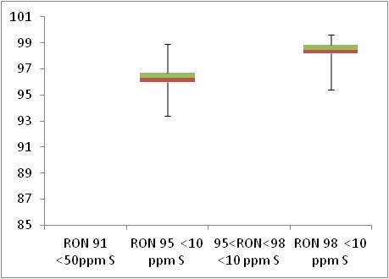  Min 95  Min 91

 | Motor Octane Number
MON | 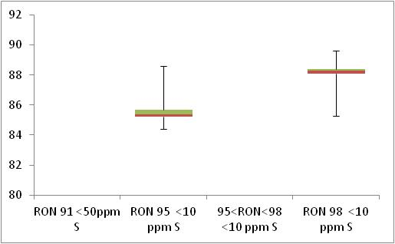  Min 85  Min 81

 | Summer Vapour Pressure (DVPE)
kPa | 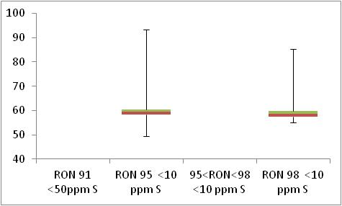  Max 60

Diesel Analysis
Figure 6-4: Diesel analysis
 | Density at 15ºC
Kg/m³ | 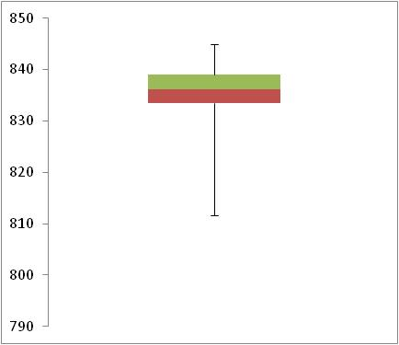  Max 845

 | Distillation – 95% v/v recovered
(⁰C) | 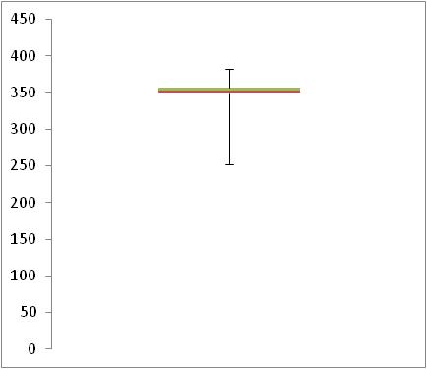  Max 360

Key Areas for Improvement
The following table summarises the main areas in which improvements could be made to the monitoring system, reporting or compliance with Directive limit values. The table includes key recommendations from the previous year to give an assessment of what action has been taken by the Member State to address any issues that may have been highlighted.
Key Areas for Improvement (3 years)
 | Monitoring | Reporting
2010 | - At least one sample tested for Motor Octane Number (MON) Eurosuper- 95RON was out of compliance  - Belgium takes a high number of samples in comparison to other countries and the percentage of infringements is low. The percentage of infringements is very small and involuntary. | No comment.
2009 | Records cetane against cetane index, rather than number. | No comment
2008 | - 14 of 18 parameters tested for petrol | - Does not report the values by which samples exceed limits  - No full-year results for low-sulphur fuel monitoring (summer and winter provided separately)

Bulgaria

Fuel Availability 2010
The following table lists the fuels that were reported to be available nationally in 2010.
Table 7-1: National fuel grade
Fuel grade | National fuel grade
min. RON=95 | RON 95
95=<RON<98 | RON>98
RON>=98 | RON 98
Diesel | Diesel

Sales, sampling and reporting

During 2010 fuel sales in Bulgaria were dominated by diesel fuel sales. 2,000 million litres of diesel was sold in comparison to less than 1,000 petrol fuel sales (all petrol grades combined). Bulgaria has not submitted full sales data; sales figures for different petrol fuel grades are combined and Figure 7-1 does not accurately represent the market share of petrol fuel sales in Bulgaria in 2010.
Figure 7-1: Fuel Sales proportions by fuel type
Petrol

Diesel

 | Million Litres
 |  |  | RON=91 |  |  | RON = 95 |  |  | RON 95=<RON<98 |  |  | RON 98 |  |  | Diesel
Table 7-2: Fuel sales and sampling
Fuel type (Parent Grade) | Sales | Sales, | Samples ⁽¹⁾ |  |  | Separate | Param’s measured ⁽⁴⁾ | Add. Notes
Fuel type (Parent Grade) | (Million litres) | % total of fuel type | S | W | TR ⁽²⁾ | S/W⁽³⁾ | Param’s measured ⁽⁴⁾ | Add. Notes
Unleaded min. RON=95 | 847 | 100.0% | 211 | 204 | - | Yes | 17 of 18 | (b) (c)
Unleaded 95=<RON<98 | Not known | Not known | 5 | 0 | - | Yes | 15 of 18 | (a) (c)
Unleaded RON>=98 | Not known | Not known | 1 | 6 | - | Yes | 15 of 18 | (a) (c)
Total Petrol | 847 | 100.00% | 217 | 210 | - | Yes
Diesel (<10 ppm S) | 2,168 | 100.0% | 257 | 211 | - | Yes | 5 of 5 | (b) (d)
Total Diesel | 2,168 | 100.00% | 257 | 211 | - | Yes
(1) | Samples |  |  |  | The actual number of samples taken by the Member State in the summer (s) and winter (w) periods
(2) | TR |  |  |  | Total requirement according to EN 14274. Dash (-) denotes National system has been used.
(3) | Separate S & W? |  |  |  | Yes indicates separate summer & winter reporting, and No indicates full year sample results reporting only.
(4) | Parameters measured |  |  |  | Currently 18 petrol parameters should be tested and reported by the Member States and 5 diesel parameters.
(a) | Bulgaria has not provided fuel sales split by fuel grades. As a result, it is impossible to assess whether the sample quantities taken for Petrol grades Unleaded 95=<RON<98 and Unleaded RON>=98 are adequate. If over 10% market share, these fuels should be sampled a minimum of 100 times per summer and winter period. Bulgaria clarifies that the market share of petrol grades with > RON 95 is much less than 10 %. According to Bulgarian Ordinance of liquid fuels quality and procedures and methods of their control petrol retail station are obliged to sale fuels only in compliance with RON grade published on the nozzles. In Bulgaria, petrols RON 95, RON 98 and RON over 98 are all for sale. The next Bulgarian report will report in accordance with that fact.
(b) | The Bulgarian seasonal period starts and finishes mid-month and as a result some samples in a month are categorised as 'summer' samples while samples within the same month may be classified as 'winter’ samples resulting in apparent discrepancies between sample totals. This report summary gives the summer and winter sample totals according to the separate summer and winter sample quantities within the reporting results section of the Bulgarian report.
(c) | No samples have been tested for MON in either summer or winter for any fuel grades. Additionally no samples of Olefins or Aromatics have been sampled and tested for petrol fuel grades Unleaded 95=<RON<98 and Unleaded RON>=98
(d) | Diesel sampling quantities in the Sales tab differ slightly from those in the reporting tables. Sample quantities in  Table 7-2 reflect the overall sample quantities given in reporting tables 257 (summer) and 211 (winter) – however full year sample quantities reported show different figure, again. All sample numbers for diesel parameters significantly exceed the required minimum (100 in both summer and winter).

Petrol Samples
- Bulgaria have almost complied with or exceeded minimum sampling requirements for RON 95 – however no samples have been tested and reported for MON and very low samples of some Hydrocarbon and Lead samples have been taken. However it is impossible to determine compliance for fuel grades RON 98 and RON >98 as fuel sales have not been provided.

Diesel Samples
- Diesel fuel samples tested in 2010 complied with the total minimum requirement for all parameters.

Fuel Quality Monitoring 2010

Description of System
Responsible organisation(s) | Ministry of Environment and Water /State Agency for Metrological and Technical Surveillance to Ministry of Economy, Energy and Tourism.
Fuel Quality Monitoring System (FQMS) | EN 14274 Statistical model B
Country Size | Small
Summer Period | Normal – Bulgaria have reported an extended summer period – from 16th April to 15th October.
Location(s) of sampling | Mainly service stations – some refinery sampling - commercial sites, public and private refuelling stations, spread all over the Bulgarian territory.
Time/frequency of sampling | Petrol grade RON 95 and diesel have been sampled in every month throughout 2010. Petrol grades 95=<RON<98 and RON 98 have been sampled 3 and 6 months of the year (respectively).
Specification of test methods | Tests have been carried out according to the tests methods mentioned in the Directive 98/70/EC amended by Directive 2003/17/EC.
Collection of sales data | The source of information on fuel consumption is the National Statistic Institute. For evaluation of the intended minimum number of samples to be taken according to the requirements of EN 14274 the amounts of petrol and diesel fuels for 2009 were used for calculations relating to 2010. Data on fuel consumption in 2010 will be available in November 2011.  Fuel sales of petrol are combined – there is no split by petrol octane number by category. Regulation 1099/2008/EO in which the National Institute of Statistics report, there are no separate requirements for different types of unleaded petrol. The amount is 625,798 for the unleaded petrol with an octane number min. RON = 95; min. 95 ≤ RON <98 and min. RON>= 98
Other details
Marketed fuels are mainly produced by one Bulgarian refinery. Small amounts of are imported from abroad. Taking into account nearly the equal amount of petrol stations, marketing nearly the same amounts of fuels in each macro-region and the availability of both fuels, produced by one refinery, having branches in each macro region, the amount of samples to be taken, is considered to be equal for each regional department of the Directorate General
Samples are tested only in stationary or at first in mobile and then in stationary laboratory of testing department. Equipment of mobile laboratories is mostly for express testing methods. When in mobile laboratory is determined non-compliance for one or more parameters, the test is repeated in stationary laboratory. In the mobile laboratory the following test methods are used; Distillation by ASTM 7345, Benzene by ASTM 6277, Oxygen content and Oxygenates by ASTM 5845 and Sulphur content by ASTM 7212. Test to the parameter "Cetane number" is carried out only in the mobile laboratory with the help of diesel analyser "Irox Diesel". Equipment in the stationary department covers requirements of EN 228 and EN 590 where equipment for "Sulphur content" complies with EN 20846. Most samples are also tested for other parameters like: Density for Petrol and Cetane index, Viscosity, Flash point, FCPP and FAME content for Diesel.

Compliance with Fuel Quality Limit Values
Table 7-3: Petrol Fuel Grades
RON 95 Petrol - Details of samples that exceed tolerance limits:
Parameter | Limit Value | Tolerance Limit* (TL) | Max/Min value of samples tested | No samples outside TL | % samples outside TL
RON | 95 | 94.6 | 86.9 | 5 | 1.2%
Summer vapour pressure, kPa | 60 | 61.8 | 70.7 | 14 | 7.6%
Distillation evaporated at 100ºC, % v/v | 46 | 43.6 | 32.2 | 1 | 0.21%
Distillation evaporated at 150ºC, % v/v | 75 | 72.6 | 58.9 | 1 | 0.21%
Oxygen content, % m/m | 2.7 | 2.9 | 5.4 | 4 | 0.94%
Methanol, % v/v | 3 | 3.2 | 7.9 | 2 | 0.47%
Ethanol, % v/v | 5 | 5.2 | 6.3 | 1 | 0.24%
Sulphur content, mg/kg | 10 | 11.6 | 54.1 | 7 | 1.58%
Lead content, g/l | 0.005 | 0.0054 | 0.01 | 1 | 4.76%
Member State notes
Each sample found to be out of compliance with specifications resulted in a fine of 10,000 lv each.

RON 95 ≤ RON <98 Petrol - Details of samples that exceed tolerance limits:
Parameter | Limit Value | Tolerance Limit* (TL) | Max/Min value of samples tested | No samples outside TL | % samples outside TL
Summer vapour pressure, kPa | 60 | 61.8 | 69.6 | 3 | 100%
Member State notes
Each sample found to be out of compliance with specifications resulted in a fine of 10,000 lv each.

Table 7-4: Diesel Fuel Grades
Diesel - Details of samples that exceed tolerance limits:
Parameter | Limit Value | Tolerance Limit* (TL) | Max/Min value of samples tested | No samples outside TL | % samples outside TL
Density at 15ºC, kg/m³ | 845 | 845.7 | 899 | 3 | 0.65%
Distillation – 95-%-Point, ºC | 360 | 365.9 | 400 | 4 | 1%
Sulphur content, mg/kg | 10 | 11.3 | 500 | 49 | 9.48%
Member State notes
Each sample found to be out of compliance with specifications resulted in a fine of 10,000 lv each.
Additionally; Cetane number has been checked for 283 samples. For the rest 185 samples instead of Cetane number" has been determined Cetane index according to EN 4264, where Minimum is 47.3; Maximum is 53.8; Median is 50,25; Mean is 50,50; Standard deviation is 1,46; 25% is 49.2 and 75% is 51.8. There are no samples outside the 95% tolerance limit.

Temporal Trends
Figure 7-2 shows the trend in total fuel sales since 2001. Bulgaria began reporting under the FQM directive in 2005. Since 2005 fuel sales in diesel have increased by 8% and have seen a 4% increase since 2009. Petrol fuel sales have increased by 3% since 2009 and have seen an overall increase of 15% in the period 2005-2010.
Figure 7-2: Temporal trends in national sales of petrol and diesel (million litres)
Sales (million litres)

 |  |  |  |  | Petrol |  | Diesel

Statistical Analysis
The following charts in this section are known as box-plots and they display the distribution of fuel characteristics per Member State by illustrating the:
- Sample minimum
- Lower 25% range
- Middle 50% range
- Median
- Upper 25% range
- Maximum
For a full explanation of the information presented in a Box Plot diagram, please see Appendix 1.

Petrol Analysis
Fuel sampling in Bulgaria in 2010 recorded a number of test results out of specification with limits and they also failed to report the Motor Octane Number parameter for any petrol fuel grade. The analysis charts for petrol (Figure 7-3) and diesel (Figure 7-4) detail the distribution of sample results for the 5 selected parameters;
Petrol:
- Research Octane Number
- Motor Octane Number
- Summer Vapour Pressure
Diesel:
- Density at 15ºC
- Distillation – 95% v/v recovered
Sample results for these parameters have been depicted using box plots based on the reported sample minimum, lower quartile (Q1), median (Q2), upper quartile (Q3), and the maximum sample value.
Sample results in 2010 have been presented in the following figures with limit values for the parameter (maximum or minimum) to demonstrate the skew of sample results. RON sample results show that the fuels available in Bulgaria have reasonably small variation in Octane levels. MON sampling was not undertaken by Bulgaria so no statistical analysis could be completed. Summer Vapour pressure results cannot be presented for Bulgaria due to anomalous figures for fuel grade RON 95 and due to the fact that only 3 and 1 samples were taken of fuel grades RON>98 and RON = 98 (respectively).
Diesel sample results for Density show a slightly wider variation in density, exhibited by the widely spread coloured bands at the 25 and 75 quartile – in comparison to the tight bands shown in the petrol analysis box plots. Density is also significantly below the tolerance limit.
Figure 7-3: petrol analysis
 | Research Octane Number
RON | 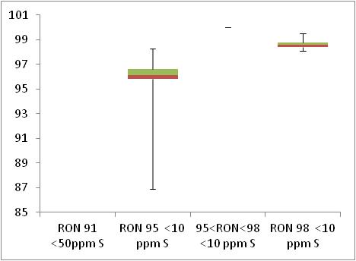  Min 95  Min 91

Diesel Analysis
Figure 7-4: Diesel analysis
 | Density at 15ºC
Kg/m³ | 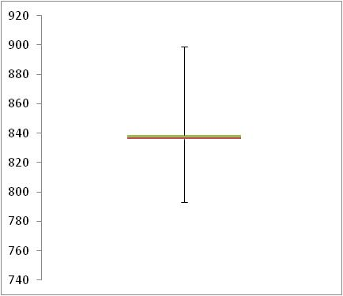  Max 845

 | Distillation – 95% v/v recovered
(⁰C) | 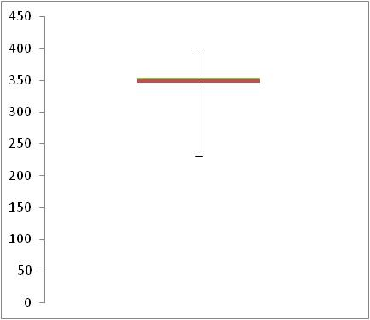  Max 360

Key Areas for Improvement
The following table summarises the main areas in which improvements could be made to the monitoring system, reporting or compliance with Directive limit values. The table includes key recommendations from the previous year to give an assessment of what action has been taken by the Member State to address any issues that may have been highlighted.
Key Areas for Improvement (3 years)
 | Monitoring | Reporting
2010 | - Fuel sales data is not available for reporting year 2010 and sales data for 2009 has been provided instead.  - 2010 diesel sales figures include international shipping fuels.  - Regional sales volumes have not been provided for Petrol or Diesel – sample distribution has been provided, however sales have not. | - Bulgaria has not submitted full sales data per petrol grade – this is a requirement outlined in EN 14274.  - Additional detail could have been provided in relation to the Fuel Quality Monitoring System for 2010.  - They did not report all parameters for the petrol grades – particularly MON where no samples were taken for any of the petrol grades.
2009 | - Not all petrol parameters are tested (MON, olefins, aromatics) | - Did not provide petrol sales data by grade making it impossible to determine compliance. Sulphur content is based on RON95 only  - Report 21 days late
2008 | - Unable to distinguish between low-sulphur and sulphur-free fuels  - Not all petrol parameters are tested | - Sales data not reported by sulphur grade  - Sulphur-free fuel sampling not reported separately

Cyprus

Fuel Availability 2010
The following table lists the fuels that were reported to be available nationally in 2010.
Table 8-1: National fuel grade
Fuel grade | National fuel grade
RON 95 < 10 ppm Sulphur | Unleaded Petrol 95
RON 98 < 10 ppm Sulphur | Unleaded Petrol 98
Diesel < 10 ppm Sulphur | Diesel

Sales, sampling and reporting
During 2010 fuel sales in Cyprus of petrol and diesel were split almost equally. Almost 400 million litres of diesel was sold and 500 million litres of petrol (all petrol grades combined). Petrol fuel sales were dominated by the RONM=95 fuel grade.
Figure 8-1: Fuel Sales proportions by fuel type
Petrol

Diesel

 | Million Litres
 |  |  | RON=91 |  |  | RON = 95 |  |  | RON 95=<RON<98 |  |  | RON 98 |  |  | Diesel

Table 8-2: Fuel sales and sampling
Fuel type (Parent Grade) | Sales | Sales, | Samples ⁽¹⁾ |  |  | Separate | Param’s measured ⁽⁴⁾ | Add. Notes
Fuel type (Parent Grade) | (Million litres) | % total of fuel type | S | W | TR ⁽²⁾ | S/W⁽³⁾ | Param’s measured ⁽⁴⁾ | Add. Notes
Unleaded min. RON=95 | 479 | 91.1% | 84 | 60 | 100
Unleaded RON>=98 | 47 | 8.9% | 84 | 65 | 9 | Yes | All of 18
Total Petrol | 526 | 100% | 168 | 125 | 109 | Yes |  | (a)
Diesel (<10 ppm S) | 428 | 100% | 100 | 67 | 100 | No | All of 5
Total Diesel | 428 | 100% | 100 | 67 | 100 | No
(1) | Samples |  |  |  | The actual number of samples taken by the Member State in the summer (s) and winter (w) periods
(2) | TR |  |  |  | Total requirement according to EN 14274. Dash (-) denotes National system has been used.
(3) | Separate S & W? |  |  |  | Yes indicates separate summer & winter reporting, and No indicates full year sample results reporting only.
(4) | Parameters measured |  |  |  | Currently 18 petrol parameters should be tested and reported by the Member States and 5 diesel parameters.
(a) | Small quantities (0.33% market share) of RON 100 were marketed in Cyprus in 2010. This fuel has not been monitored or reported.

Petrol Samples
- Cyprus have complied with or exceeded minimum sampling requirements for all petrol fuel grades.
- The samples tested and reported per parameter varies, however all parameters have been tested and reported more than the minimum sample quantity (50 per summer and winter period).

Diesel Samples
- Diesel fuel samples tested in 2010 complied with the total minimum requirement.
- The samples tested and reported per parameter varies, however all parameters have been tested and reported more than the minimum sample quantity (50 per summer and winter period).

Fuel Quality Monitoring 2010

Description of System
Responsible organisation(s) | Energy Service, Ministry of Commerce, Industry and Tourism
Fuel Quality Monitoring System (FQMS) | EN 14274 Statistical model C
Country Size | Small
Summer Period | Normal
Location(s) of sampling | Samples of all fuel grades were taken from petrol stations, the depot at Larnaca, including CPSC farm, cars and other private installations of large consumers by the inspectors of the Energy Service.  Retail site (petrol stations) samples were taken by the inspectors of the Energy Service on a monthly surveillance program prepared by the Chief Inspector and/or his Assistant. The petrol stations (from which samples are taken) were selected from the list of petrol stations based on the volume of sales and the geographical location.  The number of samples taken from the Larnaca depot was determined by the number of petroleum shipments imported. All petroleum products held by the CPSC were tested in order to secure their compliance with the EU specifications.
Time/frequency of sampling | Samples have been taken in every month throughout the year. The frequency of sampling at petrol stations as well as the Larnaca depot is decided by the Chief Inspector and/or his assistant.
Specification of test methods | The Energy Service owns a mobile lab for performing all the necessary tests for monitoring the quality of fuels marketed Cyprus. The Mobile Lab consists of 7 fully automatic analysers that can define almost all the main parameters of diesel, petrol, kerosene gasoil, jet fuel, marine and fuel oil. The Mobile Lab is in the process of being an accredited fuel laboratory, based on the CYS EN ESO/IEC 17025:2005 standard.
Collection of sales data | No information has been provided about the collection of sales data in 2010.
Other details
The Energy Service of the Ministry of Commerce Industry and Tourism is the competent authority for monitoring the quality of fuels. The Mobile Lab and the laboratory of the CPSC were appointed to conduct tests required for monitoring fuel quality. The Mobile Lab of the Energy Service carried out almost all the tests required for monitoring the fuel quality for 2010. The Laboratory of the CPSC conducted only a limited number of tests especially for verification reasons.
The design of the national fuel quality monitoring system was based on Cyprus conditions. According to the provisions of Law N.148 (I)/2003 on fuel quality, the Minister of Commerce, Industry and Tourism designates the laboratories for testing the fuel samples, maintains a list with all retail sites and terminal facilities and appoints the Chief Inspector, his Assistant and the inspectors responsible to carry out the sampling.
The Cyprus FQMS was designed based on the following parameters:
• Country size: Small and single region
• Automotive fuel consumption per year: 776.722 toe
• Import facilities: Larnaca depot comprises the three tank farms owned by the oil market companies (Petrolina, EKO, and ExxonMobil). Total Capacity: 42.000 MT (Lukoil and BP Eastern Mediterranean utilize other companies facilities)
• Common import facilities: Cyprus Petroleum Storage Company Ltd, (former refinery) of total capacity: 82.200 MT
• Number of oil marketing companies: 5 (Petrolina, EKO, ExxonMobil, Lukoil, BP Eastern Mediterranean (imports only diesel for large consumers))
• Number of retail sites: 268 petrol stations operated by the oil marketing companies.

Compliance with Fuel Quality Limit Values
Table 8-3: Petrol Fuel Grades
RON 95 Petrol - Details of samples that exceed tolerance limits:
Parameter | Limit Value | Tolerance Limit* (TL) | Max/Min value of samples tested | No samples outside TL | % samples outside TL
Summer vapour pressure, kPa | 60 | 61.8 | 74.7 | 21 | 25%
Member State notes
Sample results found to be out of specification with tolerance limits were due to transition period from winter to summer (6 weeks).

RON 98 Petrol - Details of samples that exceed tolerance limits:
Parameter | Limit Value | Tolerance Limit* (TL) | Max/Min value of samples tested | No samples outside TL | % samples outside TL
Summer vapour pressure, kPa | 60 | 61.8 | 74.9 | 20 | 25%
Member State notes
Sample results found to be out of specification with tolerance limits were due to transition period from winter to summer (6 weeks).

Table 8-4: Diesel Fuel Grades
Diesel - Details of samples that exceed tolerance limits:
Parameter | Limit Value | Tolerance Limit* (TL) | Max/Min value of samples tested | No samples outside TL | % samples outside TL
Sulphur content, mg/kg | 10 | 13 | 94.2 | 1 | 0.5%
Member State notes
Contamination at a service station as a result of mixing automotive diesel with heating diesel. Penal prosecution was instigated against the petrol station.

Temporal Trends
Figure 8-2 shows the trend in total fuel sales since 2001. Cyprus began reporting under the FQM directive in 2004. Since 2004 fuel sales in diesel have increased by 57% and have seen a 2% increase since 2009. Petrol fuel sales have increased 2% since 2009 and have seen an overall increase of 102% in the period 2004-2010.
Figure 8-2: Temporal trends in national sales of petrol and diesel (million litres)
Sales (million litres)

 |  |  |  |  | Petrol |  | Diesel

Statistical Analysis
The following charts in this section are known as box-plots and they display the distribution of fuel characteristics per Member State by illustrating the:
- Sample minimum
- Lower 25% range
- Middle 50% range
- Median
- Upper 25% range
- Maximum
For a full explanation of the information presented in a Box Plot diagram, please see Appendix 1.

Petrol Analysis
Fuel sampling in Cyprus in 2010 recorded relatively few test results out of specification with limits. The analysis charts for petrol (Figure 8-3) and diesel (Figure 8-4) detail the distribution of sample results for the 5 selected parameters;
Petrol:
- Research Octane Number
- Motor Octane Number
- Summer Vapour Pressure
Diesel:
- Density at 15ºC
- Distillation – 95% v/v recovered
Sample results for these parameters have been depicted using box plots based on the reported sample minimum, lower quartile (Q1), median (Q2), upper quartile (Q3), and the maximum sample value.
Sample results in 2010 have been presented in the following figures with limit values for the parameter (maximum or minimum) to demonstrate the skew of sample results. RON and MON sample results show that the fuels available in Austria have reasonably small variation in Octane levels. Summer Vapour pressure results shows that the samples were found to be tighter to the specifications of the Fuel Quality Directive, with some samples exceeding limit values and the majority of samples skewed closer to the limit with a wider variation.
Diesel sample results for Density show a slightly wider variation in density, exhibited by the widely spread coloured bands at the 25 and 75 quartile. Density is also significantly below the tolerance limit.
Figure 8-3: petrol analysis
 | Research Octane Number
RON | 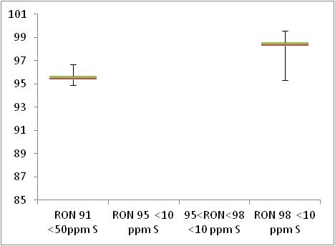  Min 91  Min 95

 | Motor Octane Number
MON | 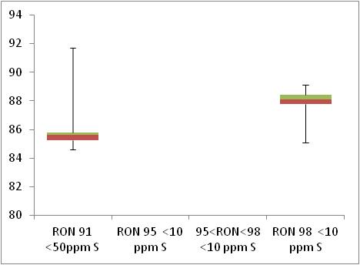  Min 81  Min 85

 | Summer Vapour Pressure (DVPE)
kPa | 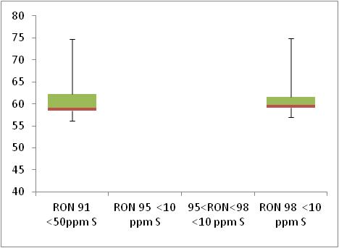  Max 60

Diesel Analysis
Figure 8-4: Diesel analysis
 | Density at 15ºC
Kg/m³ | 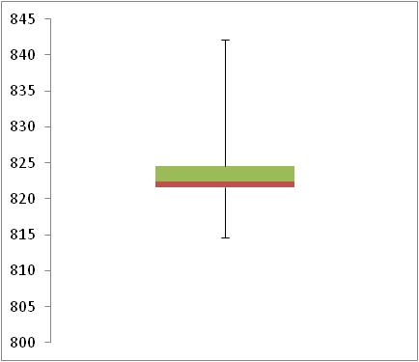  Max 845

 | Distillation – 95% v/v recovered
(⁰C) | 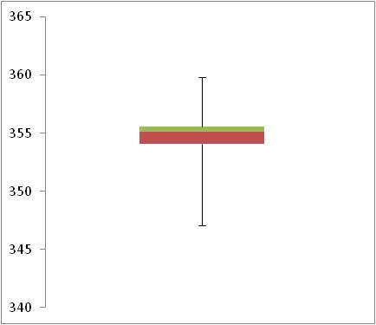  Max 360

Key Areas for Improvement
The following table summarises the main areas in which improvements could be made to the monitoring system, reporting or compliance with Directive limit values. The table includes key recommendations from the previous year to give an assessment of what action has been taken by the Member State to address any issues that may have been highlighted.
Key Areas for Improvement (3 years)
 | Monitoring | Reporting
2010 | - Cyprus has reported sales of RON 100 with less than 1% market share, however have provided no sample results. EN 14274 section 5.4.2 states that where the minimum sample required is found to be less than 1 – then at least one sample of that fuel grade should be taken. | - The 2010 report was submitted almost one full month after the 30th June annual Member State reporting deadline arriving on the 28th July.  - Parameter results should be reported in the units of measurement provided (as per Directive specification).  - Testing conducted during the transition period between summer and winter should not be reported in the summer data set unless these were conducted within the regulated summer period (between 1 May and 30 September).
2009 | - Marginally low sampling of RON95 petrol (the most common grade)  - Some sampling at depot. Unclear if sufficient sampling at petrol stations | - Report received 1 month late  - High sulphur content found in samples from rural areas early in 2009 when tanks hadn’t been cleaned before introduction of sulphur-free fuels
2008 | - Sulphur-free fuels were supposedly available but sales and sampling data are not provided by sulphur content | - Sales and sampling reported by combined sulphur content  - More detail could be provided on sampling locations

Czech Republic

Fuel Availability 2010
The following table lists the fuels that were reported to be available nationally in 2010.
Table 9-1: National fuel grade
Fuel grade | National fuel grade
RON 91 < 10 ppm Sulphur | Special BA-91
RON 95 < 10 ppm Sulphur | Super BA-95
RON 98 < 10 ppm Sulphur | Super Plus BA-98
Diesel < 10 ppm Sulphur | Motorová nafta

Sales, sampling and reporting
During 2010 fuel sales in the Czech Republic were dominated by diesel fuel sales. More than 4,500 million litres of diesel was sold in comparison to less than 2,500 petrol fuel sales (all petrol grades combined). Petrol fuel sales were mainly comprised of fuel grade RON 95.
Figure 9-1: Fuel Sales proportions by fuel type
Petrol  Diesel | 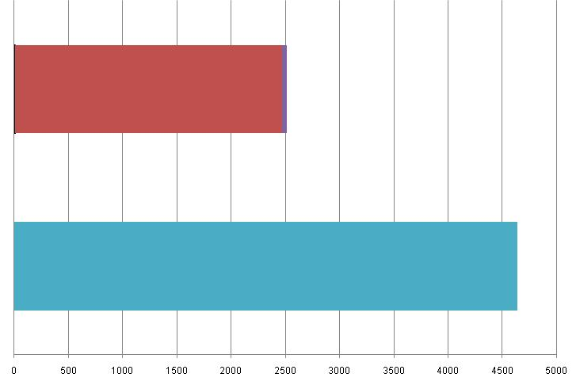
 | Million Litres
 |  |  | RON=91 |  |  | RON = 95 |  |  | RON 95=<RON<98 |  |  | RON 98 |  |  | Diesel

Table 9-2: Fuel sales and sampling
Fuel type (Parent Grade) | Sales | Sales, | Samples ⁽¹⁾ |  |  | Separate | Param’s measured ⁽⁴⁾ | Add. Notes
Fuel type (Parent Grade) | (Million litres) | % total of fuel type | S | W | TR ⁽²⁾ | S/W⁽³⁾ | Param’s measured ⁽⁴⁾ | Add. Notes
Unleaded min. RON=91 | 5 | 0.2% | 18 | 15 | 1 | Yes | All of 18
Unleaded 95=<RON<98 | 2,459 | 97.9% | 251 | 447 | 100 | Yes | All of 18
Unleaded RON>=98 | 49 | 1.9% | 5 | 11 | 2 | Yes | All of 18
Total Petrol | 2,513 | 100% | 274 | 473 | 103 | Yes | All of 18
Diesel (<10 ppm S) | 4,637 | 100% | 419 | 458 | 100 | Yes | All of 5
Total Diesel | 4,637 | 100% | 419 | 458 | 100 | Yes | All of 5
(1) | Samples |  |  |  | The actual number of samples taken by the Member State in the summer (s) and winter (w) periods
(2) | TR |  |  |  | Total requirement according to EN 14274. Dash (-) denotes National system has been used.
(3) | Separate S & W? |  |  |  | Yes indicates separate summer & winter reporting, and No indicates full year sample results reporting only.
(4) | Parameters measured |  |  |  | Currently 18 petrol parameters should be tested and reported by the Member States and 5 diesel parameters.

Petrol Samples
- The Czech Republic have complied with or exceeded minimum sampling requirements for all petrol fuel grades.

Diesel Samples
- Diesel fuel samples tested in 2010 complied with the total minimum requirement.

Fuel Quality Monitoring 2010

Description of System
Responsible organisation(s) | Ministry of Industry and Trade of the Czech Republic
Fuel Quality Monitoring System (FQMS) | EN 14274 Statistical Model C
Country Size | Small
Summer Period | Normal
Location(s) of sampling | Service Stations
Time/frequency of sampling | Samples have been taken monthly throughout the course of the year. RON 98 petrol (Super Plus BA-98) comprises less than 1% fuels sales and so has been sampled at a reduced frequency.
Specification of test methods | In conformity with the FQM Directive, fuel quality in the Czech Republic was monitored in 2010 on the basis of MIT Decree No. 229/2004 Coll., replaced by MIT Decree No. 133/2010 Coll., in effect since 1 June 2010 (Table 2 of Annex 4 of this Decree is to be in effect since 1 January 2012); in compliance with European quality standards for petrol and diesel (EN 228 and EN 590), test standards, sampling standards and the Fuel Quality Monitoring System.
Collection of sales data | Fuel sales data are based on the statistics of the Ministry of Industry and Trade, which is in line with official statistics CZSO.
Other details
All samples of petrol or diesel, which are found to have exceeded even one parameter, are recorded as being non-compliant in the monitoring report. In the case that serious breaches of fuel quality standards are discovered, the Czech Trade Inspection (CTI) has the responsibility of applying financial sanctions or closing the refuelling station until the fuel quality is judged to have been restored. In addition to the parameters required under the FQMS to conform to environmental specifications, other characteristics are also monitored for consumer protection.
Production of regular unleaded petrol with minimum RON = 91, i.e. Special BA-91, was ended in the Czech Republic in the half of the year 2010. The need for this type of petrol is solved with the help of additives.

Compliance with Fuel Quality Limit Values
Table 9-3: Petrol Fuel Grades
BA 91 Petrol - Details of samples that exceed tolerance limits:
Parameter | Limit Value | Tolerance Limit* (TL) | Max/Min value of samples tested | No samples outside TL | % samples outside TL
Summer Vapour Pressure, kPa | 60 | 61.8 | 74 | 4 | 12%
Aromatics, % v/v | 35 | 37.2 | 39.6 | ? | ?
Sulphur content, mg/kg | 10 | 11.6 | 28.6 | 9 | 27%
Member State notes
Production of regular unleaded petrol with minimum RON = 91, i.e. Special BA-91, was ended in the Czech Republic in the half of the year 2010. The need for this type of petrol is solved with the help of additives. Some samples gave results that exceeded limits for aromatics, and this was found to be as a result of deliberately added aromatics, probably in the form of technical solvents. No details have been provided about the number of samples that were out of compliance with Directive specifications for Aromatics as a result of these additives.
Up to the 22nd May, the period is regarded as interim period according to ČSN EN 228, national annex.

BA-95 Petrol - Details of samples that exceed tolerance limits:
Parameter | Limit Value | Tolerance Limit* (TL) | Max/Min value of samples tested | No samples outside | % samples outside TL
RON | 95 | 94.6 | 89.5 | 9 | 1
MON | 85 | 84.5 | 80.6 | 9 | 1%
Summer vapour pressure, kPa | 60 | 61.8 | 85.2 | 3 | 1%
Distillation – 150ºC, % v/v | 75 | 72.6 | 70 | 2 | 0.2%
Aromatics, % v/v | 35 | 36 | 52.7 | 6 | 0.08%
Oxygen content, 5 m/m | 2.7 | 2.9 | 19 | 9 | 1%
Ethanol, % v/v | 5 | 5.2 | 50.4 | 9 | 1%
Member State notes
Up to the 22nd May, the period is regarded as interim period according to ČEN EN 228, national annex.

BA-98 Petrol | Compliant with Directive 98/70/EC
Table 9-4: Diesel Fuel Grades
Diesel - Details of samples that exceed tolerance limits:
Parameter | Limit Value | Tolerance Limit* (TL) | Max/Min value of samples tested | No samples outside TL | % samples outside TL
Density at 15ºC, kg/m³ | 845 | 845.3 | 849 | 1 | 0.1%
Distillation –95-%--Point, ºC | 360 | 365.9 | 396 | 21 | 2.4%
Sulphur content, mg/kg | 10 | 11.3 | 28.8 | 7 | 0.8%
Member State notes

Temporal Trends
Figure 9-2 shows the trend in total fuel sales since 2004. Diesel sales in the Czech Republic have reduced by 5% compared to 2009 sales figures – representing an overall increase of 11% since 2004. Petrol fuel sales have reduced by 9% in the period between 2009 and 2010 with an overall reduction of 18% in the period 2004-2010.
Figure 9-2: Temporal trends in national sales of petrol and diesel (million litres)
Sales (million litres) | 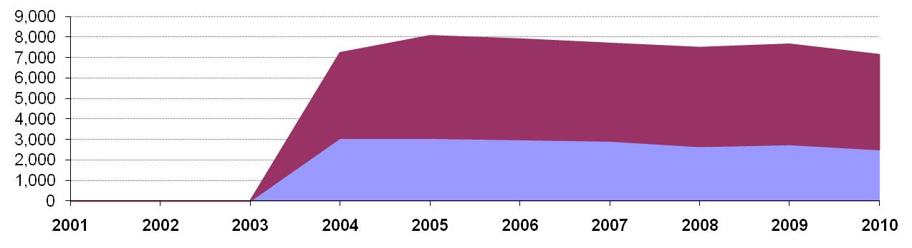
 |  |  |  |  | Petrol |  | Diesel

Statistical Analysis
The following charts in this section are known as box-plots and they display the distribution of fuel characteristics per Member State by illustrating the:
- Sample minimum
- Lower 25% range
- Middle 50% range
- Median
- Upper 25% range
- Maximum
For a full explanation of the information presented in a Box Plot diagram, please see Appendix 1.

Petrol Analysis
Fuel sampling in the Czech Republic in 2010 recorded relatively few test results out of specification with limits. Summer vapour pressure, given statistical results in Figure 9-3 are skewed due to the low number of samples taken of fuel grade RON 91 where 4 samples out of 18 tested for summer vapour pressure were found to be out of compliance, by a significant amount giving statistical results that appear to present a bleaker picture of the fuel quality of RON 91 than is the case. The analysis charts for petrol (Figure 9-3) and diesel (Figure 9-4) detail the distribution of sample results for the 5 selected parameters;
Petrol:
- Research Octane Number
- Motor Octane Number
- Summer Vapour Pressure
Diesel:
- Density at 15ºC
- Distillation – 95% v/v recovered
Sample results for these parameters have been depicted using box plots based on the reported sample minimum, lower quartile (Q1), median (Q2), upper quartile (Q3), and the maximum sample value.
Sample results in 2010 have been presented in the following figures with limit values for the parameter (maximum or minimum) to demonstrate the skew of sample results. RON and MON sample results show that the fuels available in the Czech Republic have reasonably some variation in Octane levels depending on the type of fuel. Summer Vapour pressure results show that most samples were outside of the tolerance limit.
Diesel sample results for Density also show a wide variation in density, exhibited by the widely spread coloured bands at the 25 and 75 quartile.
Figure 9-3: petrol analysis
 | Research Octane Number
RON | 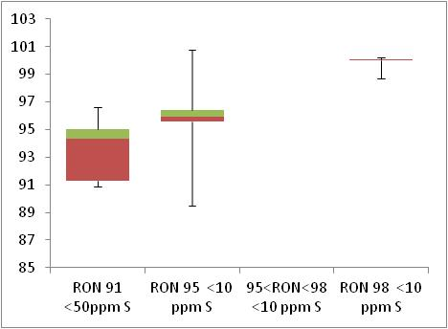  Min 95  Min 91

 | Motor Octane Number
MON | 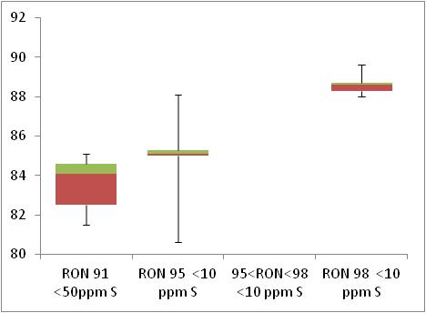  Min 85  Min 81

 | Summer Vapour Pressure (DVPE)
kPa | 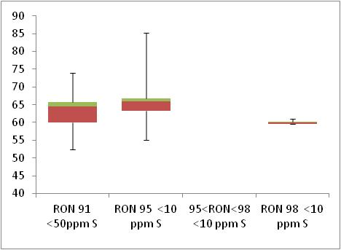  Max 60

Diesel Analysis
Figure 9-4: Diesel analysis
 | Density at 15ºC
Kg/m³ | 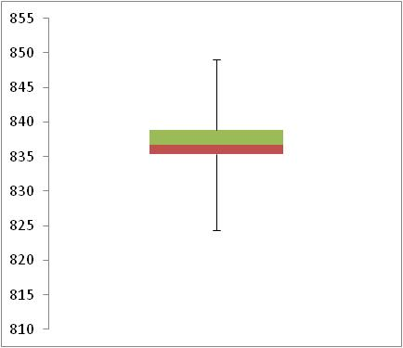  Max 845

 | Distillation – 95% v/v recovered
(⁰C) | 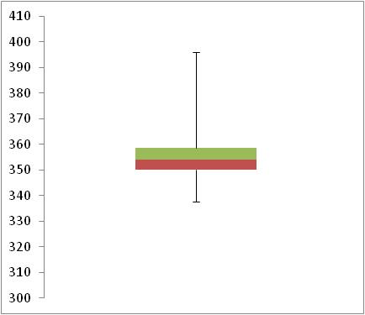  Max 360

Key Areas for Improvement
The following table summarises the main areas in which improvements could be made to the monitoring system, reporting or compliance with Directive limit values. The table includes key recommendations from the previous year to give an assessment of what action has been taken by the Member State to address any issues that may have been highlighted.
Key Areas for Improvement (3 years)
 | Monitoring | Reporting
2010 | - In 2010 the Czech Republic has used EN14274 statistical Model C. Given the country size, Model A or B may be more appropriate. | - No details were provided about the number of RON 91 samples found to be out of specification for Aromatics.
2009 | - Use Model C. Given the country size, Model A or B may be more appropriate | - Adulterated samples with high sulphur content (200ppm) mean diesel average S content >10ppm. Action was taken by MS
2008 | - Samples were split between low-sulphur and sulphur-free using an unknown method  - Sulphur-free not labelled  - Use Model C. Given country size, A or B may be more appropriate  - Don’t state how many samples are taken from fuel stations (“primarily”) | - Sales figures of some sulphur-free fuels have been reported in combination with low-sulphur (RON91 + 95 + diesel)

Denmark

Fuel Availability 2010
The following table lists the fuels that were reported to be available nationally in 2010.
Table 10-1: National fuel grade
Fuel grade | National fuel grade
RON 91 < 10 ppm Sulphur | RON 92
RON 95 < 10 ppm Sulphur | RON 95
RON 98 < 10 ppm Sulphur | RON 98
Diesel < 10 ppm Sulphur | Diesel

Sales, sampling and reporting
During 2010 fuel sales in Denmark were dominated by diesel fuel sales. Almost 3,000 million litres of diesel was sold in comparison to 2,000 petrol fuel sales (all petrol grades combined). Petrol fuel sales were mainly comprised of fuel grade RON 95.
Figure 10-1: Fuel Sales proportions by fuel type
Petrol

Diesel

 | Million Litres
 |  |  | RON=91 |  |  | RON = 95 |  |  | RON 95=<RON<98 |  |  | RON 98 |  |  | Diesel

Table 10-2: Fuel sales and sampling
Fuel type (Parent Grade) | Sales | Sales, | Samples ⁽¹⁾ |  |  | Separate | Param’s measured ⁽⁴⁾ | Add. Notes
Fuel type (Parent Grade) | (Million litres) | % total of fuel type | S | W | TR ⁽²⁾ | S/W⁽³⁾ | Param’s measured ⁽⁴⁾ | Add. Notes
Unleaded min. RON=91 | 517 | 24.8% | 5 | 4 |  | Yes | All of 18 | (a)
Unleaded min. RON=95 | 1,570 | 75.1% | 14 | 17 |  | Yes | All of 18 | (b)
Unleaded RON>=98 | 3 | 0.1% | 1 | 1 |  | Yes | All of 18 | (a)
Total Petrol | 2,090 | 100.00% | 20 | 20 | - | Yes
Diesel (<10 ppm S) | 3,101 | 100.0% | 10 | 12 |  | Yes | All of 5 | (b)
Total Diesel | 3,101 | 100.00% | 10 | 12 | - | Yes
(1) | Samples |  |  |  | The actual number of samples taken by the Member State in the summer (s) and winter (w) periods
(2) | TR |  |  |  | Total requirement according to EN 14274. Dash (-) denotes National system has been used.
(3) | Separate S & W? |  |  |  | Yes indicates separate summer & winter reporting, and No indicates full year sample results reporting only.
(4) | Parameters measured |  |  |  | Currently 18 petrol parameters should be tested and reported by the Member States and 5 diesel parameters.
(a) | Fuel grades RON 91 and RON 98 represent less than 10% total market share of fuel; 9.96% and 0.05% respectively and so have been sampled in low quantities as outlined in EN 14274. However the parameters have been sampled in varying quantities; with low sample numbers for parameters such as RON, MON and sulphur content. Whilst the overall (maximum number) of samples tested meets requirements, some of the more significant parameters should have been tested at this maximum level.
(b) | Market fuel share of RON 95 and diesel are above 10%. In order for the Danish National monitoring system to show equivalence with the recommended Statistical Model (Model A) outlined in EN 14274, there should have been a minimum of 50 samples for both of these fuel types in each summer and winter period.

Petrol Samples
- Denmark’s National Monitoring system has not taken samples of fuels with a market share of >10% equivalent to those required in EN 14274 Statistical models.
- Petrol fuel grades with a market share <10% have accordingly been sampled at lower quantities; however samples of key parameters such as sulphur content and RON/ MON are low.

Diesel Samples
- Denmark’s National Monitoring system has not taken samples of diesel with a market share of equivalent to those required in EN 14274 Statistical models.

Fuel Quality Monitoring 2010

Description of System
Responsible organisation(s) | Miljøstyrelsen (The Danish Environmental Protection Agency)
Fuel Quality Monitoring System (FQMS) | National model
Country Size | Small
Summer Period | Arctic
Location(s) of sampling | Service Stations
Time/frequency of sampling | Samples of petrol RON 92, RON 95 and diesel have been taken during 3 months of the year (2 in winter, 1 in summer). Samples of RON 98 have been taken in only two months of the year (both in winter).
Specification of test methods | Specifications are in accordance with DS/EN 228 for petrol and DS/EN 590 for diesel and the current Danish Statutory Order regarding the quality of petrol and diesel fuel. However, the test methods applied for analysis are in some cases different from the methods set out in EN 228:1999 and EN 590:1999.  SGS Sweden, who performs the analysis, has declared that the methods used correspond to the ones in the directive.  The methods are:  -ASTM D4815 is used instead of EN 13132 for oxygenates  -ASTM D5453 is used instead of ISO 20846 for sulphur  -ASTM D3237 is used instead of EN 237 for lead
Collection of sales data | The source of sales data for 2010 has not been provided.
Other details
More than 99% of fuels used for road transport in Denmark are distributed from two Danish refineries or from terminals owned by members of the Danish Petroleum Association (EOF) which have to meet the Association’s Exchange specifications.
More than 99% of the fuels used for road transport in Denmark are delivered from terminals, which are certified in accordance with ISO 9000 or equivalent quality-management systems.
More than 99% of the fuels used for road transport in Denmark are distributed from terminals where “Certificates of Quality” exist for every import/batch approved according to DS/EN 228 for petrol or DS/EN 590 for diesel and the current Danish Statutory Order regarding the quality of petrol and diesel.
Some of the specified parameters are only measured on a reduced number of samples. These are parameters estimated to have minor influence on the environment such as RON, MON, oxygen and oxygenates. Also for lead a reduced number of samples are analysed. Lead has not been present in petrol in Denmark for more than 10 years.
This is in accordance with the discussions on the first expert meeting on the implementation of directive 98/70/EC in Brussels the 3. April 2003, where "Mr. Zierock of the DG ENV suggested that fewer measurements could be taken for less sensitive parameters such as lead and octane number."
Details for the 2010 monitoring programme
The main content of the Danish fuel quality monitoring programme is as follows:
• in total 42 samples of petrol and 22 samples of diesel from retail sites have been analysed,
• samples have been taken from all companies on the Danish market,
• the number of samples of different fuel qualities (octane number) and from different companies reflects the actual market (however at least 2 samples per fuel quality),
• the sites are chosen randomly by the Danish Environmental Protection Agency from a list of existing filling stations,
• half of the samples have been taken in summer (August) and the other half in winter (May and October),
• half of the samples have been taken east of Storebaelt and the other half west of Storebaelt; the population is nearly the same east and west of Storebaelt,
• Sampling and analyses are carried out by companies which meet the criteria given in EN 14274 and EN 14275.

Compliance with Fuel Quality Limit Values
Table 10-3: Petrol Fuel Grades
Petrol | Compliant with Directive 98/70/EC
Table 10-4: Diesel Fuel Grades
Diesel | Compliant with Directive 98/70/EC

Temporal Trends
Figure 10-2 shows the trend in total fuel sales since 2001. Diesel sales in Denmark have increased by 2% compared to 2009 sales figures – representing an increase in 40% since 2001. Petrol fuel sales have reduced by 5% in the period between 2009 and 2010 with an overall reduction of 19% in the period 2001-2010.
Figure 10-2: Temporal trends in national sales of petrol and diesel (million litres)
Sales (million litres)

 |  |  |  |  | Petrol |  | Diesel

Statistical Analysis
The following charts in this section are known as box-plots and they display the distribution of fuel characteristics per Member State by illustrating the:
- Sample minimum
- Lower 25% range
- Middle 50% range
- Median
- Upper 25% range
- Maximum
For a full explanation of the information presented in a Box Plot diagram, please see Appendix 1.

Petrol Analysis
Fuel sampling in Denmark in 2010 recorded relatively few test results out of specification with limits. The analysis charts for petrol (Figure 10-3) and diesel (Figure 10-4) detail the distribution of sample results for the 5 selected parameters;
Petrol:
- Research Octane Number
- Motor Octane Number
- Summer Vapour Pressure
Only one sample has been tested for Vapour pressure for RON 98 fuel in Denmark in 2010 (with 0.05% market share this is the minimum required) and so no statistical results can be observed. Low sample quantities for petrol RON 95 and very low sample quantities for RON 92 limit the conclusions that can be drawn from the samples.
Diesel:
- Density at 15ºC
- Distillation – 95% v/v recovered
As with petrol samples, the relatively low number of diesel samples (22 in total) limit the conclusions that can be drawn from the results.
Sample results for these parameters have been depicted using box plots based on the reported sample minimum, lower quartile (Q1), median (Q2), upper quartile (Q3), and the maximum sample value.
Sample results in 2010 have been presented in the following figures with limit values for the parameter (maximum or minimum) to demonstrate the skew of sample results. RON and MON sample results show that the fuels available in Denmark have reasonably small variation in Octane levels for RON 95 and 98. RON 91 samples could not be represented due to low sample quantities and missing data. Summer Vapour pressure results show that the samples were found to be with tolerance limits.
Diesel sample results for Density show a slightly wider variation in density, exhibited by the widely spread coloured bands at the 25 and 75 quartile – in comparison to the tight bands shown in the petrol analysis box plots.
Figure 10-3: petrol analysis
 | Research Octane Number
RON | Min 95  Min 91

 | Motor Octane Number
MON | Min 85  Min 81

 | Summer Vapour Pressure (DVPE)
kPa | Max 70

Diesel Analysis
Figure 10-4: Diesel analysis
 | Density at 15ºC
Kg/m³ | 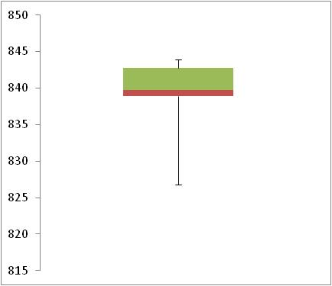  Max 845

 | Distillation – 95% v/v recovered
(⁰C) | 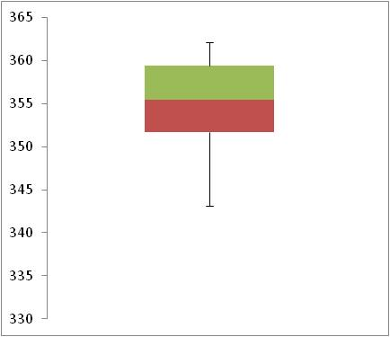  Max 360

Key Areas for Improvement
The following table summarises the main areas in which improvements could be made to the monitoring system, reporting or compliance with Directive limit values. The table includes key recommendations from the previous year to give an assessment of what action has been taken by the Member State to address any issues that may have been highlighted.
Key Areas for Improvement (3 years)
 | Monitoring | Reporting
2010 | - Denmark has sampled and tested fuels with a market share of >10% in low quantities again in 2010 using a national model that doesn’t show equivalent sample numbers with any statistical model outlined in EN 14274.  - Denmark have sampled parameters deemed to be of minor influence on the environment in reduced quantities (RON, MON, oxygen and oxygenates). This is in accordance with the discussions on the first expert meeting on the implementation of directive 98/70/EC in Brussels the 3. April 2003, where "Mr. Zierock (DG ENV) suggested that fewer measurements could be taken for less sensitive parameters such as lead and octane number” however with very low sample quantities in the first instance, this limits the conclusions even further about fuel quality that can be drawn from the analysis. | No Comment
2009 | - Use a national system and too few samples are taken  - Some tests used are different to those specified but are said to be equivalent | - Submitted 3 weeks late
2008 | - Use a national system and too few samples are taken  - Some tests used are different to those specified but are said to be equivalent | No comment

Estonia

Fuel Availability 2010
The following table lists the fuels that were reported to be available nationally in 2010.
Table 11-1: National fuel grade
Fuel grade | National fuel grade
RON 95 < 10 ppm Sulphur | Bensiin RON 95
RON 98 < 10 ppm Sulphur | Bensiin RON 98
Diesel < 10 ppm Sulphur | Diislikutus

Sales, sampling and reporting
During 2010 fuel sales in Estonia were dominated by diesel fuel sales. Almost 600 million litres of diesel was sold in comparison to less than 350 million petrol fuel sales (all petrol grades combined). Petrol fuel sales were mainly comprised of fuel grade RON 95.
Figure 11-1: Fuel Sales proportions by fuel type
Petrol  Diesel | 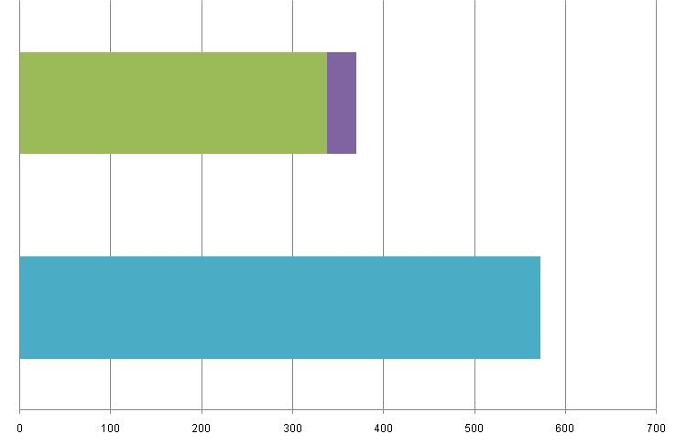
 | Million Litres
 |  |  | RON=91 |  |  | RON = 95 |  |  | RON 95=<RON<98 |  |  | RON 98 |  |  | Diesel
Table 11-2: Fuel sales and sampling
Fuel type (Parent Grade) | Sales | Sales, | Samples ⁽¹⁾ |  |  | Separate | Param’s measured ⁽⁴⁾ | Add. Notes
Fuel type (Parent Grade) | (Million litres) | % total of fuel type | S | W | TR ⁽²⁾ | S/W⁽³⁾ | Param’s measured ⁽⁴⁾ | Add. Notes
Unleaded RON 95 | 338 | 91% | 90 | 90 | 100 | Yes | All of 18
Unleaded RON>=98 | 33 | 9% | 85 | 85 | 9 | Yes | All of 18
Total Petrol | 371 | 100.00% | 175 | 175 | 100 | Yes | All of 18
Diesel (<10 ppm S) | 572 | 100.0% | 100 | 100 | 100 | Yes | All of 5
Total Diesel | 572 | 100.00% | 100 | 100 | 100 | Yes | All of 5
(1) | Samples |  |  |  | The actual number of samples taken by the Member State in the summer (s) and winter (w) periods
(2) | TR |  |  |  | Total requirement according to EN 14274. Dash (-) denotes National system has been used.
(3) | Separate S & W? |  |  |  | Yes indicates separate summer & winter reporting, and No indicates full year sample results reporting only.
(4) | Parameters measured |  |  |  | Currently 18 petrol parameters should be tested and reported by the Member States and 5 diesel parameters.

Petrol Samples
- Estonia have complied with or exceeded minimum sampling requirements for all petrol fuel grades.

Diesel Samples
- Diesel fuel samples tested in 2010 complied with the total minimum requirement.

Fuel Quality Monitoring 2010

Description of System
Responsible organisation(s) | Estonian Ministry of Environment
Fuel Quality Monitoring System (FQMS) | EN 14274 Statistical Model C
Country Size | Small
Summer Period | Normal
Location(s) of sampling | Service stations
Time/frequency of sampling | Fuel samples have been taken between 6 and 7 months of the year, throughout 2010.
Specification of test methods | Sampling followed the European Standard EN 14275 and analyses were carried out in the laboratory of EERC using accredited methods.
Collection of sales data | All sales data in the Estonian FQMS report is provided by Estonian Tax and Customs Board.
Other details
Fuel to be used for transport purposes must fulfil the requirements of standards EVS-EN 228:2008+NA: 2009, EVS-EN 590:2009+A1:2010+NA: 2009 and EVS-EN 14214:2008+A1:2009+NA: 2010.
In accordance with Directive 2003/30/EC, blends with low biofuel content can be used without any problems in vehicles presently in use in Europe, so that the sale of fuel meeting the standards in question does not require the addition of any special marking. At the same time it should be noted that many motor vehicle manufactures continue to take a very cautious view of the use of biodiesel fuel.
According to the statements provided by biofuel permit-holders, in 2010: 3 106 970 kg (3 518 264 litres) of biofuel CN 3824 90 91 was produced; 26 147 405 kg (29 613 755 litres) of biofuel CN 3824 90 91, 2 205 614 kg (2 538 392 litres) of biofuel CN 3824 90 99 and 7 188 170 kg (9 578 387 litres) of biofuel CN 2207 20 00 was imported; 1 401 934 kg (1 549 871 litres) of biofuel CN 3824 90 91, 2 182 661 kg (2 511 995 litres) of biofuel CN 3824 90 99 and 6 835 660 kg (9 082 946 litres) of biofuel CN 2207 20 00 released for consumption.
As at March 2011, 15 biofuel permits have been issued. Information on the permits is available on the Tax and Customs Board's website: http://www.emta.ee.

Compliance with Fuel Quality Limit Values
Table 11-3: Petrol Fuel Grades
RON 95 Petrol - Details of samples that exceed tolerance limits:
Parameter | Limit Value | Tolerance Limit* (TL) | Max/Min value of samples tested | No samples outside TL | % samples outside TL
RON | 95 | 94.6 | 94.1 | 3 | 1.67%
MON | 85 | 84.5 | 84.2 | 1 | 0.56%
Summer vapour pressure, kPa | 70 | 71.9 | 79 | 7 | 3.89%
Member State notes
In the case of all samples found to be non-compliant with specified limits, Authorities were informed and an investigation was initiated.

RON 98 Petrol - Details of samples that exceed tolerance limits:
Parameter | Limit Value | Tolerance Limit* (TL) | Max/Min value of samples tested | No samples outside TL | % samples outside TL
Summer vapour pressure, kPa | 70 | 71.9 | 77.2 | 5 | 2.94%
Aromatics, % v/v | 35 | 36 | 36.8 | 1 | 0.59%
Member State notes
In all cases where samples were found to be non-compliant with specified limits, Authorities were informed and an investigation was initiated.

Table 11-4: Diesel Fuel Grades
Diesel - Details of samples that exceed tolerance limits:
Parameter | Limit Value | Tolerance Limit* (TL) | Max/Min value of samples tested | No samples outside TL | % samples outside TL
Distillation – 95-%-Point, ºC | 360 | 365.9 | 376 | 1 | 1%
Sulphur content, mg/kg | 10 | 11.3 | 24.3 | 2 | 2%
Member State notes

Temporal Trends
Figure 11-2 shows the trend in total fuel sales since 2004. Diesel sales in Estonia have decreased by 9% compared to 2009 sales figures and show an increase in 16% since 2004. Petrol fuel sales have reduced by 11% in the period between 2009 and 2010 with an overall reduction of 6% in the period 2004-2010.
Figure 11-2: Temporal trends in national sales of petrol and diesel (million litres)
Sales (million litres) | 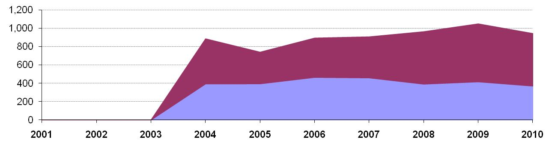
 |  |  |  |  | Petrol |  | Diesel

Statistical Analysis
The following charts in this section are known as box-plots and they display the distribution of fuel characteristics per Member State by illustrating the:
- Sample minimum
- Lower 25% range
- Middle 50% range
- Median
- Upper 25% range
- Maximum
For a full explanation of the information presented in a Box Plot diagram, please see Appendix 1.

Petrol Analysis
Fuel sampling in Estonia in 2010 recorded relatively few test results out of specification with limits. The analysis charts for petrol (Figure 11-3) and diesel (Figure 11-4) detail the distribution of sample results for the 5 selected parameters;
Petrol:
- Research Octane Number
- Motor Octane Number
- Summer Vapour Pressure
Diesel:
- Density at 15ºC
- Distillation – 95% v/v recovered
Sample results for these parameters have been depicted using box plots based on the reported sample minimum, lower quartile (Q1), median (Q2), upper quartile (Q3), and the maximum sample value.
Sample results in 2010 have been presented in the following figures with limit values for the parameter (maximum or minimum) to demonstrate the skew of sample results. RON and MON sample results show that the fuels available in Estonia have reasonably small variation in Octane levels. Summer Vapour pressure results shows that the samples were found to be tighter to the specifications of the Fuel Quality Directive, with some samples exceeding limit values and the majority of samples skewed closer to the limit.
Diesel sample results for Density show a slightly wider variation in density, exhibited by the widely spread coloured bands at the 25 and 75 quartile – in comparison to the tight bands shown in the petrol analysis box plots.
Figure 11-3: petrol analysis
 | Research Octane Number
RON | 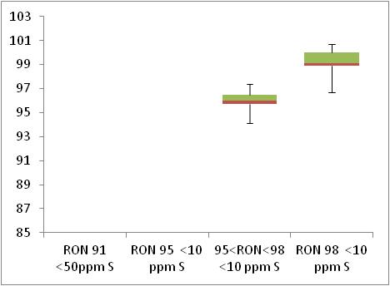  Min 95  Min 91

 | Motor Octane Number
MON | 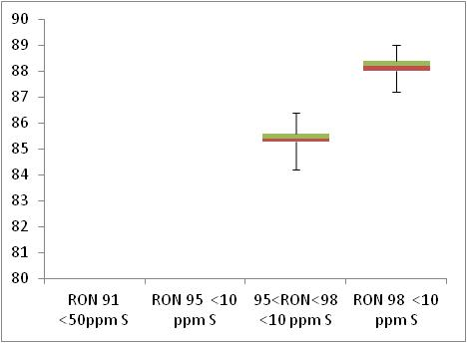  Min 85  Min 81

 | Summer Vapour Pressure (DVPE)
kPa | 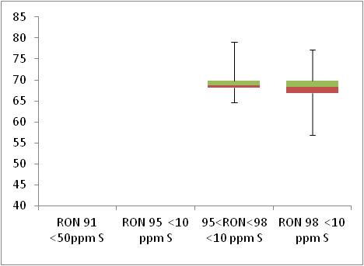  Max 70

Diesel Analysis
Figure 11-4: Diesel analysis
 | Density at 15ºC
Kg/m³ | 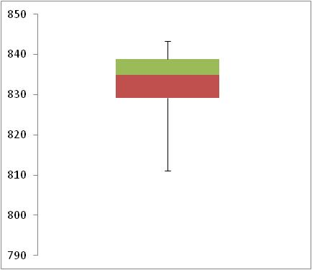  Max 845

 | Distillation – 95% v/v recovered
(⁰C) | 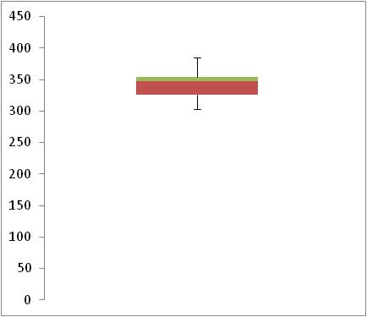  Max 360

Key Areas for Improvement
The following table summarises the main areas in which improvements could be made to the monitoring system, reporting or compliance with Directive limit values. The table includes key recommendations from the previous year to give an assessment of what action has been taken by the Member State to address any issues that may have been highlighted.
Key Areas for Improvement (3 years)
 | Monitoring | Reporting
2010 | - No regional split of sales. | No comment
2009 | No comment | No comment
2008 | - Insufficient sampling of low-sulphur diesel | No comment

Finland

Fuel Availability 2010
The following table lists the fuels that were reported to be available nationally in 2010.
Table 12-1: National fuel grade
Fuel grade | National fuel grade
RON 95 < 10 ppm Sulphur | Moottoribensiini 95
RON 98 < 10 ppm Sulphur | Moottoribensiini 98
Diesel < 10 ppm Sulphur | Dieseloljy

Sales, sampling and reporting
During 2010 fuel sales in Finland were relatively equally distributed between diesel fuel sales of more than 2,700 million litres of diesel petrol fuel sales (all petrol grades combined) of more than 2,200 million litres.. Petrol fuel sales were mainly comprised of fuel grade RON 95.
Figure 12-1: Fuel Sales proportions by fuel type
Petrol

Diesel

 | Million Litres
 |  |  | RON=91 |  |  | RON = 95 |  |  | RON 95=<RON<98 |  |  | RON 98 |  |  | Diesel

Table 12-2: Fuel sales and sampling
Fuel type (Parent Grade) | Sales | Sales, | Samples ⁽¹⁾ |  |  | Separate | Param’s measured ⁽⁴⁾ | Add. Notes
Fuel type (Parent Grade) | (Million litres) | % total of fuel type | S | W | TR ⁽²⁾ | S/W⁽³⁾ | Param’s measured ⁽⁴⁾ | Add. Notes
Unleaded min. RON=95 | 2,075 | 92.8% | 64 | 76 | 100 | Yes | All of 18
Unleaded 95=<RON<98 | 162 | 7.2% | 16 | 29 | 8 | Yes | All of 18
Total Petrol | 2,237 | 100.00% | 80 | 105 | 108 | Yes
Diesel (<10 ppm S) | 2,790 | 100.0% | 67 | 95 | 100 | Yes | All of 5
Total Diesel | 2,790 | 100.00% | 67 | 95 | 100 | Yes
(1) | Samples |  |  |  | The actual number of samples taken by the Member State in the summer (s) and winter (w) periods
(2) | TR |  |  |  | Total requirement according to EN 14274. Dash (-) denotes National system has been used.
(3) | Separate S & W? |  |  |  | Yes indicates separate summer & winter reporting, and No indicates full year sample results reporting only.
(4) | Parameters measured |  |  |  | Currently 18 petrol parameters should be tested and reported by the Member States and 5 diesel parameters.

Petrol Samples
- Finland have complied with or exceeded minimum sampling requirements for all petrol fuel grades.

Diesel Samples
- Diesel fuel samples tested in 2010 complied with the total minimum requirement.

Fuel Quality Monitoring 2010

Description of System
Responsible organisation(s) | Finnish Customs Laboratory
Fuel Quality Monitoring System (FQMS) | EN 14274 Statistical model A
Country Size | Small
Summer Period | Arctic
Location(s) of sampling | Service stations and refineries
Time/frequency of sampling | Samples were taken in retail sites with the exception that during the year 2010 octane and cetane number analysis were done from the samples taken from the fuel warehouses of refineries and terminals (altogether 45 gasoline - of which two failed to deliver octane results - and 45 diesel fuel samples).
Specification of test methods | The sampling aims to comply with the requirements of standard EN 14275:2004. The sampling was done by trained personnel. One litre metal containers and five litre plastic containers approved for this purpose were used as sampling containers. With the exception of lead method, all analysis was carried out according to the standards EN 228:2004 and EN 590:2004. The lead test method used by the laboratory is a screening method. The sensitivity of the method used, however, is thought to be much better than the limit indicated in the quality requirements. If needed, the laboratory has the ability to confirm the lead content of the sample with the EN 237 method according to the directive (Petroleum products. Petrol.
Collection of sales data
Other details
Sampling was carried out in the whole country according to the sampling plan following the guidelines of a standard EN 14274:2004 model A. Country was divided to 3 macro-regions with about same sales volume and variability factor. (See details on: Description of National Fuel Quality Monitoring System )
Samples were taken in retail sites with the exception that during the year 2010 octane and cetane number analysis were done from the samples taken from the fuel warehouses of refineries and terminals (altogether 45 gasoline - of which two failed to deliver octane results - and 45 diesel fuel samples). These supply samples were taken in all macro regions and in different time. The division of the consumption based on figures of the totals consumption of gasoline of 95 octane grade per macro region. Since the sales volume for 98 octane petrol was less than 10% the minimum is calculated as: %sales x min for this grade. Altogether 53 petrol RON 95 octane, 15 petrol RON 98 octane and 66 diesel samples were taken from macro region 1. The corresponding figures for macro region 2 were 53, 20 and 54. For macro region 3 the figures were 34, 10 and 42.
The grades investigated were unleaded RON 95 and RON 98 octane sulphur free (max. 10 mg/kg) petrol and sulphur free (max. 10 mg/kg) diesel fuels. These fuels were furthermore divided into summer and winter grade. Since the sales volume for RON 99 octane petrol was small (less than 2%) it was excluded from the actual sampling. Also, there was no quality under RON 95 octane on the market.

Compliance with Fuel Quality Limit Values
Table 12-3: Petrol Fuel Grades
RON 95 | Compliant with Directive 98/70/EC
RON 98 | Compliant with Directive 98/70/EC
Table 12-4: Diesel Fuel Grades
Diesel - Details of samples that exceed tolerance limits:
Parameter | Limit Value | Tolerance Limit* (TL) | Max/Min value of samples tested | No samples outside TL | % samples outside TL
Sulphur content, mg/kg | 10 | 11.3 | 15.5 | 1 | 1.81%
Member State notes
One sulphur content test result of 15.5 mg/kg is above the maximum tolerance limit 11.3 mg/kg. According to the owner of the product the diesel concerned has been contaminated with sulphur-rich gas oil when filling the storage tanks. Special enforcement actions were not deemed necessary.

Temporal Trends
Figure 12-2 shows the trend in total fuel sales since 2001. Diesel sales in Finland have increased by 8% compared to 2009 sales figures – representing an increase in 29% since 2001. Petrol fuel sales have reduction by 2% in the period between 2009 and 2010 with an overall reduction of 7% in the period 2001-2010.
Figure 12-2: Temporal trends in national sales of petrol and diesel (million litres)
Sales (million litres)

 |  |  |  |  | Petrol |  | Diesel

Statistical Analysis
The following charts in this section are known as box-plots and they display the distribution of fuel characteristics per Member State by illustrating the:
- Sample minimum
- Lower 25% range
- Middle 50% range
- Median
- Upper 25% range
- Maximum
For a full explanation of the information presented in a Box Plot diagram, please see Appendix 1.

Petrol Analysis
Fuel sampling in Finland in 2010 recorded relatively few test results out of specification with limits. The analysis charts for petrol (Figure 12-3) and diesel (Figure 12-4) detail the distribution of sample results for the 5 selected parameters;
Petrol:
- Research Octane Number
- Motor Octane Number
- Summer Vapour Pressure
Diesel:
- Density at 15ºC
- Distillation – 95% v/v recovered
Sample results for these parameters have been depicted using box plots based on the reported sample minimum, lower quartile (Q1), median (Q2), upper quartile (Q3), and the maximum sample value.
Sample results in 2010 have been presented in the following figures with limit values for the parameter (maximum or minimum) to demonstrate the skew of sample results. RON and MON sample results show that the fuels available in Austria have reasonably small variation in Octane levels. Summer Vapour pressure results show that all samples were within tolerance limits.
Diesel sample results for Density show a slightly wider variation in density, exhibited by the widely spread coloured bands at the 25 and 75 quartile – in comparison to the tight bands shown in the petrol analysis box plots.
Figure 12-3: petrol analysis
 | Research Octane Number
RON | 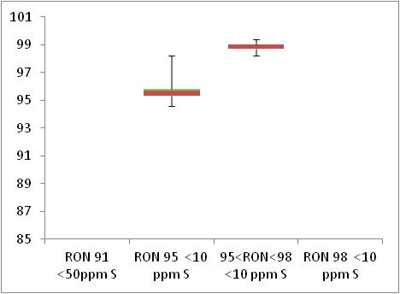  Min 95  Min 91

 | Motor Octane Number
MON | 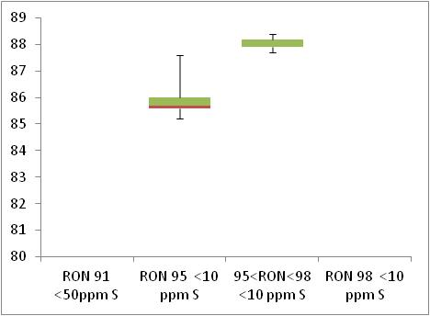  Min 85  Min 81

 | Summer Vapour Pressure (DVPE)
kPa | 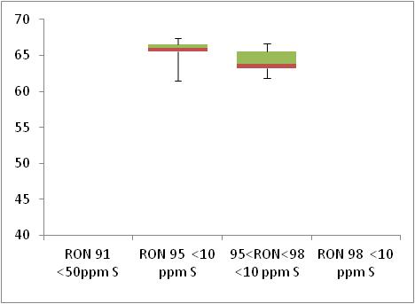  Max 70

Diesel Analysis
Figure 12-4: Diesel analysis
 | Density at 15ºC
Kg/m³ | 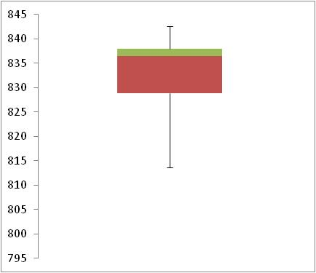  Max 845

 | Distillation – 95% v/v recovered
(⁰C) | 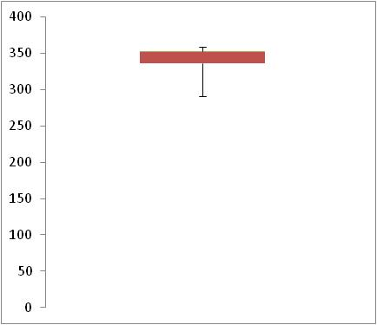  Max 360

Key Areas for Improvement
The following table summarises the main areas in which improvements could be made to the monitoring system, reporting or compliance with Directive limit values. The table includes key recommendations from the previous year to give an assessment of what action has been taken by the Member State to address any issues that may have been highlighted.
Key Areas for Improvement (3 years)
 | Monitoring | Reporting
2010 | - Low number of samples for cetane and octane | No comment.
2009 | - Low number of samples for cetane and octane and these are taken from refineries / depots | No comment.
2008 | - Octane and cetane number analysis form refinery samples | No comment.

France

Fuel Availability 2010
The following table lists the fuels that were reported to be available nationally in 2010.
Table 13-1: National fuel grade
Fuel grade | National fuel grade
RON 95 < 10 ppm Sulphur | SP95 and SP95-E10
RON 98 < 10 ppm Sulphur | SP98
Diesel < 10 ppm Sulphur | Gazole

Sales, sampling and reporting
During 2010 fuel sales in France were dominated by diesel fuel sales. Almost 40,000 million litres of diesel was sold in comparison to just over 10,000 million litres of petrol fuel sales. Petrol fuel sales were mainly comprised of fuel grade RON 95 (includes RON 95-E10).
Figure 13-1: Fuel Sales proportions by fuel type
Petrol

Diesel

 | Million Litres
 |  |  | RON=91 |  |  | RON = 95 |  |  | RON 95=<RON<98 |  |  | RON 98 |  |  | Diesel

Table 13-2: Fuel sales and sampling
Fuel type (Parent Grade) | Sales | Sales, | Samples ⁽¹⁾ |  |  | Separate | Param’s measured ⁽⁴⁾ | Add. Notes
Fuel type (Parent Grade) | (Million litres) | % total of fuel type | S | W | TR ⁽²⁾ | S/W⁽³⁾ | Param’s measured ⁽⁴⁾ | Add. Notes
Unleaded min. RON=95 (Includes RON95-E10) | 8,677 | 79.8% | 227 | 214 | 200 | Yes | All of 18
Unleaded RON>=98 | 2,202 | 20.2% | 198 | 188 | 200 | Yes | All of 18
Total Petrol | 10,880 | 100.00% | 425 | 402 | 400 | Yes | All of 18
Diesel (<10 ppm S) | 39,749 | 100.0% | 199 | 196 | 200 | Yes | 4 of 5
Total Diesel | 39,749 | 100.00% | 199 | 196 | 200 | Yes | 4 of 5
(1) | Samples |  |  |  | The actual number of samples taken by the Member State in the summer (s) and winter (w) periods
(2) | TR |  |  |  | Total requirement according to EN 14274. Dash (-) denotes National system has been used.
(3) | Separate S & W? |  |  |  | Yes indicates separate summer & winter reporting, and No indicates full year sample results reporting only.
(4) | Parameters measured |  |  |  | Currently 18 petrol parameters should be tested and reported by the Member States and 5 diesel parameters.

Petrol Samples
- France have complied with or exceeded minimum sampling requirements for all petrol fuel grades.

Diesel Samples
- France did not sample all parameters for diesel; density at 15⁰C was not included. All other diesel fuel samples tested in 2010 complied with the total minimum requirement.

Fuel Quality Monitoring 2010

Description of System
Responsible organisation(s) | General Directorate For Energy And Climate Change
Fuel Quality Monitoring System (FQMS) | EN 14274 Statistical model B
Country Size | Large
Summer Period | Normal
Location(s) of sampling | Service stations
Time/frequency of sampling | Samples have been taken during every month of the year for all fuels – with the exceptions of November and December.
Specification of test methods
Collection of sales data | Sales data in 2010 has been supplied by French Customs.
Other details
In 2010, 442 refuelling stations were checked in metropolitan France and 1222 samples were taken spread throughout the country.
The number of samples of petrol SP95-E10 has been doubled, in comparison with 2009. SP95-E10 represented almost 14 % of petrol consumption in France in December 2010. But, in refuelling stations, SP95-E10 took the place of SP95 or SP98. In some areas, it's difficult to find SP95. Sales data for 2010 give petrol fuels SP 95 and SP 95 – E10 figures in combination; however sample results have been provided separately.
Of these samples, 20 608 laboratory tests were performed with an overall non-compliance rate of less than 1.42% for all parameters controlled by grades. Refuelling stations are required to justify non-compliant sample results and present corrective and preventative action.
In 2010, the FAME content and water content of diesel samples were measured.
Superéthanol E85 was not included in our monitoring program, because E85 represents less than 1% of petrol consumption in France and is sold in only 2.5 % of French refuelling stations.

Compliance with Fuel Quality Limit Values
Table 13-3: Petrol Fuel Grades
Super Sans plomb 95 (SP95) Petrol - Details of samples that exceed tolerance limits:
Parameter | Limit Value | Tolerance Limit* (TL) | Max/Min value of samples tested | No samples outside TL | % samples outside TL
Summer vapour pressure, kPa | 60 | 61.8 | 65.3 | 5 | 2.71%
Benzene, % v/v | 1 | 1.03 | 1.07 | 1 | 0.28%
Oxygen content, % m/m | 2.7 | 2.9 | 3.2 | 4 | 1.14%
Ethanol, % v/v | 5 | 5.2 | 6.5 | 9 | 2.56%
Ethers, % v/v | 15 | 15.6 | 15.7 | 1 | 0.28%
Sulphur content, mg/kg | 10 | 11.6 | 45.5 | 5 | 1.42%
Member State notes
Refuelling stations are required to justify non-compliant sample results and present corrective and preventative action.

SP 98 Petrol - Details of samples that exceed tolerance limits:
Parameter | Limit Value | Tolerance Limit* (TL) | Max/Min value of samples tested | No samples outside TL | % samples outside TL
RON | 95 | 94.6 | 93 | 1 | 0.27%
MON | 85 | 84.5 | 84.3 | 1 | 0.27%
Summer vapour pressure, kPa | 60 | 61.8 | 70.4 | 10 | 5.05%
Oxygen content, % m/m | 2.7 | 2.9 | 3.5 | 5 | 1.3%
Ethanol, % v/v | 5 | 5.2 | 7.5 | 1 | 0.26%
Sulphur content mg/kg | 10 | 11.6 | 14.7 | 4 | 1.03%
Member State notes
Refuelling stations are required to justify non-compliant sample results and present corrective and preventative action.

SP95-E10 Petrol - Details of samples that exceed tolerance limits:
Parameter | Limit Value | Tolerance Limit* (TL) | Max/Min value of samples tested | No samples outside TL | % samples outside TL
MON | 85 | 84.5 | 84.2 | 2 | 2.56%
Summer vapour pressure, kPa | 60 | 61.8 | 63.4 | 5 | 11.62%
Aromatics, % v/v | 35 | 37.2 | 37.9 | 1 | 1.11%
Oxygen content, % m/m | 2.7 | 2.9 | 6.65 | 1 | 1.11%
Ethanol, % v/v* | 5 | 5.2 | 7.9
Ethers, % v/v* | 15 | 15.6 | 19.2
Member State notes
*Please note; there are additional non-compliances of Ethanol (maximum value of 7.9 % v/v) and Ethers (maximum value of 19.2 % v/v) in accordance with limits specified in Directive 2003/17/EC. According to Directive 2009/30/EC, from 1st January 2011, limits for Oxygen content and all oxygenates will be higher to accommodate the addition of ethanol from biofuels into traditional petrol fuels.

Table 13-4: Diesel Fuel Grades
Diesel - Details of samples that exceed tolerance limits:
Parameter | Limit Value | Tolerance Limit* (TL) | Max/Min value of samples tested | No samples outside TL | % samples outside TL
Sulphur content, mg/kg | 10 | 11.3 | 30.5 | 10 | 2.53%
Member State notes
Refuelling stations are required to justify non-compliant sample results and present corrective and preventative action.
Density at 15ºC was sampled; however no results for the parameter have been reported by France for 2010.

Temporal Trends
Figure 13-2 shows the trend in total fuel sales since 2001. Diesel sales in France have increased by 1% compared to 2009 sales figures – representing an increase in 17% since 2001. Petrol fuel sales have reduced by 8% in the period between 2009 and 2010 with an overall reduction of 39% in the period 2001-2010.
Figure 13-2: Temporal trends in national sales of petrol and diesel (million litres)
Sales (million litres)

 |  |  |  |  | Petrol |  | Diesel

Statistical Analysis
The following charts in this section are known as box-plots and they display the distribution of fuel characteristics per Member State by illustrating the:
- Sample minimum
- Lower 25% range
- Middle 50% range
- Median
- Upper 25% range
- Maximum
For a full explanation of the information presented in a Box Plot diagram, please see Appendix 1.

Petrol Analysis
Fuel sampling in France in 2010 recorded relatively few test results out of specification with limits. The analysis charts for petrol (Figure 13-3) and diesel (Figure 13-4) detail the distribution of sample results for the 5 selected parameters;
Petrol:
- Research Octane Number
- Motor Octane Number
- Summer Vapour Pressure
Diesel:
- Density at 15ºC
- Distillation – 95% v/v recovered
Sample results for these parameters have been depicted using box plots based on the reported sample minimum, lower quartile (Q1), median (Q2), upper quartile (Q3), and the maximum sample value.
Sample results in 2010 have been presented in the following figures with limit values for the parameter (maximum or minimum) to demonstrate the skew of sample results. RON and MON sample results show that the fuels available in France have reasonably small variation in Octane levels. Summer Vapour pressure results shows that the samples were found to be within tolerance limits and also showed little variation between samples.
Diesel sample results for Distillation show a slightly wider variation in density, exhibited by the widely spread coloured bands at the 25 and 75 quartile – in comparison to the tight bands shown in the petrol analysis box plots. France did not supply all parameter for Density so no statistical analysis could be undertaken.

Figure 13-3: petrol analysis
 | Research Octane Number
RON | 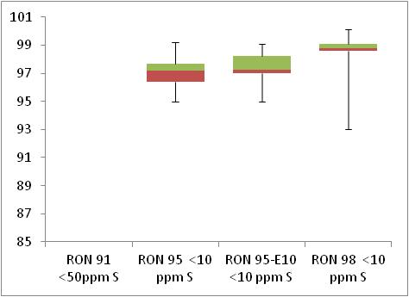  Min 91  Min 95

 | Motor Octane Number
MON | 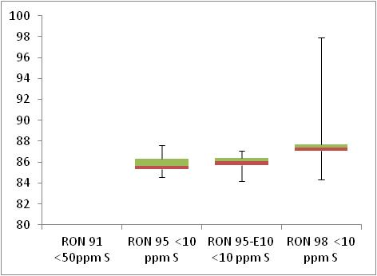  Min 85  Min 81

 | Summer Vapour Pressure (DVPE)
kPa | 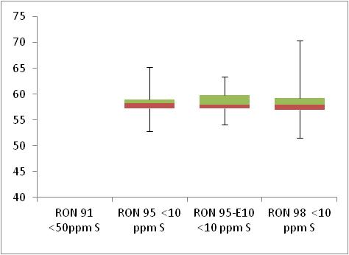  Max 60

Diesel Analysis
The Density at 15⁰C parameter was not sampled in 2010 so no analysis could be undertaken for this parameter.
Figure 13-4: Diesel analysis

 | Distillation – 95% v/v recovered
(⁰C) | 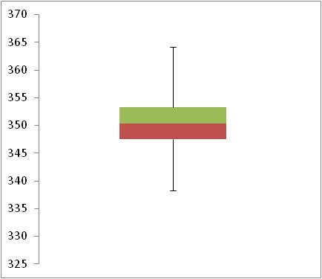  Max 360

Key Areas for Improvement
The following table summarises the main areas in which improvements could be made to the monitoring system, reporting or compliance with Directive limit values. The table includes key recommendations from the previous year to give an assessment of what action has been taken by the Member State to address any issues that may have been highlighted.
Key Areas for Improvement (3 years)
 | Monitoring | Reporting
2010 | - Diesel parameter Density at 15⁰C was not reported. | No comment.
2009 | - Slight under sampling of RON98 | No comment.
2008 | - Samples were taken in only 3 months of the year  - Insufficient sampling of sulphur-free RON 98 | - No information on recording of sales data

Germany

Fuel Availability 2010
The following table lists the fuels that were reported to be available nationally in 2010.
Table 14-1: National fuel grade
Fuel grade | National fuel grade
Min. RON 91 <10ppm Sulphur | Normal petrol
95=<RON<98< 10 ppm Sulphur | Super
Min. RON >= 98 < 10 ppm sulphur | Super Plus
Diesel | Diesel (B5 and B7)

Sales, sampling and reporting

During 2010 fuel sales in Germany were dominated by diesel fuel with 59% of the market fuel share. Diesel sales have also increased by almost 4% between 2009 and 2010. Diesel available on the market in Germany contains biofuel content, with diesel B5 and B7 available. Of the three petrol fuel grades available on the market in Germany in 2010, fuel sales were dominated by ‘Super’ grade petrol (Unleaded petrol 95=<RON<98 (<10 ppm S). Almost 25,000 million litres of Super grade fuel were sold in 2010 in comparison to 943 million litres of ‘Normal’ grade petrol (RON 91) and 740 million litres of Super Plus petrol. German petrol fuel sales decreased by almost 3% between 2009 and 2010; this continues a trend that has been in evidence since 2002.
Figure 14-1: Fuel Sales proportions by fuel type
Petrol  Diesel | 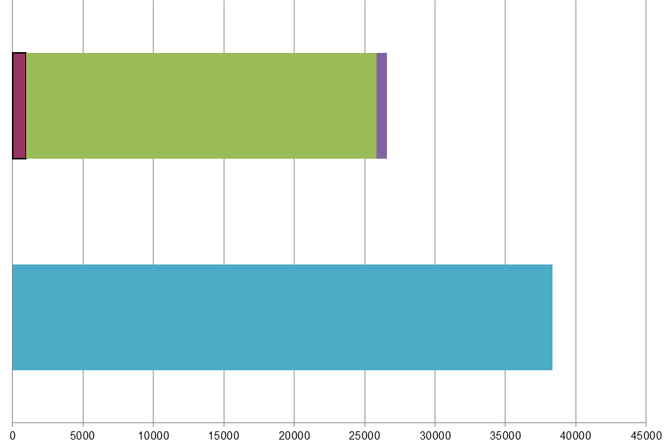
 | Million Litres
 |  |  | RON=91 |  |  | RON = 95 |  |  | RON 95=<RON<98 |  |  | RON 98 |  |  | Diesel
Table 14-2: Fuel sales and sampling
Fuel type (Parent Grade) | Sales | Sales, | Samples ⁽¹⁾ |  |  | Separate | Param’s measured ⁽⁴⁾ | Add. Notes
Fuel type (Parent Grade) | (Million litres) | % total of fuel type | S | W | TR ⁽²⁾ | S/W⁽³⁾ | Param’s measured ⁽⁴⁾ | Add. Notes
Unleaded min. RON=91 | 943 | 3.5% | 25 | 28 | - | No | All of 18
Unleaded 95=<RON<98 | 24,901 | 93.7% | 156 | 156 | - | No | All of 18
Unleaded RON>=98 | 740 | 2.8% | 26 | 26 | - | No | All of 18
Total Petrol | 26,584 | 100.00% | 207 | 210 | - | No
Diesel (<10 ppm S) | 38,356 | 100.0% | 134 | 171 | - | No | All of 5
Total Diesel | 38,356 | 100.00% | 134 | 171 | - | No
(1) | Samples |  |  |  | The actual number of samples taken by the Member State in the summer (s) and winter (w) periods
(2) | TR |  |  |  | Total requirement according to EN 14274. Dash (-) denotes National system has been used.
(3) | Separate S & W? |  |  |  | Yes indicates separate summer & winter reporting, and No indicates full year sample results reporting only.
(4) | Parameters measured |  |  |  | Currently 18 petrol parameters should be tested and reported by the Member States and 5 diesel parameters.
(a) | Add. Notes |  |  |  | Additional information provided by the Member State in relation to table contents.

Petrol Samples
- Germany have used a National Fuel Quality Monitoring System and have sampled petrol grades RON 91 and RON 98 sufficiently; sampling both fuels in quantities that would satisfy or exceed equivalence with EN 14274 recommended sampling quantities for a country considered to be ‘Large’ (annual automotive fuel sales in excess of 15 million tonnes).
- Given the high proportion of market share for fuel grade RON 95=<RON<98, to be equivalent to sample quantities recommended fin EN 14274 samples could be higher – the have equivalence with EN 14274 statistical models, samples should be in the region of 200 samples per summer and winter period.
- In addition, EN 14274 states that; “Since the specifications for automotive fuels contain climatic related requirements, the FQMS is to be run twice a year, once during the winter period and once during the summer period.” Samples in Germany have been taken throughout the year – in both summer and winter periods, however Germany have been unable to provide separate summer and winter results.

Diesel Samples
- Diesel fuel samples should be higher given the overall share of the market held by diesel (almost 60%) and the volume of fuel sales in Germany. Equivalence with the statistical models outlined in EN 14274 would be achieved with 200 fuel samples taken from fuel dispensing sites in each summer and winter period (a minimum of 400 samples in total).

Fuel Quality Monitoring 2010

Description of System
Responsible organisation(s) | Umweltbundesamt
Fuel Quality Monitoring System (FQMS) | National System
Country Size | Large
Summer Period | Normal
Location(s) of sampling | Samples have been taken only from refuelling stations or fuel dispensing sites.
Time/frequency of sampling | Petrol fuel grade RON 91 has been sampled in 8 months of the year; samples have been taken at lower quantities as it represents 3.5% total petrol fuel sales and less than 1.4% total fuel sales. Petrol fuel grades Super and Super Plus have been sampled 10 months of every year with no samples taken during the transitional months. Diesel fuels have been sampled in 9 months of the year – with the exclusion of April, May and October.
Specification of test methods | Tests have been carried out in accordance with EN 590:2004 and EN 228:2004.
Collection of sales data | The sales data were available from statistics in the Federal Office of Economics and Export Control (BAFA) report.
Other details
Annex 2 of the original FQMS report 2010 described two separate vapour pressure sampling categories. “Klasse A” refers to vapour pressure in summer; “Klasse B” refers to vapour pressure in winter. Despite the annual reports delivered by federal states, it was clearly distinguished between summer and winter vapour pressure measurements.

Compliance with Fuel Quality Limit Values
Table 14-3: Petrol Fuel Grades
Normal Petrol - Details of samples that exceed tolerance limits:
Parameter | Limit Value | Tolerance Limit* (TL) | Max/Min value of samples tested | No samples outside TL | % samples outside TL
RON | 91 | 90.6 | 85.5 | 1 | 2.12%
Summer vapour pressure, kPa | 60 | 61.8 | 88.2 | ? | ?
Oxygen Content | 2.7 | 2.9 | 11.5 | ? | ?
Details of non-compliances have not been provided for Oxygen content and Summer vapour pressure in 2010.
Member State notes
In case of exceeding or shortfall of values described in the applicable method a revision letter was sent or a penalty was imposed on the source of the non-compliant sample.

Super Petrol - Details of samples that exceed tolerance limits:
Parameter | Limit Value | Tolerance Limit* (TL) | Max/Min value of samples tested | No samples outside TL | % samples outside TL
Ethanol, %(v/v) | 5 | 5.2 | 6.1 | 2 | 0.92%
Member State notes
In case of exceeding or shortfall of values described in the applicable method a revision letter was sent or a penalty was imposed on the source of the non-compliant sample.

Super Plus Petrol - Details of samples that exceed tolerance limits:
Parameter | Limit Value | Tolerance Limit* (TL) | Max/Min value of samples tested | No samples outside TL | % samples outside TL
Summer vapour pressure, kPa | 60 | 61.8 | 65.7 | 3 | 12.5%
Aromatics, %(v/v) | 35 | 37.2 | 41 | 1 | 1.92%
Member State notes
In case of exceeding or shortfall of values described in the applicable method a revision letter was sent or a penalty was imposed on the source of the non-compliant sample.

Table 14-4: Diesel Fuel Grades
Diesel - Details of samples that exceed tolerance limits:
Parameter | Limit Value | Tolerance Limit* (TL) | Max/Min value of samples tested | No samples outside TL | % samples outside TL
Density at 15 ºC, kg/m³ | 845 | 845.7 | 863.5 | 1 | 1.67%
** Non-compliant sample found in diesel with 5% biofuel; B5.
Member State notes
In case of exceeding or shortfall of values described in the applicable method a revision letter was sent or a penalty was imposed on the source of the non-compliant sample.

Temporal Trends
Figure 14-2shows the trend in total fuel sales since 2001. Petrol fuel sales have declined steadily since 2001 with a 3% decrease between 2009 and 2010 and a more substantial decrease in petrol sales of 29% since 2001. Diesel fuel sales have fluctuated slightly with an overall decrease in sales of 4% since 2001; however sales in 2010 were 4% higher than in 2009.
Figure 14-2: Temporal trends in national sales of petrol and diesel (million litres)
Sales (million litres) | 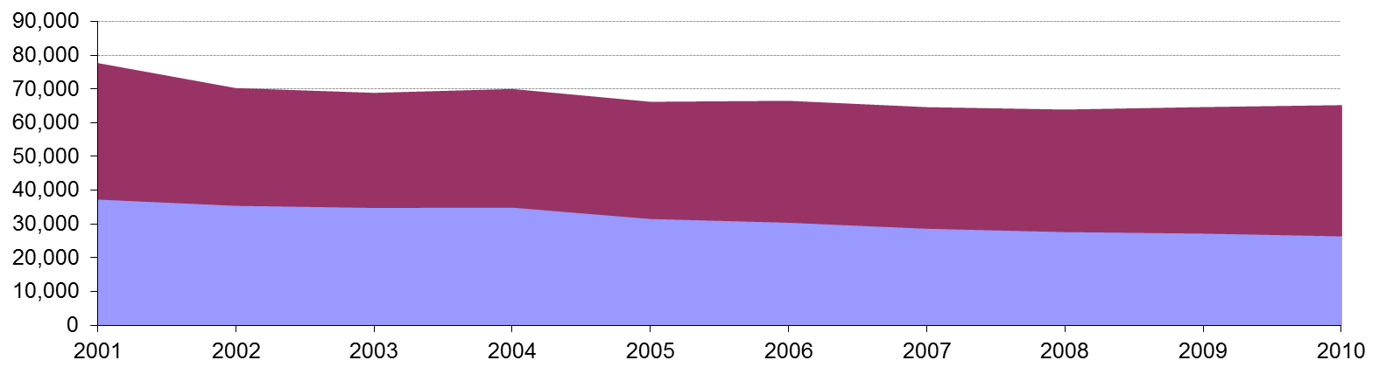
 |  |  |  |  | Petrol |  | Diesel

Statistical Analysis
The charts intended for this section are known as box-plots and they display the distribution of fuel characteristics per Member State by illustrating the:
- Sample minimum
- Lower 25% range
- Middle 50% range
- Median
- Upper 25% range
- Maximum
For a full explanation of the information presented in a Box Plot diagram, please see Appendix 1. Germany has not provided the additional data requested for 2010 to enable greater analysis of reported sample results.

Petrol and Diesel Analysis
There were samples found to be above or below limit values in Germany during 2010 – as detailed in Section 14.2.2. However, additional detail requested for 2010 has not been provided.

Key Areas for Improvement
The following table summarises the main areas in which improvements could be made to the monitoring system, reporting or compliance with Directive limit values. The table includes key recommendations from the previous year to give an assessment of what action has been taken by the Member State to address any issues that may have been highlighted.
Key Areas for Improvement (3 years)
 | Monitoring | Reporting
2010 | - No information provided on statistical equivalence of national system.  - Slightly low sample quantities for fuels with higher market share. | - Report more than 3 months late.  - Results not reported separately for summer and winter periods.  - Report not provided in the EC approved template.  - No additional detail provided in 2010 for further analysis.
2009 | - Marginally insufficient sampling of RON 95 and diesel | - Report submitted > 5 months late and not in the standard format  - Lack of detail on sample values exceeding limits – no time to seek clarification due to very late report  - Results not reported separately for summer and winter periods
2008 | - No information provided on statistical equivalence of national system. | - 5 months late  - Results not reported separately for summer and winter  - Lack of detail on non-compliances and action taken in some cases

Greece

Fuel Availability 2010
The following table lists the fuels that were reported to be available nationally in 2010.
Table 15-1: National fuel grade
Fuel grade | National fuel grade
RON 95 < 10 ppm Sulphur | RON 95
RON 95 =< RON < 98 | LPR 96 RON
RON 98 < 10 ppm Sulphur | 100 RON
Diesel < 10 ppm Sulphur | Diesel automotive

Sales, sampling and reporting
During 2010 fuel sales in Greece were dominated by Petrol fuel sales. Almost 5,000 million litres of petrol (all petrol grades combined) was sold in comparison to less than 3,000 diesel fuel sales. Petrol fuel sales were mainly comprised of fuel grade RON 95.
Figure 15-1: Fuel Sales proportions by fuel type
Petrol

Diesel

 | Million Litres
 |  |  | RON=91 |  |  | RON = 95 |  |  | RON 95=<RON<98 |  |  | RON 98 |  |  | Diesel

Table 15-2: Fuel sales and sampling
Fuel type (Parent Grade) | Sales | Sales, | Samples ⁽¹⁾ |  |  | Separate | Param’s measured ⁽⁴⁾ | Add. Notes
Fuel type (Parent Grade) | (Million litres) | % total of fuel type | S | W | TR ⁽²⁾ | S/W⁽³⁾ | Param’s measured ⁽⁴⁾ | Add. Notes
Unleaded min. RON=95 | 4,634 | 92.6% | 50 | 70 | 100 | No | All of 18
Unleaded 95=<RON<98 | 220 | 4.4% | 36 | 42 | 5 | Yes | All of 18
Unleaded RON>=98 | 153 | 3.1% | 20 | 32 | 4 | Yes | All of 18
Total Petrol | 5,006 | 100.00% | 106 | 214 | 109 | Yes
Diesel (<10 ppm S) | 2,977 | 100.0% | 50 | 70 | 100 | Yes | All of 5
Total Diesel | 2,977 | 100.00% | 50 | 70 | 100 | Yes
(1) | Samples |  |  |  | The actual number of samples taken by the Member State in the summer (s) and winter (w) periods
(2) | TR |  |  |  | Total requirement according to EN 14274. Dash (-) denotes National system has been used.
(3) | Separate S & W? |  |  |  | Yes indicates separate summer & winter reporting, and No indicates full year sample results reporting only.
(4) | Parameters measured |  |  |  | Currently 18 petrol parameters should be tested and reported by the Member States and 5 diesel parameters.
(a) | Add. Notes |  |  |  | Additional information provided by the Member State in relation to table contents.

Petrol Samples
- Greece has not complied with the minimum sampling requirements for petrol fuel grades. The sampling requirement applies to fuel stations only, the majority of the sampling taken by Greece was at refineries, and not enough sampling was taken at fuel stations.

Diesel Samples
- The number of samples taken at does not comply with the minimum requirements. Greece have taken sampling at both refinery and fuel stations, overall the number of samples tested in 2010 complied with the total minimum requirement. However, the sampling requirement applies to fuel stations only.

Fuel Quality Monitoring 2010

Description of System
Responsible organisation(s) | Directorate of Petrochemicals, Fuels Section, General Chemical State Laboratory and the Ministry of Finance
Fuel Quality Monitoring System (FQMS) | EN 14274 Statistical model A
Country Size | Small
Summer Period | Normal
Location(s) of sampling | Service stations and refineries
Time/frequency of sampling | Samples have been taken every month throughout the year for all fuel types.
Specification of test methods | Tests are carried out in line with EN 14274 specifications.
Collection of sales data | The Ministry of Environment Energy and Climate Change is responsible for reporting fuel sales.
Other details
The FQMS monitoring system as set out in the relevant Directive has not been fully applied for the year 2010. According to the Joint Ministerial Decision No 291/2004, the General Chemical State Laboratory (GCSL) is responsible for controlling the quality of petrol and diesel fuels and reporting on the fuel quality monitoring system.
Fuel samples are collected mostly from refineries and some are collected from service stations. This report concerns the results of the samples that are taken at the refineries as well as those that are collected from the petrol stations. Sampling is carried out by the chemists of the General Chemical State Laboratory for the refineries and by the team of the Fuel monitoring department, (DEDAK) of the Ministry of Environment Energy and Climate Change for the petrol stations. Samples taken at the petrol stations for the FQMS are collected only in the area of Attica where the 1/8 of all service stations in Greece is located.
All mandatory fuel parameters, according to directive 98/70/EC, are measured in the laboratories of the refineries for the samples taken at the refineries. The relevant parameters of the samples taken by the petrol stations are examined by the fuel laboratories of GCSL in Piraeus. In Athens, the fuels monitoring department DEDAK of the Ministry of Environment Energy and Climate Change has undertaken exclusively the collection of the samples taken at the petrol stations in Athens according to the standard EN 14274.

Compliance with Fuel Quality Limit Values
Table 15-3: Petrol Fuel Grades
RON 95 | Compliant with Directive 98/70/EC
LPR 96 RON | Compliant with Directive 98/70/EC
100 RON | Compliant with Directive 98/70/EC

Table 15-4: Diesel Fuel Grades
Diesel | Compliant with Directive 98/70/EC

Temporal Trends
Figure 15-2 shows the trend in total fuel sales since 2001. Diesel sales in Greece have decreased by 13% compared to 2009 sales figures with an overall increase of 9% since 2001. Petrol fuel sales have reduced by 13% in the period between 2009 and 2010 with an overall increase of 51% in the period 2001-2010.
Figure 15-2: Temporal trends in national sales of petrol and diesel (million litres)
Sales (million litres)

 |  |  |  |  | Petrol |  | Diesel

Statistical Analysis
The following charts in this section are known as box-plots and they display the distribution of fuel characteristics per Member State by illustrating the:
- Sample minimum
- Lower 25% range
- Middle 50% range
- Median
- Upper 25% range
- Maximum
For a full explanation of the information presented in a Box Plot diagram, please see Appendix 1.

Petrol Analysis
Fuel sampling in Greece in 2010 recorded relatively few test results out of specification with limit values. The analysis charts for petrol (Figure 15-3) and diesel (Figure 15-4) detail the distribution of sample results for the 5 selected parameters;
Petrol:
- Research Octane Number
- Motor Octane Number
- Summer Vapour Pressure
Diesel:
- Density at 15ºC
- Distillation – 95% v/v recovered
Sample results for these parameters have been depicted using box plots based on the reported sample minimum, lower quartile (Q1), median (Q2), upper quartile (Q3), and the maximum sample value.
Sample results in 2010 have been presented in the following figures with limit values for the parameter (maximum or minimum) to demonstrate the skew of sample results. RON and MON sample results show that the fuels available in Greece have reasonably small variation in Octane levels. Summer Vapour pressure results show that the samples were found to be tighter to the specifications of the Fuel Quality Directive, with no samples exceeding limit values.
Diesel sample results for Density show a slightly wider variation in density, exhibited by the widely spread coloured bands at the 25 and 75 quartile – in comparison to the tight bands shown in the petrol analysis box plots.
Figure 15-3: petrol analysis
 | Research Octane Number
RON | 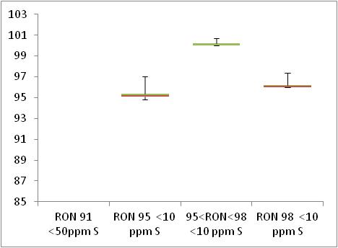  Min 95  Min 91

 | Motor Octane Number
MON | 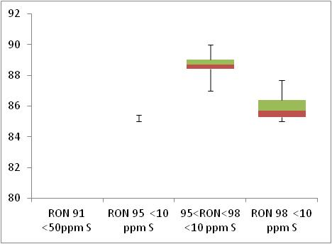  Min 81  Min 85

 | Summer Vapour Pressure (DVPE)
kPa | 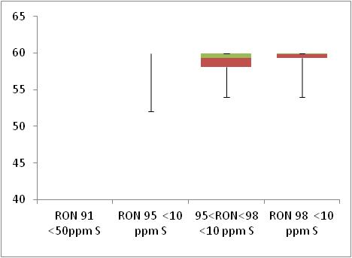  Max 60

Diesel Analysis
Figure 15-4: Diesel analysis
 | Density at 15ºC
Kg/m³ | 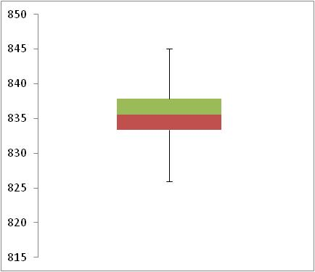  Max 845

 | Distillation – 95% v/v recovered
(⁰C) | 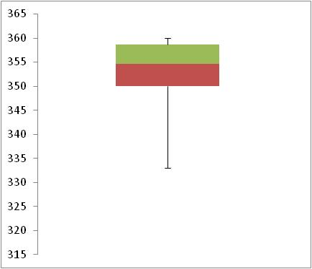  Max 360

Key Areas for Improvement
The following table summarises the main areas in which improvements could be made to the monitoring system, reporting or compliance with Directive limit values. The table includes key recommendations from the previous year to give an assessment of what action has been taken by the Member State to address any issues that may have been highlighted.
Key Areas for Improvement (3 years)
 | Monitoring | Reporting
2010 | - Regional split of sales not provided as the responsible for reporting sales department has given the regional sales report after the deadline.  - Not enough sampling has been taken at fuel stations. | - Report submitted on the 26th of July - after the deadline of 30th June.
2009 | - Insufficient sampling at petrol stations  - Greece appears to have reported only one of the oxygenates required by the Directive (ethers). It has been made clear that these parameters are in fact tested, however not reported as results fall below detection limits. This should be made clear within the FQM report in future years in order to avoid potential confusion during report analysis. | No comment
2008 | - Sulphur-free fuels are not separately labelled  - Only 20-25% of samples from petrol stations  - Only 12 of 18 petrol parameters measured | No comment

Hungary

Fuel Availability 2010
The following table lists the fuels that were reported to be available nationally in 2010.
Table 16-1: National fuel grade
Fuel grade | National fuel grade
RON 95 < 10 ppm Sulphur | ESZ-95
RON 98 < 10 ppm Sulphur | ESZ-98 (and premium products)
Diesel < 10 ppm Sulphur | Diesel

Sales, sampling and reporting
During 2010 fuel sales in Hungary were dominated by diesel fuel sales. More than 3,200 million litres of diesel was sold in comparison to less than 2,000 petrol fuel sales (all petrol grades combined). Petrol fuel sales were mainly comprised of fuel grade RON 95.
Figure 16-1: Fuel Sales proportions by fuel type
Petrol

Diesel

 | Million Litres
 |  |  | RON=91 |  |  | RON = 95 |  |  | RON 95=<RON<98 |  |  | RON 98 |  |  | Diesel

Table 16-2: Fuel sales and sampling
Fuel type (Parent Grade) | Sales | Sales, | Samples ⁽¹⁾ |  |  | Separate | Param’s measured ⁽⁴⁾ | Add. Notes
Fuel type (Parent Grade) | (Million litres) | % total of fuel type | S | W | TR ⁽²⁾ | S/W⁽³⁾ | Param’s measured ⁽⁴⁾ | Add. Notes
Unleaded min. RON=95 | 1,743 | 97.4% | 50 | 50 | 100 | Yes | All of 18
Unleaded RON>=98 | 47 | 2.6% | 10 | 10 | 6 | Yes | All of 18
Total Petrol | 1,790 | 100.00% | 60 | 60 | 106 | Yes | All of 18
Diesel (<10 ppm S) | 3,274 | 100.0% | 60 | 60 | 100 | Yes | All of 5
Total Diesel | 3,274 | 100.00% | 60 | 60 | 100 | Yes | All of 5
(1) | Samples |  |  |  | The actual number of samples taken by the Member State in the summer (s) and winter (w) periods
(2) | TR |  |  |  | Total requirement according to EN 14274. Dash (-) denotes National system has been used.
(3) | Separate S & W? |  |  |  | Yes indicates separate summer & winter reporting, and No indicates full year sample results reporting only.
(4) | Parameters measured |  |  |  | Currently 18 petrol parameters should be tested and reported by the Member States and 5 diesel parameters.

Petrol Samples
- Hungary have complied with or exceeded minimum sampling requirements for all petrol fuel grades.

Diesel Samples
- Diesel fuel samples tested in 2010 complied with the total minimum requirement.

Fuel Quality Monitoring 2010

Description of System
Responsible organisation(s) | ÁMEI Petroleum Products Quality Inspection Company Limited By Shares
Fuel Quality Monitoring System (FQMS) | EN 14274 Statistical model C
Country Size | Small
Summer Period | Normal
Location(s) of sampling | Service stations
Time/frequency of sampling | Samples have been taken 8 months in the year 2010 for petrol and 9 months of the year for diesel.
Specification of test methods
Collection of sales data | Sales volumes have been collected from the Hungarian Customs and Finance Guard.
Other details
Hungary has annual automotive fuel sales of 4117 thousand tons and so is considered a small size country for the purposes of fuel quality monitoring.
Fuels marketed in Hungary originate from various sources, i.e. local refineries and refineries in the neighbouring countries through independent traders. Fuels produced in a refinery can appear throughout the country due to the complicated logistic scheme and small geographical distances.
During the monitoring programme Hungary was not divided into different geographical areas, therefore representative of a small country made up one region (Model C).
All fuels marketed in Hungary are sulphur free fuels, so it can be stated that the Hungary fulfils the requirement of geographic availability of sulphur free fuels (Number of filling stations is 1892).

Compliance with Fuel Quality Limit Values
Table 16-3: Petrol Fuel Grades
ESZ-95 | Compliant with Directive 98/70/EC
ESZ-98 | Compliant with Directive 98/70/EC
Table 16-4: Diesel Fuel Grades
Diesel | Compliant with Directive 98/70/EC

Temporal Trends
Figure 5-2 shows the trend in total fuel sales since 2004. Diesel sales in Hungary have decreased by 5% compared to 2009 sales figures – representing an increase in 21% since 2004. Petrol fuel sales have reduced by 12% in the period between 2009 and 2010 with an overall reduction of 10% in the period 2004-2010.

Figure 16-2: Temporal trends in national sales of petrol and diesel (million litres)
Sales (million litres)

 |  |  |  |  | Petrol |  | Diesel

Statistical Analysis
The following charts in this section are known as box-plots and they display the distribution of fuel characteristics per Member State by illustrating the:
- Sample minimum
- Lower 25% range
- Middle 50% range
- Median
- Upper 25% range
- Maximum
For a full explanation of the information presented in a Box Plot diagram, please see Appendix 1.

Petrol Analysis
Fuel sampling in Hungary in 2010 recorded relatively few test results out of specification with limits. The analysis charts for petrol (Figure 16-3) and diesel (Figure 16-4) detail the distribution of sample results for the 5 selected parameters;
Petrol:
- Research Octane Number
- Motor Octane Number
- Summer Vapour Pressure
Diesel:
- Density at 15ºC
- Distillation – 95% v/v recovered
Sample results for these parameters have been depicted using box plots based on the reported sample minimum, lower quartile (Q1), median (Q2), upper quartile (Q3), and the maximum sample value.
Sample results in 2010 have been presented in the following figures with limit values for the parameter (maximum or minimum) to demonstrate the skew of sample results. RON and MON sample results show that the fuels available in Hungary have reasonably small variation in Octane levels. Summer Vapour pressure also show a small variation in samples.
Diesel sample results for Density show a little variation in samples and are within the limit values.
Figure 16-3: petrol analysis
 | Research Octane Number
RON | 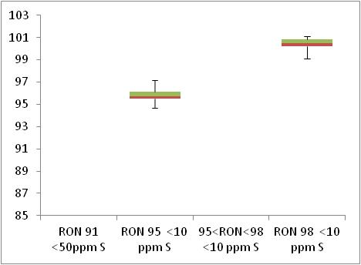  Min 95  Min 91

 | Motor Octane Number
MON | 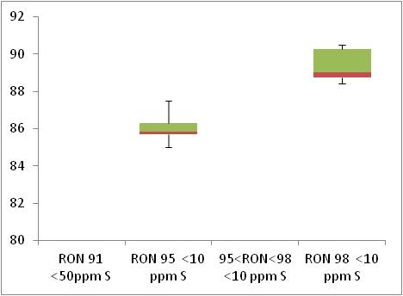  Min 85  Min 81

 | Summer Vapour Pressure (DVPE)
kPa | 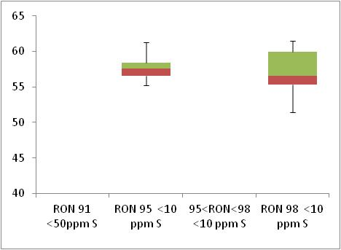  Max 60

Diesel Analysis
Figure 16-4: Diesel analysis
 | Density at 15ºC
Kg/m³ | 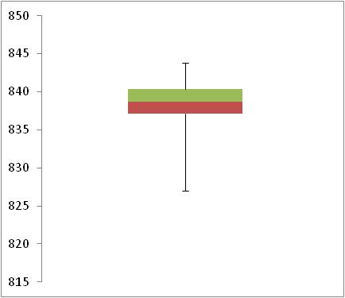  Max 845

 | Distillation – 95% v/v recovered
(⁰C) | 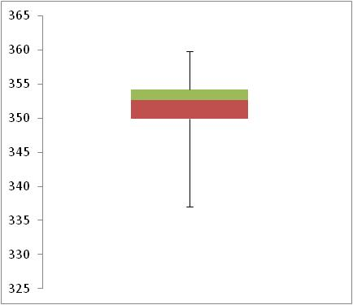  Max 360

Key Areas for Improvement
The following table summarises the main areas in which improvements could be made to the monitoring system, reporting or compliance with Directive limit values. The table includes key recommendations from the previous year to give an assessment of what action has been taken by the Member State to address any issues that may have been highlighted.
Key Areas for Improvement (3 years)
 | Monitoring | Reporting
2010 | - No regional spilt of sales provided | No comments
2009 | No comments | No comments
2008 | - Models A or B may be more appropriate than Model C (which is used) but an assessment was made | No Comments

Ireland

Fuel Availability 2010
The following table lists the fuels that were reported to be available nationally in 2010.
Table 17-1: National fuel grade
Fuel grade | National fuel grade
RON 95 < 10 ppm Sulphur | RON 95
Diesel < 10 ppm Sulphur | Diesel

Sales, sampling and reporting
During 2010 fuel sales in Ireland were dominated by diesel fuel sales. More than 2,500 million litres of diesel was sold in comparison to less than 2,000 petrol fuel sales.
Figure 17-1: Fuel Sales proportions by fuel type
Petrol

Diesel

 | Million Litres
 |  |  | RON=91 |  |  | RON = 95 |  |  | RON 95=<RON<98 |  |  | RON 98 |  |  | Diesel
Table 17-2: Fuel sales and sampling
Fuel type (Parent Grade) | Sales | Sales, | Samples ⁽¹⁾ |  |  | Separate | Param’s measured ⁽⁴⁾ | Add. Notes
Fuel type (Parent Grade) | (Million litres) | % total of fuel type | S | W | TR ⁽²⁾ | S/W⁽³⁾ | Param’s measured ⁽⁴⁾ | Add. Notes
Unleaded min. RON=95 | 1,974 | 100.0% | 62 | 82 | 100 | Yes | All of 18
Total Petrol | 1,974 | 100.00% | 62 | 82 | 100 | Yes | All of 18
Diesel (<10 ppm S) | 2,672 | 100.0% | 56 | 70 | 100 | Yes | All of 5
Total Diesel | 2,672 | 100.00% | 56 | 70 | 100 | Yes | All of 5
(1) | Samples |  |  |  | The actual number of samples taken by the Member State in the summer (s) and winter (w) periods
(2) | TR |  |  |  | Total requirement according to EN 14274. Dash (-) denotes National system has been used.
(3) | Separate S & W? |  |  |  | Yes indicates separate summer & winter reporting, and No indicates full year sample results reporting only.
(4) | Parameters measured |  |  |  | Currently 18 petrol parameters should be tested and reported by the Member States and 5 diesel parameters.

Petrol Samples
- Ireland have complied with or exceeded minimum sampling requirements for all petrol fuel grades.

Diesel Samples
- Diesel fuel samples tested in 2010 complied with the total minimum requirement.

Fuel Quality Monitoring 2010

Description of System
Responsible organisation(s) | Department of the Environment, Community and Local Government
Fuel Quality Monitoring System (FQMS) | EN 14274 Statistical model C
Country Size | Small
Summer Period | Arctic
Location(s) of sampling | Service stations, terminals and refineries.
Time/frequency of sampling | Samples have been taken in every months throughout 2010 (with the exception of May, diesel).
Specification of test methods | For Petrol Samples, test methods used were as specified in either EN228:2004 or EN 228:2008 with the following exceptions:  - RON and MON: 42 of the 144 samples were analysed by an FTNIR method.  - Sulphur: 96 of the 144 samples were analysed by EN 14596.  - Lead: Lead: 48 of the 144 samples were analysed by an XRF method.  For Diesel Samples, test methods used were as specified in either EN 590:2004 or EN 590:2009 with the following exceptions:  - Sulphur: 96 of the 126 samples were analysed by EN 14596.  - PAH: 96 of the 126 samples were analysed by a method which overestimated the concentration.
Collection of sales data | Sales figures for petrol and diesel are supplied by the Department of Communications, Energy and Natural Resources.
Other details

Compliance with Fuel Quality Limit Values
Table 17-3: Petrol Fuel Grades
RON 95 Petrol - Details of samples that exceed tolerance limits:
Parameter | Limit Value | Tolerance Limit* (TL) | Max/Min value of samples tested | No samples outside TL | % samples outside TL
RON | 95 | 94.6 | 92.6 | 8 | 5.56%
Aromatics, % v/v | 35 | 36 | 36.8 | 1 | 0.69%
Oxygen content, % m/m | 2.7 | 2.9 | 3.16 | 3 | 2.16%
Ethanol, % v/v | 5 | 5.2 | 5.37 | 3 | 2.08%
Member State notes
For the RON non-compliant samples, the Department wrote to the companies concerned. 7 of the 8 exceedences were sampled at the refinery. Petrol samples taken at the refinery and some of the samples taken at the terminals were sampled prior to the addition of ethanol. This may account for some out of specification results, in particular for RON. As the subsequent addition of ethanol prior to sale may bring some parameters back within specification, no conclusion as to compliance can be reached for such samples. Alternative sampling arrangements are being investigated to resolve this issue for future monitoring
One sample reported a breach of the environmental specifications for Aromatics. The Department wrote to the refinery and was informed that the fuel was also sampled before the addition of ethanol to the blend (see above).
For Ethanol and Oxygen content the Department wrote to industry with regard to the 3 oxygen and ethanol exceedences. Quality certificates were supplied by industry which indicated that the fuel was within specification.
An additional sample tested for Distillation at 100oC fails Dir. 2003/17/EC limits for Distillation Points evaporated @100C of Min. 46% v/v but passes calculated tolerance limits of 41.42% v/v for method used (EN3405).

Table 17-4: Diesel Fuel Grades
Diesel - Details of samples that exceed tolerance limits:
Parameter | Limit Value | Tolerance Limit* (TL) | Max/Min value of samples tested | No samples outside TL | % samples outside TL
PAH (Polycyclic Aromatic Hydrocarbons), % m/m | 11 | 13.2 | 14.7 | 1 | 0.79%
Member State notes
The Department followed up with the company which supplied the fuel to try to determine the reason for the result of 14.7. The Department was informed that the test method used to test for PAH overstated the results. Therefore the result cannot be used to demonstrate non-compliance with a maximum limit value and is not considered to be an exceedence.

Temporal Trends
Figure 17-2 shows the trend in total fuel sales since 2001. Diesel sales in Ireland have decreased by 6% compared to 2009 sales figures – representing an increase in 21% since 2001. Petrol fuel sales have reduced by 8% in the period between 2009 and 2010 with an overall reduction of 4% in the period 2001-2010.
Figure 17-2: Temporal trends in national sales of petrol and diesel (million litres)
Sales (million litres)

 |  |  |  |  | Petrol |  | Diesel

Statistical Analysis
The following charts in this section are known as box-plots and they display the distribution of fuel characteristics per Member State by illustrating the:
- Sample minimum
- Lower 25% range
- Middle 50% range
- Median
- Upper 25% range
- Maximum
For a full explanation of the information presented in a Box Plot diagram, please see Appendix 1.

Petrol Analysis
Fuel sampling in Ireland in 2010 recorded relatively few test results out of specification with limits. The analysis charts for petrol (Figure 17-3) and diesel (Figure 17-4) detail the distribution of sample results for the 5 selected parameters;
Petrol:
- Research Octane Number
- Motor Octane Number
- Summer Vapour Pressure
Diesel:
- Density at 15ºC
- Distillation – 95% v/v recovered
Sample results for these parameters have been depicted using box plots based on the reported sample minimum, lower quartile (Q1), median (Q2), upper quartile (Q3), and the maximum sample value.
Sample results in 2010 have been presented in the following figures with limit values for the parameter (maximum or minimum) to demonstrate the skew of sample results. RON and MON sample results show that the fuels available in Ireland have reasonably small variation in Octane levels. Summer Vapour pressure results show do not exceed the limit value due to the arctic summer criteria, there is also little variation in sampling results.
Diesel sample results for Density show a slightly wider variation in density, exhibited by the widely spread coloured bands at the 25 and 75 quartile – in comparison to the tight bands shown in the petrol analysis box plots.
Figure 17-3: petrol analysis
 | Research Octane Number
RON | 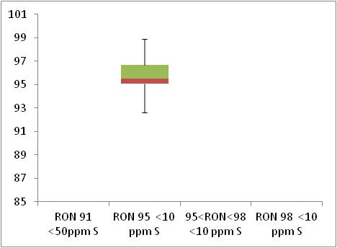  Min 95  Min 91

 | Motor Octane Number
MON | 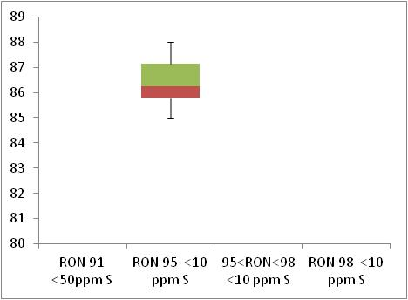  Min 85  Min 81

 | Summer Vapour Pressure (DVPE)
kPa | Max 70

Diesel Analysis
Figure 17-4: Diesel analysis
 | Density at 15ºC
Kg/m³ | 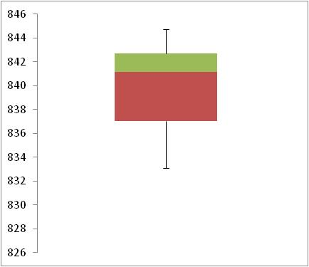  Max 845

 | Distillation – 95% v/v recovered
(⁰C) | 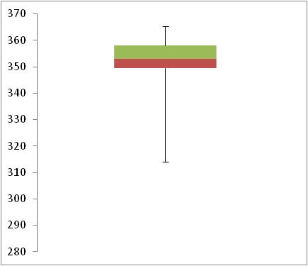  Max 360

Key Areas for Improvement
The following table summarises the main areas in which improvements could be made to the monitoring system, reporting or compliance with Directive limit values. The table includes key recommendations from the previous year to give an assessment of what action has been taken by the Member State to address any issues that may have been highlighted.
Key Areas for Improvement (3 years)
 | Monitoring | Reporting
2010 | - Insufficient sampling at service stations. | No comment.
2009 | - Insufficient sampling and not stated if samples were taken from petrol stations or refineries | No comment
2008 | - Sulphur-free fuels not separately labelled and not available everywhere  - Insufficient summer sampling  - No separate sampling by sulphur grade and number of samples insufficient for just one grade  - Sampling at refineries | - Results not reported separately by low-sulphur / sulphur-free (as can’t distinguish)

Italy

Fuel Availability 2010
The following table lists the fuels that were reported to be available nationally in 2010.
Table 18-1: National fuel grade
Fuel grade | National fuel grade
RON 95 < 10 ppm Sulphur | Normal
Diesel < 10 ppm Sulphur | Diesel

Sales, sampling and reporting
During 2010 fuel sales in Italy were dominated by diesel fuel sales. Almost 30,000 million litres of diesel was sold in comparison to 10,000 petrol fuel sales. Petrol fuel sales were comprised of fuel grade RON 95.
Figure 18-1: Fuel Sales proportions by fuel type
Petrol  Diesel | 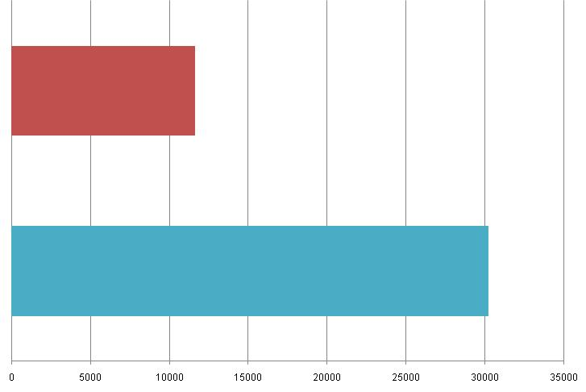
 | Million Litres
 |  |  | RON=91 |  |  | RON = 95 |  |  | RON 95=<RON<98 |  |  | RON 98 |  |  | Diesel
Table 18-2: Fuel sales and sampling
Fuel type (Parent Grade) | Sales | Sales, | Samples ⁽¹⁾ |  |  | Separate | Param’s measured ⁽⁴⁾ | Add. Notes
Fuel type (Parent Grade) | (Million litres) | % total of fuel type | S | W | TR ⁽²⁾ | S/W⁽³⁾ | Param’s measured ⁽⁴⁾ | Add. Notes
Unleaded min. RON=95 | 11,678 | 100.0% | 100 | 100 | 200 | Yes | 17 of 18
Total Petrol | 11,678 | 100.00% | 100 | 100 | 200 | Yes
Diesel (<10 ppm S) | 30,238 | 100.0% | 100 | 100 | 200 | Yes | 5 of 5
Total Diesel | 30,238 | 100.00% | 100 | 100 | 200 | Yes
(1) | Samples |  |  |  | The actual number of samples taken by the Member State in the summer (s) and winter (w) periods
(2) | TR |  |  |  | Total requirement according to EN 14274. Dash (-) denotes National system has been used.
(3) | Separate S & W? |  |  |  | Yes indicates separate summer & winter reporting, and No indicates full year sample results reporting only.
(4) | Parameters measured |  |  |  | Currently 18 petrol parameters should be tested and reported by the Member States and 5 diesel parameters.

Petrol Samples
- Italy have complied with or exceeded minimum sampling requirements for all petrol fuel grades. They have not taken samples of each parameter, lead content was not sampled.

Diesel Samples
- Diesel fuel samples tested in 2010 complied with the total minimum requirement.

Fuel Quality Monitoring 2010

Description of System
Responsible organisation(s) | Ministry of Environment, Territory and Sea
Fuel Quality Monitoring System (FQMS) | Statistical Model A
Country Size | Large
Summer Period | Normal
Location(s) of sampling | Service stations
Time/frequency of sampling | Samples have not been taken throughout the year.
Specification of test methods | Italy established a fuel quality monitoring system, in accordance with the requirements of the European standard EN 14274:2003, by decree 3 February 2005.
Collection of sales data | Sales data in 2010 was collected by Ministero dello Sviluppo Economico (Ministry of Industry) through an electronic questionnaire compiled by oil companies. The monitoring system (sampling and measurements) was carried out by independent supervisory bodies on behalf of the main oil companies.
Other details
Italy established a fuel quality monitoring system, in accordance with the requirements of the European standard EN 14274:2003, by decree 3 February 2005. The 2010 national report had been drawn up on the base of a monitoring system at sale outlets distributed throughout the Italian territory. The monitoring system (sampling and measurements) was carried out by independent supervisory bodies on behalf of the main oil companies.
Samples were taken monthly in each Winter and Summer period (Summer period for petrol: 1st May to 30th September). The 2010 monitoring system was set up using the statistical model A of EN 14274 (large country framework, five macro-regions). 200 petrol samples and 200 diesel fuel samples were analysed. The distribution of samples throughout the national territory was: 26% North-West, 22% North-East, 25% Centre, 16% South and 11% Islands.
The test methods required for fuel quality monitoring were performed by laboratories that regularly participate in one or more national inter-laboratory proficiency testing schemes, and that are accredited according to EN ISO 17025 or certified according to ISO 9000 standards. The proficiency testing schemes include all test methods listed in the FQMS. According to the requirements of EN 14274, analytical results for petrol and diesel fuel were reported separately for each season and for each grade.
In 2010 Italy has defined only one grade for each type of fuel: petrol with minimum RON = 95 and maximum sulphur content of 10 mg/kg; diesel fuel with maximum sulphur content of 10 mg/kg.
A limited quantity of petrol with minimum RON = 98 was sold in 2010 for market in trial, even if this does not correspond to any specific petrol grade defined at national level.
The test methods employed to evaluate petrol characteristics were those listed in European standard EN 228:2004 (in particular EN ISO 20884 for sulphur content). Test method EN 1601 was employed for the determination of oxygenate content in petrol samples. EN 1601 requires the examination of each sample chromatogram to identify possible oxygen containing components, before the actual determination is carried out.
The examination of all chromatograms related to FQMS samples showed that only one oxygenate compound was present in each sample (MTBE, ETBE, TAME). No other oxygenate compound was detected beside one of these ethers. Values reported as 0.0 mean values that fall into the range 0 - limit of the detection. The greatest part of Italian petrol contain oxygenates, therefore reproducibility = 4.6 % (V/V) for olefins was considered.

Compliance with Fuel Quality Limit Values
Table 18-3: Petrol Fuel Grades
Petrol - Details of samples that exceed tolerance limits:
Parameter | Limit Value | Tolerance Limit* (TL) | Max/Min value of samples tested | No samples outside TL | % samples outside TL
RON | 95 | 94.6 | 93.2 | 1 | 0.58%
Summer vapour pressure, kPa | 60 | 61.8 | 62.1 | 1 | 0.68%
Member State notes
The test methods employed to evaluate petrol characteristics were those listed in European standard EN 228:2004 (in particular EN ISO 20884 for sulphur content). Test method EN 1601 was employed for the determination of oxygenate content in petrol samples. EN 1601 requires the examination of each sample chromatogram to identify possible oxygen containing components, before the actual determination is carried out.
The examination of all chromatograms related to FQMS samples showed that only one oxygenate compound was present in each sample (MTBE, ETBE, TAME). No other oxygenate compound was detected beside one of these ethers. Values reported as 0.0 mean values that fall into the range 0 - limit of the detection. The greatest part of Italian petrol contain oxygenates, therefore reproducibility = 4.6 % (V/V) for olefins was considered.
In order to ensure the compliance with the directive 2003/17/EC, Italy determined the penalties applicable to producers, importers and distributors of fuels that do not comply with the limits reported in the directive 2003/17/EC.
Furthermore, Italy established a monitoring system carried out by a competent national authority in the production and importing sites.

Table 18-4: Diesel Fuel Grades
Diesel | Compliant with Directive 98/70/EC

Temporal Trends
Figure 18-2 shows the trend in total fuel sales since 2001. Diesel sales in Italy have decreased by 1% compared to 2009 sales figures – representing an increase in 23% since 2001. Petrol fuel sales have reduced by 6% in the period between 2009 and 2010 with an overall reduction of 37% in the period 2001-2010.
Figure 18-2: Temporal trends in national sales of petrol and diesel (million litres)
Sales (million litres) | 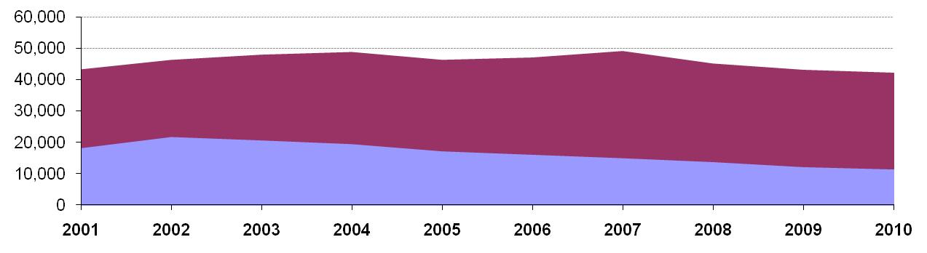
 |  |  |  |  | Petrol |  | Diesel

Statistical Analysis
The following charts in this section are known as box-plots and they display the distribution of fuel characteristics per Member State by illustrating the:
- Sample minimum
- Lower 25% range
- Middle 50% range
- Median
- Upper 25% range
- Maximum
For a full explanation of the information presented in a Box Plot diagram, please see Appendix 1.

Petrol Analysis
Fuel sampling in Italy in 2010 recorded relatively few test results out of specification with limits. The analysis charts for petrol (Figure 18-3) and diesel (Figure 18-4) detail the distribution of sample results for the 5 selected parameters;
Petrol:
- Research Octane Number
- Motor Octane Number
- Summer Vapour Pressure
Diesel:
- Density at 15ºC
- Distillation – 95% v/v recovered
Sample results for these parameters have been depicted using box plots based on the reported sample minimum, lower quartile (Q1), median (Q2), upper quartile (Q3), and the maximum sample value.
Sample results in 2010 have been presented in the following figures with limit values for the parameter (maximum or minimum) to demonstrate the skew of sample results. RON and MON sample results show that the fuels available in Italy have reasonably small variation in Octane levels. Summer Vapour pressure results are all within limit values and little variation between samples.
Diesel sample results for Density show a slightly wider variation in density, exhibited by the widely spread coloured bands at the 25 and 75 quartile – in comparison to the tight bands shown in the petrol analysis box plots.
Figure 18-3: petrol analysis
 | Research Octane Number
RON | 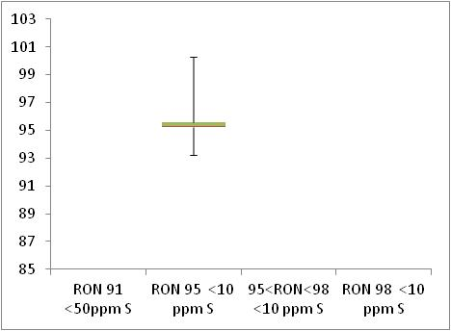  Min 95  Min 91

 | Motor Octane Number
MON | 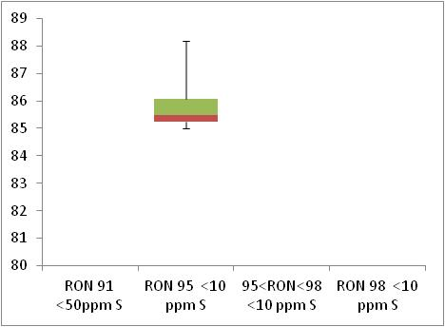  Min 85  Min 81

 | Summer Vapour Pressure (DVPE)
kPa | 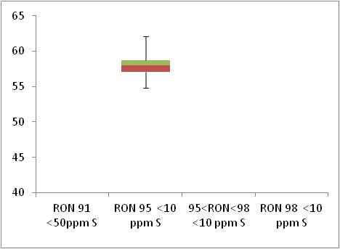  Max 60

Diesel Analysis
Figure 18-4: Diesel analysis
 | Density at 15ºC
Kg/m³ | 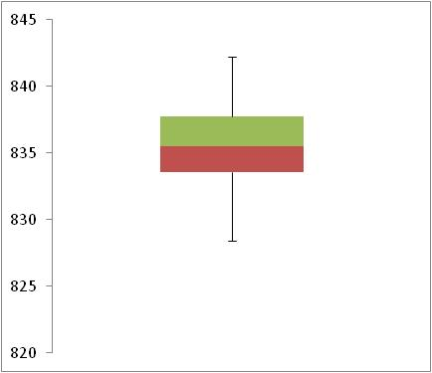  Max 845

 | Distillation – 95% v/v recovered
(⁰C) | 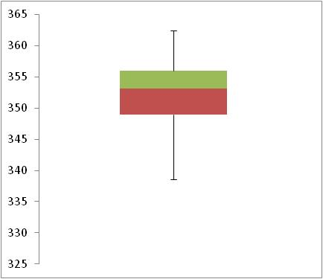  Max 360

Key Areas for Improvement
The following table summarises the main areas in which improvements could be made to the monitoring system, reporting or compliance with Directive limit values. The table includes key recommendations from the previous year to give an assessment of what action has been taken by the Member State to address any issues that may have been highlighted.
Key Areas for Improvement (3 years)
 | Monitoring | Reporting
2010 | - 17 of 18 parameters tested. Lead content not measured. | - The 2010 report was submitted after the Member State reporting deadline
2009 | No comments. | No comments.
2008 | - Insufficient samples of sulphur-free (as just over 10%) | No comments.

Latvia

Fuel Availability 2010
The following table lists the fuels that were reported to be available nationally in 2010.
Table 19-1: National fuel grade
Fuel grade | National fuel grade
95=<RON<98 < 10 ppm Sulphur | A-95
RON 98 < 10 ppm Sulphur | A-98
Diesel < 10 ppm Sulphur | DD

Sales, sampling and reporting
During 2010 fuel sales in Latvia were dominated by diesel fuel sales. Almost 800 million litres of diesel was sold in comparison to less than 400 petrol fuel sales (all petrol grades combined). Petrol fuel sales were mainly comprised of fuel grade RON 95=<RON<98.
Figure 19-1: Fuel Sales proportions by fuel type

Petrol

Diesel

 | Million Litres
 |  |  | RON=91 |  |  | RON = 95 |  |  | RON 95=<RON<98 |  |  | RON 98 |  |  | Diesel
Table 19-2: Fuel sales and sampling
Fuel type (Parent Grade) | Sales | Sales, | Samples ⁽¹⁾ |  |  | Separate | Param’s measured ⁽⁴⁾ | Add. Notes
Fuel type (Parent Grade) | (Million litres) | % total of fuel type | S | W | TR ⁽²⁾ | S/W⁽³⁾ | Param’s measured ⁽⁴⁾ | Add. Notes
Unleaded 95=<RON<98 | 347 | 92.4% | 127 | 171 | - | Yes | All of 18
Unleaded RON>=98 | 29 | 7.6% | 54 | 86 | - | Yes | All of 18
Total Petrol | 376 | 100.00% | 181 | 257 | - | Yes | All of 18
Diesel (<10 ppm S) | 801 | 100.0% | 414 | 260 | - | Yes | All of 5
Total Diesel | 801 | 100.00% | 414 | 260 | - | Yes | All of 5
(1) | Samples |  |  |  | The actual number of samples taken by the Member State in the summer (s) and winter (w) periods
(2) | TR |  |  |  | Total requirement according to EN 14274. Dash (-) denotes National system has been used.
(3) | Separate S & W? |  |  |  | Yes indicates separate summer & winter reporting, and No indicates full year sample results reporting only.
(4) | Parameters measured |  |  |  | Currently 18 petrol parameters should be tested and reported by the Member States and 5 diesel parameters.

Petrol Samples
- Latvia have complied with or exceeded minimum sampling requirements for all petrol fuel grades.

Diesel Samples
- Diesel fuel samples tested in 2010 complied with the total minimum requirement.

Fuel Quality Monitoring 2010

Description of System
Responsible organisation(s) | Latvian Ministry of Economics
Fuel Quality Monitoring System (FQMS) | National system
Country Size | Small
Summer Period | Arctic
Location(s) of sampling | Most fuel samples have been collected from refuelling stations, with a small number of samples taken at terminals in Latvia.
Time/frequency of sampling | Samples have been taken in every month throughout the year.
Specification of test methods | In compliance with Directive 98/70/EC.
Collection of sales data | The State Revenue Service of Latvia.
Other details
None

Compliance with Fuel Quality Limit Values
Table 19-3: Petrol Fuel Grades
A-95 | Compliant with Directive 98/70/EC
A-98 | Compliant with Directive 98/70/EC
Table 19-4: Diesel Fuel Grades
Diesel - Details of samples that exceed tolerance limits:
Parameter | Limit Value | Tolerance Limit* (TL) | Max/Min value of samples tested | No samples outside TL | % samples outside TL
Cetane number | 51 | 48.5 | 48 | unknown | unknown
Member State notes
No detail provided.

Temporal Trends
Figure 19-2 shows the trend in total fuel sales since 2004. Diesel sales in Latvia have increased by 2% compared to 2009 sales figures – representing an increase in 75% since 2004. Petrol fuel sales have reduced by 11% in the period between 2009 and 2010 with an overall increase of 32% in the period 2004-2010.
Figure 19-2: Temporal trends in national sales of petrol and diesel (million litres)
Sales (million litres)

 |  |  |  |  | Petrol |  | Diesel

Statistical Analysis
The following charts in this section are known as box-plots and they display the distribution of fuel characteristics per Member State by illustrating the:
- Sample minimum
- Lower 25% range
- Middle 50% range
- Median
- Upper 25% range
- Maximum
For a full explanation of the information presented in a Box Plot diagram, please see Appendix 1.

Petrol Analysis
Fuel sampling in Latvia in 2010 recorded relatively few test results out of specification with limits. The analysis charts for petrol (Figure 19-3) and diesel (Figure 19-4) detail the distribution of sample results for the 5 selected parameters;
Petrol:
- Research Octane Number
- Motor Octane Number
- Summer Vapour Pressure
Diesel:
- Density at 15ºC
- Distillation – 95% v/v recovered
Sample results for these parameters have been depicted using box plots based on the reported sample minimum, lower quartile (Q1), median (Q2), upper quartile (Q3), and the maximum sample value.
Sample results in 2010 have been presented in the following figures with limit values for the parameter (maximum or minimum) to demonstrate the skew of sample results. RON and MON sample results show that the fuels available in Latvia have reasonably small variation in Octane levels. Summer Vapour pressure results show that all samples are within the limit value.
Diesel sample results for Density show a slightly wider variation in density, exhibited by the widely spread coloured bands at the 25 and 75 quartile – in comparison to the tight bands shown in the petrol analysis box plots.
Figure 19-3: petrol analysis
 | Research Octane Number
RON | 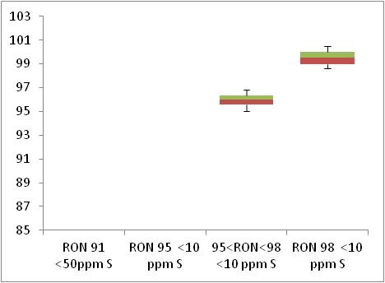  Min 95  Min 91

 | Motor Octane Number
MON | 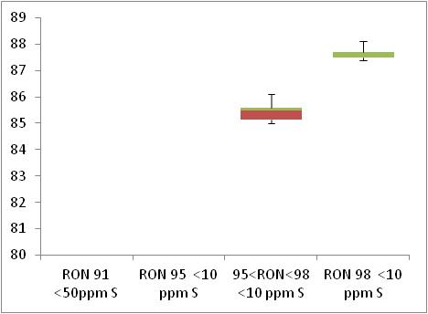  Min 85  Min 81

 | Summer Vapour Pressure (DVPE)
kPa | 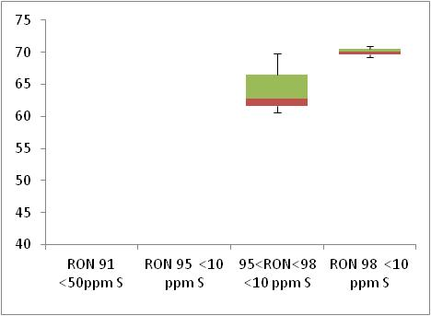  Max 70

Diesel Analysis
Figure 19-4: Diesel analysis
 | Density at 15ºC
Kg/m³ | 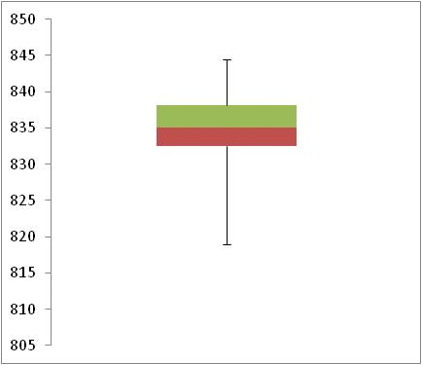  Max 845

 | Distillation – 95% v/v recovered
(⁰C) | 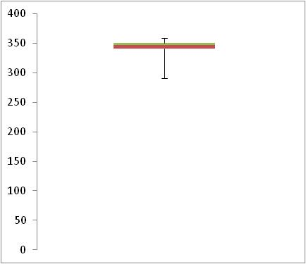  Max 360

Key Areas for Improvement
The following table summarises the main areas in which improvements could be made to the monitoring system, reporting or compliance with Directive limit values. The table includes key recommendations from the previous year to give an assessment of what action has been taken by the Member State to address any issues that may have been highlighted.
Key Areas for Improvement (3 years)
 | Monitoring | Reporting
2010 | - No detail is given on the split of samples taken so cannot determine if sampling at fuel stations is sufficient.  - No breakdown of sales by regional. | - No details provided on the number of samples which have exceeded the tolerance limit.  - The source of sales data for 2010 has not been provided.
2009 | - National model with no statistical equivalence given  - Low sampling of some petrol parameters | - Non-automotive road fuels have been reported with diesel sales but it was possible to separate them out for the first time in 2009
2008 | - Sulphur-free fuels not labelled and geographical availability not specified  - No explanation of national model or its equivalence | - Sampling results not split by sulphur content  - No information on sales recording  - Insufficient information on tested parameters (min, max etc)

Lithuania

Fuel Availability 2010
The following table lists the fuels that were reported to be available nationally in 2010.
Table 20-1: National fuel grade
Fuel grade | National fuel grade
RON 95 < 10 ppm Sulphur | A-95
RON 98 < 10 ppm Sulphur | A-98
Diesel < 10 ppm Sulphur | Diesel

Sales, sampling and reporting
During 2010 fuel sales in Lithuania were dominated by diesel fuel sales. Almost 1,200 million litres of diesel was sold in comparison to less than 400 petrol fuel sales (all petrol grades combined). Petrol fuel sales were mainly comprised of fuel grade RON 95.
Figure 20-1: Fuel Sales proportions by fuel type
Petrol

Diesel

 | Million Litres
 |  |  | RON=91 |  |  | RON = 95 |  |  | RON 95=<RON<98 |  |  | RON 98 |  |  | Diesel

Table 20-2: Fuel sales and sampling
Fuel type (Parent Grade) | Sales | Sales, | Samples ⁽¹⁾ |  |  | Separate | Param’s measured ⁽⁴⁾ | Add. Notes
Fuel type (Parent Grade) | (Million litres) | % total of fuel type | S | W | TR ⁽²⁾ | S/W⁽³⁾ | Param’s measured ⁽⁴⁾ | Add. Notes
Unleaded min. RON=95 | 380 | 97.7% | 50 | 50 | 100 | Yes | All of 18
Unleaded RON>=98 | 9 | 2.3% | 1 | 0 | 1 | Yes | All of 18
Total Petrol | 389 | 100.00% | 51 | 50 | 101
Diesel (<10 ppm S) | 1,190 | 100.0% | 50 | 50 | 100 | Yes | All of 5
Total Diesel | 1,190 | 100.00% | 50 | 50 | 100 | Yes
(1) | Samples |  |  |  | The actual number of samples taken by the Member State in the summer (s) and winter (w) periods
(2) | TR |  |  |  | Total requirement according to EN 14274. Dash (-) denotes National system has been used.
(3) | Separate S & W? |  |  |  | Yes indicates separate summer & winter reporting, and No indicates full year sample results reporting only.
(4) | Parameters measured |  |  |  | Currently 18 petrol parameters should be tested and reported by the Member States and 5 diesel parameters.

Petrol Samples
- Lithuania has almost fully complied with minimum sampling requirements for all petrol fuel grades in 2010. The vast majority of samples have been taken at refuelling stations – however any sampling at terminals or refineries should be carried out in addition to the minimum sample quota from refuelling stations. Lithuania has sampled 4 out of 104 samples in terminals although the rest of the samples have been taken at the point of use (in service stations).
- A small country using statistical model C, Lithuania have taken 50 samples in both summer and winter periods for all fuels that exceed 10% total market share.

Diesel Samples
- Diesel fuel samples tested in 2010almost fully complied with the total minimum requirement of 50 samples in both summer and winter periods. As with petrol, a very small number of samples (5 out of 100) were sampled in Terminals rather than in addition to the minimum 100 samples in the full year.

Fuel Quality Monitoring 2010

Description of System
Responsible organisation(s) | Lithuanian Ministry of Energy
Fuel Quality Monitoring System (FQMS) | EN 14274 Statistical Model C
Country Size | Small
Summer Period | Normal
Location(s) of sampling | Mainly service stations with some samples taken at terminals.
Time/frequency of sampling | Monthly throughout the year, with the exception of fuel grade A-98 which has been sampled once in 2010 (in July).
Specification of test methods | Test methods have not been specified.
Collection of sales data | Source of sales data for 2010 has not been specified.
Other details

Compliance with Fuel Quality Limit Values
Table 20-3: Petrol Fuel Grades
Petrol | Compliant with Directive 98/70/EC
Table 20-4: Diesel Fuel Grades
Diesel - Details of samples that exceed tolerance limits:
Parameter | Limit Value | Tolerance Limit* (TL) | Max/Min value of samples tested | No samples outside TL | % samples outside TL
Sulphur content, mg/kg | 10 | 11.3 | 17.9 | 1 | 1%
Member State notes

Temporal Trends
Figure 20-2 shows the trend in total fuel sales since 2004. Diesel sales in Lithuania have increased by 12% compared to 2009 sales figures – representing an increase in 35% since 2004. Petrol fuel sales have reduced by 22% in the period between 2009 and 2010 with an overall reduction of 14% in the period 2004-2010.
Figure 20-2: Temporal trends in national sales of petrol and diesel (million litres)
Sales (million litres)

 |  |  |  |  | Petrol |  | Diesel

Statistical Analysis
The following charts in this section are known as box-plots and they display the distribution of fuel characteristics per Member State by illustrating the:
- Sample minimum
- Lower 25% range
- Middle 50% range
- Median
- Upper 25% range
- Maximum
For a full explanation of the information presented in a Box Plot diagram, please see Appendix 1.

Petrol Analysis
Fuel sampling in Lithuania in 2010 recorded relatively few test results out of specification with limits. The analysis charts for petrol (Figure 20-3) and diesel (Figure 20-4) detail the distribution of sample results for the 5 selected parameters;
Petrol:
- Research Octane Number
- Motor Octane Number
- Summer Vapour Pressure
Only one sample has been taken for petrol grade RON 98 – as a result it is not possible to perform statistical analysis on this fuel grade, Figure 21-3 therefore only gives details for grade RON 95.
Diesel:
- Density at 15ºC
- Distillation – 95% v/v recovered
Sample results for these parameters have been depicted using box plots based on the reported sample minimum, lower quartile (Q1), median (Q2), upper quartile (Q3), and the maximum sample value.
Sample results in 2010 have been presented in the following figures with limit values for the parameter (maximum or minimum) to demonstrate the skew of sample results. RON and MON sample results show that the fuels available in Lithuania have reasonably small variation in Octane levels. MON samples are skewed closely to the limit value. Summer Vapour pressure results show that most samples remain well within the 70kPa maximum tolerance limit.
Diesel sample results for Density show a slightly wider variation in density, exhibited by the widely spread coloured bands at the 25 and 75 quartile – in comparison to the tight bands shown in the petrol analysis box plots.
Figure 20-3: Petrol analysis
 | Research Octane Number
RON | 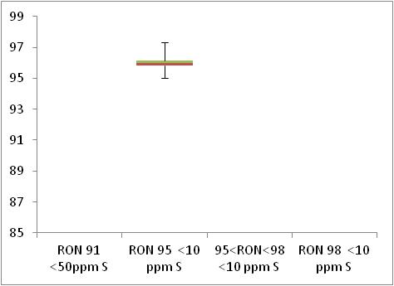  Min 95

 | Motor Octane Number
MON | 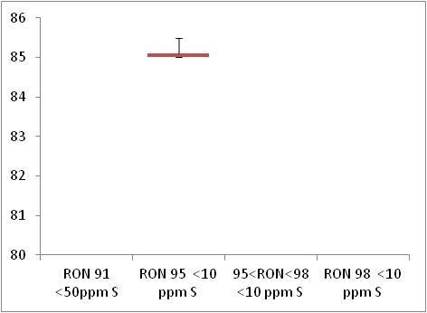  Min 85

 | Summer Vapour Pressure (DVPE)
kPa | 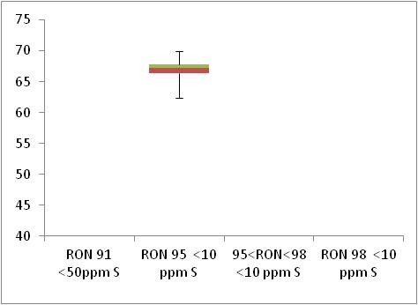  Max 70

Diesel Analysis
Figure 20-4: Diesel analysis
 | Density at 15ºC
Kg/m³ | 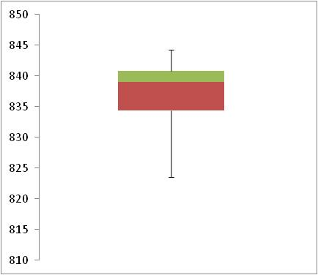  Max 845

 | Distillation – 95% v/v recovered
(⁰C) | 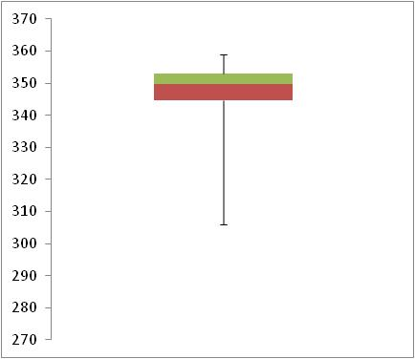  Max 360

Key Areas for Improvement
The following table summarises the main areas in which improvements could be made to the monitoring system, reporting or compliance with Directive limit values. The table includes key recommendations from the previous year to give an assessment of what action has been taken by the Member State to address any issues that may have been highlighted.
Key Areas for Improvement (3 years)
 | Monitoring | Reporting
2010 | - Lithuania are nearly fully compliant with a small country using statistical Model C, however any samples taken from terminals or refineries should be taken in addition to the minimum number of samples from service stations. | - Only one sample was found to be non-compliant in Lithuania in 2010 – Lithuania has provided almost all detail required, however have not provided information about the non-compliant sample (sample location/ when the sample was taken or why the sample exceeded specifications – if an investigation was carried out.
2009 | - A breakdown of sampling locations would assist in assessing compliance | No comment.
2008 | - Insufficient sampling, particularly in the summer  - As sampling is from other locations as well as refuelling stations, a breakdown of sampling locations would assist in assessing compliance | No comment.

Luxembourg

Fuel Availability 2010
The following table lists the fuels that were reported to be available nationally in 2010.
Table 21-1: National fuel grade
Fuel grade | National fuel grade
RON 95 < 10 ppm Sulphur | E95
RON 98 < 10 ppm Sulphur | E98
Diesel < 10 ppm Sulphur | Diesel

Sales, sampling and reporting
During 2010 fuel sales in Luxembourg were dominated by diesel fuel sales. More than 1,800 million litres of diesel was sold in comparison to less than 500 petrol fuel sales (all petrol grades combined). Petrol fuel sales were mainly comprised of fuel grade RON 95.
Figure 21-1: Fuel Sales proportions by fuel type
Petrol

Diesel

 | Million Litres
 |  |  | RON=91 |  |  | RON = 95 |  |  | RON 95=<RON<98 |  |  | RON 98 |  |  | Diesel

Table 21-2: Fuel sales and sampling
Fuel type (Parent Grade) | Sales | Sales, | Samples ⁽¹⁾ |  |  | Separate | Param’s measured ⁽⁴⁾ | Add. Notes
Fuel type (Parent Grade) | (Million litres) | % total of fuel type | S | W | TR ⁽²⁾ | S/W⁽³⁾ | Param’s measured ⁽⁴⁾ | Add. Notes
Unleaded min. RON=91 | 1 | 0.1% | 0 | 0 | 1 | No |  | (A)
Unleaded min. RON=95 | 373 | 80.1% | 6 | 30 | 100 | Yes | All of 18 | (A)
Unleaded RON>=98 | 92 | 19.7% | 0 | 11 | 100 | No | All of 18 | (A)
Total Petrol | 466 | 100.00% | 6 | 41 | 201 |  |  | (A)
Diesel (<10 ppm S) | 1,894 | 100.0% | 10 | 65 | 100 | Yes | 5 of 5 | (A)
Total Diesel | 1,894 | 100.00% | 10 | 65 | 100 | Yes | 5 of 5 | (A)
(1) | Samples |  |  |  | The actual number of samples taken by the Member State in the summer (s) and winter (w) periods
(2) | TR |  |  |  | Total requirement according to EN 14274. Dash (-) denotes National system has been used.
(3) | Separate S & W? |  |  |  | Yes indicates separate summer & winter reporting, and No indicates full year sample results reporting only.
(4) | Parameters measured |  |  |  | Currently 18 petrol parameters should be tested and reported by the Member States and 5 diesel parameters.
(A) |  |  |  |  | The minimum sampling requirements have not been met. Statistical model C for small countries requires 50 samples to be taken in both winter and summer per fuel grade.

Petrol Samples
- Luxembourg has failed to comply with the minimum sampling requirements. They have failed to sample enough in summer and winter for each of the petrol fuel grades.

Diesel Samples
- Diesel fuel samples tested in 2010 have failed to comply with the minimum requirement, not enough sampling during the summer period.

Fuel Quality Monitoring 2010

Description of System
Responsible organisation(s) | Administration de l'environnement (The Luxembourg Environmental Administration)
Fuel Quality Monitoring System (FQMS) | EN 14274 Statistical model C
Country Size | Small
Summer Period | Normal
Location(s) of sampling | Mainly service stations, some refinery sampling
Time/frequency of sampling | Samples of RON 95 petrol and diesel have been taken in 5 months of the year, from August to December. Samples for fuel grade RON 98 petrol have been taken in winter months (October, November and December) only.
Specification of test methods | No additional information has been given with regard to test methods used during monitoring.
Collection of sales data | The source of sales data in 2010 has not been provided.
Other details
Luxembourg has not submitted a Fuel Quality Monitoring report for previous reporting periods. The FQMS, in compliance with the European Standard EN 14274:2003, was being developed, to be applied from 2010 on.

Compliance with Fuel Quality Limit Values
Table 21-3: Petrol Fuel Grades
E95 Petrol - Details of samples that exceed tolerance limits:
Parameter | Limit Value | Tolerance Limit* (TL) | Max/Min value of samples tested | No samples outside TL | % samples outside TL
Summer vapour pressure, kPa | 60 | 61.8 | 85.9 | 5 | 13.89%
Oxygen content, % m/m | 2.7 | 2.9 | 4.99 | 2 | 5.56%
Member State notes

Table 21-4: Diesel Fuel Grades
Diesel | Compliant with Directive 98/70/EC

Temporal Trends
Figure 21-2 shows the trend in total fuel sales since 2001. Diesel sales in Luxembourg have decreased by 6% compared to 2009 sales figures – representing an increase in 52% since 2001. Petrol fuel sales have reduced by 18% in the period between 2009 and 2010 with an overall reduction of 39% in the period 2001-2010.
Figure 21-2: Temporal trends in national sales of petrol and diesel (million litres)
Sales (million litres)

 |  |  |  |  | Petrol |  | Diesel

Statistical Analysis
The following charts in this section are known as box-plots and they display the distribution of fuel characteristics per Member State by illustrating the:
- Sample minimum
- Lower 25% range
- Middle 50% range
- Median
- Upper 25% range
- Maximum
For a full explanation of the information presented in a Box Plot diagram, please see Appendix 1.

Petrol Analysis
Fuel sampling in Luxembourg in 2010 recorded relatively few test results out of specification with limits. The analysis charts for petrol (Figure 21-3) and diesel (Figure 21-4) detail the distribution of sample results for the 5 selected parameters;
Petrol:
- Research Octane Number
- Motor Octane Number
- Summer Vapour Pressure
Diesel:
- Density at 15ºC
- Distillation – 95% v/v recovered
Sample results for these parameters have been depicted using box plots based on the reported sample minimum, lower quartile (Q1), median (Q2), upper quartile (Q3), and the maximum sample value.
Sample results in 2010 have been presented in the following figures with limit values for the parameter (maximum or minimum) to demonstrate the skew of sample results. RON and MON sample results show that the fuels available in Luxembourg have reasonably small variation in Octane levels. Summer Vapour pressure results are skewed due to the low number of samples reported by Luxembourg for petrol – only 47 petrol samples in total with only 6 of these samples taken during the summer period.
Diesel sample results for Density show a slightly wider variation in density, exhibited by the widely spread coloured bands at the 25 and 75 quartile – in comparison to the tight bands shown in the petrol analysis box plots.
Figure 21-3: petrol analysis
 | Research Octane Number
RON | 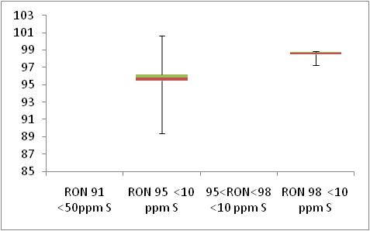  Min 91  Min 95

 | Motor Octane Number
MON | 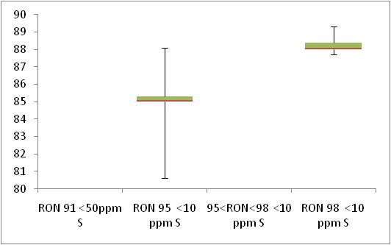  Min 85  Min 81

 | Summer Vapour Pressure (DVPE)
kPa | 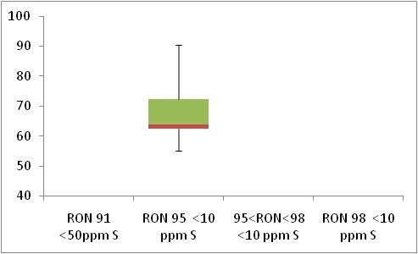  Max 60

Diesel Analysis
Figure 21-4: Diesel analysis
 | Density at 15ºC
Kg/m³ | 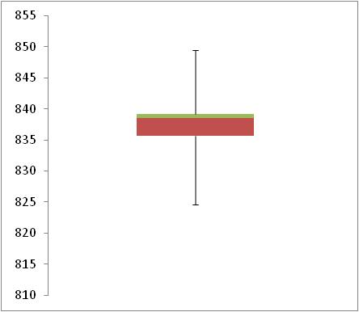  Max 845

 | Distillation – 95% v/v recovered
(⁰C) | 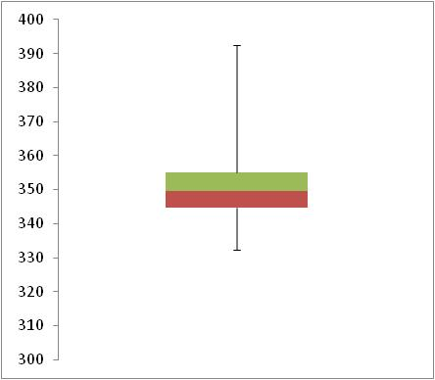  Max 360

Key Areas for Improvement
The following table summarises the main areas in which improvements could be made to the monitoring system, reporting or compliance with Directive limit values. The table includes key recommendations from the previous year to give an assessment of what action has been taken by the Member State to address any issues that may have been highlighted.
Key Areas for Improvement (3 years)
 | Monitoring | Reporting
2010 | - Not enough sampling done in winter summer periods to meet minimum requirements.  - No breakdown of sales by region. | - Report was not submitted by the deadline.
2009 | - No sampling in 2009 – compliant system to be introduced from 2010  - Planned scheme seems to have insufficient sampling | No comment.
2008 | - No sampling in 2009 – compliant system to be introduced from 2010  - Planned scheme seems to have insufficient sampling | No comment.

Malta

Fuel Availability 2010
The following table lists the fuels that were reported to be available nationally in 2010.
Table 22-1: National fuel grade
Fuel grade | National fuel grade
RON 95 < 10 ppm Sulphur | Unleaded petrol
RON 98 < 10 ppm Sulphur | LRP
Diesel < 10 ppm Sulphur | Diesel

Sales, sampling and reporting
During 2010 fuel sales in Malta were split relatively evenly between diesel and petrol fuel sales. 120 million litres of diesel was sold in comparison to 100 million litres petrol fuel sales (all petrol grades combined). Petrol fuel sales were mainly comprised of fuel grade RON 95=<RON<98.
Figure 22-1: Fuel Sales proportions by fuel type
Petrol  Diesel | 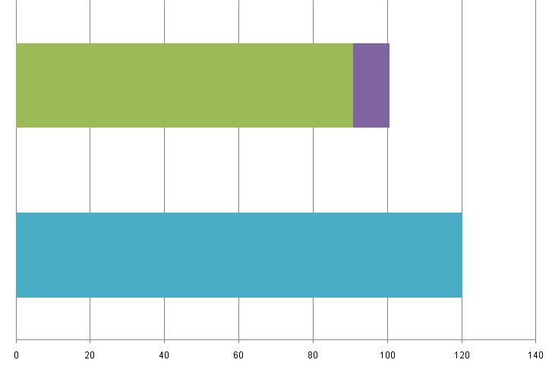
 | Million Litres
 |  |  | RON=91 |  |  | RON = 95 |  |  | RON 95=<RON<98 |  |  | RON 98 |  |  | Diesel

Table 22-2: Fuel sales and sampling
Fuel type (Parent Grade) | Sales | Sales, | Samples ⁽¹⁾ |  |  | Separate | Param’s measured ⁽⁴⁾ | Add. Notes
Fuel type (Parent Grade) | (Million litres) | % total of fuel type | S | W | TR ⁽²⁾ | S/W⁽³⁾ | Param’s measured ⁽⁴⁾ | Add. Notes
Unleaded 95=<RON<98 | 91 | 90.2% | 19 | 15 | - | Yes | All of 18
Unleaded RON>=98 | 10 | 9.8% | 10 | 5 | - | Yes | All of 18
Total Petrol | 100 | 100% | 29 | 20 | - | Yes | All of 18
Diesel (<10 ppm S) | 120 | 100% | 28 | 15 | - | Yes | All of 5
Total Diesel | 120 | 100% | 28 | 15 | - | Yes | All of 5
(1) | Samples |  |  |  | The actual number of samples taken by the Member State in the summer (s) and winter (w) periods
(2) | TR |  |  |  | Total requirement according to EN 14274. Dash (-) denotes National system has been used.
(3) | Separate S & W? |  |  |  | Yes indicates separate summer & winter reporting, and No indicates full year sample results reporting only.
(4) | Parameters measured |  |  |  | Currently 18 petrol parameters should be tested and reported by the Member States and 5 diesel parameters.

Petrol Samples
- Although Malta use a national system model and as such have no minimum sampling requirements they should undertake similar sampling to the one of the other statistical models. The number of samples undertaken by Malta is low. In comparison to other EU Member States, fuel sales in Malta are low, and therefore Malta sample in correspondingly reduced numbers.

Diesel Samples
- The number of samples taken by Malta is low – fuel sales in Malta are very low compared to other EU member states and Malta samples in low quantities as a result.

Fuel Quality Monitoring 2010

Description of System
Responsible organisation(s) | MRA
Fuel Quality Monitoring System (FQMS) | National System
Country Size | Small
Summer Period | Normal
Location(s) of sampling | Service stations and Terminals
Time/frequency of sampling | Samples for petrol fuel grades RON 95 ≤ RON <98 and RON 98 have been taken in most months throughout 2010 – dispersed mostly evenly across summer and winter periods. Diesel fuel grade RON mainly sampled in summer although some sampling done in winter.
Specification of test methods | Where detail has been given test method appears to comply with directive specifications.  Malta reports Cetane number instead of the Cetane index.
Collection of sales data | Unleaded petrol and LRP are imported only by Enemalta  Diesel is imported by both Enemalta + Falzon Fuel Energy  The conversion between litres and tonnes is taken from the Energy Statistics Manual, IEA Publications, Stedi as 1185 litres per tonne
Other details
Enemalta Corporation was the active importer of petrol and diesel for use in Malta in 2010. Falzon Group of Companies was also an active importer for diesel in Malta in 2010. Other importers are currently dormant in this field. Deliveries are made periodically by ship to the terminals. Each fuel consignment is accompanied by a quality certificate issued by a recognized fuel analysis organization. For every shipment, a sample is also taken and analysed by a separate independent analytical laboratory. Malta currently has more than 80 service stations. On a regular basis, a randomly selected refuelling station is sampled for each fuel type available and the necessary analytical testing carried out by an independent analytical laboratory. This system ensures full coverage of road/transport fuels used in Maltese territory. Based on fuel sales for the year 2010, the overall samples to sales ratio for the year corresponds to: 374 samples per billion litres of unleaded petrol, 1529 samples per billion litres of LRP and 357 samples per billion litres of diesel.
Malta reports Cetane number instead of the Cetane index

Compliance with Fuel Quality Limit Values
Table 22-3: Petrol Fuel Grades
Unleaded Petrol - Details of samples that exceed tolerance limits:
Parameter | Limit Value | Tolerance Limit* (TL) | Max/Min value of samples tested | No samples outside TL | % samples outside TL
Summer vapour pressure, kPa | 60 | 61.8 | 75 | 1 | 5.26%
Aromatics | 35 | 37.2 | 38 | 1 | 2.94%
Member State notes
Summer vapour pressure - This sample was imported at the end of September and tested on the 23-9-2010. This fuel was subsequently dispatched on to the Market after 01-10-10.

Table 22-4: Diesel Fuel Grades
Diesel - Details of samples that exceed tolerance limits:
Parameter | Limit Value | Tolerance Limit* (TL) | Max/Min value of samples tested | No samples outside TL | % samples outside TL
Cetane number | 51 | 48.5 | 45.5 | 2
Distillation -- 95-%-Point | 360 | 365.9 | 366.7 | 1 | 2.33%
Member State notes
Malta measures Cetane index rather than Cetane number.

Temporal Trends
Figure 22-2 shows the trend in total fuel sales since 2004. Diesel sales in Malta have increased by 25% compared to 2009 sales figures – representing an increase in 92% since 2004. Petrol fuel sales have increased by 1% in the period between 2009 and 2010 with an overall increase of 64% in the period 2004-2010.
Figure 22-2: Temporal trends in national sales of petrol and diesel (million litres)
Sales (million litres) | 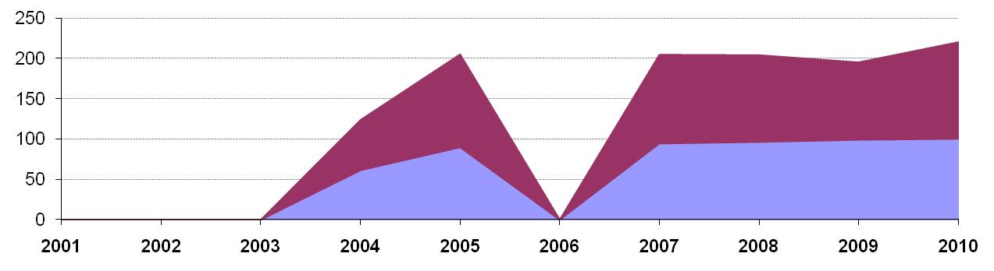
 |  |  |  |  | Petrol |  | Diesel

Statistical Analysis
The following charts in this section are known as box-plots and they display the distribution of fuel characteristics per Member State by illustrating the:
- Sample minimum
- Lower 25% range
- Middle 50% range
- Median
- Upper 25% range
- Maximum
For a full explanation of the information presented in a Box Plot diagram, please see Appendix 1.

Petrol Analysis
Fuel sampling in Malta in 2010 recorded relatively few test results out of specification with limits. The analysis charts for petrol (Figure 22-3) and diesel (Figure 22-4) detail the distribution of sample results for the 5 selected parameters;
Petrol:
- Research Octane Number
- Motor Octane Number
- Summer Vapour Pressure
Diesel:
- Density at 15ºC
- Distillation – 95% v/v recovered
Sample results for these parameters have been depicted using box plots based on the reported sample minimum, lower quartile (Q1), median (Q2), upper quartile (Q3), and the maximum sample value.
Sample results in 2010 have been presented in the following figures with limit values for the parameter (maximum or minimum) to demonstrate the skew of sample results. RON and MON sample results show that the fuels available in Malta have reasonably small variation in Octane levels and do not exceed the limit values. Summer Vapour pressure results show that a significant number of samples exceed limit values. However Malta have stated that vapour pressure values that exceeded the tolerance limit for the parameter were tested during the transition period; from among the first batches of winter fuel imported to Malta.
Diesel sample results for Density show a slightly wider variation in density, exhibited by the widely spread coloured bands at the 25 and 75 quartile – in comparison to the tight bands shown in the petrol analysis box plots.
Figure 22-3: petrol analysis
 | Research Octane Number
RON | 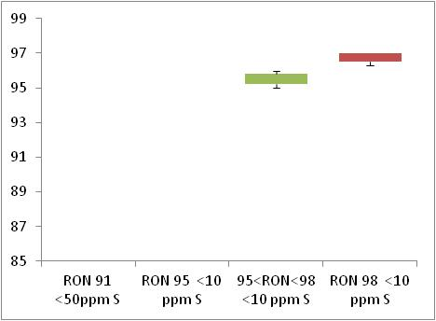  Min 95  Min 91

 | Motor Octane Number
MON | 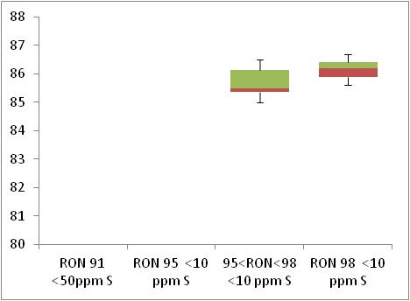  Min 85  Min 81

 | Summer Vapour Pressure (DVPE)
kPa | 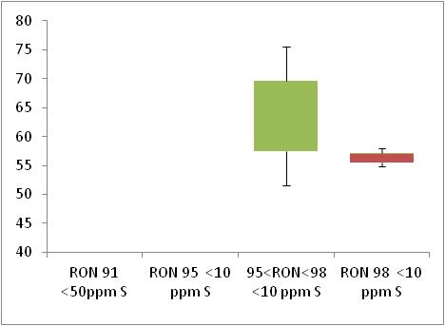  Max 60

Diesel Analysis
Figure 22-4: Diesel analysis
Density at 15ºC
Max 845
Kg/m³ | 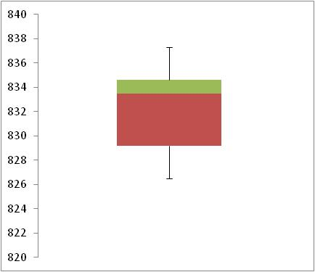

 | Distillation – 95% v/v recovered
(⁰C) | 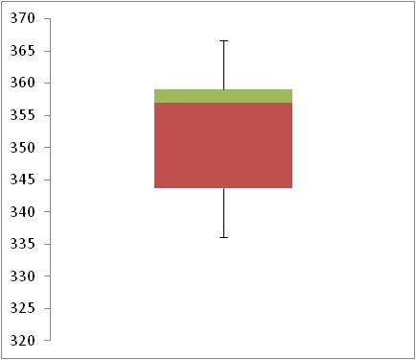  Max 360

Key Areas for Improvement
The following table summarises the main areas in which improvements could be made to the monitoring system, reporting or compliance with Directive limit values. The table includes key recommendations from the previous year to give an assessment of what action has been taken by the Member State to address any issues that may have been highlighted.
Key Areas for Improvement (3 years)
 | Monitoring | Reporting
2010 | - Have done a very small amount of sampling on all fuel grades  - Have reported Cetane Index and not Cetane number | No comment.
2009 | - Malta has used a national monitoring system – additional information could have been provided.  - In addition, sample quantities very low and include sampling at terminals which will not capture any contamination that could occur in the supply chains and before fuels reach the point of use. | - The report from Malta was very late, received in December 2010. As a result, the data from Malta was too late to be included in the EU-wide trends analysis. Reports should be submitted to the Commission by the 30th June annually.
2008 | - No sulphur-free sales reported and no information on availability  - Low sampling allowed due to extremely low sales  - Additional info on national system required | - 7 months late

Netherlands

Fuel Availability 2010
The following table lists the fuels that were reported to be available nationally in 2010.
Table 23-1: National fuel grade
Fuel grade | National fuel grade
min. RON=95 | Euro 95
RON>=98 | Super Plus
Diesel | Diesel

Sales, sampling and reporting

During 2010 fuel sales in The Netherlands were dominated by diesel fuel sales which represented more almost 69% total market share of fuels. Petrol fuel sales were weighted heavily towards Euro 95 (RON 95) fuel sales with less than 1.5% of Super Plus (RON 98) fuel sales.
Figure 23-1: Fuel Sales proportions by fuel type
Petrol  Diesel | 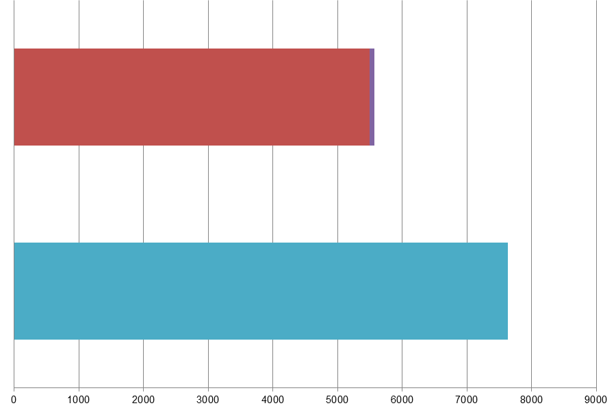
 | Million Litres
 |  |  | RON=91 |  |  | RON = 95 |  |  | RON 95=<RON<98 |  |  | RON 98 |  |  | Diesel

Table 23-2: Fuel sales and sampling
Fuel type (Parent Grade) | Sales | Sales, | Samples ⁽¹⁾ |  |  | Separate | Param’s measured ⁽⁴⁾ | Add. Notes
Fuel type (Parent Grade) | (Million litres) | % total of fuel type | S | W | TR ⁽²⁾ | S/W⁽³⁾ | Param’s measured ⁽⁴⁾ | Add. Notes
Unleaded min. RON=95 | 5,496 | 98.7% | 50 | 50 | 100 | No | All of 18
Unleaded RON>=98 | 75 | 1.3% | 0 | 0 | 2
Total Petrol | 5,571 | 100.00% | 50 | 50 | 102
Diesel (<10 ppm S) | 7,634 | 100.0% | 50 | 50 | 100 | No | All of 5
Total Diesel | 7,634 | 100.00% | 50 | 50 | 100 | No
(1) | Samples |  |  |  | The actual number of samples taken by the Member State in the summer (s) and winter (w) periods
(2) | TR |  |  |  | Total requirement according to EN 14274. Dash (-) denotes National system has been used.
(3) | Separate S & W? |  |  |  | Yes indicates separate summer & winter reporting, and No indicates full year sample results reporting only.
(4) | Parameters measured |  |  |  | Currently 18 petrol parameters should be tested and reported by the Member States and 5 diesel parameters.
(a) | Add. Notes |  |  |  | Additional information provided by the Member State in relation to table contents.

Petrol Samples
- The Netherlands have not taken any samples of fuel grade Euro Super. This fuel grade represents less than 10% share of the market – however fuels with a less than 10% share should be sampled in reduced quantities according to EN 14274. In this instance, with a 1.3% share of the market, samples should have totalled 2 for the full year.
- The Netherlands have not provided data for some of the additional fields requested from Member States in 2010 reporting (to enable statistical analysis of EU-wide results).

Diesel Samples
- The Netherlands have tested 100 diesel samples; 590 in the summer period and 50 in the winter period; this meets with the requirements for a country classified as ‘small’ (less than 15 million tonnes of fuel sales) using statistical Model A.

Fuel Quality Monitoring 2010

Description of System
Responsible organisation(s) | VROM-Inspectorate
Fuel Quality Monitoring System (FQMS) | EN 14274 Statistical model A
Country Size | Small
Summer Period | Normal
Location(s) of sampling | Service stations
Time/frequency of sampling | Both petrol and diesel samples have been taken in only 4 months of the year; July and August during the summer period and November and December of the winter period. No samples have been taken or tested for petrol fuel grade Super Plus (min RON 98) with less than 1% market fuel share.
Specification of test methods | No information has been provided about test methods.
Collection of sales data | The source of sales data for 2010 has not been provided.
Other details
No samples have been taken or tested for petrol fuel grade Super Plus (min RON 98) with less than 1% market fuel share.

Compliance with Fuel Quality Limit Values
Table 23-3: Petrol Fuel Grades
Euro 95 Petrol - Details of samples that exceed tolerance limits:
Parameter | Limit Value | Tolerance Limit* (TL) | Max/Min value of samples tested | No samples outside TL | % samples outside TL
Summer vapour pressure, kPa | 60 | 61.8 | 63.9
Ethanol, % (v/v) | 5 | 5.2 | 7.8
Member State notes
* Please note: Ethanol non-compliance reported in the winter period – however maximum value in full year period is reported as 6.9 % (v/v) (which still exceed tolerance limits)
Full Year reported results do not match the extremes (maximum / minimum values) of results reported in the summer or winter periods. Analysis has been carried out according to the most extreme values in either period.

Table 23-4: Diesel Fuel Grades
Diesel - Details of samples that exceed tolerance limits:
Parameter | Limit Value | Tolerance Limit* (TL) | Max/Min value of samples tested | No samples outside TL | % samples outside TL
Sulphur content, mg/kg | 10 | 11.3 | 12.8*
Member State notes
* Please note: the Sulphur content non-compliance (unless using test method EN ISO 14596) was reported in the summer period. The maximum Sulphur content is reported as 12.8 mg/kg in the summer period, 9.3 mg/kg in the winter period and then as 7.9 mg/kg in the full year results.
Full Year reported results should reflect the extremes (maximum / minimum values) of results reported in the summer or winter periods – in addition, the average sulphur content for diesel reported by the Netherlands for the Full year is 5.2 mg/kg – when the average sulphur content reported in the summer and winter months are 8 mg/kg and 7.3 mg/kg, respectively. The average sulphur content reported for diesel would be expected to be in the region of 7.65 mg/kg (as sample quantities in the two periods are 49 in summer and 50 in winter).
This raises some concern about the accuracy of data reported by the Netherlands.

Temporal Trends
Figure 23-2 shows the trend in total fuel sales in the Netherlands from 2001. Sales of diesel have fluctuated slightly in the Netherlands with a dip in 2003, decreasing by 21% from 9,602 million litres to 8,535 million litres then increasing again in 2004 (by 12%) to the maximum diesel fuel sales volume of 9,724 million litres. Diesel sales figure in 2010 are comparable to 2009, having declined since 2004 (with minor fluctuations). Since 2001, diesel fuel sales have fallen by 20% overall. Petrol fuel sales have also fluctuated, decreasing overall by 21% between 2001 and 2010 with a peak in 2004 when petrol fuel sales were reported at 9,724 million litres.
Figure 23-2: Temporal trends in national sales of petrol and diesel (million litres)
Sales (million litres) | 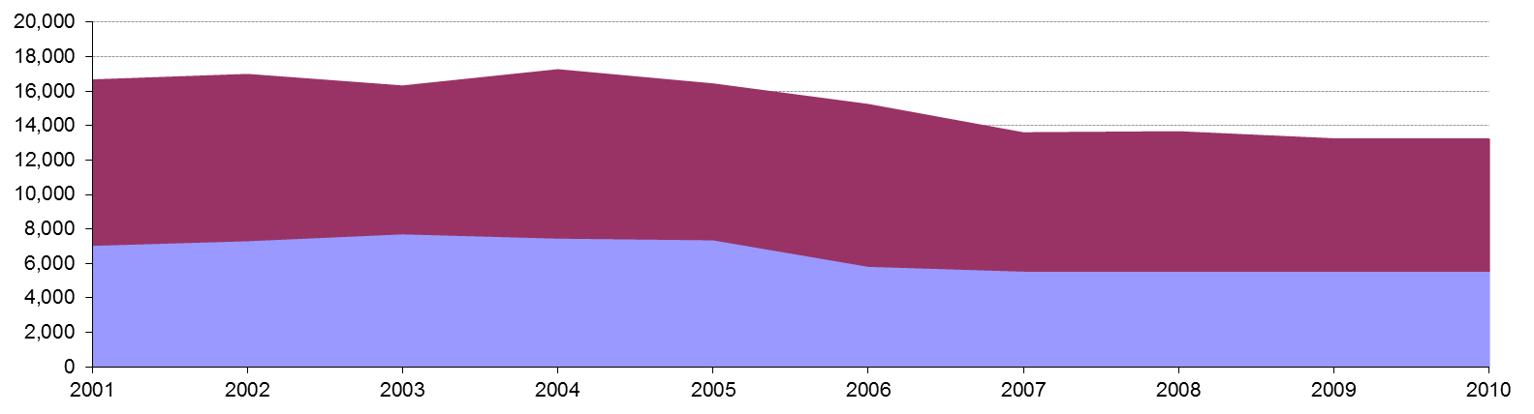
 |  |  |  |  | Petrol |  | Diesel

Statistical Analysis
The charts intended for this section are known as box-plots and they display the distribution of fuel characteristics per Member State by illustrating the:
- Sample minimum
- Lower 25% range
- Middle 50% range
- Median
- Upper 25% range
- Maximum
For a full explanation of the information presented in a Box Plot diagram, please see Appendix 1. The Netherlands have not provided the additional data requested for 2010 to enable greater analysis of reported sample results.

Petrol and Diesel Analysis
There were samples found to be above or below limit values in The Netherlands in 2010 – as shown in Section 23.2.2. However, additional detail requested for 2010 has not been provided.

Key Areas for Improvement
The following table summarises the main areas in which improvements could be made to the monitoring system, reporting or compliance with Directive limit values. The table includes key recommendations from the previous year to give an assessment of what action has been taken by the Member State to address any issues that may have been highlighted.
Key Areas for Improvement (3 years)
 | Monitoring | Reporting
2010 | - RON 98 (1.3% of petrol sales) was not sampled and tested at all.  - The number of non-compliant samples has not been detailed within the report – additionally no information has been provided about actions taken to address instances of non-compliance. | - Report not in EC template.  - Report submitted extremely late (in November 2011; more than 4 months late)  - Additional data requested by the Commission for 2010 has not been provided.  - Test methods used in 2010 have not been confirmed.  - The source of sales data has not been confirmed.  - Summer, winter and full year reported data does not correspond (e.g. maximum values in summer or winter period not accounted for in Full Year reporting sheets).
2009 | - Sampling is heavily weighted to the winter period  - RON 98 (2% of petrol sales) was not sampled | - Confusion over whether mean or median values have been reported  - Report was submitted late
2008 | - No analysis of oxygen content of petrol  - Insufficient samples taken for some other parameters | - Insufficient detail on exceedences and action taken

Poland

Fuel Availability 2010
The following table lists the fuels that were reported to be available nationally in 2010.
Table 24-1: National fuel grade
Fuel grade | National fuel grade
min. RON=95 | Unleaded 95
RON>=98 | Unleaded 98
Diesel | Diesel

Sales, sampling and reporting

During 2010 fuel sales in Poland were dominated by diesel fuel sales which represented more than 73% total market share. Nearly 14 million litres of diesel was sold in comparison to less than 6,000 million litres petrol fuel sales (all petrol grades combined). Petrol share of the fuel market was split according to 24% Unleaded 95 and 2.4% Unleaded 98 grade petrol.
Figure 24-1: Fuel Sales proportions by fuel type
Petrol  Diesel | 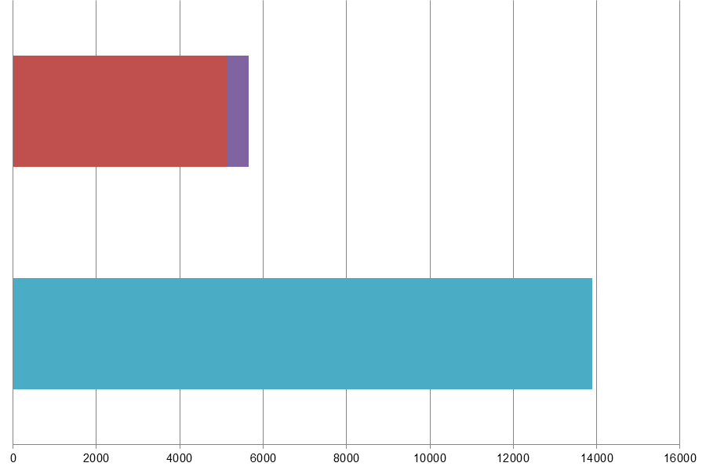
 | Million Litres
 |  |  | RON=91 |  |  | RON = 95 |  |  | RON 95=<RON<98 |  |  | RON 98 |  |  | Diesel

Table 24-2: Fuel sales and sampling
Fuel type (Parent Grade) | Sales | Sales, | Samples ⁽¹⁾ |  |  | Separate | Param’s measured ⁽⁴⁾ | Add. Notes
Fuel type (Parent Grade) | (Million litres) | % total of fuel type | S | W | TR ⁽²⁾ | S/W⁽³⁾ | Param’s measured ⁽⁴⁾ | Add. Notes
Unleaded min. RON=95 | 5,138 | 90.9% | 100 | 112 | 400 | Yes | All of 18
Unleaded RON>=98 | 513 | 9.1% | 31 | 48 | 37 | Yes | All of 18
Total Petrol | 5,652 | 100.00% | 131 | 160 | 437 | Yes
Diesel (<10 ppm S) | 13,896 | 100.0% | 105 | 124 | 400 | Yes | All of 5
Total Diesel | 13,896 | 100.00% | 105 | 124 | 400 | Yes
(1) | Samples |  |  |  | The actual number of samples taken by the Member State in the summer (s) and winter (w) periods
(2) | TR |  |  |  | Total requirement according to EN 14274. Dash (-) denotes National system has been used.
(3) | Separate S & W? |  |  |  | Yes indicates separate summer & winter reporting, and No indicates full year sample results reporting only.
(4) | Parameters measured |  |  |  | Currently 18 petrol parameters should be tested and reported by the Member States and 5 diesel parameters.
(a) | Add. Notes |  |  |  | Additional information provided by the Member State in relation to table contents.

Petrol Samples
- In addition, Polish fuel sales first exceeded 15 million tonnes in 2009. According to EN 14274, a member states must report according to a country classification of ‘Large’ if fuel sales are in excess of 15 million tonnes. With fuel sales of 15.77 million tonnes, Poland is now classed as a ‘large’ country. This has an impact on the number of samples required in order to be equivalent to statistical models outlined in EN 14274. Fuel samples for all grades with more than 10% market share for a large country using Statistical Model B are 200 in each summer and winter period (and so would apply to Petrol grade Unleaded 95).
- Poland has not provided data for some of the additional fields requested from Member States in 2010 reporting (to enable statistical analysis of EU-wide results).

Diesel Samples
- As discussed in Section 1.1.1.1, with more than 15 million tonnes of fuel sold in Poland in 2010, sample quantity requirements for Statistical model B are 200 in the summer period and 200 in the winter period; 400 samples in total. Poland have sampled diesel (which represents more than 70% market share), only 229 times in total.
- Poland has not provided data for some of the additional fields requested from Member States in 2010 reporting (to enable statistical analysis of EU-wide results).

Fuel Quality Monitoring 2010

Description of System
Responsible organisation(s) | Office of Competition and Consumer protection
Fuel Quality Monitoring System (FQMS) | EN 14274 Statistical model B
Country Size | Large
Summer Period | Normal (e.g. ambient summer temperature) however summer and winter periods for petrol and diesel differ in Poland:  Summer Period  Start Petrol: 1st May Diesel: 16th April  End Petrol: 30th September, Diesel: 30th September  Winter Period  Start: Petrol: 1st October, Diesel: 1st October  End: Petrol: 30th April, Diesel 15th April
Location(s) of sampling | Service stations
Time/frequency of sampling | Samples have been taken and tested during every month of the year.
Specification of test methods | Specifications of test methods are in compliance with Directive 98/70/EC. Laboratories that analyse fuel quality and conduct tests are accredited to the Polish Centre for Accreditation of fuel test methods and use methods specified in the regulations on the testing methods (PN-EN 228:2009, PN-EN 590:2009).
Collection of sales data | The source of the sales data for 2010 in Poland was the Energy Market Agency.

Compliance with Fuel Quality Limit Values
Table 24-3: Petrol Fuel Grades
Unleaded 95 - Details of samples that exceed tolerance limits:
Parameter | Limit Value | Tolerance Limit* (TL) | Max/Min value of samples tested | No samples outside TL | % samples outside TL
Research Octane Number | 95 | 94.6 | 93.3 | 2 | 0.96%
Motor Octane Number | 85 | 84.5 | 82.8 | 6 | 2.88%
Summer vapour pressure, kPa | 60 | 61.8 | 63.4 | 3 | 3%
Methanol, % (v/v) | 3 | 3.2 | 4 | 1 | 0.47%
Member State notes
Non-compliant samples were noted to the Public Prosecutor and the Chairman of ERO

Unleaded 98 - Details of samples that exceed tolerance limits:
Parameter | Limit Value | Tolerance Limit* (TL) | Max/Min value of samples tested | No samples outside TL | % samples outside TL
Summer vapour pressure, kPa | 60 | 61.8 | 75.2 (summer period only) | 1 | 3.2%
Aromatics, % (v/v) | 35 | 37.2 (2005 test methods) | 38.8 | 2 | 5%
Member State notes
Non-compliant samples were noted to the Public Prosecutor and the Chairman of ERO

Table 24-4: Diesel Fuel Grades
Diesel - Details of samples that exceed tolerance limits:
Parameter | Limit Value | Tolerance Limit* (TL) | Max/Min value of samples tested | No samples outside TL | % samples outside TL
Sulphur content, mg/kg | 10 | 13 | 455 | 3 | 1.31%
Member State notes
Fuel with extremely high sulphur content was withdrawn from the market. Polish authorities also notified the Office of Fiscal Control and Customs Board and the Regional Inspectorate of Environment Protection.

Temporal Trends
Figure 24-2 shows the trend in total fuel sales since Poland started to report Fuel Quality Monitoring in 2004. Sales of diesel have increased year on year, with the greatest increase occurring between 2006 and 2007 when diesel fuel sales in 2007 increased by 13% to 11.3 million litres. Petrol fuel sales have fluctuated more, with petrol fuel sales slightly less in 2010 than in 2004 (5.6 million litres compared to 5.7 million litres). Petrol fuel sales peaked in 2009 at just over 5.8 million litres and have decreased by 3% compared to 2009.
Figure 24-2: Temporal trends in national sales of petrol and diesel (million litres)
Sales (million litres) | 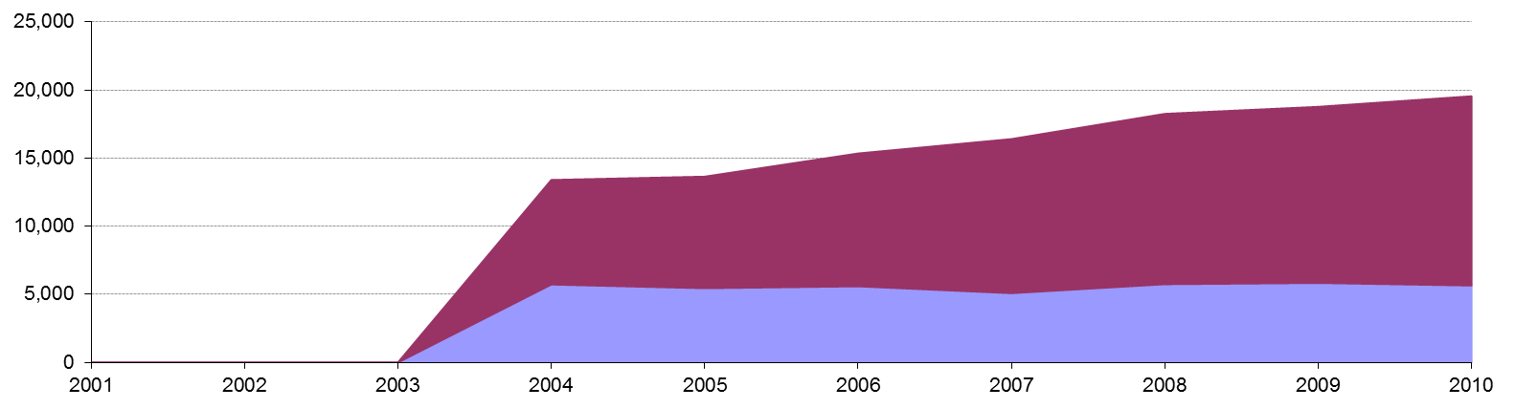
 |  |  |  |  | Petrol |  | Diesel

Statistical Analysis
The charts intended for this section are known as box-plots and they display the distribution of fuel characteristics per Member State by illustrating the:
- Sample minimum
- Lower 25% range
- Middle 50% range
- Median
- Upper 25% range
- Maximum
For a full explanation of the information presented in a Box Plot diagram, please see Appendix 1. Poland has not provided the additional data requested for 2010 to enable greater analysis of reported sample results.

Petrol and Diesel Analysis
There were samples found to be above or below limit values in Poland in 2010 – as shown in Section 24.2.2. However, Poland has not provided the additional detail requested for 2010 reporting to enable further analysis.

Key Areas for Improvement
The following table summarises the main areas in which improvements could be made to the monitoring system, reporting or compliance with Directive limit values. The table includes key recommendations from the previous year to give an assessment of what action has been taken by the Member State to address any issues that may have been highlighted.
Key Areas for Improvement (3 years)
 | Monitoring | Reporting
2010 | - Fuel sales are again over 15 Million tonnes and so Poland should be sampling and reporting as a ‘Large’ country according to EN 14274.  - Consequently, sample numbers for fuels with over 10% market share were low. | - Report not in EC template.  - Additional data requested by the Commission for 2010 has not been provided.  - Test methods used in 2010 have not been confirmed.  - The source of sales data has not been confirmed.
2009 | - Fuel sales are now high enough that Poland should sample as a large country.  - RON 98 represents more than10% of sales so should have been sampled fully. | - Report not in EC template.
2008 | - Data on sulphur-free was estimated and separate analysis wasn’t carried out.  - Sulphur-free fuels were reportedly not labelled at the pump. | - Sulphur-free and low-sulphur grades were reported together.

Portugal

Fuel Availability 2010
The following table lists the fuels that were reported to be available nationally in 2010.
Table 25-1: National fuel grade
Fuel grade | National fuel grade
95=<RON<98 < 10 ppm Sulphur | EuroSuper
RON>=98 < 10 ppm Sulphur | Super Plus
Diesel < 10 ppm Sulphur | Gasóleo

Sales, sampling and reporting
During 2010 fuel sales in Portugal were dominated by diesel fuel sales. Almost 6,000 million litres of diesel was sold in comparison to almost 2,000 petrol fuel sales (all petrol grades combined). Petrol fuel sales were mainly comprised of fuel grade RON 95=<RON<98.
Figure 25-1: Fuel Sales proportions by fuel type
Petrol

Diesel

 | Million Litres
 |  |  | RON=91 |  |  | RON = 95 |  |  | RON 95=<RON<98 |  |  | RON 98 |  |  | Diesel
Table 25-2: Fuel sales and sampling
Fuel type (Parent Grade) | Sales | Sales, | Samples ⁽¹⁾ |  |  | Separate | Param’s measured ⁽⁴⁾ | Add. Notes
Fuel type (Parent Grade) | (Million litres) | % total of fuel type | S | W | TR ⁽²⁾ | S/W⁽³⁾ | Param’s measured ⁽⁴⁾ | Add. Notes
Unleaded 95=<RON<98 | 1,703 | 90.1% | 63 | 55 | - | Yes | All of 18
Unleaded RON>=98 | 187 | 9.9% | 62 | 56 | - | Yes | All of 18
Total Petrol | 1,889 | 100.00% | 125 | 111 | - | Yes | All of 18
Diesel (<10 ppm S) | 5,898 | 100.0% | 59 | 59 | - | Yes | All of 5
Total Diesel | 5,898 | 100.00% | 59 | 59 | - | Yes | All of 5
(1) | Samples |  |  |  | The actual number of samples taken by the Member State in the summer (s) and winter (w) periods
(2) | TR |  |  |  | Total requirement according to EN 14274. Dash (-) denotes National system has been used.
(3) | Separate S & W? |  |  |  | Yes indicates separate summer & winter reporting, and No indicates full year sample results reporting only.
(4) | Parameters measured |  |  |  | Currently 18 petrol parameters should be tested and reported by the Member States and 5 diesel parameters.

Petrol Samples
- Portugal have complied with or exceeded minimum sampling requirements for all petrol fuel grades.

Diesel Samples
- Diesel fuel samples tested in 2010 complied with or exceeded the total minimum requirement.

Fuel Quality Monitoring 2010

Description of System
Responsible organisation(s) | DGEG
Fuel Quality Monitoring System (FQMS) | National system
Country Size | Small
Summer Period | Normal
Location(s) of sampling | Service stations, refineries and terminals
Time/frequency of sampling | Samples have been taken in 10 months throughout the year 2010 and fuel samples taken during transition periods are not included in the FQMS, as defined in EN 14274:2003.
Specification of test methods | Test methods are those specified in Directive 98/70/CE.
Collection of sales data | According to national legislation the companies report their sales to DGEG monthly.
Other details
There are two refineries that supply the market, one of them in the north and the other in the south.
The companies themselves carry out tests, taking samples in refineries and terminals. Samples in retail sites are taken across the country by government authorities and were taken most months across the winter and summer periods. The minimum number of tests established for small countries, (300 tests / year) were taken at service stations. Tests carried out in service stations were tested for all parameters specified in the Directive.
In tests carried out at refineries and terminals the determination of lead content and oxygenates, with the exception of Ethers with>=5 carbon atoms/molecule were not carried out.

Compliance with Fuel Quality Limit Values
Table 25-3: Petrol Fuel Grades
Eurosuper Petrol - Details of samples that exceed tolerance limits:
Parameter | Limit Value | Tolerance Limit* (TL) | Max/Min value of samples tested | No samples outside TL | % samples outside TL
RON | 95 | 94.6 | 94.1 | 3 | 2.54%
Summer vapour pressure, kPa | 60 | 61.8 | 66.8 | 1 | 1.58%
Sulphur content, mg/kg | 10 | 11.6 | 12.8 | 2 | 1.69%
Member State notes
All results for lead content analysis are expressed as < 0.001g/l. For purpose of calculation those values were considered as 0.001g/l, which means that the true minimum and maximum values are less than 0.001g/l. For purpose of calculation all the results of methanol, ethanol and other oxygenates expressed as < 0.10%(v/v) were considered as 0.10%(v/v). That means that the true minimum values are less than 0.10 % (v/v). As defined in EN 14274:2003 fuel samples taken during transition periods are not included in the FQMS.
The marketing of fuels that do not meet the specifications in force constitutes an infraction punishable by fine, which involves reporting to the responsible authority for prosecution.

Super Plus Petrol - Details of samples that exceed tolerance limits:
Parameter | Limit Value | Tolerance Limit* (TL) | Max/Min value of samples tested | No samples outside TL | % samples outside TL
RON | 95 | 94.6 | 94.3 | 4 | 3.38%
Summer vapour pressure, kPa | 60 | 61.8 | 79.2 | 12 | 19.35%
Distillation evaporated at 100ºC, % v/v | 46 | 43.6 | 36.4 | 1 | 0.85%
Aromatics, % v/v | 35 | 36 | 45.0 | 3 | 2.54%
Sulphur content, mg/kg | 10 | 11.6 | 45.9 | 3 | 1.54%
Member State notes
All results for lead content analysis are expressed as < 0.001g/l. For the purposes of calculation those values were considered as 0.001g/l, which means that the true minimum and maximum values are less than 0.001g/l. For purpose of calculation all the results of methanol, ethanol and other oxygenates expressed as < 0.10%(v/v) were considered as 0.10%(v/v). That means that the true minimum values are less than 0.10 %( v/v).
As defined in EN 14274:2003 fuel samples taken during transition periods are not included in the FQMS.
The marketing of fuels that do not meet the specifications in force constitutes an infraction punishable by fine, which involves reporting to the responsible authority for prosecution.

Table 25-4: Diesel Fuel Grades
Diesel - Details of samples that exceed tolerance limits:
Parameter | Limit Value | Tolerance Limit* (TL) | Max/Min value of samples tested | No samples outside TL | % samples outside TL
Cetane number | 51 | 48.5 | 46.4 | 1 | 0.85%
Density at 15ºC, kg/m³ | 845 | 845.7 | 847 | 1 | 0.85%
Sulphur content, mg/kg | 10 | 11.3 | 44.7 | 6 | 5.08%
Member State notes
As defined in EN 14274:2003 fuel samples taken during transition periods are not included in the FQMS.
The marketing of fuels that do not meet the specifications in force constitutes an infraction punishable by fine, which involves reporting to the responsible authority for prosecution.

Temporal Trends
Figure 25-2 shows the trend in total fuel sales since 2001. Diesel sales in Portugal have increased by 3% compared to 2009 sales figures – representing a decrease of 3% since 2001. Petrol fuel sales have reduced by 3% in the period between 2009 and 2010 with an overall reduction of 14% in the period 2001-2010.
Figure 25-2: Temporal trends in national sales of petrol and diesel (million litres)
Sales (million litres)

 |  |  |  |  | Petrol |  | Diesel

Statistical Analysis
The following charts in this section are known as box-plots and they display the distribution of fuel characteristics per Member State by illustrating the:
- Sample minimum
- Lower 25% range
- Middle 50% range
- Median
- Upper 25% range
- Maximum
For a full explanation of the information presented in a Box Plot diagram, please see Appendix 1.

Petrol Analysis
Fuel sampling in Portugal in 2010 recorded relatively few test results out of specification with limits. The analysis charts for petrol (Figure 25-3) and diesel (Figure 25-4) detail the distribution of sample results for the 5 selected parameters;
Petrol:
- Research Octane Number
- Motor Octane Number
- Summer Vapour Pressure
Diesel:
- Density at 15ºC
- Distillation – 95% v/v recovered
Sample results for these parameters have been depicted using box plots based on the reported sample minimum, lower quartile (Q1), median (Q2), upper quartile (Q3), and the maximum sample value.
Sample results in 2010 have been presented in the following figures with limit values for the parameter (maximum or minimum) to demonstrate the skew of sample results. RON and MON sample results show that the fuels available in Portugal have reasonably small variation in Octane levels. Summer Vapour pressure results show some samples exceeding limit values.
Diesel sample results for Density show a slightly wider variation in density, exhibited by the widely spread coloured bands at the 25 and 75 quartile – in comparison to the tight bands shown in the petrol analysis box plots.
Figure 25-3: petrol analysis
 | Research Octane Number
RON | 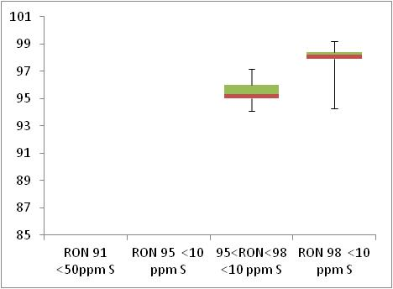  Min 95  Min 91

 | Motor Octane Number
MON | 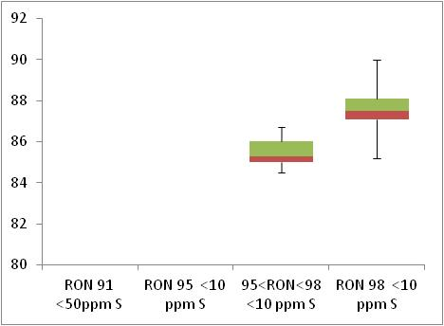  Min 85  Min 81

 | Summer Vapour Pressure (DVPE)
kPa | 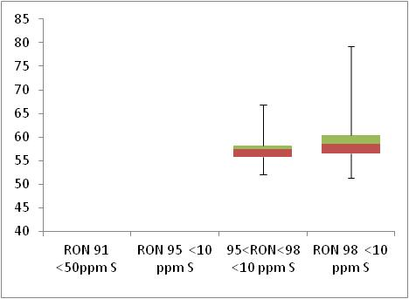  Max 60

Diesel Analysis
Figure 25-4: Diesel analysis
 | Density at 15ºC
Kg/m³ | 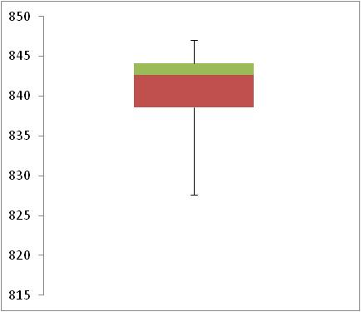  Max 845

 | Distillation – 95% v/v recovered
(⁰C) | 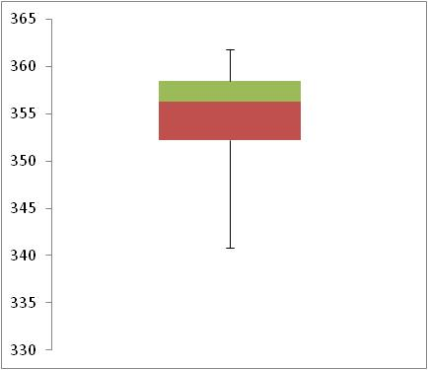  Max 360

Key Areas for Improvement
The following table summarises the main areas in which improvements could be made to the monitoring system, reporting or compliance with Directive limit values. The table includes key recommendations from the previous year to give an assessment of what action has been taken by the Member State to address any issues that may have been highlighted.
Key Areas for Improvement (3 years)
 | Monitoring | Reporting
2010 | - Fuel sales were not provided separated by region. | - The report was submitted after the deadline
2009 | - Sampling improved but still insufficient and too many samples from refineries | - 2 days late
2008 | - National system used while Model is developed  - Insufficient sampling – too many from refineries  - Not all petrol parameters tested | - More detail on samples exceeding limit values could be provided

Romania

Fuel Availability 2010
The following table lists the fuels that were reported to be available nationally in 2010.
Table 26-1: National fuel grade
Fuel grade | National fuel grade
RON 95 < 10 ppm Sulphur | RON 95
RON 98 < 10 ppm Sulphur | RON 98
Diesel < 10 ppm Sulphur | Diesel

Sales, sampling and reporting
During 2010 fuel sales in Romania were dominated by diesel fuel sales. Almost 5,000 million litres of diesel was sold in comparison to 2,000 petrol fuel sales (all petrol grades combined). Petrol fuel sales were mainly comprised of fuel grade RON 95=<RON<98.
Figure 26-1: Fuel Sales proportions by fuel type
Petrol

Diesel

 | Million Litres
 |  |  | RON=91 |  |  | RON = 95 |  |  | RON 95=<RON<98 |  |  | RON 98 |  |  | Diesel
Table 26-2: Fuel sales and sampling
Fuel type (Parent Grade) | Sales | Sales, | Samples ⁽¹⁾ |  |  | Separate | Param’s measured ⁽⁴⁾ | Add. Notes
Fuel type (Parent Grade) | (Million litres) | % total of fuel type | S | W | TR ⁽²⁾ | S/W⁽³⁾ | Param’s measured ⁽⁴⁾ | Add. Notes
Unleaded 95=<RON<98 | 1,274 | 61.6% | 88 | 96 | 200 | Yes | All of 18 | (A)
Unleaded RON>=98 | 793 | 38.4% | 85 | 91 | 200 | Yes | All of 18 | (A)
Total Petrol | 2,067 | 100.00% | 173 | 187 | 400 | Yes | All of 18 | (A)
Diesel (<10 ppm S) | 4,997 | 100.0% | 106 | 104 | 200 | Yes | All of 5
Total Diesel | 4,997 | 100.00% | 106 | 104 | 200 | Yes | All of 5
(1) | Samples |  |  |  | The actual number of samples taken by the Member State in the summer (s) and winter (w) periods
(2) | TR |  |  |  | Total requirement according to EN 14274. Dash (-) denotes National system has been used.
(3) | Separate S & W? |  |  |  | Yes indicates separate summer & winter reporting, and No indicates full year sample results reporting only.
(4) | Parameters measured |  |  |  | Currently 18 petrol parameters should be tested and reported by the Member States and 5 diesel parameters.
(A) |  |  |  |  | The minimum requirements of statistical model B for small countries are 100 samples for both summer and winter periods per fuel grade.

Petrol Samples
- Romania has not taken the required minimum sampling requirements for petrol fuel grades. Statistical model B for small countries requires 100 samples during both summer and winter periods per fuel grade.

Diesel Samples
- Diesel fuel samples tested in 2010 complied with the total minimum requirement.

Fuel Quality Monitoring 2010

Description of System
Responsible organisation(s) | Ministry of Economy, Trade and Business Environment
Fuel Quality Monitoring System (FQMS) | EN 14274 Statistical model B
Country Size | Small
Summer Period | Normal
Location(s) of sampling | Service stations
Time/frequency of sampling | Samples have been taken in three months of both the summer and winter periods for all fuel types.
Specification of test methods | Sampling and analysis of petrol and diesel is carried out by testing laboratories, product certification bodies or third party inspection bodies recognized for this purpose by the Ministry of Economy and Commerce, Recognition is made after a trial assessment, based on the following criteria set forth in Annex 1 of the Order no.742/2004, replaced by Order no.58/2006:  • be accredited for testing, field / certification schemes on the quality of petrol and diesel;  • to have liability insurance;  • To demonstrate its own sampling capability, equipped with appropriate equipment to perform tests according to the methods stipulated in Government Decree amended and supplemented nr.689/2004.
Collection of sales data | The source of 2010 sales data has not been provided.
Other details
To transpose EU legislation, into national legislation Romania adopted the Government Decision no. 689/2004 regarding the establishment of marketing of gasoline and diesel, modified and completed by Government Decision no. 15/2006.
The two Government decisions take full provisions of Directive 98/70/EC on the quality of petrol and diesel and amendments thereto contained in Directive 2003/17/EC.
In applying the provisions of this Decision, the Ministry of Economy, Trade and Business the Environment is responsible for implementing the "qualitative and quantitative monitoring system for petrol and diesel," sold by filling stations, approved by Minister of Economy and Trade through Order no.742/2004, whose annex was replaced by Order no.58/2006.
The monitoring procedure consists of sampling, analysis, verification of compliance condition marketing of petrol and diesel, having as referential SR EN 14275 - torch sampling pumps at filling stations and networks outside the private network stations.
Test methods are mentioned in both petrol and diesel specific standards:
a) SR EN 228 automotive fuels, unleaded petrol, requirements and test methods.
b) SR EN 590 automotive fuels, diesel fuels, requirements and test methods.
According to Order no.58/2006 in the monitoring system of petrol and diesel, work sampling is done at least two bodies.
After evaluating the requests received from organizations, the Ministry of Economy, Trade and Business the Environment recognized SC ROMPETROL SA and SC ROMCONTROL QUALITY CONTROL SRL to perform sampling activities.
The list of organizations recognized for the sampling activity of petrol and diesel is approved by Ministry of Economy and Commerce no.527/2006.
Based on the result as "qualitative and quantitative monitoring system for petrol and diesel" the National Annual Report is prepared. This report which contains information on petrol and diesel quality and the quantity of petrol and diesel sold on previous the year.
Framework for presenting the report is provided by the provisions of the Order of the Minister of Economy and Commerce nr.662/2004 establishing a common format for submission of national annual report concerning fuel quality placed on the market, which fully transposes Decision no.2002/159/EC.
Romania is divided in 8 regions. Samples were taken at filling stations that deliver fuel to private and commercial users; fuel was provided to the stations by oil companies (local, national and international). Therefore samples were taken randomly over the identified regions. Since the total amount of petrol and diesel fuel used in Romania was below 15 million tonnes in 2010, Romania is regarded as a small country (European Standard EN 14274:2003, paragraph 3.2) and due to the lack of sales data per region, Statistical Model B as prescribed in European Standard EN 14274:2003 was applied.

Compliance with Fuel Quality Limit Values
Table 26-3: Petrol Fuel Grades
unleaded petrol (min.95≤ RON<98&<10ppm sulphur) - Details of samples that exceed tolerance limits:
Parameter | Limit Value | Tolerance Limit* (TL) | Max/Min value of samples tested | No samples outside TL | % samples outside T
Sulphur content, mg/kg | 10 | 11.6 | 14 | ? | ?
Member State notes

unleaded petrol (min.95≤ RON<98&<10ppm sulphur) - Details of samples that exceed tolerance limits:
Parameter | Limit Value | Tolerance Limit* (TL) | Max/Min value of samples tested | No samples outside TL | % samples outside T
Summer vapour pressure,  kPa | 60 | 61.8 | 64.4 | ? | ?
Distillation evaporated at 150º | 7 | 72.6 | 70 | 1 | 0.56%
Oxygen content, % m/m | 2.7 | 2.9 | 3.9 | ? | ?
Sulphur content, mg/kg | 10 | 11.6 | 22 | 4 | 2.27%
Member State notes

Table 26-4: Diesel Fuel Grades
Diesel - Details of samples that exceed tolerance limits:
Parameter | Limit Value | Tolerance Limit* (TL) | Max/Min value of samples tested | No samples outside TL | % samples outside TL
Density at 15ºC, kg/m³ | 845 | 845.3 | 854 | 1 | 0.48%
Distillation—95 %-Point, ºC | 360 | 365.9 | 404.6 | 3 | 1.42%
Sulphur content, mg/kg | 10 | 11.3 | 294 | 7 | 3.33%
Member State notes

Temporal Trends
Figure 26-2 shows the trend in total fuel sales since 2006. Diesel sales in Romania have increased by 3% compared to 2009 sales figures – representing an increase in 35% since 2006. Petrol fuel sales have reduced by 6% in the period between 2009 and 2010 with an overall increase of 5% in the period 2006-2010.
Figure 26-2: Temporal trends in national sales of petrol and diesel (million litres)
Sales (million litres)

 |  |  |  |  | Petrol |  | Diesel

Statistical Analysis
The following charts in this section are known as box-plots and they display the distribution of fuel characteristics per Member State by illustrating the:
- Sample minimum
- Lower 25% range
- Middle 50% range
- Median
- Upper 25% range
- Maximum
For a full explanation of the information presented in a Box Plot diagram, please see Appendix 1.

Petrol Analysis
Fuel sampling in Romania in 2010 recorded relatively few test results out of specification with limits. Romania did not complete the statistical results section of the template and hence no statistical analysis charts for petrol are available to detail the distribution of sample results for the 5 selected parameters;
Petrol:
- Research Octane Number
- Motor Octane Number
- Summer Vapour Pressure
Diesel:
- Density at 15ºC
- Distillation – 95% v/v recovered

Diesel Analysis
Insufficient data provided to present statistical analysis of sample monitoring results.

Key Areas for Improvement
The following table summarises the main areas in which improvements could be made to the monitoring system, reporting or compliance with Directive limit values. The table includes key recommendations from the previous year to give an assessment of what action has been taken by the Member State to address any issues that may have been highlighted.
Key Areas for Improvement (3 years)
 | Monitoring | Reporting
2010 | - Did not undertake the minimum sampling requirements for petrol grades.  - Did not provide details of the test method used and the number of samples found to be out of compliance with specifications. | - The statistical analysis section of the template was not completed  - Did not submit their report by the deadline.
2009 | - Average sulphur content > 10ppm thanks to some samples with very high content. MS fined those responsible | - Not in reporting template
2008 | - No information on separate labelling of sulphur-free fuels  - Model A seems more appropriate than Model C  - Insufficient sampling of sulphur-free diesel  - High S content of sulphur-free diesel (apparently, although not reflected in notes on exceedences) | No comment.

Slovakia

Fuel Availability 2010
The following table lists the fuels that were reported to be available nationally in 2010.
Table 27-1: National fuel grade
Fuel grade | National fuel grade
RON 95 < 10 ppm Sulphur | SUPER 95
RON 98 < 10 ppm Sulphur | SUPERPLUS 98
Diesel < 10 ppm Sulphur | DIESEL

Sales, sampling and reporting
During 2010 fuel sales in Slovakia were dominated by diesel fuel sales. Almost 1,200 million litres of diesel was sold in comparison to 800 petrol fuel sales (all petrol grades combined). Petrol fuel sales were mainly comprised of fuel grade RON 95.
Figure 27-1: Fuel Sales proportions by fuel type
Petrol

Diesel

 | Million Litres
 |  |  | RON=91 |  |  | RON = 95 |  |  | RON 95=<RON<98 |  |  | RON 98 |  |  | Diesel
Table 27-2: Fuel sales and sampling
Fuel type (Parent Grade) | Sales | Sales, | Samples ⁽¹⁾ |  |  | Separate | Param’s measured ⁽⁴⁾ | Add. Notes
Fuel type (Parent Grade) | (Million litres) | % total of fuel type | S | W | TR ⁽²⁾ | S/W⁽³⁾ | Param’s measured ⁽⁴⁾ | Add. Notes
Unleaded min. RON=95 | 781 | 97.7% | 68 | 68 | 100 | Yes | All of 18
Unleaded RON>=98 | 19 | 2.3% | 17 | 15 | 3 | Yes | All of 18
Total Petrol | 800 | 100.00% | 85 | 83 | 103 | Yes
Diesel (<10 ppm S) | 1,281 | 100.0% | 68 | 69 | 100 | Yes | All of 5
Total Diesel | 1,281 | 100.00% | 68 | 69 | 100 | Yes
(1) | Samples |  |  |  | The actual number of samples taken by the Member State in the summer (s) and winter (w) periods
(2) | TR |  |  |  | Total requirement according to EN 14274. Dash (-) denotes National system has been used.
(3) | Separate S & W? |  |  |  | Yes indicates separate summer & winter reporting, and No indicates full year sample results reporting only.
(4) | Parameters measured |  |  |  | Currently 18 petrol parameters should be tested and reported by the Member States and 5 diesel parameters.

Petrol Samples
- Slovakia have complied with or exceeded minimum sampling requirements for all petrol fuel grades.

Diesel Samples
- Diesel fuel samples tested in 2010 complied with the total minimum requirement.

Fuel Quality Monitoring 2010

Description of System
Responsible organisation(s) | VURUP, a.s. (Accredited Testing Laboratories & Accredited Inspection Body)
Fuel Quality Monitoring System (FQMS) | EN 14274 Statistical Model C
Country Size | Small
Summer Period | Normal
Location(s) of sampling | Service Stations
Time/frequency of sampling | Sampling takes place in 6 months of the year – during 4 months in winter, and 2 in summer.
Specification of test methods | In addition to the required analyses, the density of each petrol sample had been determined. This data was used for recalculation of the sold litres to tonnes of each petrol grade.
Collection of sales data | The source of sales data for 2010 has not been provided; sales data is available for the full year, only.
Other details
None

Compliance with Fuel Quality Limit Values
Table 27-3: Petrol Fuel Grades
Petrol | Compliant with Directive 98/70/EC
Table 27-4: Diesel Fuel Grades
Diesel - Details of samples that exceed tolerance limits:
Parameter | Limit Value | Tolerance Limit* (TL) | Max/Min value of samples tested | No samples outside TL | % samples outside TL
Distillation – 95-%-Point, ºC | 360 | 365.9 | 387.4 | 5 | 3.6%
Sulphur content, mg/kg | 10 | 11.3 | 35.5 | 2 | 1.4%
Member State notes
Dealers were penalized by the S.I.E for non-compliant samples.

Temporal Trends
Figure 27-2 shows the trend in total fuel sales since 2004. Diesel sales in Slovakia have increased by 30% compared to 2009 sales figures – representing an increase in 103% since 2004. Petrol fuel sales have increased by 4% in the period between 2009 and 2010 with an overall increase of 1% in the period 2004-2010.
Figure 27-2: Temporal trends in national sales of petrol and diesel (million litres)
Sales (million litres)

 |  |  |  |  | Petrol |  | Diesel

Statistical Analysis
The following charts in this section are known as box-plots and they display the distribution of fuel characteristics per Member State by illustrating the:
- Sample minimum
- Lower 25% range
- Middle 50% range
- Median
- Upper 25% range
- Maximum
For a full explanation of the information presented in a Box Plot diagram, please see Appendix 1.

Petrol Analysis
Fuel sampling in Slovakia in 2010 recorded relatively few test results out of specification with limits. The analysis charts for petrol (Figure 27-3) and diesel (Figure 27-4) detail the distribution of sample results for the 5 selected parameters;
Petrol:
- Research Octane Number
- Motor Octane Number
- Summer Vapour Pressure
Diesel:
- Density at 15ºC
- Distillation – 95% v/v recovered
Sample results for these parameters have been depicted using box plots based on the reported sample minimum, lower quartile (Q1), median (Q2), upper quartile (Q3), and the maximum sample value.
Sample results in 2010 have been presented in the following figures with limit values for the parameter (maximum or minimum) to demonstrate the skew of sample results. RON and MON sample results show that the fuels available in Slovakia have reasonably small variation in Octane levels. Summer Vapour pressure results show a wider variation of samples, shown by the widely spread coloured bands.
Diesel sample results for Density show a slightly wider variation in density, exhibited by the widely spread coloured bands at the 25 and 75 quartile – in comparison to the tight bands shown in the petrol analysis box plots.
Figure 27-3: petrol analysis
 | Research Octane Number
RON | 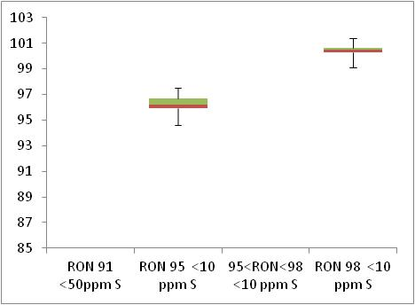  Min 95  Min 91

 | Motor Octane Number
MON | 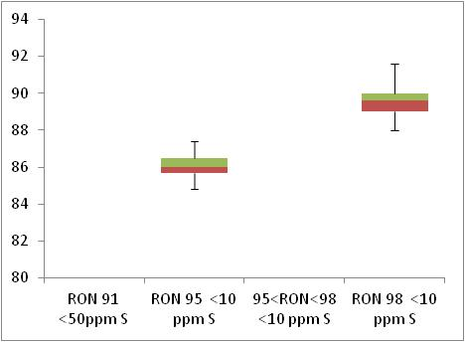  Min 85  Min 81

 | Summer Vapour Pressure (DVPE)
kPa | 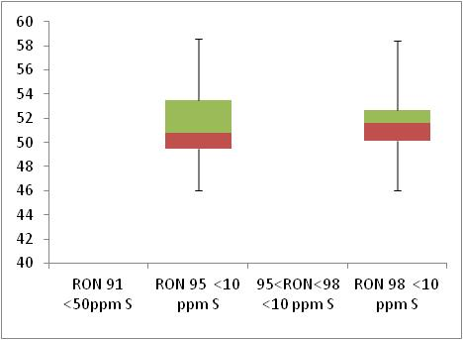  Max 60

Diesel Analysis
Figure 27-4: Diesel analysis
 | Density at 15ºC
Kg/m³ | 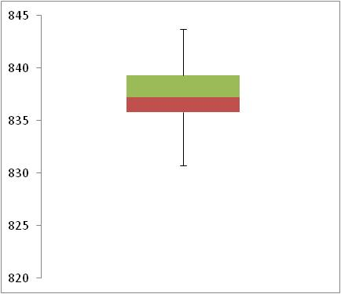  Max 845

 | Distillation – 95% v/v recovered
(⁰C) | 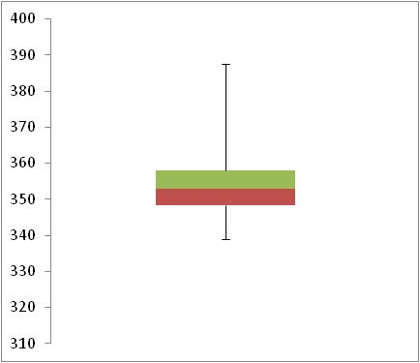  Max 360

Key Areas for Improvement
The following table summarises the main areas in which improvements could be made to the monitoring system, reporting or compliance with Directive limit values. The table includes key recommendations from the previous year to give an assessment of what action has been taken by the Member State to address any issues that may have been highlighted.
Key Areas for Improvement (3 years)
 | Monitoring | Reporting
2010 | - Slovakia uses EN 14274 Model C; however Model A may be more appropriate as outlined in EN 14274.  - No description has been given of why statistical model C is used in preference to Models A (recommended) or B (next preferred Model). | No comment.
2009 | - Average sulphur content was 18ppm due to some samples with v high sulphur content  - Uses Model C but A seems more appropriate. Should provide a justification for using Model C | No comment.
2008 | - No low-sulphur petrol samples, insufficient low-sulphur diesel samples and marginally insufficient sulphur-free diesel samples  - Uses Model C but A seems more appropriate. Should provide a justification for using Model C | No comment.

Slovenia

Fuel Availability 2010
The following table lists the fuels that were reported to be available nationally in 2010.
Table 28-1: National fuel grade
Fuel grade | National fuel grade
95<RON<98 < 10 ppm Sulphur | Unleaded Petrol Super 95 (NMB 95)
RON 98 < 10 ppm Sulphur | Unleaded Petrol Super 98 (NMB 98)
Diesel < 10 ppm Sulphur | Diesel (D-2)

Sales, sampling and reporting
During 2010 fuel sales in Slovenia were dominated by diesel fuel sales. Almost 1,400 million litres of diesel was sold in comparison to less than 800 million litres of petrol fuel sales (all petrol grades combined). Petrol fuel sales were mainly comprised of fuel grade RON 95.
Figure 28-1: Fuel Sales proportions by fuel type
Petrol

Diesel

 | Million Litres
 |  |  | RON=91 |  |  | RON = 95 |  |  | RON 95=<RON<98 |  |  | RON 98 |  |  | Diesel
Table 28-2: Fuel sales and sampling
Fuel type (Parent Grade) | Sales | Sales, | Samples ⁽¹⁾ |  |  | Separate | Param’s measured ⁽⁴⁾ | Add. Notes
Fuel type (Parent Grade) | (Million litres) | % total of fuel type | S | W | TR ⁽²⁾ | S/W⁽³⁾ | Param’s measured ⁽⁴⁾ | Add. Notes
Unleaded min. RON=91 | 0 |  | 0 | 0
Unleaded min. RON=95 | 0 |  | 0 | 0
Unleaded 95=<RON<98 | 660 | 89.3% | 68 | 52 | 100 | Yes | All of 18
Unleaded RON>=98 | 79 | 10.7% | 17 | 12 | 1 | Yes | All of 18 | (a)
Total Petrol | 739 | 100.00% | 85 | 64 | 200 | Yes
Diesel (<10 ppm S) | 1,419 | 100.0% | 84 | 97 | 100 | Yes | All of 5
Total Diesel | 1,419 | 100.00% | 84 | 97 | 100 | Yes
(1) | Samples |  |  |  | The actual number of samples taken by the Member State in the summer (s) and winter (w) periods
(2) | TR |  |  |  | Total requirement according to EN 14274. Dash (-) denotes National system has been used.
(3) | Separate S & W? |  |  |  | Yes indicates separate summer & winter reporting, and No indicates full year sample results reporting only.
(4) | Parameters measured |  |  |  | Currently 18 petrol parameters should be tested and reported by the Member States and 5 diesel parameters.
(a) | Fuel grade Unleaded RON>=98 represents less than 1% market share of fuel sales and so the total minimum requirement has been exceeded.

Petrol Samples
- Slovenia have complied with or exceeded minimum sampling requirements for all petrol fuel grades.

Diesel Samples
- Diesel fuel samples tested in 2010 complied with the total minimum requirement of 50 samples per summer and winter period.

Fuel Quality Monitoring 2010

Description of System
Responsible organisation(s) | Slovenian Environment Agency
Fuel Quality Monitoring System (FQMS) | EN 14274 Statistical Model C
Country Size | Small
Summer Period | Normal
Location(s) of sampling | Service stations
Time/frequency of sampling | Samples have been taken during most months throughout the year.
Specification of test methods | All parameters which are specified in Directives 98/70/EC were analysed in petrol and diesel fuels samples.
Collection of sales data | The sales data have been provided by each individual distributor operating in Slovenia to the Environment Agency of Slovenia.
Other details
The Environment Agency of the Republic of Slovenia receives monthly and annual reports from two independent inspection bodies, which are responsible for preparing the sampling plan, carrying out the sampling and analysis of fuel samples out, and collecting and processing data. They are accredited by the Slovenian Accreditation as an inspection body according to EN ISO/IEC 17020:2004. The analyses of samples are carried out by testing laboratories accredited according to EN ISO/IEC 17025:2005.
Samples of Petrol, Diesel Fuel and Gas Oil are taken each month throughout the year at refuelling stations and depots (total number of samples in 2010: 462).
The test methods were in compliance with the Directive specifications, except for determination of lead and cetane number. Validation and traceability of both methods were provided according to EN ISO/IEC 17025:2005.
All parameters specified in Directives 98/70/EC were analysed in petrol and diesel fuels samples. No exceedence of Directive 98/70/EC limit values were observed for petrol and diesel fuels in 2010. The information on the fuel quality monitoring was delivered to the Inspectorate of the Environment and Spatial Planning of the Republic of Slovenia monthly. According to the national legislation which transposes the Directive 98/70/EC, and was amended in June 2006, the distributors would be penalised in case of any exceedence.

Compliance with Fuel Quality Limit Values
Table 28-3: Petrol Fuel Grades
Petrol | Compliant with Directive 98/70/EC
Table 28-4: Diesel Fuel Grades
Diesel | Compliant with Directive 98/70/EC

Temporal Trends
Figure 28-2 shows the trend in total fuel sales since 2004. Diesel sales in Slovenia have increased by 6% compared to 2009 sales figures – representing an increase in 59% since 2004. Petrol fuel sales have reduced by 8% in the period between 2009 and 2010 with an overall reduction of 18% in the period 2004-2010.
Figure 28-2: Temporal trends in national sales of petrol and diesel (million litres)
Sales (million litres) | 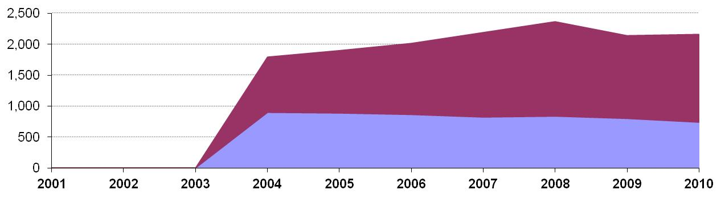
 |  |  |  |  | Petrol |  | Diesel

Statistical Analysis
The following charts in this section are known as box-plots and they display the distribution of fuel characteristics per Member State by illustrating the:
- Sample minimum
- Lower 25% range
- Middle 50% range
- Median
- Upper 25% range
- Maximum
For a full explanation of the information presented in a Box Plot diagram, please see Appendix 1.

Petrol and Diesel Analysis
Fuel sampling in Slovenia in 2010 recorded relatively few test results out of specification with tolerance limits, however there were samples found to be above or below limit values. Slovenia has not provided the additional detail requested for 2010 reporting to enable further analysis.

Key Areas for Improvement
The following table summarises the main areas in which improvements could be made to the monitoring system, reporting or compliance with Directive limit values. The table includes key recommendations from the previous year to give an assessment of what action has been taken by the Member State to address any issues that may have been highlighted.
Key Areas for Improvement (3 years)
 | Monitoring | Reporting
2010 | No comment | - Slovenia has not provided additional detail requested about parameter sample group results. This has been explained as a result of old versions of the reporting template having been used by monitoring bodies for 2010.  - Sample quantities in the sales data sheet do not match completely those reported in the parameter results tables of the reporting template.
2009 | - Different methods used for testing lead and cetane number.  - RON 98 just exceeded 10% so should have been fully sampled.  - Model C appears to have been used but this has not been stated or justified. | - 1 day late and not submitted as specified.
2008 | - Different methods used for testing 95% distillation point and cetane number. | - Insufficient information on the number of samples exceeding limit values in each grade.

Spain

Fuel Availability 2010
The following table lists the fuels that were reported to be available nationally in 2010.
Table 29-1: National fuel grade
Fuel grade | National fuel grade
RON 95 < 10 ppm Sulphur | Gasolina IO95
RON 98 < 10 ppm Sulphur | Gasolina IO98
Diesel < 10 ppm Sulphur | Gasóleo automoción

Sales, sampling and reporting
During 2010 fuel sales in Spain were heavily dominated by diesel fuel sales. Over 80% of fuel sales were diesel sales with over 31,500 million litres of diesel sold in comparison to 7,600 million litres of petrol fuel sales (all petrol grades combined). Petrol fuel sales were mainly comprised of fuel grade RON 95 with just less than 10% of petrol fuels ales of RON 98 (9.98%).
Figure 29-1: Fuel Sales proportions by fuel type
Petrol

Diesel

 | Million Litres
 |  |  | RON=91 |  |  | RON = 95 |  |  | RON 95=<RON<98 |  |  | RON 98 |  |  | Diesel

Table 29-2: Fuel sales and sampling
Fuel type (Parent Grade) | Sales | Sales, | Samples ⁽¹⁾ |  |  | Separate | Param’s measured ⁽⁴⁾ | Add. Notes
Fuel type (Parent Grade) | (Million litres) | % total of fuel type | S | W | TR ⁽²⁾ | S/W⁽³⁾ | Param’s measured ⁽⁴⁾ | Add. Notes
Unleaded min. RON=95 | 6,908 | 90.0% | 99 | 165 | - | Yes | All of 18
Unleaded RON>=98 | 766 | 10.0% | 96 | 160 | - | Yes | All of 18
Total Petrol | 7,674 | 100.00% | 195 | 325 | - | Yes
Diesel (<10 ppm S) | 31,540 | 100.0% | 99 | 165 | - | Yes | All of 5
Total Diesel | 31,540 | 100.00% | 99 | 165 | - | Yes
(1) | Samples |  |  |  | The actual number of samples taken by the Member State in the summer (s) and winter (w) periods
(2) | TR |  |  |  | Total requirement according to EN 14274. Dash (-) denotes National system has been used.
(3) | Separate S & W? |  |  |  | Yes indicates separate summer & winter reporting, and No indicates full year sample results reporting only.
(4) | Parameters measured |  |  |  | Currently 18 petrol parameters should be tested and reported by the Member States and 5 diesel parameters.
(a) | Add. Notes |  |  |  | Additional information provided by the Member State in relation to table contents.

Petrol Samples
- Spain have sampled insufficiently in summer periods for a country with fuel sales of more than 15 million tonnes per year (classified as a ‘large’ country in international standard EN 14274). 99 samples of RON 95 and 96 samples of RON 98 have been taken by Spain during the summer period. For a large country using a National System, the minimum number of samples to be taken in each reporting period (summer and winter) should meet equivalence to the statistical models outlined in EN 14274; 100 samples. A minimum quantity of 100 samples is specified in EN 14274 for summer and winter. It was a mistake in the procedure. Nevertheless, for 2011 the minimum quantity of samples will be reported. Spain also notes that their summer reporting period account for 5 months of the year and the winter period is 7 months.
- Samples taken during winter months exceed the minimum requirement.
- According the Standard UNE EN 14274 ( Point 1), Spain do not sample during the transitional months; during which time fuels at service stations are substituted for the winter or summer grade fuel.

Diesel Samples
- Similarly to petrol fuel sampling, Spain has not taken sufficient diesel samples in the summer period to demonstrate equivalence with EN 14274 statistical model requirements. A minimum quantity of 100 samples is specified in EN 14274 for summer and winter. It was a mistake in the sampling procedure. For 2011 the minimum quantity of samples will be reported by Spain. In Spain the summer period is for 5 months and the winter period is for 7 months.
- Samples taken during winter months exceed the minimum requirement.
- According the Standard UNE EN 14274 in point 1, Spain do not sample during the transitional months; during which time fuels at service stations are substituted for the winter or summer grade fuel.

Fuel Quality Monitoring 2010

Description of System
Responsible organisation(s) | Directorate General for Energy Policy and Mines and the Ministry of Industry, Tourism and Trade
Fuel Quality Monitoring System (FQMS) | Spain use a National system that is similar to Model A in EN 14274. The country is divided in micro region supplied from the same terminal and then macro regions composed of a number of the micro regions. The determination of the “variability factor” (point 3.9 in EN 14274) is difficult in most regions because logistics in Spain connect most of them, allowing transfer of product from one region to other.  For 2011 Spain can provide the schedule of samples taken per macro region.
Country Size | Large
Summer Period | Normal (
Location(s) of sampling | A breakdown of sampling locations has not been provided. It is impossible to determine whether an appropriate number of samples have been taken from service stations.  Due the characteristics of logistic Spanish system the sample test in service stations can be considered equivalent.
Time/frequency of sampling | According the Standard UNE EN 14274 in point 1, an even spread of samples have been taken throughout the year. Spain does not sample during the transition months (when winter and summer fuel grades are substituted according to season.).
Specification of test methods | Testing has been carried out according to EN 590 (diesel) and EN 228 (petrol) test methods.
Collection of sales data | Sales data is collected from market operators according with a legal Spanish rule (Resolución de la Dirección general de Política Energética y Minas de 9de mayo de 2007 (BOE de 29 de junio).  Data is published on a monthly and annual basis by CORES (www.cores.es).
Other details

Compliance with Fuel Quality Limit Values
Table 29-3: Petrol Fuel Grades
Gasolina IO98 – Details of samples that exceed tolerance limits:
Parameter | Limit Value | Tolerance Limit* (TL) | Max/Min value of samples tested | No samples outside TL | % samples outside TL
Ethers % (v/v) | 15 | 15.6 | 16 | 6 | 4
Member State notes
Sample out of compliance in winter period.
Royal Decree 1088/2010 (4 September 2010) established a limit of 22 % ethers % according with Directive 2009/30/CE.

Table 29-4: Diesel Fuel Grades
Diesel - Details of samples that exceed tolerance limits:
No samples exceeded the minimum or maximum tolerance limits for diesel.

Temporal Trends
Figure 29-2 shows the trend in total fuel sales since 2001. Diesel sales in Spain have increased by 3,382 million litres (12%) compared to 2009 sales figures (diesel fuel sales bucked a rising trend in 2009 with a reduction of just over 1,500 million litres compared to the previous year). This figure represents an overall increase of 46% in the period since 2001. Petrol fuel sales have decreased by 6% in the period between 2009 and 2010 with an overall reduction of 33% in the period 2001-2010.
Figure 29-2: Temporal trends in national sales of petrol and diesel (million litres)
Sales (million litres)

 |  |  |  |  | Petrol |  | Diesel

Statistical Analysis
The charts intended for this section are known as box-plots and they display the distribution of fuel characteristics per Member State by illustrating the:
- Sample minimum
- Lower 25% range
- Middle 50% range
- Median
- Upper 25% range
- Maximum
For a full explanation of the information presented in a Box Plot diagram, please see Appendix 1. Spain has not provided the additional data requested for 2010 to enable greater analysis of reported sample results.

Petrol and Diesel Analysis
There were samples found to be above or below limit values in Spain during 2010 – as shown in Section 29.2.2. However, additional detail requested for 2010 has not been provided.

Key Areas for Improvement
The following table summarises the main areas in which improvements could be made to the monitoring system, reporting or compliance with Directive limit values. The table includes key recommendations from the previous year to give an assessment of what action has been taken by the Member State to address any issues that may have been highlighted.
Key Areas for Improvement (3 years)
 | Monitoring | Reporting
2010 | - Samples numbers in each summer and winter period should demonstrate equivalence with samples required for a large country in EN 14274; a minimum of 100 samples from service stations per summer period and per winter period. Summer sampling in Spain is less than 100.  - Spain has not confirmed the location from which samples have been taken in 2010. International Standard EN 14274 gives the minimum number of fuel dispensing sites to be sampled. Any terminal and refinery sampling must be carried out in addition to samples at point of use (service stations). As Spain has not provided sample location; it is impossible to determine sample compliance. | - The 2010 report was submitted after the official report submission deadline of 30th June 2011.  - The 2010 Spanish report was initially submitted by Fax and not as an electronic copy.  - The report was submitted in a National format and not using the EU approved reporting template.  - Additional detail requested to enable statistical analysis of results has not been provided for 2010.
2009 | - Use a national system and have not reported equivalence  - Sample numbers low for a large country, especially given some sampling at refineries | - Report submitted 1 week late and with some information gaps
2008 | - Use a national system and have not reported equivalence  - Sample numbers low for a large country, especially given some sampling at refineries | - Diesel fuel sales are combined but samples are separate making it difficult to calculate average S content  - 4 months late

Sweden

Fuel Availability 2010
The following table lists the fuels that were reported to be available nationally in 2010.
Table 30-1: National fuel grade
Fuel grade | National fuel grade
RON 95 < 10 ppm Sulphur | Class 1 unleaded petrol 95 octane
RON 98 < 10 ppm Sulphur | Class 1 unleaded petrol 98 octane
Diesel < 10 ppm Sulphur | Diesel

Sales, sampling and reporting
During 2010 fuel sales in Sweden were dominated by diesel fuel sales. More than 5,000 million litres of diesel was sold in comparison to 4,500 petrol fuel sales (all petrol grades combined). Petrol fuel sales were mainly comprised of fuel grade RON 95.
Figure 30-1: Fuel Sales proportions by fuel type
Petrol

Diesel

 | Million Litres
 |  |  | RON=91 |  |  | RON = 95 |  |  | RON 95=<RON<98 |  |  | RON 98 |  |  | Diesel
Table 30-2: Fuel sales and sampling
Fuel type (Parent Grade) | Sales | Sales, | Samples ⁽¹⁾ |  |  | Separate | Param’s measured ⁽⁴⁾ | Add. Notes
Fuel type (Parent Grade) | (Million litres) | % total of fuel type | S | W | TR ⁽²⁾ | S/W⁽³⁾ | Param’s measured ⁽⁴⁾ | Add. Notes
Unleaded min. RON=95 | 4,394 | 96.9% | 303 | 160 | - | Yes | 11 of 18
Unleaded RON>=98 | 138 | 3.1% | 72 | 18 | - | Yes | 12 of 18
Total Petrol | 4,533 | 100.0% | 375 | 178 | - | Yes
Diesel (<10 ppm S) | 5,164 | 100.0% | 620 | 0 | - | No | All of 5
Total Diesel | 5,164 | 100.0% | 620 | 0 | - | No | All of 5
(1) | Samples |  |  |  | The actual number of samples taken by the Member State in the summer (s) and winter (w) periods
(2) | TR |  |  |  | Total requirement according to EN 14274. Dash (-) denotes National system has been used.
(3) | Separate S & W? |  |  |  | Yes indicates separate summer & winter reporting, and No indicates full year sample results reporting only.
(4) | Parameters measured |  |  |  | Currently 18 petrol parameters should be tested and reported by the Member States and 5 diesel parameters.

Petrol Samples
- Sweden did not sample the required number of parameters for all petrol fuel grades. RON 95 measurements were not taken for Oxygen content and all oxygenates (except Ethers and the ethanol sample quantity is unknown). RON 98 measurements were not taken for oxygenates (expect Ethers).

Diesel Samples
- Diesel was sampled for all parameters in 2010 however, there was no winter testing.

Fuel Quality Monitoring 2010

Description of System
Responsible organisation(s) | The Swedish Petroleum Institute
Fuel Quality Monitoring System (FQMS) | National System
Country Size | Small
Summer Period | Arctic
Location(s) of sampling | Terminals
Time/frequency of sampling | Sampling has been carried out in both the summer and winter periods, however no detail about the frequency of sampling has been provided by Sweden.
Specification of test methods | No details have been provided.
Collection of sales data | No details have been provided.
Other details
In Sweden, Ethanol is added at the gantry to petrol but also at refineries. Therefore the DVPE is a mix of both with and without ethanol. The addition of ethanol of up to 5% increases the DVPE with approximately 7 kPa. The oxygen content of the fuel is not available.
Diesel fuel sales include off road diesel use. Sweden has the same diesel fuel on road as off road.
For diesel sampling, Cetane index is reported rather than cetane number and so the Minimum limit value for cetane index is considered to be 50. The definition for PAH is tri aromatic and heavier. Therefore the values measured are not in line with the PAH limits in the FQD.

Compliance with Fuel Quality Limit Values
Table 30-3: Petrol Fuel Grades
RON 95 | Compliant with Directive 98/70/EC
RON 98 | Compliant with Directive 98/70/EC
Table 30-4: Diesel Fuel Grades
Diesel | Compliant with Directive 98/70/EC

Temporal Trends
Figure 30-2 shows the trend in total fuel sales since 2001. Diesel sales in Sweden have increased by 8% compared to 2009 sales figures – representing an increase in 45% since 2001. Petrol fuel sales have reduced by 6% in the period between 2009 and 2010 with an overall reduction of 16% in the period 2001-2010.
Figure 30-2: Temporal trends in national sales of petrol and diesel (million litres)
Sales (million litres)

 |  |  |  |  | Petrol |  | Diesel

Statistical Analysis
The following charts in this section are known as box-plots and they display the distribution of fuel characteristics per Member State by illustrating the:
- Sample minimum
- Lower 25% range
- Middle 50% range
- Median
- Upper 25% range
- Maximum
For a full explanation of the information presented in a Box Plot diagram, please see Appendix 1.

Petrol Analysis
Fuel sampling in Sweden in 2010 recorded relatively few test results out of specification with limits. Sweden did not provide a completed set of statistical results for any of the parameters for all petrol and diesel grades, this means that the analysis charts for petrol which detail the distribution of sample results for the 5 selected parameters could not be compiled;
Petrol:
- Research Octane Number
- Motor Octane Number
- Summer Vapour Pressure
Diesel:
- Density at 15ºC
- Distillation – 95% v/v recovered

Diesel Analysis
Insufficient data provided to present statistical analysis of sample monitoring results.

Key Areas for Improvement
The following table summarises the main areas in which improvements could be made to the monitoring system, reporting or compliance with Directive limit values. The table includes key recommendations from the previous year to give an assessment of what action has been taken by the Member State to address any issues that may have been highlighted.
Key Areas for Improvement (3 years)
 | Monitoring | Reporting
2010 | - Analytical and statistical results tables not completed for petrol and diesel grades, so no statistical analysis able to be undertaken.  - No split of sales by region provided.  - Diesel grade not sampled in winter.  - Samples taken at terminals and not fuel stations.  - Not all petrol parameters sampled. | - Frequency of sampling per month is not reported.  - No details provided on specification of test methods.  - No details provided on source of sales data.
2009 | - Sweden uses a system which samples every batch from refineries and import to terminals but does sample at fuel stations. Therefore fuel may get contaminated between the refinery and point of sale. | - Frequency of sampling per month is not reported.
2008 | - All sampling carried out at refineries. | - Frequency of sampling per month is not reported.

UK

Fuel Availability 2010
The following table lists the fuels that were reported to be available nationally in 2010.
Table 31-1: National fuel grade
Fuel grade | National fuel grade
RON 95 < 10 ppm Sulphur | Premium Unleaded Petrol
RON 98 < 10 ppm Sulphur | Super unleaded Petrol
Diesel < 10 ppm Sulphur | Diesel

Sales, sampling and reporting
During 2010 fuel sales in UK were dominated by diesel fuel sales. Almost 25,000 million litres of diesel was sold in comparison 20,000 petrol fuel sales (all petrol grades combined). Petrol fuel sales were mainly comprised of fuel grade RON 95.
Figure 31-1: Fuel Sales proportions by fuel type
Petrol

Diesel

 | Million Litres
 |  |  | RON=91 |  |  | RON = 95 |  |  | RON 95=<RON<98 |  |  | RON 98 |  |  | Diesel
Table 31-2: Fuel sales and sampling
Fuel type (Parent Grade) | Sales | Sales, | Samples ⁽¹⁾ |  |  | Separate | Param’s measured ⁽⁴⁾ | Add. Notes
Fuel type (Parent Grade) | (Million litres) | % total of fuel type | S | W | TR ⁽²⁾ | S/W⁽³⁾ | Param’s measured ⁽⁴⁾ | Add. Notes
Unleaded min. RON=95 | 19,444 | 95.3% | 0 | 0 | - | No | All of 18 | (A)
Unleaded 95=<RON<98 | 953 | 4.7% | 0 | 0 | - | No | 14 of 18 | (A)
Total Petrol | 20,396 | 100.00% | 2195 | 0 | - | No | All of 18 | (A)
Diesel (<10 ppm S) | 24,876 | 100.0% | 0 | 0 | - | No | All of 5 | (A)
Total Diesel | 24,876 | 100.00% | 2428 | 0 | - | No | All of 5 | (A)
(1) | Samples |  |  |  | The actual number of samples taken by the Member State in the summer (s) and winter (w) periods
(2) | TR |  |  |  | Total requirement according to EN 14274. Dash (-) denotes National system has been used.
(3) | Separate S & W? |  |  |  | Yes indicates separate summer & winter reporting, and No indicates full year sample results reporting only.
(4) | Parameters measured |  |  |  | Currently 18 petrol parameters should be tested and reported by the Member States and 5 diesel parameters.
(A) |  |  |  |  | No breakdown of summer and winter sampling provided.

Petrol Samples
- The UK has exceeded the minimum sampling requirements for all petrol fuel grades. They have not measured all of the 18 petrol parameters for RON 95. The following have been missed out: Methanol, Iso-propyl alcohol, tert-butyl alcohol, Iso-Butyl alcohol.

Diesel Samples
- Diesel fuel samples tested in 2010 complied with the total minimum requirement.

Fuel Quality Monitoring 2010

Description of System
Responsible organisation(s) | Department of Energy and Climate Change (DECC)
Fuel Quality Monitoring System (FQMS) | National system.
Country Size | Large
Summer Period | Arctic
Location(s) of sampling | The UK fuel quality monitoring system makes use of industry quality analyses on every batch of fuel produced in, or imported into, the UK, plus samples taken at distribution terminals and forecourts (to check for contamination in the distribution network). A breakdown of samples by location has not been provided in 2010.
Time/frequency of sampling | Samples have been taken every month throughout the year.
Specification of test methods | A very large number of samples are taken in the UK and tests are carried out making use of industry quality analysis.
Collection of sales data | The source of sales data in the United Kingdom is DECC Energy Statistics data.
Other details

Compliance with Fuel Quality Limit Values
Table 31-3: Petrol Fuel Grades
Premium Unleaded Petrol - Details of samples that exceed tolerance limits:
Parameter | Limit Value | Tolerance Limit* (TL) | Max/Min value of samples tested | No samples outside TL | % samples outside TL
RON | 95 | 94.6 | 94.5 | 1 | 0.05%
Aromatics, % v/v | 35 | 37.2 | 37.6 | 1 | 0.05%
Ethanol, % v/v | 5 | 5.2 | 5.47 | 2 | 0.3%
Member State notes
Samples taken from service stations.

Super Unleaded Petrol - Details of samples that exceed tolerance limits:
Parameter | Limit Value | Tolerance Limit* (TL) | Max/Min value of samples tested | No samples outside TL | % samples outside TL
Aromatics, % v/v | 35 | 37.2 | 41.6 | 1 | 0.5%
Member State notes
Sample taken at a service station.

Table 31-4: Diesel Fuel Grades
Diesel | Compliant with Directive 98/70/EC

Temporal Trends
Figure 31-2 shows the trend in total fuel sales since 2001. Diesel sales in the UK have increased by 4% compared to 2009 sales figures – representing an increase in 26% since 2001. Petrol fuel sales have reduced by 6% in the period between 2009 and 2010 with an overall reduction of 28% in the period 2001-2010.
Figure 31-2: Temporal trends in national sales of petrol and diesel (million litres)
Sales (million litres)

 |  |  |  |  | Petrol |  | Diesel

Statistical Analysis
The following charts in this section are known as box-plots and they display the distribution of fuel characteristics per Member State by illustrating the:
- Sample minimum
- Lower 25% range
- Middle 50% range
- Median
- Upper 25% range
- Maximum
For a full explanation of the information presented in a Box Plot diagram, please see Appendix 1.

Petrol Analysis
Fuel sampling in the UK in 2010 recorded relatively few test results out of specification with limits. The analysis charts for petrol (Figure 31-3) and diesel (Figure 31-4) detail the distribution of sample results for the 5 selected parameters;
Petrol:
- Research Octane Number
- Motor Octane Number
- Summer Vapour Pressure
Diesel:
- Density at 15ºC
- Distillation – 95% v/v recovered
Sample results for these parameters have been depicted using box plots based on the reported sample minimum, lower quartile (Q1), median (Q2), upper quartile (Q3), and the maximum sample value.
Sample results in 2010 have been presented in the following figures with limit values for the parameter (maximum or minimum) to demonstrate the skew of sample results. RON and MON sample results show that the fuels available in the UK have reasonably small variation in Octane levels. The Limit value for Summer Vapour pressure in the UK because the UK is classified as having an arctic summer, the results show that the samples were found to be tighter to the specifications of the Fuel Quality Directive but still within specification.
Diesel sample results for Density show a slightly wider variation in density, exhibited by the widely spread coloured bands at the 25 and 75 quartile – in comparison to the tight bands shown in the petrol analysis box plots.
Figure 31-3: petrol analysis
 | Research Octane Number
RON | 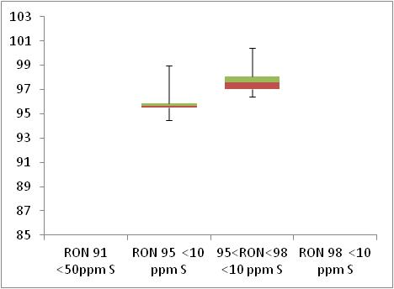  Min 95  Min 91

 | Motor Octane Number
MON | 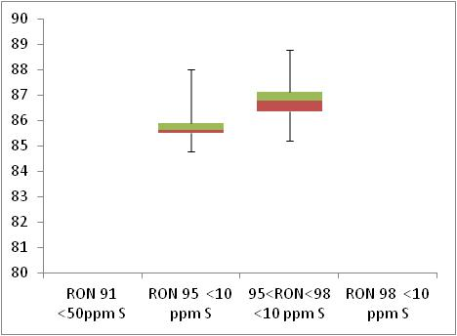  Min 85  Min 81

 | Summer Vapour Pressure (DVPE)
kPa | 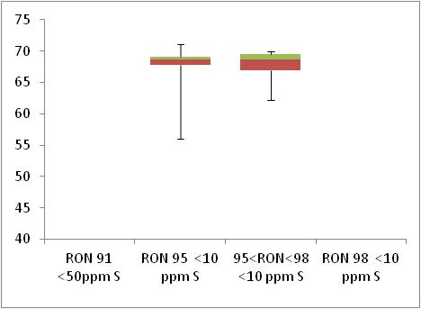  Max 70

Diesel Analysis
Figure 31-4: Diesel analysis
 | Density at 15ºC
Kg/m³ | 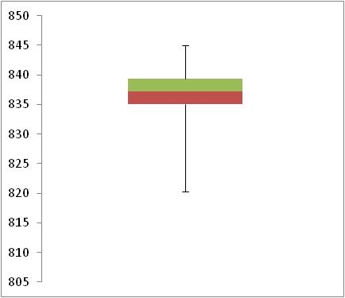  Max 845

 | Distillation – 95% v/v recovered
(⁰C) | 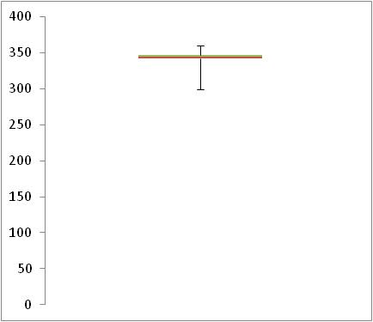  Max 360

Key Areas for Improvement
The following table summarises the main areas in which improvements could be made to the monitoring system, reporting or compliance with Directive limit values. The table includes key recommendations from the previous year to give an assessment of what action has been taken by the Member State to address any issues that may have been highlighted.
Key Areas for Improvement (3 years)
 | Monitoring | Reporting
2010 | - A national system is used based on industry quality analysis of all fuels from refineries and import terminals and samples at fuel stations. However, no detail is given on the split of samples taken so can not determine if sampling at fuel stations is sufficient  - No breakdown of sales by regional.  - Only 14 of 18 petrol parameters tested for RON 95. | - Do not report summer winter sampling split
2009 | - A national system is used based on industry quality analysis of all fuels from refineries and import terminals and samples at fuel stations. However, no detail is given on the split of samples taken so can not determine if sampling at fuel stations is sufficient  - Only 12 of 18 petrol parameters tested | - 1 day late  - Do not report summer winter sampling split
2008 | - National system with lots of samples but no proof of statistical equivalence  - Only 12 of 18 petrol parameters tested | - No separate summer and winter report  - >3 months late

Discussion and Conclusion

Discussion
Key Messages
- Consistency of reporting is key to enable accurate temporal and national comparisons of fuel quality within the Community.
- Clear guidelines and a common format is required in order to ensure reporting obligations and timelines are understood and can be met.

Reporting Submissions

Completeness
The original format for reporting Fuel Quality Monitoring was agreed with Member States was officially established with 'Commission Decision 2002/159/EC of 18 February 2002 on the common format for the submission of summaries of national fuel quality data'. This document specified that the first report be submitted to the European Commission by 30 June 2002 in both paper and electronic formats and this requirement remains in place. A reporting template has been developed using Microsoft Excel in order to facilitate analysis, ensure rapid assessment of the data and reduce the need to seek clarification from Member States. The Microsoft Excel template is appropriate for the numerical data contained within the report – with provision made for explanatory sections.
The completeness of submissions has improved over time. The majority of Member States now meet the deadline on 30 June and submit their reports in electronic format – 23 Member States submitted their report in the dedicated 2010 template. Delays to the analysis can be caused if insufficient data is supplied, however this problem is minimised through use of the recommended reporting template.

Fuel Quality Submission Database
In addition to the preparation of this summary report, a Microsoft Access database is updated annually and contains the raw data and essential information provided by Member States. From 2010 onwards, the database has been further updated to make it more user-friendly. The database has been constructed to allow for easy selection of fields, storage/viewing of submission data, printable reports including, full reported data sets, as well as Member State and EU Summary Reports with a degree of basic analysis and graphical presentation of results and trends.

Reporting Format
Changes to the 2010 reporting template have increased the number of queries from Member States. Enquiries have related to how to copy and paste information into the spreadsheets to how to calculate the 25% and 75% datasets to provide the additional information requested. In 2010, the template has been locked to prevent re-structuring or formatting of the data presented by Member States. In previous years this had led to issues whereby additional parameters had been included – or even parameters reported in place of those required by the Directive – skewing the parameter results. On the whole, the approach has been effective, with far fewer inconsistencies and a more fluid analysis process. In addition, fewer clarifications have been necessary as the majority of Member States have provided the full information requested.
From 2011, additional parameters will be incorporated into the current FQM reporting processes. It is apparent that clear guidelines on the reporting requirements and a recommended and specially designed template will ease reporting and subsequently the analysis and incorporation of new data into the EU Summary report.
Many reports have improved in terms of quality, accuracy and consistency in the period since reporting began. However further improvements could still be made and would be aided by the provision of a clear and updated decision on the common formats of Member States FQM reports.

Conclusions and Recommendations
It is difficult to draw definitive conclusions from the data given that temporal trends are subject to reports that have been missing over the years. In addition, a lack of clarity on how to treat particular areas (such as the transition period) creates inconsistencies between the Member State reports. In addition, the trends observed within National territories may be amplified or disguised when aggregating the data into EU-wide summaries – this could be aided by a requirement for Member States to provide an assessment of changes to conditions within their National territory. For example, in 2010, some Member States have bucked a historical trend of declining fuel sales (or vice versa) and the National assessment of why these changes occur could help to understand Community-wide patterns.
Member States have responded to and complied with the reduction in Sulphur content throughout the Community with an EU-wide average for petrol and diesel well below the mandatory limits (5.8 ppm and 6.5 ppm, respectively). The timescales involved in this transition to sulphur free fuels enable most Member States to comply fully with requirements in 2009 (the first year of reduced mandatory limit) and all Member States have complied in 2010.
There are still some key areas to improve upon in future years and these will be monitored annually to further enhance the reliability of EU wide summary data.
Key areas for improvement
- Member States should submit an electronic copy of their National report to ENV-Report-98-70@ec.europa.eu .
- Accurate data should be provided in the FQM report by 30th June, annually.
- Many Member States do not provide regional data when it would be appropriate.
- Member States are encouraged to provide their annual FQM report in the dedicated template provided to assist with the timely analysis and reporting of EU-wide results.
- Treatment of data affected by transition periods should be clearer.
- Monitoring and consistency with EN 14274 standards;
  - Selection of the most appropriate monitoring model – or a detailed rationale for the National system chosen could be improved by many Member States.
  - Any sampling from terminals/ refineries should be taken and reported in addition to those at service stations.
  - Some Member States still sample in insufficient quantities.
  - Provision of supporting information (where appropriate) will help to ensure accurate analysis of the reports.

Glossary
<10 ppm fuels | See sulphur-free fuels
‘Arctic’ Seasonal Period | Seasonal period as outlined in European Specifications relating to countries that experience low ambient summer temperatures and for which the summer period spans 1st June to 31st August.
Cetane Number | Measure of fuel ignition characteristics. Like the octane number used for petrol, the higher the value, the better the fuel performance.
Commission Decision 2002/159/EC | Commission Decision of 18 February 2002 on a common format for the submission of summaries of national fuel quality data
Commission Recommendation 2005/27/EC | of 12 January 2005 on what, for the purposes of Directive 98/70/EC of the European Parliament and of the Council concerning petrol and diesel fuels, constitutes availability of unleaded petrol and diesel fuel with a maximum sulphur content on an appropriately balanced geographical basis
Directive 98/70/EC | of 13 October 1998 relating to the quality of petrol and diesel fuels and amending Council Directive 93/12/EEC
Directive 2003/17/EC | of 3 March 2003 amending Directive 98/70/EC relating to the quality of petrol and diesel fuels
EN 14274: 2003 | Automotive fuels - Assessment of petrol and diesel quality - Fuel Quality Monitoring System (FQMS)
EN 228 | European Standard EN 228:2004 which specifies requirements and test methods and limits for petrol fuel parameters.
EN 590 | European Standard EN 590:2004 which specifies requirements and test methods and limits for diesel fuel parameters.
Euro standards | European Union emission regulations for new vehicles, e.g. Euro 3
Fuel Dispensing Sites | See refuelling stations.
FQMS | Fuel Quality Monitoring System
Large-size country | Country in which a total of 15 million tons or more of automotive fuel is dispensed per annum.
Low Sulphur Fuels | Petrol and diesel fuels that contain less than 50 mg/kg (ppm) of sulphur.
MON | Motor Octane Number (petrol vehicles, related to RON)
National fuel grade | Member States may, define ‘national’ fuel grades that must still, however, respect the specification of the parent fuel grade. For example, national fuel grades may comprise super unleaded petrol (RON > 98), lead replacement petrol, zero sulphur petrol, <50 ppm sulphur petrol, zero sulphur diesel, <50 ppm sulphur diesel, etc.
‘Normal’ seasonal period | The seasonal period as outlined in European Standards EN 590 and EN 228 whereby the summer period which spans 1st May until 30th September.
NRMM | Non-Road Mobile Machinery – this includes some farm machinery and construction and demolition vehicles.
Parent fuel grade | Directive 98/70/EC sets the environmental specifications for petrol and diesel fuel marketed in the EU. The specifications in the Directive can be thought of as ‘parent fuel grades’. These include:  (i) regular unleaded petrol (RON>91), (ii) unleaded petrol (RON>95) and (iii) diesel fuel.
PAH | Polycyclic Aromatic Hydrocarbons, also known as PAH, are chemical compounds formed by the incomplete combustion of hydrocarbons and also contained in small amounts in diesel, other fuels. Many of them are known or suspected carcinogens and are consequently restricted in content in diesel.
Refuelling Stations | Sites, retail or commercial, where fuel is dispensed into road vehicles for propulsion (as defined in EN 14274: 2003)
RON | Research Octane Number (petrol vehicles, related to MON). The octane number is a performance rating used to classify motor fuels by grading the relative antiknock properties of petrol grades.
Small-size country | Country in which a total of 15 million tons or less of automotive fuel is dispensed per annum.
Sulphur free fuels | Petrol and diesel fuels that contain less than 10 mg/kg (ppm) of sulphur (whether actual distinct national fuel grades, or simply marketed products meeting this criterion).
The Sulphur Review | ‘Consultation on the Need to Reduce the Sulphur Content of Petrol and Diesel Fuels Below 50 ppm: - A Policy Maker’s Summary’. A report produced for the European Commission, DG Environment; George Marsh, Nikolas Hill and Jessica Sully, November 2000; AEA Technology Environment, UK.  See: http://europa.eu.int/comm/environment/sulphur/summary.pdf
Zero sulphur fuels | See sulphur free fuels.

Member State Abbreviations
AT | Austria
BE | Belgium
BG | Bulgaria
CY | Cyprus
CZ | Czech Republic
DK | Denmark
EE | Estonia
FI | Finland
FR | France
DE | Germany
EL | Greece
HU | Hungary
IE | Ireland
IT | Italy
LV | Latvia
LT | Lithuania
LU | Luxembourg
MT | Malta
NL | Netherlands
PL | Poland
PT | Portugal
RO | Romania
SK | Slovakia
SI | Slovenia
ES | Spain
SE | Sweden
UK | UK

Appendices

Details on Limit Values, Test Methods and Tolerance Limits

Reporting Template (2010)



The Gemini Building
Fermi Avenue
Harwell International Business Centre
Didcot
Oxfordshire
OX11 0QR
United Kingdom
Tel: 0870 190 1900
Fax: 0870 190 6318
www.aeat.co.uk

O.J. L 350 of 28.12.1998, p. 58
O.J. L 53 of 23.2.2002, p.30
O.J. L 350 of 28.12.1998, p. 58
O.J. L 53 of 23.2.2002, p.30
O.J. L 140 of 5.6.1010
Graph based on figures in DG Energy (2010) EU energy and transport in figures Statistical Pocketbook 2010 Luxembourg, Publications Office of the European Union, 2010. Available online at: http://ec.europa.eu/energy/publications/statistics/statistics_en.htm
(COM(95) 689 final, supported by the Council in 1996 and the European Parliament in 1997
The Framework Directive 96/62/EC, the first Daughter Directive 1999/30/EC relating to limit values for sulphur dioxide, nitrogen dioxide and oxides of nitrogen, particulate matter and lead in ambient air, the second Daughter Directive 2000/69/EC relating to limit values for benzene and carbon monoxide in ambient air, the third Daughter Directive 2002/3/EC relating to ozone in ambient air, and the Exchange of Information Decision 97/101/EC.
Directive 2008/50/EC on ambient air quality and cleaner air for Europe.
Regulation No 715/2007 on type approval of motor vehicles with respect to emissions from light passenger and commercial vehicles (Euro 5 and Euro 6) and on access to vehicle repair and maintenance information. Available at: http://eur-lex.europa.eu/LexUriServ/LexUriServ.do?uri=OJ:L:2007:171:0001:0016:EN:PDF
Proposal for a Regulation of the European Parliament and of the Council on type-approval of motor vehicles and engines with respect to emissions from heavy duty vehicles (Euro VI) and on access to vehicle repair and maintenance information. Available at: http://eur-lex.europa.eu/LexUriServ/LexUriServ.do?uri=COM:2007:0851:FIN:EN:PDF
The results of this consultation may be found on in the following report available on DG Environment’s website: ‘Consultation on the Need to Reduce the Sulphur Content of Petrol and Diesel Fuels Below 50 ppm: - A Policy Maker’s Summary’. A report produced for the European Commission, DG Environment; George Marsh, Nikolas Hill and Jessica Sully, November 2000; AEA Technology Environment, UK.
Directive 98/70/EC also specifies that Member States shall adopt and publish the laws, regulations and administrative provisions necessary to comply with the Directive by 30 June 2003.
Article 8 of Directive 98/70/EC, as amended by Directive 2003/17/EC
O.J. L76 of 22.3.2003, p. 10
EN 14274:2003 - Automotive fuels - Assessment of petrol and diesel quality - Fuel Quality Monitoring System (FQMS).

