|  |  |
| --- | --- |
|  | EUROPEAN COMMISSION  EUROSTAT  Directorate F: Social statistics  **Unit F-3: Labour market statistics** |

**Doc.: *Eurostat/F3/LAMAS/27/12***

**Working Group**

**Labour Market Statistics**

**Document for item 2.3 of the agenda**

**Task Force on simplification of the SES**

**17–18 October 2012  
BECH Building   
Room QUETELET**

**Luxembourg**

***Summary****: this document informs the LAbour MArket Statistics (LAMAS) Working Group (WG) on the work and the outcomes of the dedicated Task Force (TF) on possible response burden reduction and simplification of the Structure of Earnings Survey (SES).*

**1. Background**

At the 9th meeting of the European Statistical System Committee (ESSC) on 18 and 19 May 2011, the ESSC asked among others to review the Structure of Earnings Survey (SES) and identify possible options for burden reduction or other simplification actions. This aim was to analyse whether it was possible to achieve a fair level of quality while decreasing the costs for statistical institutes and the burden on respondents.

At the LAMAS WG meeting of 06 and 07 June 2011, it was then agreed to set up a dedicated Task Force in order to identify fields for possible simplification and burden reduction of the SES. The mandate of the taskforce was the following:

1) Review the needs of the different groups of actors involved in the data collection and production procedures (enterprises (respondents), the National Statistic Institutes (NSIs), the government bodies supplying their administrative data to the NSIs and Eurostat) and of the data users (policy makers, research community).

2) Review experience gained in NSIs in terms of burden reduction and simplification of SES or other business surveys and assess them taking into account identified needs.

3) Evaluate in this context several options aiming at simplification/reduction of response burden, including:

1. Dropping some of the SES variables;
2. Reducing the number of categories within a variable, having less disaggregation as regards NUTS/NACE/ISCED/ISCO classification;
3. Reducing the scope of the survey;
4. Using existing data (other surveys, administrative records) or estimates;
5. Matching data sources (e.g., LFS);
6. SES data collection using IT (Internet questionnaire);
7. Statistical units;
8. Sampling aspects;
9. Any other relevant option.

4) Prepare a report to the LAMAS working group in 2012. Eurostat would then further report to DSS and ESS Committee before the end of 2012.

The taskforce met twice; on the 10 and 11 November 2011 and 29 and 30 March 2012. Both meetings were held in Luxembourg.

The final report of the TF is available in annex of this document. It includes an overview and background of the SES, the context and mandate of the TF, the work done by the members of the TF and Eurostat in relation to each of the proposed actions for burden reduction and / or simplification and finally the outcomes and recommendations of the TF.

Finally, it is proposed to organise in the course of 2014 a workshop entirely dedicated to structure of earnings surveys. It may also cover labour cost surveys in the context of the LCS 2012 data collection.

**2. Conclusion**

**In view of this, the delegates of the LAMAS WG are invited:**

* To express their views about the general work, outcomes and proposed recommendations of the Task Force;
* To endorse the final report of the taskforce, with comments if need be;
* To inform Eurostat of the interest of organising and hosting a workshop on structure of earnings surveys and maybe labour costs surveys in 2014.

ANNEX: Final report of the Task Force on simplification and burden

reduction of the Structure of Earnings Survey

|  |  |  |
| --- | --- | --- |
|  | **EUROPEAN COMMISSION**  **Directorate F: Social Statistics**  **Unit F3: Labour market: Earnings and labour cost statistics** | DgLogo |

**Task Force on possible response burden reduction and simplification of the Structure of Earnings Survey (SES)**

**Eurostat**

**Luxembourg**

**FINAL REPORT**

**SEPTEMBER 2012**

**TABLE OF CONTENTS**

1. Introduction 3

2. Context and Task Force mandate 5

3. Summary of users' and respondents' needs 7

3.1 Users' needs 7

3.2 Respondents' needs 8

4. Simplification and burden reduction options 9

4.1 Dropping and simplification of SES variables 9

4.2 Calculated Hourly and Annual Earnings 15

4.3 Reducing the scope of the survey 23

4.4 Use of administrative data 24

4.5 Use of Information Technology (IT) tools 29

4.6 Statistical units and sampling aspects 33

5. Conclusions 35

ANNEX 1: SUGGESTED DROPPING OF VARIABLES BY MEMBER STATES 36

ANNEX 2: ANALYSIS OF OPTIONAL VARIABLES IN SES 2006 37

ANNEX 3: NEW CODING OF EDUCATION ATTAINMENT (ISCED 2011) 38

ANNEX 4: OUTCOMES OF CALCULATED ANNUAL EARNINGS BY NACE 40

ANNEX 5: SYNTHESIS OF INFORMATION RECEIVED FROM THE COUNTRIES

ABOUT THE USE OF ADMINISTRATIVE DATA QUESTIONNAIRE 45

ANNEX 6: SYNTHESIS OF TASK FORCE MEMBERS COUNTRIES' USE OF

ADMINISTRATIVE DATA 49

ANNEX 7: QUESTIONNAIRE ON THE USE OF IT TOOLS IN SES AND OTHER

EARNINGS AND LABOUR COST DATA COLLECTION 50

# 1. Introduction

This report describes the background, the context and mandate of the Task Force (TF), particular users' and respondents' needs of the Structure of Earnings Survey (SES), the work done, followed by outcomes and proposals of the TF.

The SES provides EU-wide harmonised structural data on gross earnings, hours paid and annual days of paid holiday leave which are collected every four years under Council Regulation (EC) No 530/1999 concerning structural statistics on earnings and labour costs, and Commission Regulation (EC) No 1738/2005 amending Regulation (EC) No 1916/2000 as regards the definition and transmission of information on the structure of earnings. The objective of this legislation is to provide accurate and harmonised data on earnings at national and European level for policy-making and research purposes.

The SES has a unique feature in that it provides linked employer-employee datasets. It provides detailed and comparable information on relationships between the level of hourly, monthly and annual remuneration, personal characteristics of employees such as gender, age, occupation, length of service, highest educational level attained, etc. and characteristics of their employer, mainly economic activity, size and economic control of the enterprise. Information is available in NACE Rev. 1.1 (SES 2002 and 2006) whereas SES 2010 is coded in NACE Rev. 2 classification for the first time. The statistics are mandatory for all economic activities, with the exception of 'Public administration and defence; compulsory social security' (NACE Rev. 1.1 Section L and NACE Rev. 2 Section O), and for enterprises employing 10 employees or more. Some countries also send information for micro-enterprises employing less than 10 employees, which information is optional to deliver.

Where applicable, regional breakdowns are also available and based on the Nomenclature of Territorial Units for Statistics (NUTS) at one-digit level. Information about occupations is classified according to the International Standard Classification of Occupations (ISCO-88 for SES 2002 and 2006 and ISCO-08 for SES 2010) at two-digit level and if possible at three-digit level. Information about the highest successfully completed level of education attainment is also provided and classified according to the International Standard Classification of Education (ISCED 1997).

The SES is a business survey which provides information about employees' earnings and their characteristics. Employees are all persons who have a direct employment contract with the enterprise or local unit and receive remuneration, irrespective of the type of work performed, the number of hours worked (full or part-time) and the duration of the contract (fixed or indefinite). Whereas the average monthly gross earnings in the reference month (October; as stipulated by the regulation) cover remuneration in cash (paid before any tax deductions) and social security contributions payable by wage earners and retained by the employer, paid in each pay period during the reference month, the average annual gross earnings include all other irregular payments (not occurring in each pay period) such as the 13th or 14th month payments, holiday bonuses, company bonuses and annual payments in kind. The average hourly gross earnings in the reference month represent the gross monthly earnings divided by the number of hours paid during the same period. The number of hours paid include all normal and overtime hours worked and remunerated by the employer during the reference month. Hours not worked but which are nevertheless paid, are also recorded as paid hours. These usually represent paid annual leave and public holidays, paid sick leave, paid vocational training, paid special leave, etc.

# 2. Context and Task Force mandate

At the 9th meeting of the European Statistical System Committee (ESSC) on 18 and 19 May 2011, the ESSC endorsed a list of negative priorities in which the four-yearly Structure of Earnings Survey (SES)[1] was proposed for a review in order to identify any possible options for burden reduction or simplification actions.

In response, the Labour Market Statistics (LAMAS) Working Group (WG) at its meeting on 6 and 7 June 2011, set up a dedicated 'Task Force (TF) on possible response burden reduction and simplification of the SES; and the agreed mandate was as follows:

1) Review the needs of the different groups of actors involved in the data collection and production procedures (enterprises / respondents), the National Statistic Institutes (NSIs), the government bodies (supplying their administrative data to the NSIs and Eurostat) and of the data users (policy makers, research community).

2) Review experiences gained in NSIs in terms of burden reduction and simplification of SES or other business surveys and assess them taking into account identified needs.

3) Evaluate in this context several options aiming at simplification/reduction of response burden, including:

i. Dropping some of the SES variables;

ii. Reducing the number of categories within a variable, having less disaggregation as regards NUTS/NACE/ISCED/ISCO classification;

iii. Reducing the scope of the survey;

iv. Using existing data (other surveys, administrative records) or estimates;

v. Matching data sources (e.g. LFS);

vi. SES data collection using IT (Internet questionnaire);

vii. Statistical units;

viii. Sampling aspects;

ix. Any other relevant option.

4) Prepare a report to the LAMAS working group in 2012. Eurostat would then further report to Directors of Social Statistics (DSS) and, possibly, the ESSC before the end of 2012.

The mechanism behind the TF mandate, in view of negative priorities, as proposed by the ESSC in the November 2011 meeting, is to screen existing statistical requirements and identify if any legal acts are to be repealed, voluntary data collections based on gentlemen's agreement to be stopped, and other areas to be reduced or simplified. The SES, which falls within the last category, was analysed with respect to balancing the increasing needs for detailed European statistics and the reduced resources available for the production of statistics.

The TF met twice: the first time on 10 and 11 November 2011, and the second time on 29 and 30 March 2012. The members of the TF were Pieter Vermeulen (Belgium), Roland Guenther (Germany), Mare Kusma (Estonia), Elisa Martin Hernandez (Spain), Fabiana Rocci (Italy), Jean Ries (Luxembourg), Ben Dankmeyer (The Netherlands), Miran Žavbi (Slovenia), Mika Idman (Finland), David Koch; for the first meeting and Didier Froidevaux; for the second meeting (Switzerland). Businesses also had an active participation in the Task Force, who were well-represented by Martin Jeppesen for Business Europe (the Confederation of Danish Employers). Joachim Recktenwald, Didier Dupre, Eusebio Bezzina and Edwin Schaaf represented Eurostat.

In the light of users' needs and the national experiences in terms of burden reduction and simplification of the SES, the TF addressed several options aimed at burden reduction and simplification, mainly dropping some of the SES variables, making extensive use of administrative data and information technology (IT) tools, survey design and sampling aspects.

In preparation for the first meeting, Eurostat also contacted Member States (MS) and other countries not participating in the TF, asking about information on users' needs and the different actors involved in the data collection and production process of SES. The request also asked for any national experiences within the NSIs in terms of burden reduction and simplification of the SES and other business surveys. Eurostat's microdata users and other stakeholders of the SES, such as DG EMPL and DG JUST, were also informed about this simplification exercise, and their comments in relation to their work and use of the SES were taken into account.

# 3. Summary of users' and respondents' needs

**3.1 Users' needs**

The users of SES data are Government ministries and public service institutions; national legislators and policy makers, trade unions and labour organisations, research institutes and education bodies; students, universities and researchers, journalists, media and the general public.

Key users of SES microdata were also informed about this exercise and they were asked to what extent do they use or intend making future use of the current SES variables.

Many of the key users of the SES need access to microdata that allows in-depth analysis in the scope of their work, at least once every 4 years. The main areas of focus are: low wage earners and their characteristics, demographic and socio-economic characteristics of employees, earnings and economic activity and location of the organisation, age and seniority earnings and different education levels, earnings vis-à-vis the size of the organisation, and wage differences between sexes, also known as the Gender Pay Gap (GPG). It needs to be highlighted that the SES includes a set of variables which are of crucial importance for GPG estimation.

The less relevant pieces of information (to national and Eurostat’s microdata users) in the SES were identified to be economic and financial control, annual days of holiday leave and other annual days of paid absence.

One may also add that Eurostat's data and publications related to the SES are well followed by users, with the specific SES 2006 (Earnings Statistics[2]) page registering over 20,000 viewers. In addition to Eurostat's publications, several national publications and press releases are followed by most of the distinct data users when the SES data becomes available at national level.

**3.2 Respondents' needs**

The SES is a business survey. Reliable and valid earnings statistics depend on cooperation with the reporting enterprises. Even though statistics are often profitable for enterprises, Eurostat and NSIs also acknowledge that reporting may be costly to them and for this reason, it must be ensured that only information of high demand is requested and that information is provided in the easiest and burden-less way.

To this extent, respondents should regularly be asked for feedback regarding possible improvements to the responding process. The following elements are usually highlighted by the respondents:

* Same information should only be reported once by a particular enterprise and if information is already reported in another survey or administrative register, it should be obtained from the respective source.
* When possible, information should be estimated from other available data within the survey or from other sources instead of asking directly in the enterprise survey.
* A high level of integration with payroll or other company specific systems should be in place.

In view of this, the TF took into consideration both the users' and the respondents' needs before analysing or proposing any of the following simplification or burden reduction elements as described into further details below.

# 4. Simplification and burden reduction options

Among all possible elements of simplification and burden reduction options, as highlighted in the mandate, the TF analysed into further detail, the possibilities, followed by the possible impact of: dropping particular variables; calculating variables from other existing data; reducing the scope of SES; using (further) administrative data and Information Technology (IT) tools, choosing among different possibilities of sampling.

**4.1 Dropping and simplification of SES variables**

*Optional variables*

According to the Regulation, the SES includes 9 optional variables. Some of these variables are not asked in national annual wage surveys and therefore these variables cannot be derived directly from other enterprise surveys. This causes additional work and burden for both enterprises and the Statistical Office of the countries that collect these optional variables.

At first instance, it seemed reasonable to drop the optional variables as these had the highest scores when feedback was asked from National Statistical Institutes (NSIs), both members and non-members of the TF (see Annex 1: Suggested dropping of variables by Member States). Most countries do not consider information about optional variables to be important. However, some information may be considered relevant for some countries for national purposes. Hence it is up to the country's decision to ask for and deliver such data or not. It was decided to further investigate what countries actually sent in 2006 in terms of optional variables and base further discussion upon these findings. As shown in Annex 2: "Analysis of optional variables in SES 2006", most of the optional variables have a high score of 'no delivery' among Member States. Based on this analysis, feedback received from Eurostat’s microdata users and further discussion with its stakeholders, the TF decided to propose excluding completely most of the optional variables from the SES.

Below, we will provide detailed description of each of the optional variables and what has been concluded by the TF, with respect to each of them.

**Variable 1.6[3]: Number of employees in the local unit**

Users of SES data seem to mix this variable up with mandatory variable 1.2 (size of the enterprise to which the local unit belongs) as their main concern is not to delete such information due to the fact that pay levels and structures have a direct correlation to the size of the enterprise. The TF highlights that the latter is more important in determining pay, rather than the number of employees in the local unit. Hence, the TF agreed that this item *should be deleted*.

**Variable 1.7: Affiliation of the local unit to a group of enterprises**

It was observed that for SES 2006, no country provided any information for this variable and since users of SES had no particular strong comments about this variable, the TF agreed to propose *deleting* this item from the SES collection.

**Variable 2.4: Managerial or supervisory position**

Those countries which in 2006 included this variable in their SES data collection informed that such information is usually neither problematic nor burdensome for enterprises to report about. It was hence proposed *not to exclude* this information from the list of optional items.

**Variable 2.9: Citizenship**

This piece of information appears to be important for some countries. Those countries who reported this information in SES 2006 informed that this information is not problematic to obtain and which can also be acquired from other sources and registers. The TF also learned that this variable is also important for microdata users of SES. Hence, the TF proposes *to keep* this variable (as optional) in the scope of SES.

**Variable 3.4: Other annual days of paid absence**

Dropping this variable would not create any problems with user needs, as it does not seem to be important to them. After all, most of the countries did not include this variable in their SES 2006 data delivery. For this reason, the TF proposes *to exclude* information about 'other annual days of paid absence' from the SES.

**Variable 4.1.2: Annual payments in kind**

While this item is optional, it is a sub-component of the mandatory variable Gross Annual Earnings in the reference year (B41). For those countries which delivered such data in 2006, it appears that such information is easily available and possible to include in SES. Users of SES also informed that this component plays a central role in the composition of annual earnings and hence it should be kept. The TF concluded that this variable *should be kept* as an optional item.

**Variable 4.2.3: Compulsory social contributions and taxes paid by the employer on behalf of the**

**employee**

This variable, including its 2 sub-components: Compulsory social-security contributions (Variable 4.2.3.1) and Taxes (Variable 4.2.3.2) were identified to be of less relevance in SES since the focus of this survey is more directed towards gross earnings of individuals and their components. The majority of countries did not include data for these variables in 2006 and the TF proposed that it should therefore *be excluded* from SES.

Below is a summary of the proposals made by the TF with respect to optional variables.

|  |  |  |
| --- | --- | --- |
| **Code** | **Variable Name** | **Proposal** |
| 1.6 | Number of employees in the local unit | DELETE |
| 1.7 | Affiliation of the local unit to a group of enterprises | DELETE |
| 2.4 | Managerial or supervisory position | KEEP |
| 2.9 | Citizenship | KEEP |
| 3.4 | Other annual days of paid absence | DELETE |
| 4.1.2 | Annual payments in kind | KEEP |
| 4.2.3 | Compulsory social contributions and taxes paid by employer on behalf of employee | DELETE |
| 4.2.3.1 | Compulsory social-security contributions | DELETE |
| 4.2.3.2 | Taxes | DELETE |

*Compulsory variables*

With regard to the compulsory variables, it was not an easy task to identify possible candidate variables that could be suggested for dropping since most variables in the SES are of crucial importance in calculating other statistics, such as the Gender Pay Gap (GPG). Nonetheless, the TF successfully identified potential mandatory variables which could be dropped or simplified and would like to propose the following recommendations after further consultation and feedback received from users of SES data.

**Variable 1.5: Collective pay agreement**

Currently, this question asks enterprises to choose the most appropriate answer, distinguishing from 7 different categories of collective pay agreements covering at least 50 % of employees in the local unit.

One of the following should usually be chosen:

* A (national level or inter-confederal agreement)
* B (industry agreement)
* C (agreement for individual industries in individual regions)
* D (enterprise or single employer agreement)
* E (agreement applying only to workers in the local unit)
* F (any other type of agreement)
* N (no collective agreement exists)

It appears that such level of detail is not frequently sought by national / European users of SES. Sometimes it is also problematic for enterprises to choose the best type of agreement.

For this reason the TF proposes *to simplify* this variable, keeping only 2 categorical answers:

* YES (covered)
* NO (not covered)

Countries may wish to keep the current detailed classification for national purposes, but only the 2-categorical answer should be mandatory for EU purposes.

**Variable 2.5: Highest successfully completed level of education and training[4]**

The TF also initiated the first discussions on the implementation of the new educational attainment classification (ISCED 2011). It appears that information about education (highest qualification attained in this case) is often available only in the employees' CVs and is rarely updated, even if the person increases knowledge by attending vocational or other training courses. This constitutes burden for enterprises to report (correctly) about the highest education level of their employees.

Whereas currently data is collected at 6 ISCED (1997) levels, the new classification ISCED 2011 (see Annex 3: New coding of Education attainment) consists of 8 education levels. The division of the current two tertiary education levels into four categories reflect the introduction of the so-called ‘Bologna structures’ in Europe (Bachelor, Master and Doctorate).

In view of this, reducing burden on enterprises in reporting about the highest education attainment of their employees on the one hand, and distinguishing between the different levels of tertiary education on the other, the TF propose *to group* the 8 levels of education attainment classifications into 4 main groups as below:

*Group 1: Basic education*

0 Less than primary

1 Primary

2 Lower secondary

*Group 2: Secondary education*

3 Upper secondary

4 Post-secondary (non-tertiary)

*Group 3: Tertiary education (up to 4 years)*

5 Short-cycle tertiary

6 Bachelor or equivalent

*Group 4: Tertiary education (more than 4 years)*

7 Master or equivalent

8 Doctoral or equivalent

**Variable 2.8: Type of employment contract**

In analysing the structural components of earnings and the different pay levels with respect to the type of work done, this variable is of crucial importance in SES. It is also important in associating pay with respect to fixed and temporary work contracts. The TF agrees and proposes that, since this piece of information is very useful and not hard for users to provide, it *should be kept* in SES.

**Variable 3.3: Annual days of holiday leave**

This variable is burdensome for respondents to provide information for, with a relatively high item non-response rate and one of the highest scoring variable with wrong information provided. In addition, almost no interest is shown by users in this information since the main scope of SES is to provide the structural components of earnings. The Task Force therefore propose *to delete* this item from SES.

The TF concluded and propose the following mandatory variables to be dropped / simplified:

|  |  |  |
| --- | --- | --- |
| **Code** | **Variable Name** | **Proposal** |
| 1.5 | Collective pay agreement | SIMPLIFY |
| 2.5 | Highest successfully completed level of education and training (ISCED 2011) | SIMPLIFY |
| 2.8 | Type of employment contract | KEEP |
| 3.3 | Annual days of holiday leave | DELETE |

# 4.2 Calculated Hourly and Annual Earnings

Other possible options around simplification and burden reduction were analysed with respect to information about earnings. The TF discussed and analysed the possibilities of asking only for one "earnings" variable (hourly, monthly or annual) and compute the rest from respective variables.

In the case of hourly earnings, the test calculations were done on the actual SES 2006 data sent by the countries. The variables taken into consideration were:

* Number of hours actually paid during the reference month (B32)
* Gross earnings in the reference month (B42)
* Average gross hourly earnings in the reference month (B43)

In order to obtain the average gross hourly earnings (calculated B43), the gross earnings in the reference month (B42) were divided by the number of hours actually paid during the reference month (B32). The outcomes of these calculations were compared to the actual hourly earnings (B43) data supplied by the countries and the differences (in percentage) between the two were grouped by country and percentage segments. The TF observed that in the majority of observations, calculations done yield figures which are close to those provided by the countries for 2006. The TF also informed Eurostat that none of them ask for hourly earnings separately, but indeed such information is calculated as above. The minor differences to the actual hourly earnings are due to rounding up of variables B32 and B43. Hence, with respect to hourly earnings, the TF can only recommend other NSIs who have not yet adopted such principles, to consider this approach as from the next SES data collection.

In addition to hourly earnings, the TF also discussed the possibility to simplify the provision of annual earnings data. In particular, the TF suggested investigating if the earnings paid during the reference month are reliable indicators of earnings for an entire reference year. This would allow, in addition to hourly earnings, to derive annual earnings from monthly earnings, enabling respondents to fill in the survey for only one reference period.

Five countries (BE, DE, ES, FI and LU) volunteered to test the differences between the current calculation method and two alternative approaches based on monthly earnings. The SES 2010 data were used as the source for these calculations.

**Traditional approach (benchmark)**

A benchmark is calculated to test the result reliability of the alternative approaches[5]. This benchmark is based on the current variable B41, which reflects the gross earnings during the reference year for each employee. The variable B31 is used for employees who did not work a full year to level up their actual annual earnings to the entire calendar year (52.14 weeks). The traditional approach therefore uses the following formula:

Annual(a) = B41 * (52.14 / B31)

**Alternative approaches**

In addition to the traditional calculation method two alternative approaches were tested that both use the gross monthly earnings (B42) as a basis. Both methods start from multiplying the value of variable B42 by factor 12 to obtain annual earnings. However, in the next step of the formula both approaches differ, which may be explained by the fact that the concept of 'earnings' between variables B41 and B42 is different in two respects. On the one hand, annual earnings comprise bonuses that are not paid at each pay period (B411). On the other hand, payments in kind are only embodied in the annual earnings concept (B412). The difference between the two alternative approaches lies in the way in which this additional information is added to the monthly earnings.

The first alternative approach adds the sum of variables B411 + B412 to the annual earnings derived from the monthly earnings. This therefore results in the following formula:

Annual(b) = B42 * 12 + (B411+B412)

The drawback of this method is that there is no levelling up of non-periodical bonuses and payments in kind for employees that did not work a full year (i.e. for whom B31 < 52.14). However, we may assume that the size of the sum B411 + B412 is influenced by the number of weeks worked.

The second alternative approach therefore levels this sum up to the entire calendar year. This results in the following formula:

Annual(c) = B42 * 12 + (B411 + B412) * (52.14/B31)

**Comparing the different approaches**

In the following section, the result of this exercise and the differences between the three approaches are presented. The first comparison includes data of all employees in full-time units:

|  |  |  |  |  |  |  |  |
| --- | --- | --- | --- | --- | --- | --- | --- |
| **Total (in FTU)** | | Mean | Standard Deviation | 10th percentile | Median | 90th percentile | Coefficient of variation |
| **Belgium** | (a) in euros | 42 284 | 19 610 | 25 701 | 37 544 | 62 361 | 46.38 |
|  | (b) in euros | 38 485 | 18 203 | 23 221 | 33 944 | 57 893 | 47.30 |
|  | (c) in euros | 38 683 | 18 195 | 23 496 | 34 098 | 58 028 | 47.04 |
|  | **Difference:**  **(b) - (a) in % of (a)** | -8.98 | -7.17 | -9.65 | -9.59 | -7.16 | 1.99 |
|  | **(c) - (a) in % of (a)** | -8.52 | -7.22 | -8.58 | -9.18 | -6.95 | 1.42 |
|  |  |  |  |  |  |  |  |
| **Germany** | (a) in euros | 37 570 | 27 985 | 14 515 | 33 328 | 62 410 | 74.49 |
|  | (b) in euros | 37 598 | 27 149 | 14 676 | 33 435 | 62 502 | 72.21 |
|  | (c) in euros | 37 736 | 27 896 | 14 701 | 33 520 | 62 672 | 73.93 |
|  | **Difference:**  **(b) - (a) in % of (a)** | 0.07 | -2.99 | 1.11 | 0.32 | 0.15 | -3.06 |
|  | **(c) - (a) in % of (a)** | 0.44 | -0.32 | 1.28 | 0.58 | 0.42 | -0.75 |
|  |  |  |  |  |  |  |  |
| **Spain** | (a) in euros | 24 875 | 16 918 | 12 560 | 20 168 | 42 111 | 68.01 |
|  | (b) in euros | 24 900 | 16 843 | 12 589 | 20 079 | 42 168 | 67.64 |
|  | (c) in euros | 25 047 | 16 894 | 12 720 | 20 223 | 42 342 | 67.45 |
|  | **Difference:**  **(b) - (a) in % of (a)** | 0.10 | -0.44 | 0.23 | -0.44 | 0.14 | -0.54 |
|  | **(c) - (a) in % of (a)** | 0.69 | -0.14 | 1.28 | 0.27 | 0.55 | -0.83 |
|  |  |  |  |  |  |  |  |
| **Luxembourg** | (a) in euros | 48 792 | 42 417 | 21 852 | 38 658 | 83 840 | 0.87 |
|  | (b) in euros | 46 506 | 40 812 | 19 876 | 37 128 | 82 014 | 0.88 |
|  | (c) in euros | 46 692 | 40 906 | 19 966 | 37 274 | 82 252 | 0.88 |
|  | **Difference:**  **(b) - (a) in % of (a)** | -4.69 | -3.78 | -9.05 | -3.96 | -2.18 | 0.95 |
|  | **(c) - (a) in % of (a)** | -4.30 | -3.56 | -8.63 | -3.58 | -1.89 | 0.78 |
|  |  |  |  |  |  |  |  |
| **Finland** | (a) in euros | 39 767 | 63 979 | 33 965 | 23 248 | 60 079 | 61.00 |
|  | (b) in euros | 37 974 | 38 701 | 33 384 | 23 501 | 56 712 | 2.00 |
|  | (c) in euros | 38 111 | 38 892 | 33 513 | 23 585 | 56 932 | 2.00 |
|  | **Difference:**  **(b) - (a) in % of (a)** | -4.50 | -39.50 | -1.70 | 1.10 | -5.60 | -36.70 |
|  | **(c) - (a) in % of (a)** | -4.20 | -39.20 | -1.30 | 1.40 | -5.20 | -36.60 |

For the total economy, differences between the annual(b) and the benchmark annual(a) varies between 0.1% in the case of Germany and Spain to 9.0% for Belgium. So while accuracy losses are limited for Germany and Spain, we notice significant differences for Belgium, Finland and Luxembourg. In the latter three countries, annual(b) underestimates substantially the annual earnings, which could be partly explained by the fact that the optional variable 'payments in kind' (B412) is not transmitted by these countries.

For the second alternative approach, annual(c), the differences with the benchmark varies namely between 0.4% in the case of Germany up to 8.5% for Belgium. In the case of Germany and Spain, annual b) gives slightly better results than the annual(c) but the results of both methods are overall very close (maximum 0.6 percentage point difference in the respective gaps vis-à-vis annual a).

Besides the figures for the total economy, the calculations were also done for full-time and part-time workers separately. Below is an overview of the main outcomes for full-time workers:

|  |  |  |  |  |  |  |  |
| --- | --- | --- | --- | --- | --- | --- | --- |
| **Full-Time Workers** | | Mean | Standard Deviation | 10th percentile | Median | 90th percentile | Coefficient of variation |
| **Belgium** | (a) in euros | 44 291 | 20 641 | 27 518 | 38 925 | 65 844 | 46.60 |
|  | (b) in euros | 40 589 | 19 195 | 25 089 | 35 351 | 60 568 | 47.29 |
|  | (c) in euros | 40 795 | 19 184 | 25 411 | 35 525 | 60 723 | 47.03 |
|  | **Difference:**  **(b) - (a) in % of (a)** | -8.36 | -7.01 | -8.83 | -9.18 | -8.01 | 1.48 |
|  | **(c) - (a) in % of (a)** | -7.89 | -7.06 | -7.66 | -8.73 | -7.78 | 0.91 |
|  |  |  |  |  |  |  |  |
| **Germany** | (a) in euros | 39 957 | 30 480 | 15 521 | 35 263 | 65 953 | 76.28 |
|  | (b) in euros | 40 082 | 29 446 | 15 600 | 35 476 | 66 138 | 73.46 |
|  | (c) in euros | 40 239 | 30 397 | 15 624 | 35 563 | 66 328 | 75.54 |
|  | **Difference:**  **(b) - (a) in % of (a)** | 0.31 | -3.39 | 0.51 | 0.60 | 0.28 | -3.70 |
|  | **(c) - (a) in % of (a)** | 0.71 | -0.27 | 0.66 | 0.85 | 0.57 | -0.97 |
|  |  |  |  |  |  |  |  |
| **Spain** | (a) in euros | 25 944 | 15 231 | 13 296 | 21 562 | 43 835 | 58.71 |
|  | (b) in euros | 26 060 | 15 241 | 13 440 | 21 558 | 44 039 | 58.49 |
|  | (c) in euros | 26 192 | 15 264 | 13 565 | 21 672 | 44 230 | 58.28 |
|  | **Difference:**  **(b) - (a) in % of (a)** | 0.45 | 0.07 | 1.09 | -0.02 | 0.47 | -0.38 |
|  | **(c) - (a) in % of (a)** | 0.96 | 0.22 | 2.03 | 0.51 | 0.90 | -0.73 |
|  |  |  |  |  |  |  |  |
| **Luxembourg** | (a) in euros | 51 713 | 44 296 | 24 884 | 40 302 | 87 590 | 0.86 |
|  | (b) in euros | 49 374 | 42 545 | 22 782 | 38 857 | 85 262 | 0.86 |
|  | (c) in euros | 49 557 | 42 640 | 22 855 | 39 011 | 85 559 | 0.86 |
|  | **Difference:**  **(b) - (a) in % of (a)** | -4.52 | -3.95 | -8.45 | -3.59 | -2.66 | 0.60 |
|  | **(c) - (a) in % of (a)** | -4.17 | -3.74 | -8.16 | -3.20 | -2.32 | 0.45 |
|  |  |  |  |  |  |  |  |
| **Finland** | (a) in euros | 39 135 | 41 470 | 34 203 | 23 744 | 59 141 | 6.00 |
|  | (b) in euros | 38 724 | 38 536 | 34 203 | 24 238 | 57 250 | 0.00 |
|  | (c) in euros | 38 851 | 38 691 | 34 331 | 24 327 | 57 469 | 0.00 |
|  | **Difference:**  **(b) - (a) in % of (a)** | -1.10 | -7.10 | 0.00 | 2.10 | -3.20 | -0.61 |
|  | **(c) - (a) in % of (a)** | -0.70 | -6.70 | 0.40 | 2.50 | -2.80 | -0.60 |

Similar to the outcomes for all employees in FTU, the same comments apply for calculating annual earnings of full-time workers. The differences between the several methods are much smaller in the case of Finland, slightly smaller for Belgium and Luxembourg and a bit higher in the case of Germany and Spain. In the case of Finland, limiting the analysis to full-time workers reduces the underestimation from 4% to 1% with the annual(b).

Finally, below is an overview of results obtained for part-time workers converted in full-time units:

|  |  |  |  |  |  |  |  |
| --- | --- | --- | --- | --- | --- | --- | --- |
| **Part-Time Workers (FTU)** | | Mean | Standard Deviation | 10th percentile | Median | 90th percentile | Coefficient of variation |
| **Belgium** | (a) in euros | 35 791 | 13 966 | 22 904 | 32 525 | 52 560 | 39,02 |
|  | (b) in euros | 31 678 | 12 274 | 20 397 | 28 533 | 46 552 | 38,75 |
|  | (c) in euros | 31 849 | 12 262 | 20 606 | 28 711 | 46 666 | 38,50 |
|  | **Difference:**  **(b) - (a) in % of (a)** | -11.49 | -12.12 | -10.95 | -12.27 | -11.43 | -0.70 |
|  | **(c) - (a) in % of (a)** | -11.01 | -12.20 | -10.03 | -11.73 | -11.21 | -1.33 |
|  |  |  |  |  |  |  |  |
| **Germany** | (a) in euros | 32 107 | 20 642 | 13 710 | 27 949 | 54 131 | 64.29 |
|  | (b) in euros | 31 912 | 20 274 | 13 858 | 27 779 | 53 795 | 63.53 |
|  | (c) in euros | 32 006 | 20 424 | 13 862 | 27 884 | 53 941 | 63.81 |
|  | **Difference:**  **(b) - (a) in % of (a)** | -0.61 | -1.78 | 1.08 | -0.61 | -0.62 | -1.18 |
|  | **(c) - (a) in % of (a)** | -0.32 | -1.06 | 1.11 | -0.23 | -0.35 | -0.75 |
|  |  |  |  |  |  |  |  |
| **Spain** | (a) in euros | 20 670 | 21 849 | 11 086 | 15 915 | 32 398 | 105.71 |
|  | (b) in euros | 20 335 | 21 442 | 11 029 | 15 788 | 31 546 | 105.44 |
|  | (c) in euros | 20 542 | 21 589 | 11 151 | 15 971 | 31 921 | 105.10 |
|  | **Difference:**  **(b) - (a) in % of (a)** | -1.62 | -1.86 | -0.51 | -0.80 | -2.63 | -0.25 |
|  | **(c) - (a) in % of (a)** | -0.62 | -1.19 | 0.59 | 0.35 | -1.47 | -0.57 |
|  |  |  |  |  |  |  |  |
| **Luxembourg** | (a) in euros | 32 334 | 23 710 | 10 620 | 26 382 | 61 113 | 0.73 |
|  | (b) in euros | 30 307 | 23 265 | 9 091 | 24 489 | 57 561 | 0.77 |
|  | (c) in euros | 30 511 | 23 392 | 9 144 | 24 894 | 57 981 | 0.77 |
|  | **Difference:**  **(b) - (a) in % of (a)** | -6.27 | -1.88 | -14.40 | -7.17 | -5.81 | 4.68 |
|  | **(c) - (a) in % of (a)** | -5.64 | -1.34 | -13.90 | -5.64 | -5.12 | 4.55 |
|  |  |  |  |  |  |  |  |
| **Finland** | (a) in euros | 44 183 | 140 037 | 31 870 | 20 077 | 68 003 | 317 |
|  | (b) in euros | 32 727 | 37 994 | 27 577 | 20 100 | 51 481 | 116 |
|  | (c) in euros | 32 941 | 38 491 | 27 714 | 20 170 | 51 780 | 117 |
|  | **Difference:**  **(b) - (a) in % of (a)** | -25.90 | -72.90 | -13.50 | 0.10 | -24.30 | -0.63 |
|  | **(c) - (a) in % of (a)** | -25.40 | -72.50 | -13.00 | 0.50 | -23.90 | -0.63 |

The alternative approaches result for all the five countries in an underestimation of the annual earnings. The relative numbers varies from 0.3% in the case of Germany to 26% for Finland. Moreover it can be noticed that for part-time workers the annual(c) gives better results than the annual(b), although the differences between both methods are generally small.

In the case of Finland, the large underestimation was explained by the fact that many of the part-timers do not work on part-time basis during the whole year. Therefore, there are many cases where annual earnings are much greater than those in the reference month multiplied by 12. Finally it is worth mentioning that for all the five countries, the alternative approaches result in a lower coefficient of variation.

Eurostat extended these test calculations based on SES2010 data to further countries which were not members of the TF. Using the two alternative approaches also resulted in significant differences (underestimation greater than 5%) with the benchmark method, especially for part-timers. The countries concerned (AT, RO, SK, SE, IS and NO) informed that working hours and earnings of part-timers in the reference month (October) were not necessarily representative for the entire year. This results from different working hours and working patterns of part-time employees (switching to full-time) throughout the reference year. Some enterprises have a different economic activity (e.g. due to seasonal demand) during the year which translates into a change in the working pattern of particular employees, especially part-timers.

Annex 4 gives a more detailed overview of the TF testing results, broken down by economic activity. The figures by NACE section are in line with the general results, although the differences between the classical approach and the alternative approaches seem bigger for smaller activities like NACE section D in Spain and temporal / seasonal economic activities like NACE section I in Belgium.

To sum up, the comparative study between the three different approaches indicates that the monthly earnings (B42) aren’t necessarily a reliable source to calculate annual earnings. Moreover the results differ substantially between the five countries. For Germany and Spain the outcome of the test is positive, because the difference between the alternative approaches and the benchmark amounts to less than 1%. For the three other countries, the loss of accuracy varies between 4% and 25%. The following reasons could explain this substantial difference.

Several countries (BE, DE, FI and LU) don’t collect the annual payments in kind (B412) separately[6]. These countries are therefore encountered with a difference in content between the classical approach based on the annual earnings and the alternative approaches derived from the monthly earnings. Variable B41 includes namely the payments in kind, while for the alternative approaches it isn’t possible to add this information to the calculated annual earnings. An underestimation of the annual earnings with a few percentages could therefore be explained for those countries where B412 isn’t available. In the case of Germany though, for which B412 is not available either, the tests show very comparable results between the benchmark and the alternative approaches. This could indicate that methods based on monthly earnings in reality overestimate the annual earnings or alternatively that the benchmark annual earnings do not fully capture payments in kind.

The two alternative approaches start from the assumption that the earnings paid during the reference month are representative of the whole year. The practice shows that this assumption is not necessarily true, for a number of reasons listed below:

* Earnings are often determined by collective pay agreements. In Luxembourg e.g., all the wages were indexed with 2.5% in July 2010. In Belgium, the same process took place in November 2010. So where in Luxembourg the calculated annual earnings (based on the monthly earnings of October, being the reference month) would overestimate the real figures, these methods would lead to an underestimation for Belgium.
* Concerning the working profile (full-time versus part-time worker), the situation in October isn’t necessarily representative for the whole year. The contractual working time could namely differ substantially between the different months of the year. In the tourism industry, people can e.g. work on a full-time basis during the busy summer period while in October there is only work for a part-time post. In general, the variability of working arrangements is higher for part-time workers, which explains why for this category of workers the differences with the classical approach are more pronounced.

*Given the above remarks, the TF proposes to keep collecting the annual earnings as the general rule.* This proposition implies that all the variables related to the reference year should be kept as separate variables, collected independently from the reference month.

On the other hand, the comparative study between the different approaches makes clear that for two of the five countries accuracy losses are limited. For Belgium and Luxembourg, part of this gap could already be explained by the absence of the payments in kind as a separate variable. Moreover, the TF could not ignore that for some member states the variables related to the reference year are very burdensome for enterprises. The alternative approaches have clearly the advantage that some information could be derived from the monthly earnings. This benefit is a more important issue for annual(b), because in this approach not only variable B41 but also variable B31 could be crossed off. However, using method annual(b) implies that data on bonuses (B411) and in-kind payments (B412) have been extrapolated to the full year and that B31 is made equal to 52.14 for every employee in the data file.

Therefore, it is proposed to allow countries to use any of the alternative approaches provide they meet the two following conditions:

* Data on annual payments in kind (B412) are separately reported to Eurostat. This way annual earnings derived from monthly earnings can be complemented to reach the full scope of the current annual earnings. This means that the optional variable B412 would become mandatory for those member states who stop collecting the annual earnings (B41);
* Member States demonstrate that, for their country, the alternative method chosen would not cause accuracy losses, for the average annual earnings in Full Time Units, of more than 1 % for the grand total and 5% for every NACE section. This demonstration could be done in a dedicated section of the Quality Report, where the countries concerned compare the calculated earnings with the classical approach using the SES 2010 data.

# 4.3 Reducing the scope of the survey

The TF also analysed what possible options could be proposed with respect to reducing the scope of the survey. Several reduction options are possible: size class threshold, coverage of economic sector (NACE) as well as changes in the frequency of data collection, however these had to also be analysed with respect to loss of relevance should any of the above mentioned options is taken on board.

The purpose of SES is to give structural information on the labour market. If the mandatory scope is reduced to enterprises employing 20 employees or more, the relevance of SES, in analysing and providing information on micro enterprises would suffer dramatically. The TF also learned that SES is more of a burden for larger firms, mainly due to the number of employees to include in the sample rather than smaller ones. Small firms have only few employees, out of which a sample should be drawn, so burden is much lower. In addition to that, most countries have a significant share of small business entities, which goes up to 85% (employing less than 10 employees) and 92% (with less than 20 employees) in Slovenia for SES 2010. Most countries include and deliver information on enterprises employing less than 10 employees even though this size class category is optional to include.

The option of reducing the frequency from four to a six-yearly survey was also taken into consideration. However, policy-makers and data users need timely information in order to monitor the structural changes of the labour market and therefore they want to keep the time gap with the reference period of the data as short as possible. Hence, the TF thinks that the SES should at least be produced every four years and a further reduction in the frequency of the survey will undermine this important principle. In these dynamic times when every year the economic and social situation is changing rapidly, even a 4-yearly period is at the limit.

# 4.4 Use of administrative data

One of the possibilities to reduce the response burden is by using administrative data. Council Regulation (EG) 530/1999 concerning structural statistics on earnings and labour costs explicitly encourages the use of administrative records (see Recital and article 7 (3)). The use of administrative sources depends crucially on the national framework, and Member States’ starting situations, activities and experiences differ widely. Numerous difficulties exist against re-use of administrative data in Member States, starting with some of them having strong legal barriers. However manifold and long-standing experiences exist in other countries and such good practices, more generally for any kind of business survey, shall be made known and shared. The conditions of their success as well as the difficulties they faced should be also analysed. This objective becomes even more useful in the light of the Commission’s recent proposal for a regulation of the European Parliament and of the Council amending Regulation (EC) No 223/2009 on European statistics[7]. The proposal puts much weight on enhancing and facilitating the use of administrative data for the production of European statistics. Draft article 17a “Access, use and integration of administrative records” could provide a general breakthrough for the legal framework in all Member States for all statistics, including SES.

The Task Force developed a questionnaire which was sent to all countries in order to collect the relevant information on the current use of administrative data for SES. The aim of the questionnaire was to obtain information in a harmonised way and to draw conclusions which could be used for recommendations or as an example for the countries’ future production of SES. A copy of the questionnaire (including a summary of results obtained from the countries) is available in Annex 5 of this document. The questionnaire comprised two sections: the first section checked the national legal and administrative prerequisites for using administrative data for SES, whereas the second section asked for the experiences made in using administrative data for SES. The questionnaire was answered by 27 countries, of which 10 do not use administrative data for SES yet and therefore could only report on the first section of the questionnaire (CZ, DE, EE, FR, LV, PL, RO, SK, TR, CH). The other 17 countries have already used administrative data for SES and had to report additionally on the second section of the questionnaire (BE, DK, ES, CY, IT, LT, LU, HU, MT, NL, AT, PT, SI, FI, SE, UK, IS).

In the Task Force discussions, national examples, details and further aspects related to the SES, which were not covered by the questionnaire, were addressed.

Consolidated, the status quo of using administrative data for SES is summarized in the following.

There are countries that have been using administrative data for many years and exhaustively, for example the Netherlands and there are countries not using any administrative data at all, for example Germany. Whereas most of the countries make partial use of administrative data in the compilation of SES, all countries are interested in making further use in the (near) future.

5 of the 17 countries, who already use administrative data for the SES, have been doing so even before 2002 whereas SES 2002 appeared to be the point of initiation for another 7 countries. The national legal and administrative framework differs a lot from country to country. Not for the majority, but still for quite a number of countries, national legislation prevents from using and matching administrative data. Furthermore, in some countries useful tools such as a centralised municipal population register, which could provide a steady backbone for linking administrative sources, do not exist. This tool is of crucial importance if one is to match with other sources, for variables not available in the administrative data. In the Netherlands, one country making use of this process, the matching (with the LFS) is done by one key variable (unique for every person) via a deterministic record linkage procedure on individual level. For other countries, linking, by a unique key is not possible because no unique identifying key variable in the LFS and the administrative data is available. For the countries using administrative data, it appears that this is a general approach within the National Statistical Institute (NSI), not specifically done for SES, e.g. in Spain and the Netherlands. Furthermore, in Belgium and Switzerland the statistical office is obliged to use administrative sources and a direct survey is not possible to organise as long as there is no justification that there are no other possible sources in acquiring such information.

Not a single country can use administrative data for all SES variables. All countries using administrative data do so for only part of the variables or for (at least parts of) information about the public sector only (Cyprus, Italy and Luxemburg). The variables not covered by administrative data are surveyed, as in Belgium, or drawn from the Labour Force Survey, as the variables 'occupation' and 'education' in the Netherlands. If surveyed, depending on the national framework, the survey sample is drawn from the administrative data or another source. Linking sources was reported to be easy for most countries.

In general, the use of administrative data need not lead to insufficient data quality. Most countries experience unvarying quality with respect to accuracy, timeliness and coherence (see results for questions 5.1 to 5.6 in Annex 5). For accuracy, almost all countries rated the problems encountered to be of negligible or only minor magnitude. This means that coverage, statistical concepts and the frequency of missing values of the administrative sources sufficiently fitted to SES demands. Problems are usually solved by imputation methods, for example in Austria in the case of missing values for gross annual earnings or in the United Kingdom if information on age is missing. Timeliness of administrative data compared to survey data was reported to range from better to worse. It seems that these factors depend on the national characteristics on the use of the administrative data. Coherence of administrative data compared to survey data was reported to be the same and there is a tendency of better coherence when other statistics also make use of administrative data.

The majority of countries reported that using administrative data requires staff with different capabilities compared to organising a specific survey. Staff should usually have qualification in Information Technology (e.g. databases) and knowledge of the administrative sources. The majority of countries reported about efficiency gains (and corresponding saving of resources) compared to organising a survey. The saving’s scale is hard to estimate, however in the maximum it could reach from 50 to 80% of the former cost. Most countries reported between one to four years necessary to establish a sufficient process of using administrative data for SES, once legal conditions are in place. Further details about the information obtained by the countries are available in the annex.

In summary, the lessons learned from the Member States' experiences are as follows:

* Using administrative data and matching/linking data sources to compile SES is real life in the majority of countries. Even if it is not possible to collect all the variables from administrative sources it is still very useful to collect those available and match the data.
* Using administrative data and matching/linking data sources to compile SES clearly reduces burden. In the long run it will also result in lowering costs on statistical offices.
* Using administrative data and matching/linking data sources to compile SES is not an easy switch. It will need an investment in IT and statisticians familiar with IT and contents of administrative sources.
* The preparation for using administrative data and matching/linking data to compile SES takes time especially in countries where it is necessary to get legislation on the use of administrative data for statistical purposes. In this case, the first step in the process of compiling the SES with administrative data must be to get an appropriate legal basis.
* Using administrative data and matching/linking data sources to compile SES require a unique identifier to connect the different datasets in an unambiguous way.
* Using administrative data and matching/linking data sources to compile SES need not lead to insufficient data quality. Most countries experience unvarying quality with respect to accuracy, timeliness and coherence.

In view of this, the TF concludes that using administrative data and matching data sources is an appropriate means for reducing response burden of SES without jeopardising the fulfilment of the EU regulations and other user needs. It is evident that there is room for strengthening the use of administrative data in the Member states, however the situation and possibilities are often country specific.

The Task Force is not in a position to recommend a general approach on the use of administrative data but would encourage countries to learn from each other's' experiences and practices.

To that end, the members of the Task Force prepared a so-called country information sheet[8], describing in detail who is doing what, which variables and what information is acquired from administrative sources, what the sources are and if any conceptual adjustments are involved. This shall allow countries to identify a best-match country, to use as a reference point in allowing any possible use of administrative sources in the data collection for SES. Information sheets are currently only available for the countries that are members of the TF, however all countries are asked to join this action and provide further country information sheets to Eurostat. The key lessons from the investigation should serve as a starting point and as a motivation for countries' own activities.

A synthesis of the Task Force members’ country specific information sheet is shown in Annex 6. For variables "geographical location of local unit" and "principal economic activity of the local unit" all countries obtain the data from administrative registers and from other surveys. For other variables most countries obtain the information from administrative registers and other surveys. These variables being "size of enterprise to which the local unit belongs", "form of economic and financial control of the enterprise" and "number of employees in the local unit". For other variables only one country (Italy) obtain the information from administrative registers and other surveys, and this only applies to the public sector of education.

For some variables there is great potential for using administrative data, either directly, with some transformation or after further examination. For example the variable "gross annual earnings" has such potential in 4 countries and in one country implementation is already planned. Similarly, variables "length of service in the enterprise", "form of economic and financial control", "affiliation of the local unit to a group of enterprises", "sex", "age", "citizenship", "number of weeks to which annual earnings relate", "other annual days of paid absence", "annual payments in kind", "gross earnings for the reference month" and "social contributions and taxes paid by the employer on behalf of the employee" have the potential of being obtained from registers in several countries.

For some variables, the majority of countries find no potential of obtaining information from registers or other surveys. This is for instance the case for "annual days of holiday leave", "special payments for shift work", "occupation", "managerial/supervisory position", "number of hours actually paid during the reference month", "number of overtime hours paid in the reference month", "earnings related to overtime" and "gross hourly earnings in the reference month". The most common reasons for this lack of potential is that the content of available information is not suitable, due to legal obstacles and other reasons.

# 4.5 Use of Information Technology (IT) tools

IT tools can be very effective to reduce burden in the SES. The burden reduction can be achieved on the side of the respondents as well as on the side of the NSI’s. IT tools can assist in different ways: automatic extraction of existing data, automatic error checking and validation, or encoding helps such as copy/paste functions and dropdown lists for categorical variables. The range of the IT tools deployed in the Member States is quite large. It goes from the e-mail transfer of an Excel file to sophisticated web questionnaires and modules for payroll software.

The TF sent a questionnaire to Member States on the “Use of IT tools in SES (and other Earnings and Labour Cost) data collection”. A copy of the questionnaire can be found in Annex 7 of this document. The aim of this questionnaire was to find out to what extent IT tools are used and what kind of tools are used.

Among the EU member states, 23 have replied to the questionnaire, namely: Belgium, Czech Republic, Denmark, Germany, Estonia, Spain, France, Italy, Cyprus, Latvia, Lithuania, Luxembourg, Hungary, Malta, Austria, Poland, Portugal, Romania, Slovenia, Slovakia, Finland, Sweden and the United Kingdom. Moreover, one candidate country, Turkey, two European Free Trade Association (EFTA) countries, Iceland and Switzerland, as well as the Confederation of Danish employers, hereafter abbreviated as DNK, have replied.

Among the 27 respondents, all of them declared that they have used some sort of IT tools to collect data for SES 2010 and the same countries declared that they will also make use of for the 2014 round. Detailed information on countries making use of IT tools is given below:

|  |  |
| --- | --- |
|  | **Using or planning to use IT tools** |
| **SES 2010** | BE, CZ, DK, DE, EE, ES, FR, IT, CY, LV, LT, LU, HU, MT, AT, PL, PT, RO, SI, SK, FI, SE, UK, TR, IS, CH and DNK |
| **SES 2014** | BE, CZ, DE, DK, EE, ES, FR, IT, CY, LT, LV, LU, HU, MT, AT, PL, PT, RO, SI, SK, FI, SE, UK, TR, IS, CH and DNK |

The use of IT tools is widespread in the SES. It can be split into three main categories:

**Payroll software:** This category contains tools tapping directly the enterprises’ payroll software. This usually takes the form of a module added to the payroll software of enterprises, which extracts the information needed and puts it into a pre-specified format.

**Web questionnaire:** This category contains questionnaires that are designed to allow data capturing via the internet.

**Electronic transmission:** This category contains a collection of tools that are used to transmit electronic files. These can be structured files such as XML, Excel, or text files. These can also be electronic forms or questionnaires sent to the firms. Different types of transmission are available: dedicated transfer tools, e-mail and USB sticks.

The graph below shows the popularity of these three categories. Electronic transmission has been used in 18 out of 27 countries. Web questionnaires have been used in 15 countries and payroll software has been tapped in 9 countries.



Each country can make use of tools from more than one category. The table below shows the combinations of tools used in the different countries. There are 12 countries relying on one category and 15 countries combining tools from two categories. Electronic transmission is the most popular single category, being used in 8 countries. The most popular combination of tools is the web questionnaire and the electronic transmission, currently being used in 7 countries.



In each of the above mentioned categories, several 'check' schemes can be implemented:

- **Interactive control on the web questionnaire:** check boxes and notifications of possible errors are possible immediately after the inputting the data;

**- Further software tools (sometimes to be installed on user's computer):** check specific edits on the data and the presence of mandatory variable, especially implemented in the payroll category;

**- Software tools the NSI uses:** check the data once they are transmitted, to eventually call back the respondent to ask for clarification or to correct the data.

Among all countries, 19 countries have applied validation controls: 11 during data input, 19 when data is complete. Basically, controls are usually distinguished in:

**I. basic:** missing mandatory fields;

**II. soft and hard:** in the first case, signals of strange figures are given in order to ask the respondent to correct or confirm the data; in the second case serious mistakes or missing mandatory variables are identified. In the case of the latter, the transmission of the data is not permitted.

Only 9 countries have applied ‘blocks’ on erroneous data, indeed in some cases too many hard edits are considered to discourage the users to fulfil the questionnaire.

From the questionnaire, a few remarks came out regarding achievements and difficulties:

* Launching a new tool requires some attention and extra support for assistance on how the tool works, at least at the beginning until respondents get used to it.
* The IT tools must be straightforward to use and easy to access.
* When payroll systems are to be exploited, a good communication between the software providers and the NSI’s is indispensable.
* IT tools enable a timelier transmission of the final data. Moreover, validation controls and error checking ensure to increase the quality of the data and reduce time burden in follow-ups.
* It is important to harmonize IT tools across the NSI’s. This increases the usability of the tools, as the users do not have to be retrained for each specific survey.

In the case of add-on modules for payroll systems there may be a cost issue for the respondents. Indeed, software developers are ready to develop add-ons but they will also charge their clients for using these add-ons. Thus, for the respondents the benefits of using these tools must be clear.

When it comes to IT tools, it might be a good idea to propose alternatives, rather than focusing on one tool. Moreover, the choice of the right tool(s) depends very much on the country specific situations. One should seek an answer to questions like:

* Are there existing platforms that could be used for the SES?
* Is it possible to get software providers on board?

Finally, the TF concludes that IT tools should not be used for the sake of using them but they should be considered as an effective way to simplify and rationalize the job of the respondents and data collectors.

# 4.6 Statistical units and sampling aspects

According to Article 5 of Council Regulation (EC) No 530/1999, concerning structural statistics on earnings and on labour costs, the compilation of the statistics shall be based on local units and enterprises as defined in Council Regulation (EEC) No 696/93 of 15 March 1993 on the statistical units for the observation and analysis of the production system in the Community. Although the observation unit in SES is the employee, the first set of questions include information about the local unit, according to the Commission Regulation (EC) No 1738/2005 amending Regulation (EC) No 1916/2000 as regards the definition and transmission of information on the structure of earnings (Annex 1, List of variables, Item 1: Information about the local unit to which the sampled employees are attached).

Members of the TF have tested the differences between the statistical units used on the first stage sampling (sample of units and enterprises). From the set of variables in SES, the TF decided to analyse those mostly used, namely gross average wage, the number of employees and the sum of their gross wages, and in some cases the number of units. Data were analysed by economic activity (NACE Rev. 2 at 2-digit level) and by regions (NUTS 1)[9], which levels are required by the SES regulations. Whereas data is requested for local units, for some countries analysis was done on local kind of activity unit (LKAU) due to the fact that statistics on earnings are calculated at such level of detail.

The results highlighted the differences between reporting on local kind of activity or enterprise level. Analysis showed considerable differences in gross average wages and number of employees between the two for particular NACE sections and even bigger differences at further detailed level. In comparison to data by NACE, there were smaller differences at NUTS 1 level with the exception of countries, where many of the enterprises had headquarters in one NUTS region (usually the capital city) and local units in other NUTS regions. Changing the statistical unit from local unit to enterprise would have a great impact on results by region. Since such detailed information is important for most countries and the impact is more or less significant at NUTS 1 level and more drastic at NACE 2-digit level, the TF would not propose any changes to the legal requirements.

With respect to sampling aspects, no alternative solutions or recommendations could be identified by the TF. For most countries, it is not possible to reduce administrative burden by changing or reducing the sample design. Hence, the current sampling principles would be kept.

# 5. Conclusions

The TF concludes that there is not much room for manoeuvre in terms of eliminating a number of variables to lighten the SES, in particular, mandatory variables which are fundamental to the calculation of important indicators such as the Gender Pay Gap (GPG). With the exception of three mandatory variables, the possible simplification or dropping could only be considered for optional variables. Six optional variables are proposed for deletion.

The possibilities of calculating variables (such as hourly and annual earnings) from other variables (such as monthly earnings) were also discussed and tested. In principle all Task Force members' countries reported that hourly earnings are already calculated from monthly earnings and hence this information is excluded from the specific enterprise survey. The TF can only recommend countries not yet calculating hourly earnings from monthly earnings data to apply this approach as from SES 2014. On the other hand, deriving annual earnings from monthly earnings could indeed reduce burden by removing variables B41 (annual gross earnings) and B31 (number of week relating to gross annual earnings) from data collection. Whereas the alternative approach works well for full-time employees, the calculations do not provide convincing results for part-time employees. Any of the alternative approaches would require making variable B412 (annual payments in kind) mandatory for the countries concerned which would limit the gains to be expected from the simplification. Moreover, a country could opt for the alternative approach only if it demonstrates in the SES quality report that it will not change the annual earnings in FTU by more than 1 % for the grand total and 5% for every NACE section.

The TF proposes countries to make better use of administrative data and IT tools (mainly web-questionnaires and use of payroll data), which appear to be two good elements aimed at reducing burden on enterprises. The country sheets on use of administrative data shows great potential for extended use of administrative data or reuse of data from other surveys in several countries.

Finally, with regard to the statistical unit used, the TF considers that there is no reason for changing the basic principles of the regulation and each country should establish its sampling methods according to what's best and feasible at national level and what is needed by national users as long as the basic requirements of the regulation are respected.

# ANNEX 1: SUGGESTED DROPPING OF VARIABLES BY MEMBER STATES

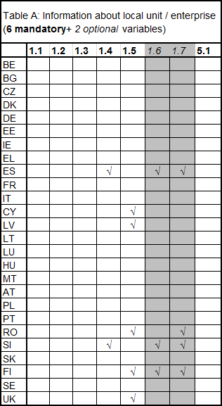

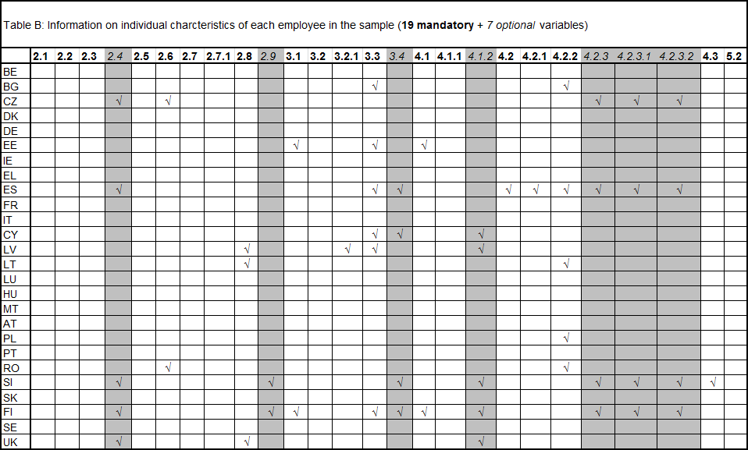

# ANNEX 2: ANALYSIS OF OPTIONAL VARIABLES IN SES 2006

|  |  |  |
| --- | --- | --- |
| **Code** | **Variable name** | **Countries not**  **providing data** |
| A16 | Number of employees in the local unit | 17 |
| A17 | Affiliation of the local unit to a group of enterprises | 29 |
| B24 | Managerial or supervisory position | 20 |
| B29 | Citizenship | 22 |
| B34 | Other annual days of paid absence | 24 |
| B412 | Annual payments in kind | 22 |
| B423 | Compulsory social contributions & taxes paid by employer on behalf of employee | 23 |
| B4231 | Compulsory social contributions | 24 |
| B4232 | Taxes | 23 |

# ANNEX 3: NEW CODING OF EDUCATION ATTAINMENT (ISCED 2011)

**0 Less than primary**

01 never attended an educational programme

010 never attended an educational programme

02 some early childhood education

020 some early childhood education

03 some primary education (without level completion)

030 some primary education (without level completion)

**1 Primary**

10 primary

100 including recognized successful completion of a lower secondary programme insufficient for level completion or partial level completion

**2 Lower secondary**

24 general

242 partial level completion and without direct access to upper secondary

243 level completion, without direct access to upper secondary

244 level completion, with direct access to upper secondary

25 vocational

252 partial level completion and without direct access to upper secondary

253 level completion, without direct access to upper secondary

254 level completion, with direct access to upper secondary

**3 Upper secondary**

34 general

342 partial level completion and without direct access to tertiary

343 level completion, without direct access to tertiary

344 level completion, with direct access to tertiary

35 vocational

352 partial level completion and without direct access to tertiary

353 level completion, without direct access to tertiary

354 level completion, with direct access to tertiary

**4 Post-secondary non-tertiary**

44 general

443 level completion, without direct access to tertiary

444 level completion, with direct access to tertiary

45 vocational

453 level completion, without direct access to tertiary

454 level completion, with direct access to tertiary

**5 Short-cycle tertiary**

54 general

540 not further defined

55 vocational

550 not further defined

56 orientation unspecified

560 not further defined

**6 Bachelor or equivalent**

64 academic

644 not further defined

65 professional1

654 not further defined

66 orientation unspecified

664 not further defined

**7 Master or equivalent**

74 academic

744 not further defined

75 professional

754 not further defined

76 orientation unspecified

764 not further defined

**8 Doctoral or equivalent**

84 academic

840 not further defined

85 professional

850 not further defined

86 orientation unspecified

860 not further defined

**9 Not elsewhere classified**

99 not elsewhere classified

999 not elsewhere classified

# ANNEX 4: OUTCOMES OF CALCULATED ANNUAL EARNINGS BY NACE[10]

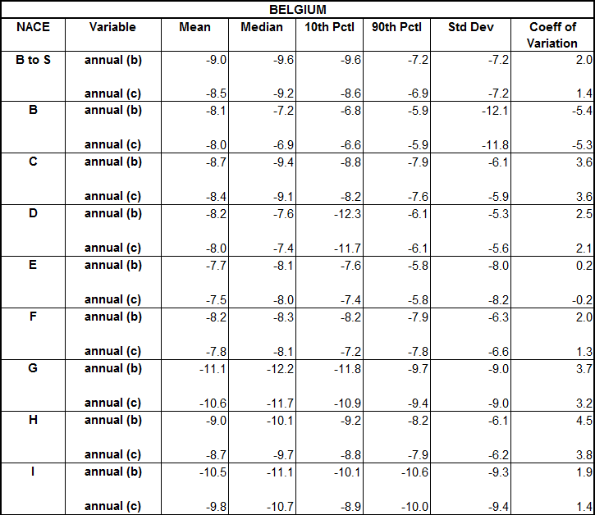 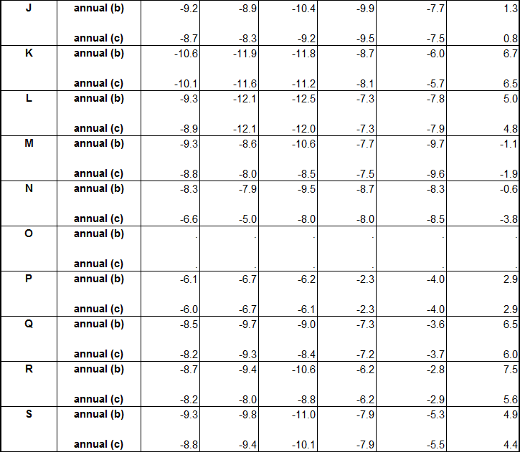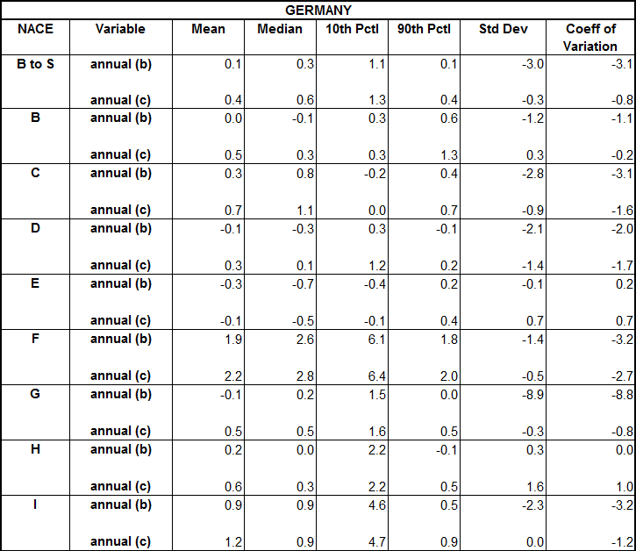 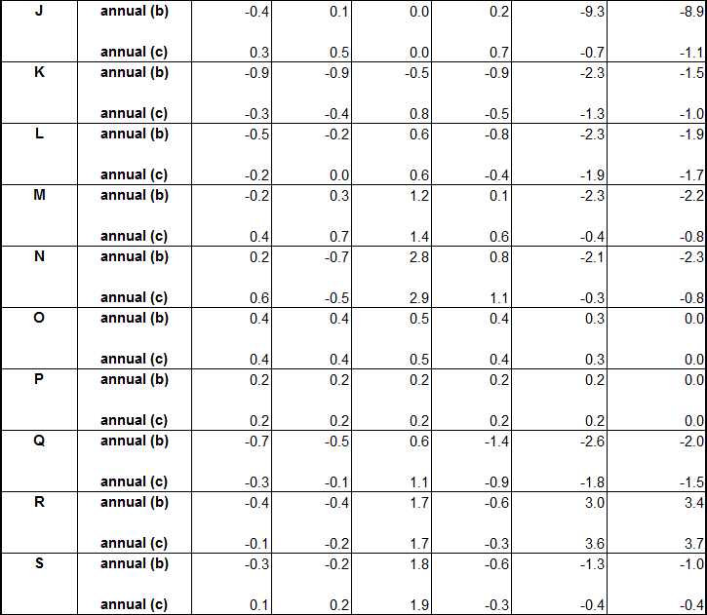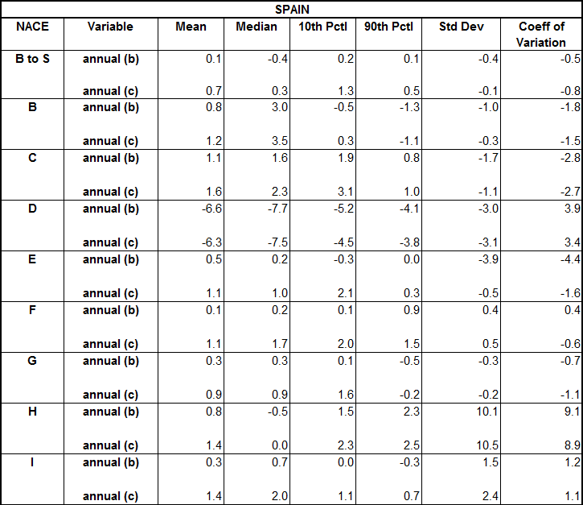

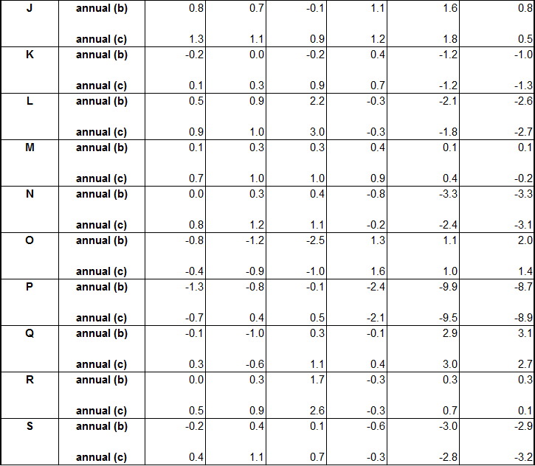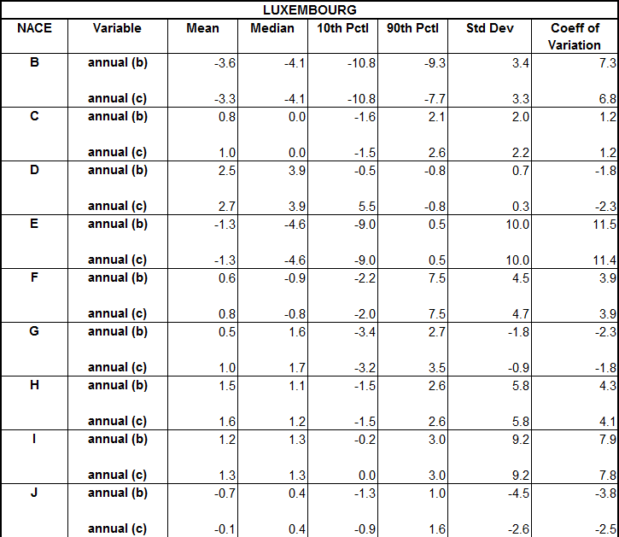 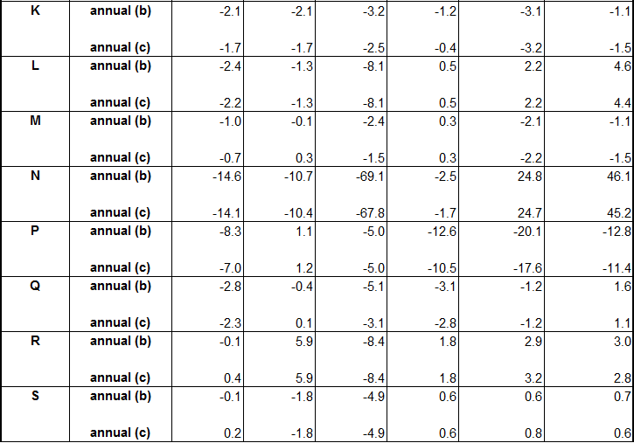

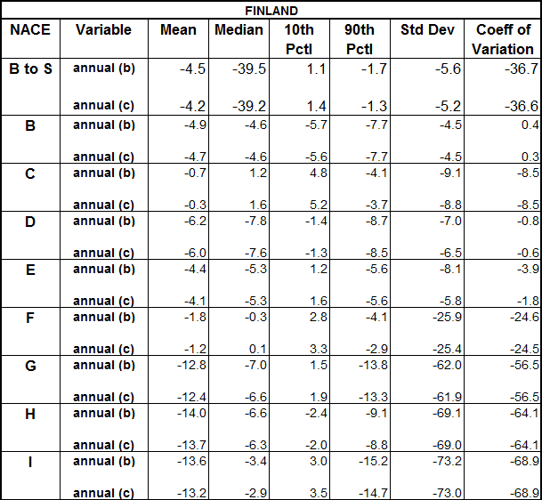 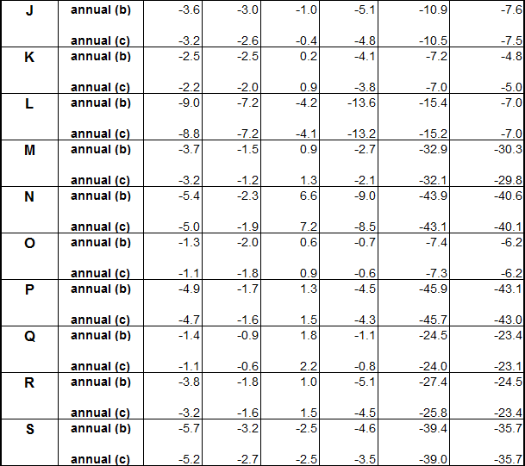

# ANNEX 5: SYNTHESIS OF INFORMATION RECEIVED FROM THE COUNTRIES

# ABOUT THE USE OF ADMINISTRATIVE DATA QUESTIONNAIRE

**Section 1: General questions on micro data release/access**

**Q1. Does your national legislation allow the use of administrative data, not collected for statistical purposes, for any National and / or European dissemination of anonymized microdata file stemming from the Structure of Earnings Survey?**

|  |  |
| --- | --- |
| YES | 21 |
| NO | 6 |

**Q2. Does a centralised Municipal Population Register exist in your country?**

|  |  |
| --- | --- |
| YES | 19 |
| NO | 8 |

**Q3a. Does a centralised institution collecting and distributing administrative information about employees and employers exist in your country?**

|  |  |
| --- | --- |
| YES | 18 |
| NO | 9 |

**Q3b. If the answer to Q3a is NO please answer the next question: Is it possible to collect the information needed for SES, in such a way that one data base with all employees and employers' information needed can be created?**

|  |  |
| --- | --- |
| YES | 7 |
| NO | 20 |

**Q4. Is it technically possible to connect other statistical data sources / surveys (e.g. the Labour Force Survey) and the data sets mentioned in Q2 and Q3 by a unique key? 15**

|  |  |
| --- | --- |
| YES | 16 |
| NO | 11 |

**Q5. Are there juridical problems to connect existing surveys with the data sets mentioned in Q2 and Q3 by a unique key? 9**

|  |  |
| --- | --- |
| YES | 9 |
| NO | 18 |

**Section 2: Questions on experience in using administrative data for SES**

**Q1. Since when do you use administrative data for SES?**

< 1999 4 countries

1999 1 country

2002 7 countries

2006 2 countries

2008 1 country

2010 2 countries

**Q2. How many SES variables are obtained from administrative data?**

**If not all, which not and how are they obtained instead (e.g. surveyed)?**

|  |  |
| --- | --- |
| all | 0 |
| not all | 17 |

**Q3. If some variables are surveyed, what is used as the survey’s sampling frame?**

**If "another frame", how do you link the administrative and the survey data?**

|  |  |
| --- | --- |
| not applicable (no survey) | 3 |
| the administrative data | 7 |
| another frame | 7 |

**Q4. If variables come from different administrative sources, was linking easy?**

**If not easy, why?**

|  |  |
| --- | --- |
| not applicable (single source) | 4 |
| easy | 9 |
| not easy | 4 |

**Q5. How do you assess the accuracy of the SES variables obtained from administrative data?**

**Q5.1 Accuracy in terms of coverage error (i.e. under- or over-coverage of employees)**

Magnitude of error

|  |  |
| --- | --- |
| major | 1 |
| minor | 8 |
| none | 8 |

**Q5.2 Accuracy in terms of measurement error (i.e. compliance with SES definitions)**

Magnitude of error

|  |  |
| --- | --- |
| major | 0 |
| minor | 6 |
| none | 11 |

**Q5.3 Accuracy in terms of item non response (i.e. missing values for some units for a variable draw from administrative data)**

Magnitude of error

|  |  |
| --- | --- |
| major | 0 |
| minor | 7 |
| none | 10 |

**Q5.4 If you report some lacks of accuracy in Q4.1 to Q4.3, do you take any countermeasures? If yes, which (e.g. imputation)?**

|  |  |
| --- | --- |
| YES | 9 |
| NO | 4 |
| n.a. | 4 |

**Q5.5 How do you assess the timeliness of the SES variables obtained from administrative data compared to a survey, and why?**

|  |  |
| --- | --- |
| better | 5 |
| same | 5 |
| worse | 6 |
| missing | 1 |

**Q5.6 How do you assess the coherence of the SES variables obtained from administrative data compared to a survey (i.e. how well SES results fit to other statistics and why)?**

|  |  |
| --- | --- |
| better | 4 |
| same | 10 |
| worse | 1 |
| missing | 2 |

**Q6 The use of administrative data for SES requires processes different from doing a survey. Which experience did you make on the processes?**

**Q6.1 Does the processes require different staff or skills compared to a survey?**

**If different, which?**

|  |  |
| --- | --- |
| different | 11 |
| same | 5 |
| missing | 1 |

**Q6.2 Does the processes require less human resources compared to a survey?**

**If yes, by which factor less (rule-of-thumb, e.g. by factor 4 = 75% less)?**

|  |  |
| --- | --- |
| YES | 11 |
| NO | 5 |
| missing | 1 |

**Q6.3 How long did it or will it take to establish processes which satisfy in terms of data accuracy and timeliness?**

|  |  |
| --- | --- |
| Years | 2, 2-4, 4, 1, 1, 1, 0, 3-4, 0.1, 2 |

# ANNEX 6: SYNTHESIS OF TASK FORCE MEMBERS COUNTRIES' USE OF

# ADMINISTRATIVE DATA

|  |  |  |  |  |  |  |
| --- | --- | --- | --- | --- | --- | --- |
| **Code** | **Variable name** | **Use / reuse**  **admin.** | **Potential** | | **No potential** | |
|  |  |  |  | **Plan** |  | **Reason** |
| A11 | Geographical location of unit | 10/10 |  |  |  |  |
| A12 | Size of enterprise | 8/10 | 1 |  | 1 | Timeliness, cost/benefit, other |
| A13 | Economic activity | 10/10 |  |  |  |  |
| A14 | Economic control | 7/10 | 3 | 1 |  |  |
| A15 | Collective pay agreement | 4/9 | 1 | 1 | 4 | Not suitable, cost/benefit. Other |
| A16 | Nb. employees in local unit | 6/8 |  |  | 2 | Not suitable, timeliness, cost/benefit, other |
| A17 | Affiliation to group of enterprises | 4/8 | 2 |  | 2 | Not suitable |
| A51 | Grossing-up factor for local units | 5/8 | 1 |  | 2 | Not suitable., other |
| B21 | Sex | 5/9 | 2 | 1 | 2 | Legal obstacles |
| B22 | Year of birth | 5/9 | 2 | 1 | 2 | Legal obstacles |
| B23 | Occupation | 3/9 |  |  | 6 | Not suitable, legal obstacles, cost/benefit, other |
| B24 | Management/superv. position | 1/8 | 1 |  | 6 | Not suitable, legal obstacles, other |
| B25 | Level of education | 4/9 | 1 |  | 4 | Not suitable, legal obstacles, other |
| B26 | Length of service | 1/9 | 7 |  | 1 | Legal obstacles |
| B27 | Full/ part time | 5/9 | 1 |  | 3 | Not suitable, legal obstacles |
| B271 | Share in % of normal hours | 3/8 | 1 |  | 4 | Not suitable, other |
| B28 | Type of contract | 4/9 | 1 |  | 4 | Not suitable, legal obstacles |
| B29 | Citizenship | 5/9 | 3 |  | 1 | Legal obstacles |
| B31 | Nb. of weeks worked | 3/9 | 2 |  | 4 | Not suitable, legal obstacles |
| B32 | Nb. of hours paid in reference month | 2/9 | 1 |  | 6 | Not suitable, legal obstacles, other |
| B321 | Nb. of overtime hours | 2/9 | 1 |  | 6 | Not suitable, legal obstacles, other |
| B33 | Annual days of holiday leave | 2/9 |  |  | 7 | Not suitable, other |
| B34 | Other annual days of paid absence | 1/8 | 2 |  | 5 | Not suitable, other |
| B41 | Gross annual earnings | 4/9 | 4 | 1 | 1 | Legal obstacles |
| B411 | Annual bonuses and allowances | 4/9 | 1 |  | 4 | Not suitable, legal obstacles, cost/benefit, other |
| B412 | Annual payments in kind | 3/8 | 3 |  | 2 | Not suitable, legal obstacles, cost/benefit, other |
| B42 | Gross earnings in reference month | 1/8 | 2 |  | 5 | Not suitable, legal obstacles, other |
| B421 | Earnings related to overtime | 1/8 | 1 |  | 6 | Not suitable, legal obstacles, other |
| B422 | Special payments for shift work | 1/8 |  |  | 7 | Not suitable, legal obstacles, other |
| B423 | Social contributions and taxes | 1/8 | 4 |  | 3 | Not suitable, legal obstacles |
| B4231 | Social contributions | 2/8 | 5 |  | 1 | Legal obstacles |
| B4232 | Taxes | 2/8 | 2 |  | 4 | Not suitable, legal obstacles |
| B43 | Gross hourly earnings | 2/8 | 1 |  | 6 | Not suitable, other |
| B52 | Grossing-up factors employees | 4/8 | 1 |  | 3 | Not suitable |

# ANNEX 7: QUESTIONNAIRE ON THE USE OF IT TOOLS IN SES AND OTHER

# EARNINGS AND LABOUR COST DATA COLLECTION

**Country:**

|  |
| --- |
|  |

**Please tick (√) as applicable;**

**1. Do you make use, or are you planning to use, any Information Technology (IT) applications for Earnings and Labour Cost data collection?**

|  |  |  |
| --- | --- | --- |
| **YES** |  | go to 1.2 |
| **NO** |  | go to 1.1 and stop |

**1.1. If you don't use nor plan to use IT tools**

**1.1.1. Why?**

**-----------------------------------------------------------------------------------------------------------------**

**-------------------------------------------------------------------------------------------------------------------------------------------------------------------------------------------------------------------------------------------------------------------------------------------------------------------------------------------------------------------------------------------------------------------------------------------------------------------------------------------------------------------------------------------------------------------------------------**

**1.1.2. Would you be interested to use such technology in future (although no plan exists yet)?**

**-----------------------------------------------------------------------------------------------------------------**

**-----------------------------------------------------------------------------------------------------------------**

**--------------------------------------------------------------------------------------------------------------------------------------------------------------------------------------------------------------------------------------------------------------------------------------------------------------------------------------------------------------------------------------------------------------------------------------------------------------------**

**1.2. If you use or plan to use IT tools**

**1.2.1. Please specify for which data collection:**

|  |  |  |
| --- | --- | --- |
|  | **using** | **planning** |
| **ANNUAL EARNINGS** |  |  |
| **ANNUAL LABOUR COSTS** |  |  |
| **SES 2010** |  |  |
| **LCS 2012** |  |  |
| **SES 2014** |  |  |

**1.2.2. What kind of IT applications do you make use of for the collection of the data from the respondents (file filed and sent to the National Statistical Institute)?**

**1.2.2.1. File type**

|  |  |
| --- | --- |
| **Excel** |  |
| **Access** |  |
| **HTML** |  |
| **XML** |  |
| **Other** |  |

**1.2.2.2. Transmission type**

|  |  |
| --- | --- |
| **Web-based questionnaire (e-survey)** |  |
| **USB stick or similar** |  |
| **Direct transmission via e-mail** |  |
| **Others** |  |

**1.2.2.3. Is it possible for enterprises to obtain a hard-copy of the filled questionnaire (such as word, pdf format etc.)?**

|  |  |
| --- | --- |
| **YES** |  |
| **NO** |  |

**1.2.3. Could you shortly explain how it works in general (details will be asked below) both to gather the data at enterprise level and to prepare and send the data between the enterprise and the National Statistical Institute?**

**-----------------------------------------------------------------------------------------------------------------**

**---------------------------------------------------------------------------------------------------------------------------------------------------------------------------------------------------------------------------------------------------------------------------------------------------------------------------------------------------**

**----------------------------------------------------------------------------------------------------------------------------------------------------------------------------------------------------------------------------------**

**2. In the IT approach you use, is there any software supporting respondents in gathering (not sending) data to be transmitted (e.g. reporting system integrated with payroll systems)?**

|  |  |  |
| --- | --- | --- |
| **YES** |  | go to 2.1 |
| **NO** |  | go to 3 |

**2.1. Please specify what kind of support it offers and how does it work (copy-paste type function, direct extraction of the file to be sent, etc.):**

**----------------------------------------------------------------------------------------------------------------------------------------------------------------------------------------------------------------------------------**

**----------------------------------------------------------------------------------------------------------------------------------------------------------------------------------------------------------------------------------**

**----------------------------------------------------------------------------------------------------------------------------------------------------------------------------------------------------------------------------------**

**2.2. Is the supporting software a product of the NSI or a commercial product?**

|  |  |  |
| --- | --- | --- |
| **NSI product** |  | go to 2.3 |
| **commercial** |  | go to 2.4 |

**2.3. How does the NSI ensure the software to work properly and to be customized properly by the respondent?**

**----------------------------------------------------------------------------------------------------------------------------------------------------------------------------------------------------------------------------------**

**-----------------------------------------------------------------------------------------------------------------**

**---------------------------------------------------------------------------------------------------------------------------------------------------------------------------------------------------------------------------------------------------------------------------------------------------------------------------------------------------**

**2.4. Which channels does the NSI use to communicate with the software provider and how does it work?**

**--------------------------------------------------------------------------------------------------------------------------------------------------------------------------------------------------------------------------------------------------------------------------------------------------------------------------------------------------------------------------------------------------------------------------------------------------------------------**

**----------------------------------------------------------------------------------------------------------------------------------------------------------------------------------------------------------------------------------**

**3. In case of a data collection tool with no possibility of direct extraction from payroll**

**(e.g. questionnaire to be filled)**

**3.1. Are there any drop-down menus for categorical variables?**

|  |  |  |
| --- | --- | --- |
| **YES** |  | go to 3.1 |
| **NO** |  | go to 3.2 |

**3.1.1. For which variables?**

|  |  |
| --- | --- |
| **Variable Code** | **Variable Label** |
|  |  |
|  |  |
|  |  |
|  |  |
|  |  |

**3.2. For web-based questionnaire (e-survey)**

**3.2.1. Is there any minimum ADSL speed required? If yes, please specify;**

|  |  |
| --- | --- |
| **YES** |  |
| **NO** |  |

**3.2.2. Is it possible to fill-in the questionnaire in multiple sessions? Is it possible to save previous data inputting?**

|  |  |
| --- | --- |
| **YES** |  |
| **NO** |  |

**3.2.3 Was the web questionnaire developed by the NSI (in-house) or by an external company?**

|  |  |
| --- | --- |
| **NSI** |  |
| **External** |  |

**4. Does your IT application has validation controls (i.e. data are validated while prepared/entered and before sending them to the NSI)?**

|  |  |  |
| --- | --- | --- |
| **YES** |  | go to 4.1 |
| **NO** |  | go to 5 |

**4.1. Does your IT application generate a description of errors in dialog box format?**

|  |  |  |
| --- | --- | --- |
| **YES** |  | go to 4.2 |
| **NO** |  | go to 4.3 |

**4.2. Are the users aware of the errors:**

|  |  |
| --- | --- |
| **When entering data** |  |
| **When data is completed** |  |

**4.3 Could you give a short description of the error checking function(s)?**

**5. Have you applied any "blocks" on data transmission, if a number of errors exist when users are about to send their data file?**

|  |  |  |
| --- | --- | --- |
| **YES** |  | go to 5.1 |
| **NO** |  | go to 6 |

**5.1 Could you give a short description of the data transmission "blocks" function(s)?**

**-----------------------------------------------------------------------------------------------------------------**

**-------------------------------------------------------------------------------------------------------------------------------------------------------------------------------------------------------------------------------------------------------------------------------------------------------------------------------------------------------------------------------------------------------------------------------------------------------------------------------------------------------------------------------------------------------------------------------------**

**6. In your country, is it (also) possible to obtain earnings and labour cost data directly**

**(via IT) from administrative sources (Tax authorities, Social Security bodies, etc.)?**

|  |  |  |
| --- | --- | --- |
| **YES** |  | go to 6.1 |
| **NO** |  | go to 7 |

**6.1. Is it possible to obtain public service employees' earnings and labour cost data directly (via IT) from administrative sources?**

|  |  |
| --- | --- |
| **YES** |  |
| **NO** |  |

**6.2 Which earnings and labour cost information ("variables") do you gather directly (via IT) from such administrative sources?**

**----------------------------------------------------------------------------------------------------------------------------------------------------------------------------------------------------------------------------------**

**----------------------------------------------------------------------------------------------------------------------------------------------------------------------------------------------------------------------------------**

**----------------------------------------------------------------------------------------------------------------------------------------------------------------------------------------------------------------------------------**

**7. Could you shortly explain the successful achievements of the tool and the main difficulties you face (d) in implementing it?**

**-----------------------------------------------------------------------------------------------------------------**

**-------------------------------------------------------------------------------------------------------------------------------------------------------------------------------------------------------------------------------------------------------------------------------------------------------------------------------------------------------------------------------------------------------------------------------------------------------------------------------------------------------------------------------------------------------------------------------------**

**7.1 How long does the implementation of the tool take on average?**

**-----------------------------------------------------------------------------------------------------------------**

**-------------------------------------------------------------------------------------------------------------------------------------------------------------------------------------------------------------------------------------------------------------------------------------------------------------------------------------------------------------------------------------------------------------------------------------------------------------------------------------------------------------------------------------------------------------------------------------**

**8. Could you recommend any "best practices" about any of the subjects mentioned above?**

**----------------------------------------------------------------------------------------------------------------------------------------------------------------------------------------------------------------------------------**

**----------------------------------------------------------------------------------------------------------------------------------------------------------------------------------------------------------------------------------**

**----------------------------------------------------------------------------------------------------------------------------------------------------------------------------------------------------------------------------------**

**9. Could you recommend any "best practices" or comment about other IT approaches not mentioned above?**

**----------------------------------------------------------------------------------------------------------------------------------------------------------------------------------------------------------------------------------**

**----------------------------------------------------------------------------------------------------------------------------------------------------------------------------------------------------------------------------------**

**----------------------------------------------------------------------------------------------------------------------------------------------------------------------------------------------------------------------------------**

1. Council Regulation 530/1999 and Commission Regulations 1916/2000 and 1738/2005
2. <http://epp.eurostat.ec.europa.eu/statistics_explained/index.php/Earnings_statistics>
3. Variable numbers as indicated in the Commission Regulation (EC) No 1738/2005 of 21 October 2005 amending Regulation (EC) No 1916/2000 as regards the definition and transmission of information on the structure of earnings
4. As from SES 2014, ISCED 2011 will replace the current ISCED 97 classification.
5. In all the calculations, data for part-time employees are converted into full-time units using variable B271.
6. According to the current Regulation, B412 is an optional variable. For SES 2006, 22 countries did not provide information for this variable.
7. COM (2012) 167 final
8. <https://circa.europa.eu/Public/irc/dsis/Home/main?f=login&referer=http%3A%2F%2Fcirca.europa.eu%2FMembers%2Firc%2Fdsis%2Fwages%2Flibrary%3Fl%3D%2Fworking_documents%2Fworkshops_seminars%2F2012%2Freduction_simplification%2Fadministrative_informati>
9. Analysis are available on CIRCA: <http://circa.europa.eu/Members/irc/dsis/wages/library?l=/working_documents/workshops_seminars/2012/reduction_simplification/2_documents&vm=detailed&sb=Title>
10. Difference = (b/a-1)*100 and ((c/a-1)*100