European Commission - Eurostat/C6

Architecture of the Integrated PPP System

Table OF CONTENTS
1. Introduction 2
2. Logical View of the Integrated PPP System 3
2.1 Package Diagram 3
2.1.1 Item List Management Tool 3
2.1.2 Data Entry Tool 4
2.1.3 Data Loader Web Service 4
2.1.4 Central Database 4
2.1.5 Validation Tool 4
2.1.6 Calculation & Aggregation Tool 4
2.1.7 Monitoring Tool 5
2.1.8 Reporting Tool 5
2.2 Component Diagram 5
2.2.1 Item List Management Tool 7
2.2.2 Data Entry Tool 7
2.2.3 Data Loader Web Service 8
2.2.4 Central Database 8
2.2.5 Validation Tool 8
2.2.6 Calculation & Aggregation Tool 9
2.2.7 Monitoring Tool 9
2.2.8 Reporting Tool 9
3. Deployment View 11
4. Data View 12
4.1 Common database sub-schema 12
4.2 Item List Management sub-schema 15
4.3 Validation Tool sub-schema 18
4.4 Monitoring sub-schema 22

Introduction
This document provides the overall architecture of the Integrated PPP system. It describes the involved components and the interrelationships between the components, as well as how these components are physically deployed. Finally, it provides a detailed description of the PPP database.
The structure of this document is as follows:
In section 2 the logical view of the Integrated PPP system architecture is presented. This view depicts the detailed design decomposition of the application into packages and components.
In section 3 the deployment view of the Integrated PPP system is depicted.
In section 4 a description of the persistent data storage perspective of the system is provided.

Logical View of the Integrated PPP System
The following section provides a description of the logical view of the architecture. This view includes a package diagram, which represents the subsystems of the integrated PPP system providing an overall view, as well as a component diagram where the components of each subsystem are presented, describing how the components interact.

Package Diagram
The package diagram of Figure 1 depicts the subsystems of the Integrated PPP system along with their dependencies. There can be identified eight subsystems: Item List Management Tool, Data Entry Tool, Validation Tool, Calculation & Aggregation Tool, Monitoring Tool, Data Loader Web Service, Central Database, and Reporting Tool.
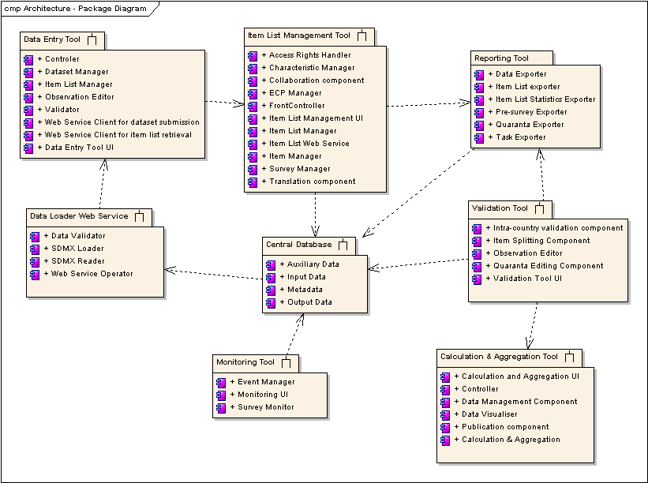
Figure 1: System Architecture - Package Diagram

Item List Management Tool
The Item List Management Tool is a web-based tool through which the survey preparation is accomplished. The tool can also support the translation of the Item List, even including a thesaurus of item related concepts and suggestion mechanisms to facilitate the translation process.

Data Entry Tool
The data entry tool is a stand-alone application, used for the price collection phase by both price collectors, who are responsible for the actual price collection and the entry of the observed prices to the tool, and by national coordinators, who are responsible for compiling the data from the different price collectors, performing the initial intra-country validation on the final compiled dataset and submitting the validated dataset to Eurostat. The data entry tool is capable of automatically retrieving the applicable item list for the specific survey, and can automatically transmit the validated dataset to the central DB. The latter is accomplished by calling the data collection web service, which uses the SDMX XML standard for structuring the data.

Data Loader Web Service
The Data Loader is a web service capable of receiving initial validated price data sets, validating them again (i.e. detecting and marking of outliers) and storing them in a central data repository as a first version of the data.

Central Database
The central DB of the Integrated PPP System stores three different kinds of data: a) the input data, i.e. the actual observations collected through surveys and transmitted by countries b) output data, i.e. results of the calculation and aggregation process, at different levels of aggregation; c) auxiliary data, i.e. data stemming from other sources and required to support the calculation process such as temporal adjustment factors, spatial adjustment factors, exchange rates etc; and d) metadata such as survey metadata, the ECP classification, user access and user preferences, item lists and item specifications, validation metadata, translation metadata.

Validation Tool
The validation tool is a web-based tool allowing for the collaborative validation and correction of data for both intra- and inter-country comparisons in consecutive rounds. Primary actors of the validation tool are the Group leaders, who are checking countries’ data and instruct them to correct them, the countries who are make the corrections as instructed by the group leaders and Eurostat who is in charge of the overall running of the validation. The validation tool provides functionality to facilitate the collaboration between group leaders and countries, is capable of maintaining the history of the corrections, and provides several different views of the data being validated, with options to export them in MS Excel format.

Calculation & Aggregation Tool
The Calculation Tool & Aggregation Tool is in charge of performing the calculation and aggregation procedures. The tool is capable of estimating survey PPPs, annual survey PPPs or overall annual PPPs at different aggregation levels and storing multiple versions of these results. It provides a user interface for visualising input, output and auxiliary data, making interactive multidimensional OLAP operations for analysing the data, managing auxiliary data, as well as for publishing the official results.

Monitoring Tool
The Monitoring Tool supports the coordination, time planning and monitoring of the entire process. Its user interface provides the door to the rest of the PPP tools.

Reporting Tool
The Reporting Tool is the module responsible for a series of predefined or ad hoc reports, e.g. item list in RTF or XML format, Pre-survey questionnaires, Task reports, Quaranta table reports, data reports, etc. The reporting tool supports all the subsystems by providing different kind of reports for each tool.

Component Diagram
The component diagram depicted in Figure 2 presents the different components of Integrated PPP System. The components of each subsystem are annotated with different colours for reasons of clarity.
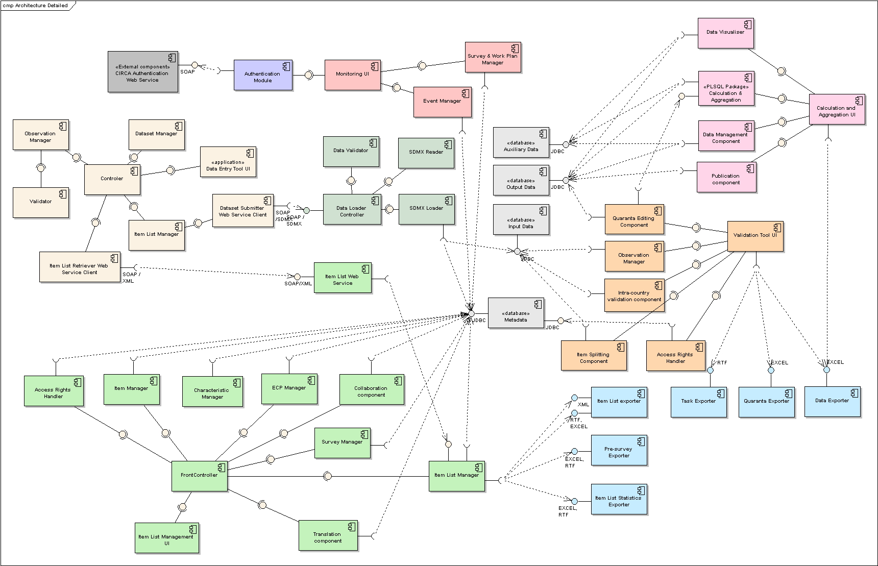
Figure 2: System Architecture – Component Diagram

Item List Management Tool
The Item List Management UI component represents the user interface of the Item List Management Tool, which communicates with the rest of the subsystem’s components through the FrontController. In other words, the FrontController is the mediator between the user interface and the back-end business logic. The business logic is accomplished by the following components:
- the Item Manager responsible for the management (create, edit, delete, etc) of items and item versions
- the Item List Manager, responsible for the management of the lists (creation, modification, deletion, finalisation etc). The item list manager communicates with the reporting tool, specifically with the Item List exporter, pre-survey exporter and Item List Statistics exporter components, for successfully supporting the entire survey preparation process.
- The ECP Manager responsible for the management of the ECP classification (e.g. managing BHs, SPDs etc).
- The Characteristics Manager, responsible the management of the item characteristics, which provide the basis for a concrete the definition / description of items.
- The Survey Manager, in control of surveys and survey instances
- The Translation component, facilitates translation of characteristics, items and item lists with a smart suggestion mechanism.
- The collaboration component allows for the exchange of questions and answers between the involved actors (e.g. between countries and group leaders), at BH, SPD or item level supporting not only the pre-survey process but also the entire survey preparation process.
- The Access rights Handler, in charge of the granting or refusing access rights to the users, according to their profile. The access rights for each user profile are defined for that profile at the DB.
All the back-end components of the Item List Management Tool are accessing the Central Database, and in particular the Metadata base.
Moreover, one more component can be identified in the Item List Management subsystem, namely the Item List Web Service. This web service provides a SOAP interface to the Data Entry Tool for automatically serving the appropriate item list in XML format. To realise this, it communicates with the Item List Manager, which ultimately delegates the task to the Item List export of the reporting tool.

Data Entry Tool
The Data Entry Tool UI component denotes the user interface of the data entry tool. It allows for editing observations and offers a number of different views for visualizing the data or statistics about these data. The Controller is in charge of accepting user requests (through the UI) and delegating to one of the remaining components, namely:
- The Item List manager, responsible for the initialization of the item list either manually using a locally stored XML file or automatically from the DB by delegating the task to the Item List Retriever Web Service Client. Moreover, the item list manager allows for the partial of full export of the item list, in order to be subsequently distributed to one or more price collectors.
- The Dataset manager, capable of handling multiple versions of a country’s dataset (i.e. renaming, deleting, saving as, exporting, merging etc)
- The observation manager, responsible for editing, deleting or flagging of observations. The observation manager relies on the Validator component for the detection of outliers.
- The Item List Retriever Web Service client is responsible for communicating with the Item List Web Service component (of the Item List Management Tool) for retrieving the detailed description of the items to be priced (i.e. the item list).
- Finally, the Dataset Submitter Web Service Client is capable of calling the Data collection web service and in particular the Data Loader Controller component, which will ultimately load the dataset to the central database.

Data Loader Web Service
The Data Loader Web Service is a web service capable of reading (SDMX Reader), validating (Data Validator) and finally loading (SDMX Loader) an SDMX formatted dataset to the central database.

Central Database
The central DB is decomposed to four components: a) the input data, i.e. the actual observations collected through surveys and transmitted by countries b) output data, i.e. results of the calculation and aggregation process, at different levels of aggregation; c) auxiliary data, i.e. other data required to support the calculation process such as temporal adjustment factors, spatial adjustment factors, exchange rates etc; and d) metadata such as survey metadata, the ECP classification, user access and user preferences, item lists and item specifications, validation metadata, translation metadata.

Validation Tool
In the validation tool the following subcomponents can be identified:
- The validation tool UI, representing the user interface
- The intra-country validation component, which apart from the actual intra country validation, allows for the effective collaboration between group leaders and countries for achieving the correct validation of data.
- The observation manager, which is responsible for the editing, deletion or even the addition of observations, as well as for keeping track of a history of changes in the observations.
- The Item Splitting component, which allows the group leaders or Eurostat to split items and transfer observation from one item to the other.
- The quaranta editing component, which is the main tool for performing inter-country validation. To achieve this, the quaranta editing component communicates with the Calculation and Aggregation component for calculating survey level PPPs at basic heading or higher aggregate level.
- The Access Rights Handler, which is used by most of the components of the validation tool for allowing or refusing access to actual observations according to the user’s profile.

Calculation & Aggregation Tool
The Calculation & Aggregation Tool is responsible for calculating overall PPPs or survey level PPPs at different aggregation levels of the ECP classification. This is achieved by the Calculation & Aggregation PLSQL package, which is considered the core component of this subsystem. Other components include: a) the Calculation & Aggregation UI, representing the user interface; b) the data visualiser component, capable of visualising and comparing data across years and/or different versions; c) the data management component, allowing for the management of auxiliary and output data; and d) the publication component allowing for the official publication of results for a reference year or for a specific survey.

Monitoring Tool
The Monitoring tool provides a user interface (Monitoring UI) for viewing the progress of each survey, as well as for the management of the annual work plan of the entire PPP exercise for a specific year (Survey & Work Plan Manager) and even for the posting and management of events such as group meeting, deadlines etc (Event Manager).
The Monitoring Tool provides the main page (or home page) of the entire PPP system. Therefore, it provides links to the rest of the tools and is the first tool accessed after the successful authentication, which is accomplished by the authentication module. The authentication module is actually a web service client, since the actual authentication is done by an external subsystem, the CIRCA Authentication Web Service.

Reporting Tool
The Reporting Tool aims at supporting all the subsystems of the integrated PPP system by serving reports (or outputs) of different formats. In particular the following components can be identified in the reporting tool:
- Item List Exporter, providing item list related reports in several formats (RTF, Excel, CSV, XML, ZIP), such as item list comparison reports, summary list comparison, survey booklets, picture archive, item descriptions by SPD or by item list etc.
- Pre-survey exporter, responsible for providing exports to support the pre-survey process, such as pre-survey questionnaire, availability importance statistics etc.
- Item List Statistics exporter, providing reports with overlap statistics and brand level statistics
- Task Reporter, supporting the validation tool by providing a list with to-do tasks for a country, in terms of unanswered questions or other comments at item or observation level.
- Data exporter, which is capable of exporting a UI grid with data in Excel format. This component serves both the Validation and the Calculation Tools.
- Quaranta exporter, which exports in Excel format the quaranta tables.

Deployment View
In Figure 3 the deployment environment of the Integrated PPP System is depicted. Four hardware elements can be identified in the following figure: A Sun Solaris Server, where the application server resides, the database server where an Oracle Database (v.10i) resides, the CIRCA Server (external), where the authentication module is deployed, and a client workstation representing the user’s machines. Note that it is possible to have the database and application servers at the same physical machine, however, in the diagram are depicted separately in order to underline an alternative solution. The Oracle database, which contains the PPP data, provides a JDBC interface enabling the online PPP tools, deployed on the application server, to access its data. The application server, which is a BEA Weblogic application server (version 9.2), is accessible by the users’ web browser via HTTP. Finally, the CIRCA application server is accessible via HTTP / SOAP to the PPP application server.
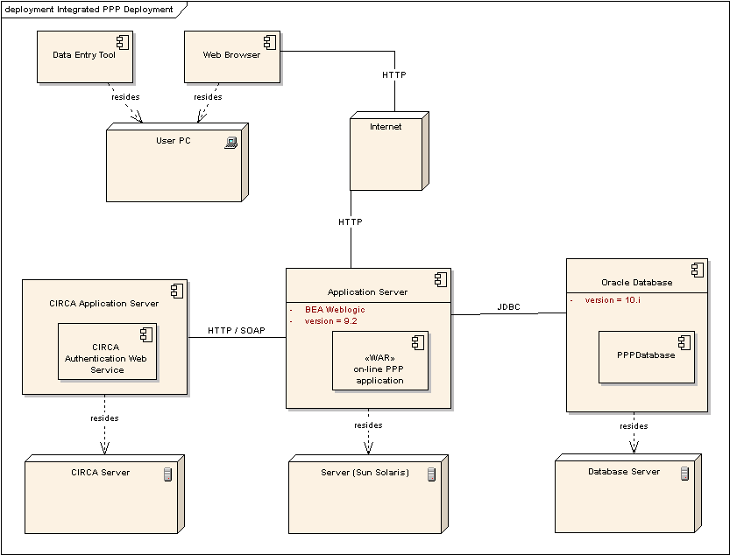
Figure 3: Integrated PPP System Deployment Diagram

Data View
This section provides a description of the persistent data storage perspective of the system, i.e. it describes in detail the central database component. The central database of the integrated PPP is decomposed into four sub-schemata: a) the common sub-schema, which contains entities shared among the tools, b) the ILMT sub-schema, which contains entities supporting the Item List Management Tool, c) the Validation sub-schema, which consists of entities for storing the actual data and supporting the Validation and Calculation Tools, and d) the Monitoring sub-schema, which contains entities related with the monitoring tool.

Common database sub-schema
The common sub-schema is depicted in Figure 4. Below a detailed description follows:
The table USERS is used to store all the users of the Integrated PPP System. It serves as a linkage between the CIRCA LDAP, where all users are registered and through which are authenticated, and the PPP database. In order for a user to be able to login into the system, he must have been registered both in CIRCA and the PPP db through this table.
The table ROLES is use to store the various user roles (or profiles). Each user, according to his assigned profiles, and the access rights granted for each profile (see below) can perform specific operations. The following user roles are currently in use by the PPP tools: ESTAT for Eurostat users, GROUP LEADER for group leaders, COUNTRY for countries, EGS EXPERT for special county users, which have access only to Equipment Goods related surveys and the LOT_C, which represents the users who are responsible for performing specific operations on Eurostat’s behalf.
The table USER_ROLES stores for each user the associated profiles. A user may have more than one profile assigned but only one at a time can be used through out a session.
The USER_SESSION represents user’s last session and is used to store information about the user’s last actions in the Item List Management Tool (like selected survey, selected item list, expanded tree nodes etc). The details of the session are stored in the USER_SESSION_DETAILS. The information is stored as soon as the user logs out, and is retrieved again from the DB the next time he logs in for restoring the last session, so as the user to be able to continue his work from the same point.
The table ACTION is used to store all the restricted operations (i.e. operations that might not be accessible to everybody).
The table ACCESS_RIGHTS defines for each user role and type of list (if applicable) the permissible operations. For example, the operation “assignGroups” may be allowed to certain user roles and certain type of lists. The following example indicates that a LOT_C user can assign groups to an item version of the Final or Draft European list, while the group leaders can assign groups only to the draft group list. If the list type does not contain any value, this means that either the action is not applicable at list level or that it applies to any type of list.
Table 1 example of access rights
Action | USER_ROLE | LIST_TYPE
assignGroups | LOT_C | FINAL EUROPEAN LIST
assignGroups | LOT_C | DRAFT EUROPEAN LIST
assignGroups | GROUP_LEADER | DRAFT GROUP LIST
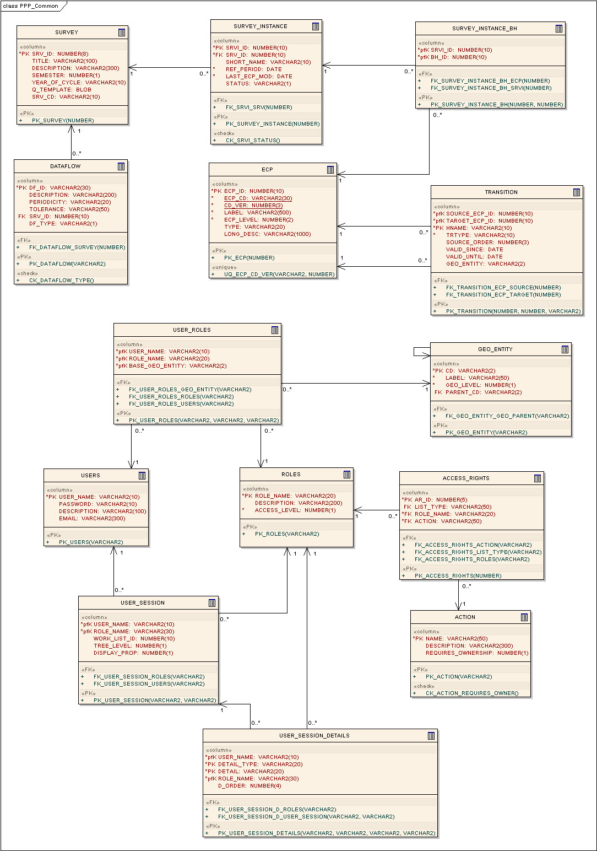
Figure 4 Common sub-schema
The table SURVEY stores the different kind of surveys conducted by Eurostat for the purposes of the PPP (e.g. Food, drinks and tobacco, Personal Appearance, Equipment Goods etc).
SURVEY_INSTANCE: Each survey is conducted regularly, e.g. surveys regarding consumer goods and services are conducted every three years, while those regarding capital goods and services are conducted every two years. The survey instance is logically bounded with the reference year at which the survey is conducted. For example “Food, drinks and Tobacco 2009” is an instance of survey “Food, drinks and Tobacco” for the reference year 2009.
Each survey comprises a set of Basic Headings, which may in the long-term move to other surveys. For that reason association between surveys and basic heading is accomplished at survey instance level and is stored in the SURVEY_INSTANCE_BH table.
The table DATAFLOW stores information about the datasets and their periodicity that are transmitted to Eurostat by the countries for each survey. The Data Entry Tool uses this information for storing dataset identification information to the generated and transmitted SDMX dataset. Thus allowing the dataset recipient (i.e. eDAMIS) to correctly identify the incoming dataset.
The table GEO_ENTITY stores, as its name implies, any geopolitical entity that takes part in the PPP process and has an active role in PPP tools. Three types of Geopolitical entities can be identified in the PPP database: a) all the countries participating in the Eurostat-OECD programme, b) all the groups to which the countries are classified (i.e. Northern Group, Southern Group, Center Group, Western Balkan Group) and c) a special geopolitical entity representing the Eurostat. This table contains a self-recursive relationship (parent-child relationship) for representing the geopolitical entities hierarchically, i.e. a tree with Eurostat as the root, the groups as immediate children and the countries as group leafs or in some special cases the cities as leafs below the countries (e.g. case of Germany).
The ECP table represents the ECP classification, which breaks down final expenditure on GDP into seven main aggregates. These main aggregates are subsequently broken down first into expenditure categories, then into expenditure groups and expenditure classes, then into Basic heading and SPDs and finally into items (goods or services). The information about the hierarchy is stored into the TRANSITION table (see below).
The TRANSITION table is used to store either hierarchy information or history information. The field hname is a qualifier used to distinguish the usage of the transition table. When the table is used for storing hierarchical information the hname has the value “PARENT” and in this case the source_ecp_id denotes the id of an ECP entry, while the target_ecp_id denotes the id of its parent. On the other hand, when the table is used to store historical information the hname has the value “HISTORY” and the source_ecp_id indicates the id of the ECP entry, which the target_ecp_id comes from.
Each ECP entry has a validity period indicated by the valid_since and valid_until fields. When the valid_until is null, it means that the ECP entry is still valid.
The field trtype indicates the transition type and can take the following values: “recoded”, “relabeled”, “deleted”, “split” and “merged” in case the hname is equal to ‘HISTORY’, while it takes the value ‘default’ in case the hname is equal to “PARENT”.
The field geo_entity stores the code of the geopolitical entity that created the ecp entry. This has meaning in the ILMT when creating items, as items can be created by many different geopolitical entities.

Item List Management sub-schema
The Item List Management sub-schema is depicted in Figure 5. In the following a detailed description is provided:
The table ITEM_LIST is used to store information about an item list. The item list plays a central role in the Item List Management Tool and can be perceived as a compilation of reusable items or rather, more specifically, item versions (see below). An item list is created in the context of a specific survey instance (e.g. Food, drinks and Tobacco 2006), has a specific type (e.g. pre-survey list, draft group list, final group list, European draft list etc.) and is owned by a single geopolitical entity (e.g. north group leader, ESTAT, Slovenia). A geopolitical entity may own only one list of the same type (for the same survey instance). Available list types are stored in the LIST_TYPE table.
Item versions are distinct versions of a single item that differ in one or more properties or characteristics. All item versions of an item intend to model the same real world entity; this is achieved by referring to the same item. In other words, item versions are different descriptions of the same item. Item versions are stored in the ITEM_VERSION table.
An item version may be used by (assigned to) more than one item list. A list may contain only one item version for each individual item. This is implemented with the table ITEM_LIST_ASSIGNMENT. Moreover, the ITEM_LIST_ASSIGNMENT tables stores additional information that applies for specific item version and specific item list, such as notes, proposed item codes and labels, as well as information needed throughout the pre-survey process, i.e. questions and answers, representativity and availability indications. On the other hand, notes and pre-survey questions and answers at higher ECP levels (i.e. SPD and Basic Heading) for each list are stored in the ITEM_LIST_BH table.
An item version has several characteristics (stored in the CHARACTERISTICS table), and a characteristic is used in many items. Thus, the intermediated table CHAR_VALUES stores, for each item version–characteristic pair, the respective value. A value of a characteristic may be either a free text value or coded value. In the latter case, the set of allowable values is either defined at the SPD level, the so-called SPD enumeration (see below the description in BH_CHARACTERISTICS table) or defined globally in the table DOMAIN_VALUES (global enumeration). Currently, globally defined allowable values are used for “Brand Type” and “Brand Stratum” characteristics, whereas SPD enumerations are used for the “reference unit”, since the allowable values of the reference unit may differ from SPD to SPD. Moreover, except from actual value of the characteristics, for each item version – characteristic pair, the database also stores whether the characteristic needs to be specified or not during the price collection process.
In addition, an item version may have an attached picture, stored in the IV_IMAGE table as a blob.
An item version in the context of a specific item list may be assigned to one ore more Groups, indicating that an item version is available at the countries of the specific group. Group assignments are stored in the ITEM_VERSION_GROUP table. Typically, groups are assigned at the European level lists, which are derived from group level list, and thus containing item versions from all groups, however the database can accommodate group assignments in any type of list.
Furthermore, for each item version in the context of a specific item list, every user may start a discussion on that item with other users. The discussion feature is implemented with table ITEM_LIST_IV_QA in terms of questions and answers. More specifically, for each item version-item list pair one or more questions can be defined by one ore more geopolitical entities. For each question any geopolitical entity can provide an answer.
The table CHARACTERISTICS is a pool with all the characteristics in one (the default) or more languages as indicated by the “lng” field. A characteristic can be a normal characteristic or of a special type, e.g. Brand type, brand, brand stratum, reference quantity, etc (indicated by the field char_type), and as described previously can be coded or not (field is_coded) and/or can take values from a globally defined domain (field dom_id).
The table “BH_CHARACTERISTICS” stores the characteristics belonging to a Basic Heading and ultimately to an SPD. In other words, this table is used to store the definition of an SPD in terms of the characteristics included, its data type (table DATATYPE), its font style as well as the order and the definition within the scope of an SPD. The table “ENUMERATED_VALUES” is used when the data type of a characteristic is “enumeration”. In that case, it contains the allowable values of a characteristic in a specific SPD.
The field “c_order” plays a crucial role in the translation mechanism. On one hand, the field indicates the order of the characteristic within an SPD, and on the other hand it serves as a key for identifying how the characteristic is translated in other languages. In other words, the table has as primary key the combination ecp id, survey instance id and characteristic id and as alternate key the combination ecp id, survey instance id and c_order.
The design pattern implemented for the needs of the translation can be briefly described as follows: for the database, characteristics, even their translations, are stored as separate entities in the characteristics table, i.e. each having its own id. In the definition of the SPD, there is always a set of characteristics assigned for the default language (i.e. English), and possibly, depending on whether the country has provided translations, a set of characteristics for each language. The various sets of characteristics for an SPD are connected with each other through the characteristic’s order. In a similar fashion, translated item versions are always separate entities with their own id, which are associated with a special type of list, “the translated list”. This is the only case where item versions are not shared among the different item lists.
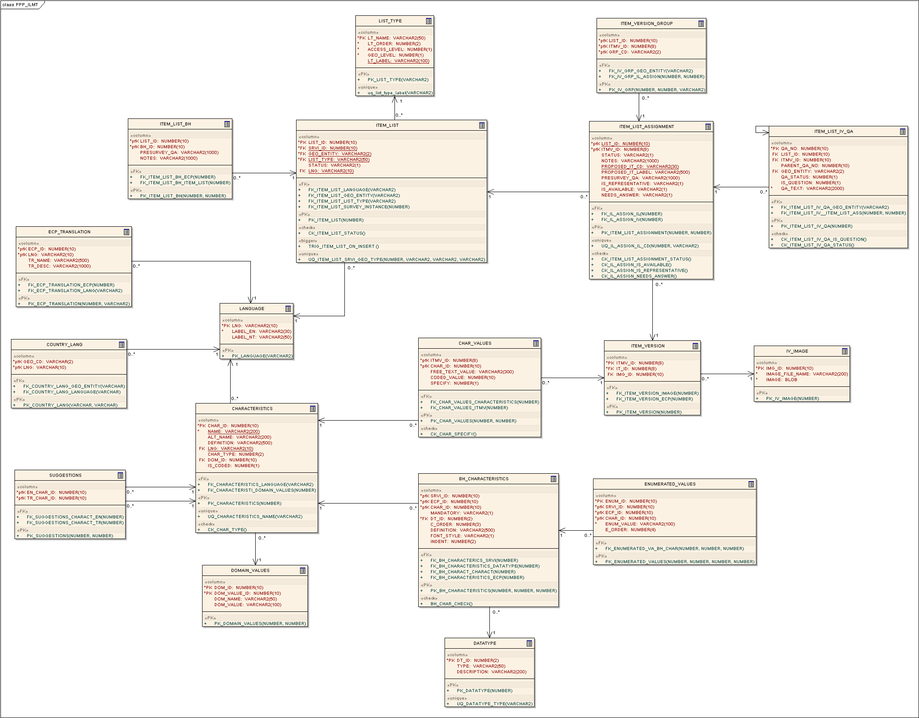
Figure 5 ILMT sub-schema
The table SUGGESTIONS stores all the possible translations (in any language) that have been provided for a specific characteristic in the default language (i.e. English) in the current or a previous survey instance. For example, the characteristic “size” may be translated in French as “taille” in an SPD and as “grosseur” in another SPD. The suggestion table would store both translations of “size”, in order to support the translation mechanism to automatically suggest to the user the most frequently used translation.
All the available languages are stored in the LANGUAGE table, whereas the association of the country with one or more languages is implemented in table COUNTRY_LANG.
Finally, as far as the translation is concerned, not only items are translated but any entry in the ECP. These translations are stored in the ECP_TRANSLATION table.

Validation Tool sub-schema
The validation tool sub-schema is depicted in Figure 6. Below a detailed description is provided:
Each survey instance has different versions. The different versions of a survey instance are stored in table "VT_SURVEY_INST_VERSION". This table contains a unique identifier for each version of a survey instance (field named SRVI_VER) and is related with table "SURVEY_INSTANCE" by using the survey instance's identifier as a foreign key.
Table "VT_ECP" contains the sub-tree of the ECP that is applicable for a certain survey instance version. In other words, for each survey instance version there is a different ECP tree. The main fields of each record of the table include the record's identifier (field named ECP_ID) and the identifier of the survey instance's version (field names SRVI_VER). Both of these two fields provide the primary key of the record. There is another field (field named PARENT_ECP_ID) that shows which ecp entry is the parent of the ecp entry in reference. This means that every record of the table has a parent, which is simply another record of the same table. Apart from the already mentioned fields, there are some others that concern an item's standard characteristics (TYPE, BRAND_TYPE, BRAND_STATUM and REF_QUANTITY), which are useful during validation process.
Characteristics that need to be specified by the countries for each item and survey instance version are stored in the "VT_OBSERVED_CHARACTERISTICS" table. These characteristics are derived from the corresponding item definitions of the final European list.
Table "VT_BH_DATA" holds the information about the basic headings that a certain country reports (e.g. expenditure weights). Therefore three of the fields of the table provide the primary key of a record. The first one is about the survey instance's version (field SRVI_VER), the second is a unique code that specifies the country (field named GEO_CD) and the last one is the basic heading's unique identifier (field ECP_ID).
Table "VT_ITEM_DATA" contains in general all the calculated values, concerning an item, according to the observations for this particular item. To be more specific, we could say that a certain record of this table shows the aggregate values (e.g. the average price of the item expressed in national currency units) that were calculated for a certain item (field named ECP_ID) and that have derived from the observations which have been collected in a certain country (field named GEO_CD) and in a certain version of a particular survey instance (field named SRVI_VER). With the exception of two certain values (VAT and REPRESENTATIVITY) that are given by the user, all the other values as it is already mentioned, are calculated in the database by taking into account the observations.

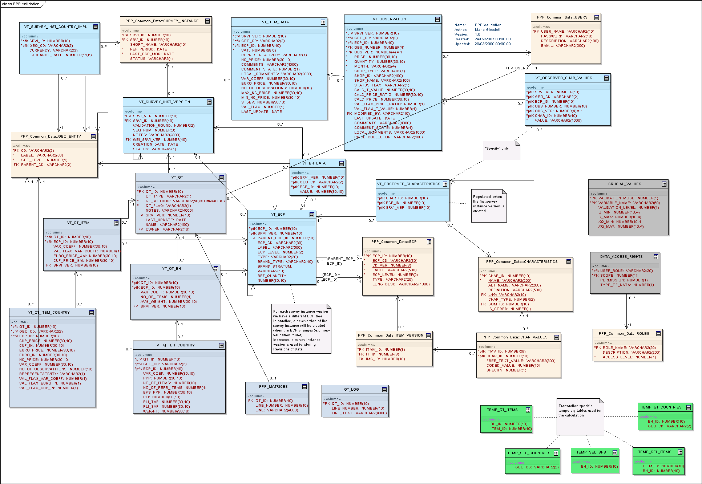
Figure 6 Validation sub-schema

At this point, a brief description of the table in which the observations are stored, is going to follow. Table "VT_OBSERVATION" holds all the observations made by all countries for all the items. In order to become clear what a certain observation is about, the identifier of survey instance's version (field SRVI_VER), the code of the country (field GEO_CD), the identifier of the item (field ECP_ID) along with other two fields that uniquely identify an observation (fields OBS_NUMBER and OBS_VERSION), all of them provide the primary key of the table. The observed values for the characteristics that need to be specified countries, are stored in table "VT_OBSERVED_CHAR_VALUES", that is related to table "VT_OBSERVATION" by containing the observation's number and version as two of its fields.
To finish the part of the database which is about the items and the observations, table "VT_SURVEY_INST_COUNTRY_IMPL" has to be explained. This table contains all the country codes for a certain survey instance and gives information about the currency and exchange rate values of each of them. These certain values are used for converting the prices expressed in national currencies to Euro. The identifier of the survey instance (field SRVI_ID) and the code of the country (field GEO_CD) provide the primary key of the table.
Another important part of the database concerns the Quaranta tables and the validation of them. The main table is table "VT_QT" which contains the information about all the quaranta tables. A unique identifier (field QT_ID) for each Quaranta table provides the primary key of the table. Apart from this, the table holds information about the type of the quaranta table, the method used for its calculation, the name of the table and the user who created it. The identifier of the survey instance version provides a foreign key in the table.
Table "VT_QT_BH" is the table that holds the information of a certain Quaranta table (QT) at Basic Heading or higher levels that applies to all countries covered by the QT. This information includes the estimated variable coefficient (field VAR_COEFF), the number of items (field NO_OF_ITEMS) of the basic heading and the average weight (field AVG_WEIGHT) for the group of countries covered by the QT. The identifier of the QT (field QT_ID) along with the identifier of the basic heading (field ECP_ID), provide the primary key of the table, whereas the identifier of the survey instance version (field SRVI_VER) is a foreign key. On the other hand table "VT_QT_BH_COUNTRY" holds the information of a certain QT for each country. Therefore the identifier of the QT, the basic heading and the country code are used as a primary key for the table.
The above two tables are used and make sense when the level is that of a basic heading or higher. In the case of item level, there are two other tables that have a similar use to the ones mentioned above. Table "VT_QT_ITEM" stores information about a quaranta table at item level that applies to all QT countries, whereas table "VT_QT_ITEM_COUNTRY" contains QT information for each country separately. The general information includes the variation coefficient (field VAR_COEFF), a flag indicating whether the estimated variable coefficient value is an expected one or not (field VAL_FLAG_VAR_COEFF), the geometric mean of the exchange rate converted prices (field EURO_PRICE_GM) and the geometric mean of the PPP converted prices (field CUP_PRICE_GM).
Table "PPP_MATRICES" is a table that holds all the intermediate matrices that are calculated in order to get the final PPP values. Taking into account that the calculation of all the matrices is a time consuming operation that may take several minutes to complete, the "QT_LOG" is a table every record of which provides the state of the calculation.
Table "CRUCIAL_VALUES" holds the limits for various variables (calculated in intra- or inter- validation mode), which are used to flag outliers.
Finally table "DATA_ACCESS_RIGHTS" defines the access rights to the actual observation data. Access rights are defined per scope, permission and type of data. In particular, scope is either 3 or 2 or 1 for data of the owner country (country level), data within the same group (group level) or data of another group (European level) respectively; Permission is either 1 or 2 for “read” and “write” respectively; and type of data is either 1 or 2 for “public” and “private” data respectively (private data are considered the price collector and local comments). In a typical scenario, the following access rights are applied:
A Group leader can read public data of countries that are in the same group.
A Country can write its own (scope = 3) private data. Since write permission prevails over read and private data prevail over public, a country can read or write its own public or private data.
Eurostat can read or write private or public for any country data, regardless of group.
In terms of completion, we are just going to add that tables "TEMP_QT_ITEMS", "TEMP_SEL_COUNTRIES", "TEMP_SEL_BHS", "TEMP_SEL_ITEMS" and "TEMP_QT_COUNTRIES" are oracle transaction-specific temporary tables used only during the PPP calculation process.
The table COUNTRY_METADATA stores for each year and country the exchange rates and the currency used.

Monitoring sub-schema
In this section a brief description of the part of the database that concerns the monitoring of the whole process of a survey is provided (see Figure 7).
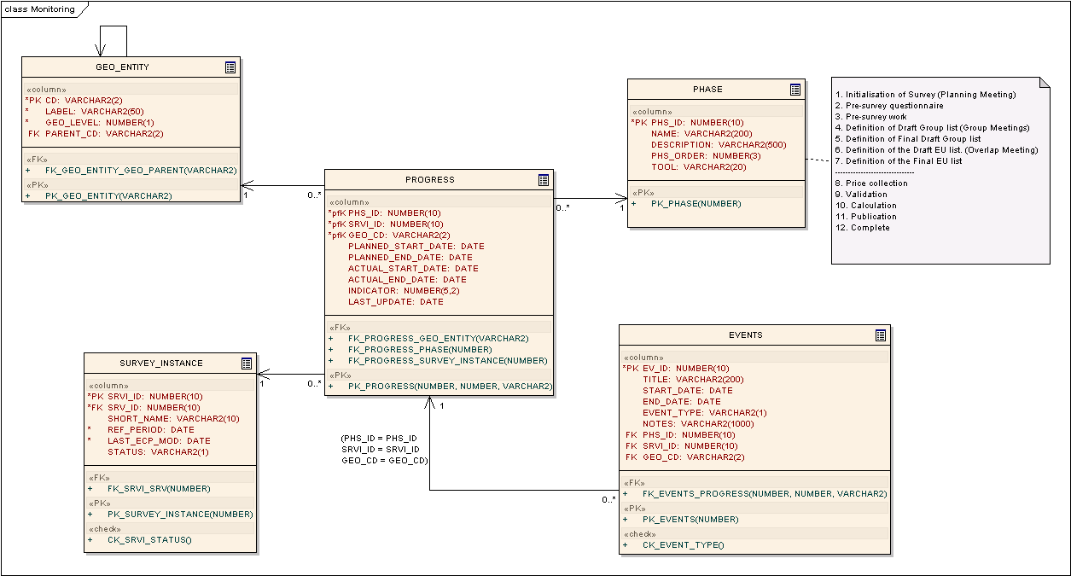
Figure 7 Monitoring sub-schema
First of all table “PHASE” is the table in which all the phases of the process of a survey are stored. Each phase is identified by a unique identifier (PHS_ID). Other fields of the table are the name of a phase (NAME), a description of the operations that takes place within this particular phase (DESCRIPTION) and the order of the phase in reference to the other phases (PHS_ORDER).
The phases are the following:
- Initialization of survey (planning meeting)
- Pre-survey questionnaire
- Pre-survey work
- Definition of Draft Group List (Group Meetings)
- Definition of Final Draft Group List
- Definition of the Draft European List (Overlap Meeting)
- Definition of the Final EU List
- Price collection
- Validation
- Calculation
- Publication
- Complete

Table “PROGRESS” contains information about the progress of a certain phase of a survey instance that a certain geopolitical entity has made. The table holds the date that a phase is arranged to start (PLANNED_START_DATE) as well as the date that the phase is arranged to end (PLANNED_END_DATE). There are also fields for the actual date that the phase finally started (ACTUAL_START_DATE) in case it differs from the originally arranged date and for the actual date that the phase finally ended (ACTUAL_END_DATE). Lastly the field INDICATOR shows the percentage of the progress that a geopolitical entity has made for a particular phase.
Finally table “EVENTS” is a table that stores all the planned meetings and deadlines during the process. Each record of the table has an identifier for the event (EV_ID). There are also fields containing the title for the event (TITLE), the date it started (START_DATE) as well as the date it ended (END_DATE) and its type (EVENT_TYPE). There is also a field that contains notes about the event (NOTES).

