Interactive Visualization for Statistics Education and for Official Statistics

Hans-Joachim Mittag
European Commission, Eurostat, Unit E1, L-2920 Luxembourg
joachim.mittag@cec.eu.int

The project “New Statistics”

In 2001 the German State launched a huge multimedia initiative ”New Media in Education” in order to exploit the potentials connected with the use of innovative media for universities and to serve the growing demand for interactive learning environments. Within this framework, an interdisciplinary project “New Statistics” involving 10 universities was funded up to October 2003 (for details, see http://www.neuestatistik.de). The interdisciplinary project aims at providing a multimedia-based and web-supported virtual environment for learning and teaching statistics in economics, social sciences, medicine and other disciplines. The pillars of the modular structured project are Java applets designed for trying out statistical concepts by means of interactive experiments, Flash animations for explaining statistical theory, and a learning laboratory based on the programming language R, the free version of S, for performing statistical calculations based on self-selected data sets. The modular approach gives maximal flexibility and supports very different use scenarios. The Java applets may, for example, be employed independently from other project components as a supplement to traditional lecturing or for self-study purposes.

Java applets for Statistics education

This paper focuses on Java applets as one of the pillars of the project “New Statistics”. The applets represent a particularly suitable starting-point for improved international cooperation in Statistics education. The project already covers a library containing over 60 Java applets which could be used online as well as offline. The applets visualize basic concepts in descriptive statistics, probability theory and inferential statistics. An example layout is illustrated in Figure 1 by means of an applet dealing with the geometric distribution.

The learner may change the distribution parameter by varying the slider position using a mouse and to study the effect on the probability function f(x) and the cumulative distribution function F(x). The scale of the x-axis can be modified via a predefined menu. The functionality “View” offers a choice between the graphical presentation of both functions or only one and also between the presentation or suppression of the numerical values of f(x) and F(x). The “Zoom” option is designed to support lecturing in front of large audiences. The features “Notation” and “Hilfe” (Help) deliver theoretical explanations and hints for optimal use. In the future, all applets could be enhanced by an additional functionality “Language” offering the option to change the language (see figure 2). Multilingual applets and further educational resources could be organized in the form of repositories shared by content providers in different countries (for a prototype of such a catalogue look at https://mmk.fernuni-hagen.de).

Interactive visualization for official statistics

In today’s global information society statistical offices have to cope with growing demands for user-friendly data dissemination and presentation. Eurostat has recently started to meet these challenges by testing interactive visualization for European data sets. The visualization is performed by means of self-contained Java applets designed in the same style as those developed within the project “New Statistics”. The Eurostat applets allow the language to be changed from English (default) to French or German. Figure 2 shows a trilingual applet on labour costs in the EU Candidates Countries for the most important economic activities in 2000. The “View” feature offers beyond display or suppression of numerical values the choice between bar charts and basic boxplots.

Fig. 1: "Trying out" the geometric distribution Fig. 2: Labour costs in the EU Candidate Countries

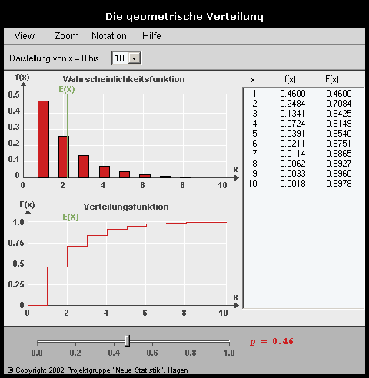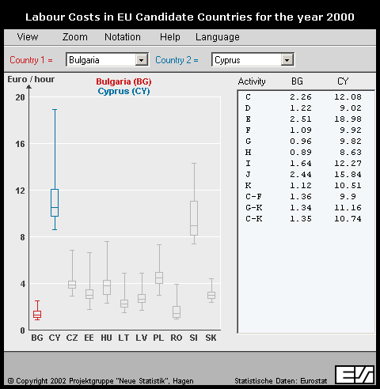

Interactive Java applets and multimedia components, brought together in multilingual repositories, could be exchanged and shared between statistical offices. They could also be disseminated to educational institutions in order to reinforce the visibility of official statistics in society and to improve communication with the citizen.
REFERENCE
Mittag, H.-J. (2002), Java applets and multimedia catalogues for statistics education. Invited paper presented at the 6th International Conference on Teaching Statistics, Cape Town, South Africa, July 7 - 12, 2002 (accessible via http://www.fernuni-hagen.de/e-statistik, English version, see at « Publications »)
Razi, N. , and Hiemenz, B. (2003), New Statistics: Elements for blended learning, Paper to be presented at the 54th Session of the International Statistical Institute, Berlin, Germany, August 13 - 20, 2003.
RÉSUMÉ
Ce document présente un projet éducatif allemand intitulé "New Statistics" et, en particulier, la portée des applications interactives Java qui constituent l'un des piliers du projet. A l'aide d'applications Java utilisées sur des données d'Eurostat, il montre que la visualisation interactive pourrait aussi constituer un outil important d'amélioration de la communication entre les offices statistiques et leurs clients.

