Virtual learning environments for statistics education
and applications for official statistics

Hans-Joachim Mittag
University of Hagen, Germany / European Commission, Eurostat, Luxembourg
joachim.mittag@cec.eu.int

Summary

In our fast-moving information and knowledge society, skills and know-how rapidly become outdated. Virtual learning environments play a key role in meeting today’s growing demand for customized educational and vocational training and life-long learning.

The scope of multimedia-based and web-supported education is illustrated by means of an interdisciplinary multimedia project “New Statistics” funded by the German government. The project output contains more than 70 learning modules covering the complete curriculum of an introductory statistics course. All modules are based on a statistical laboratory and on a multitude of Java applets, animations and case studies.

The paper focuses on presenting the statistical laboratory and the applets. These components present the main project pillars und are particularly suitable for international use, independently from the original project framework. This article also demonstrates the application of Java applets and other multimedia developments from the educational world to official statistics for interactive presentation of statistical information.

New media in education and e-learning initiatives in Europe

Traditional media for learning and teaching, i.e. printed material and teacher-centred instruction, are more and more complemented by multimedia resources and rich interactive learning environments. World-wide, universities have already started to establish virtual campus systems in order to meet the growing demand for individually-tailored education and vocational training. The new media surmount obvious limitations of traditional educational frameworks with respect to accessibility and customization of learning contents or time-independence (“learning on demand”).

As a response to these developments and as a contribution to Europe’s move to a knowledge-based society, the European Parliament adopted in December 2003 the e-learning action plan of the European Commission. The main objective is an effective integration of information and communication technologies in education and training systems in Europe. The multi-annual European plan was supplemented by national initiatives. The German government, for example, acknowledged the strategic importance of e-learning for tomorrow’s education by funding, from 2001 to 2003 under the label ”New media in education”, several huge multimedia projects related to different disciplines, with emphasis on statistics.

The project “New Statistics”

One of the major projects launched by the German State within the framework “New media in education” and led by a consortium of 10 German universities is the multimedia project “New Statistics”. This interdisciplinary project aims at providing a multimedia-based and web-supported virtual environment for learning and teaching statistics in economics, social sciences, medicine and other disciplines. The project output consists of a set of approximately 70 learning modules covering the complete curriculum of an introductory statistics course. All modules are based on the same pillars: an innovative learning laboratory, the Statistical Lab, based on the programming language R for performing ad-hoc analyses of user-defined data sets, Java applets for trying out statistical concepts by means of user-controlled experiments, Flash animations for explaining statistical theory step by step and case studies related to different sciences and applications. The modular approach gives maximal flexibility and supports very different use scenarios.

The award-winning Statistical Lab represents an interactive and flexible working environment designed for explorative and problem-oriented learning and teaching. Avoiding a great emphasis on abstract theory and formulas, the program provides a realistic, problem-based approach to statistical methods in a straightforward and user-friendly way. With the Lab, teachers and instructors obtain a powerful tool for developing statistical exercises with sample solutions, real-life scenarios and sophisticated simulations. Figure 1 shows a Lab-based graphical analysis of data on age structures in Korea in 1970 and 2000. The data stem from the web site of the Korean National Statistical Office.

Figure 1: Graphical analysis of Korean population data by means of the Statistical Lab

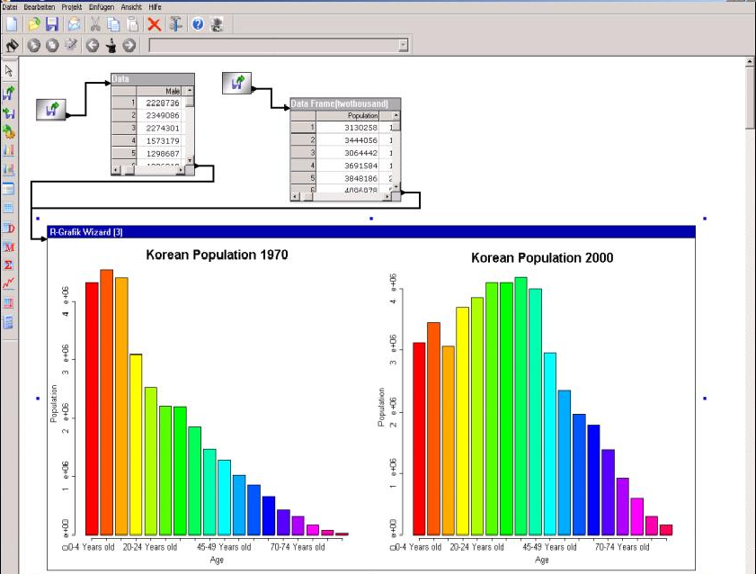

The applets are interactive experiments visualising basic concepts in descriptive statistics, probability theory and inferential statistics, designed as a supplement to traditional lecturing and for self-study purposes. They enable students to “play” with statistical methods by trying them out whereas the teacher or trainer may use them for demonstration purposes, for example offline as an integral part of PowerPoint presentations. Figure 2a shows results of repeated coin experiments where the user controls the number n of virtual coin throws and the probability p for the occurrence of “tail” (T). The development of the relative frequency h_{i}({T}) for “tail” during the running experiment is displayed, i = 1, 2, … , n. The course of the outcomes is visualised in light red. (The graph refers to the ninth experiment carried out in sequence with n = 500 and p = 0.5). The course of a new experiment based on the same simulation parameters n und p, here interrupted by the user after approximately 250 throws, is displayed in dark red. Figure 2b refers to an interactive experiment dealing with the geometric distribution. The user is enabled to vary the distribution parameter p or the scale of the x-axis and to observe the effects.

For all applets, the functionality “View” offers access to alternative graphical presentations, for example suppression or display of numerical values or selection of graphical instruments. The features “Notes” and “Help” provide meta information (theoretical background, technical hints for optimal use) whereas “Language” offers the option to switch from English to other languages.

Figure 2: Visualising statistical concepts by means of Java applets

a. Virtual coin experiment b. The geometric distribution

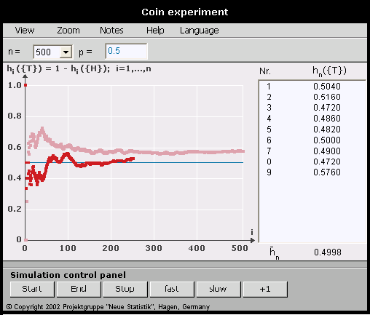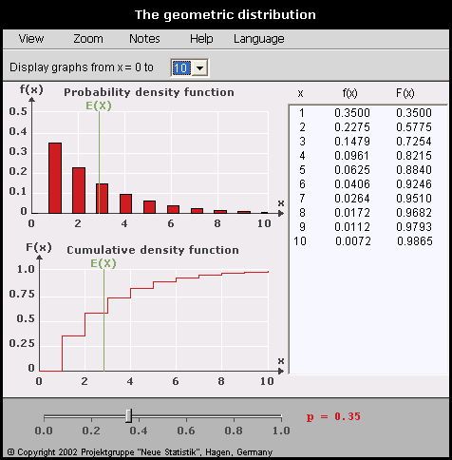

The Statistical Lab and the Java applets, both in parts already available in English language, may also be employed outside the project framework, independently from the other project components, and both are of particular interest for international use.

New challenges for official statistics

Statistics are increasingly important for governments as a basis for evidence-based decision-making and, as well, for citizens as a measure for understanding the complex world around them. Hence, statistical offices have to cope with imperative demands for more and more high-quality statistics that are easy to understand and to access. Statistical offices try to meet these challenges by providing free dissemination of data and by developing a more user-centred approach. They are aware that clearly communicated statistics essentially contribute to sharpening the profile of a statistical office and to positively influence its visibility and creditibility.

Free dissemination of data and easy access to statistics creates new waves of demands and implies the appearance of new users and user groups. Statistical offices are nowadays expected to provide clearly understandable and relevant statistical information for a wide audience. The website of the Office for National Statistics of the United Kingdom, for example, receives currently more than half a million visitors per month.

The developments sketched above ask for new strategies for improving the usability of the statistical information delivered and for ensuring satisfaction of the expanded audience. An essential instrument of any suitable strategy is the maximization of user-friendliness as regards the communication and presentation of data. Progress in this area is continuously ongoing but for the time being statistical offices still do not fully exploit the potentials connected with virtual dissemination channels, such as the Internet and the distribution of information via e-mail. The Internet is still mainly used for transporting static information and the user is not enabled to visualise self-defined data subsets by means of self-chosen graphical instruments. The idea of making use of multimedia developments from the educational world and of adapting them to the needs of the world of official statistics is therefore obvious.

Successful attempts for providing interactive visualisation of data from official statistics have been made within the project “New Statistics”. Again, the visualisation is performed by means of self-contained multi-lingual Java applets. These could be presented either online (presentation on website of statistical offices, distribution via e-mail attachments) or offline (CD-ROMs, as part of a dynamic PowerPoint presentation). Figure 3 shows an applet visualising excerpts from a pocketbook published by Eurostat on the occasion of its 50th birthday. The applet presents statistical information on the relative size of the age classes 0-14 years (“young” people) and over 64 years (“old” people) in the 15 countries constituting the European Union until 30 April 2004. The data refer to 1958, 1973, 1881, 1986, 1995 (years of foundation or enlargement of the European Community / European Union) and to 2001. EC-6 denotes the mean of the age group sizes for the 6 founding Member States represented in Figure 3a by a bar in black. The bars in dark blue refer to the Member States at the chosen point of time. For both age classes, the size of the age class 15-64 years (“middle-aged” or working population) is used as a reference basis. Figure 3b uses boxplots for visualising the development over time and also gives numerical information which is suppressed in Figure 3a. The two parts of Figure 3 represent only a small share of a hidden multitude of user-defined views on the same data set.

Figure 3: Relative size of the age group “0 -14 years” in Europe

a. Percentages for 15 countries and for the EC-6, 1958 b. Aggregated information for 15 countries, 1958 - 2001

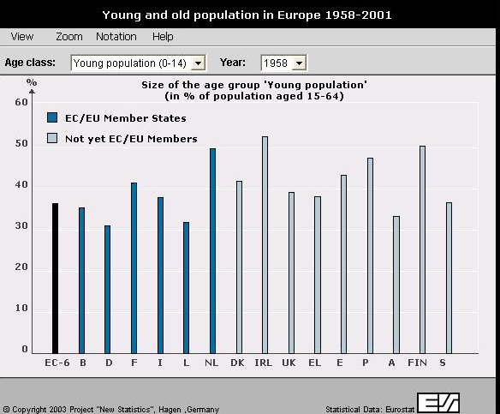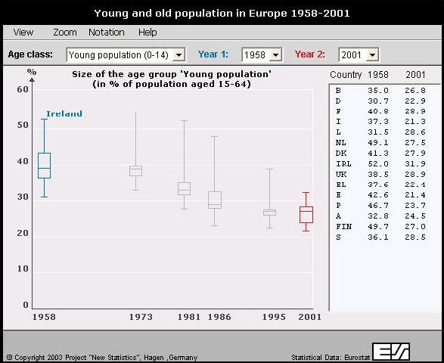

Sole tabular data presentation is less suitable than well-designed graphs to communicate the messages behind the data to the users. Figure 3 shows at a glance the dramatic changes of age structures over time and provides evidence-based arguments for the ongoing debates on reforms linked to social security systems in Europe.
Interactive visualisation tools as shown above could not only be disseminated to schools, universities or media agencies but also be incorporated into electronic publications. The added value of the resulting interactive publications for a wide public audience is obvious.
Tools for dynamic data presentation are not the only potential by-product of recent multimedia projects launched for improving the quality and efficiency of statistics education at universities. Another promising area for the application of e-components is statistical training for employees in national and supranational offices. A modern training concept will make use of computer-based and web-supported learning modules and combine classical and virtual learning environments. The statistical offices might here cooperate with educational institutions, in particular with public distance universities, being forerunners as regards the promotion of virtual campus systems and international virtual networks.
Acknowledgements and note
The author is indebted to Dr. Werner Grünewald (Eurostat, Luxembourg) and Dr. Eberhard Heuel (University of Hagen, Germany) for useful comments and to the Center of Digital Systems (Berlin, Germany) for technical support. The views expressed in this paper are those of the author and may not be considered as stating an official position of any institution.
Links and references
http://www.nso.go.kr/eng/ (link to the web site of the National Statistical Office of Korea, population data accessible via “Statistical DataBase (KOSIS)” under “Population / Household”)
http://www.neuestatistik.de/en (link to the English version of the website for the German project “New Statistics”)
http://forum.europa.eu.int/Public/irc/dsis/wages/information (link to applications of the project “New Statistics” to recent Eurostat data, click on “Java applets …”)
http://www.fernuni-hagen.de/e-statistik (English version accessible via the British flag, click on “Publications” in order to get access to publications related to this paper)
http://www.fernuni-hagen.de/neuestatistik (further link to the project “New Statistics” and to project-related publications, accessible by end of 2004)
Eurostat (2003), 50 years of figures on Europe, Office for Official Publications of the European Communities, Luxembourg, May 2003.
Mittag, H.-J. (2004), Dynamic data presentation and interactive publication for official statistics. Proceedings of the European Conference on Quality and Methodology in Official Statistics, Mainz, Germany, 24- 26 May, 2004
Rafalowska, H. (2004), Statistics for non-statisticians – can we read and understand statistics? Paper presented at the International Conference “Statistics: Investment in the Future”, Czech Statistical Office, Prague, Czech Republic, 6-7 September 2004
Razi, N., and Hiemenz, B. (2003), New Statistics: Elements for blended learning, Paper presented at the 54th Session of the International Statistical Institute, Berlin, Germany, 13 – 20 August, 2003.

